Design a resource pack to support an element of effective classroom management in your learning environment.
“Give the pupils something to do, not something to learn; and the doing is such a nature as to demand thinking; learning naturally results.” (John Dewey (1980). “The Middle Works, 1899-1924”, .161, SUI Press).
Classroom management covers many components of techniques and skills that teachers adopt whilst planning for their students enabling for positive learning. It is not only practiced in behaviour management. The teacher has to have effective strategies in place to enable students to keep focused on their tasks, in an orderly manner to ensure the classroom is a safe and enjoyable environment (Edglossary.com).
In later years there has been a lot of spotlight on classroom management by many researchers, reformers and education leaders who have put into motion investigating and analysing strategies that have been very impressive by lucrative teachers. The flourishing emphasis on classroom management is placed on the generic perception that practical guidance depends upon powerful classroom management.
Although, the debate is still ongoing between educators as to what strategies are the most effective to students. Some say that students should conform by following classroom arrangements to enable them to learn to their full potential, others say that learners should be actively involved in this process (Edglossary.com).
According to teach.com all students are created equally (and differently). So, it is important for teachers to understand that all students have a preferred learning style in the way they take in, convert, assimilate and maintain information. The students will also benefit in their learning by teachers implementing the appropriate strategies into their daily planning. The concept of distinguished learning styles has acquired extensive acknowledgement in the theory of education and classroom management (Team.com, 2020).
The resource chosen for this year 10 pupil is a ‘tactile’ resource which involves a practical approach to learning. Kolb’s model of learning styles (1984) suggests this type of learning as ‘Accommodating’. Stating that people with this style count on instinct rather than coherence. They tend to use other people’s reasoning and information and adopt to use a practical and experimental approach (McLeod, 2017).
The resource is available to the pupil in a specified room in the LRC. The resource has been loaned from Green links Hair and beauty department. Green links is a local registered community company which support and give young people and adults of all abilities, including those with ALN (additional learning needs) the opportunities to training to gain skills, experience and qualifications to progress in work or further training (Arcswood, 2012).
Agored Cymru is an awarding body for education in Wales. The qualifications gained by pupils are extensively accepted and valued by the education area and employers. These qualifications prepare students with a range of skills, knowledge and experience to allow students to further their training or future employment (Agored Cymru, 2015-2020).
The pupil goes to Green links to attend Hair and Beauty lessons on a weekly basis where there are other female pupils who have a good relationship with the pupil. This option was agreed with the pupil, Centre Head, Parents and Green Links. The pupil does intend to go to his local college to further his education in hair and beauty when leaving school with the support of an LSA.
The resources consist of: Hairdressing models, hairdryers, curling tongs, brushes and combs. There are also creative resources available so the pupil can make models etc, to learn about the topic (see images below). This includes making models related to hairdressing. There is a nail bar which consists of false nails to practice nail painting. A selection of nail varnish, nail remover and examples of different designs to try.
These two images of hair follicles below were what the pupil created with support from the LSA in a series of lessons in the quiet room of the LRC. The quiet room is a ‘safe haven’ for this pupil where he can become more relaxed and have time out from others. This strategy is used for this pupil as a reward for his work and an effective behaviour strategy. These two activities were carried out by the pupil with support from the LSA. The pupil is always rewarded for positive behaviour and having a go at the tasks given by being able to go to the quiet room and carry on with his ongoing activities. This resource has been a great success for the pupil for his learning and behaviour. Fox states how important it is for LSA’s to give pupils plenty of praise and encouragement in their role to increase the pupil’s confidence and self -esteem (Fox, 2003 pg. 15).
Once the pupil has completed an activity, he takes it down to the tutor in Green links where she then puts it on display for everyone to see. He also has praise and recognition from her for excellent work by being given a ‘Well Done’ postcard to take home.
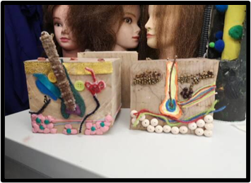
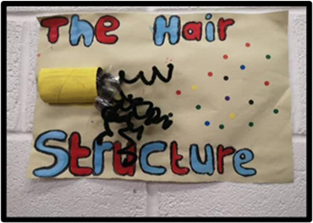

This resource chosen is a learning strategy for a year ten who has autism who attends the Learning Resource Centre in the local secondary school. The secondary school’s Additional Needs Policy states that Governors and staff, are committed to the education of all pupils/students by making suitable provision for those pupils/students with additional learning needs and strive to meet the individuality of each pupil, ensuring they reach their full potential through effective teaching and support (School A, ALN Policy, 2019). As part of the Labour Government’s strategy, The Inclusion Development Programme (2009), aims are to promote equality and opportunities for ALN pupils promoting awareness of Autism to establish an effective approach to learning (Knowles, 2006. Pg. 79).
The resource is a ‘tactile’ resource which involves a practical approach to learning. Kolb’s model of learning styles (1984) suggests this type of learning as ‘Accommodating’. Stating that people with this style count on instinct rather than coherence. They tend to use other people’s reasoning and information and adopt to use a practical and experimental approach (McLeod, 2017).
This particular pupil has attempted on numerous occasions to access mainstream lessons with his LSA as he feels he wants to be ‘normal’ and fit in but, unfortunately has had to leave and go back to the LRC due to many issues in the classroom such as; sensory overload, negative behaviour of others and not fitting in. His anxiety plummets which then often leads to negative behaviour such as; shouting out inappropriate language to other pupils and hand gestures. Rudolph Dreikurs was influenced by Alfred Adler’s theory, that all human’s motivation is having a feeling of belongingness in society and to being excepted by others, and that all behaviours including negative is methodical, determined and conducted towards achieving social approval. When this particular pupil feels that he is not being accepted by others in the classroom this is when a pattern of behaviour starts. Dreikurs highlights four types of goals that stimulates negative behaviours in children as; attention seeking, power and control, revenge, feeling inadequate and the sense of helplessness. The last goal of feeling inadequate and the sense of helplessness is what triggers this particular pupil off in the classroom. The class teacher can escalate the situation by using ‘you’ and point directly at the pupil which then puts all the focus on him from the others. Dreikurs ‘Social Discipline Model ‘theory works successfully in the LRC as all staff follow the strategies set out by the Centre.
Unfortunately, the teacher does not always have the time to speak to the pupil when this occurs as they are dealing with pupils that are challenging. Some teachers especially supply teachers do not have enough awareness of autism and do not know how to deal with pupils in their class with this condition. They sometimes see them as a difficult bad behaved pupil and respond in an inappropriate way by singling the pupil out. This is why it is so important that LSA’s who support have the knowledge and understanding of the disorder so they have a positive relationship and know how to communicate with the pupil. The LRCs behaviour strategies are similar to mainstream but, due to the pupils that attend there are all on the spectrum means the way behaviour is dealt with is very much about communication and different strategies that suit each pupil.
Hiam Ginott’s theories linked setting boundaries and applying compassion with congruent communication as the primary tool. He regards that there are only behaviours that are unacceptable and not an unacceptable child. He encourages parents and teachers to refrain from using personal labelling when addressing communication and using ‘I’ instead of ‘you’ without attacking and blaming the individual (Ginott, 1975). This theory works very well in the LRC and has a positive impact with the pupils.
This pupil has difficulties with language and communication, processing information, social interaction, limited and repetitive patterns of behaviour, and a highly-focused interest in mobile phones, hairdressing and make up (Individual Development Plan, School A, 2020)
Baron-Cohen suggests that people who have autism experience ‘mind blindness’. Their inability to attain cooperative attention with others interferes with how they interpret and their thinking and perceiving of them. They then become ‘blind’ to other people. Conventional humans are able to ‘mind read’ also known as what they are thinking and their feelings (Baron-Cohen, 1995).
This can be a major issue for pupils with autism in mainstream school as it causes anxiety and stress. This is why it is so important that all pupils in schools are made aware of others that have autism and how it affects them. This can also help others to have more understanding and how to include them into society. Break times can be very intimidating for them as they may have difficulty in developing social skills. The school incorporate this information in their bullying Policy and regularly have assemblies where videos are shown to educate others on pupils with disabilities (School A, Bullying Policy, 2019). The National Autistic Society also suggest creating awareness and understanding in schools by holding assemblies where ALN can be presented without highlighting a particular condition or pupil (NAS, 2018).
The resources for this pupil have been chosen and arranged in the quiet room by himself and the LSA.
- There is one station which has a hairdressing model attached to the table with a drawer unit with all the resources needed for that specific activity.
- There is a small table with designs of nail art displayed, nail varnishes, nail remover and cotton wool.
- There are creative activities which consist of instructions to follow, paints, glue, brushes and materials.
- There are tunics for the pupil to wear at all times whilst in there. The pupil is encouraged to wash hands regularly throughout the activities.
- An LSA is always present to support the pupil.
- If there are LSA’s that would like to have their nails painted, they are invited into the quiet room.
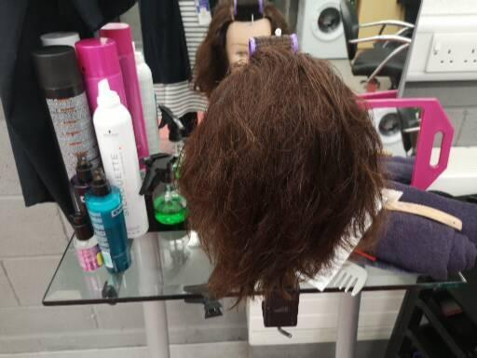
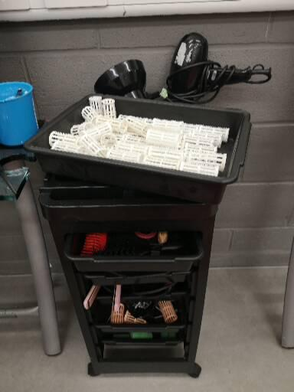

Images of pupil styling models hair and painting an LSA’s nails.
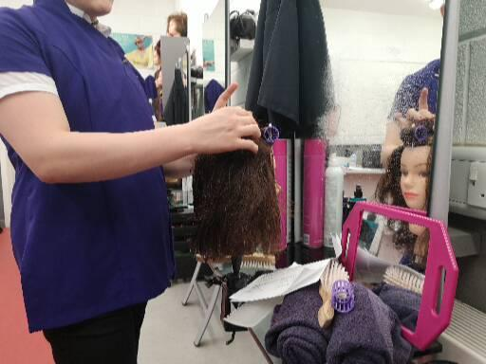
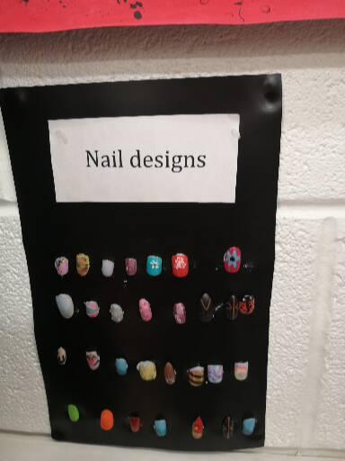

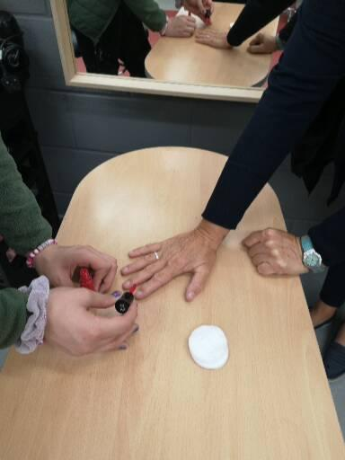

References:
AZ Quotes, (no date) John Dewey (1980) Available at. www.azquotes.com/quote/496976" (Accessed 24/07/2020).
Baron-Cohen, S. (1995) Mind blindness: An Essay on Autism and Theory of Mind. Massachusetts: MIT Press.

Costley, D. Keane, E et al (2012) A Practical Guide for Teachers of Students with an Autism Spectrum Disorder in secondary school. London: Jessica Kingsley.

Dreikurs, R. Grunwald, B. et al (1998) Maintaining Sanity in The Classroom: Classroom Management Techniques East Sussex: Taylor and Francis.

Ginott, H. (1975) Teacher and Child: A book for parents and teachers, New York: Macmillan.

Glossary of Educational Reform. Available at: http://edglossary.org/classroom-management/ (Accessed 18/07/2020).
Knowles, G. (Ed.) (2006) Supporting Inclusive Practice Oxford: David Fulton​

Marzano, R.J. (2006) Classroom management that works: Research based strategies for every teacher, VA: Association for supervision and Development.
Rajendran, G., & Mitchell, P. (2007). Cognitive theories of autism. Developmental Review, 27(2), 224-260. ​

Rogers, B. (2007) Behaviour Management London: Sage​

Rogers, B. (2011) Classroom Behaviour (3rd edition), London: Sage.
Rogers, B. (2009) How to Manage Children’s Challenging Behaviour London: Sage​

School A, (2020) Individual Development Plan, Bullying Policy, ALN Policy.
Seach, D. Lloyd, M. et al (2002) Supporting Children with Autism in Mainstream Schools London: Continuum International.

Simply Psychology. McLeod, S (2017) Kolb's Learning Styles and Experiential Learning Cycle. Available online. https://www.simplypsychology.org/learning-kolb.html (Accessed 18/07/2020).
Walton, A. and Goddard, G. (Eds.) (2009) Supporting Every Child London: Sage. ​

​
​
​

