Programs in C and documentation
- Part C

Software
Development

Programs in C and documentation
By Xuyuan Liu

Part C
1. Identify the problem
This program uses a while loop and an if loop and one function to input the positions. The program first uses the while loop to enter two position numbers. Then use the if loop to determine if the two numbers are equal. If they are equal and the two numbers are not equal to 0, then a match is completed. Assign a value of 0 to both of the arrays. And add 1 to the counter with an initial value of 0. If the counter is less than 6, continue the while loop. Otherwise the program ends.
Figure 1. flowchart of Part C
2.Annotated Code
#include<stdio.h>

int enterinteger(); //prototype for function

void main()
{

int pairs[12] = { 6,5,2,3,1,2,4,1,3,4,5,6 }; //input the array
int card1, card2, matches = 0;

while (matches < 6) //while loop 6 times
{
card1 = enterinteger(); //call the function to input the position
card2 = enterinteger(); //call the function to input the position

if (pairs[card1] == 0 || pairs[card2] == 0) //adjust if the position have been chosen
{
printf("You have already chosen these\n");
}

else if (pairs[card1] == pairs[card2]) //two position is matched
{
printf("It's a match!\n");
pairs[card1] = 0;
pairs[card2] = 0;
matches++;
printf("You have %d so far\n", matches);
}

else //not match
{
printf("Sorry\n");
}

}

}

int enterinteger() //user function
{
int thevalue;
printf("Enter position of a card ");
scanf("%d", &thevalue);
return thevalue;
}
3.Testing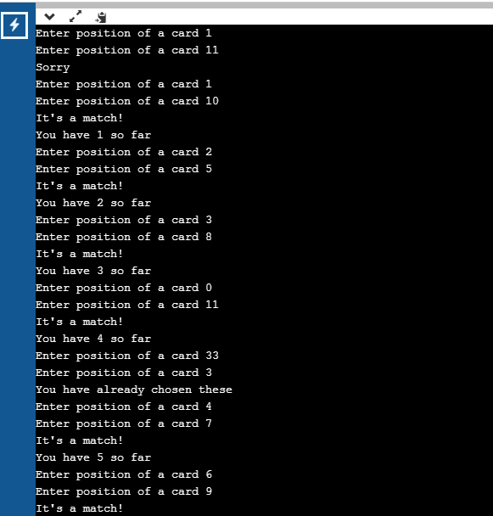
Figure 2. Screenshot of C part
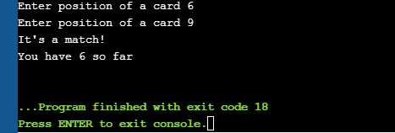
Figure 3. End after six times

Figure 4. Not matched

Figure 5. Same chosen

