Script Rehearsal and Performance Module Process Workbook.
Nicole Evans
2303744
Approximate word count excluding brackets, quotations and titles: 1,504
Word count altogether: 2,004

The preparation needed to ensure a performance is at its highest standard is equally as important as the performance itself, as actors and directors work intensely to break down scripts and lace the text with character ideas and intentions, pulling the work apart before putting it back together, which is explored in rehearsals with physicality and staging, to ultimately bring to life on stage. This has been explored through the Script Rehearsal and Performance module.

Script: Breakdown and Analysis Techniques
Looking at ‘The Last of the Pelican Daughters’ written by The Wardrobe Ensemble, the play follows four daughters dealing with problems in their personal lives and their relationships with each other, all on top of the loss of their mother, her birthday, and the arrangements regarding her will and their childhood home. Rehearsal preparations start with script analysis, as it is imperative that actors and directors understand the text they’re working with. Katie Mitchell’s methodologies have proven to be an influential way to do so for over a decade. ‘Facts and Questions’ is an established method by Mitchell herself, used to assist in the discoveries and early responses to the text, Mitchell defines facts as “the non-negotiable elements of the text. They are the main clues the writer gives you about the play” (Mitchell, 2009, p.11) – “Pink walls”, “Frida Kahlo painted on the chimney breast”, “Bookshelves filled with de Beauvoir and Butler and Plath” (The Wardrobe Ensemble, 2019) - while “questions are a way of notating the areas of the text that are less clear or that you are simply not sure of.” (Mitchell, 2009, p.11) – ‘Who are Beauvoir, Butler, and Plath?’, ‘What is the significance of these facts in the Pelican household?’.
When working with chapters four and five of this text for the first time, using ‘Facts and Questions’ proves helpful in organising information to prevent “premature attempts to interpret the play” (Mitchell, 2009, p.11), the facts give directors a baseline to “map the physical, geographical, and temporal certainties of the play,” (Mitchell, 2009, p.12), whilst questions allow for creative interpretation and expansion. Actors using facts are able to organise their thoughts and encourage elaborative character biographies influenced by the given circumstances.
Mike Alfreds labels ‘given circumstances’ as “any facts, events and conditions that influence the situation taking place.” and “These conditions are established to influence the characters in some pertinent way (for us to discover) or to throw more light on them.” (Alfreds, 2007, p.71). Bella Merlin discusses how “given circumstances consist of all the data you can glean from the script” (Merlin, 2007, p.67). Both authors make perceptive points, however in this context, some given circumstances are subjective, as major decisions stem from the enquiries made during the ‘Facts and Questions’ exploration, which leaves space to conduct research that could influence the given circumstances of the characters. Using ‘What is the significance of Frida Kahlo in the Pelican household?,’ as an example, researching Frida Kahlo’s practises implied that the Pelican household respects her work, and often refer to it in their daily lives, a fact that the script does not present, but can subjectively be decided upon.
Katie Mitchell also highlights the importance of ‘eventing’ scenes; an ‘event’ is a change during the action of the play, this change must have a quality and affect that can be played by everyone. All exits/entrances are events, and subject changes do not qualify as events. Its purpose is to section scenes, working towards a ‘main event,’ doing so “makes things clear for the actors and the audience in equal measure” (Mitchell, 2009, p.56). In chapter four of ‘The Last of the Pelican Daughters,’ the ‘main event’ is Maya, the youngest of her sisters, announcing that she is pregnant. Similarly, with chapter five, the main event is the surprise arrival of Luke, the youngest of all the Pelican children, after his sisters believed he wasn’t coming, when in reality he hadn’t been invited. To ensure that these main events do not get undercut, actors work on the tempo of the surrounding events, keeping scenes upbeat and succinct until a main event erupts a major change in atmosphere.
It is through the use of these methods that rehearsal preparation can be achieved, and actors and directors are able to start the next stage – rehearsals.

Rehearsals: Monologue Preparation and Characterisation
‘Quiche isn’t Sexy’ is a one act play written by Gabriel Davis; the story follows Jay, a man addicted to eating burgers. Jay attends ‘Meat Eating Anonymous,’ where he meets Jackie, a woman once obsessed with eating lamb. During an at-home date night, Jackie confronts Jay’s vegetarian menu option with her monologue ‘Quiche isn’t Sexy,’ which leads them into a meat relapse.
For a performance of this monologue where context of the whole play isn’t available to an audience, decontextualising this speech becomes necessary – instead of Jackie using sex as a metaphor for wanting to eat meat, she uses her desire for meat as a metaphor for her desire to have sex with Jay. Altering the context shifts character objectives, which Mike Alfreds describes as “wants,” “we are drawn through our lives by a mesh of intertwined wants, long-term and momentary,” (Alfreds, 2007, p.39). Jackie’s objectives consist of wanting intimacy with Jay, she wants to educate him on the difference in presenting her with a quiche at the dinner table, rather than a rack of lamb. Jackie’s objectives never change during this monologue, however as an actor using John Barton’s “Fresh-Minting” technique (Barton, 2009) defeats generalising the text and encourages true feelings within her objectives.
Along with the change of character objectives, comes the change of subtext; it is known that the metaphors that make up Jackie’s speech have changed, but it is important to recognise the moments of subtext that have changed in this speech in particular, as they influence the playing of the character. Originally, Jackie was trying to use intimacy with Jay as a cover up for actually wanting to eat lamb, claiming that quiche is just “a savoury pie” and that lamb is “rare and wonderful” (Davis, 2015), changing the context changes the subtext therefore, to Jackie, whilst it may seem that she is just exclaiming how “pretentious” (Davis, 2015) she finds quiche, she is actually comparing quiche eaters to those with ‘vanilla’ relationships and lamb eaters to those with more ‘experimental’ relationships.
To understand Storm Pelican from ‘The Last of the Pelican Daughters,’ a textual exercise is Mike Alfred’s ‘Character Lists.’ Character lists can consist of: What the character says about themselves, what the character says about others, what others say about the character (Alfreds, 2007, p.131). These lists are practical and can be helpful during the characterisation process as they provide a deeper understanding of the structure of the play and a character’s personality – how they see themselves and others, and how others see them. It can help to take lines from the text - “I don’t have any friends. They all moved away.” (The Wardrobe Ensemble, 2020) - and turn them into an emotion, like ‘I am lonely’, “these thoughts determine how we respond to events in our lives.” (Mitchell, 2009. P68). Actors can return to these phrases as many times as they need to remind themselves of the character they are portraying, as Uta Hagen mentions, “we must not take the emotions but allow the emotions to take us instead.” (Hagen, 2001).

Research and Development
Research and development phases are where “the world of a show – characters, style, story – is explored. It provides space to experiment with ideas and adopt blue-sky thinking.” (Joseph, n.d). Every research and development process is executed differently – this process sometimes not being used at all, but when explored, RNDs provide the opportunity to investigate creative enquiries and bring forward areas to further develop in order to create a new draft to proceed from, it encourages those involved to think about the lasting effect that is left on an audience, and whether or not that is accessible through the current draft. As an actor, it can be useful to set goals to achieve during the RND process, whether that is independently, or as a company. Working collaboratively is significant during an RND process as it requires positivity, patience, and the willingness to make company-identified problems and solve them.
‘Mythfits: Tales of the Unaccepted’ is a script in development written by Tim Davies, it explores characters and stories from Greek myths such as Jason and Medea, Penelope and Odysseus, and Perseus and Medusa, except with added twists and plotlines that explore these stories in a new perspective. Working with objectives to meet is important, but in this scenario it can be more important to acknowledge the bigger picture – RNDs do not have an end product, therefore they are the perfect opportunity to be experimental with ideas, “to start from what is obvious and simple and by stages proceed to the unexpected and complex” (Alfreds, 2007, p.79), a trait useful for professional rehearsals.
In traditional Greek Theatre, a Greek chorus was “a group of actors who described and commented on the main action of the play with song, dance, and recitation.” (Britannica, 2020) As the prologue of this script begins with ‘The Orator’, who uses techniques like imagery and rhyme, this dialogue is suited to be spoken by the chorus, to capture the audience’s attention ahead of the first scene. A useful exercise to practice sharing a voice is “Bryan Adams in a Toga” by Jessica Swale. The exercise consists of various challenges such as “There must be a minimum of two people speaking at once,” or “You must use repetition as an echo, whether whole lines or single words” which encourage varied dynamics throughout chorus-based dialogue (Swale, 2016, p.71).
In addition to vocality, the Greek chorus explores physicality through Anne Bogart’s ‘The Viewpoints.’ Each viewpoint is firstly explored individually, to “isolate awareness,” doing this means that “each viewpoint is, in turn, dealt with on its own terms, then added to what has already been investigated” (Bogart and Landau, 2005, p.35). As previously mentioned, John Barton’s ‘Fresh-Minting’ is useful to apply to a performance that is becoming generalised, this can be applied during the investigation of physicality as, in combination with Bogart and Landau’s viewpoints, movement makes emotion.

Performance
Jackie from ‘Quiche isn’t Sexy’ is a passionate character with a comedic speech; an audience with a particular member acting as ‘Jay’ to aim the speech towards is beneficial, as their reactions encourage the meaning of Jackie’s speech.
Working physically with Mythfits is exciting, moving uniquely provides new emotions to feel, whilst making connections between the movement and the dialogue influences how it is expressed and spoken towards an audience.
‘The Last of the Pelican Daughters’ is full of love, hate, comedy, and tragedy. It is an honour to perform and to invite an audience into the manifestation of the grief that each sister presents. Storm Pelican is a whirlwind of a character; her vulnerability needs to be seen by an outsider (the audience) for her to be understood.
The methodologies explored in the Script, Rehearsal, and Performance module have been useful and have become versatile, adaptable, and crucial tools to incorporate into future projects and opportunities from both an acting and directing perspective.

Bibliography
Alfreds, M (2007) Different Every Night. London: Nick Hern Books.
Barton, J (2009) Performing Shakespeare. London: Methuen.
Bogart, A and Landau, T (2005) The Viewpoints Book. New York: Theatre Communications Group, Inc.
Britannica (2020) Chorus. https://www.britannica.com/art/chorus-theatre (Accessed 7th December).
Davies, T (Unpublished) Mythfits: Tales of the Unaccepted.
Davis, G (2015) Quiche isn’t Sexy. CreateSpace Independent Publishing Platform.
Galen, J. (2015) Uta Hagen’s Acting Class part 1. Available at: https://www.youtube.com/watch?v=SseJhOPV9nY&pp=ygUddXRhIGhhZ2VuIGFjdGluZyBjbGFzcyBwYXJ0IDE%3D (Accessed 11th December 2024)
Joseph, N (no date) https://www.spotlight.com/news-and-advice/the-essentials/what-actors-need-to-know-about-rd/ (Accessed 1st December 2024).
Merlin, B (2007) The Complete Stanislavsky Toolkit. London: Nick Hern Books.
Mitchell, K (2009) The Director’s Craft. A Handbook for the Theatre. Oxon: Routledge.
The Wardrobe Ensemble, (2020) The Last of the Pelican Daughters. London: Nick Hern Books.
Swale, J (2016) Drama Games for Rehearsals. London: Nick Hern Books.

AI Acknowledgment.
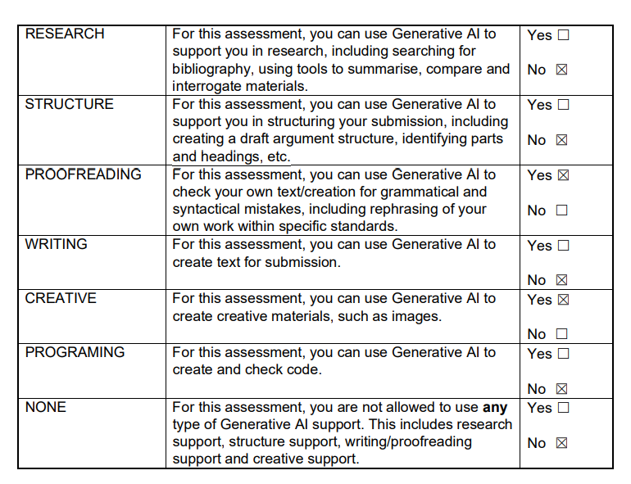

I confirm that I have not used any AI tools in the research and creation of this assignment. I confirm that I have not presented any AI generated materials as my own work. I confirm I have copies of my drafts, notes, and other resources I used, which I may be asked to provide in evidence.

