Feasibility Plan for an International Meeting
Winter Wonderland Christmas Fair
Frosty Fair

Student name: Andreea Violeta Panciu
Student ID Number: 2214991
Module Title: International Meetings Management for the Hotel Industry
Module code: BMIH6007
Lecturer’s Name : Kathryn Flynn
Date : 18 October 2024

Slide 1: Title


Slide 2: Introduction

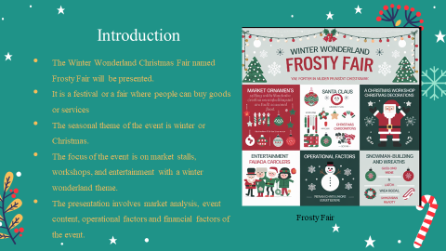
Winter Wonderland Christmas Fair entitled Frosty Fair is a type of seasonal exhibition, which aims at giving people a festive atmosphere. It will contain stalls and shows designed according to a specific theme, performance, or craft. Some of the aspects to be covered in the feasibility study are content matter, market requirement, competitors, working plan joint venture practicality and pragmatic fiscal values.
Slide 3: Event Content and Context
- Frosty Fair is a festive Christmas fair
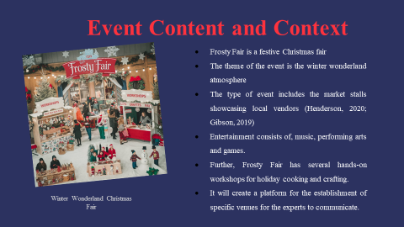.
The Winter Wonderland Christmas Fair will also have a specific theme to help give people the yuletide aura they need. At Frosty Fair, the different local sellers will exhibit different market stalls with reassembled holiday products. The household is fitted with state-of-the-art equipment for hosting convene including live performances/band and Artesian crafting besides Gameplay culinary classes, especially during festive seasons.

Slide 4: Event Goals
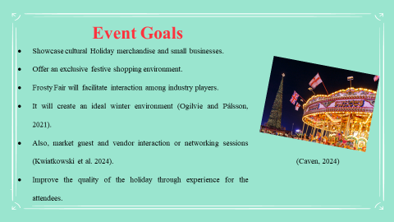
The main objectives of the Frosty Fair are as follows – to provide the opportunity for festive purchases and to create a platform for local sellers to present their Christmas goods. It is strategically planned to generate an illusionary spirit that enables it to provide a platform for the exchange of information among industry players in addition to the intended element of fun that will depict and complement the holiday spirit among all participants of the event.

Slide 5: Target Market
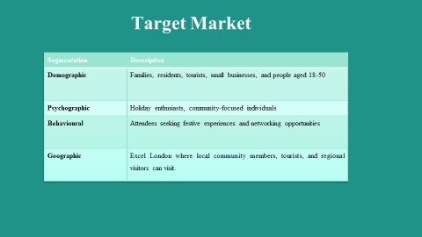
Segmentation | Description
Demographic | Families, residents, tourists, small businesses, and people aged 18-50
Psychographic | Holiday enthusiasts, community-focused individuals
Behavioural | Attendees seeking festive experiences and networking opportunities
Geographic | Excel London where local community members, tourists, and regional visitors can visit.

The target group for the Winter Wonderland Christmas Fair includes families, people living in the area, visitors, and businesses. Psychographically, the audience is the festive and community group. Behaviorally, they look for business stimuli during celebrations and with opportunities for meeting and greeting. In terms of territory identification, the fair will be aimed at members of the local community together with regional visitors and tourists willing to enjoy the seasonal activities at the Excel London Centre.

Slide 6: Demand and Competition
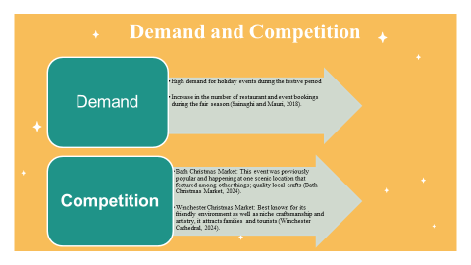
Trends relating to festive themes are highly sought after during the holiday season, specifically with reference to the hospitality and events sector with special regard to seasonal fairs. The main competitors are the Bath Christmas Market, which is already rather popular, located in a beautiful place, and presents exquisite handmade products. Likewise, Winchester Christmas Market receives significant attention because of its fabulous ambience and exceptional homemade items to sell at the Winter Wonderland Christmas Fair.

Slide 7: Marketing Strategy

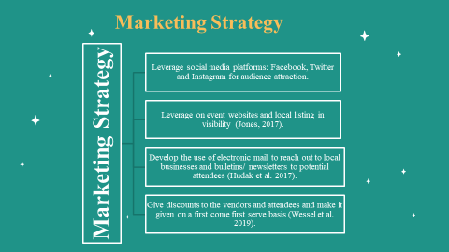
In circumstances, the marketing strategy for the Frosty Fair will include the use of Facebook, Instagram, and Twitter handles to reach possible attendees. We will also include the use of event websites and local listings as well as proper management of the e-mail advertising. Promotional activities will be providing incentives for early registration and enlisting local opinion leaders and corporate supporters to join the project; advertising the project in the media outlets within the region to reach as many people as possible.

Slide 8: Location and Venue Availability
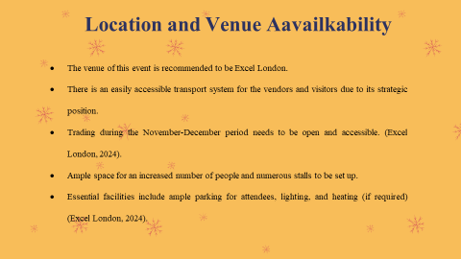
The selected location for the Frosty Fair is Excel London since the location is strategic and has easy accessibility to transport to ensure even the vendors can easily access the place, and it will be easy for people to access. It is located during the festive November-December period and has enough space to accommodate many people and other stalls. Besides, it of course has to include adequate lighting, heating if necessary, and sufficient parking space for participants.

Slide 9: Operational Factors: Staffing and Resources
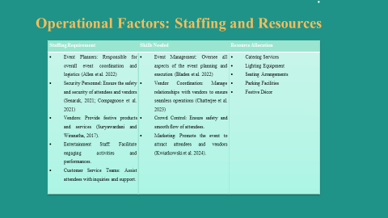
Staffing Requirement | Skills Needed | Resource Allocation
- Event Planners: Responsible for overall event coordination and logistics (Allen et al. 2022)  - Security Personnel: Ensure the safety and security of attendees and vendors (Senarak, 2021; Compagnone et al. 2021)  - Vendors: Provide festive products and services (Suryawardani and Wiranatha, 2017).  - Entertainment Staff: Facilitate engaging activities and performances.  - Customer Service Teams: Assist attendees with inquiries and support. | - Event Management: Oversee all aspects of the event planning and execution (Bladen et al. 2022)  - Vendor Coordination: Manage relationships with vendors to ensure seamless operations (Chatterjee et al. 2023)  - Crowd Control: Ensure safety and smooth flow of attendees.  - Marketing: Promote the event to attract attendees and vendors (Kwiatkowski et al. 2024). | - Catering Services  - Lighting Equipment  - Seating Arrangements  - Parking Facilities  - Festive Décor
The Frosty Fair operational elements pertain to staffing necessities of event planners for organization, security staff, holiday merchants, performers, and customer care attendants. Some of the key competencies identified are the ability to coordinate events, the ability to coordinate vendors, the ability to manage crowds and marketing skills. Deductions include catering, lighting, seating, parking and festoon to make the environment appealing and magical.
Slide 10: Financial Factors: Income
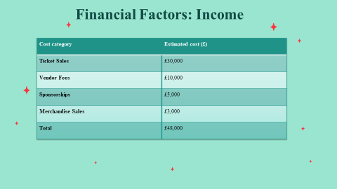
Cost category | Estimated cost (£)
Ticket Sales | £30,000
Vendor Fees | £10,000
Sponsorships | £5,000
Merchandise Sales | £3,000
Total | £48,000
Income: ticket sales £30,000 based on the assumption that 2000 people will attend the event, vending £10,000 based on 50 vending which will operate at the event, sponsorship £5000 from the businesses around the Town and the sales of merchandise £3000. These projections suggest a fairly sound financial framework for such an event.

Slide 11: Financial Factors: Expenditure
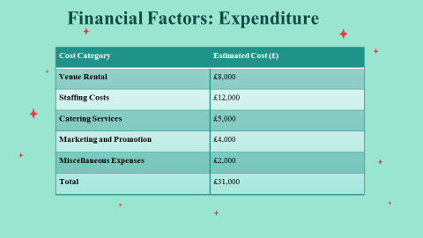
Cost Category | Estimated Cost (£)
Venue Rental | £8,000
Staffing Costs | £12,000
Catering Services | £5,000
Marketing and Promotion | £4,000
Miscellaneous Expenses | £2,000
Total | £31,000

The expected expenditure has been figured out based on different estimates and it has been seen that the Frosty Fair can generate 48000 pounds. Tickets will amount to £30,000 and vendors £10,000. More money is expected to be made from sponsorships, £5,000 and merchandise sales, £3,000. This condition of multiple sources of funds shows a strong financial base for the event, making planning and implementation efficient and guaranteeing the fact that operational costs as well as other expenses cannot be a major challenge.

Slide 11: Financial Factors: Projected Revenue
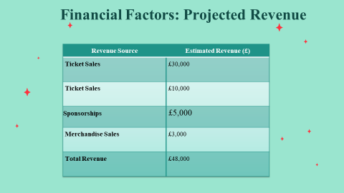
Revenue Source | Estimated Revenue (£)
Ticket Sales | £30,000
Ticket Sales | £10,000
 | £5,000
  Sponsorships
Merchandise Sales | £3,000
Total Revenue | £48,000

The revenue to be expected from the Frosty Fair is £48,000, which will arise from different sources. This includes ticket sales at £30,000, vendor fees at £10,000, sponsorships at £5,000, and merchandise sales at £3,000. It shows a revenue inflow into the event from multiple streams, which demonstrates all the economic aspects of the event are well set up.

Slide 12: Funding Sources
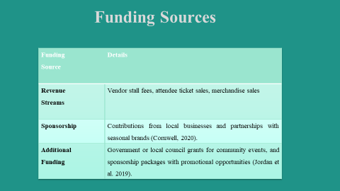
Funding Source | Details
Revenue Streams | Vendor stall fees, attendee ticket sales, merchandise sales
Sponsorship | Contributions from local businesses and partnerships with seasonal brands (Cornwell, 2020).
Additional Funding | Government or local council grants for community events, and sponsorship packages with promotional opportunities (Jordan et al. 2019).
Other sources of finance for the Frosty Fair include various activities such as fees paid by vendors who rent stalls during the fair, ticket prices for attendants, and sales of merchandise during the event. In addition, revenue incomes rise from local sponsorship by local traders and partnering with seasonal brands.

Slide 13: Conclusion
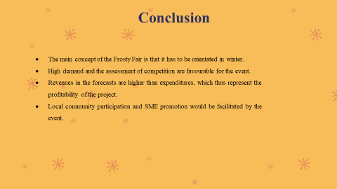
Hence, the Frosty Fair project presents a good snapshot of an event that is feasible to hold in winter with enough analysis of feasibility to be implemented. In addition, there is excellent demand for the offered product and an excellent position of the competitive environment for it to take. The financial planning shows that revenues would be higher than expenses, ensuring profitability, and encouraging community participation as well as encouraging the local entrepreneurial initiatives along with the coordination.

References
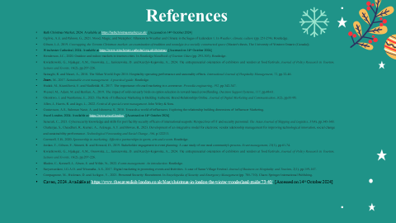
Allen, J., Harris, R. and Jago, L., 2022. Festival & special event management. John Wiley & Sons.
Bath Christmas Market, 2024. Available at https://bathchristmasmarket.co.uk/. [Accessed on 14th October 2024]
Bladen, C., Kennell, J., Abson, E. and Wilde, N., 2022. Events management: An introduction. Routledge.
Chatterjee, S., Chaudhuri, R., Kumar, A., Aránega, A.Y. and Biswas, B., 2023. Development of an integrative model for electronic vendor relationship management for improving technological innovation, social change and sustainability performance. Technological Forecasting and Social Change, 186, p.122213.
Compagnone, M., Hickman, D. and Acikgoz, Y., 2021. Personnel Security: Recruitment. In Encyclopedia of Security and Emergency Management (pp. 705-710). Cham: Springer International Publishing.
Cornwell, T.B., 2020. Sponsorship in marketing: Effective partnerships in sports, arts and events. Routledge.
Excel London, 2024. Available at https://www.excel.london/. [Accessed on 14th October 2024]
Gibson, L.J., 2019. Unwrapping the Toronto Christmas market: an examination of tradition and nostalgia in a socially constructed space (Master's thesis, The University of Western Ontario (Canada)).
Gustavsson, A.S., Suleman Nasir, A. and Ishonova, S., 2018. Towards a world of influencers: Exploring the relationship building dimensions of Influencer Marketing.
Henderson, J.C., 2020. Outdoor and indoor markets in tourism cities. In Routledge Handbook of Tourism Cities (pp. 293-303). Routledge.
Hudak, M., Kianičková, E. and Madleňák, R., 2017. The importance of e-mail marketing in e-commerce. Procedia engineering, 192, pp.342-347.
Jones, M., 2017. Sustainable event management: A practical guide. Routledge.
Jordan, T., Gibson, F., Stinnett, B. and Howard, D., 2019. Stakeholder engagement in event planning: A case study of one rural community's process. Event management, 23(1), pp.61-74.
Kwiatkowski, G., Hjalager, A.M., Ossowska, L., Janiszewska, D. and Kurdyś-Kujawska, A., 2024. The entrepreneurial orientation of exhibitors and vendors at food festivals. Journal of Policy Research in Tourism, Leisure and Events, 16(2), pp.207-226.
Kwiatkowski, G., Hjalager, A.M., Ossowska, L., Janiszewska, D. and Kurdyś-Kujawska, A., 2024. The entrepreneurial orientation of exhibitors and vendors at food festivals. Journal of Policy Research in Tourism, Leisure and Events, 16(2), pp.207-226.
Ogilvie, A.E. and Pálsson, G., 2021. Mood, Magic, and Metaphor: Allusions to Weather and Climate in the Sagas of Icelanders 1. In Weather, climate, culture (pp. 251-274). Routledge.
Okonkwo, I. and Namkoisse, E., 2023. The Role of Influencer Marketing in Building Authentic Brand Relationships Online. Journal of Digital Marketing and Communication, 3(2), pp.81-90.
Sainaghi, R. and Mauri, A., 2018. The Milan World Expo 2015: Hospitality operating performance and seasonality effects. International Journal of Hospitality Management, 72, pp.32-46.
Senarak, C., 2021. Cybersecurity knowledge and skills for port facility security officers of international seaports: Perspectives of IT and security personnel. The Asian Journal of Shipping and Logistics, 37(4), pp.345-360.
Suryawardani, I.G.A.O. and Wiranatha, A.S., 2017. Digital marketing in promoting events and festivities. A case of Sanur Village Festival. Journal of Business on Hospitality and Tourism, 2(1), pp.159-167.
Wessel, M., Adam, M. and Benlian, A., 2019. The impact of sold-out early birds on option selection in reward-based crowdfunding. Decision Support Systems, 117, pp.48-61.
Winchester Cathedral, 2024. Available at https://www.winchester-cathedral.org.uk/christmas. [Accessed on 14th October 2024]

