
Module Title: Managing Enterprise
Module Code: BMSW4011
Assignment Title: Business Plan and Reflection
Student Name: Roxana Horvatova
Student Number: 2506472
Lecturer: Melanie Squire
Assignment Deadline: Friday 19th June 2026

AI Statement
I do acknowledge the use of ChatGPT “https://chatgpt.com/ ” in my reflective report only for understanding what is needed in a Hair-Salon at home. I confirm that I have not used any AI generated text as my own words.

Table of Contents
Table of Contents 1
Concept 2
Company name 3
Business Aims 4
Target market 4
Legal Identity 4
Marketing and PR Plan 5
Pricing Strategy 5
Human resource strategy 6
Source of Finance 6
Cash Flow Forecast 7
SWOT Analysis 7
References 8
Reflection 9

The business that I want to do is to open my own hair-salon at my house. I prefer to have my own salon at my house because there are not many around my area in Tremorfa. It is also because it offers immense freedom, lower financial overhead, and a better work-life balance. By eliminating rent and commuting, you save significant money and time, and you are in control of your schedule and providing a private, highly personalized experience for your clients. Ali, M. (2026) Why You Should Choose Home Salon Services: Benefits of Home Salons. Ref 1.
Since I was a child, I have always taken the interest of working in a hair-salon because I find it fun and an excellent job. I have chosen this job because I was always interested of doing peoples hair, such as washing, cutting, blow-drying, and dyeing. I would have equipment's like different colours of dye and bleach, scissors, combs, shampoos, foil, curler, straightener, comfortable chairs, and basins when washing hairs, and aprons, and brushes. Trieu, F. (2026) Basic Salon Equipment Required to Get Stared. Ref 2

Concept
The thought of being independent and helping customers with their preferred hair style over-joyed me because I would be able to satisfy them. I want my concept of my own hair-salon to be welcoming with dim lighting to avoid overwhelming clients with bright light and with a clean environment. I want everything to be new with the walls to be painted light pink and white Luxury Vinyl Tile floor and comfortable black and gold chairs, and big mirrors with bulbs stuck around them. Reservio. (2026) Create a Compelling Concept To Start Your Salon Business. Ref 3. I would also like to have a big white neon sign that glows with my salons name stuck on a wall. Another concept is to have a general atmosphere of well-being that radiates from the hair-salon so that the customers will feel welcomed and comfortable, and a scalp massager with professional techniques that induce immediate relaxation. I would also aim to have an organic and eco-friendly products to create a healthier environment for my clients and a free parking sport. Business Education. (2025) Keeping a Bright Atmosphere in Your Salon: Prohair. Ref 4.

Company name
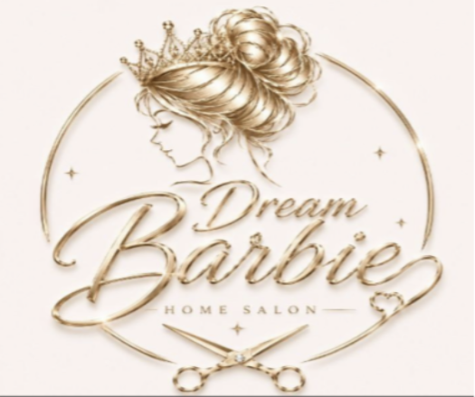
The name that I have come up with will be ‘Dream Barbie.’ I love the name because it is simple and cute. I love the design and the colour of the logo. It is not too flashy, and it is elegant with a catchy name. I love the women with the crown and the scissor on the bottom with the name ‘Home Salon.’ I want this logo because for my salon because I love the details and how it looks like. Franzen, T. (2025) How to Create Logos for a Hair Salon? Ref 5.
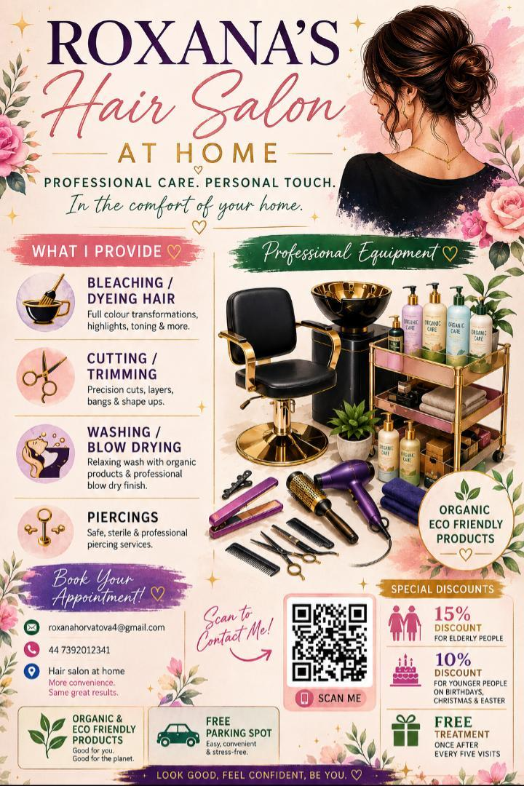 This is my promotional flyer for my home-based business. It has details such as my name, email, phone number, what I will provide, and the equipment's. There is also a QR code to scan so it is easier to contact me. This flyer is helpful to gain clients with all the essential information needed to book an appointment and know what I provide.

Business Aims
I am going to achieve my business aims by doing research of what customers are interested in and staying updated on new trends, having a SMART goal that is specific and measurable, such as what I am going to do, what I need for my salon and my clients. Sending automated reminders or personal text messages after appointments to keep brand top-of-mind. Reading client’s feedback and rebooking rates to understand what is working and where improvement is needed. Simionato, C. (2024) Mobile Hairdressing Business Plan: Strategic Guide to Plan Your Hair Business. Ref 9. Posting on Social Media videos and photos of my business to attract clients with good offers, such as posting a new opening business, before and after photos of client's hair, and giving out business cards to customers in person. Young, E. (2024) Building Your Salon’s Success with Social Media. Ref 10.

Target market
My target market is women from the ages of 30 to 55. This is because, younger adults would prefer to go to a normal salon rather than an in-home salon and because women juggle work and family, making salon travel difficult. A home salon offers a private, stress-free escape away from the busy, noisy atmosphere of normal salons. I would sell and promote my products or services to my customers by social media. This will help people know what things you offer and what they do. Another one is to talk with customers in person and explain what the product does and the benefits of it. British Hairdressing Association. (2024) Keys to Success: Marketing Strategies for Hairdressers and Client Attraction. Ref 11.

Legal Identity
To opening my own Hair salon at my house and being the boss with the essential skills that I already qualify, would be my successful accomplishment. I have hair-dressing level 2 and 3 Diploma from college, and I have also registered to the council to check local authority to make sure my house is safe, legal, and professional. Firth, A. (2026) Setting Up a Hair Salon: Key Legal Considerations. Ref 6. I have also got Public Liability Insurance from Protectivity so that if a client injures themselves by slipping or accuses me, they will defend me and cover injuries to clients or damage to property, and also a Treatment Risk Insurance which will cover me in-case a client claims a treatment or hair dye caused them damage or injury. Leslie, J. (2022) Should hairdressers be required to have Public Liability Insurance? Ref 7.
Lastly, a Special Treatments License is required if you offer piercing, tattooing, or certain high-tech cosmetic procedures, which is important because I plan to have a qualified professional assistant working with me to give customers piercings. Offering different things such as piercings, and jewellery with a set of various products for damaged hair, will boost my hair-salon, because of all the different things I would provide. Osberne, C. (2025) Why Every Salon Owner Needs Health & Safety Sorted. Ref 8.

Marketing and PR Plan
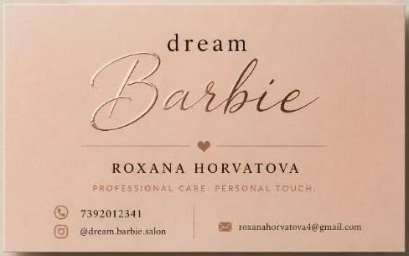 A marketing plan for a hair salon is a strategy where you have a structured framework of how the salon will attract new clients, different ways to showcase your work, retain existing clients, and increase revenue. Doing this will help me reach success and help my business progress. This includes to have a social media such as Facebook, Instagram, and TikTok which will attract new customers. Platforms on social media allows stylists to connect with local customers. Posting and updating regularly will also increase customers. Showing before and after hair styles, updating latest offers such as discounts and distributing business cards. Ben, A. (2025) How to Initiate a Hair Salon Marketing Plan? With Example. Ref 12.

Pricing Strategy
My pricing strategy is to offer good offers such as 15% discounts for elderly people, and 10% discount for only younger people when there are Birthdays, Christmas, and Easter. Free treatment once after every five visits and offering piercings for £50. Kirby, A. (2026) Discount coupons are good for salon business – it’s a fact. Ref 13.
- Washing- No charge
- Blow drying- No charge
- Trim for short hair- £20
- Trim for long hair- £30
- Cut for short hair- £30
- Cut for long hair- £40
- Dye for short hair- £30
- Dye for long hair- £40
- Highlights for short hair- £50
- Highlights for long hair- £60
- Wet hair cut for short hair- £40
- Wet hair cut for long hair- £55
- Piercings- £50

Human resource strategy
At first, I will work on my own and then I will hire two people to support and help me to do peoples hair. I also want to run my business with a person who will be in charge of doing piercings. The role that person will have is to do piercings for ears, nose, and lips. I will be doings this by posting a hiring notice on social media for people who are interested of working. They will have to be professional and know how to do it without any issues that may result in a client getting injured like scarring and bacterial infection. I want someone to work with me but have a different role, so that customers who are interested in having a piercing, would get it at my salon. The person would have their own call appointments. Each piercing would be £50, and I would get 20% off their earnings. This will help our business grow and more customers visiting because of different things we are offering.

Source of Finance
In the beginning of my business, I aim to open my salon with the essential equipment’s such as:
- Five different colours of dye (Black, Brown, Blonde, Red)
- Fifteen bleaches
- Five scissors (Straight Shears, longer Straight Shears, thinning/Texturizing Shears)
- One hundred pins
- Ten hair claw clips
- Ten combs
- Five hairbrushes
- 5 x 30m Foils
- Curling rollers small and big for different hair types
- Two straighteners
- Two curling irons
- Two blow-dryers
- Spray bottle for styling.
- Four aprons
- Two black chairs
- Two mirrors
- Two small mirrors
- One basic basin sink with a comfortable chair.
- Ten towels
- Mixing bowls and tint brushes
- Sanitizing jar and disinfectant
- Gloves
- Complete cleaner set such as mops, bucket, cleaning spray, rag, etc
- Hair products (shampoo, conditioner, toner, treatments)
All this together will cost around £3,500.

Cash Flow Forecast
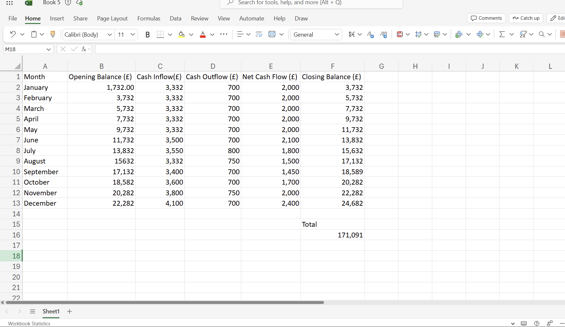

SWOT Analysis
Strengths  Good at communicating, cutting, and trimming people's hair. Good at cleaning and dyeing/ bleaching hair. Good at blow-drying, straightening, and curling hair. |  | Weaknesses  Not good at doing side quests such as piercings, makeup, or nails. I am good at styling hairs but not if it involves doing it in fancy styles suitable for special occasions such as birthdays or weddings.
Opportunities  Get to learn more new things such as new way of bleaching hairs and the opportunity to expand my salon bigger and growing popular with many customers looking forward to my services. And being updated on new hair trends. |  | Threats  Not many customers and bad reviews online. Customers being dissatisfied with my services and in case of trips or a customer accuses me of something. Customers can be also aggressive which can put me in a dangerous situation.

References
Ali, M. (2026) Why You Should Choose Home Salon Services: Benefits of Home Salons. Ref 1.
Trieu, F. (2026| Basic Salon Equipment Required to Get Stared. Ref 2.
Reservio. (2026) Create a Compelling Concept To Start Your Salon Business. Ref 3.
Business Education. (2025) Keeping a Bright Atmosphere in Your Salon: Prohair. Ref 4.
Franzen, T. (2025) How to Create Logos for a Hair Salon? Ref 5.
Firth, A. (2026) Setting Up a Hair Salon: Key Legal Considerations. Ref 6.
Leslie, J. (2022) Should hairdressers be required to have Public Liability Insurance? Ref 7.
Osberne, C. (2025) Why Every Salon Owner Needs Health & Safety Sorted. Ref 8.
Simionato, C. (2024) Mobile Hairdressing Business Plan: Strategic Guide to Plan Your Hair Business. Ref 9.
Young, E. (2024) Building Your Salon’s Success with Social Media. Ref 10.
British Hairdressing Association. (2024) Keys to Success: Marketing Strategies for Hairdressers and Client Attraction. Ref 11.
Ben, A. (2025) How to Initiate a Hair Salon Marketing Plan? With Example. Ref 12.
Kirby, A. (2026) Discount coupons are good for salon business – it’s a fact. Ref 13.

Reflection
Introduction
In this report, I will focus on how this assignment has helped me to understand how to carry out a business plan. I gained a better understanding of the importance of planning before starting a business. Through doing a business plan, I have learned many things I did not know before such as recognizing the key elements required to establish a successful salon business, including identifying the target market, understanding customer needs, and the services that will be offered. I also learned the advantages of having a Salon at home and the advantages it offers such as lower overhead costs and flexible working hours, while I also need to maintain professional and comply with local regulations. Reflecting on this business plan assignment, I gained a better understanding of the process involved in developing a successful business idea. Researching and finding out how to create a business, helped me understand the importance of planning before starting a business.
Feelings
When coming up with a business plan, I was feeling a bit overwhelmed because I had no idea of what to talk about or how to start. I had to come up with a suitable business plan where I eventually chose a hair-salon at home. I thought this would be a bit easy and an amazing idea as there are not many in Tremorfa. Although I found it a bit easy, I had to research a lot such as what is needed in a hair-salon at home, why people prefer home salons, target market, what licenses I need and certificates, how much I will earn and how I will give out discounts, how I will promote and showcase my business, why and how I will recruit, and the concept. It was also difficult for me to manage the finance part such as how much the services I will provide will cost. There had to be a lot of researching for me to find the useful information I need. It is important to know what things are needed when doing a business plan. Overall, even though I had trouble and I was feeling overwhelmed, I also enjoyed doing this assignment because I have learned how to come up with a business plan and learn how to manage it.
What went well?
One aspect that went well was the importance of why Salons at home needs licenses. I was able to use research to support me and to explain how this will help my business. This improved my confidence and knowledge of the importance of having different types of licenses and how it helps.
Conclusion
In conclusion, this business plan has helped me understand what is needed to run a successful hair salon at home. It has improved my knowledge of business planning, and how to manage finance. It also taught me many things that is needed for a business plan and the importance of being organised and prepared when starting a business. Overall, this has improved my knowledge of how to plan a business plan which was very helpful and useful.

