  Procurement & Contract Selection | Patrick Furlong (0650804)  Procurement Process

Contents
Introduction 1
Traditional 2
Design and Build 4
Collaboration 6
NEC vs JCT summary 9
Conclusion 11
References 12

Introduction
Procurement in construction is commonly understood to be the purchase of goods and services Greenhalgh et al (2022) or the management arrangement by which a project is realised Delves et al (2001). Purchases of standard goods and services is normally straightforward, however, in construction it is more complicated due to the amount of variables leading to the finished product; there is a constant trade- off between time, cost and quality that will determine a project’s value for money Greenhalgh et al (2022).
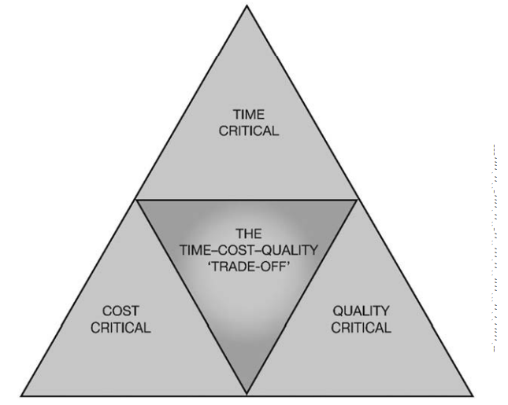
Figure 1Time, cost and quality relationship triangle Greenhalgh et al (2022).
The selection of a procurement route will be governed on the emphasis placed on key criteria of quality, cost, time, flexibility, risk and client experience Procurement and Partnering Strategy (2000). The failure or success of a project can be determined by the procurement method, and it should be made carefully with all the project objectives in mind; too often procurement is chosen on familiarity however this one size fits all approach doesn’t work Wassenaar (2017). The consequences of poor procurement and how its managed can reduce the likelihood a building being safe Hackitt (2018)
The most popular forms of procurement in the UK in terms of the number of projects are shown in Figure 2.
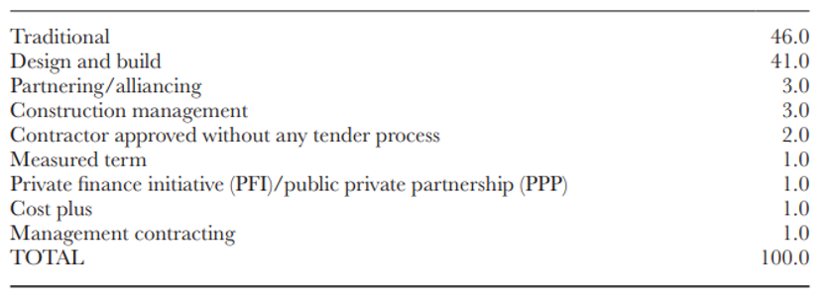
Figure 2 Most frequently used methods of procurement National Building Specification (2018), National Construction Contracts and Law Report, NBS.
O'Connor (2017) states that in the UK, procurement methods can be placed into 5 principal categories Traditional, Design and Build, Contractor’s Design Portion (a hybrid of Traditional Procurement with Design and Build), Package contracting (Construction Management or Management Contracting) and Integrated (collaborative or partnering/alliancing).

Traditional
When the design is carried out by an independent architect and construction by a separate building company, this is generally known as traditional procurement and has been used by the construction the industry for at least 160 years Greenhalgh et al (2022). The sequential nature of the traditional route offers certainty in that the design is complete and costs can be accurately known however this makes the process slow Figure 3 and this route is usually favoured where budget or finances are the major concern Morledge (2024).
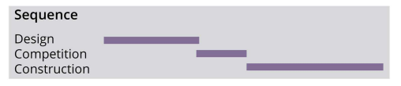
Figure 3 Traditional Procurement Sequence
This approach is typically adopted by inexperienced or occasional construction clients as it is seen as a very low risk approach; this is due to the certainty in the design, cost and duration Morledge (2024).
As the client selects and appoints the design team prior to tendering, the contractor has no or limited input into the design and therefore liability March (2017). During the tendering process the client is responsible for supplying accurate designs, specifications and quantities usually in the form of a bill of quantities (although the client can, via the contract, transfer this responsibility to the contractor) March (2017). As the process is design led, the client can directly influence performance and quality of the building Morledge (2024) Figure 4.
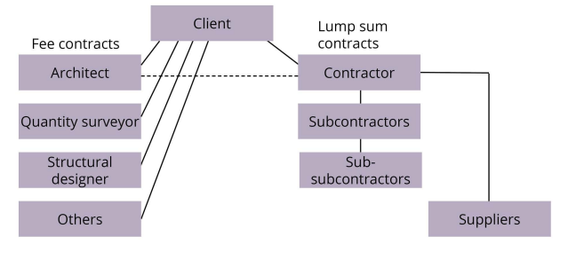
Figure 4 The organisational structure of traditional procurement
This means the client takes the risk of the design whereas the contractor takes the risk for the construction for an agreed sum; this can create an adversarial situation Garvey (2015) in which the contractor tenders the lowest price (Abnormally low bids, ALBs Adams. J, et al (2020) to win work especially in the public sector, the contractor then works to letter of the contract and uses every available clause for extra payment with the client ultimately picking up the bill March (2017). The failure to utilise the contractor at an early stage in the design is the primary cause of uncertainty, delay, increased costs and conflict in many construction projects Hill (2000).

Design and Build
Design and build is:
“a procurement route in which the main contractor is appointed to design and construct the works” Hackitt (2018)
Historically, design and build was how buildings were produced, in that the architect would design the building to the client’s approval and would then engage craftsmen to build it. The current “traditional” procurement route only materialised after the separation of architectural profession from the construction process in the early 20th century Murcutt. (1988). Design and build began to gain favour again in the 1960s to cope with the advancement in building technology; the increase in complexity of modern construction techniques made it increasingly difficult for designers to be responsible for all aspects of design and administration Latham (1994). It was criticised by construction professionals however it gained much support from clients Murcutt. (1988). Its popularity was due to the fact it is a more integrated or joined-up way of delivering a built environment solution Peace and Bennet (2002).
In its simplest form a single company enters a contract with a client to design and construct a new building with the burden of risk borne by the contractor usually for a fixed-price lump sum Morledge (2024). That contractor is solely responsible for producing the building the client wants rather than that responsibility being divided up between multiple entities Peace and Bennet (2002). Design and build outperforms the traditional approach in most aspects of project performance and the advantages of design and build is predominantly in early contractor involvement Procurement and Partnering Strategy (2000). Clients are likely to benefit from advice on alternative methods of construction to achieve their aims Latham (1994). The contractor’s specialist knowledge can result in more cost-effective solutions and fewer variations than the traditional route; the contractor can use its own design team that it regularly works with and can leverage their skills to produce building solutions March (2017). Unlike the traditional route the design and construction stages can overlap each other Figure 5 which can lead to reduced completion times March (2017).
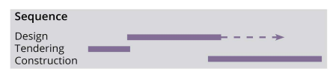
Figure 5 Design and build sequence Morledge (2024)
Another advantage is that there is a single point of contact for the client Figure 6. This should be easier to manage especially for clients with little knowledge or experience and should require less resources.
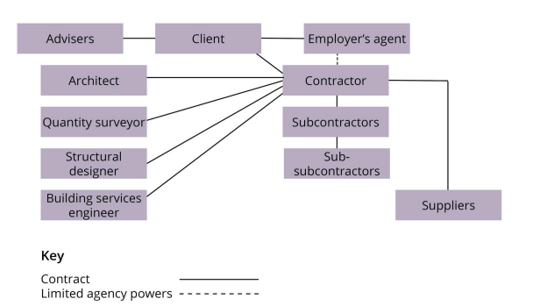
Figure 6 The project organisation structure for design and build Morledge (2024).
Design and build procurement is best suited to relatively simple projects which can be fully defined and are unlikely to change Partnering Strategy (2000). The client will also need to commit to a concept design at an early stage before detailed designed are completed, so they may inadvertently be agreeing to something they don’t want. Although there may be price certainty any changes the client makes may be costly and liability is limited to standard contracts Morledge (2024). In the past design and build has led to issues with quality, as the client has relinquished control to the contractor Figure 6; the design team is engaged by the contractor and is working in the interest of the contractor and not client Morledge (2024). A contractor may have little incentive to provide quality if they can increase profit margins through value engineer or reducing the specification if it still meets the clients brief Procurement and Partnering Strategy (2000). This “race to the bottom” not only leads to a lower quality product and poor value for the client but it can impact the safety of the building’s inhabitants; procurement was highlighted as a key failure that led to Grenfell Tower disaster Hackitt (2018). To avoid the loss of quality and to gain the full benefits of fast-tracked design and build the client’s needs must be carefully and fully defined at the outset in a detailed brief Latham (1994). Given the lack of previous experience of developing a brief and the need to start this project while the design is still proceeding the design and build route could be a disaster Latham (1994)
“It is not uncommon for the transition from the outline planning drawings to the construction set, upon which the design and build price is agreed, to lead to significant disappointment and dispute, particularly if the deliverables are not fully or adequately described.” Hopfe and McLeod (2015)

Collaboration
Collaborative procurement is sometimes known as integrated, partnering or alliancing and it emerged in the 1990’s because of the adversarial situations encountered in the existing procurement methods; It aimed to focus all participants on the mutual objective of not only delivering on cost, time and quality O’Conor (2017) but also no disputes and stakeholder satisfaction Wassenaer (2017) Figure 7
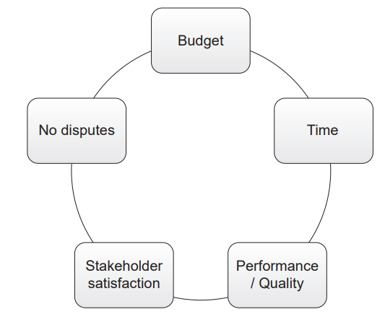
Figure 7 The 5 interdependent for determining project success Wassenaer (2017)
It requires stakeholders adopt a change in attitude and encourages a team approach to problem solving rather than an adversarial allocation of responsibility: it encourages them to take responsibility for solving problems where previously they may have sought to pass them on Brookhouse (2013). A successful collaborative procurement approach was used for the London 2012 Olympic games Higham et al (2017). Through early open dialogue collaborative procurement leads to efficiencies and enhanced site safety Brookhouse (2013) Figure 8.
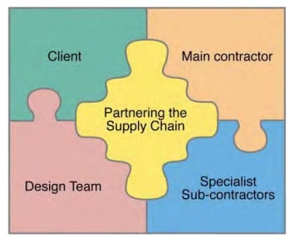
Figure 8 The integrated (collaborative) approach to early involvement Hill (2000)
Along with potential cost savings of between 5-15% Stuart (2012). The design and construction process are integrated, this allows for overlap of stages and changes to be made as the project progresses at a lower premium than other methods Morledge (2024). Collaborative procurement can improve sustainability if it supports the principles of the circular economy, emphasizing waste reduction, material reuse, and resource regeneration Ababio, B.K. et al. (2025).
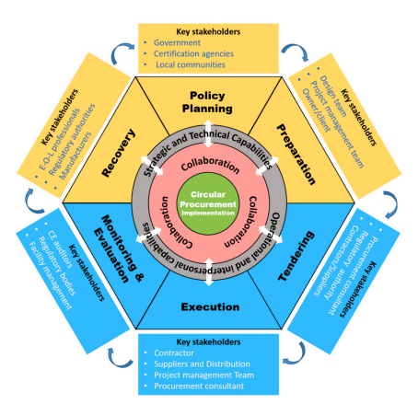
Figure 9 The circular nature of collaborative procurement and the link between the circular economy
Collaborative procurement relies on trust Garvey (2015) with the risks and rewards being shared Hill (2000). It is important to recognise the strengths of stakeholders with the risk allocated, and resting on whoever can manage it most effectively Brookhouse (2013). It is vital to establish a realistic cost ceiling with clearly defined outcomes with the process continually monitored Hansford (2014), this incentivises the delivery of value Greenhalgh et al (2022). The cost ceiling offers the possibility of moving away from lump sum prices and towards cost reimbursement based upon open book accounting, all parties benefit from financial gain if there is under-spend or the shared pain if there is an over-spend Higham (2017). This shared risk and gain encourages a more open approach to pricing and the establishment of long-term partnerships which avoid the learning curve at the start up stage which results in shorter lead-times Brookhouse (2013). Lessons learned from previous projects can be fed into subsequent projects leading to higher quality and lower cost Hopfe and McLeod (2015)

The ‘warts-and-all’ approach to risk sharing is not for the faint hearted and is suited to ‘professional clients’ who understand project processes and are prepared to take on project risks themselves in return for greater transparency and efficiency Brookhouse (2013). A continuous and substantial workstream will be required from the client to encourage business to invest resources into a collaborative approach Stuart (2012). EU procurement rules made long-term collaborative approaches difficult, and it can be difficult to establish partnership during austerity when companies are concentrating on survival Garvey (2015). This leads to a decrease in collaborative partnering and a tendency to delegate risk down the supply chain, with practice such as late payment and retention still widespread despite the UK governments 2014 Fair Payment Charter O’Conor (2017). There is an enhanced possibility and risk of “bidding rigging” when selecting only a few contractors to work within a collaborative procurement model Higham (2017). It requires more client resources; intense early management involvement and the process can collapse if it is abused by one of the parties and therefore the benefits of collaboration will take multiple projects before they are tangible Morledge 2024.

NEC vs JCT summary
The NEC contract takes a more positive proactive carrot approach to contract management, it uses simple language and is highly flexible with its ‘pick-and-mix’ approach. It encourages the anticipation and mitigation of risk. The JCT contract takes a reactive stick approach to management with rigid and traditional language which is far more adversarial. It’s a more structured approach which is better suited to less experienced clients due to its limited choices.
Table 1 JCT vs NEC comparison
NEC | JCT
in the mid-1980s by a new Legal Affairs Committee from a general dissatisfaction with ‘Victorian’ style standard form contracts within the construction industry, which had been conceived of prior to the commonplace requirement for complex multidisciplinary projects and which had become increasingly convoluted, in response to the perception of a ‘high-risk’ and ‘adversarial’ construction industry. | Its origins lie in 1870, when the Builders’ Society (now the CIOB) and the RIBA together produced the first ‘standard form’ of contract only in London  And the first national standard form became available in 1909
An important factor in the interest generated in the NEC was its applicability to a broad range of ‘engineering’ projects. This was ‘officially’ extended to include all construction projects following the Latham report | On being roundly criticized by Latham (1994), the JCT completely reorganized itself to involve more appropriate approaches to the negotiation and drafting of standard-form contracts
There was also a clear intention that the NEC should be conceived as a contract that would be operable globally and the drafting is intended to facilitate diversity on a number of levels
The NEC approach encompassed the concept that both the legal and the management requirements of a diverse range of ‘modern’ projects could be met in a single document and that the avoidance of ‘legalistic’ language would assist in that aim. The principles of risk theory and risk management were also important considerations, and an early decision was made that the contracting parties and their representatives should be required to act in a ‘spirit of mutual trust and co-operation’.14 The stated objectives of NEC are flexibility, clarity and simplicity, as well as providing a stimulus to good management. The key objectives in drafting NEC4 include providing a greater stimulus to good management and supporting new approaches to procurement which improve contract management – evolution, not revolution. 15 In practice, the NEC approach offers a range of benefits which are key to its success: ‘pick-and-mix’ contract conditions, to suit both the Project and the Project Team plain English, giving both legal and project management rights and obligations equal status real-time project management, with contemporaneous decision-making cross-industry application, facilitating multidisciplinary working practices. | The JCT suite of contracts take a more adversarial approach. Some attempts have been made by the JCT to promote collaboration, but it relies heavily on overarching documents which in the main are not binding on the parties and simply exhort collaborative behaviour.
plain old ‘completion’ in the NEC | practical completion’ in JCT contracts,
The drafters of NEC3 have at least tried to provide more clarity by abandoning the preliminary adjective and opting simply for ‘completion’. This requires the contractor to carry out all work within the ‘works information’ and rectify any defects which would have prevented use | In the JCT forms, except the Major Project Construction Contract, there is no definition of practical completion at all
 | JCT Standard Building Contract requires the contractor to obtain consent before sub-contracting, in order to provide some level of control by the employer in respect of the portions of the works that are subcontracted
Many of the common standard forms of contract (JCT-SBC, NEC and FIDIC) allow the contractor to give a variation quotation before the PM / engineer issues an instruction

Conclusion
Given the urgency of time, the traditional procurement route can be eliminated due to its end-on-end process. This leaves design and build or collaborative approach as both allow for certain construction stages to overlap and reduce time.
The collaborative route can also be ruled out due to lack of experience Morledge (2024) and the need to use more complex “pick and mix” contracts such as NEC to manage the sharing of risk which add an increased degree of administration that parties may prefer to avoid in straightforward projects Ho (2015) and you may find yourself entering into contract with unknown or unfair risks O’Conor (2017).
Given that the building is a simple residential property the Design and build route is best suited to your lack of experience. It will give you a single point of responsibility, the ability to utilise the contractor’s experience and enable you to transfer the risk Latham (1994). I would recommend the use of the JCT Design and Build Contract, which are widely used, and relatively simpler to understand in comparison to NEC, making them a good choice for a developer with limited experience. I would encourage a “turnkey” design and build contract where the contractor not only designs and constructs the building, but they also complete anything necessary for the use of the building March (2017)

References
Ababio, B.K. et al. (2025). ‘Enhancing circular construction through procurement: A conceptual stakeholder-centric collaborative framework for sustainable outcomes’, Environmental impact assessment review, 112, pp. 107784-. Accessed on 8/5/25, Available at: https://doi.org/10.1016/j.eiar.2024.107784.
Adams, J. et al. (2020). White paper: “Price evaluation models for the housing sector”, Trowers & Hamlins
BROOKHOUSE, S. (2013). “PROFESSIONAL STUDIES IN ARCHITECTURE A PRIMER”, SPECIMEN Copyright RIBA Publishing
Delves, A. Drayton, R. Sheehan, T. (2001). “Faster construction on site by selection of methods and materials”. DTI
Greenhalgh, B. Squires, G. and Mahamadu, A. (2022). “Construction procurement: Complex property development”. Routledge.
Hackitt, J. (2018).“Building a Safer Future Independent Review of Building Regulations and Fire Safety”: Final Report Presented to Parliament by the Secretary of State for Housing, Communities and Local Government by Command of Her Majesty May 2018 Crown copyright Accessed on 8/5/25, Available at: https://assets.publishing.service.gov.uk/media/5afc50c840f0b622e4844ab4/Building_a_Safer_Future_-_web.pdf
Hansford, P. (2014). New Models of Construction Procurement Cabinet Office, Accessed on 8/5/25, Available at: https://assets.publishing.service.gov.uk/media/5a7d97fce5274a6b89a50fc4/New_Models_of_Construction_Procurement_-_Introduction_to_the_Guidance_-_2_July_2014.pdf
Higham, A., Bridge, C. and Farrell, P. (2017). “Project finance for construction”. Routledge
Hill, R. (2000). Integrating the supply chain: a guide for clients and their consultants, BRE
Ho, F. (2015) In good form, The Estates Gazette. Sutton: Reed Business Information UK, pp. 104
Hopfe, C. and McLeod, R. (2015). “The Passivhaus Designer’s Manual A technical guide to low and zero energy buildings”, Routledge
Latham. M. (1994) CONSTRUCTING THE TEAM, Review of Procurement and Contractual Arrangements in the United Kingdom Construction Industry Final Report
O'Connor, L. (2017). “Guidelines on contracts and procurement”, ASUC: Edition 1
March, C. (2017). “Construction Management Theory and practice”, Routledge
Morledge, R., (2024). “Developing a construction procurement strategy and selecting an appropriate route” RICS, practice information UK 2nd edition, Accessed on 8/5/25, Available at: https://www.rics.org/content/dam/ricsglobal/documents/standards/Developing-a-construction-procurement-strategy.pdf
Murcutt, G. (1988). “Design and Build, code of estimating practice supplement two”, The Chartered Institute of Building
Peace, S. and Bennett, J. (2002). “How To Use A Design Build Approach For A Construction Project: A Client Guide”, The Chartered Institute of Building
“Procurement and Partnering Strategy” (2000). Scottish Homes, Performance and Regulation
Stuart, I. (2012). Local Highway Authorities Collaborative Alliance Toolkit Department for Transport, Accessed on 8/5/25, Available at: https://www.theihe.org/wp-content/uploads/2020/07/120824-lha-collaborative-alliance-toolkit-v1-appendices.pdf
Wassenaer, V. (2017) “A PRACTICAL GUIDE TO SUCCESSFUL CONSTRUCTION PROJECTS”, The Faithful Goose – The Hague, The Netherlands 2017

