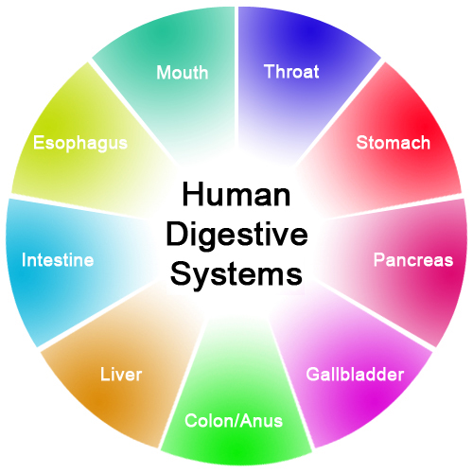

MODULE CODE: BMHP 5003

NAME: MOHAMMED HUSSAIN

STUDENT NUMBER: 1809052

LECTURER NAME: MUMTAZ GOOLAM

THE DIGESTIVE SYSTEM

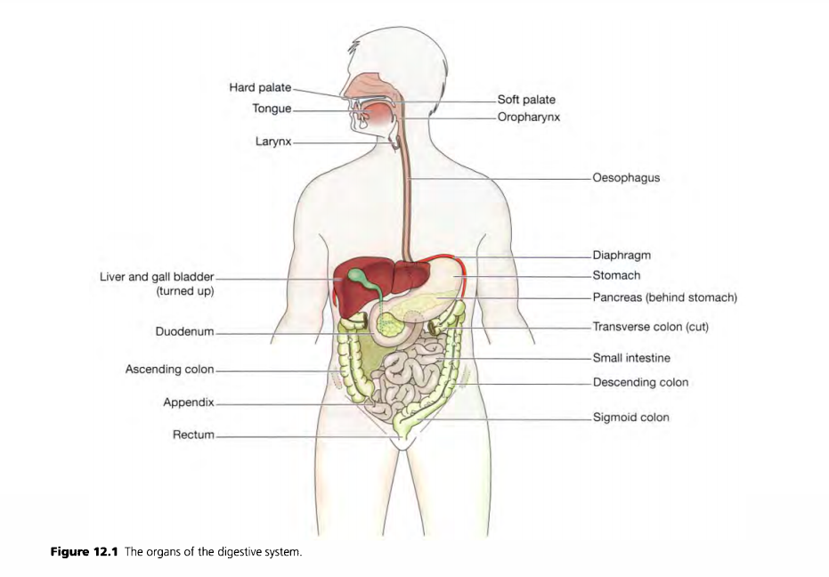
(Waugh and Grant, 2004, p.281)

The process of breaking down our food, the absorption of nutrients and excretion of waste. It turns the food we eat into nutrients which the body absorbs and uses for energy, growth and cell repair. It is the collective name used to describe the alimentary canal, some accessory organs and a number of digestive processes. This whole process is called the digestive system.

This system can be described in the following headings which are the activities of the digestive system.
INGESTION & PROPULSION – Taking and moving food down the alimentary tract (long tube which food passed starting with the mouth and ending with the anus.)
DIGESTION – Breaking food down by mastication (chewing) followed by release of enzymes from secretion produced by glands and accessory organs.
ABSORPTION – substances pass through the walls of the alimentary canal into the blood and lymph’s for circulation around the body. Absorption occurs in stages and each stage is dependant upon the previous stages.
ELIMINATION – food that cannot be digested or absorbed are excreted by the bowls as stool. (Marieb and Keller, n.d.)

THE PROCESS:
MOUTH: This process all starts in the mouth. The chewing with your teeth, use of the tongue the mix with saliva breaks the food down into small pieces so it can be swallowed and move into the throat (pharynx). Food can get stuck between teeth and if not cleaned, overtime can cause tooth decay. (Petrie, 2007)
OESOPHAGUS: A 10inch long fibro muscular tube that passes food from the pharynx to the stomach by a series of contractions. Heartburn is a common complaint which occurs when acidity from the stomach comes up to the oesophagus. (Ballard, 2004)
STOMACH: A sac-like organ with strong muscular walls that can stretch and shrink. The stomach holds the food and breaks it down into further smaller pieces. The stomach secretes acid and enzymes that continue the breaking down of the food with its three layers of smooth muscle acting as a churn then adding with gastric acid until it leaves the stomach as a liquid/paste moving next to the small intestine. The acid in the stomach also kills off bacteria. (Waugh and Grant, 2004)

PANCREAS: 12 to 15cm long and is situated in the abdominal cavity. The pancreas secretes enzymes into the small intestine, these enzymes break down protein, fats and carbohydrates. It also secretes the hormones insulin and glucagon, which are principally concerned with control of blood glucose levels. (Waugh and Grant, 2004)

SMALL INTESTINE: A little over 22 feet long, is continuous with the stomach and leads to the large intestine. This is where the chemical digestion of all nutrients is completed and is absorbed. Carbohydrates are broken down to monosaccharaides, Proteins are broken down into amino acids and fats are broken down to fatty acids and glycerol.
It is made up of three sections; Duodenum, Jejunum (middle section) and Ileum (terminal section) which is the first part of the large intestine. Another function of the small intestine is protection against infection. (Waugh and Grant, 2004)

LARGE INTESTINE: About 5 feet long and ending at the rectum and anal canal deep in the pelvis. Functions are; Absorption - until a semi-solid consistency of faces is achieved, Microbial Activity, Mass Movement and Defecations. (Waugh and Grant, 2004)

RECTUM: Stores and expels faeces. (Mandira p, 2016)

ANUS: opening for the elimination of faeces. (Mandira p, 2016)

LIVER: The largest gland in the body and an extremely active organ. Their main function is to make and secrete bile and to cleanse and purify the blood. One of its other functions is Carbohydrate metabolism - conversion of glucose to glycogen in the presence of insulin, and converting liver glycogen back to glucose in the presence of glucagon. Another function is that the liver converts stored fat so it can be used by the tissues to provide energy. (Digestive System Processes and Regulation | Anatomy and Physiology II, 2020)

GALL BLADDER: Sits under the liver and stores bile. When eating, the gallbladder contracts, sending bile to the small intestine. (Waugh and Grant, 2004)

METOBOLISM: Refers to how the cells utilize the energy we have absorbed from food during digestion. The rate of one's digestive process is generally measured in terms of "whole gut" transit time: how long it takes for food matter (or its residue) to make it from the mouth all the way to the end of the colon. (Health news,2020)

DISEASE OF THE GALL BLADDER

GALLSTONES: consists of the deposits of the constituents of bile, which is most commonly cholesterol. This leads to the formation of either many small stones or one large stone. The causes of why this happens are not fully clear but some pre disposing factors include: Changes in the composition of bile that affect the solubility of its constituents, high levels of blood and dietary cholesterol, cholecysitis, obesity, female gender and long term use of contraceptives.
COMPLICATIONS
BILIARY COLIC - If gallstones get stuck in the common bile duct or in the cystic a spasm occurs in the effort to move the stone onwards. Severe pain which is connected with the biliary colic is due to ischemia of the duct wall over the stone during the smooth muscle spasm.
INFLAMATION: Inflammation and irritation of the walls of the gall bladder and cystic common bile dusts are caused by gallstones. This may result to superimposed microbial infection.
IMPACTION – Distension of the gall bladder and cholecystitis occurs due to the blockage of the cystic duct by a gallstone (Lennon, 2014)

References

Waugh, A. and Grant, A., n.d. Ross & Wilson Anatomy And Physiology In Health And Illness.

Marieb, E. and Keller, S., n.d. Essentials Of Human Anatomy & Physiology.

Petrie, K., 2007. The Digestive System. Edina, Minn.: Abdo Pub.

Ballard, C., 2004. The Digestive System. Oxford: Heinemann Library.
Lennon, A., 2014. Digestive Disorders. [Baltimore, Md.]: Johns Hopkins Medicine.

Courses.lumenlearning.com. 2020. Digestive System Processes And Regulation | Anatomy And Physiology II. [online] Available at: <https://courses.lumenlearning.com/ap2/chapter/digestive-system-processes-and-regulation(Accessed 6 November 2020])

2020. [online] Available at: <https://health.usnews.com/health-news/blogs/eat-run/2013/02/05/digestion-vs-metabolism#:~:text=Metabolism%20refers%20to%20how%20the,the%20end%20of%20the%20colon.> (Accessed 6 November 2020).

system?, W., 2020. What Are All The Components Of The Digestive System? | Socratic. [online] Socratic.org. Available at: <https://socratic.org/questions/what-are-all-the-components-of-the-digestive-system> (Accessed 6 November 2020).

