  Component One:  What are the key skills required when working in the housekeeping team? 750 words (+/- 10%)  Contribution to Overall Module Assessment: 25% | Student No: | 2212713
 | Module Title: | Operating Hotel Facilities
 | Module Code: | BMIH4006
 | Lecturer: | Lola Villard
To do right job requests right people. To be part of housekeeping team of a hotel requires a set of multiple skills which could ensure efficient and effective cleaning and maintenance operations. These skills can be categorized into key skills, hard skills, soft skills and cognitive skills.
Key Skills: Key skills refer to the essential abilities that are fundamental to success in a housekeeping role.
Attention to Detail Housekeeping staff should be concentrated to small detail to ensure thorough cleaning, spotlessness, and adherence to standards.
Time Management Efficient time management is crucial in balancing multiple tasks, prioritizing assignments, and meeting deadlines.
Adaptability Housekeeping staff must remain adaptable to changes in schedules, guest requests, and unexpected situations.
Physical Stamina The role often means to be physically involved, often demanding tasks and movements as lifting light or heavy objects, standing for extended periods (hours) and always to repeat same gestures, doing repetitive motions. Physical stamina is necessary to execute these tasks effectively.
Hard Skills: Hard skills refer to the specific technical abilities and knowledge required for housekeeping tasks.
Cleaning Techniques: Housekeeping staff should be proficient in various cleaning techniques, such as dusting, vacuuming, mopping, and disinfecting.
Knowledge of Cleaning Equipment: Familiarity with cleaning equipment, such as vacuum cleaners, carpet extractors, and floor polishers, is essential to operate them safely and effectively.
Laundry Operations: Understanding laundry washing, ironing or dry-clean procedures, or just sorting, declassing products, or stain removal, also proper use of linen porter trucks, washing machines and hot air dryers operations, is necessary for maintaining clean linens and uniforms.
Knowledge of Chemicals and Cleaning Agents: Housekeeping staff should be knowledgeable about the safe handling and usage of cleaning chemicals, ensuring the appropriate dilution and following safety protocols.
Soft Skills: Soft skills refer to the interpersonal and communication abilities that enable effective interaction with guests and team members.
Communication: Clear and effective communication is vital in understanding guest requirements, coordinating with team members, and providing excellent customer service.
Teamwork: Housekeeping staff often work in a team environment. Collaborating with colleagues, assisting in peak periods, and maintaining harmonious relationships contribute to efficient operations.
Professionalism: Demonstrating professionalism by maintaining a neat appearance, respecting guest privacy, and adhering to hotel policies and standards is crucial for guest satisfaction.
Empathy: The ability to understand and empathize with guest needs and concerns enhances the overall guest experience and promotes positive interactions.
Cognitive Skills: Cognitive skills involve mental processes and abilities that enable problem-solving, decision-making, and critical thinking. In housekeeping, cognitive skills are important in:
Problem-Solving: Housekeeping staff should be able to identify and resolve issues, such as maintenance requirements, cleaning challenges, and guest complaints, efficiently and independently.
Attention and Memory: Remembering guest preferences, specific cleaning instructions, and safety protocols requires good attention and memory skills.
Organizational Skills: Managing cleaning supplies, maintaining inventories, and organizing work schedules necessitate strong organizational abilities.
Multitasking: Housekeeping staff often handle multiple tasks simultaneously, such as cleaning rooms, restocking supplies, and responding to guest requests. Effective multitasking is crucial for productivity and efficiency.
While the exact number of skills may vary depending on the specific hotel and its requirements, here are extra key skills that are often valuable for housekeeping team members:
Inventory Management: Knowledge of stock levels and proper usage of cleaning supplies.
Safety Awareness: Adhering to safety protocols and ensuring a safe working environment.
Work Ethics: Demonstrating professionalism, reliability, and integrity.
Confidentiality: Respecting guest privacy and maintaining confidentiality of information.
Team Leadership: Ability to take charge and supervise a small team, if required.
Flexibility: Willingness to work different shifts, weekends, and holidays as needed.
Cultural Sensitivity: Respecting and understanding diverse cultural backgrounds.
Reporting Skills: Documenting maintenance issues, lost and found items, and guest requests.
Initiative: Taking proactive steps to identify and fulfil housekeeping needs.
Knowledge of Environmental Practices: Understanding and implementing sustainable cleaning practices.
Room Setup: Ability to arrange furniture, amenities, and linens to meet guest preferences.
Problem Reporting: Communicating maintenance and repair needs to appropriate personnel.
Knowledge of Safety Regulations: Understanding and following safety guidelines and protocols.
Discretion: Handling lost and found items and reporting any suspicious activities.
Interpersonal Skills: Building positive relationships with guests and colleagues.
Conflict Resolution: Ability to handle and resolve conflicts or complaints in a professional manner.
Positive Attitude: Maintaining a friendly and positive demeanour while working with guests and colleagues.
These skills are not exhaustive, but they provide a solid foundation for anyone working in a housekeeping team in a hotel setting. The specific skill set required may vary depending on the hotel's size, standards, and target market.
Word Count

Component Two:
Contribution to Overall Module Assessment: 25%
In this scenario – You have just been promoted to team leader for a floor within the hotel. A guest complains that on their arrival, their room had not been properly cleaned. Create an action plan and answer the following questions.

Problem | Why did it happen? | What are you going to do? | How will you prevent this from happening in the future? | What measures would you introduce to improve team effectiveness?
Insufficient Staff Training | The housekeeping team may lack proper training on cleaning procedures, standards, and attention to detail, leading to oversight or incomplete cleaning of the room. | Provide comprehensive training sessions to ensure that the housekeeping team is well-versed in cleaning procedures, standards, and attention to detail. Conduct refresher training periodically to reinforce best practices. | Comprehensive Training: Provide thorough initial training to new housekeeping staff and ongoing training sessions to reinforce cleaning procedures, standards, and attention to detail. Emphasize the importance of thorough room cleaning and the specific expectations of the hotel. | Clear Communication: Establish effective communication channels within the team. Conduct regular team meetings to discuss goals, tasks, and updates. Encourage open and transparent communication to address any challenges or concerns.
High Workload or Time Constraints | The housekeeping staff may be overwhelmed with a high volume of rooms to clean within a limited time, which could result in rushed or incomplete cleaning. | Assess the workload and allocate sufficient time for cleaning each room. Adjust staffing levels or scheduling to ensure an appropriate balance between quantity and quality of cleaning. | Proper Workload Distribution: Monitor and manage the workload to ensure that the housekeeping team has sufficient time to clean each room properly. Adjust staffing levels or scheduling to accommodate busy periods and prevent excessive workload. | Goal Setting and Performance Metrics: Set clear performance goals for the housekeeping team. Define key performance indicators (KPIs) related to cleanliness, efficiency, and guest satisfaction. Regularly track and measure performance against these metrics.
Inadequate Supervision | The team may not be receiving adequate supervision or quality checks from the team leader, which can lead to oversight and subpar cleaning practices. | Increase supervision and conduct regular quality checks to ensure that rooms are cleaned to the expected standards. Provide feedback and guidance to the housekeeping team to address any shortcomings. | Regular Quality Checks: Conduct regular quality checks to ensure that rooms meet the expected cleanliness standards. Establish a system for internal inspections or utilize technology solutions to track and monitor cleaning performance. | Training and Development: Invest in ongoing training and development programs for the housekeeping team. Provide them with opportunities to enhance their skills, learn new cleaning techniques, and stay updated with industry best practices.
Communication Gap | Miscommunication or a breakdown in communication between the front desk, housekeeping, and the guest may result in a room not being properly identified as dirty or in need of thorough cleaning. | : Make sure the fact the communication channels between team members and the front desk, housekeeping, and guests. Instate clear protocols for reporting and addressing room cleanliness issues. Enhance communication with guests to identify any specific cleaning requirements or preferences. | Effective Communication Channels: Establish clear communication channels between the front desk, housekeeping, and guests. Ensure that guest requests and specific cleaning requirements are communicated accurately and promptly to the housekeeping team. | Standard Operating Procedures (SOPs): Establish comprehensive SOPs for all cleaning processes and tasks. Clearly document step-by-step instructions, standards, and expectations. Ensure that all team members are trained on and follow these SOPs consistently.
Equipment or Supply Issues | The housekeeping team might face challenges due to malfunctioning or inadequate cleaning equipment, shortage of cleaning supplies, or faulty machinery, which can affect the quality of cleaning. | : Regularly inspect and maintain cleaning equipment to ensure proper functionality. Ensure an adequate supply of cleaning materials, replacing or restocking them as needed. | Equipment and Supply Management: Regularly inspect and maintain cleaning equipment to ensure its proper functioning. Establish a system for monitoring and restocking cleaning supplies to avoid shortages or equipment malfunctions. | Quality Assurance: Implement a robust quality assurance program. Conduct regular inspections and audits of cleaned rooms to ensure adherence to cleanliness standards. Provide constructive feedback to the team members and recognize exceptional performance.
Lack of Standard Operating Procedures (SOPs) | The absence or improper implementation of SOPs for cleaning processes can result in inconsistencies or gaps in the cleaning routine, leading to rooms not being adequately cleaned. | Develop and implement comprehensive SOPs for cleaning processes. Clearly outline the steps, expectations, and standards for each task to maintain consistency and thoroughness. | Well-Defined Standard Operating Procedures (SOPs): Develop and implement comprehensive SOPs for cleaning processes. Clearly outline the steps, expectations, and standards for each task. Regularly review and update SOPs to address any changes or improvements. | Efficient Workflows: Streamline workflows and processes to improve efficiency. Analyse the cleaning procedures and identify areas where time or effort can be saved without compromising quality. Optimize the room assignment process to minimize unnecessary backtracking or travel time.
Staffing Shortages or Absenteeism | A shortage of housekeeping staff or unexpected absences can put a strain on the team's ability to clean rooms thoroughly, especially during peak periods or unforeseen circumstances. | Monitor and manage staffing levels to prevent overburdening the team. Develop contingency plans for unexpected absences to ensure adequate coverage and minimize disruptions in cleaning routines. | Staffing Planning and Absenteeism Management: Develop effective staffing plans considering peak periods and guest occupancy. Maintain a backup plan for unexpected absences to ensure that the workload is adequately covered without compromising room cleaning standards. | Performance Recognition and Incentives: where appliable, when a member team exceed the expectations, have to recognize his high performance in the housekeeping team. To compensate that, could instate a program that acknowledges team members who consistently exceed expectations. Offer incentives such as bonuses, extra time off, or other rewards to motivate and encourage high performance.
Human Error | Mistakes can happen due to human error, such as unintentionally skipping certain areas, overlooking specific cleaning requirements, or misinterpreting guest preferences. | Encourage an open and honest reporting culture within the housekeeping team. Establish a system for reporting errors or incidents and use them as learning opportunities to identify areas for improvement and implement corrective actions. | Continuous Improvement and Training: Foster a culture of personal development within the housekeeping team. Encourage feedback from staff members and guests to identify areas for improvement. Provide ongoing training and a recognizing value system, also professional self-development opportunities which conduct to better skills and results. | Technology Integration: Explore the use of technology to enhance housekeeping operations. Implement a property management system (PMS) with integrated housekeeping modules to streamline room assignments, track cleaning status, and generate reports. Utilize mobile devices or tablets to provide real-time updates and access to SOPs.
It is essential for the team leader to investigate these potential reasons thoroughly, addressing any underlying issues, and implementing corrective measures to ensure that such instances are minimized or eliminated in the future. | Team leader of housekeeping team should investigate and identify the possible reasons for a guest complaint regarding inadequate room cleaning | By implementing these corrective measures, the team leader can address the identified possibilities for inadequate room cleaning. | By implementing these preventive measures, the team leader can significantly reduce the likelihood of inadequate room cleaning. | Feedback and Continuous Improvement: Encourage feedback from team members and guests to identify areas for improvement. Conduct regular performance reviews and provide individual feedback and coaching to support professional growth. Continuously seek ways to enhance processes and optimize efficiency.
This may involve additional training, improved communication channels, enhanced supervision, equipment maintenance, and effective roster management to optimize staffing levels. | By implementing these measures, the effectiveness of the housekeeping team can be significantly improved. Clear communication, training and development, defined SOPs, quality assurance, and recognition programs will contribute to a motivated and efficient team that consistently delivers high-quality cleaning services. | Regular monitoring, ongoing training, effective communication, and continuous improvement will help ensure that rooms are cleaned to the expected standards, enhancing guest satisfaction and maintaining a positive reputation for the hotel. | . Regular monitoring, effective communication, comprehensive training, and continuous improvement initiatives will contribute to maintaining high standards of cleanliness and guest satisfaction in the long run. | Team Building and Engagement: Foster a positive and supportive team culture. Organize team-building activities, social events, or training workshops to strengthen teamwork and collaboration. Encourage the housekeeping team to become better day by day.

Component Three:
Contribution to Overall Module Assessment: 50%
Your task is to create and prepare a presentation following the detailed scenario provided below.

As the floor housekeeping manager and given the recent guest complaints you need to put together a basic training presentation for your colleagues within the housekeeping team to get the best out of them, ensure that brand standard is being achieved and that Health and Safety procedures are also being followed.

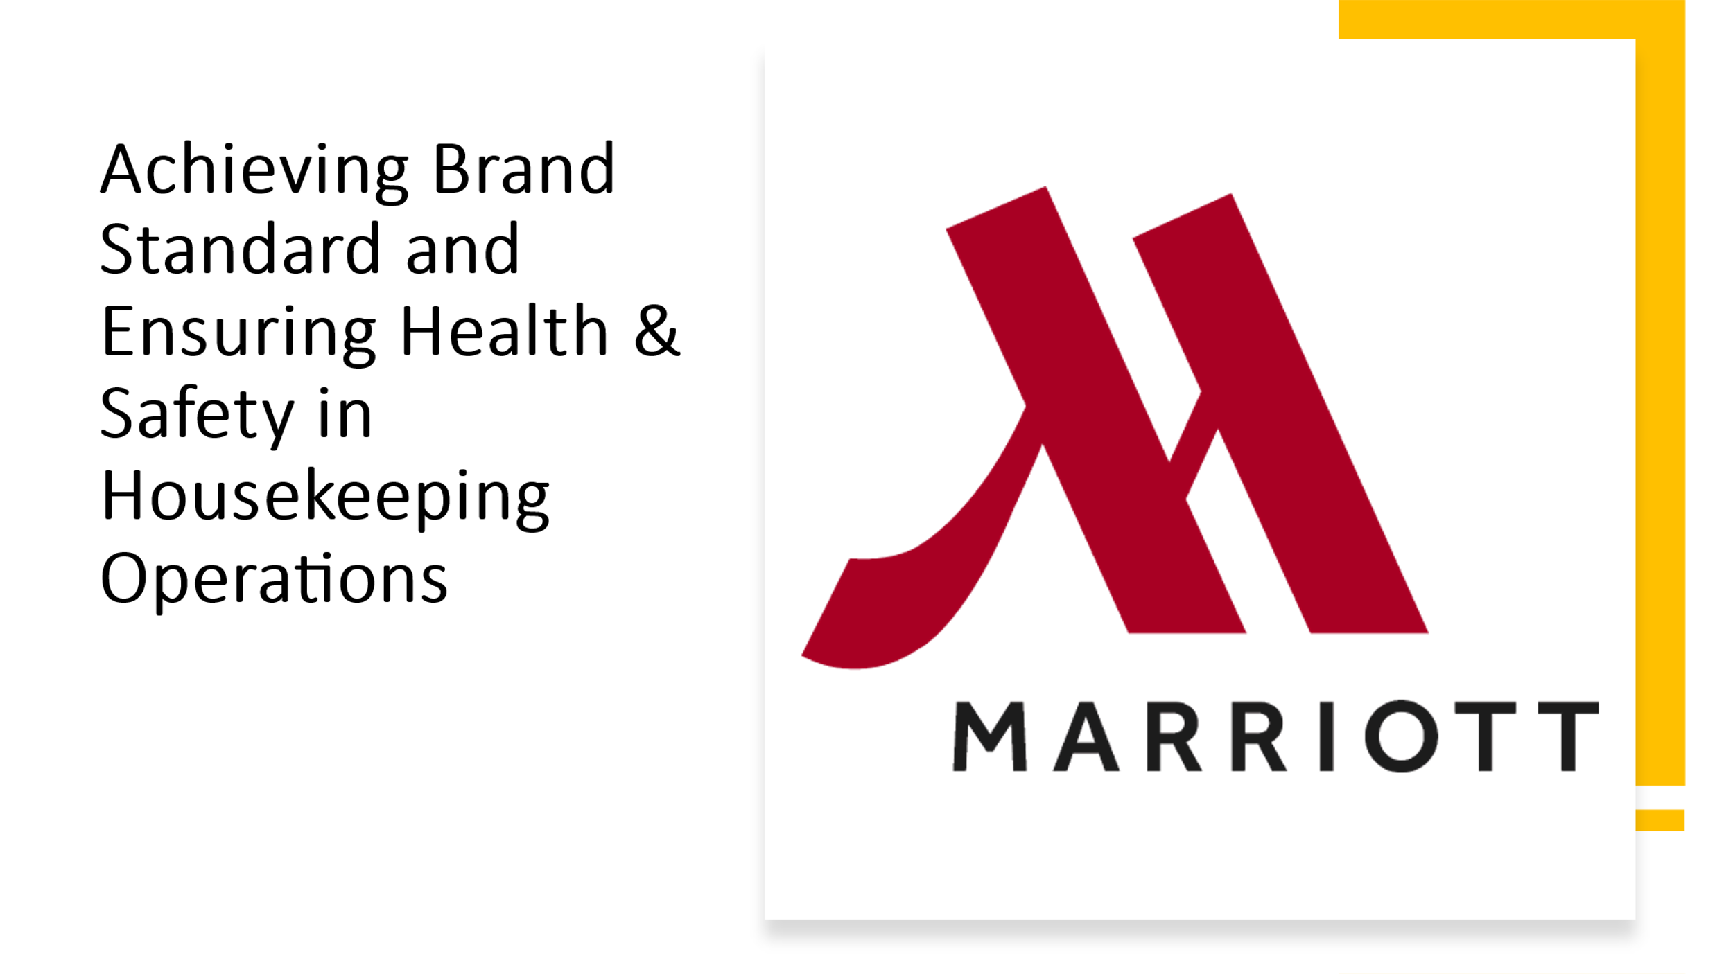
Training Notes: Introduce the topic of the presentation: "Achieving Brand Standard and Ensuring Health & Safety in Housekeeping Operations."
Include a visually appealing title and relevant graphics.
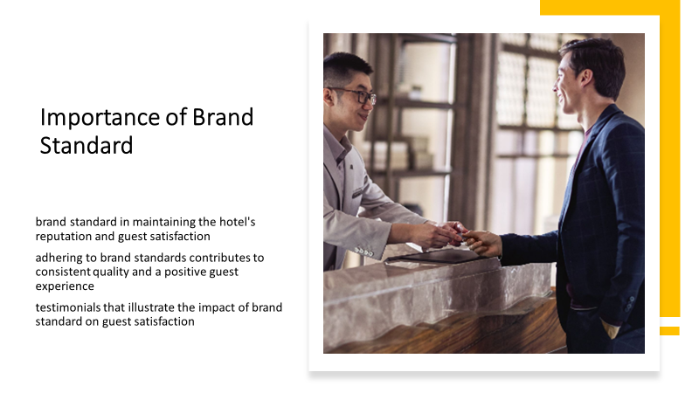
Training Notes: Explain the significance of brand standard in maintaining the hotel's reputation and guest satisfaction.
Highlight how adhering to brand standards contributes to consistent quality and a positive guest experience.
Include examples or testimonials that illustrate the impact of brand standard on guest satisfaction.
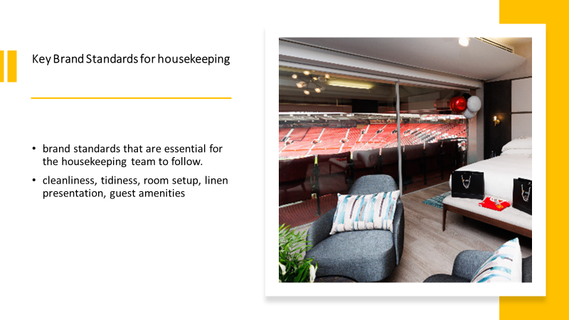

Training Notes: Identify and explain the specific brand standards that are essential for the housekeeping team to follow.
This may include cleanliness, tidiness, room setup, linen presentation, and guest amenities.
Use visuals or before-after pictures to emphasize the expected standards.
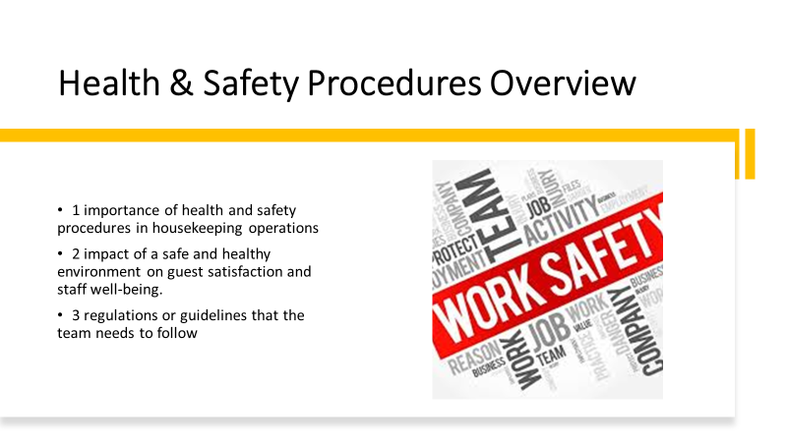
Training Notes: Provide an overview of the importance of respecting H&S procedures in housekeeping operations.
Discuss the impact of a safe and healthy environment on guest satisfaction and staff well-being.
Mention any relevant regulations or guidelines that the team needs to follow.
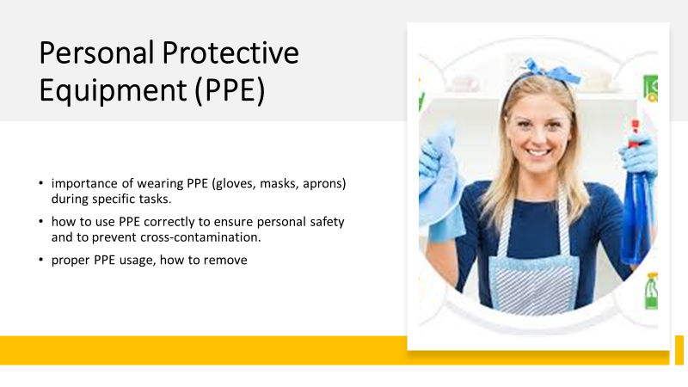
Training Notes: Explain the importance of wearing PPE (e.g., gloves, masks, and aprons) during specific tasks.
Describe when and how to use PPE correctly to ensure personal safety and prevent cross-contamination.
Provide visuals that demonstrate proper PPE usage.

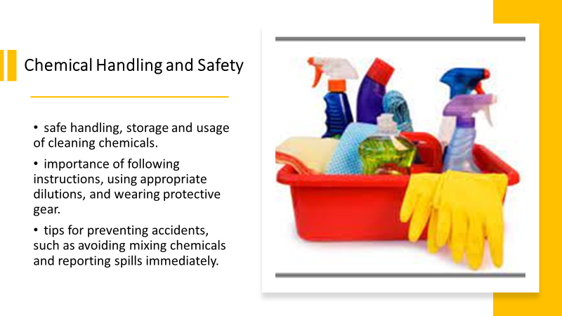

Training Notes: Discuss the safe handling, storage, and usage of cleaning chemicals.
Explain the importance of following instructions, using appropriate dilutions, and wearing protective gear.
Provide tips for preventing accidents, such as avoiding mixing chemicals and reporting spills immediately.
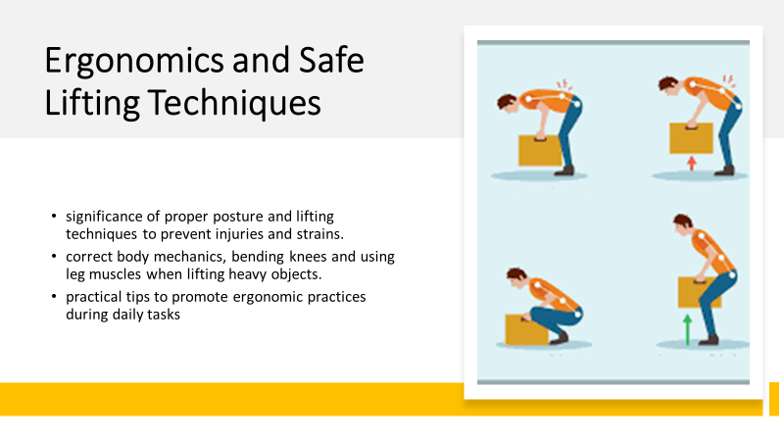
Training Notes: Highlight the significance of proper posture and lifting techniques to prevent injuries and strains.
Demonstrate correct body mechanics, such as bending knees and using leg muscles when lifting heavy objects.
Share practical tips to promote ergonomic practices during daily tasks.
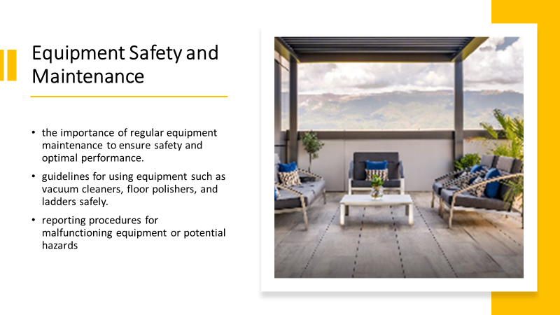

Training Notes: Explain the importance of regular equipment maintenance to ensure safety and optimal performance.
Provide guidelines for using equipment such as vacuum cleaners, floor polishers, and ladders safely.
Discuss reporting procedures for malfunctioning equipment or potential hazards.
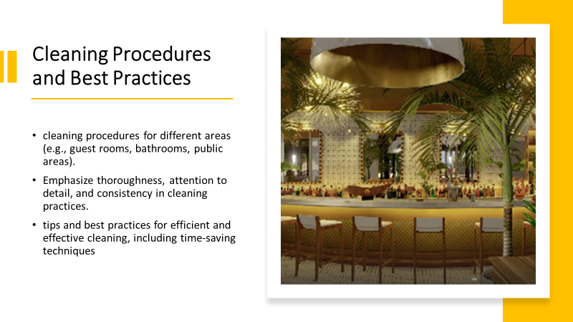

Training Notes: Detail the step-by-step cleaning procedures for different areas (e.g., guest rooms, bathrooms, public areas).
Emphasize thoroughness, attention to detail, and consistency in cleaning practices.
Share tips and best practices for efficient and effective cleaning, including time-saving techniques.
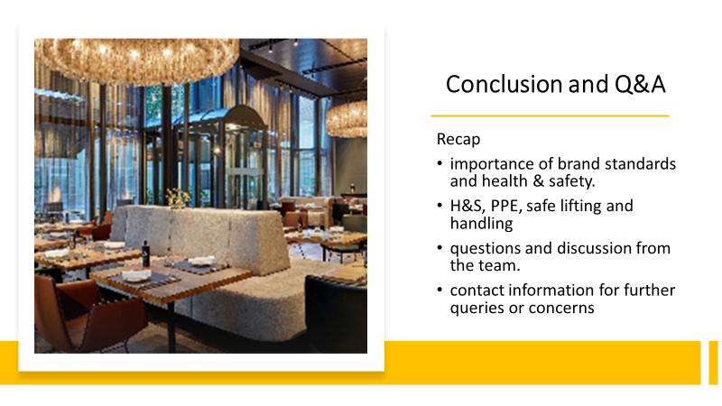
Training Notes: Recap the main points covered in the presentation, emphasizing the importance of brand standards and health & safety.
Encourage questions and discussion from the team.
Provide contact information for further queries or concerns.

References
Johnston, R Clark, G. Shulver, M. (2012) Service Operations Management, Pearson, London.
Solomon, M, & Humler, H 2016, The Heart of Hospitality: Great Hotel and Restaurant Leaders Share Their Secrets, SelectBooks, Chicago.
Tesone, Dana V. 2010, Principles of Management for the Hospitality Industry, The Management of Hospitality and Tourism Enterprises Series, Routledge, Amsterdam.
Vallen, G. & Vallen, J. (2012) Managing Hotel Operations.
Wood, R. (2013) Key Concepts in Hospitality Management, Sage, London.
Websites
https://marriott-hotels.marriott.com/
https://www.google.com/img/who-is-responsible-for-workplace-health-and-safety.jpg
https://www.google.com/img/Posture1.png

