Postgraduate/Distance Learning
Assignment coversheet & feedback form

THIS SHEET MUST BE THE FIRST PAGE OF THE ASSIGNMENT YOU ARE SUBMITTING (DO NOT SEND AS A SEPARATE FILE)

For completion by the student:
Student Name:
Wanda Freeman
Module code: HPEN7018  Module title: Writing Workshop: Researching and writing to a single focus | Student ID number:  2003410 |  |  | Educational support needs:  Yes
Module tutor:
Sarah Reynolds

Assignment due date:05/01/2024
If your module has multiple submissions please indicate which piece of work this is.

1st
I confirm that this is my original work and that I have adhered to the University policy on plagiarism.
Signed ……………Wanda Freeman………………………………………………
Email submission: if you are submitting this form via email, please tick this box □
(as a substitute for your signature) to confirm that you agree to the above declaration.
Assignment Mark
1st Marker’s Provisional mark
2nd Marker’s/Moderator’s provisional mark
External Examiner’s mark (if relevant)
Final Mark

NB. All marks are provisional until confirmed by the Final Examination Board.

For completion by Marker 1 :
Comments:

Marker’s signature: |  |  | Date:
For completion by Marker 2/Moderator:

Comments:

Marker’s Signature: |  | Date:
External Examiner’s comments (if relevant)

External Examiner’s Signature: |  | Date:

Food and Fire, Memoir Essays by Wanda Freeman

Apple Pie
My dad died recently.
When I try to write, I find my mind crowded, and after ten minutes of despairing, I put my pen down and go to the kitchen or the forest.
This cramped council house kitchen is designed for less. It's bursting at the seams with food that doesn’t fit in the too few cupboards and herbs on strings wishing for a pantry to dry in. Pots and pans have found permanent homes stacked on the six-ring cooker that only fits in its space because of my brutal dissection of the worktop.
Chopping butter into flour, peeling Bramley apples, and sprinkling cinnamon I can do with my eyes closed. As I feel the texture turn to crumb between my fingers, it’s easy for my mind to wander.
I remember… when Mum taught me to make apple pie in our old kitchen caravan, I was eight. She showed me how to create the crumb and peel the apples at the counter Dad had extended with a piece of plyboard. My first pies were baked in the small LPG oven that always burnt things at the back unless you turned them around every five minutes. That kitchen was smaller than this council house one but had more room to breathe.
However, that is not the memory conjured from the smell of tart apples and buttery fingers. The place I am transported back to is the kitchen where I mastered apple pie. I was thirteen, and Dad had finally given us a real kitchen. In that new kitchen, I took the basic knowledge of pie that Mum had gifted me, and I obsessed over it.
As a child, we camped in caravans and wagons next to an old, abandoned airstrip from World War two. In the centre of our camp was an ancient apple tree. Apple Pie Summer was in 1997. That was the year Dad bought a wooden building that had previously served as a chapel on a military base. All summer, there had been men at the camp putting up the wooden building and turning it into a communal living space. Mum was often away in Norwich teaching flamenco in those days, so it was my job to prepare lunch and pots of tea for the workmen. My favourite of the men that Dad employed was Sam, a carpenter. He had a gentle face with piercing blue eyes, and as long as Dad provided plenty of cans of strong lager, he usually turned up for work.
I remember sitting outside cross-legged on the warm, cracked concrete with a hairy lurcher lying by my side as I chatted to Sam. I watched him work, and he patiently answered my endless questions. Watching him chisel, sand, and saw the wood into smooth and intricate shapes was mesmerizing. It was as if the wood in his hands was as pliable as pastry. Dad always said Sam was a genius, and there was a fine line between genius and insane. At the end of that summer, the kitchen was ready, and so were the apples.
Sam's work was beautiful; he turned one end of the vast wooden building into a handmade fitted kitchen out of a giant strip of old oak that Dad had got from one of his deals. The worktop was four times the size we had in the caravan kitchen, and the front edge curved as it followed the natural shape of the wood. Behind the counter was a network of carefully crafted shelves and cubby holes to house our abundance of herbs, spices, and teas. We had a six-ring gas cooker with a huge oven and a deep sink with hot and cold running water. This was a big deal as it was the first time in my life that I had not had to carry water inside and boil it whenever I wanted to cook or clean.
It was there, in that beautiful high-roofed chapel of a kitchen that smelled of sawdust and linseed polish, that I mastered apple pie. The old apple tree had two main trunks that split like a vee and hunched towards the ground with age. That year, the apples were giant, and the tree was laden. Each day, I took the big stainless bowl and walked up the trunk into the welcoming branches of the apple tree. The apples on that tree were Juicy, crisp, tart, and sweet, with a fluffy texture when baked—the profile for all future apples to live up to.
I baked pies most days, usually three or four at a time, and I would serve them up to my siblings, the workmen, mum, and all the people from our flamenco dance troupe. I practiced and practiced until I was satisfied that I had achieved apple pie perfection. I felt like my pie had moved beyond Mum's apple pie. Like it was more refined. I wondered why she didn’t take more time and care to perfect her recipes.
And then one day, as I was serving up a pie, Dad walked in, and Mum said to him…
‘Would you like some apple pie?’
‘Only if Wanda made it,’
I remember feeling so proud that he had acknowledged my pie-making expertise, but I could see that Mum was hurt by his comment. Dad was a complicated man. He was always lifting somebody up, favouring them, and dropping somebody else down. Somebody was always out of flavour. That summer, I performed exactly as a daughter ‘should.’
I have made apple pie a lot since Dad died. It is hard to come to terms with a world without my dad in it. I feel like somebody has removed the foundations from underneath the home in which my soul resides. But stirring cinnamon into apples, nourishing my children, hearing my son tell me my pie is perfect, and being steady with affection in a way that dad never could… is easy. 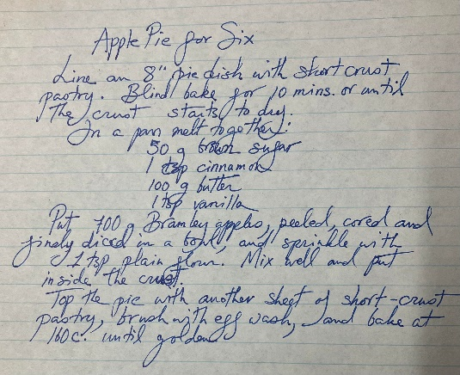
Gravy
My journey as a mum began when I was 17. I will never forget the reaction of my eldest sister when I announced to my family that I was having my first baby.
‘I would be worried if I thought she couldn’t look after the baby properly. But Wanda will be a great mother,’
Thank you for your faith, Essie.
In striving to live up to the title of ‘great mother’ I have always placed food at the centre of my home. I use it to nourish growing bodies, bring my family together as we eat, and relax them enough to talk. Cooking with children helps them develop numeracy skills, improve dexterity, and learn how to manage dangers such as knives, gas, and fire. In the name of food, we go on adventures to forage for ingredients and learn how to fix our bodies with kitchen medicine.
My sisters and I helped Mum cook out of necessity, and our skills grew as steadily as we did. Preparing dinner was a big task in a family of six children and two parents. Not to mention the extended family and friends who were always camped with us. There were usually at least five extras and often many more. Preparing fresh, healthy meals for an average of fifteen people was a big job.
My childhood days were spent outside with my siblings and friends. When I wasn’t doing jobs, I was in the barn with the animals, catching newts in the pond or playing up in the trees. As evening approached, we would hear Mum's voice calling our names, and we knew it was time to go and cook.
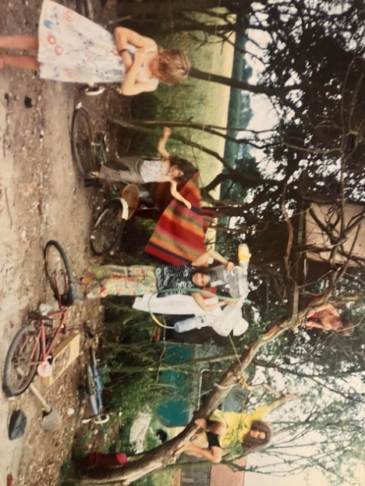
Figure 1 Siblings playing. Author’s personal photo.

There were often four or five of us cooking elbow to elbow in the small caravan kitchen. One day, my job would be chopping the salad, and Mum would show me how to do it. Then, I would do that each evening until I had learned it. Then, my job would be preparing the rice, making the red sauce, stirring the bechamel, or layering the lasagna, etc.
My children don’t help as much as I did. There is just less imperative without the hoard of people to cook for. For a while, I was worried they would grow up to be inept. However, my eldest put my mind at rest. When she was about fourteen, she went through a phase of avoiding home at all costs and spent as much time at her best friend’s house as she could. Maybe she wanted to help her friend's mum or perhaps she missed home cooking, but one day she texted me asking for my gravy recipe. It obviously went down well, as that was the first of many texts asking for recipes. She had learned enough of the basics from her time in the kitchen with me to easily pick up any recipe she desired. Josie, my eldest, is now twenty-one and an inspiring cook in her own home.
I got to grips with gravy when I was eight years old. I remember when Mum called me into her little caravan when it was time to prepare dinner one day. Her caravan was a small Vickers. The walls were lined with auburn-coloured wood. The mirrored surfaces were decorated with silk scarves and arrangements of all her precious things: tiny Buddhas, crystals, ornate boxes, and incense burners. Embroidered Spanish shawls, castanets, and flamenco shoes adorned the small disused kitchenette. At the far end was Mum's bed. Always soft, clean, and comforting, surrounded by small shelves crammed with books.
Mum was in bed that day, which was unusual.
‘Wondy, my darlin', I’m feeling really unwell. Can you be in charge of cooking dinner? We have a chicken to roast. Kyla and Zeta will help you. Is that ok, my lovely girl?’
Sitting on the narrow bench between the kitchen and the bed, I felt excitement and pride swell inside me. I was going to be in charge. Mum trusted and needed me. And I even got to cook the chicken. The most important part of the dinner!
I left Mum's caravan elated. The sun was shining down on me, the trees surrounding our camp were brighter green than usual, and they rustled as they applauded me and my newfound responsibility. I walked across the yard to the chrome-striped caravan that held our kitchen and hopped up through the open door. My younger sisters Zeta and Kyla were sitting on seats that wrapped around the far end of the caravan (our living room), playing with their china dolls. I stood inside the door by the cooker and announced that I was in charge of dinner, and they had to help me.
‘I will do the chicken and gravy, and you two can do the vegetables,’ I said with authority.
Despite my best efforts to delegate, Zeta and Kyla did not cook that day. After growing bored of my nagging, they ran past me, giggling. One of them (I suspect Kyla) even managed to slap my bum as she ran past and out the door to go and play in peace.
Roasting the chicken takes the longest, so that is where I started. I rubbed it with salt and olive oil, pierced it with a knife, and filled the holes with cloves of garlic before putting it in the oven. While the chicken was roasting, I went outside to fill a bowl from the water churn and washed the carrots. I cut the carrots into sticks as I had seen them in books, and it seemed more refined than simple circles of carrot. We had green cabbage and runner beans, so I decided to cook them too. Slicing the large hard cabbage was difficult as it tried to roll away from me, but once I had it in half, it lay on its flat side and behaved itself. The runner beans were too mature, so I had to snap and string them. But that was okay because of the sweet-smelling spray that shot from each satisfying snap. All the vegetables went together into one big pot with just an inch of water in the bottom. Mum always said steam, don’t boil to preserve the goodness. A sprinkle of salt and on the flame they went.
I was pleased with myself. Just the gravy to go. I put the vegetable scraps in the slop bucket and took it outside to feed the chickens. Mum was going to be so happy. She always said to clean up as you go along.
‘Chuck chuck, chuck chuck,’ I called as I watched the chickens flutter down from trees, run from bushes, and look up from scratching in the ashes of yesterday's fire. I threw the scraps down into the feathery mass and ran back to the kitchen, swinging the slop bucket.
Finally, it was gravy time, and I needed the juices from the chicken pan. I put a small saucepan on the cooker for the gravy. I then got a dry kitchen cloth and lifted the roasting tray from the oven to pour out the fat and stock from beneath the chicken. I was short, as I was only eight, so I had to tiptoe to tilt the roasting dish up towards the saucepan. It was working! The golden juices began to flow from the bottom corner of the oven dish into my waiting gravy pan. Then, the chicken decided to try and make a run for it. The hot steaming bird slid from one end of its dish to the other, causing bubbling fat to slosh out onto my shirt.
The burning fat soaked straight through the thin fabric and onto my chest, causing me to squeal in pain. But luckily, most of the good gravy stuff had made it into the pan. I put the chicken back into the oven and went running to Mum. With tears in my eyes, I explained to her what happened and how my sisters had run away.
‘O my darling girl. You are so brave and clever. I’m so proud of you,’
I insisted that Mum stay in bed and that I would be ok. She instructed me to take off my shirt, go into the kitchen, snap a stalk from the aloe vera plant, and rub the gel onto my burn.
In the kitchen caravan, I stood in front of the large cut glass mirror on the airing cupboard door above the stove. I rubbed the gel onto my blistering chest. I looked at my face in the mirror. The tears had made stripes in the dirt on my cheeks, and my blonde hair was a tangle around my head. I was supposed to tie my hair up to cook. And wash my hands. I better do that before I carry on.
Once I had tied my hair up with the elastic band from the carrots, I chopped onions and garlic to sizzle in the meat juices. I made a roux by adding flour, then gradually stirred in the vegetable water. It didn’t taste right. I ransacked the cupboard, adding things bit by bit and tasting them as I went. Mustard, pepper, salt, Worcestershire sauce. It tasted good now but not perfect. It was salty, tart, and meaty… but needed sweetness for a full round flavour. One more cupboard search and I found plum jam. A dollop of plum jam, and it tasted sublime.
I put the pots of food, plates, and forks on the kitchen counter. Then I called everybody for dinner.
I don’t remember who came. But I remember Dad did. I dished up his dinner for him before everybody else helped themselves, as was our custom. Roast chicken, steamed vegetables, and gravy.
Dad sat on the seat by the stove with his plate on his lap and said…
‘Where’s the potatoes?’ He was hangry.
I looked at the floor, and again, the tears built up in my eyes. I didn’t understand.
‘I cooked it all myself,’ I whispered.
‘You can’t just serve chicken and vegetables. All dinners need potatoes or rice,’ he snapped back at me through his dark mood.
Once we became adults, my siblings and I adopted the habit of serving the children first.
I still like roast chicken without potatoes. I know it's terrible, but we are wild in my house. Sometimes, we just have apple crumble and custard. NO DINNER, JUST PUDDING! Anarchy!

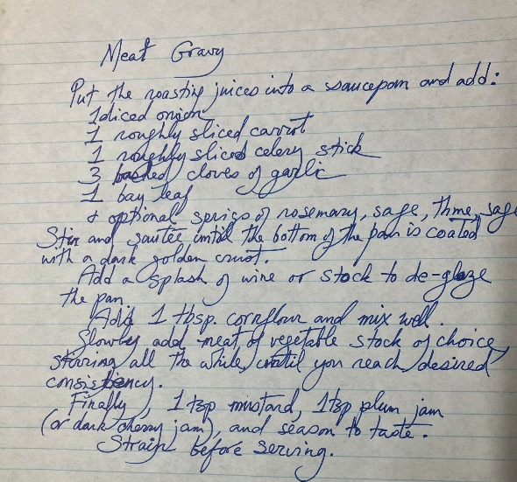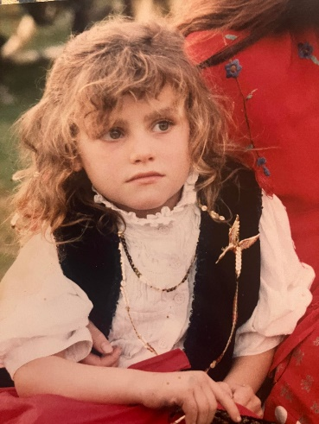
Figure 2 Wanda, age 8. Author’s personal photo.

Goat curry
It's November and my birthday has just been. The smell of cold appeared overnight, signalling the passing of autumn. Winter is coming, and with that, the tumultuous medley of feelings about Christmas.
Every year, I find myself torn. Most of me wants to bake mince pies, decorate the tree with the kids and give them lovely gifts. However, a small part of me wants to grab my children and run away from civilization. Forget Christmas and spend the week cooking on the fire and playing in the trees.
As December approaches and shops fill with landfill fodder, I think about Dad, he was not Christian, and he loathed ‘the silly season’ When I was a child, he was not willing to join the masses and just go along with Christmas: no presents and no tree covered in lights for us.
When “normal people” found out that Santa didn’t visit us, they looked down at me with furrowed brows and pitying eyes. I didn’t care that we didn’t celebrate Christmas. I was confused; why did parents lie to their children about Santa? Every year, somebody would ask, ‘what’s Santa going to bring you this year?’ Sometimes I would say,
‘Nothing. He isn’t real,’ I enjoyed the look of horror on their faces. But I soon realized that response upset Mum. So, I learned to smile and shrug my shoulders.
I always respected Dad for his convictions. The problem was not the lack of Christmas spirit. It was the anti-Christmas spirit.
Dad had two sides. Loving, mischievous, and playful, or the dark side that hung like a lingering storm over the whole camp. At Christmas, the storm would come, and there were always extra jobs for all. Animals to feed, fences to mend, and logs to cut.
After reading that, you may think we lived a glum life of sadness with no joy or celebration. However, Dad loved parties and was a pagan at heart with a deep love and respect for the natural world, so we followed the ancient tradition of celebrating the winter solstice.

I was born in Ireland when my family was still horse-drawn. All seven of us lived in a barrel-top wagon and relied on horses for transport. When I was still a small one, Dad got a lorry, and we moved to England with the horses, dogs, chickens, and goats. Eventually, Dad made a deal with a landowner, and we settled on his airstrip near the village of Thorpe Abbots in Norfolk. We camped around an old WW2 aircraft hangar and had use of some beautiful red brick barns, a pond, and a couple of acres. The barn became a comforting haven of sweet milky goats, cats, and haystacks. The camp became our base for many years and the location of many winter solstice parties.
The weeks leading up to winter solstice were filled with exciting preparations. My memories may be a bit jumbled, but I recall this from winter solstice 1993.
First, we invited our tribe. Mum drew, and we coloured invitations with pictures of people dancing around fires. Mum sent copies to our extended family and friends scattered around Europe. Then we set to work on decorations. Together with Mum, we painted canvas backdrops, flags, signs, and menus.
The preparations for the winter feast truly began in spring. Dad made a point of fussing over the male goat kids. Stroking their necks and head wrestling with them. Preparing them for the solstice celebration.
We all knew Dad killed the goats, but he always told us to stay away when it was happening. That year, my morbid curiosity got the better of me, and I snuck up to the barn and watched through a small gap in the door.
I was worried about what I would see. I had heard conflicting information about slaughter. Dad always assured me that he culled in the most humane way possible. He even told me horror stories about slaughterhouses. On the other hand, I had heard it was illegal and inhumane to slaughter with a knife.
The young billy goat was confident with Dad, his familiar rough-and-tumble playmate. He was happily lured away from the other goats into a small outer room of the barn. I could see clearly from where I stood; amongst the dusty tackle, buckets, and bales, they playfully tussled. As if part of the game, Dad stepped over the young goat and looked down at him, now caught securely between his legs. The little goat looked up into Dad's eyes while his hairy neck was scratched and rubbed. A game I had seen them play many times before.
‘There you go, little Billie. Yes, you like a good scratch, don’t you?’ The rumble of Dad's calming words rolled around the barn, lulling me and the kid into a false sense of security.
As dad cradled the kid's chin in his left hand, still looking into its eyes and muttering his soothing words, he lifted his butcher’s knife, and with one swift and assured stroke, he slit the goat's throat.
Blood pumped onto Dad's wellies before he kicked a tin bath under the gushing red torrent. Gentle words of reassurance still drifted through the air.
‘It’s ok, there you go,’
I was expecting some gross, fearsome battle with squealing and terror. But the kid didn’t even get a chance to cry. For a moment, I froze in place, eyes fixed on the bath of blood before coming around and realizing I could get caught. I crept away quietly, a little shocked but also reassured.
Later that day, I wandered into the hangar to see what was happening; all the usual half-fixed cars, tools, and motorbikes were gone. There were sofas by the huge wood-burning stove, and our backdrops hung around the corrugated walls. festoon lights sat in piles, ready to be hung, and Just inside the huge sliding door was Dad, gutting and skinning the goat. It hung by its feet from ratchet straps slung over the iron beams.
‘Your mum might not want you in here,’ Dad said.
‘It's okay, I don’t mind. It's not scary,’ I replied. Dad was calm inside, so I watched in fascination as he skilfully removed the organs and separated the skin from the muscle.
‘You have to eat the organs when they are fresh,’ Dad told me while he worked. ‘The carcass can hang for longer to let the muscle relax and tenderize,’
That night, when Mum was cooking dinner of goat liver and onions, Dad cooked by her side. He prepared the testicles. First sliced, then dipped in seasoned egg and flour before being fried in butter. All the while, Dad joked about hot, crispy balls. Finally, he handed them around, and we ate them as appetizers. They were surprisingly good. Crispy on the outside and creamy on the inside.
The day before the winter solstice, the air buzzed with energy and excitement. It was a crisp, cool afternoon, and I stood watching my brother in the digger as he built a towering bonfire. Then he stopped the digger and grinned in the direction of the airstrip, where a convoy of lorries, vans, and fire trucks were fast approaching.
I ran over to the yard and called Zeta.
‘Look, Zeta, they’re here. Quick!’
Now that our tribe had arrived, the camp was filled with laughter and activity. Familiar smiling faces and busy hands helped to raise the big top, hang the festoon lights, and arrange hay bale seats by the fire. My brother and stepbrothers zoomed around on motorbikes, jumping them off vehicles and generally monkeying around in a blaze of noise and petrol fumes.
The following day, winter solstice finally arrived. Mum woke me up as she walked past my caravan, singing her ritual good morning to the birds. Zeta and I got up, filled with the springing joy of excited children, and rushed out to see who wanted to play. By afternoon, the warm, homely smell of roasted spices began to drift around the camp as Mum got to work on cooking the cauldrons of goat curry.
I was wandering around the aircraft hangar looking for my hidden friends, absorbed in a game of sardines in a can when Dad spotted me and shouted me over to help organize the makeshift bar.
When darkness drew in, the bonfire was lit. The distant glow of which called me from bar to fire. In the light of its blaze, our dear friends, John, Esther, and Maxine began to rehearse.
Lovely John, the gentle giant, reminded me of one of Tolkien’s Ents. He was a man of patience and soft words who had spent many hours teaching me to play Irish jigs. With no sheet music in sight, just the melody twirling in the air between us and hours staring at his long dancing stick insect fingers.
As I watched sparks dive into the black sky like synchronized swimmers in time to the music, John spotted me.
‘Get your fiddle wanderer,’ he said through the roar of the fire and music. I excitedly ran to my caravan and got my violin. Then joined in playing the Raggle Taggle Gypsies. We could play it in our sleep, and with every round, we played faster and faster until my fingers stumbled, and we slowed. Maxine put down her fiddle and sang the song of the girl who ran away with the gypsies, and our audience of friends joined in with the chorus.
‘Come away with me, my fair lady, come away with the raggle taggle gypsies o’.
I exhausted my repertoire and lay down my violin just in time to see the headlights of cars on the airstrip, illuminating the arrival of the revellers. Like a spellbound hoard guided by the pillar of fire, people approached our camp. They came in vehicles and on foot, smiling, skipping, and juggling.
I ran to find Zeta.
‘Come on, Bibi, let's get ready,’ I said, and we went to our caravan to change. Zeta was eight, and she had been my Bibi since birth. I was two when she was born, and even though I couldn’t pronounce her name, I treasured her more than life itself.
While we were getting changed, we heard Mum calling us to help. We found her carrying a giant pan of curry across the yard towards the bar.
We helped Mum make boxes of curry and rice to sell to spellbound strangers and gift to our loved ones. Then Zeta and I took our food and sat by the fire.
The warm box of food in my hand, with its rich smell of spices and goat meat, was the comforting essence of family and festivity. In that moment, time stood still. Only the food and the warmth of the fire existed in my consciousness.
Only when I had licked the last bit of aromatic oil from my fingers did I notice the sound of John's violin emanating from the big top. The music drifted out into the cold winter night and mingled with the smells of fire, curry, and elation, calling people in to dance.
I went to find my big sisters to tell them the band was playing. The aircraft hangar was loud with seventies disco music, and people crowded by the bar and lounged on sofas by the stove. I weaved amongst the legs of grownups, reached the bar, and sat atop boxes of champagne. From there, I could see illuminated bubbles floating into the crowd, and all around the walls, our backdrops glowed in blue light.
Eventually, I delivered my message about the band, and I squeezed back through the crowd and ran outside. The bitter cold bit my nose as I followed the glowing festoons across the dark space to the tower of fire. There, the music from the disco bar mixed with the folk band in the marquee. Teenagers sat smoking and laughing, and an old lady danced in a trance, arms reaching for the stars.
I continued to follow the floating lights into the marquee, where another sea of legs danced, and I weaved my way to the stage. I stood for a while listening in awe until I saw my three older sisters come to join me. Essie, Roxy, and Perly, all with manes of black curls, all beautiful and wild seamlessly joined the dancing. And my brother, usually so quiet and reserved, all legs and arms flailing as he jumped, eyes closed, free. And Mum with a rose in her hair and her flamenco shoes on, swirling with Zeta.
Then Dad, his thick mane of shiny black hair, released from its bun, tumbling down his back. He smiled at me and reached out. Taking my hand, he pulled me towards him and spun me around. With his strong hand around mine, I followed his lead, twirling under his arm and then dancing close and resting into his pink silk shirt and the warm, horsey smell of his hair.
When the bands stopped playing, DJs took over, and I found my friends. We ran around the party, enjoying the freedom and happiness that surrounded us until I was too tired to run, dance, or play anymore. When I curled up on a warm sofa by the bar, a sister spotted me and guided me to my caravan. I climbed In with Zeta and fell asleep to the pulsing beat of the year's longest night.
When my siblings and I grew up and had families of our own, we continued to celebrate solstice together. However, it became more practical to do it at Christmas time when nobody has to work.
Dad attended many Christmas/solstice feasts with us. He just accepted how we chose to do things and relaxed into the family festivities. He enjoyed watching his 24 grandchildren making their memories as a gang of cousins while we drank champagne and ate good food, as he had taught us to do.
I must finish writing now; it is winter solstice, and darkness is closing in. My children are eager for me to go and light a bonfire to signal the beginning of our winter celebrations.
I don’t want them to learn their narrative from stories told in school, recited from a bible that I do not believe. So, while we play with fire, we talk about life.
I don’t talk about my beliefs often, and I am not a poet. But it's hard to express my feelings without a few pretty words,
My gods show their power in the changing of the seasons and the roaring elements. Their truths are written on specks of sea foam and on the tips of the bird's wings. Life itself is divine, and worship takes place in observation and reciprocal connection. 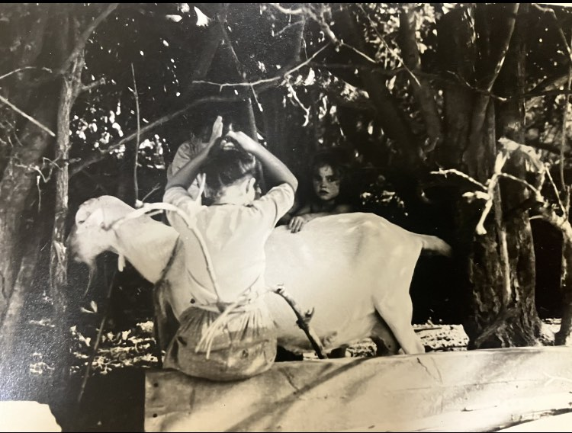
Figure 3 Wanda, Roxy, and goat. Author’s personal photto
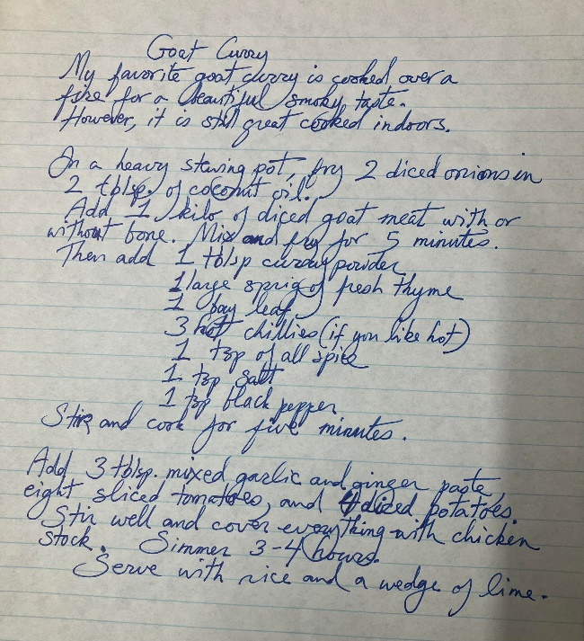

Fried fish
My beloved is called Tom, and he lives all the way over in the flatlands of Norfolk. I used to live there, but I moved to the hills and valleys of Wales, got married, and made a family. Now I’m divorced, and I drive six hours every month to be with him.
Tom loves fried fish; it reminds him of his grandmother, who raised him. Whenever we drive to the seaside, he buys fish, then takes it home to flour and fry for us to eat. I love to sit in his tiny home reading to him while he fills the air with smells of melted butter, fried fish, and devotion.
I have many memories of being surrounded by my family in our kitchen caravan—the smell of the wood-burning stove, frying fish, butter, and burnt flour. Mum used to buy fish from the Friday market. Usually the cheapest available, like sprats or sardines, but sometimes lovely soft, flaky white fish. Dad also loved fried fish; I think it reminded him of his childhood, too. We rarely got fish and chips from the chippy, but on the odd occasion, Dad surprised us by coming home with a stack of warm bundles wrapped in steaming paper. This was a double bonus; Dad was in a good mood, and we got fish and chips.
Laundry day was also chip day. My sisters and I would go with Mum and all our sacks of dirty laundry to take over the launderette. If Mum could afford it, she would buy us fish cakes and chips for £1.50. The smell of warm laundry, vinegar, and fried potatoes will forever be linked in my mind.
Retrospectively, a row of girls lined up on the bench in front of the washing machines, surrounded by bin liners of laundry, swooning over bags of chips, was probably a funny sight for anybody hoping to use a washing machine.
Dad lived in Ireland on his dream horse ranch when he developed Parkinson’s. Eventually, through much deliberation, a thin and shaky dad moved to Bristol to live in a purpose-built cabin at the bottom of my sister Roxy’s Garden. Thank you, Roxy.
His taste for spicy food and his cruel temper diminished with his health. This is when Dad entered his true fish and chip phase.
Parkinsons made Dad scared. Everything became uncomfortable and difficult for him. He no longer enjoyed family celebrations, which was something I found really hard. Dad was alive, and I could sit in the quiet of his cabin and talk about my life and keep him up to date with the outside world. But he no longer sat drinking champagne at family parties or playing nine card brag till midnight, stoned and smiling.
When Roxy and her family wanted to get away, my sisters and I took turns looking after him.
Caring for Dad at the end of his life was a simple routine. Get up and keep an eye on the cabin at the bottom of the garden. When the floor-length pink curtains opened around 10/11 am, bring Dad a high-calorie protein shake. At 2 pm, bring Dad a cup of creamed soup. Around 3 pm, take Dad for his walk around the churchyard. At 6 pm, bring Dad dinner, which was always some variety of battered fish and chips. Around 9 pm, check if Dad wanted hot chocolate.
This routine was so far from the dad I had grown up with.
The man with the black mane of hair that was always outside wrangling a group of stallions. Or spinning me around our tiny kitchen caravan while singing rock n roll songs in his deep, bellowing, soulful voice.
‘Itty bitty pretty one, come on and dance with me,’
Or the man whose angry voice would carry to whatever quiet place I was avoiding him in. I would hear his raging tones as he banished one of his now ex-friends from our camp.
Or the man who drove us in his lorry, touring Europe. While we, his troupe of performing daughters and wife, would dance flamenco and play our instruments at festivals and bars along the way.
The dark-haired, charming stallion of a man who had multiple other girlfriends and even other children.
Dad was a lot of things, but not a predictable man of routine.
In his youth, before he was a hippie, Dad was a Vidal Sassoon ladies' hairdresser. This proved useful when he went on to have nine children. He insisted all of his daughters have ‘long lush hair’, but he kept it trimmed and even styled it for parties. Dad remained the family hairdresser until his hands began to shake. As a child, I loved watching him flip his head upside down to brush and cut his own thick, dark mane. We used to joke that he was half-horse, I think there was a time when I believed it.
In those times of looking after him in the cabin, brushing Dad's hair was cathartic for both of us. Even at seventy-six, his hair was thick, long, and mostly dark. And still smelled rich, warm, and horsey.
The last time I saw him alive, he was still alive. That sounds stupid, but he was still so alive. He was there. I could talk to him; he asked me questions, ate food, enjoyed company, and took his daily walk. He was still living a good life.
That last time I had stopped in briefly to see Roxy. I walked down the garden to say a quick hi. I was in a rush. I hugged him. I held both his hands in mine, and I said,
‘Look, Dad. You don’t shake if I hold both your hands,’
‘Ok, darling. You just stay here and do that then,’
Then I hugged him and said I’ll be back. As I left, I said,
‘Love you, Dad,’
‘Love you too wonderful,’
Dad died during a heat wave. It was a Sunday, and I was on a roof in Norfolk. I had spent the weekend helping my beloved put a new roof on the workshop. The text about him being taken to hospital didn’t arrive as my phone was dead.
We managed to get the roof on before I found out. Then I plugged in my phone. While preparing a BBQ for friends, my phone rang, and it was my Zeta.
She just cried and said,
‘Dad’s dead,’
Neither of us could talk. So, we hung up. I walked away from the BBQ, and my legs collapsed. I will remember that spot forever. In a field under a tree by a pond, I stayed on my knees and cried. Everything around me disappeared, and all I could feel was the shock of pain that had taken my legs from under me.
I drove to be with Roxy. Maybe I could help her not be alone? But truthfully, it didn’t matter who was around. We were all alone.
Roxy, Mum, and I drank champagne and ate take-out curry as we toasted Dad's life. This is one occasion where I remember no details about the food.
That night, I slept in Dad's cabin. In his bed. On entering the cabin, I was hit with a wave of Dad. It smelt like his hair. There was his comfy reclining chair. His single bed with the bright, rosy bedspread. His tin of biscuits. His long, floaty pink curtains. His hairbrush with his hair in it. Just no dad.
I lay down on his bed and slept with his smell. In the middle of the night, I woke and felt he was standing by the bed looking at me. I thought about it. If he was a ghost, where else would he go? He died very fast; maybe he thought he was still alive and came home to get into bed. I kept my eyes closed in case he was there. Or even worse, he wasn’t there.
Roxy was with Dad when he died. When she delivered his morning smoothie, he said he thought he had inhaled some biscuit. It was hard to breathe.
He died later that day in hospital. Roxy was alone with him when he desperately tried to tear the wires and tubes from his body while choking to death. I know this story because Roxy recounted it in a fit of hysterical tears. She irrationally blamed herself for letting him die on her watch. It's odd how a man can choke to death in a hospital…
When Roxy tried to sleep that night, and many nights to come, she was kept awake by the image of Dad's dying eyes.
Dad was everywhere at Roxy’s house. The pink curtains that didn’t get opened at the bottom of the garden, the smoothie maker on the kitchen counter, the drawer full of calorie powder, the freezer full of fried fish... Roxy was inconsolable and wracked with guilt. She needed to arrange the funeral as fast as possible; she needed to be busy to cope. His funeral was one week after he died. It was too fast for me.
We managed to arrange for a traveller man with a horse and cart to take Dad's coffin, piled high with pink roses to the crematorium. His family and loved ones followed in a convoy. At the service, Dad's coffin was carried by his son and sons-in-law. The coffin followed Maxine as she played the violin through the crematorium. I wrote his eulogy, but I could not speak.
I saw Dad the day before the funeral. I went into the room at the funeral home alone. I just wanted to make sure he was dead. It was awful. He was so cold. I just wanted to warm him up and take him home. I wanted to brush his hair, but I couldn’t, so I stroked it, over and over. I laid my head on his chest, but it felt like cold marble, so I pulled away. But then I did it again, and I sobbed. Then I felt guilty for getting tears all over his pink silk shirt. I held his cold hand inside mine to try and warm them up and pleaded with him to open his eyes. I told him that if he opened his eyes, we could bring him home and make him warm.
It all felt so wrong. The funeral home was sterile and alien. The city was too tame, and the crematorium was too ordinary. We went to a pub where we stood around, numb, while our friends ate quiche, looked at pictures of Dad, and told us he was in a better place.
I desperately wanted to be back at the camp. Still living in a community with my siblings. I wanted to have Dad at home. I wanted to sit by his body and cry. I wanted to brush his hair with my sisters. I wanted to kill a goat and make curry. I wanted a party where people drank champagne. I wanted to burn his body in his wagon and say fuck the law.
I don’t want Dad to be dead. For each of his faults, which are many, he has an abundance of qualities. He loved us with undying affection, he had strength in conviction, and he taught us life was for living. Having Dad in the world made me feel like I was deeply rooted. If I needed him, I could call, and he would help. And now I can’t call.
Tom told me that when our body is breaking and our soul can’t yet escape, we have an internal battle that only ends with the victory of death.
He also said that I could still talk to Dad. He chats with his late grandad all the time. I was not ready to learn how to have an internal monologue with Dad. I was struggling to let go. But as I write, I move forward. Talking to Dad is getting easier, and sometimes I hear his answers.
He is glad we got the roof on the workshop before I found out. He wouldn’t want me to leave a job half done.

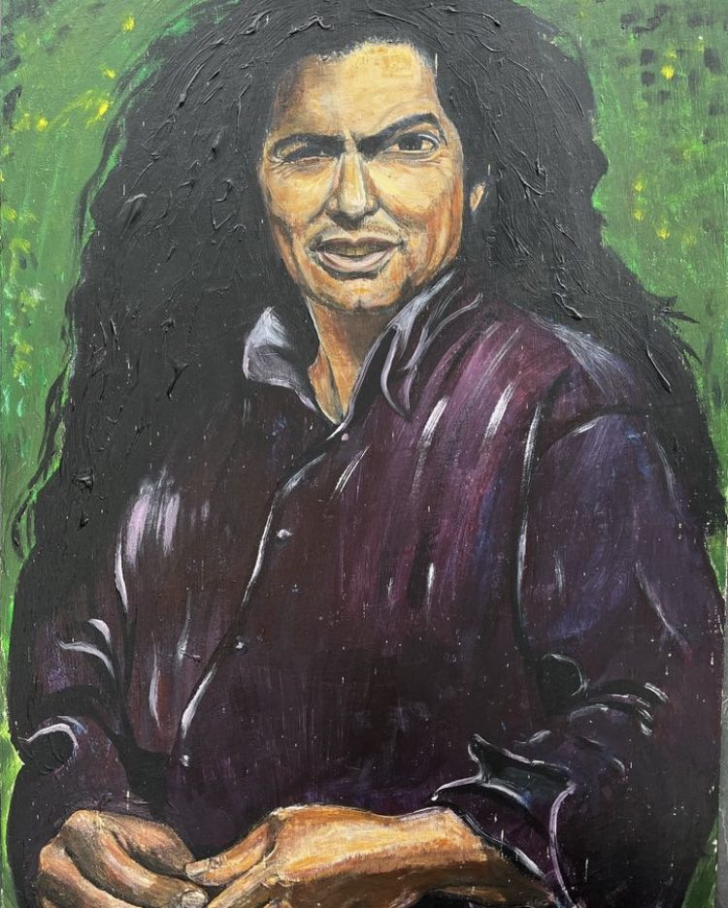
Figure 4fire of life. portrait of Dad by Mum. Author’s personal photo.



