
Geographical Information Systems
Geodemographic Analysis using GIS software
Luke Davies | 5/11/26 | 2315714

Contents
Introduction 2
Principles of geographical data mapping 3
Case study overview 4
Mapping approach for case study 5
Preparation of Health Data 6
Creation of data visualisations 8
Visualizations of Health Data 11
Analysis of Visualizations 18
Discussion of Analysis 24
Limitations and additional data 26
Conclusion 27
References 28

Introduction
This report discusses the results of a Geographical Information System build made within the QGIS software environment.
The report begins with a discussion of the principles of data mapping, including how maps can be utilized as a means of displaying data visually. A brief description of the case study and data inputted into the QGIS environment is then provided, and screenshots of the resulting outputs are provided. A discussion and analysis of the outputs is then provided, alongside a review of additional data that may further enhance the study. A conclusion completes the report alongside a list of references.

Principles of geographical data mapping
A Geographical Information System is defined by Zhang et al as a system used to “capture…manipulate… and visualize geo-referenced data” [1]. Geo-referenced data can be described as data containing a spatial element, which includes reference to the earth’s geography, such as coordinate data.
If geo-referenced data is linked to attribute data (for example, data on numbers of people who exercise in an area) then effective visualisations can be provided which assist in answering key questions about the data. For example, and as described by Heywood et al, linking spatial and non-spatial data using GIS software can assist with easily identifying higher geographical concentrations of a specified data set, or identify trends in the data related to a particular area [2].
Maps can be utilised to bridge the gap between these two data types in an intelligible visual format. This can be achieved via effective visualisation methods of the core geometric types of vector data - such as points, lines, and polygons (e.g. boundaries on a map) such as the Welsh MSOA boundaries used in this study.
Such visualisation involves the use of “visual variables” which, as described by Roth, are how a map can be “varied to encode information” [3]. This can be achieved by choropleth mapping, as employed in this study, which involves grouping data into classes and assigning varied colours or shades to highlight variations in the data [4].
A GIS environment functions as a ‘visual information system’– one which “enable us to relate to spatial phenomena beyond direct experience” [5]. As such, the created map allows easier perception of and, more importantly, a clearer analysis into relationships between data within a spatial context rather than, for example, viewing a report or spreadsheet recording the information in isolation, which would make identifying relationships much more cognitively complex due to the relationship between the spatial and non-spatial data being far less obvious from a visual perspective.
Careful consideration must be given to how information is mapped within a geographical information system – for reasons such as those highlighted by Klettner, where their distinction of how a map can not only “denote but also connote” [5] highlights that those viewing the data can draw inferences from not only the data, but also how it is displayed (e.g. associating darker colours with ‘bad’ outcomes).

Case study overview
As outlined in the presentation element of this module, the following questions were investigated as part of this case study for Welsh MSOAs:
Primary question - Is lower income associated with a reduced adoption of healthier behaviors and poorer mental health outcomes?
Secondary question - Are Primary Care and mental health services adequately distributed in areas with lower income, poorer mental health, and reduced healthy behaviours?
The case study below will therefore analyse the available data with a view to producing insights into these questions.

Mapping approach for case study
Given Klettner’s findings, the way data is displayed on a map is crucial to ensure the end user digests the full scope of the non-spatial data effectively. Brewer outlines that the use of colour in mapping is particularly effective insofar that it “permits greater accuracy in map reading” [6]. Brewer in particular highlights how the use of “diverging lightness steps” [6], meaning a progression from lighter to darker colours, can effectively be utilized to display data on a map.
Given the above and considering the case study questions posed below, a yellow-red colour scheme is utilized in this project to visualise the health data presented.
Given the question requires the user to easily understand where poorer health outcomes are presented within Wales, poorer outcomes are deliberately graded in darker colours on the maps presented. Whilst utilizing light-to-dark colours to correlate with better to poorer health outcome is described as a potential weakness in visualisation by Klettner, it will be used in this study as a strength. This will be achieved by deliberately colouring poorer outcomes with darker colours, thereby assisting in presenting a clear visual reference point across all maps of where outcomes are poorer.
The colour scheme is repeated across all maps to ensure visual consistency. Research by Al-Samarraie et al identified that design characteristics in mapping have a direct effect on a map viewer’s cognitive load (that being the mental effort required to process data), particularly where more complex design choices are made [7].
In the maps presented below, effort has been made to reduce this cognitive load by removing the need to refer to map legends when viewing the different maps available, achieved via this colour consistency. This is particularly important given the study question requires an element of comparison between health outcomes with reference to household income and GP practices, and as such the analysis is eased by the consistency in colour utilized.

Preparation of Health Data
  - Available data
Several datasets were obtained as part of this study as outlined in the presentation element of this module. Details on the data sources can be obtained via the presentation submitted, including the ONS, Census 2021, and Datamap Wales.
The raw data included for analysis is as follows:
Figure 1 – Same raw data: Income
Figure 2 – Sample raw data: Educational attainment
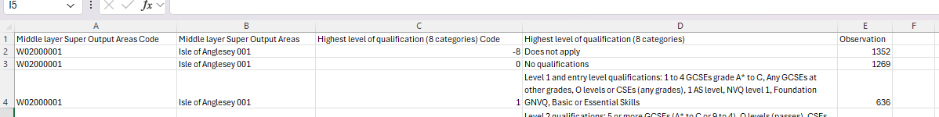
Figure 3 – Sample raw data: BMI
Figure 4 – Sample raw data: Physical Activity
Figure 5 - Sample raw data: Disabilities
Figure 6 – Sample raw data: General Health

Figure 7 – Sample raw data: Suicide data
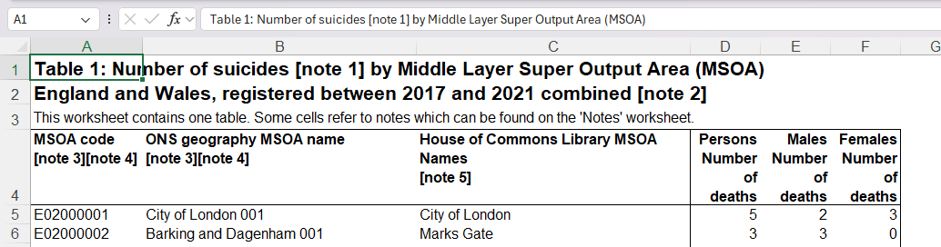
  - Data preparation
Several of the datasets obtained were cleaned prior to importing into the QGIS environment. The cleaning of datasets was considered an essential first step prior to adding the data into QGIS, as data which is in an inconsistent format may not map correctly to the base map layer.
Data cleaning was carried out for the following reasons:
- To remove redundant title rows
- To check no nil values existed within the data
- To clean data into one tab where multiple unrelated tabs were included (for example, the suicide data which contained a title tab)
- To remove rows unrelated to Wales (e.g. English MSOAs)
- To calculate percentages of chosen visual elements – this was carried out on educational attainment to calculate the percentage of those with no educational attainment, on disability data to calculate the percentage of those who identify as having a disability, and on general health for those who identify as having bad or very bad health. Calculations within excel were utilized to calculate the percentage of these columns against the entire sample size available.
The resulting amended tables imported into the QGIS environment. For example, a percentage of those with no qualification was added to the educational attainment was calculated and visualised in the end build (see column G below).
Figure 8 – No educational attainment cleaned data

Creation of data visualisations
To begin, the base map and data was imported into the QGIS environment via the Data Source Manager. As can be seen in the screenshot below, QGIS automatically maps the various columns in the data sets to data types, for example integer or string. Care was taken to ensure that the column which was to be later joined to the base map was selected as an integer, which is required to ensure that a choropleth map is created based on the integer values in that column.
Figure 9 – Example import of data via Data Source Manager
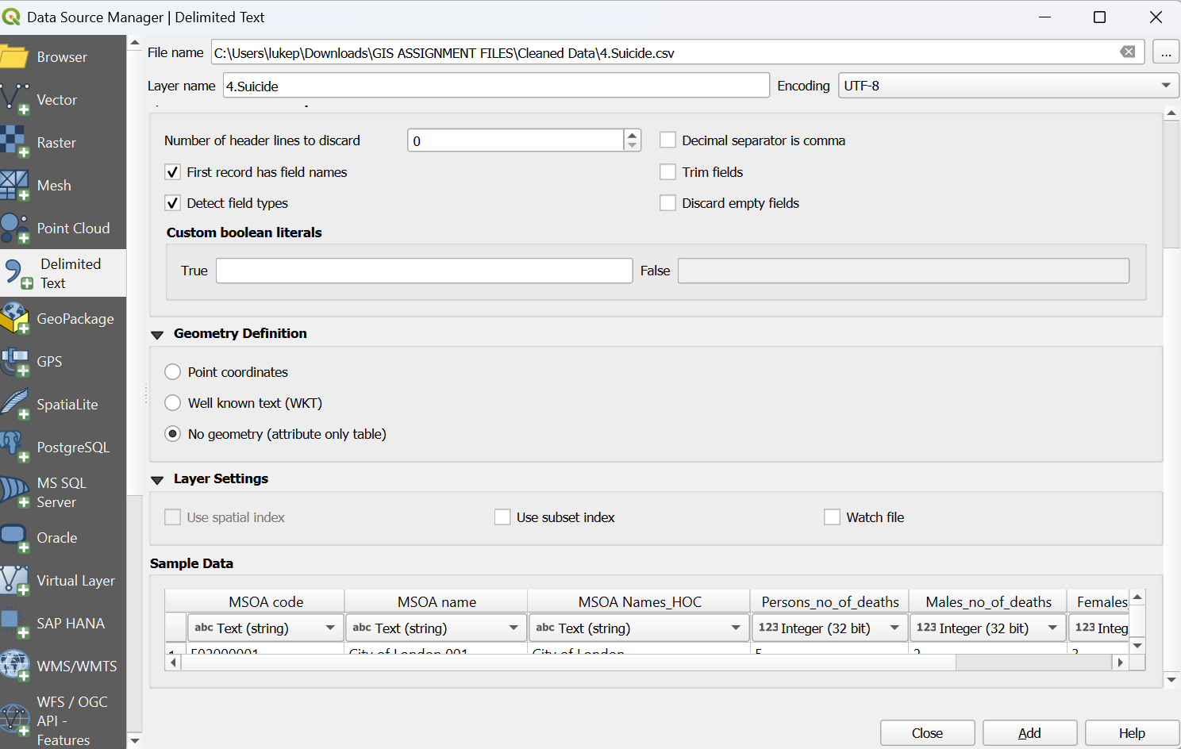
Following adding the data into the environment, the data was joined to a copy of the base map via the Joins function. Here an essential step took place of joining the relevant MSOA codes within each dataset to ensure the attribute data successfully connected to the spatial map data.

Figure 10 – Joining dataset to base map

Symbology was then applied to the data alongside natural breaks to create a choropleth map for each of the seven sets of data imported, as can be seen below.
Figure 11 – Symbology added to map
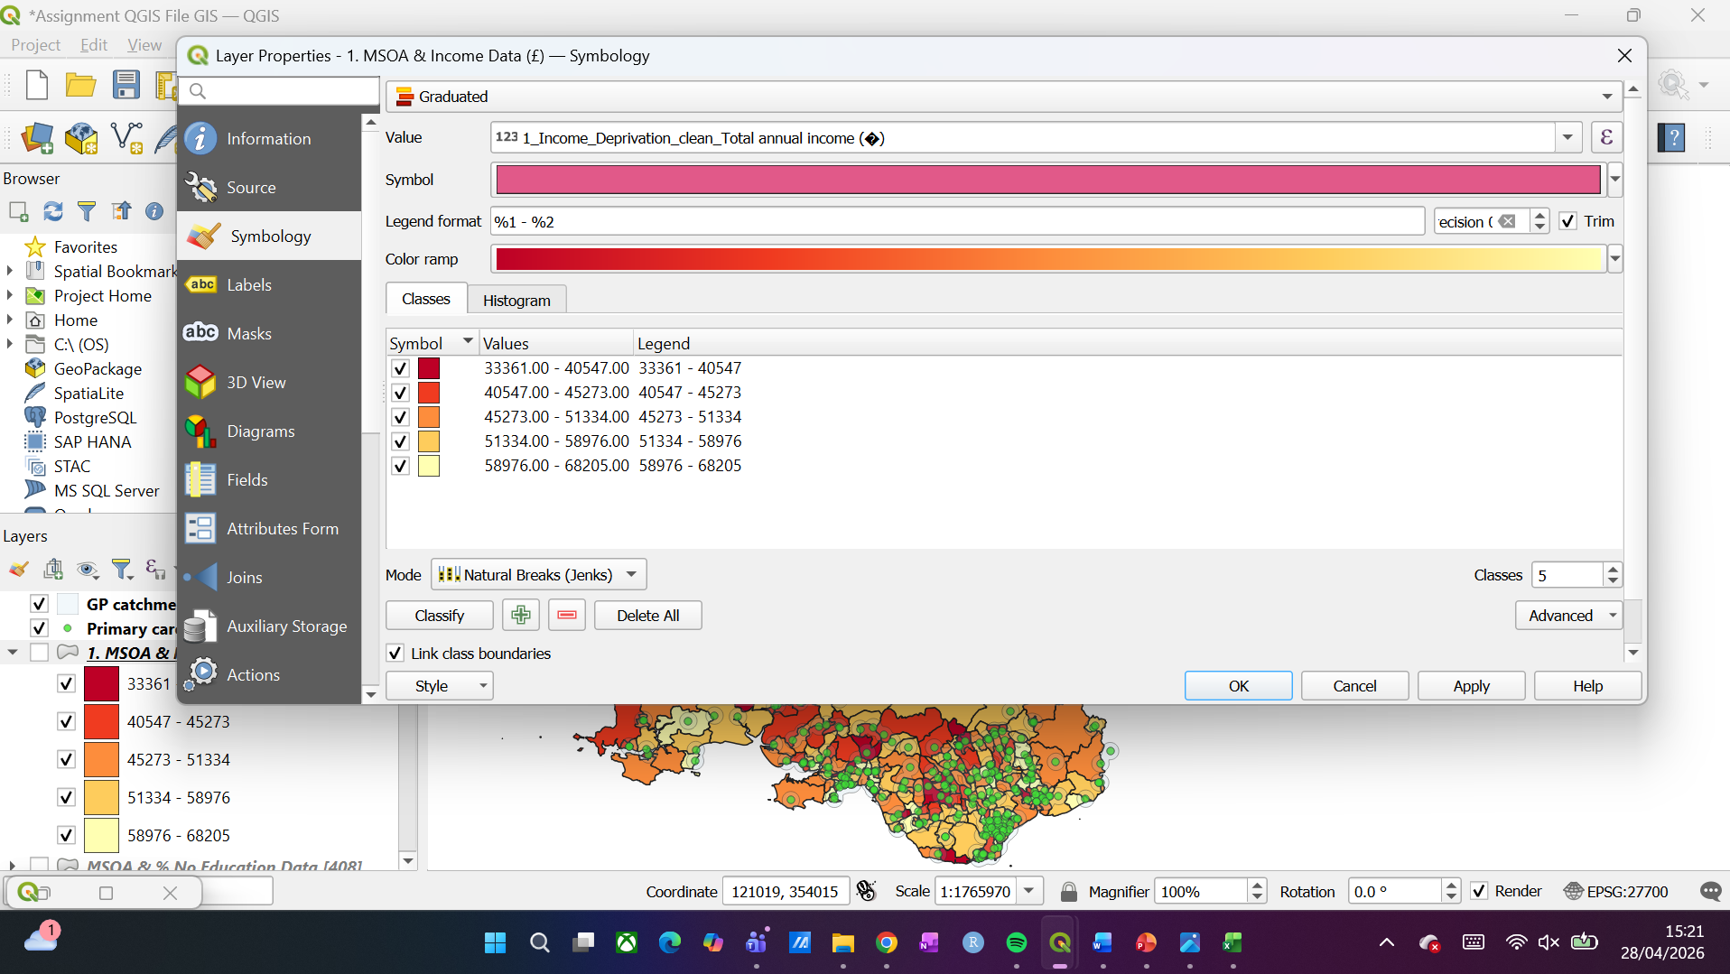
With regards to the particular colours chosen, care was taken to reduce cognitive load and ensure that poorer outcome for each dataset was easily visualised.
Experimentation was carried out with a green-red colour scale, however it was felt that this did not accurately show good and bad outcomes (for example, poorer vs higher household income, or lower vs higher BMI) for the datasets collated. Instead, a yellow-red colour range was employed to provide a clear visual spectral range (light to dark) as discussed by Brewer et al, who outlined that “spectral schemes are effective if designed to include diverging lightness steps suited to the logical structure of mapped data” [6]. Given the data here can be segmented easily by value ranges, a spectral colour range of light to dark proved useful in easily identifying the areas of poorer health or income outcomes within the data.
GP vector points were added to the data with a buffer layer to visualize a ‘catchment’ area of GP access within a 3000-metre radius:
Figure 12 – GP Buffer layer created
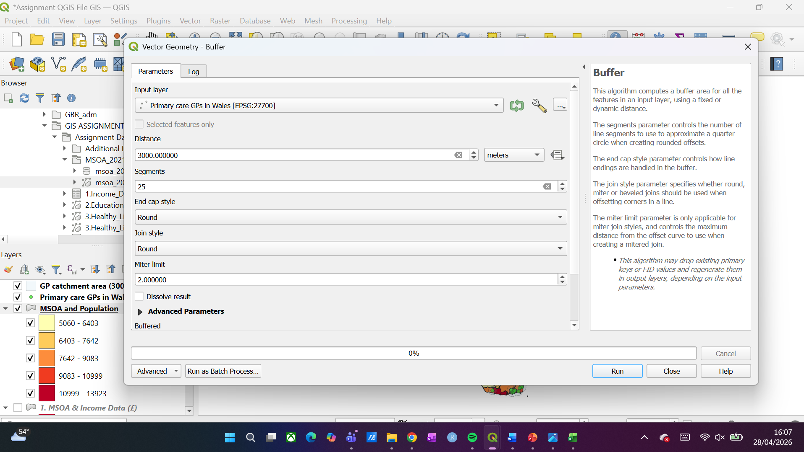

Visualizations of Health Data
Figure 13 – Income data visualisation
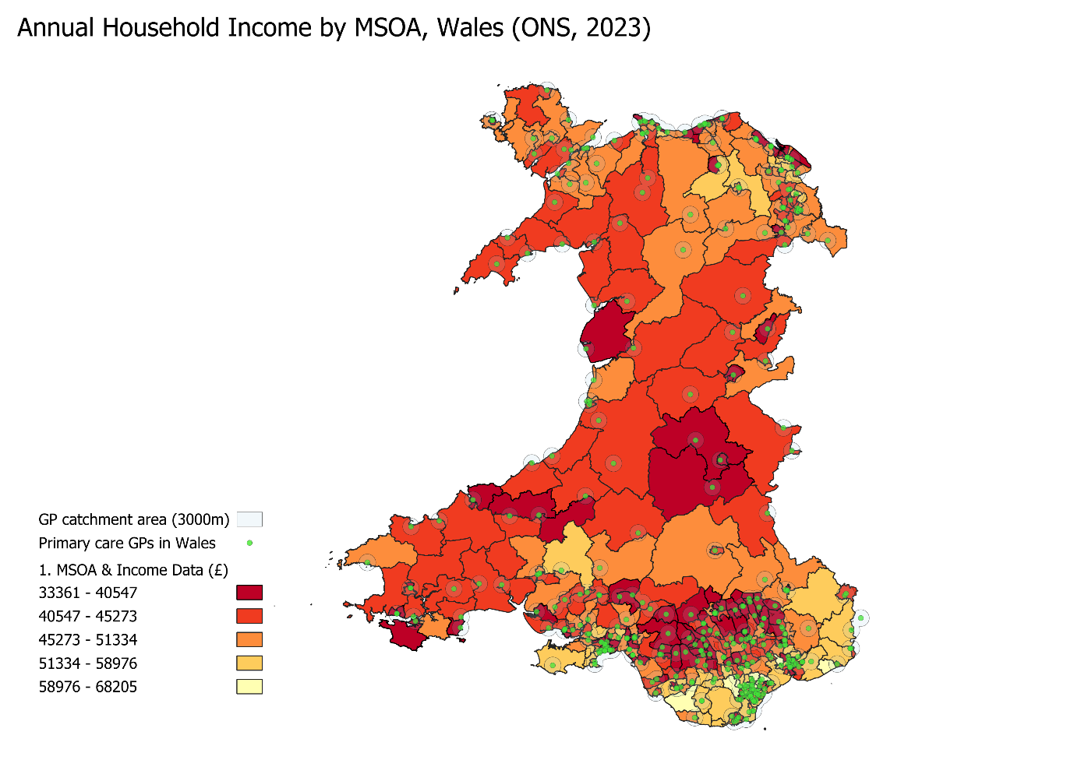

Figure 14 – Qualification visualisation
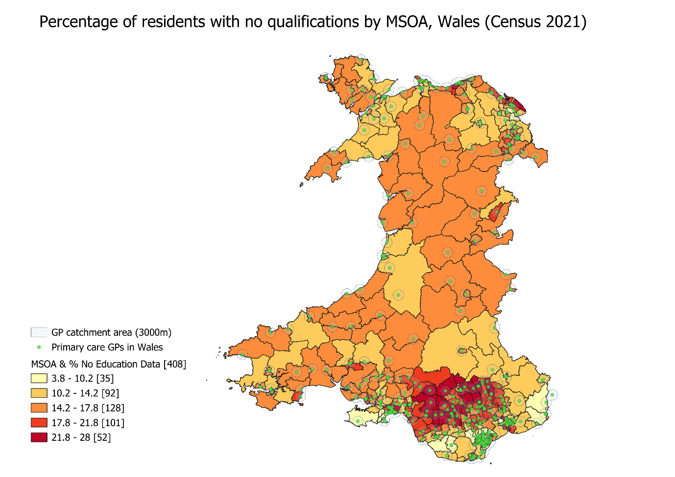

Figure 15 – BMI Visualisation
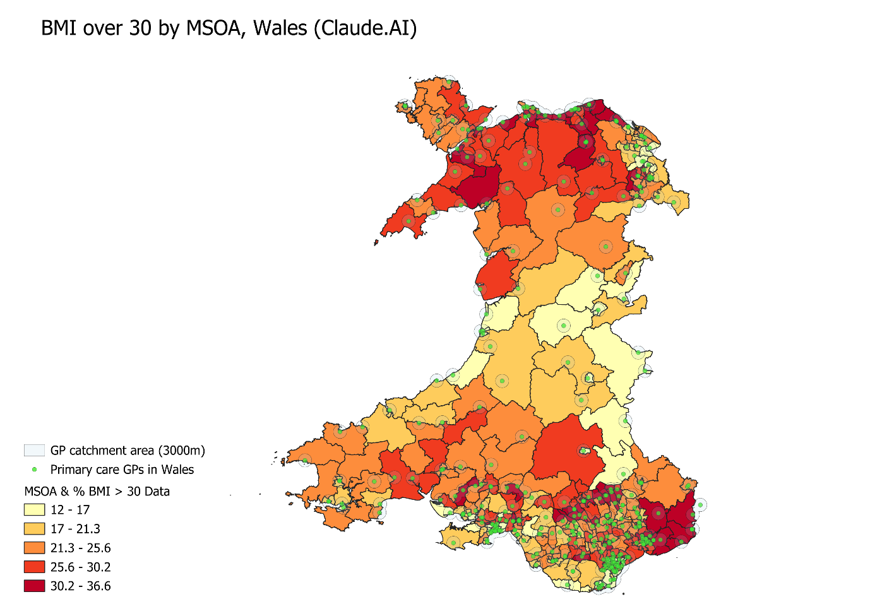

Figure 16 – Physical inactivity visualisation
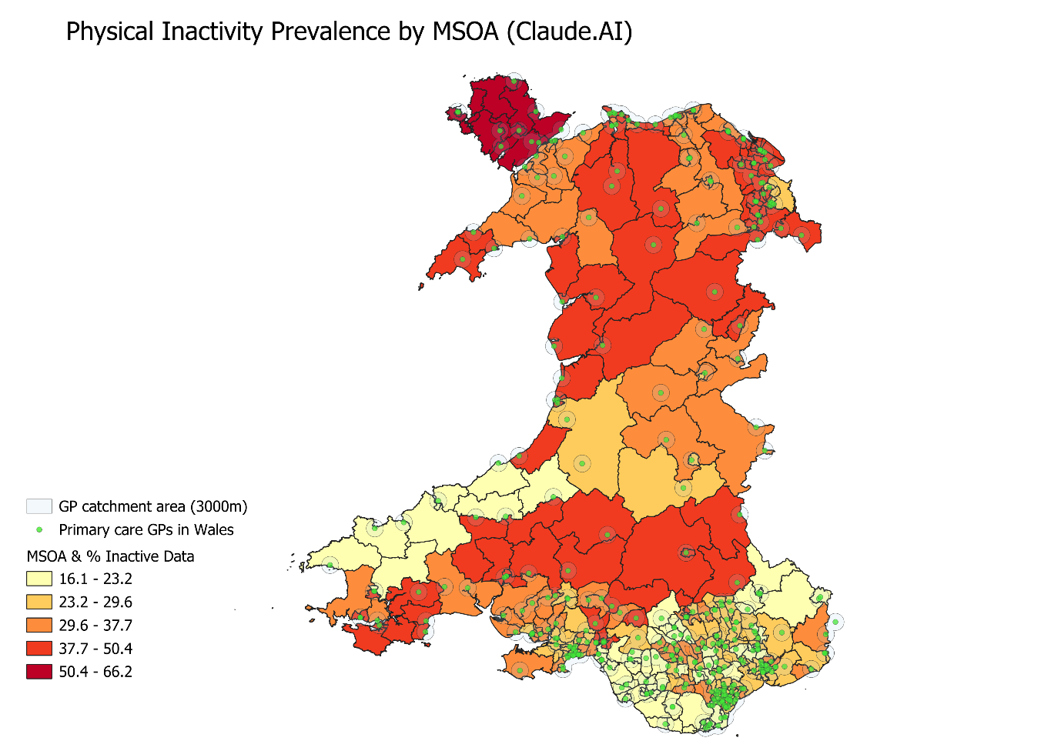

Figure 17 – Self-reported poor health visualisation
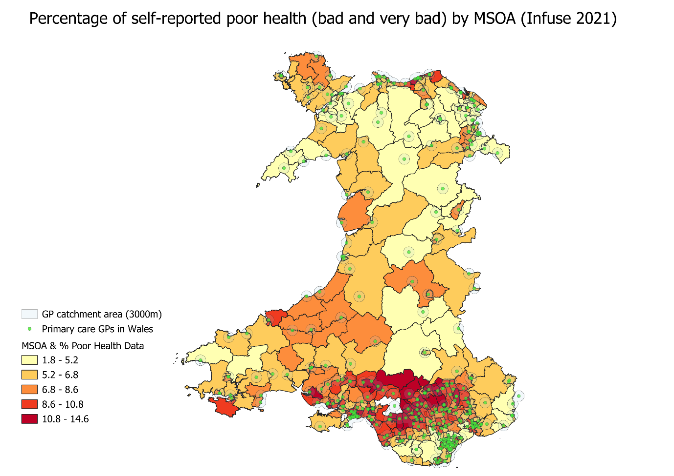

Figure 18 – Disability visualisation
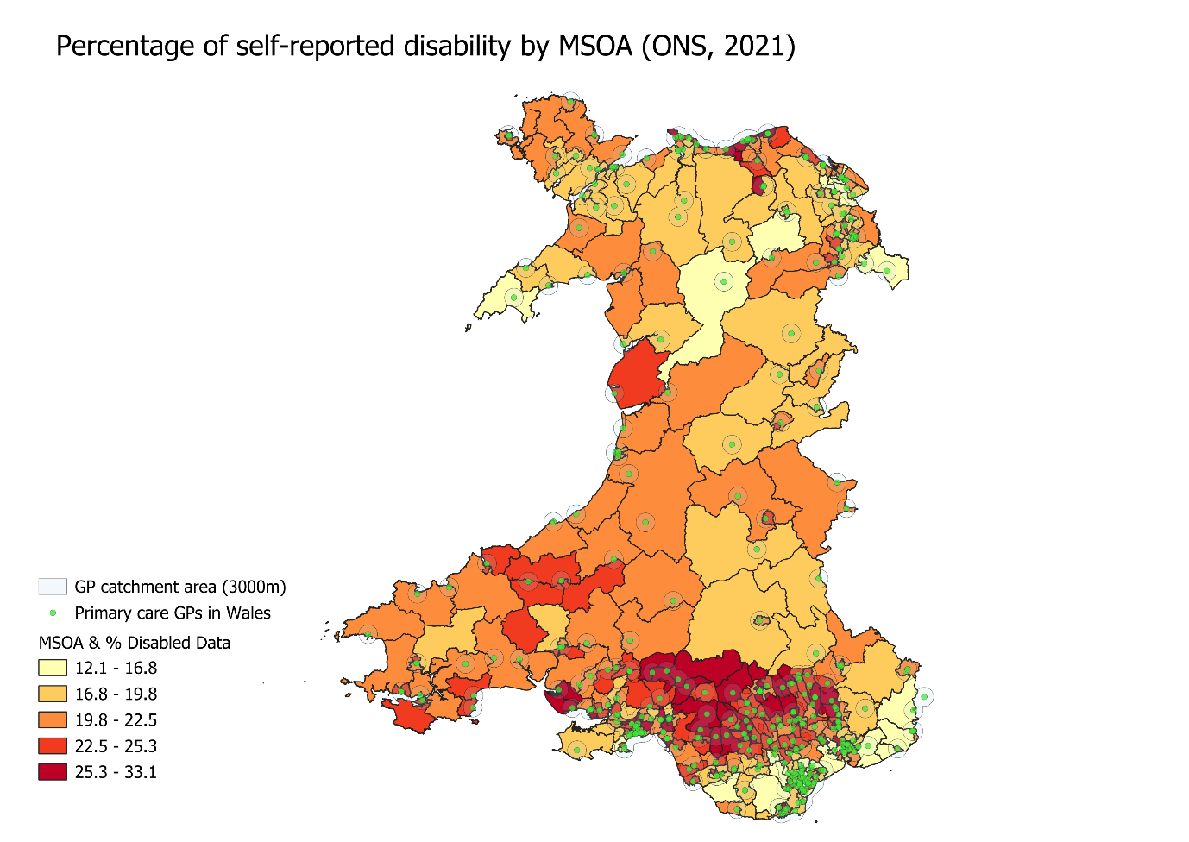

Figure 19 – Suicide visualisation
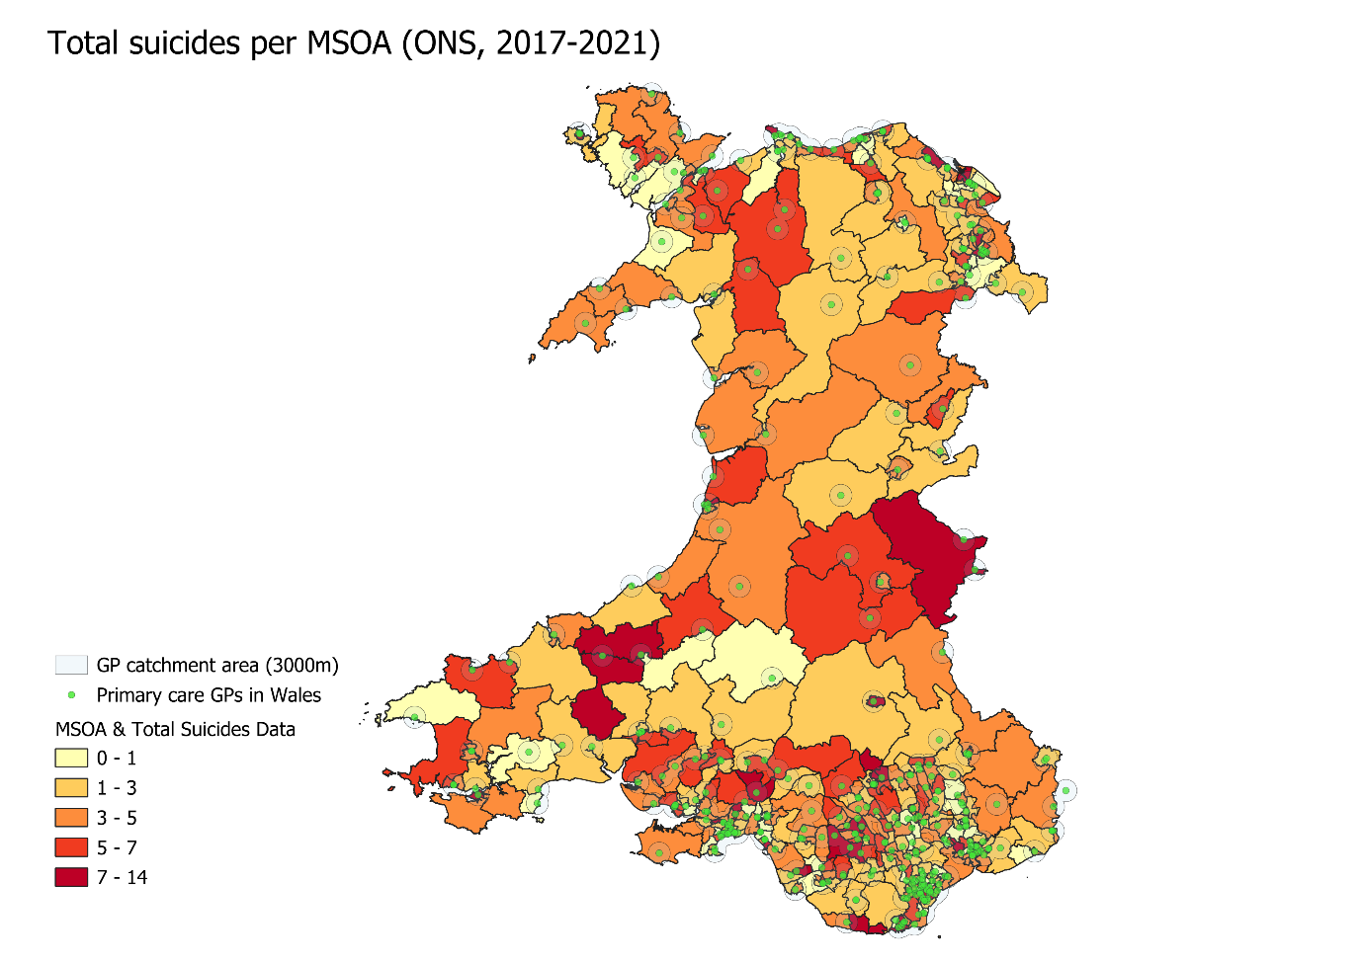

Analysis of Visualizations
The visualisations above can be analysed with regards to the study questions set.
As a contextual reference, the population of Wales is also mapped from mid 2024 ONS data [8] here:
Figure 20 – Welsh population map
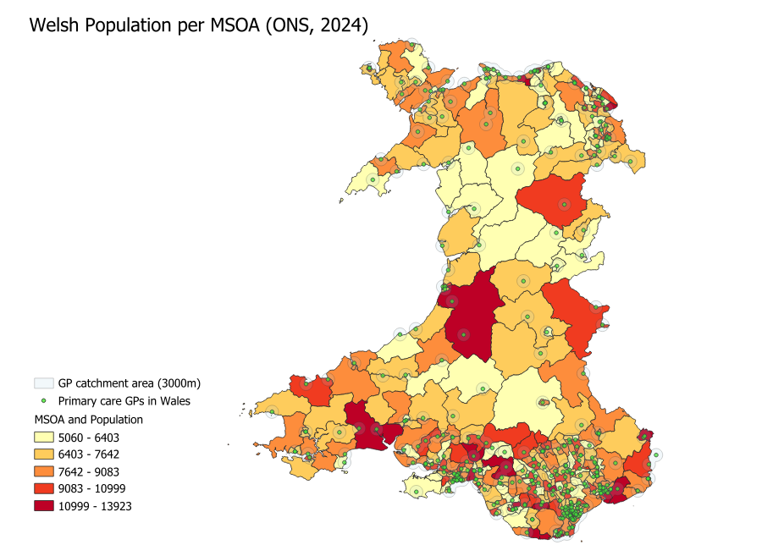

The following is evident from viewing the maps generated:
- The majority of primary care GP surgeries are contained in the south-east of Wales, which accords with the highest percentage of population as noted above (e.g. higher concentration of darker areas in South and South-east Wales):

Figure 21 – Higher cluster of GP surgeries in more densely populated area of Wales
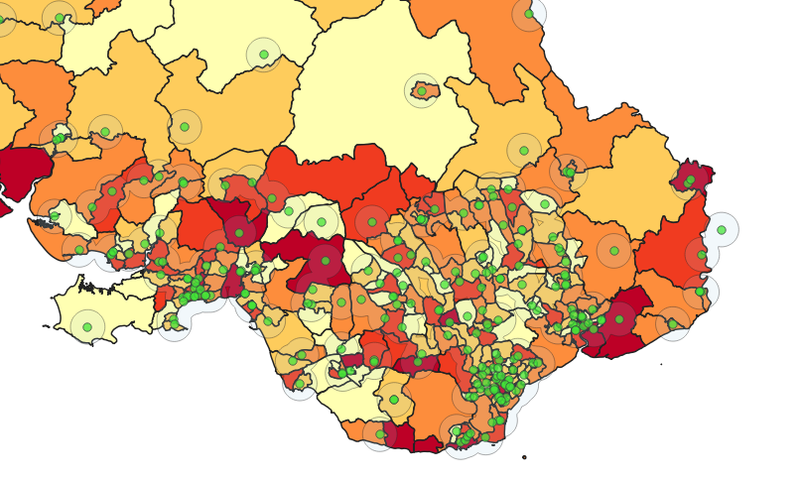

- Higher income within Wales is focused nearer to the South and southeast English border lighter yellow) with noticeable darker red patches in the South central area (Rhondda Cynon Taf, Merthyr Tydfil, Blaenau Gwent) and in mid-Wales, with higher household income in the north of Wales compared to mid-Wales.

Figure 22 – South central Wales and West Wales income visualisation

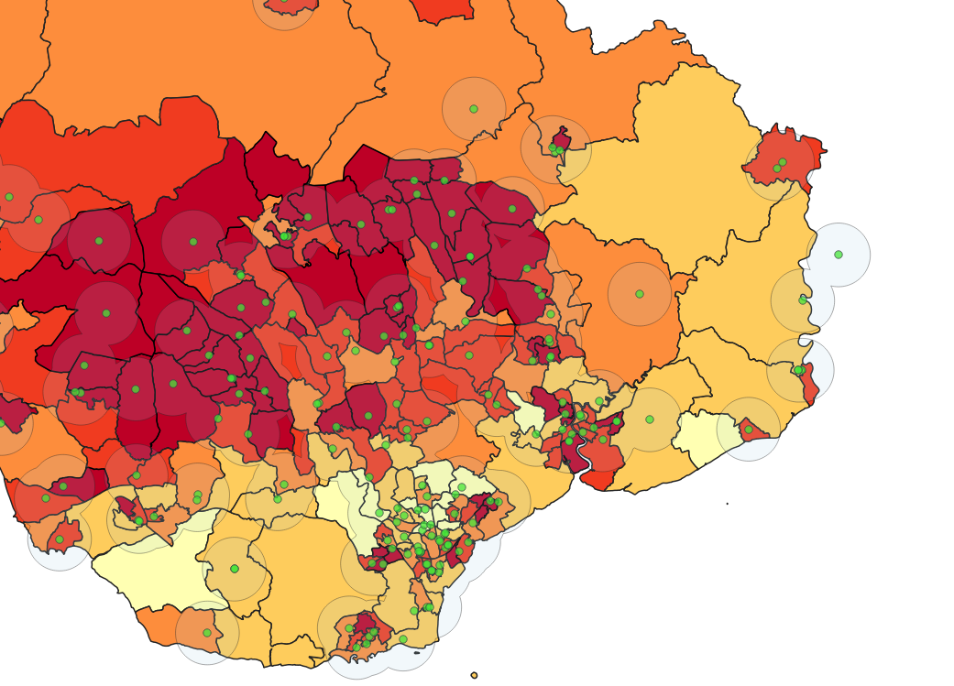

- Areas with no educational attainment are focused to the Welsh Valleys (the dark red on the map being areas of Rhondda Cynon Taf, Merthyr Tydfil, Blaenau Gwent) with better outcomes nearer the southeast English border, west Wales, and North Wales.

Figure 23 – focus of area with no educational attainment:
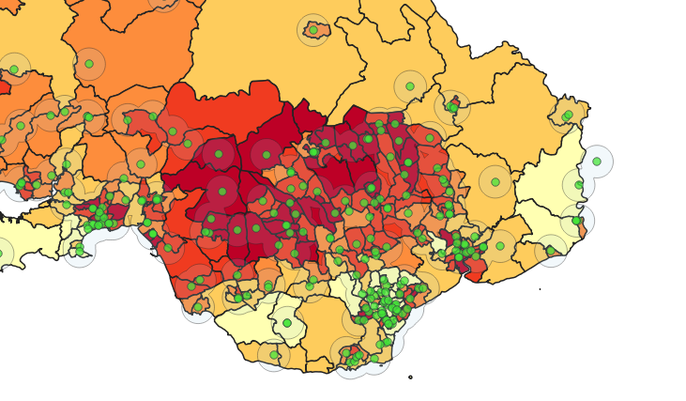

- BMI data shows poorer outcomes in North and South Wales, in contrast with Mid Wales where BMI is generally lower.

- Higher percentages of inactive individuals per MSOA can be seen in south mid-Wales and North Wales as opposed to South Wales.

- Those self-reporting poorer health outcomes are focused to the Welsh Valleys (the dark red on the map being areas of Rhondda Cynon Taf, Merthyr Tydfil, Blaenau Gwent)

Figure 24 – Concentration of poorer self reported health outcomes
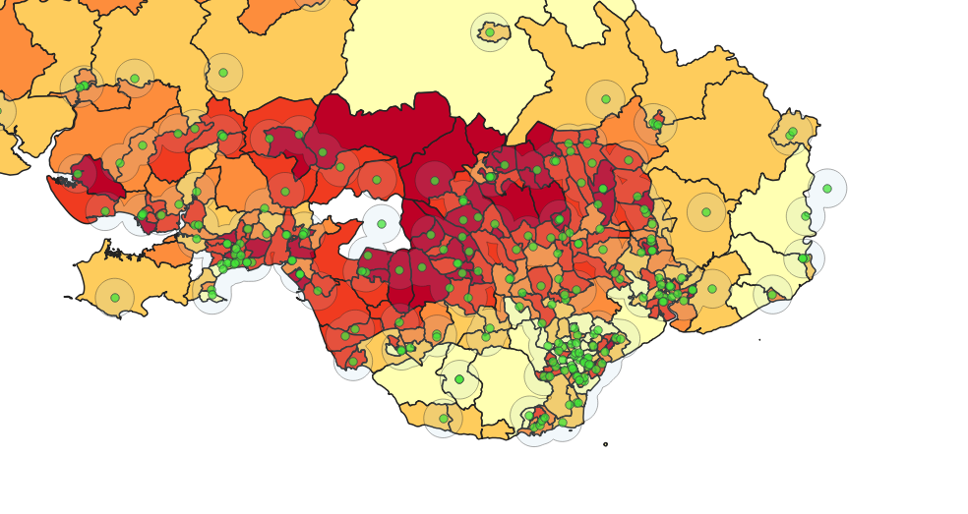
- MSOAs with a higher percentage of self-reported disability are concentrated in the Welsh Valleys (the dark red on the map being areas of Rhondda Cynon Taf, Merthyr Tydfil, Blaenau Gwent)
Figure 25 – Higher concentration of disabilities in mid central Wales
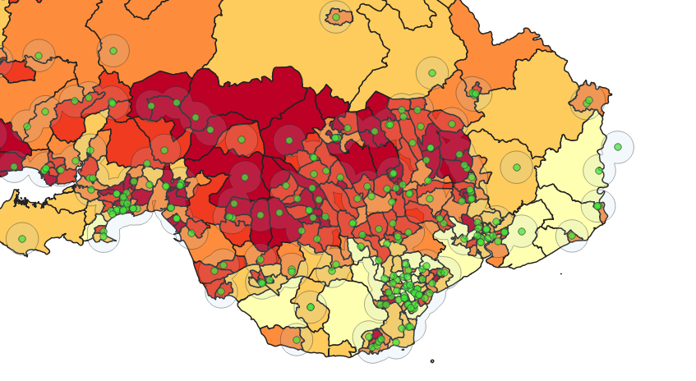

- Suicide data is somewhat mixed, with reported suicides being small in number throughout Wales and darker areas appearing sporadically across the map.

Discussion of Analysis
The spatial visualisations presented have identified some key findings relevant to the two study questions.
With regards to the primary study question, given both poorer household income and poor educational attainment are visible in the Welsh Valleys and mid-Wales areas, it is arguable that poorer household income and lack of education are related, given the correlation of darker areas on both choropleth maps. Poorer household income and poorer educational attainment may influence health outcomes by producing a lack of access to paid healthcare when required.
It is less arguable that household income has an impact on BMI, given there is a less of an overlap between the two maps (e.g. a higher BMI is seen in North and Southwest Wales as opposed to lower household income being seen in mid and south-central Wales). It is therefore arguable that factors outside of household income, such as access to recreational spaces, may influence BMI rates rather than household income.
Regarding inactivity data, more inactive percentages can be seen around south-Mid Wales and North Wales, correlating somewhat with lower household income. This may suggest that higher incomes are indicative of better levels of activity – this can particularly be seen in Southeast Wales where income levels are higher and activity levels are also recorded as higher.
A strong correlation can be seen between those self-reporting poor health and a lower income within the South Wales Valleys (the dark red on the map being areas of Rhondda Cynon Taf, Merthyr Tydfil, Blaenau Gwent), with both areas being darker red. The same conclusion can be drawn with regards to self-reports of disability, which are similarly concentrated in the Welsh Valleys area. For these two measures, a strong argument could be made that levels of self-reported poorer health outcomes correlate with lower household income.
It is less arguable that there is a relationship between income and suicide rates within Wales, with the areas of darker colour correlation being more sporadic. This may be due to the low counts of suicides within each area correlating with a lower statistical reliability, particularly when relating to larger MSOA areas. As such, it is difficult to argue a correlation between the suicide data available and lower income – this could be further explored with additional data, perhaps from a more localised data set at LSOA level.
With regards to the secondary research question, one could argue that GP placement being concentrated in the South Wales Valleys is suitable given the consistent reports of disability and poorer health outcomes. However, the visualisations make clear that the concentration of primary GP catchment areas (as visualised in the buffer included in the maps) do not extend into many Mid and North Wales areas effectively and in proportion to the poorer outcomes outlined above such as increased BMI levels and poorer activity levels. A valid argument could therefore be presented that additional primary care GPs are required in Mid and North Wales to tackle poorer health outcomes – such a conclusion is one reflected in real life studies of GP availability within Wales, such as the study of the Economic and Social Research Council [9], which found that those in rural areas may not register with their nearest GP surgery and may travel further to visit their GP, suggesting not only a potential lack of GP quality in rural Wales (evidenced in those joining further away GP surgeries rather than those closer to them, possibly due to the quality of their local surgeries), but also directly reflecting the results of this study regarding the concentration of GPs in rural Wales.

Limitations and additional data
There are various limitations with the conclusions presented which should be highlighted.
Firstly, the data visualised (as outlined in the presentation element of this module) is from varying years. This therefore leads to potential inaccuracies in drawing correlations between data from differing time periods, as opposed to taking data from one period alone.
Further and as outlined in the presentation element, part of the data used in this study was data collected at USOA, rather than MSOA level. The data may therefore not represent real world outcomes and rather may represent estimates per MSOA, and as such the data per MSOA may be inaccurate.
Finally, use of MSOA coding may be a limitation of the study as opposed to utilizing more granular area levels such as LSOA. Increasing the granuality of data to smaller areas may focus the study, for example identifying which specific boroughs suffer poorer outcomes.
Additional data may assist in providing further views into the relationship between income, poorer health outcomes, and GP placement. In particular, the following data sets could assist:
- Green space/recreational ground data – a visual map of green spaces may assist in understanding whether, for example, increased BMI can be correlated with a lack of exercise space.
- Public transport data – incorporating data relating to public transport may strengthen the study by outlining journey times to primary care services. For example, if public transport access is poorer in Mid and North Wales areas, then this would strengthen the need for additional primary GP services alongside the findings of this study. Data such as the Transport (National Survey for Wales) report outline, for example, that satisfaction with many public transport services is lower in Mid Wales, which would support a need for further GP practices to cover more difficult to access rural areas.
- Consumer data – Data such as food purchase data (e.g. healthier/unhealthy foods) may assist in demonstrating where BMI is higher and health outcomes are poorer, and may suggest where additional GP services are required.
- Hospital location/A&E data – to expand on a review of GP services only, data concerning locations of hospitals and A&E wait times may assist in, for example, strengthening the argument that further healthcare centres are required in Mid and North Wales, or may demonstrate that adequate coverage is present in the poorer outcome areas identified.

Conclusion
In summary, the evidence available broadly supports the research question posed – lower income can be associated with reduced adoption of healthier behaviours and poorer health outcomes across Welsh MSOAs. A spatial consistency in poorer outcomes has been identified in the South Wales Valleys, with the relationship between BMI and physical activity being less clear, suggesting alternative factors may influence the poorer outcomes seen (such as access to green spaces).
With regards to GP numbers, a clearer picture is presented of a higher need of primary GP services within Mid and North Wales relative to the health needs of those areas identified in this study.

References
[1] Y. Zhang and Q. Cheng, Eds., Geographic Information Systems and Applications in Coastal Studies. London: IntechOpen, 2022. doi: 10.5772/intechopen.97909.
[2] D. I. Heywood, S. Cornelius, and S. Carver, An introduction to geographical information systems, 4th ed. Harlow: Pearson, 2011.
[3] R. E. Roth, "Visual Variables," in The International Encyclopedia of Geography: People, the Earth, Environment and Technology, D. Richardson, Ed. New York: Wiley-Blackwell, 2017, pp. 1–11. doi: 10.1002/9781118786352.wbieg0761
[4] W. Mu and D. Tong, “A general model for creating robust choropleth maps,” Computers, environment and urban systems, vol. 96, Art. no. 101850, Sept. 2022, doi: 10.1016/j.compenvurbsys.2022.101850.
[5] S. Klettner, “Affective Communication of Map Symbols: A Semantic Differential Analysis,” ISPRS international journal of geo-information, vol. 9, no. 5, p. 289, May 2020, doi: 10.3390/ijgi9050289.
[6] C. A. Brewer, A. M. MacEachren, L. W. Pickle, and D. Herrmann, “Mapping Mortality: Evaluating Color Schemes for Choropleth Maps,” Annals of the Association of American Geographers, vol. 87, no. 3, pp. 411–438, Sept. 1997, doi: 10.1111/1467-8306.00061.
[7] H. Al-Samarraie, A. Eldenfria, M. L. Price, F. Zaqout, and W. M. Fauzy, "Effects of map design characteristics on users' search performance and cognitive load: An empirical study," The Electronic Library, vol. 37, no. 4, pp. 667–679, 2019
[8] Office for National Statistics, "Middle Layer Super Output Area Population Estimates (Supporting Information)," ONS, London, UK, Nov. 2025. [Online]. Available: https://www.ons.gov.uk/peoplepopulationandcommunity/populationandmigration/populationestimates/datasets/middlesuperoutputareamidyearpopulationestimates [Accessed: 28 Apr. 2026].
[9] R. D. Johnson et al., “Assessing access to primary care in rural and urban Wales,” International Journal of Population Data Science, vol. 10, no. 4, Aug. 2025, doi: https://doi.org/10.23889/ijpds.v10i4.3085.
‌[10] “Transport (National Survey for Wales): April 2022 to March 2023 [HTML] | GOV.WALES,” GOV.WALES, Dec. 11, 2024. https://www.gov.wales/transport-national-survey-wales-april-2022-march-2023-html
‌

