Junior Richard (1605599)
Lecturer | Dr Amare Desta
Abstract
Stock products have discovered a patent to which plasma has a whitening if teeth effect. The board would like an answer on whether to invest a sum of money into this project. After extensive research on Stockholm products approach and literature of innovation it was recommended that Stockholm products ought to invest in the project by redesigning their business model in order to create value.
Developing innovation and creativity for business advantage
BMSK6002

Table of Contents
Introduction 2
Innovation, Invention, Creativity with Stockholm Products 2
Closed or Open innovation 8
Key individual in the ‘plasma teeth whitening’ project 12
SP project recommendations 13
Conclusion 15
References 15
Appendix 20
A 20
B 21
C 22

Introduction
Currently, Stockholm products (SP) and other organisations to make sure of their survival have been prompted to act fast due to rapid changes. They do this by launching innovative products and services with sophisticated technology, requiring invention, creativity, innovation and entrepreneurship (Fadaee & Obaid Abd Alzahrh, 2014). The role of some of the important elements can be summarised (see Figure 1). Creativity is individual capability that could lead to an integral invention or idea by a creative individual. Whilst, innovation process is converting the idea of a plasma cleaning tool into a marketable product or service (Fadaee & Obaid Abd Alzahrh, 2014). Consequently, entrepreneurship is an distinct characteristic that indicates the innovation process successfully in bringing a new product or service to the teeth whitening market despite many obstacles (Ghasemzadeh, 2001; Fadaee & Obaid Abd Alzahrh, 2014).
Utilising these definitions, this report aims to demonstrate a clear idea of the significance of innovation for business development as well as critically evaluating innovation models and characteristics of the process of innovation. In order to achieve this, this report will provide teeth whitening case study of SP (see Appendix) and critically reflect on their approach to innovation utilizing academic theories and models. Furthermore, recognise and analyse an employee of SP as well as their application of creative thinking at an individual, organisational and industry level. Moreover, explain an open and closed model of innovation in addition to analysing how they can be applied towards SP project. After the analysist recommend with justifications which model ought to be applied to the project. Lastly, with everything considered this report will make a recommendation to the SP board on whether the organisation should invest in the new product development.

Innovation, Invention, Creativity with Stockholm Products
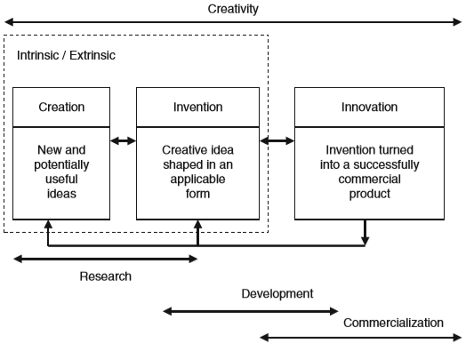
Figure 1: Link between invention, creativity and innovation

Source: (Carayannis, 2013)
Several consider creativity as something that accidentally occurs as a result of an enjoyable event and may not be created or to create an idea in mind by several ways and organisational changes, but one thing will provoke ideas or words in a mind. Creativity typically has five steps in this process (see Fig.2).
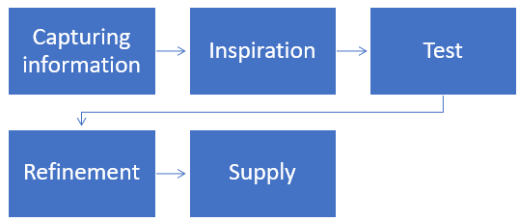
Figure 2: Stockholm products creation process
Source: Author
First, at the SP review meeting, the group draws attention to information as well as study issues about plasma in order to examine and browse for solutions. Throughout this period, the mind of creative individuals starts working with data slowly, then quantifies, analyses, and synthesises information to solve the plasma issue. Then upon discovering new ideas, the creative team puts this to the test of success or failure. Such move can also enhance the efficiency of a solution. Flexible behaviours as well as thought, advantages and drawbacks of the plasma teeth whitening solution must therefore be embraced. Next, the plasma experiment is carried out and a verification of the viability as well as validity of the proposal might have to be streamlined, which implies that perhaps the ideal answer would be explored. Supply provides creative ideas so new thoughts could be portrayed in a such a manner that they are described in a simple and practical way. Once the creative process gets completed successfully, the implementation of thinking is carried out (Moshbeki, 2001). SP utilises a creative method as a means of developing creativity as well as creative problem-solving capabilities to assist people across all stages of creativity as well as creative problem-solving process. Six hats is a method used during SP meeting, and the main goal of this approach is to break cognitive patterns utilising efficient methods (see below) (Hosseini, 2001):
- Avoiding instantaneous judgement: seems to be an invaluable tool in creativity since an instant judgement on such a solution removes innovative ideas.
- Primary sense: is perhaps the core of the process of creation, creative thinking which analyses data for problem-solving as well as launches significant, non-major and non-useful objects. It allows individuals not to be influenced by governing concept.
- Doubt: The prerequisite for innovation to be met would be that individuals do not embrace assumptions because the intention is to change the model.
- Strong imagination: It is among the factors of creativity the capacity to imagine artefacts, ideas as well as processes. How important the image is? The photos are vibrant, powerful dynamic as well as diverse, encouraging enhanced innovation and creativity.
- Imagination: this is a result of several innovations and inventions. Today, numerous fictions are now fact. A part of the approach would be an individual is going to substitute himself with an abstract thing or individual.
- New approach: A fresh approach to a problem is also an important part of the game of creativity and innovation. Conceptual individuals are exploring new elements of the trend like a creative artist from such a different perspective of the problems and draws a painting.
Developed by Edward de Bono, six hats approach is when individuals within SP bring various approaches to the process of solving the teeth whitening project and that there is value of creating versatility in using any of those to promote and synthesise ideas. Each has related weaknesses and strengths, but all that is required to create and develop the idea to ensure that it is innovative, reliable and effective.
Table 1: The six thinking hats
WHITE | It includes seeking information on plasma technology and the teeth whitening product, a sceptical probing approach that seeks knowledge, evidence and facts about the teeth whitening product.
RED | Emotional reactions by team members, thoughts including reactions towards the idea. It may be intuition, instinctive reactions, reactions towards a proposal lacking any reason or justification, simply however somebody thinks about it.
BLACK | Rational reasoning, review of both the evidence and new concepts, decision centred upon thoughtful consideration as well as analysis, weighting of either the strengths and weaknesses of the proposal.
YELLOW | Rational, hopeful analysis, searching for perks as well as synergies, having to ask, ‘What would be good about that?’ A bridge between ideas as well as underlying constructive components.
GREEN | Creativity, proposing then experimenting in such a new way, utilising 'crazy ideas,' questioning yet stimulating, changing the natural form of new concepts, free-wheeling across the issue without judgement, enabling 'everything goes' attitude of thought.
BLUE | A meta-style that is conscious that the other hats were worn so this can facilitate a transition amongst them. This becomes the overall goals and priorities of the problem-solving meeting – what is the topic that participants are focused on? (Teeth whitening project).
Source: adapted from (de Bono, 1985)
Innovation is progressing through all the innovative progress, which is being made throughout society and economy, in the intervention of all sorts of agents. SP, the government, institutions as well as non-profit organisations (Caraça, 1993; Lundvall, 1992). According to Caraça (1993, p. 82), in which it is stated that, irrespective of their scientific or practical origin, it involves the idea or scheme (e.g. the discovery of plasma by SP as a cleaning agent) of anticipating the prospect of a new teeth whitening product, processes or system. In the meantime, innovation is initial commercialisation of either the teeth whitening product, process or system correlating to that of the emergence on to the market (Caraça, 1993, p. 82-83). Therefore, the fundamental variation amongst the two is, innovation is the creation of the plasma product, process or system for the teeth whitening market, whilst invention is its discovery of plasma whitening technology as well as creation. To practice the innovation notion is quite diverse and therefore different definitions are being established and applied in narrative (Abernathy & Clark, 1985; Cumming, 1998; Johannessen, et al., 2001). Many academics also concentrated on technologically related innovation, including the emergence of products which require radical change throughout the manufacturing process. Nevertheless, innovation concept is seen as moving further than the technological radical innovation (see Fig.3). This possibly will provide enhancements to the teeth whitening product as well as processes, alterations to organisational structures but also activities, in order to exploit the new teeth whitening market. Such notion is mirrored throughout Lundvall's theory (1992, p. 8), who views innovation as continuous learning, searching as well as exploration processes that lead to teeth whitening products, technique, organisation architype including new markets.
Innovation is sometimes the result of a change happening at the same time in various regions, in which inter-relationship as well as interdependence are key aspects (Caraça, et al., 2009). Product innovation can be a good, service or idea that anyone perceives as fresh (Lundvall, 1992; Caraça, et al., 2009). For instance, within SP plasma cleaning agent is the idea, whilst the idea of a handheld tool whitening tool is the good. Thereby, one individual or SP may recognise a product as an innovation, whilst another might not (Johannessen, et al., 2001). Product innovation may be triggered by alterations in the organisational company structure for instance, new products that emerge as new market segments is examined. Furthermore, in recent decades, new market segments were developed throughout the information and communication technology industry, spanning between personal computers and navigation devices (Tidd, et al., 1997; Tidd & Bessant, 2013). Nevertheless, SP product innovation is ultimately related to process improvement. Process of innovation involves the adaptation of SP’s current production lines, the construction of totally new facilities as well as the implementation of new technology. In general, process innovation contributes to the development of SP new good. Nonetheless, process innovation might be required to reorganise a business or to discover a new market (Jenssen & Aasheim, 2010). Organisational innovation involves improvements throughout the relationship of leadership, organisational structure, distribution of workers, remuneration structures, communications systems as well as in other forms of structured interaction during the organisation with individuals (Slappendel, 1996). Albeit just limited amount of studies on organisational innovation are accessible, they have nevertheless gained prominence across all industries. For instance, the success of ISO 9000, which lays down guidelines to make processes transparent, documenting as well as guaranteeing that they must be replicable and regulated (Tidd, et al., 1997).
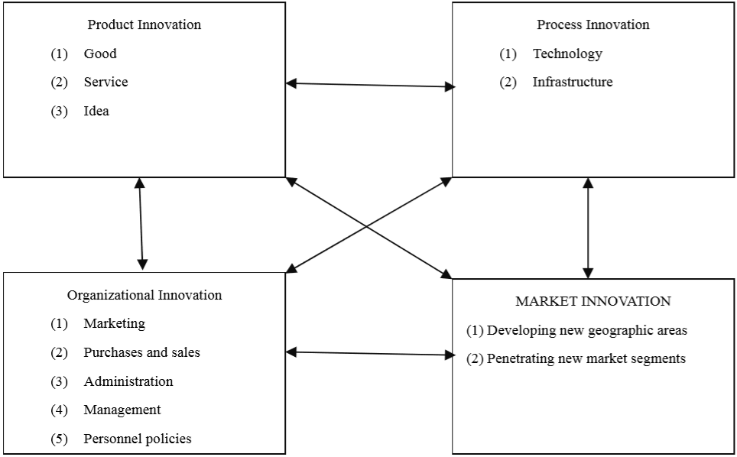
Figure 3: Fields of the innovation concept
Source: (Marques, 2014)
Another innovation field involves market innovation, that includes discovering new strategic markets as well as entering new market segments inside the scope of the current strategy. For instance, recent advances throughout the biopharmaceutical industry indicate how market innovation is highly correlated to product and organisational innovation but is not closely related in the direction of process innovation (Khilji, et al., 2006).
Therefore, it is evident that the realms as well as parameters of innovation concept are diverse and complex. While we might differentiate amongst invention (which is the idea of plasma as a cleaning tool) and innovation (which is the marketing of the teeth whitening drug) since the latter means that the new product is made accessible for consumers. The four realms addressed are intertwined because of the complexities of inter-and intra-organisational learning. Therefore, innovation is 'open' by nature, but its four fields represent its contribution to the economy overall.
Schumpeter (1934) and a few scholars also discussed the innovation process concept. Innovation has always been a crucial factor in development of industrial economics, in competitiveness, the sustainability of SPs, while being an indispensable tool for entrepreneurship (Drucker, 1989). The innovation process evolutionary paths were outlined by Kline & Rosenberg (1986). In the beginning, innovation was perceived as a linear process which is found to be instigated within SP. A gradual process where it would start with research such as SP’s scientists making an unexpected discovery of a patent succumbed by the University of Southern California. To which claimed, plasma was being utilised to disinfect teeth and whitening of teeth was found to be one of the side effects. Then, move on to industrial development where they hold a review meeting on how to develop this idea into a teeth whitening product and develop product ideas such as large cylinders of plasma or micro cylinder product, then proceed towards production with innovation ultimately being fruitfully positioned on the market. The perception technology-push accounts for this notion (see Fig.4) (Trott, 2017). Therefore, highlighting SP characterise technology (science) their source of innovation. It is said that innovation was predominantly clarified properly in the 20th century in which robust industrial growth was available in an economy where demand surpassed supply consequently innovation as well as scientific changes were understood instinctively.
A reopening of the global economy became noticeable throughout the following decades. Developments in information technology, particularly the internet and telecommunications, globalisation, competition as well as the subsequent increase in supply to meet demand. This demonstrates obsolete complexity of earlier linear model then revealed the interactive innovation theory called interactive model by Kline & Rosenberg (1986). The whole perspective featured market pull viewpoint, underlining the interactivity of the innovation cycle, focusing on collaboration, sharing, engagement as well as input between stakeholders in and around SP, representing the opening up of innovation towards knowledge sources as well as the teeth whitening market. Collaboration through both sciences combined with technology ecosystem will govern mechanism for addressing technological issues, solving and progressing.
Figure 4: Stockholm products linear process
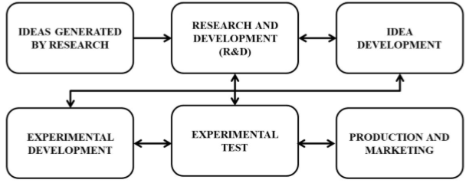
Source: (Moraes, et al., 2019)

Lately, Caraça et al. (2009), predicted major developments throughout the opening of research as well as R&D. Firstly, a science and technology system were designated, that had been previously constructed. Secondly, the opening up of a market via innovation, information as well as developments in customer understanding, new human needs, possibilities as well as improvements. Thirdly, the opening up of knowledge in a company, established entity opening up to new management, organisational practises, new systems and organisational structures. Evolutionary complexities, continuous change throughout the macro and micro-environment have an impact on outputs throughout the context of product, process, organisation and market innovation.
Such innovation, developmental elements emphasise value of knowledge/technology transfer inside SP as well as the concept of absorption capability as pivotal for learning and conveyed as a dynamic multitude of interactions which drive collaboration, transfer as well as knowledge/technology sharing (Rothwell, 1992; Senker & Faulkner, 1996). A linear perception of innovation that SP demonstrates through fixating on science seems to have a strong bias to be "closed approach to innovation". As research shows, this closed approach is gradually becoming substituted by an "open approach to innovation", interactive view that is based on lifelong learning of stakeholders.
Through analysing evolution of the concept of innovation, creativity and invention it is determined that SP approach to the innovation process is linear (as discussed above) to which they rely heavily on the developments of R&D hence the organisation invest vast amounts of money towards R&D. It is considered that the model utilised by SP is outdated as developments in technology and shifted the balance of innovation. In order to successfully innovate according to literature, SP ought to consider a more interactive model as it will put value on the teeth whitening project. Furthermore, research has explained with this linear view, has a strong bias for a closed type innovation. This is demonstrated by SP when the organisation does not consider interacting with any external sources and believe they should keep their innovation within their realms.

Closed or Open innovation
This section will discuss open and closed innovation along with examples and justifications. After evaluating both concepts, this report aims to recommend either closed or open innovation for SP. According to Paul Trott’s book ‘innovation and new product development’, it is evident that the need for external linkages and connectivity is a vital aspect influencing the management of innovation (see Fig.5 ) (Trott, 2017). In addition, Chesbrough (2006) claimed that innovation process has progressed further from any of the closed systems (as mentioned earlier in the thread), internal to SP, to a new element of open systems comprising a number of players in the supply chain (see Fig.5). It appears to have been reinforced by the implementation of network philosophy to even more aspects of business management (Parkhe & Dhanaraj, 2006).
Each segment shows a strong correlation throughout the process of innovation amongst the company's external and internal climate. This investigates as well as discusses the flow of information through the process of innovation. This shows why the 'open innovation' approach builds upon past studies and is viewed as an incentive to innovation management. This indicates how access to and use of such knowledge streams is indeed a key component of SP's process of innovation. Accessing as well as transferring technology process is therefore becoming progressively essential to innovation as well as the development of new products such as the plasma teeth whitening product. 203 labs in Japanese companies situated in Japan were studied, to which was disclosed that an open innovation policy could add value to SP's R&D performance by enabling external cooperation between research labs (Asakawa et al., 2010).

Figure 5: Chesbrough’s open innovation
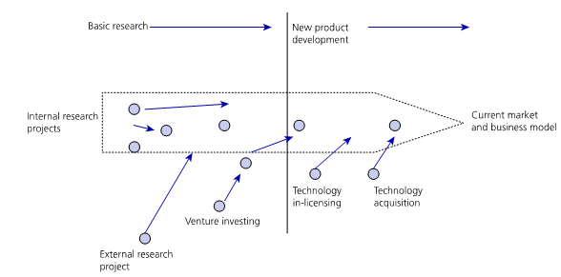

Source: (Trott, 2017)
Introduced by Chesbrough (2003), he presented six principles which reside behind SP closed innovation paradigm (see Tab.2). Nevertheless, whereas the contradiction regarding closed as well as open innovation might be valid, in principle in industry today this does not exist. Undeniably, Chesbrough is rather active at pioneering the concept of technology transfer with the need to collaborate and share knowledge. Nonetheless, from a corporate strategy standpoint, open innovation paradigm might have reached new markets (e.g. chief executive of technology-intensive companies) which innovation and R&D studies were unable to enter for several years. The fact that big global corporations, like Procter & Gamble, have adopted the concepts of open innovation as well as supported seminars and publications on the topic merits respect and recognition. Essentially, actual-life labs have been developed wherein the processes of open innovation could be analysed in considerable detail (Hacievliyagil, et al., 2008).
Consistent with the definition of innovation as well as broad interpretation of innovation process, the presenting and opposing of those six principles appears to decrease reality into a simple and easy approach. For instance, first in the principle of closed innovation, maintains that all knowledge base for the development of R&D were produced within SP. On the other hand, Allen & Cowen (1969), found the ‘gatekeeper’ role within companies, where internal scientists connect with bands scientists beyond the business (Tushman, 1977). In addition, empirical research on innovation has been around for several years emphasised social interaction, that offers a chance to share ideas, thoughts and opinions (Rothwell & Zegveld, 1985; Rothwell, 1991; Cohen & Levinthal, 1989). Such findings all appear to be overlooked for the benefit of that first principle of open innovation.
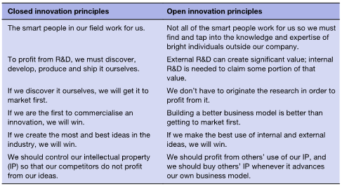
Table 2: Closed vs Open innovation
Source: (Trott, 2017)
Closed innovation second principle can be compared with claims whereby technological collaborations grew rapidly throughout 70s and 80s. With expense of R&D rising most of the time, no organisation can be successful when it remains technologically isolated. Therefore, the creation through strategic partnerships is always been the approach embraced so businesses can survive. Integration as well as collaboration amongst organisations therefore tend to be nothing unique as they have been part of business operation for a number of years (Grow & Nath, 1990; Rothwell, 1991; Tidd, et al., 1997). However, the principle for open innovation tends to neglect work in technology transfer as well as absorption potential (Dosi, 1982; Freeman, 1987) through constant reference concerning the need to form an alliance, both in terms of accessibility to technology and in R&D, so that SP may benefit through external developed technology.
When addressing the third principle for closed innovation, Trott & Hartman (2009) cites a couple of firms, Corning as well as Xerox. Corning was observed to have opted for strategic technology-based partnerships, whereas Xerox, despite having state-of-the-art technology, has not. Recent developments companies making about technical resource management and R&D is listed, as well as the three key aspects characterized by Rothwell & Zegveld (1985). These are: the proliferation of technology; reduction of both the technology cycle as well as technology globalisation. The value in technology-based organisations obtaining technology suggests the change from internal emphasis in R&D to external approach, considering that perhaps SP's technology foundation is an asset which reflects its human, technological as well as financial potential (Rothwell, 1991). The economic value of the gains of intellectual and industrial ownership and capitalisation of intangibles is also neglected (Bainbridge, 1996).
Fourth principle is not really a linear notion, as reports of innovative companies that were dominated by followers were recognised. For example, online browser was run by Internet Explorer, as well as the search engine AltaVista were surpassed by Google in the year 2000 (Trott & Hartmann, 2009). A key argument would be companies understand that excellence through innovation requires as much as just being the only one to put a product onto the teeth whitening market. Therefore signalling, as per Freeman (1982), those four innovation approaches implemented by technology-intensive companies were proactive leadership, quickest follower (defensive), expense minimisation (imitation) then specialisation in conventional sectors. Examples identify the potential strategic positions of SP in regard to technological innovation, which include external acquisitions and licencing (Granstrand, et al., 1992), showing enormous financial economic advantages of possessing intellectual property (Bainbridge, 1996).
Principle number five brings one back to SP's notion of more R&D the greater. In addition, this is valid unless the result of the R&D is ultimately extended to a development of SP new good. In addition, technology must be built with competitive market in which SP operates in mind. R&D is a potential input for businesses to innovate, but not alone (Hoffman, et al., 1998). At present, R&D requirements is handled in such a way which is incorporated into the strategic management of the SP (Dussauge & Ramanantsoa, 1987; Grow & Nath, 1990; Barney, 2001).
Trott & Hartman (2009), defined sixth principle as an unreasonable concept since, for instance, patent selling, or companies seeking to buy and sell one another's licences is an appropriate business practice. This shared intention of having licencing agreements amongst businesses is indeed a unifying factor to them and can produce amazing outcomes for their company (Tidd, et al., 1997). To summarise it is suggested open innovation will be beneficial towards the teeth whitening market (see Fig.4)
Figure 4: Benefits and challenges for SP in open innovation
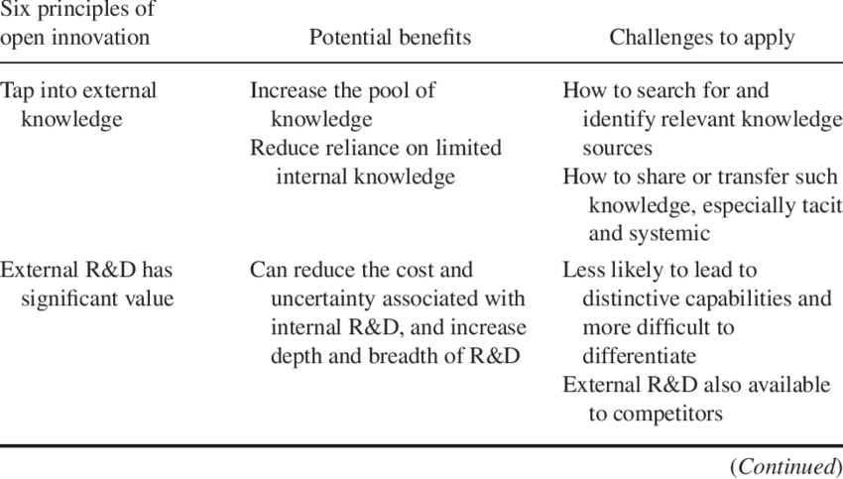
Source: (Tidd, 2014)

Key individual in the ‘plasma teeth whitening’ project
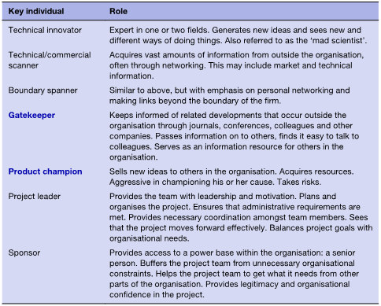
Table 3: Key individuals within the innovation process.
Source: (Trott, 2017)
Innovation management usually concentrates on maintaining as well as developing innovation through managing the processes, strategies, structures, and external links that are associated with innovation (Tidd et al., 2001). This section takes a narrower scope in that it deals with Michael Glass’s (MG) role of R&D team leader within the plasma teeth whitening project whilst considering their individual as well as organisational knowledge and experience. Table 3 above recognises MG as a critical part of the cycle of innovation (see Project leader). Inside SP it is MG that identify issues, provide ideas as well as create innovative ties and connections which contribute to innovation. In addition, MG determines what tasks must be performed, the amount of resources to be mobilised and in which way they ought to be carried out. Innovation research have repeatedly recognised the significance for the involvement of individuals throughout the cycle of industrial technological innovation (Boh, et al., 2014; Langrish, et al., 1972; Martins & Terblanche, 2003; Van de Ven, 1986; Wolfe, 1994).
MG is primarily responsible for overseeing its production of the R&D dental whitening project and eventually optimising the value of the product. MG is responsible for managing, preparing as well as controlling the production of teeth whitening projects with minimal supervision in compliance with authorized project strategy SP's Generic R&D Function. Accountability begins once the project is approved for pipeline but concludes once the project is approved on the corresponding market. Moreover, MG helps all start-up operations, like changes between R&D and operations. Furthermore, he is seen to chair a team meeting on the decision of the teeth whitening project. In this meeting, the MG shows his knowledge when he presents his findings were the results were promising.
Michael Glass’s main responsibilities:
- Leading comprehensive development strategy of the product (Teva, 2019).
- Direct teeth whitening project team to obtain support as well as funding for the entire product development plan through strategic planning and execution of the development programme. In addition, actively recognise, address problems, risks and ensure that decisions are taken at the acceptable level along with appropriate cross-functional feedback (Teva, 2019).
- Leading cross-functional implementation to established development budget as well as timetable collaborating with cross-functional members of the team to monitor and handle budget. Furthermore, Michal Glass schedules issues and brings substantial changes in R&D management to acceptance centred on the established level (Teva, 2019).
- Working with role leaders to ensure that the team are adequately resourced and trained to produce, work properly. Engage in the leadership of the team (Teva, 2019).
- Build as well as manage end-to-end product development strategies in SP to reflect the actual strategic plan /timeline and interconnected features (Teva, 2019).
MG as the leader becomes important to promoting innovation. He provides required mechanisms that permit innovation and creativity to thrive by communicating with the team as well as share ideas (Mumford, et al., 2002; Shalley & Gilson, 2004; Denti, 2011). For example, MG does indeed have a part to play when managing innovation between people and teams. It provides desirable conditions as well as numerous chances which contribute to innovation (Shalley & Gilson, 2004; Denti, 2013). For instance, he creates and promote a cohesive team environment where people could convey their ideas in a team (Anderson & West, 1998 ), promote problem-solving as well as team reflection (Puccio, et al., 2010; Somech, 2006; Tierney, et al., 1999) and bring together a variety of teams (Keller, 2001). In addition, MG helps improve employee motivation (Deci & Ryan, 1987) as well as building and maintaining high-quality professional relationships with members of the team (Scott & Bruce, 1994). In that position, MG encourages innovation as a bottom-up process. His role encourages the development of circumstances which enable members of the team to achieve innovative results on the teeth whitening project.

SP project recommendations
This section will recommend SP to invest into the plasma teeth whitening as literature suggests innovating is a way SP can gain a competitive advantage. However, because the case study has expressed the lack of research on plasma aspect as a cleaning tool, a yes decision was taken because of the opportunity to redesign the way the company makes money. SP need to develop further research within this technology as this might decide the fate on the project. In examining the case study, it is seen that the professional market is easier to attain, and SP can work along with a few lead users to create the highly suitable product. Such a product would use plasma larger cylinders, as these will be in a controlled market operated by professional dental practitioners in their surgeries. The professional market provides a lower risk, SP may also be able to construct a yearly service for the product. This could be spare parts as well as filtration. The professional market presents prospect for repair and maintenance along with aftermarket service. Moreover, Stefan Boch the Licensing manager explained a feasible option for SP to license the product to dental practitioners, so it could be integrated in a product and this can be achieved via a credit system. Furthermore, he explained licensing also would gain revenue for SP and can assist SP in existing at this stage without further additional costs and guarantee future revenue. SP licencing reasons are the avoidance or resolve patent contravention matters; branch out plus grow by adding a new product; attain enhanced production and processing technology; ensuring autonomy of action within SP’s R&D programme; protect R&D from outflow and interruption; eliminating uncertainty and risk tangled within developing substitute processes and technology (Trott & Hartmann, 2009).
The business model explains value that SP provides towards its consumers. It demonstrates capabilities as well as resources needed to create, promote as well as implement this value to develop sustainable revenue streams. This is the revenue stream which is the secret factor. Where would the funding come from, as well as what will SP be able to maintain? This requires the consideration of things such as premiums, the distribution of profits to those in the supply chain. For instance, Apple remains profitable partly as its sales margin are much higher than its rivals. Therefore, there is also a central question which needs to be considered: how is SP looking to profit? In theory, a business model will not apply for consumers; this is essential to SP as well as to the structure of its company. The business model creates mutual ties with manufacturers, consumers and partners. Nevertheless, it focuses mainly on a business operation of SP. Appendix B illustrates the various components of the SP business model.
There is evidently a broad array of different business models appropriate throughout all sectors, and thus the licencing business model is suggested to SP in order to create value. According to Trott (2017), this option works good in circumstances in which developing an entire product autonomously is not viable. Also, when recommending the business model six aspects will be considered; value proposition, market segment, value chain structure, revenue generation and margins, position in value network and competitive strategy (Chesbrough & Rosenbloom, 2002). According to Trott (2017), businesses which innovate at a business model level will experience higher rates of growth versus businesses which concentrate towards innovation in goods as well as operations. Johnson et al. (2008), showed why SP can redesign its business model. Several approaches which SP could use to construct an innovative model, include revenue/price model, an enterprise model as well as a market model. Nonetheless, as suggested by the author, the enterprise model focuses on redefining the internal and external limits of the company in order to create a new business model. It involves going forwards or backwards every value chain, using a network of partners or outsourcing of non-core tasks. In certain situations, this includes going up the value chain, such as Samsung for mobile phone chips, or moving down the value chain, such as Apple with digital (iTunes) as well as tangible shopfronts. A further choice for SP would be to find ways to enhance a network of partnerships which improves their productivity as well as quality of development, delivery, distribution and sales. For instance, Enterprise Car Rental has established a network of insurance companies as well as auto dealers which assist in sales as well as recommendations. As a result, SP should look down their value chain to make large plasma tubes, and collaborate with another business, such as Colgate, to ensure sustainable value. A proposed business model canvas and framework is recommended to SP for the project to be valuable.

Conclusion
Innovation is a broad concept and a lot has to be considered. Having reviewed academic literature, it can be seen SP have to change in order to keep up their dominant position. Firstly, it was identified that their linear approach to innovation was not sufficient to create value in the teeth whitening product. Therefore, through understanding of the open innovation, it was suggested by academics that in order for SP to gain a business advantage is to change and this requires an open network and a value proposition. Therefore, it was proposed for SP to invest in the project with requirements that they adapt a new business model to which will create value towards the project.

References
Abernathy, J. & Clark, K., 1985. Mapping the winds of change. Research Policy, Volume 3, pp. 3-22.
Allen, T. J. & Cohen, W., 1969. Information flow in research and development laboratories. Administrative Science Quarterly, 14(1), pp. 12-19.
Anderson, N. R. & West, M. A., 1998 . Measuring climate for work group innovation: Development and validation of the team climate inventory. Journal of Organizational Behavior. Journal of Organizational Behavior, Volume 19, p. 235–258.
Bainbridge, D. I., 1996. Intellectual Property: Financial Times. 3rd ed. London: Bitman Publishing.
Barney, J. B., 2001. Is the resource based view a useful perspective for strategic management research?. Academy of Management Review, 26(1), pp. 41-56.
Blank, S., 2011. Slideshare. [Online]
Available at: https://www.slideshare.net/sblank/gf-canvas-finalv7/17-The_Business_Model_Canvas_Lead
[Accessed 1 December 2019].
Boh, W. F., Evaristo, R. & Ouderkirk, A., 2014. Balancing breadth and depth of expertise for innovation: a 3M story. Research Policy, 43(2), p. 349–66.
Caraça, J. M. G., 1993. Do Saber ao Fazer: Porquê organizar a Ciência?. Lisbon: Gradiva.
Caraça, J. M. G., Lundvall, B. A. & Mendonça, S., 2009. The changing role of science in the innovation process: from Queen to Cinderella?. Technological Forecasting and Social Change, 76(6), pp. 861-867.
Carayannis, E. G., 2013. Encyclopedia of Creativity, Invention, Innovation, and Entrepreneurship. New York: Springer.
Chesbrough, H., 2003. Open Innovation: The new imperative for creating and profiting from technology. 1st ed. Boston: Harvard Business School Press.
Chesbrough, H., 2003. The era of open innovation. MIT Sloan Management Review, 44(3), pp. 35-41.
Chesbrough, H., 2004. Managing open innovation. Research-Technology Management, 47(1), pp. 23-26.
Chesbrough, H. & Rosenbloom, R. S., 2002. The role of the business model in capturing value from innovation: evidence from Xerox Corporation’s technology spin-off companies. Industrial and Corporate, 11(3), p. 529–55.
Cohen, W. & Levinthal, D., 1989. Innovation and Learning: The two faces of R&D. The Economic Journal, Volume 99, pp. 569-596.
Cooper, R. G. & Kleinschmidt, E. J., 1986. An investigation into the new product process: steps and deficiencies and impact. Journal of Product Innovation Management, Volume 3, pp. 71-85.
Cumming, B. S., 1998. Innovation overview and future challenges. European Journal of Innovation Management, 1(1), pp. 9-21.
de Bono, E., 1985. Six Thinking Hats: An Essential Approach to Business Management. s.l.:Little Brown & Company.
Deci, E. L. & Ryan, R. M., 1987. The support of autonomy and the control of behavior. Journal of Personality and Social Psychology , Volume 53, p. 1024–1037.
Denti, L., 2011. Leadership and Innovation: How and When do Leaders Influence Innovation in R&D Teams?, Gothenburg: s.n.
Denti, L., 2013. LEADERSHIP AND INNOVATION IN RESEARCH AND DEVELOPMENT. Gothenburg: Ineko AB.
Dosi, G., 1982. Technical Paradigms and Technological Trajectories - A suggested interpretation of the determinants and directions of technical change. Research Policy, 11(3), pp. 147-162.
Drucker, P., 1989. Inovação e Gestão. 3rd ed. Lisbon: Presença.
Dussauge, P. & Ramanantsoa, B., 1987. Technologie et stratégie d’entreprise. Paris: McGraw-Hill.
Fadaee, A. & Obaid Abd Alzahrh, H., 2014. Explaining the Relationship between Creativity, Innovation and Entrepreneurship. International Journal of Economy, Management and Social Science, 3(12), pp. 1-4.
Freeman, C., 1982. The Economics of Industrial Innovation. 2nd ed. London: Frances Pinter.
Freeman, C., 1987. Technology Policy and Economic Performance: Lessons from Japan. London: Pinter Publishers.
Ghasemzadeh, 2001. the importance of creativity in development approach. Magazine, p. 26.
Granstrand, O., Bohlin, C., Oskarsson, C. & Sjoberg, N., 1992. External technology acquisition in large multi-technology corporations. R&D Management, 22(2), pp. 111-133.
Grow, M. & Nath, S., 1990. Technology strategy development in Japanese industry: an assessment of market and government influences. Technovation, 10(5), pp. 333-346.
Hacievliyagil, N. K., Auger, J. F., Maisonneuve, Y. & Hartmann, A., 2008. The position of virtual knowledge brokers in the core process of open innovation. International Journal of Knowledge, Technology and Society, 3(5), pp. 47-60.
Hoffman, K., Parejo, M., Bessant, J. & Perren, L., 1998. Small firms, R&D, technology and innovation in the UK: a literature review. Technovation, Volume 16, pp. 19-35.
Hosseini, A., 2001. Managing Creativity and Innovation Management. Journal of Approach, Volume 26.
Jenssen, J. & Aasheim, K., 2010. Organizational innovation promoters and performance effects in small, knowledge-intensive firms. Entrepreneurship and Innovation Management, 11(1), pp. 19-27.
Johannessen, J. A., Olsen, B. & Lumpkin, G., 2001. Innovation as newness: what is new, how new and new to whom?. European Journal of Innovation Management, 4(1), pp. 20-32.
Keller, R. T., 2001. Cross-functional project groups in research and new product development: Diversity, communications, job stress, and outcomes. Academy of Management Journal, Volume 44, p. 547–555.
Khilji, S., Mroczkowski, T. & Bernstein, B., 2006. From Invention to Innovation: Toward Developing an Integrated Innovation Model for Biotech Firms. The Journal of Product Innovation Management, Volume 23, pp. 528-540.
Kline, S. J. & Rosenberg, N., 1986. The Positive Sum Strategy: Harnessing Technology for Economic Growth. In: An Overview of Innovation. In National Academy of Engineering. Washington, DC: The National Academy Press, pp. 275-305.
Langrish, J., Gibbons, M., Evans, W. G. & Jevons, F. R., 1972. Wealth from Knowledge. London: Macmillan.
Lundvall, B. A., 1992. National Systems of Innovation: Towards a theory of Innovation and Interactive Learning. London: Frances Pinter.
Marques, J. P. C., 2014. Closed versus Open Innovation: Evolution or Combination?. International Journal of Business and Management, 9(3), pp. 196-203.
Martins, E. C. & Terblanche, F., 2003. Building organizational culture that stimulates creativity and innovation. European Journal of Innovation Management, 6(1), p. 64–74.
Moraes, M. B. d., Campos, T. M. & Lima, E., 2019. Models of innovation development in small and median-sized enterprises of the aeronautical sector in Brazil and in Canada. Gestão & Produção, 26(1), pp. 1-15.
Moshbeki, A., 2001. Creativity can be nurtured talent in individuals and organizations. Journal of approach, Volume 26.
Mumford, M. D., Gaddis, B. H., Scott, G. M. & Strange, J. M., 2002. Leading Creative People: Orchestrating Expertise and Relationships. The Leadership Quarterly, 13(6), pp. 705-750.
Parkhe, A. & Dhanaraj, C., 2006. Orchestrating Innovation Networks. The Academy of Management Review, 31(3), pp. 659-669.
Puccio, G. J., Mance, M. & Murdock, M. C., 2010. Creative Leadership: Skills That Drive Change. 2nd ed. Thousand Oaks: Sage.
Rothwell, R., 1991. External networking and innovation in small and medium-sized manufacturing firms in Europe. Technovation, 11(2), pp. 93-112.
Rothwell, R., 1992. Sucessful industrial innovation: critical factors for the 1990’s. R&D Management, 22(3), pp. 231-239.
Rothwell, R. & Zegveld, 1985. Reindustrialisation and Technology. London: Longman.
Schumpeter, J., 1934. The Theory of Economic Development. 1st ed. Cambridge: Harvard Economic Studies.
Scott, S. G. & Bruce, R. A., 1994. Determinants of innovative behavior: A path model of individual innovation in the workplace. Academy of Management, Volume 37, p. 580–607.
Senker, J. & Faulkner, W., 1996. Networks, tacit knowledge and innovation. In: R. Coombs, et al. eds. Technological Collaboration. Cheltenham: Edward Elgar Publishing Ltd, pp. 76-97.
Shalley, C. E. & Gilson, L., 2004. What Leaders Need To Know: A Review of Social and Contextual Factors That Can Foster or Hinder Creativity. The Leadership Quarterly , 15(1), pp. 33-53.
Slappendel, C., 1996. Perspectives on innovation in organizations. Organization Studies, 17(1), pp. 107-129.
Somech, A., 2006. The effects of leadership style and team process on performance and innovation in functionally heterogeneous teams. Journal of Management, Volume 32, p. 132–157.
Teva, 2019. Teva. [Online]
Available at: https://careers.teva/job/Waterford-Project-Leader-Research-&-Development-X91/609478500/
[Accessed 1 December 2019].
Tidd, J., 2014. Open Innovation Management Research and Practice. s.l.:s.n.
Tidd, J. & Bessant, J., 2013. Managing Innovation: Intergrating Technological, Market and Organizational Change. 5th ed. Chichester: John Wiley & Sons Ltd.
Tidd, J., Bessant, J. & Pavitt, K., 1997. Managing innovation: integration technological, market and organizational change. Manchester: John Wiley and Sons.
Tierney, P., Farmer, S. M. & Graen, G. B., 1999. An examination of leadership and employee creativity: The relevance of traits and relationships. Personnel Psychology, Volume 52, p. 591–620.
Trott, P., 2017. Innovation and New Product Development. 6th ed. Harlow: Pearson Education Limited.
Trott, P. & Hartmann, W., 2009. Why open innovation is old wine in new bottles. International Journal of Innovation Management, 13(4), pp. 715-736.
Tushman, M. L., 1977. Technical communication in R&D laboratories: The impact of project work characteristics. Academy of Management Journal, Volume 20, pp. 624-645.
Van de Ven, A. H., 1986. Central problems: the management of innovation. Management Science, 32(5), p. 590–607.
Wolfe, R. A., 1994. Organisational innovation: review and critique and suggested research directions. Journal of Management Studies, 31(3), p. 405–431.

Appendix

A

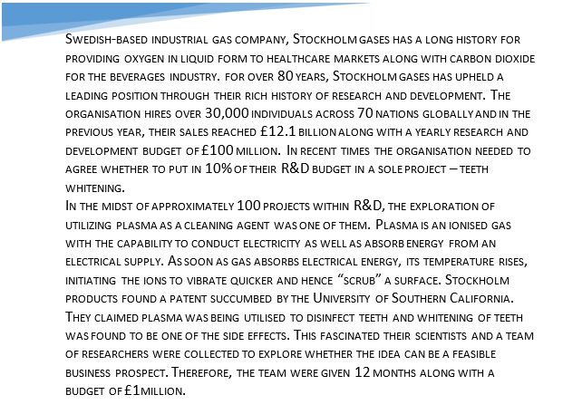

B
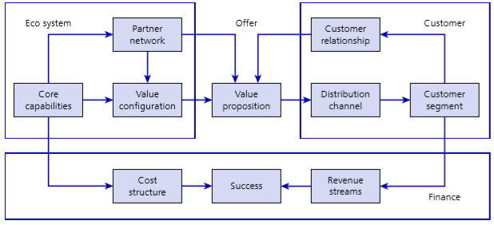
Proposed Stockholm products business model framework
Source (Trott, 2017)

C
Proposed Business model
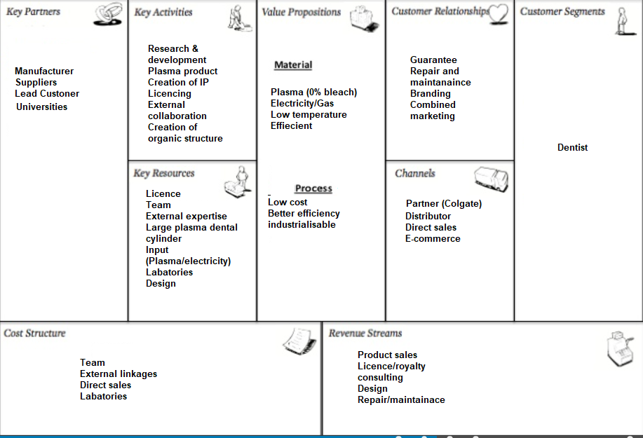
Source: adapted from (Blank, 2011)

