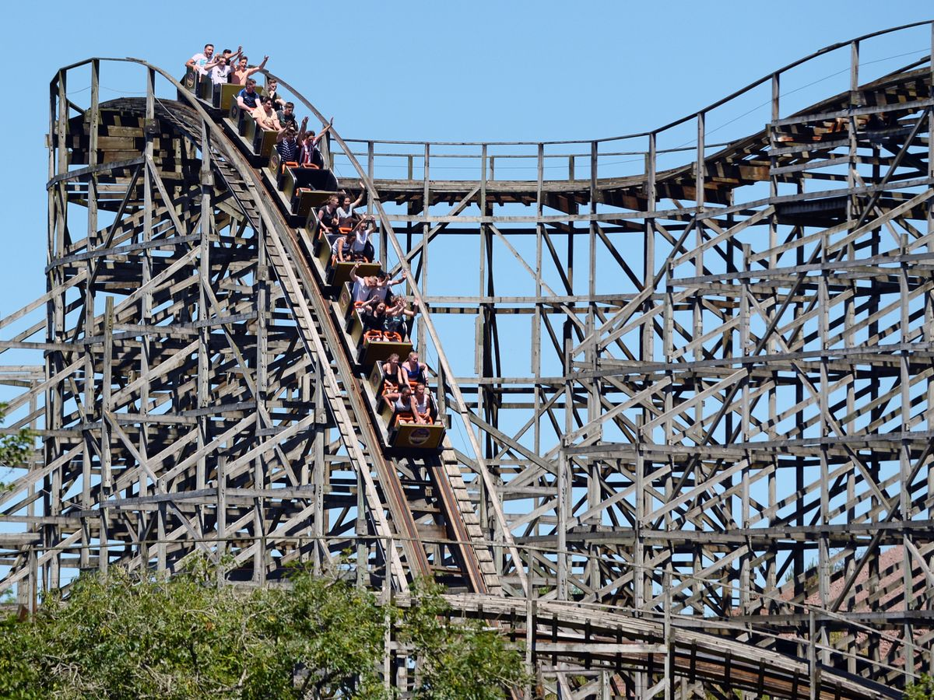
(Wales Online, 2019)

Oakwood Theme Park

Author: Alicia Hiles
Date: 20th May 2020
Student number: 1707152
No client due to Covid 19

Terms of Reference
Alicia Hiles is an independent student consultant undertaking a market research project for Oakwood Theme Park, in order to investigate the concerns guests may have when it comes to the reopening after Covid 19 and to examine ways in which Oakwood Theme Park can prevent these issues and concerns from occurring.

Abstract
The introduction will give a overview of Oakwood Theme Park and will familiarize the consultant with the issues resulted due to Covid 19. Oakwood Theme Park opened in 1987 and is located in Pembrokeshire, it’s also known as the best Theme Park in Wales. Unfortunately it is known as a domestic Theme Park which results in making it hard to compete as individuals are willing to travel to other Theme Parks so the consultant will undertake research to find ways to gain custom and discover the needs and wants of individuals. Due to Covid 19, Theme Parks will be currently loosing millions of pounds so for that reason it’s important for Theme parks to find ways to promote in order to gain as many visitors when the park is allowed to reopen.
To gather market research both primary and secondary research will be carried out by the consultant and shown in greater detail in the research methodology. As for Primary research a survey will be made by the consultant asking appropriate questions in order to achieve results and recommendations. Also as many countries are easing lock down regulations some Theme Parks around the world have started to reopen and produce safety measures guidelines which will be followed up by the consultant to identify. Secondary research will be undertaken to underpin and backup any information stated, to do this journals, books, articles and online resources will be looked upon.
The findings will discuss the results of the survey in greater detail however, it’s been noted that individuals do have a concern about visiting Theme Parks and ways in which they can prevent the worries from occurring is by identifying that the safety measures guidelines are strict and work as proven in other Theme parks (DisneyLand Shanghai, Legoland Florida), also the government will only lift lockdown rules when they believe it’s safe to do so. Ways in which Oakwood Theme Park can promote during this time has been identified and followed up by studying other Theme Park websites. Alton Towers post VR and ride experiences on a weekly basis to keep guests engaged. As discovered events and new developments increase economic benefits and visitor numbers, the consultant will analyze and consider what can be done. The different demographics will be looked upon in order to name the best target audience to reach out to and to look at different potential events.
The conclusion will include a summary of what the consultant has determined: ways in which Oakwood Theme Park can promote, the importance of safety measures and finally ways in which they can develop visitor numbers.
The recommendations is the most significant part of the report as it studies the opportunities and ways Oakwood can improve. While on lockdown it’d be a great opportunity for Oakwood Theme Park to promote and advertise like other Theme parks are doing by presenting VR and ride experiences. Oakwood Theme Park could focus more on visitor experiences, price strategies and marketing methods to produce a well known Theme Park and to compete with other major Theme parks. It is also recommended that Oakwood Theme Park undertake they’re own research in order to gain an insight into potential events they could host and to underpin different demographics/target audience.

Contents Page
Section | Page
1.0 Introduction | 5
1.1 Research Methodology | 6
2.0 Findings | 7
3.0 Conclusion | 14
4.0 Recommendations | 15
5.0 Appendix | 16
5.1 SWOT Analysis | 16
5.2 Guideline Plan | 16
5.3 Questionnaire | 17
6.0 Bibliography | 19

1.0 Introduction
The ‘biggest Theme Park in Wales’ as stated by Oakwood Theme Park blog, (2019), first opened in 1987 by a family of Pembrokeshire farmland owners. Located in the heart of Pembrokeshire, South Wales, Oakwood now offers a variety of fun for the entire family with - children's friendly rides, fast thrills and drops (including UK 's favorite wooden roller coaster – Megafobia). Oakwood is currently owned by Aspro Parks which is one of the “largest European operator of leisure parks and centers with a total amount of 68 parks and centers around Europe” (Aspro parks, 2020)
Unfortunately due to Covid 19, the original consultancy project had to be changed as the consultant was unable to get hold of the employee or carry on with the research due to the furlough scheme, for that underpinning issue a decision was made to work without a professional client and look at a local theme park called Oakwood to gather market research; The study that will be carried out by the consultant will gain an insight into whether guests are willing to visit theme parks after the reopening and if they are expecting any safety measures/ new features. With the pandemic Covid 19 being a huge issue and affecting Theme Parks worldwide it is essential for Theme Parks to market and promote themselves during lockdown to ensure visitor numbers when the parks are able to reopen.
The information that will be collected for this project is both the following; primary and secondary research. Primary research will be used to gain data with the use of questionnaires to find out the general public’s thoughts and to gather market research. Due to Oakwood being a neighborhood leisure attraction it’s important to discover whether the local residents support the attraction. Another example of primary research that will be used is multiple of online resources I.e the reopening of Disney Shanghai and Merlin entertainments policies and strategy’s for reopening. As for secondary research a number of theories will be looked upon to support the undergone primary research to display evidence and to support of the text.
As you all know theme parks are a popular leisure attraction to tourists and it remains a competitive market worldwide. “Domestic theme parks are now facing high competition pressure” (Jung, L. 2016) stated and it seems Oakwood Theme Park has always had an issue with attracting individuals not only because Pembrokeshire is surrounded with fun attractions like Folly Farm and Heatherton but the park is also competing with major famous Theme Parks like Disney. As part of this project an understanding of ways in which Oakwood Theme Park will be able to create an image and stand out from the rest will be made and shown on the created guideline plan. According to SAGE (2017) “Beginning in the 1950s with the opening of Walt Disney’s Disneyland, the theme park sector has expanded throughout the global economy. Today, the annual attendance at the world’s 70 largest and most attended theme parks is 334.6 million”.
As stated by Camilleri, M. A. (2018) “Business ought to understand their customers’ needs and wants, if they want to remain successful in a competitive market place.” This statement is so crucial and important not only during normal times but also during the pandemic which is why it’s vital for the consultant to gather market research.
On the 12th May Shanghai DisneyLand reopened the park after being closed for 3 months, many safety measures were introduced and put in place to ensure the safety of guests and colleagues. After following governments guidelines the specified listed is now what the Disney Shanghai have introduced; cap on visitor numbers (maximum of 24,000 people – 30% of the parks regular capacity), masks are mandatory and new bins to dispose, temperature taken on arrival, purple mats places on ground to ensure there’s always 2m in queues, alternative rows left empty on rides, seats and safety bars regularly disinfected, characters can only pose with guests at a distance, many of the spectacular events like parades and fireworks have been suspended to avoid crowds (BBC News, 2020). Currently there are no Theme Parks opened in the UK but in this investigation many Theme Parks around the UK will be looked upon and analyzed to see whether they are acting upon the reopening of DisneyLand Shanghai and producing policies ready for reopening.

1.1 Research Methodology
Jankowicz (1995: 174), states the meaning of methodology is ‘the analysis of, and rationale for the particular methods used in a given study’. Both paradigms; Quantitative and qualitative research serves as a key and a practical tool when undertaking research however when it comes to this study most research that will be undertaken is quantitative due to the fact the study will be heavily relied upon participants, and because of Covid 19, there was a lack of resources and qualitative research methods were unable to be carried out.
“Qualitative research is an umbrella term for an array of attitudes towards and strategies for conducting inquiry that are aimed at discovering how human beings understand, experience, interpret, and produce the social world”. (Sandelowski 2004: 893). Qualitative research isn’t really necessary for this project as it’ll be heavily relied on statistical data rather collecting data through observation and interviews. All the questions that were in the survey were non open questions and involved participants selecting answers.
Creswell (1994) has given a very concise definition of quantitative research as a type of research that is “explaining phenomena by collecting numerical data that are analyzed using mathematically based methods (in particular statistics).” Survey research is not only implicated in quantitative research, but it is also a way of undertaking primary research. The survey takes advantage of scientific sampling and questionnaire design to measure population characteristics with statistical precision. It seeks to provide answers to such questions as "Will individuals want to visit a Theme Park after Covid 19?" and "Are guests expecting any safety measures in place?". The Survey research will enable the consultant to gain individuals views and requirements which can then be presented in the final guideline plan. The survey that was produced was unable to be piloted to the public due to Covid 19 but the consultant utilized a university tutor which worked as part as the exercise.To analyze all responses bar graphs and pie charts will be used and shown in the finding section.
Since the outbreak was declared a Public health emergency of International concern on January 30th (World Health Organisation, 2020) and lockdown occurred, to this day only a few Theme Parks have reopened and one being Shanghai DisneyLand. Due to this type of research being ‘raw’ and first-hand evidence it’s considered as a Primary research method.
To underpin and support evidence that has been used throughout this report a form of secondary research will be used including: Journal articles, Marketing theories, VR ride a rollercoaster and many more. It’s important that secondary research is undertaken due to the “size and scale, professional quality and accessibility” Martin, K.St. & Pavlovskaya, M. (2010).
Unfortunately due to Covid 19 the original project consumed many more research methods like interviews which were discussed in the product initiation document however in this case it all had to be changed under the Covid 19 circumstances and research became limited but it’s believed that the research methods that will be used to gain an insight will be more than enough information to report on to Oakwood Theme Park. Also another weakness that has been identified due to this pandemic is that the consultant was left without an employer meaning that ideas and findings weren’t able to be analyzed and brainstormed.

2.0 Findings
Only a total of 146 people responded to the questionnaire that was released on social media platforms due to the results having to be taken in quickly. As there was no target audience and wanted to be aimed at people of all ages the consultant decided that social media would be the best platform. By not having a target audience it’d widen the research and the consultant will gain a broader understanding. According to the Welsh Government website StatsWales (2019) the mid year population in the UK in 2019 estimated at “64,903,140” and the Welsh population in 2019 estimated at “ 3,152,879” meaning that the questionnaire isn’t really representable but however it does give a representative of the different market segments and the consultant did this by asking the participants the following questions: how old are you?, What county do you live in?, what is your occupation?.
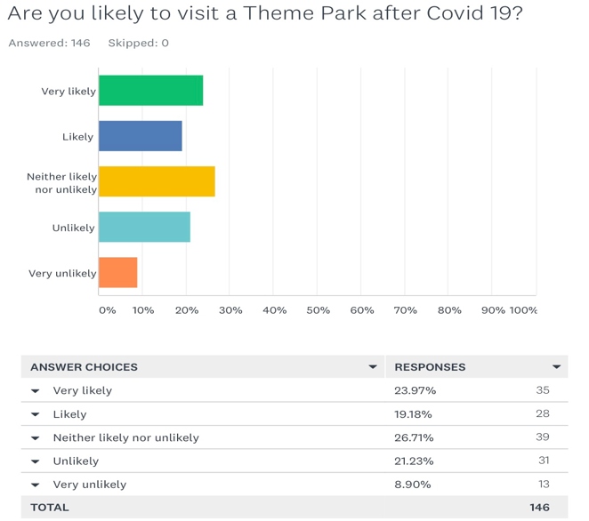
The reopening of Shanghai DisneyLand after a four month lockdown meant that tickets were released on the 8th May ready for online booking and with no doubt they were ‘sold out of tickets for its 11 May re-opening” Independent (2020).
The bar graph that is presented above was the first question on the survey and the goal was to find out whether individuals are likely to visit a Theme Park after Covid 19 or not. As shown above there’s been mixed response and those individuals that stated ‘very unlikely and ‘unlikely’ may be anxious about visiting Theme Parks, this is fully proven that there is a concern when Question 4 was asked ‘Do you have any concerns about visiting a Theme Park’s after Covid 19’ a number of 90 participants claimed that they had concerns and the remaining 53 claimed that they didn’t. More than half of the participants had concerns meaning that they could be looking for multiple safety measures to be placed to ensure the safety of guests. The consultant decided to split up the different age categories to see whether the older generation had different views to the younger however this wasn’t proven and there were still mixed responses in both categories. The first image below shows whether individuals aged between 18-24 are likely to visit theme parks and the second image reveals the results of aged 35-54 participants.
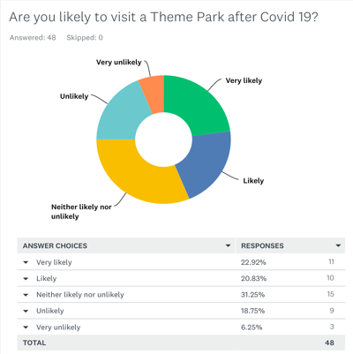
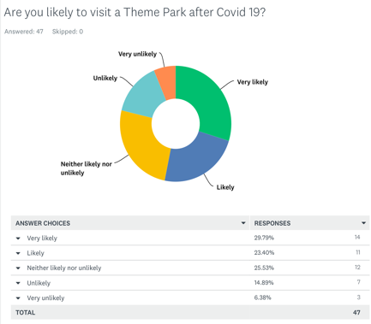

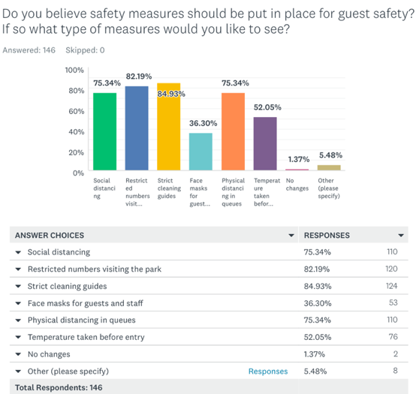
Theme Parks “must plan to accommodate a diversity of visitors in order to satisfy visitor expectations and encourage future visitation” Zanon, D. Et al. (2014), it’s essential for a Theme Park to have a wide range of facilities and attractions so that it is suitable and enticing for all ages. Before any leisure facility is able to open safety measures must be put in place and approved by the government ensuring all guests are safe and protected. According to Gov.Scot (2020) “A high performing planning system will have a critical role in supporting our future economic and societal recovery” this statement suggests that leisure attractions that will be reopening shortly in the UK will provide strict guest safety guidelines produced by professionals. DisneyLand Shanghai was the first Theme Park to open worldwide and the strict policies that were put in place seem to be working and keeping the public safe. A question in the survey asked whether individuals believe safety measures to be put in place for a Theme Park reopening.
This question allowed participants to tick more than one box and as shown above all the boxes have been ticked at least once. There was also another option which noted ‘other’ all the comments that were specified by the participants stated “all” meaning that every participant before entering a Theme Park is expecting guest safety to materialize and presented throughout the parks.

As many leisure attractions around the World are now revealing the opening dates and the guidelines that have been put in place for guest safety hopefully many more leisure attractions will be able to open soon because of the advise that’s being passed over from attractions. The general manager of Legoland Florida Rex Jackson stated that “at Legoland Florida we take this new reality seriously. Nothing is as important as health and safety to our guests and employees” (LinkedIn 2020) and revealed that with guidance by the CDC the following extensive changes throughout the resort were made: non invasive temperature checks at the entrance and advise if you have a temperature or aren’t feeling well then please leave it to another time, all rides have staggered queue lines, all ride vehicles services are wiped down several times a day, restaurants and stores are configured for appropriate social distancing, play areas get thoroughly cleaned on a regular basis, installed over 200 hand sanitizers stations throughout the park, encourage all guests to visit face masks, only card payment method, ensure to download app before arrive to get up to minute information during your visit (Legoland Florida, 2020)
Following the reopening of LegoLand in Florida, Merlin Entertainments in the UK have been working extremely hard to ensure when it’s safe for Theme Parks to reopen then they’ll be ready. On the 6th June Merlin Entertainments opened up the beautiful gardens of both Warwick Castle and Alton Towers welcoming guests back but of course with the safety measures in place. (Merlin Entertainments, 2020)
Currently in Wales, Oakwood Theme Park wouldn’t even considering opening due to the different policies Wales obtain to the rest of the UK. The initiative that is currently promoted by the Welsh Government is ‘Visit Wales. Later’ this is to prevent people visiting however this will be changed when the Government believe it’s safe to reopen the country and facilities. (Visit Wales, 2020)
In 2019 TripAdvisor named the best Theme Park rated by the public. The Family favourites Paultons Park in Romsey also known as Peppa Pig land came in at number one (The Sun, 2019). The park also announced a huge new themed world called Tornado Springs which is set to launch in 2020 featuring over eight different rides and attractions. The approach is designed to appeal to the ages from 3 – 14 to strengthen the parks position as the ‘top family leisure destination in UK’ (Paultons Park, 2019). Question 3 on the survey asked ‘What Theme Park are you most likely to visit after Covid 19’ unfortunately Paultons Park wasn’t included in the list. If the Theme Park was included it’d allow the consultant to look at the different demographic and would give an understanding into whether Oakwood Theme Park is keeping up with the trends.

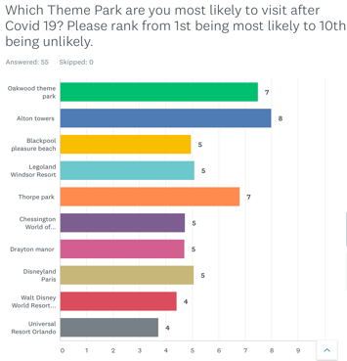
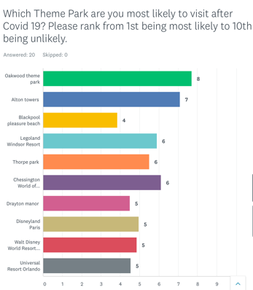
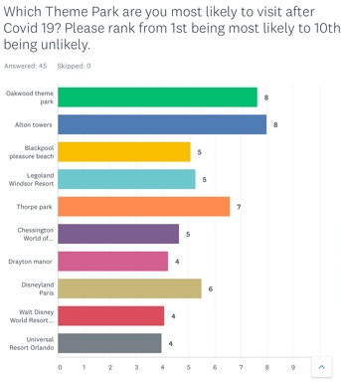
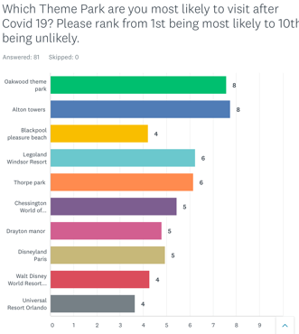
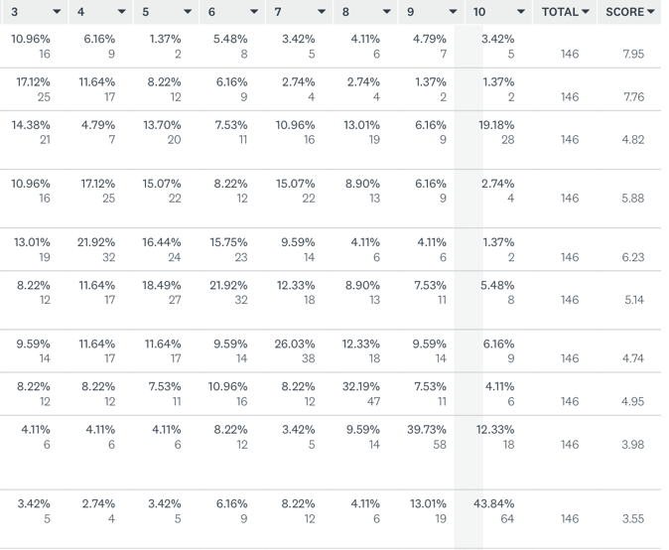
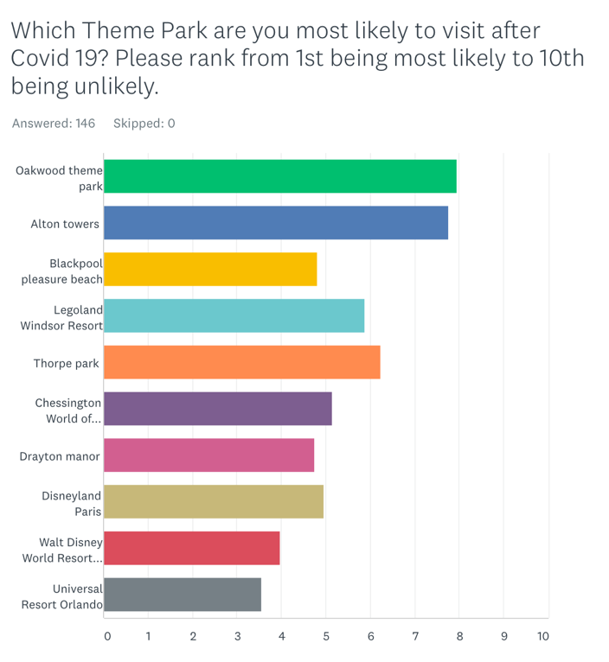
As you can see on the above bar graph Oakwood Theme Park has been ranked the top and a number of 69 participants stated Oakwood as their first choice. The consultant decided it’d be interesting to look into the different demographics and see whether families or couples had different responses.
Family Friends Partner Children
Participants with children voted Oakwood as top but is this because of the inconvenience of being a neighborhood attraction or due to the themed ‘Neverland’ sector? This type of visitor could be considered as a Pyschocentic traveller/visitor . It’s also interesting to see the rest of the categories the vast majority have chosen Alton Towers to be the 1st ranking showing that individuals are willing to travel to major Theme Parks also could be known as the allocentric travellers/visitors and is the results determining that Oakwood is in need of a new development?. “As more international well-known theme parks enter the market, theme parks… have been faced with the transition, and novel concepts introduced into the operation of these parks” Li, M. & Xiong, G (2013).Unfortunately major Theme Parks and companies like Merlin Entertainment have much more money and investment and are able to build new developments and rides in order to keep promoting the park. It is proven that a new ride is successful and attracts visitors; in 2006 when the new ride Speed was constructed “OAKWOOD Theme Park is on target to achieve an 18% hike in visitor numbers this year, thanks to a £3m investment in a new rollercoaster” and even claimed “39% of visitors to Oakwood were from outside Wales” and group of “54 Americans travelled to Pembrokeshire specifically to ride Speed” (Wales Online, 2006)
According to Plog, destinations are increasing and declining in popularity as they attract specific types of visitors over time and follow a fairly constant growth pattern and decline in popularity (Cruz-Milán, O 2017). Stanley Plog (1974) developed the psychographic scale model of travel characteristics to differentiate the categories of travelers, the model classifies tourists into 3 different categories in which are: the allocentric (the wanderers), Pyschocentic (The repeaters) and finally midcentic which is a combination of both (Piucman, M. 2018). Identified above Oakwood Theme Park has attracted all of the Plog tourists but when it comes to the reopening the Pyschocentic are more than likely to visit due to Covid 19. There’s a high chance of travellers not being able to travel abroad this year meaning that individuals are likely to travel and visit local attractions.
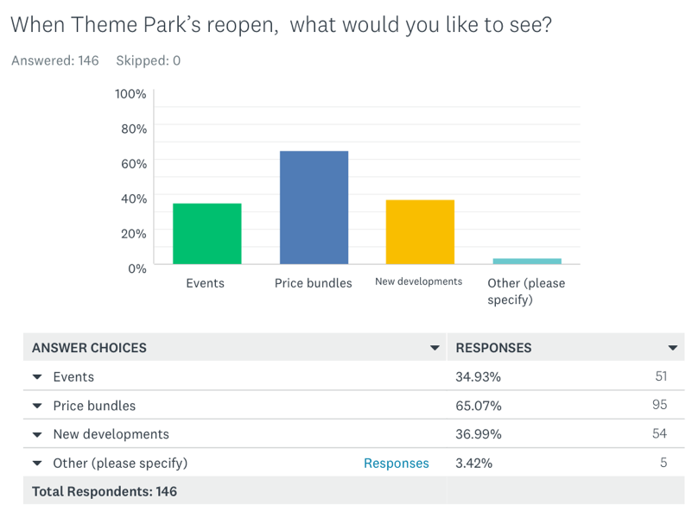
According to A, Milman, (2001) “The trend towards theme parks will continue because they offer new and diverse experiences”. To understand what individuals would like to see when Theme parks reopen in the UK a question in the survey stated “When Theme Parks reopen, what would you like to see?”

This question allowed participants to tick more than one box and as shown above most participants ticked ‘Price Bundles’. Stated by Cardell, D. (2015) “Different strategies can be employed to limit spending: purchase online tickets, memberships in various organizations offer reduced price tickets, price bundles for entrance to Theme Park and Hotels” this would be a good opportunity for Oakwood Theme Park to team up with hotels around Pembrokeshire or even attractions like Heatherton and Folly Farm to offer bundle deals.
“A global crisis can either paralyze marketing or galvanize it to thrive” (Reid, A. 2020). A Theme Park that has marketed extremely well over lockdown is Alton Towers which is part of the Merlin Entertainment group. The Theme Park has been releasing VR and ride experiences on social media platforms and promoting the different events Alton Towers host throughout the year; Oktoberfest, Scarefest, fireworks and Santa’s sleepover (Alton Towers, 2020). As lockdown is still ongoing in Wales, Oakwood Theme Park could release this marketing method and post ride experiences on different social media platforms as it entices people and is more than likely to be an advantage for when it comes to the reopening. An opportunity for Oakwood Theme Park to attract visitors is by hosting a variety of events, other Theme parks have identified a target market and produced different events whether it’s for families, teenagers, or even adults. Byrd, A, (2001) stated that Orland SeaWorld “ launched a weekly Friday night event aimed solely at 13- to 19-year olds. Pepsi is a sponsor of Club SeaWorld, an event featuring a DJ followed by a fashion show”. Abe Pizam, dean of the University of Central Florida's Rosen School of Hospitality Management, says that it's a significant departure. "It is a very great marketing," he says. "I 'm surprised the other parks haven’t done this”. There’s all different types of markets Oakwood Theme Park can reach out to and the consultant will be identifying more and will be placed in the guideline sheet.
Independent research was deliberately made so the investigation wasn’t lead by people saying ‘I wouldn’t go to Oakwood Theme Park’. By doing this it’s given the consultant a better understanding and has allowed for research to be carried out to see what other Theme Parks are achieving. Due to Covid 19 unfortunately the consultant was left without a client meaning that the consultant wasn’t able to complete brainstorming. Please see Appenix 1 for a SWOT analysis that has been produced by the consultant to present the key findings in a point to point form.

3.0 Conclusion

- To conclude, the consultant found different ways that Oakwood Theme Park can promote themselves by creating VR and ride experiences to post on social media platforms and also a way in which they can get visitors numbers lined up is by creating and advertising different events or even developing a new development will increase visitor numbers immensely as proven in the findings.
- As many Theme Parks have been reopening over the last few weeks with safety measures it has allowed other Theme Parks to observe and has given tips for others to undertake their own policies in order to open safely. The safety measures that have been placed in many Theme Parks have been discussed throughout the report and the questionnaire has even informed the consultant on what the local market are expecting. It’s allowed Oakwood Theme Park to acknowledge these safety measures and guests concerns and will hopefully act upon and be ready for when the government allows the park to reopen.
- Overall Oakwood Theme Park is spacious Park which has potential to increase economic benefits and tourists numbers by looking at the needs and wants of individuals (results of questionnaire). Most visitors that visit Oakwood Theme Park are local residents and individuals that are just looking for a fun day out but by creating events like: family days out, gigs/ live performances, 13-18 disco day, kids fun day, Christmas special. By identifying and looking at different age markets will create different markets and a wide variety of visitors.

4.0 Recommendations

- Oakwood Theme Park has been functioning since 1987, and many developments have been in place since opening however the latest development was in 2019 which is now a family ride called ‘Dizzy Disk’ more appropriate for children. It’d be extremely positive and recommended that a ‘wow factor’ new development goes under way that is adapted to all ages. Also some consider the Theme Park as ‘outdated’ so a refurbishment could occur.

- Oakwood Theme Park could improve on many factors and this quote defines a well-developed and experienced Park.. “By focusing more on visitors’ experience, devoting more in developing new products, adopting flexible price strategies, and integrating advertisement marketing, internet marketing, and other marketing methods, outstanding brands will be formed” Li, M. & Xiong, G (2013), by undertaking all the above it’d allow and enable to compete with Theme parks like Alton towers and Thorpe Park.

- To gather an understanding of what type of events individuals will attend at the Theme Park, Oakwood should undertake their own market research in order to target audience and increase visitor numbers and economic boosts.

- Currently Wales is still in lockdown and leisure attractions still remain shut. In order to promote Oakwood Theme Park what they could do now is post VR and ride experiences on social media platforms or even could offer Park tickets at a discounted price so when it comes to reopening hopefully visitor numbers will increase.

5.0 Appendices

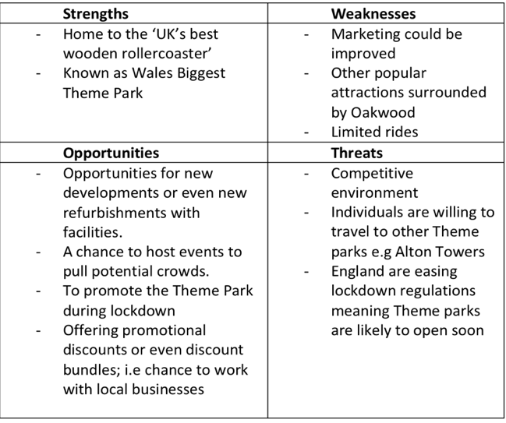
5.1 Appendix 1 – SWOT Analysis

5.2 Appendix 2 – Guideline plan
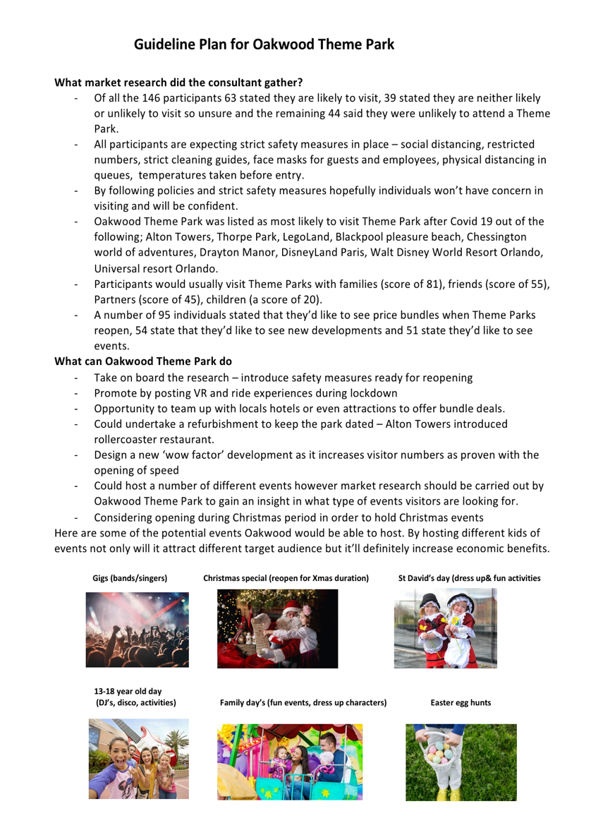

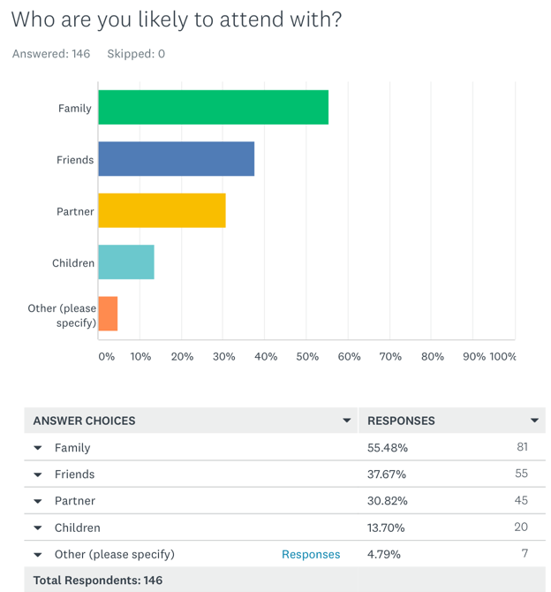
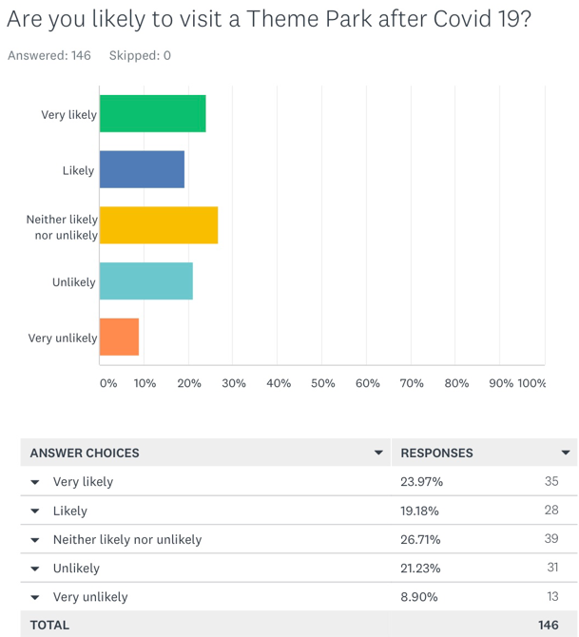
5.3 Appendix 3 – Questionnaire
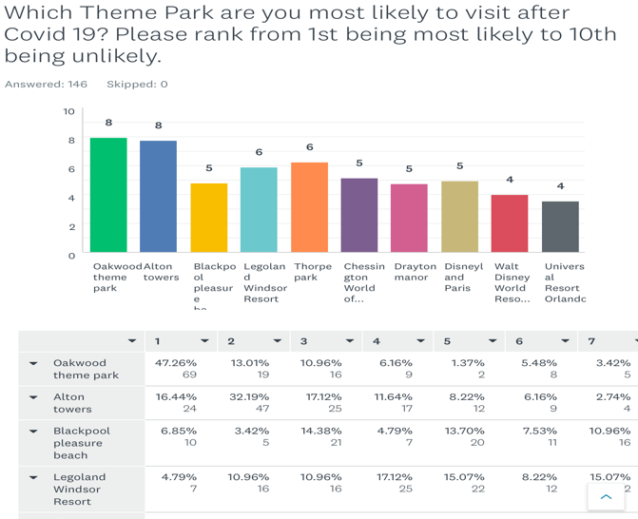
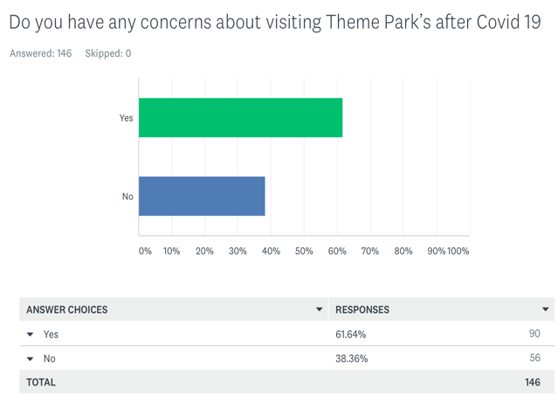
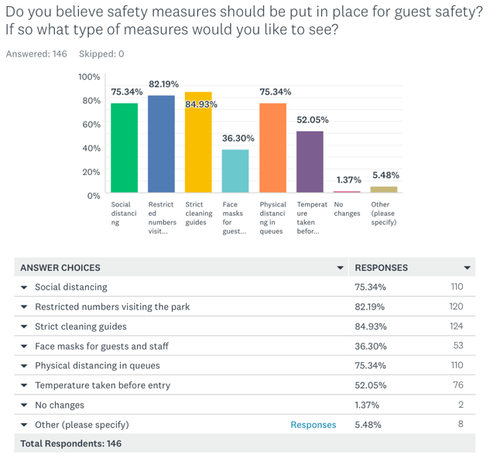
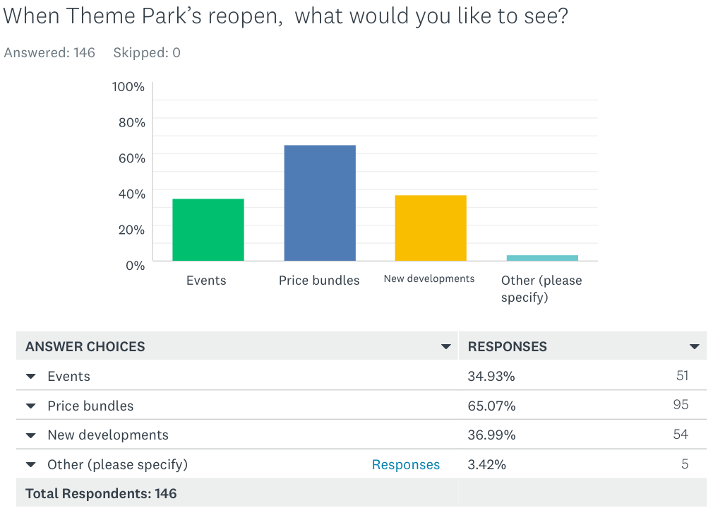

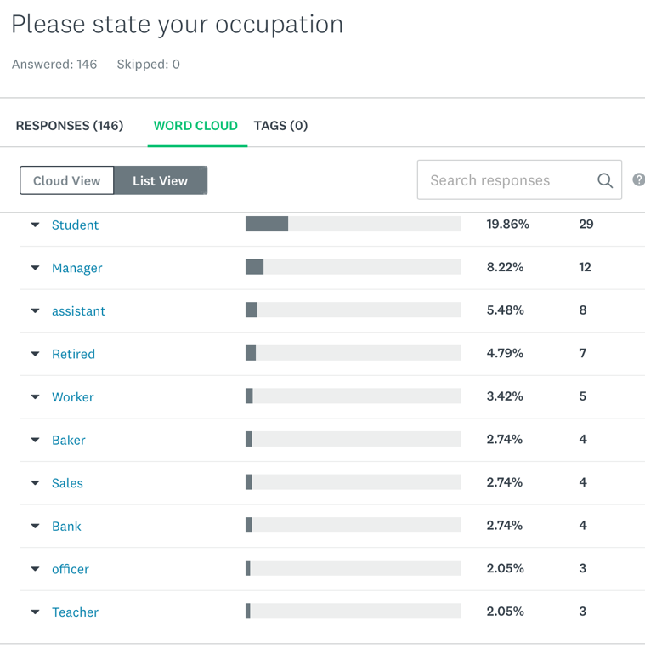
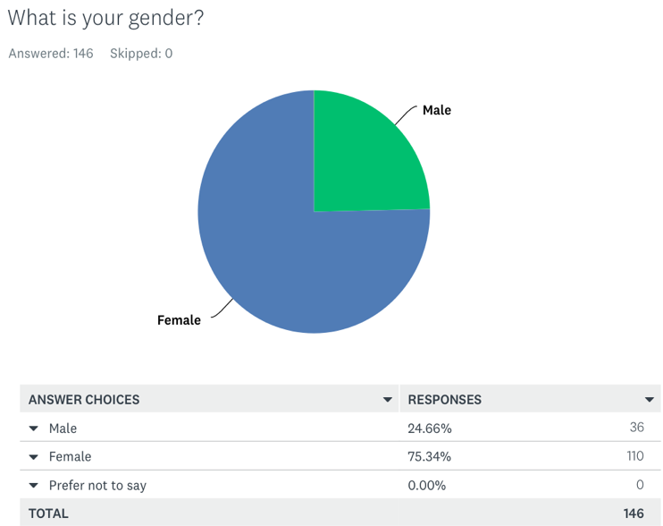
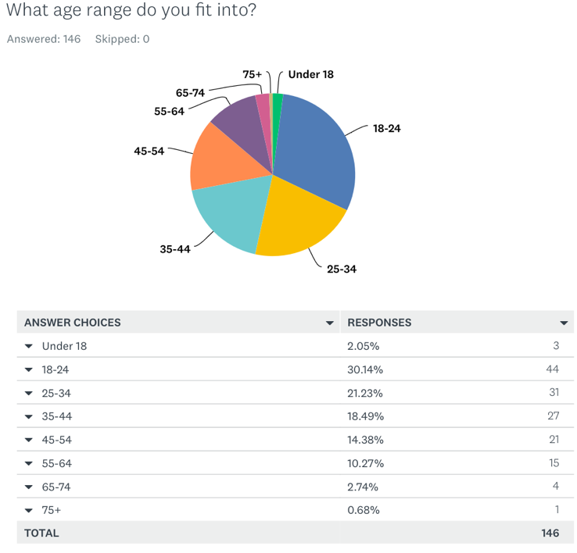
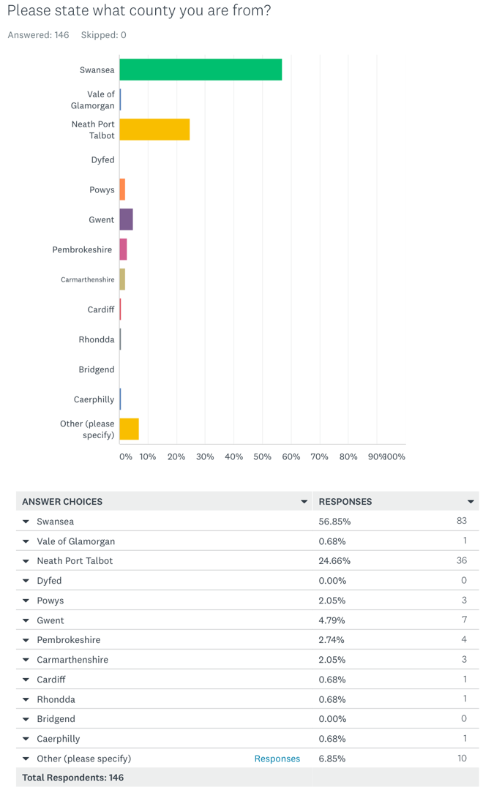

6.0 Bibliography

Alton Towers. (2020), Events, [Online]. Available: https://www.altontowers.com/explore/events/, [Last accessed: 8th June 2020]
Anton, C, S. (2007), The Global Theme Park Industry. Wallingford: CABI.
Aspro Parks. (2020), About Us, [Online]. Available: https://www.asproparks.com/en/about-us/, [Last accessed: 20th May 2020]
BBC News. (2020), In pictures: Shanghai disneyland reopens, [Online]. Available: https://www.bbc.co.uk/news/in-pictures-52620179, [Last accessed: 20th May 2020]
BYRD, A, (2001). Park hopes to make splash in teen market. Orlando Business Journal, 18(4), pp. 3.
Camilleri, M. A. (2018). Understanding Customer Needs and Wants. In TravelMarketing, Tourism Economics and the Airline Product (Chapter 2, pp. 29-50). Cham,Switzerland: Springer Nature.
Creswell, J.W. (1994), Research Design: Qualitative & Quantitative Approaches, London: SAGE Publications.
Cruz-Milán, O. ( 2017), 'Plog’s model of typologies of tourists', in Lowry, L (ed.), The sage international encyclopedia of travel and tourism, SAGE Publications, Inc, Thousand Oaks, CA, pp. 954-956,, doi: 10.4135/9781483368924.n356.
Cardwell, D. (2015), Family Theme parks, happiness and children’s consumption, Department of thematic studies: Linkoping University.
Gov.Scot. (2020), Coronavirus (COVID-19): planning procedures - Chief Planner letter April 2020, [Online]. Available: https://www.gov.scot/publications/planning-procedures-and-covid-19/, [Last accessed: 8th June 2020]
Independent. (2020), Tickets for Shanghai Disneyland re-opening sell out in minutes, [Online]. Available: https://www.independent.co.uk/news/world/asia/shanghai-disneyland-reopening-tickets-sell-out-a9505716.html, [Last accessed: 25th May 2020]
Jankowicz, A. D. (1995) Business Research Projects. (2nd Ed.) London: International Thomson Business Press.
Jung, L. (2016), RESEARCH ON TAIWAN THEME PARKS' EXPERIENCE MARKETING STRATEGY AND REVISIT WILLINGNESS, PURCHASE WILLINGNESS AND RECOMMENDATION WILLINGNESS. International Journal of Organizational Innovation (Online), 9(1), pp.35–53.
Kemperman, Astrid D. A. M. (2000), Consumer Choice of Theme Parks: A Conjoint Choice Model of Seasonality Effects and Variety Seeking Behavior. Leisure Sciences, 22(1), pp.1–19.

Legoland Florida. (2020), Operations Update, [Online]. Available: https://www.legoland.com/florida/about-us/operations-update/, [Last accessed: 8th June 2020]
Linkedin. (2020), LEGOLAND Florida is ready to play again, [Online]. Available: https://www.linkedin.com/posts/jacksonrex_im-extremely-proud-of-the-legoland-florida-activity-6672232724763312129-oFnW, [Last accessed: 8th June 2020]
Li, M. & Xiong, G. (2013), Improvement of Theme Park Marketing Mode: A Case Study of Theme Parks in Chengdu. Asian Agricultural Research, USA-China Science and Culture Media Corporation, vol. 5(12), pages 1-3.
Martin, K.St. & Pavlovskaya, M. (2010), Secondary Data. In Gomez, B., Jones, J.P. (eds.), Research methods in geography. A critical introduction (173-193). New York: Wiley-Blackwell.
Merlin Entertainments. (2020), HEALTH, SAFETY AND SECURITY, [Online]. Available: https://www.merlinentertainments.biz/responsible-business/health-safety-and-security/, [Last accessed: 8th June 2020]
Milman, A, (2001). The future of the theme park and attraction industry: A management perspective. Journal of Travel Research, 40(2), 139–147. 10.1177/004728750104000204

Oakwood Theme Park blog. (2019), The History of the Rollercoaster: How did it all begin?, [Online]. Available: https://www.oakwoodthemepark.co.uk/blog/sin-categoria/the-history-of-the-roller-coaster-how-did-it-all-begin/, [Last accessed: 20th May 2020]

Paultons Park. (2019), Multi-million-pound new themed world set to launch at Paultons Park in 2020, [Online]. Available: https://paultonspark.co.uk/blog/article/14318/multi-million-pound-new-themed-world-set-to-launch-at-paultons-park-in-2020, [Last accessed: 8th June 2020]
Piucman, M. (2018), Plog’s and Butler’s Models: a critical review of Psychographic Tourist Typology and the Tourist Area Life Cycle. TURIZAM, Volume 22, Issue 3 95–106, DOI: 10.5937/turizam22-18835.
Raluca, D C. (2008), THEME PARK - THE MAIN CONCEPT OF TOURISM INDUSTRY DEVELOPMENT. Annals of the University of Oradea, Economic Science Series, 17(2), pp.641–647.
Reid, A. (2020), Best Practices for Marketing During and After COVID-19,[Online]. Available: www.entrepreneur.com/amphtml/349535, [Last accessed: 8th June 2020]
Richard, B, Kaak, K & Orlowski, M. (2017), 'Theme park tourism', in Lowry, L (ed.), The sage international encyclopedia of travel and tourism, SAGE Publications, Inc, Thousand Oaks, CA, pp. 1218-1221, doi: 10.4135/9781483368924.n449.

Sandelowski, M. (2004) ‘Qualitative Research’, in Lewis-Beck, M., Bryman, A., and Liao, T. (eds) The Sage Encyclopedia of Social Science Research Methods, Thousand Oaks CA, Sage.
StatsWales. (2019), Population estimates by local authority and year, [Online]. Available: https://statswales.gov.wales/Catalogue/Population-and-Migration/Population/Estimates/Local-Authority/populationestimates-by-localauthority-year, [Last accessed: 25th May 2020]
Slootweg, E & Rowson, B .(2018), My generation: A review of marketing strategies on different age groups, Research in Hospitality Management, 8:2, 85-92, DOI: 10.1080/22243534.2018.1553369
The Sun. (2019), TripAdvisor names the best UK theme parks for 2019 as voted by you, [Online]. Available: https://www.thesun.co.uk/travel/9559480/tripadvisor-best-uk-theme-parks-2019/, [Last accessed: 8th June 2020]
Vincent, J. (2020), Shanghai Disneyland reopens with mandatory face masks and social distancing, [Online]. Available: https://www.theverge.com/2020/5/11/21254283/disneyland-shanghai-reopens-safety-measures-coronavirus, [Last accessed: 20th May 2020]
Visit Wales. (2020), Visit Wales. Later., [Online]. Available: https://www.visitwales.com/coronavirus, [Last accessed: 8th June 2020]
Wales Online. (2006), Oakwood visitors number gather Spped, [Online]. Available: https://www.walesonline.co.uk/business/business-news/oakwood-visitor-numbers-gather-speed-2312353, [Last accessed: 8th June 2020]
Wales Online. (2019), Oakwood Theme Park, [Online]. Available: https://www.walesonline.co.uk/business/business-news/new-rides-oakwood-theme-park-16011565, [Last accessed: 20th May 2020]
World Health Organisation. (2020), Coronavirus, [Online]. Available: https://www.who.int/health-topics/coronavirus#tab=tab_1, [Last accessed: 21st May 2020]
Yoshii, C. (2018), Theme Park Development Trends: Expanding Markets. Park World, pp.22–26.
Zanon, D. et al. (2014), Development of a Whole Agency Approach to Market Segmentation in Parks. Journal of Leisure Research, 46(5), pp.563–592.

