3.0 Chapter 3 – Methodology
This chapter will help to achieve the second research objective of this dissertation:
2. Conduct primary research in the form of an online questionnaire which will evaluate FB current brand perception and determine the CSR responsibilities most effective in improving FB brand perception

3.1 Research onion
Research has been defined as ‘enquiry and investigation (that)…is systematic and methodical…(and) increases knowledge’, (Collins and Hussey 2013, pg.1). People undertake research to find matters out in a systematic way, thereby increasing their knowledge, (Jankowicz, 1995). The Saunders, et al (2009) Research Onion diagram will be used to detail the primary research method the researcher will conduct and justify the chosen research approach, the data collection methodology and the data analysis process.
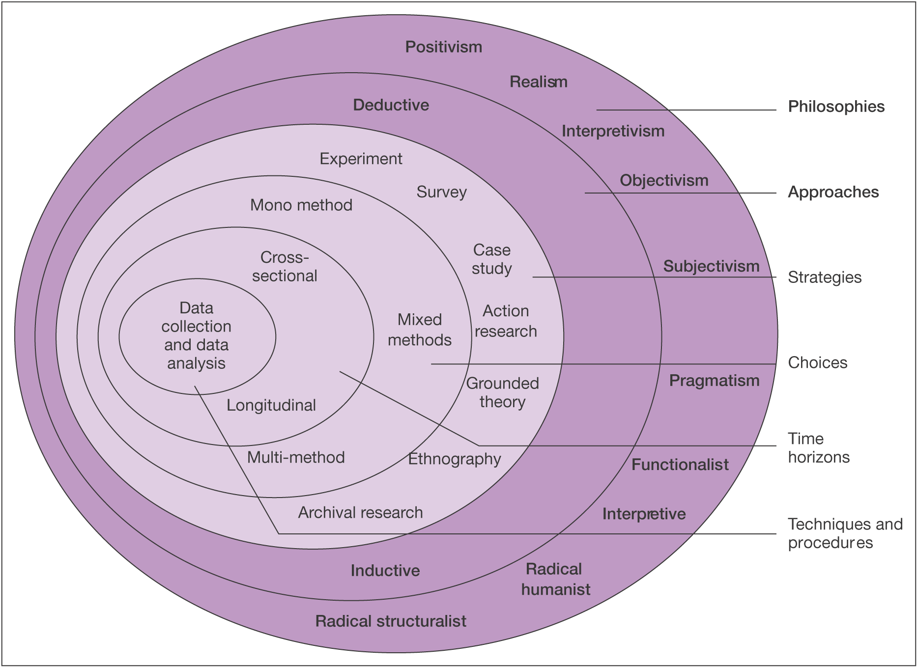
Figure 3.1 The Research Onion. Source: (Saunders et al., 2007)
The researcher will use Figure 3.1, starting from the outer layer inwards, to assist in the selection of the appropriate research route. The philosophic perspective of this dissertation will use phenomenology and apply a deductive approach. The strategy for the information collection method in this dissertation will be in the form of a multi-method using an online questionnaire. This will be a cross-sectional study, as the information being obtained will be gathered at one point in time. At the core of the research onion, is data collection and data analysis which will be addressed by the researcher through the collection of data through the online survey, which will then be analysed using the programmes NVivo and SPSS.

3.1.1 Research Philosophy
Research philosophy is explained as “relating to the development of knowledge and the nature of that knowledge”, (Saunders et al., 2003. Pg.106). This dissertation research philosophy will use phenomenology. Phenomenology initiated in the early twentieth century is the study of phenomena which is commonly used in social science to study first-person interaction and builds the foundation of knowledge, (Merleau-Ponty, 1996; Giorgi and Giorgi, 2003; Cope, 2005; Smith, 2006). This type of philosophy will underpin the research strategy as well as the methods chosen as part the strategy, as the study focuses on FB user’s perceptions of the brand and whether there is a consequent need for FB to incorporate CSR.

3.1.3 Research Approach
The research approach is the second layer of the research onion, which involves two approaches. Inductive and deductive. An inductive approach is often found along-side a qualitative research model and refers to the trends and themes that can be identified when the textualized data is condensed, the researcher creates a theory from the collected data which is turned into a framework or model, (Thomas, 2003; Thomas, 2006; Jebreen., 2012; Liu, 2016). Deductive research is often used when gathering quantitative data. The collected data informs whether a prior developed hypothesis is valid or not, (Manna and Waldinger, 1980; Saunders et al., 2003). This dissertation will be a deductive approach as the primary research will pursue qualitative and quantitative data and will be testing existing theory.

3.1.4 Research strategies
Research strategies states several data collection methods. The researcher will collect primary data using the data collection method surveys in the form of online questionnaires. Questionnaires are commonly used as a way of collecting data. They are structured in a way that the information collected is concerning two or more similar variables which result in the formation of a data grid, (De Vaus and De Vaus., 2013). The researcher has opted for online questionnaires because they can be widely distributed geographically to large sample sizes as well as provide a quick turnaround, which is desirable given that there is limited time to collect the data, (Evans and Mathur, 2005; Sue and Ritter, 2012).

3.1.5 Research choice
The researcher has chosen to undertake a mixed method approach. Multi-method analysis draws and combines data from various sources and includes qualitative and quantitative data, providing more accurate results as it allows triangulation to take place, (Paul, 1996; Flick, 2004; Brewer and Hunter, 2006; Lauri, 2011). Multi-method was the original option of data collection, but due to unforeseen circumstances of the COVID 19 crisis, this prevented the possibility of interviews to take place, instead qualitative questions will be included into the questionnaire.

3.1.6 Time horizons
Time horizon refers to the length of time which research is carried out which is independent on which research strategy the researcher chooses to use, (Saunders et al., 2007). The previous chapter highlighted that there is a gap within existing literature when attempting to identify whether there is a need for FB to integrate CSR to improve brand perception. This research will therefore be a new phenomenon requiring primary research to be undertaken. Cross-sectional research is conducted within a given time frame, while longitudinal research represents events over a number of years, (Bethlehem, 1999; Levin., 2006). Given that the dissertation is time-restricted, the research carried out must be cross-sectional.

3.1.7 Techniques and Procedures
Techniques and procedures are at the core of the research onion. As identified previously, the researcher will use mixed method to gather information which will consist of quantitative and qualitative research in the form of an online questionnaire.

3.1.7.1 Questionnaire
Qualitative research can yield a large amount of data that is typically gathered through interviews and focus groups. The notes taken from these endeavours are transcribed which can be very time-consuming. The transcribes provide explanations and It is the job of the researcher to find patterns and links by interpreting the data, (Pope et al., 2000). Quantitative research is described as being, “Explaining phenomena by collecting numerical data that are analysed using mathematically based methods”, (Mujis, 2010, Pg.14). Questionnaires are often a form of quantitative research and are considered to be useful for non-experimental descriptive designs that seek to describe reality by collecting information on attitudes and behaviour, (Mathers et al.,2007). Using online questionnaires, the researcher will be able to collect a vast amount of data in a standardised way so that the data can be internally coherent for analysis within a short period of time, (Malhotra, 2006). The questionnaire will be created using Google Forms as this is a trusted site and all participants replies can only be accessed through a Google account login which only the researcher will have access to. Unlike other survey building sites such as survey monkey, Google forms do not allow the access of third parties, (Privacy Policy | SurveyMonkey, 2020). The questionnaire will be designed to reflect the research in Chapter two and engage participants thoughts, feelings, and perceptions of FB. The number of questions which will be asked will not exceed 15, as the research into the relationship between the length of a survey and the response rate suggests that the longer a survey the fewer respondents it will receive, (Kost and da Rosa., 2018). The types of responses the questionnaire will gain will be categorical, ordinal and nominal which will assist in determining FB’s brand perception and whether there is a need for FB to integrate CSR to improve brand perception, (Fink., 2003). The questionnaire will be shared via email and WhatsApp and uploaded on to the researchers Instagram page which can then be shared by other Instagram users to reach a larger number of participants. It will also be available on survey circle which is a website that has the largest community for online research, which will assist in finding respondents, (Survey Circle, 2020). By uploading the questionnaire to this amount of platforms it will increase the number of possible respondents. Once the questionnaire is closed and all data collected has been analysed the results will be accessible at EmilyCMiller.blogspot.com commencing the 30th of May 2020.

3.1.7.2 Question and Literature review matrix
Questionnaire questions | Relation to secondary research
Q1. Participation and all data collected as a result of taking part in this questionnaire will remain anonymous and confidential. Please state whether you give your consent for the results to be used as part of the researcher’s BA research project. | asking for consent is considered an ethical requirement but is also mandatory for the researcher to be able to process the data collected and later share the results. Article 7 of the GDPR, Conditions for Consent highlights this, ((UK Data Service, 2020; Vollmer, 2020).
Q2. How old are you? | This demographic question will assist in identifying whether FB brand perception changes depending on age and will be used as a test variable on SPSS.
Q3. How familiar are you with FB?  Q4. How would you describe your overall perception of FB?  Q5. Please briefly explain your overall perception of FB. | Q3 measures respondents brand awareness, 2.2.2 (Severi and Ling, 2013).  Q 4 and 5 identify the depth of the brand awareness and establish whether the participants identify characteristics associated with Fb 2.2.3 and measures brand loyalty 2.2.4, (Yoo and Donthu, 2001; Dew and Kwon, 2010; Severi and Ling, 2013).
Q6. Corporate Social Responsibility (CSR) has been defined as "The responsibilities corporations have to their stakeholder groups", (Johnson et al, 2008). Please state how far you agree with the following statements.  Fb does the minimum to maintain relationships with its users.  Fb goes above and beyond to satisfy their user’s needs.  Fb supports socially responsible causes which benefit society at large.  Fb complies with all consumer rights and acts in accordance with the law.  Fb is more focused on generating revenue than user satisfaction. | Definition of CSR, 1.2, (Johson et al, 2008).  Statement 1 and 2, stems from 2.1.1, Shareholder vs Stakeholder theory, (Moore, 1999; Ferrero et al, 2014).  Statement 3, derives from 2.1.2 Ethical CSR, (Swift, 2001; Adams and Zutshi, 2004; Porter and Kamerr, 2006; Baur and Schmitz, 2012).  Statement 4. 2.1.3, Legal CSR, (George, 2019; Li, 2019)  Statement 5. 2.1.4, Economic CSR, (Carroll, 2016, Siddiqui, 2019).  These statements will assist in determining whether participants agree with shareholder or stakeholder theory which will help determine if there is a need for CSR.
Q7. In 2018 it was revealed that FB allowed CA to harvest the profiles of 50 million FB users without consent. Does this affect your perception of FB?  Q8. Please state why you answered yes or no to the previous question. | Q7 and 8 derive from 2.1.3 Legal CSR, (Lilley and Gumbus, 2012; Cadwalladr and Graham-Harrison, 2018) as well as chapter 2.2.1, Perceived quality, (Kirmani and Zeithaml, 1993; Tsiotsou, 2006). It will identify if corporate scandals impact brand perception.
Q9. How far do you agree with these statements?  FB has a responsibility for improving the welfare of all of its stakeholders  FB has an obligation to do what is right, just and fair to avoid causing harm.  FB has a duty to abide by society’s codification of what is right and what is wrong  FB has an economic responsibility  Q10. Which of the following is the most important responsibility FB has in your opinion? Please choose every option that applies.  Philanthropic (Be a good a corporate citizen)  Ethical  Legal  Economic | Figure 2.1.4. The Pyramid of Corporate Social Responsibility, (Carroll, 1991). By identifying which responsibility participants feel most strongly about will help determine if there is need for FB to integrate CSR as well as identify the responsibility respondents feel is the most important for improving brand perception.
Q11. Do you feel that FB could do more to act on the previously chosen responsibilities?  Q12. If FB acted on the responsibilities listed in question 10 would this improve your perception of FB?  Q13. Please briefly explain why you have chosen the answer to the previous question. | 2.2 Brand Equity, (Barwise, 1993; Building Brand Equity, 2017).  These questions will assist the researcher to make conclusions and recommendations for FB.

3.2 Reliability and Validity
Reliability concerns the consistency of a measure and the validity is defined as the degree to which a concept is accurately measured in a quantitative analysis, (Del Greco et al., 1987; Heale and Twycross., 2015). Joppe (2000) defines reliability and validity in research as the following, “if the results of a study can be reproduced under a similar methodology, then the research instrument is considered to be reliable…Validity determines whether the research measures which it intended to measure or how truthful the results are”, (Golafshani., 2003. Pg.3). Reliability and validity of the study is the duty of the researcher to generate well-designed research that reflects the main objective of the study and then to build a compelling case once the data has been analysed. Questionnaires are deemed as positivist research. Positivism in research takes the view that factual knowledge is gained through scientific evidence. This will ensure that the data being collected will be of a valid, and reliable source. For data extraction both quantitative and qualitative data is being collected so triangulation can take place which will enhance the validity of the research. Triangulation increases validity as it uses more than one approach to researching a question, this increases the confidence in the findings by using more than one independent measure, (Heale and Forbes, 2013).

3.3 Limitations
One prominent limitation within this dissertation is the effect that Covid-19 has, is the access to resources. Access to computers which have the appropriate software for analysing the collected primary research is no longer available. To overcome this the researcher will download the software on to a PC available to them with the assistance of their lecture and their university IT services.
Due to Covid-19, this has resulted in one to one meeting with supervisors being cancelled due to social distancing measures. To adhere to these new legal measures and to continue to have support throughout this journey email and Microsoft Teams will be used as a way of contact.
A third limitation to consider is the restricted time period provided to collect primary research and analyse the data. To assist in reducing the impact of this limitation, the researcher has created a Gantt chart which will be referred to throughout the dissertation to improve time management.
Another limitation to this research which could be encountered is not gaining enough responses. As the research is concerning FB the questionnaire will not be posted on to this platform. This could restrict the number of responses as the researcher will have to use other platforms which are not as well-known or used for sharing such documents. To overcome this limitation the questionnaire will be posted to several other platforms and shared through the researcher’s friends and family via WhatsApp.

3.4 Ethical considerations
Ethical issues must be given a great deal of consideration by the researcher to ensure no person will be harmed or offended by the nature of this research. To achieve this the design of the research, process and storage of personal data will be treated with the upmost respect. This will be achieved by providing complete confidentiality to all participants and not including questions within the questionnaire which could cause the respondent to feel uneasy or cause upset, (Kajornboon, 2005). The respondent’s data will be saved to one computer which will be passcode protected to ensure it will be protected.

3.5 Conclusion
This chapter has identified and explained the research methodology which will be carried out in the next chapter which will fulfil objective two, conduct primary research in the form of an online questionnaire which will evaluate FB current brand perception and determine the CSR responsibilities most effective in improving FB brand perception.

