Problem Solving and Decision Making - BMSW4004

Student Name: Claudia Buica
Student ID: 2133742
Table of Contents
Introduction 2
The workplace problem 2
Analyzing Information 2
Root cause analysis 2
Applying situational analysis models 4
Range of alternative solutions 6
Evaluation of alternative solutions 7
Implementing the solution 8
Conclusion 9
References 11

Introduction
This report will discuss workplace issues which is bullying and harassment. Workplace bullying and harassment can have negative impacts on both individuals and organizations. Not only do these behaviors harm the targeted individuals, but they also create a toxic work environment that can lead to decreased productivity, increased turnover, and damage to the organization's reputation. Organizations need to adopt a proactive approach to prevent and tackle workplace bullying and harassment. Additionally, this particular report will focus workplace bullying and harassment within British Airways. The report will define the problem, including its scope and impact on the organization, first. To determine the actual root cause, a root cause analysis will be performed to identify potential causes of the issue. The report will also apply situational analysis models, such as PESTLE analysis, to provide a comprehensive understanding of the situation.

The workplace problem
Organizations such as British Airways encounter the prevalent issue of workplace harassment and bullying, which is defined as repeated unwanted behavior that aims to intimidate or offend an individual or group (Östermanand Boström, 2022). The victim's physical and mental health as well as their job performance can be greatly impacted by verbal or psychological behaviors, and the issue that is pervasive in British Airways affects employees throughout the organization. Among cabin crew members and ground staff bullying and harassment are frequently experienced as per reports, furthermore employees are hesitant to speak out or report incidents due to fear of retaliation or being labeled a troublemaker (Cobb, 2017). Also, there have been allegations of a culture of fear within the company, moreover employees are afraid to speak out or report incidents for fear of retaliation or being labeled a troublemaker.

Analyzing Information

Root cause analysis
Fishbone diagram to identify the possible causes and root causes of workplace bullying and harassment at British Airways:
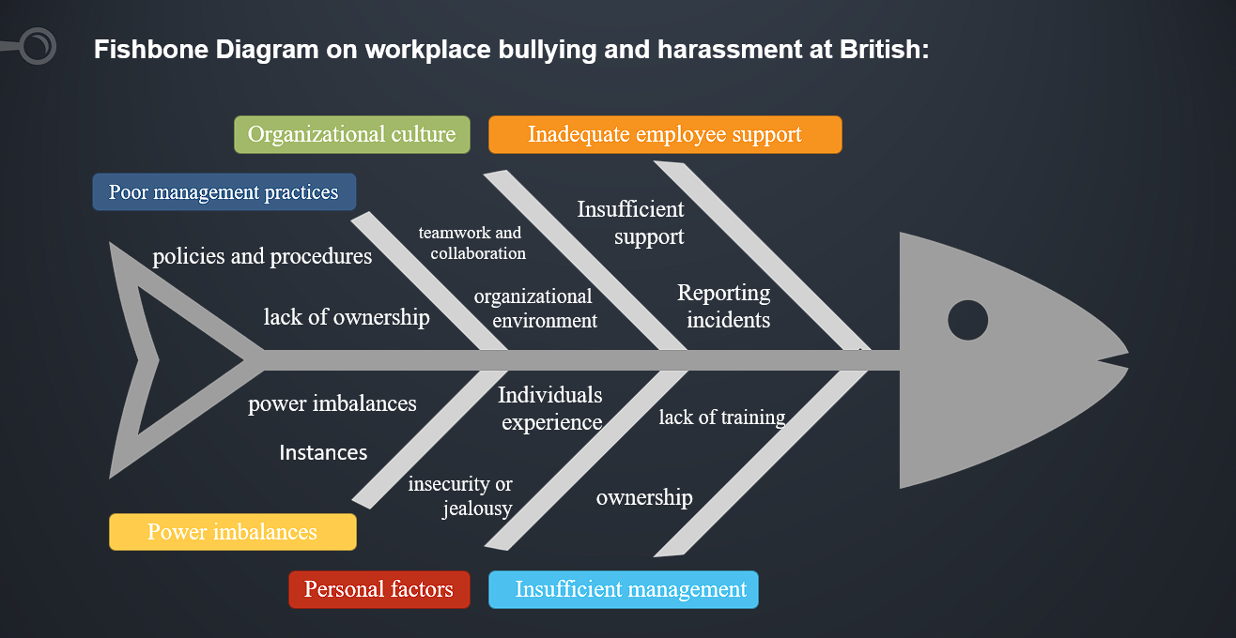
Figure 01: Fishbone diagram. Source: Self-made
Some possible causes and root causes that may contribute to workplace bullying and harassment at British Airways include:
- Poor management practices: Insufficient management practices such as vague policies and procedures for handling bullying and harassment coupled with a lack of training for managers to recognize and manage these problems may lead to poor management (Balducci, Conway andvan Heugten, 2021). Furthermore, there could be a lack of ownership for managerial decisions.
- Organizational culture: In an organizational environment characterized by fear and apprehension among workers, reporting incidents or speaking up about issues of concern can result in workplace bullying and harassment (Rayner and Lewis, 2020). Similarly, a culture that emphasizes individualism and competition over teamwork and collaboration can lead to an environment in which bullying and harassment are more probable.
- Inadequate employee support: Providing insufficient support and resources like counseling or mental health services to employees can have a more severe impact on them in case of bullying or harassment (Keashly, 2021). The lack of support might cause employees to avoid reporting incidents.
- Power imbalances: Instances of bullying and harassment can arise from power imbalances among employees. Examples include those between senior and junior staff or managers and subordinates.
- Personal factors: Some individuals experience personal factors such as insecurity or jealousy that can lead to bullying and harassment.
Collecting data and information on the prevalence, frequency, and severity of reported incidents, the demographics of affected employees, and the perceived reasons is necessary to identify the actual root causes of workplace bullying and harassment at British Airways. To filter potential root causes and identify the most significant contributors to the problem, this data can be utilized. Conducting surveys or focus groups can lead to gaining valuable insights into employees' experiences with bullying and harassment (Cowan, Clayton and Bochantin, 2021). Gaining valuable insights into employee experiences with bullying and harassment, as well as the factors that contribute to these issues, can be achieved by conducting surveys or focus groups. This approach can also be useful.

Applying situational analysis models
Sure, here is a situational analysis of the workplace bullying and harassment problem at British Airways using the PESTLE model:
Political:
- Government regulations and policies may impact how British Airways addresses workplace bullying and harassment.
- The company's internal policies and procedures for handling complaints of bullying and harassment may be affected by external pressures and the political climate.
Economic:
- An organization can face significant economic impacts due to workplace bullying and harassment, including decreased productivity along with increased absenteeism and employee turnover.
- Considering the costs of providing support and resources to employees who experience bullying or harassment may be important.
Sociocultural:
- How British Airways handles workplace bullying and harassment issues may be influenced by societal attitudes.
- The way bullying and harassment are dealt with, and their frequency can be affected by the values and culture of the company.
Technological:
- Preventing or facilitating workplace bullying and harassment hinges on technology, so social media and email are technologies that can make bullying and harassment easier to take place. To oversee and thwart these actions' technology can be used alternatively.
Legal:
- Creating a safe and healthy workplace that is free of harassment and discrimination for its employees is a legal obligation for British Airways.
- Not complying with these legal obligations can lead to legal action being taken against you as well as causing harm to the reputation of the company and incurring financial penalties.
Environmental:
- The occurrence of bullying and harassment can be attributed to environmental factors such as workplace design along with lighting and temperature which also impact employee wellbeing.
To suggest other options for addressing workplace bullying and harassment at British Airways effectively requires collecting data on its prevalence and impact as well as the company's existing policies and procedures, which facilitates the identification of areas for improvement and guides the development of alternative solutions (Taniguchi et al., 2016). To gain valuable insights into employees' experiences with bullying and harassment, as well as the most effective types of interventions, conducting surveys or focus groups can be helpful. This approach can also be very useful.
Some alternative solutions that may be effective in addressing workplace bullying and harassment at British Airways include:
- Ensure that all employees are aware of the policies and procedures for handling complaints of bullying and harassment by developing clear ones.
- Managers and employees will receive training on how to identify and address bullying and harassment, with managers being held responsible for their actions.
- Providing counseling or mental health services to employees who have experienced bullying or harassment, as a way of establishing a support system.
- To foster a workplace environment of appreciation and acceptance, where staff members feel esteemed and assisted, and where acts of bullying and harassment are not accepted.
- Promoting respectful behavior through technology, such as anonymous reporting systems or communication platforms, to monitor and prevent bullying and harassment.

Range of alternative solutions
Three alternative solutions to address workplace bullying and harassment at British Airways:
Solution 1: Develop a comprehensive anti-bullying and harassment policy
Developing a detailed policy that clearly outlines the company's position on bullying and harassment, the types of behaviors that will not be tolerated, the reporting process, and the consequences for perpetrators is involved in this solution (Harrison, Foxand Hulme, 2020). To guarantee comprehension of what constitutes bullying and harassment, and how to prevent it, the policy should also provide training for all employees and managers.
Solution 2: Implement an anonymous reporting system
Employees can report incidents of bullying and harassment without fear of retaliation through an anonymous reporting system. Establishing an anonymous reporting system and promoting it throughout the organization is involved in this solution. A designated person or team should be included in the system to handle reports and conduct investigations.
Solution 3: Establish an employee support program
Creating a support program for employees who have experienced bullying and harassment is involved in this solution. To help employees deal with the emotional and psychological effects of bullying and harassment, the program may offer counseling or mental health services, legal assistance, and other resources (Edrees et al., 2016). All employees should be informed about the support program, and managers should receive training on how to direct employees to it.

Evaluation of alternative solutions
Evaluating the three alternative solutions using a weighted decision-making matrix:
Weighted Decision-Making Matrix:
Criteria | Weight | Solution 1 | Solution 2 | Solution 3
Effectiveness in addressing root cause | 40 | 4 | 3 | 4
Feasibility of implementation | 30 | 4 | 4 | 3
Cost-effectiveness | 20 | 3 | 4 | 3
Employee satisfaction | 10 | 4 | 3 | 4
Total Score |  | 3.8 | 3.3 | 3.6

Based on the weighted decision-making matrix, solution 1 (developing a comprehensive anti-bullying and harassment policy) received the highest score of 3.8 out of 5, making it the most appropriate solution to address workplace bullying and harassment at British Airways.
Pros and cons analysis:
Solution 1:
Pros | Cons
- Provides clear guidelines and expectations for behavior  - Demonstrates a dedication to resolving the problem of workplace bullying and harassment.  - Creating a more positive work environment can be achieved by training employees and managers on policy and prevention. | - Enforcement is necessary for effectiveness.  - If employees do not understand or take the policy seriously, enforcing it can become difficult.

Solution 2:
Pros | Cons
- Enables anonymous reporting, which may make employees more at ease when reporting.  - Provides a designated team to handle reports and investigations | - The reporting system may not be effective if employees do not trust it.  - Investigations can be time-consuming and costly

Solution 3:
Pros | Cons
- Employees who have experienced bullying and harassment are provided with resources and support.  - Shows a commitment to employee well-being | - Demonstrating a dedication to the well-being of employees may not necessarily be effective in preventing bullying and harassment.  - Can be costly to implement and maintain

Solution 1 seems to be the most suitable option for dealing with workplace bullying and harassment at British Airways, as it offers explicit guidelines and expectations for behavior, and shows a dedication to addressing the problem based on this analysis. It is important to note that this solution should be combined with the other solutions mentioned earlier, such as anonymous reporting and employee support programs, for a comprehensive approach.

Implementing the solution
Gantt Chart:
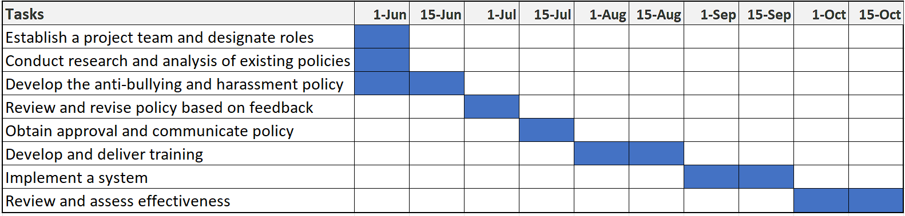
Figure 02: Gantt Chart. Source: Self-made
Milestones and Deliverables:
- Project team established and roles designated
- Existing policies analyzed and reviewed
- Anti-bullying and harassment policy developed
- Policy reviewed and revised based on stakeholder feedback
- Policy approved and communicated to all employees
- Employee and manager training developed and delivered
- Reporting and investigation system implemented
- The policy's effectiveness was reviewed and assessed, and any necessary changes were made.
British Airways can effectively develop and implement a comprehensive anti-bullying and harassment policy to address workplace bullying and harassment by following this implementation plan. Throughout the process, tracking and evaluating progress is ensured by milestones and deliverables.

Conclusion
In conclusion, both individuals and organizations can be negatively impacted by workplace bullying and harassment, making them serious issues. It is crucial for British Airways to take a proactive approach in addressing these issues, as the company is not immune to them. Poor leadership and communication were identified as the root cause of workplace bullying and harassment at British Airways through root cause analysis. The report has proposed several alternative solutions to address this problem, such as creating a thorough policy against bullying and harassment, providing training programs for employees, and setting up a system for reporting and investigating incidents. Using a weighted decision-making matrix, a comprehensive policy against bullying and harassment has been created by the report to evaluate the available solutions. The report has furnished a comprehensive implementation plan with distinct milestones and deliverables to effectively execute this solution. To create a safe and inclusive work environment for all employees, British Airways can effectively address workplace bullying and harassment through this plan.

References
Balducci, C., Conway, P.M. and van Heugten, K., 2021. The contribution of organizational factors to workplace bullying, emotional abuse and harassment. Pathways of job-related negative behaviour, pp.3-28.
Cobb, E.P., 2017. Workplace bullying and harassment: New developments in international law. Taylor & Francis.
Harrison, E.D., Fox, C.L. and Hulme, J.A., 2020. Student anti-bullying and harassment policies at UK universities. Journal of Higher Education Policy and Management, 42(5), pp.547-562.
Rayner, C. and Lewis, D., 2020. Managing workplace bullying: The role of policies. In Bullying and harassment in the workplace (pp. 497-519). CRC Press.
Taniguchi, T., Takaki, J., Hirokawa, K., Fujii, Y. and Harano, K., 2016. Associations of workplace bullying and harassment with stress reactions: a two-year follow-up study. Industrial health, 54(2), pp.131-138.

