Effective Team Working and Communication


Student Name: Samuel Filipe Torres da Silva
Student ID: 2107485
Module Code: BMSW 4002
Assignment Title: Component 1 Report Effective Teamworking for team success.
Lecturer Name: Richmond Lamptey

Summary
Based on Abdul's case study, this report comes to diagnose the issues found in his group and to recommend how Abdul can establish an effective team and what theoretical model could be applied. What sorts of roles are required to form a successful team? What influence does good collaboration have on team success?
At the end of the report, it is presented the recommendations on how Abdul’s case study could be reversed to a successful team.

Content
1 Introduction 3
2 How can Abdul develop an effective team and what theoretical model can be used? 4
2.1 What defines a team? 5
2.2 What contributes to effective teamwork? 5
2.3 Which team development model could be considered in Abdul’s case and why? 6
3 Team Roles 8
3.1 What roles are needed to create a cohesive and effective team? 8
3.2 What are the theories relating to this? 8
3.3 Why is it important to consider team roles when recruiting new staff? 9
4 Discussion 9
4.1 What type of impact can effective teamwork have on team success 10
4.2 What are the barriers to effective teamwork identified in this scenario 10
5 Conclusion and recommendations 11
6 References 12

1 Introduction

On Abdul's case report he is put in charge of a new group project with 18 employees, but unexpectedly, his group is faced with a worldwide pandemic that affected the team performance due to the covid restrictions, leaving Abdul with failed project tasks deadlines with low efforts of support between the team members that led to many of the members to raise the will to resign from the project.
This report will address the models of team development, which development models might be considered, and why a model of team development should be identified, explained, and justified for Abdul’s project.
Furthermore, an explanation of team roles and what responsibilities are required to form a cohesive and productive team, as well as what theories are associated with it and why it is necessary to consider team roles for this project.

2 How can Abdul develop an effective team and what theoretical model can be used?

To get to these themes we must check first a few points of view.

2.1 What defines a team?

According to Salas et al. (2006, p504) definition of a team is ‘two or more people who interact, dynamically, interdependently, and adaptively toward a common and valued goal’
In the case of Abdul’s project, he was left with a group of 18 people that by Abdul’s standards for two months the team was getting positive results until the start of the country Covid restrictions.
Then later he finds himself with several complaints about targets not getting met due to lack of commitment or communication from several group members.
Agreeing to Driskell et al. (2008), the fundamental requirements of high levels of interaction between team members is essential to become an effective team so Abdul needs to find a solution for the lack of communication engagement between certain team members.

2.2 What contributes to effective teamwork?

As per Salas, et al. (2005) there are five core components for effective teamwork.
- Leadership - The ability to coordinate activities of other team members, develop the team performance, assess team knowledge and skills, motivate team members, have a good sense of planning, organization and establish a positive relationship between the team members.

- Mutual Performance Monitoring - The capacity to use task-specific techniques create a shared knowledge of the team environment. This involves comprehension of team members' workload, exhaustion, stress, skills, and the team's surroundings. (McIntyre and Salas (1995).

- Backup Behaviour - The capacity of a person to anticipate the demands of other team members through understanding their tasks.

- Adaptability - The ability to change team plans and actions based on gained knowledge of the environment through the use of prudent behaviour and the reallocation of skills within the team.

- Team Orientation - An attitude defined by an attention to considering other people's behaviour during group interactions, as well as highlighting the importance of team goals over member goals.

We conclude, that when it comes to leadership roles, as others have (Hinsz, Tindale, & Vollrath, 1997; Zaccaro et al., 2001), as team leaders empower team success not just by organising and combining the unique contributions of each team member, but also by ensuring that everyone on the team understands their connection and the benefits of working together.

2.3 Which team development model could be considered in Abdul’s case and why?

For Abdul’s case, it would be more appropriate to use Wheelan’s, (2009) model arranged in four stages.
- Stage 1 Dependency and Inclusion
Characterised by members' dependency on the designed leader about safety, concerns or feelings included in the group.
The group development may manifest itself as members' compliance with the plans proposed by the leader.
Members also wait for the leader to make decisions and in fact members urge the leader to take charge and tell them what to do.

- Stage 2 Counter-dependency and Fighting
Characterised by the group seeking to free itself from its dependency of the leader and members fight about group goals, procedures and conflict is an inevitable part of this process.
The group’s task at this stage is to develop a unified set of goals, values and operational procedures. This task usually generates conflict. Task conflict is necessary for trust establishment and a climate in which members feel free to disagree with others.
Some groups remain stuck in this development stage due to interpersonal conflict or revert to Stage 1 with the leader dependency.

- Stage 3 Trust and Structure
Characterised by trust and structure. If the group manages to get through the conflicts of Stage 2, members' trust, commitment to the team and willingness to cooperate increase.
Communication becomes more open and task-oriented and less focused on power, status or influence.
At this stage, the leader becomes less directive and more consultive.

- Stage 4 Work
Characterised by work, at this stage, the group has become a high performing team that has resolved conflicts and is focused on task accomplishment. (Morgan, et al. 2017).
Although some work occurs at every stage of the development stages, the quality of work increases significantly during this stage.
Many teams in the workplace never reach this stage.
The Abdul’s case scenario we can see that the group passed already from Stage 1 duelling with the failed project tasks on Stage 2 where Abdul faces lack of group members cooperation, complaints, with members frightening to resign from the project and at this stage the group is about to reverse back to Wheelan’s Stage 1 if Abdul does not take any measure to reverse the situation and lead the group to the Stage 3.
Although we have several team development models to be considered like the most common one used the Tuckman’s, (1965) model brought by Tuckman himself in 1965 or even the Gersick, (1988) model that instead of making use of stages uses phases compared to Tuckman’s model, we do have a great array of choices but for the Abdul case, it would be more appropriate to use the Wheelan’s model that it is composed of four stages as the Abdul group is already in Stage 2 of Wheelan’s, (2009) model.

3 Team Roles
To take on the role to manage a team to its planned task or tasks is essential to focus on the roles played inside the team to make it succeed, so let us speak about the needed team roles in three points, as Morgan, (2017) remarked, the combination between personalities of individuals in a team said by Belbin, (2010) and others that the roles of each team individual may grant improvement or destabilise the capacity for the team task success.

3.1 What roles are needed to create a cohesive and effective team?

Making use of the Belbin’s, (2010) team roles theory, we can recognise nine key team roles separated by three main groups.
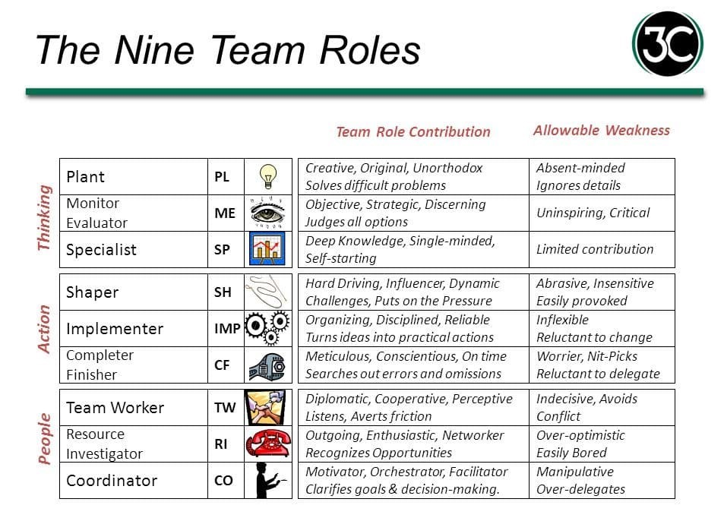 (Belbin’s, 2010)

3.2 What are the theories relating to this?
The theories behind Belbin’s, (2010) team roles led us to a point of view that some of the roles are moderative or control active and others roles much less so. As Eisenhardt et al. (1997) relate that behind effective management team decisions it needs to be based on a balanced power structure to work.

3.3 Why is it important to consider team roles when recruiting new staff?
Each role plays an important assignment that needs to be well-coordinated, blended and implemented with a well effective team member role so the team can blend diverse skills and perspectives and therefore, they could accomplish their goal or goals effectively.

4 Discussion
Several characteristics essential for effective cooperation have been identified via research.
Many of these characteristics have been repeatedly recognised in the literature. The following is an overview of the successful traits required for good teamwork:
- Commitment to team success and shared objectives - Team members are dedicated to the team's success and their project's shared goals. Effective teams are engaged, motivated, and pursue excellence.
- Interdependence - teams must establish an atmosphere in which they may offer significantly more as a group than as an individual. A good interdependent team structure gets the best in everyone, allowing the team to reach its targets at a much higher level (Johnson & Johnson, 1995, 1999). Individuals contribute to strengthening their team members to accomplish, develop, and grow.
- Interpersonal skills - would include the capacity to freely address difficulties with team members, to be transparent, reliable, and collaborative, show consideration, dedication to the team and its members.
- Open communication and positive feedback - proactively hearing team members' problems, wants, appreciating, help to build a productive atmosphere. Team members must be prepared to provide and take constructive feedback. (Anon, 2012)
- Appropriate team composition - is critical in building a successful team. Team members must be completely aware of their unique team function and grasp what's expected of team and project achievements.
- Commitment to team processes, leadership, and accountability - team members must accept responsibility for their commitments to the project. They must be informed on team processes, methodologies, and innovative ideas. Team success requires leadership, which includes collaborative selection and problem-solving. Effective people are engaged, motivated, and pursue excellence.

4.1 What type of impact can effective teamwork have on team success

When individuals can create a positive relationship with one another, they have an impact on the working relationship influence.
For a good connection to be productive and have an impact on the team's performance, each member must have benefits and the will that contribute to the team's overall success.
All the team members must work together to complete the delayed task goals so they can close the community event with success. (Bandura 1991; Campion, et al. 1993).
Teamwork is a precise organizational measurement that demonstrates a variety of characteristics in various types of companies, including non-profits. (Abbas, 2021).
Abdul’s scenario needs to take into consideration what makes effective teamwork to be able to invert the situation of his team and start to work those methods in favour of the project's success.

4.2 What are the barriers to effective teamwork identified in this scenario

When team members do not collaborate, this is referred to as poor teamwork. There are several examples of ineffective collaboration, such as:
- Management and other staff members show a lack of enthusiasm.
- Poor communications.
- A lack of dedication.
- Interpersonal dispute and blaming another
- There are no set goals.
- Lack of faith in leadership, as well as an inability to connect, etc.
According to Cameron,2009)The team leader's coordination, clarity of position, experience, planning, management, and decisiveness have been stated as being of crucial relevance.
In the Abdul case, there is a clear difficulty between the team members to complete project tasks, lack of communication, deficiency of support between team members and risk of staff resignment due to project frustration.
The situation of Abdul's team resembles a situation that I went through when my department had a very deficient performance due to the absence of our manager caused by sick leave.
The lack of direction from the manager during that phase made us go through a moment of disagreement between the team members and led to many of my colleagues becoming purposely absent and the ones that showed up to work would be overloaded with patient care needs.

5 Conclusion and recommendations

Overall, to build a successful work team and achieve Abdul's goals, you must be a competent leader.
This requires improved communication, providing essential support to the team, and seeking assistance in areas where the team is weak (emails, etc).
Motivate the team by providing constructive criticism and assisting in areas where they are unable to assist.
The manager may also inspire the team by going out in groups (meals, walks, marathons, etc.) so that there is a social moment away from work but with the team.
One of the reasons why organisations maintain their employees is because they have a leader that listens to them and supports them, allowing them to form a great team.

6 References

- Anon (2012) Effective communication skills. MTD Training & Ventus Publishing Aps. (Accessed: 24th February 2022).
- Bandura, A. (1991). Self regulation of motivation through anticipatory and self-reactive mechanisms. In R. Dienstbier (Ed.), Nebraska symposium on motivation 1990 (Vol. 38, pp. 69-164). Lincoln: University of Nebraska Press. (Accessed: 2nd February 2022).
- Cameron, Sheila, (2009) The business student's handbook: skills for study and employment. Available at: ProQuest Ebook Central (Accessed: 27th February 2022).
- Campion, M. A., Medsker, G. J., & Higgs, A. C. (1993). Relations between work group characteristics and effectiveness: Implications for designing effective work groups. Personnel psychology, 46(4), 823-847. Available at::https://www.mijnvclb.be/toolbox/directie/downloads/Relations%20between%20work%20team%20characteristics%20and%20effectiveness_implications%20for%20designing.pdf (Accessed: 7th February 2022).
- Driskell, J.E., Goodwin, G.F., Salas, E. and O'Shea, P.G., 2006. What makes a good team player? Personality and team effectiveness. Group Dynamics: Theory, Research, and Practice, 10(4), p.249. Available from: http://homepages.se.edu/cvonbergen/files/2013/01/What-Makes-a-Good-Team-Player_Personality-and-Team-Effectiveness.pdf (Accessed: 4th February 2022).
- Eisenhardt, K.M., Kahwajy, J.L. and Bourgeois, L.J.III (1997), “How management teams can have a good fight”, Harvard Business Review, Vol. 75, July-August, pp. 77-85. (Accessed: 10th February 2022).
- Gersick, C. J. (1988). Time and transition in work teams: Toward a new model of group development. Academy of Management journal, 31(1), 9-41. Available at: http://web.mit.edu/curhan/www/docs/Articles/15341_Readings/Group_Dynamics/Gersick_1988_Time_and_transition.pdf
- Griffith, B. A., & Dunham, E. B. (2014). Working in teams : Moving From High Potential to High Performance, SAGE Publications, Thousand Oaks. Available at: ProQuest Ebook Central. [12 February 2022].
- Hinsz, V. B., Tindale, R. S., & Vollrath, D. A. (1997). The emerging conceptualization of groups as information processors. Psychological Bulletin, 121, 43-64. (Accessed: 8th February 2022).
- Johnson, D.W. and R. Johnson. (1997). Learning to Lead Teams: Developing Leadership Skills, Edina, MN: Interaction Book Company. (Accessed: 25th February 2022).
- Johnson, K. E. (1995). Understanding communication in second language classrooms. Cambridge University Press, 40 West 20th Street, New York, NY 10011-4211 (ISBN-0-521-45355-0, hardback: ISBN-0-521-45968-0, paperback). (Accessed: 25th February 2022).
- McIntyre, R. M., & Salas, E. (1995). Measuring and managing for team performance: Emerging principles from complex environments. In R. A. Guzzo & E. Salas (Eds.), Team effectiveness and decision making in organizations (pp. 9-45). San Francisco: Jossey-Bass. Available at:https://www.researchgate.net/profile/Susan-Jackson-5/publication/275714101_Understanding_the_Dynamics_of_Diversity_in_Decision_Making_Teams/links/565f625608ae1ef9298548d5/Understanding-the-Dynamics-of-Diversity-in-Decision-Making-Teams.pdf (Accessed: 12th February 2022).
- Morgan, P. (2017), The Business Student’s guide to study and employability, London, SAGE. Available at: https://books.google.co.uk/books?hl=en&lr=&id=A7AEEAAAQBAJ&oi=fnd&pg=PP1&dq=Morgan,+P.+(2017), (Accessed: 18th February 2022).
- Morgan, S. J., Pullon, S. R., Macdonald, L. M., McKinlay, E. M., & Gray, B. V. (2017). Case study observational research: A framework for conducting case study research where observation data are the focus. Qualitative health research, 27(7), 1060-1068. Available at: (Accessed: 9th February 2022).
- R Meredith Belbin (2010). Team Roles at Work. Oxford: Routledge. Available at: https://search-ebscohost-com.ezproxy.uwtsd.ac.uk/login.aspx?direct=true&db=nlebk&AN=459724&site=ehost-live (Accessed: 1st March 2022).
- Sahar Kadhim Abbas. (2021). TEAM BUILDING EFFECT IN IMPROVING EMPLOYEES’ PERFORMANCE FOR GOVERNMENT INSTITUTIONS. Academy of Entrepreneurship Journal, 27, 1–12. Available at: https://www.proquest.com/openview/3a789cc07634f6beb0d19c2702506243/1?pq-origsite=gscholar&cbl=29726. (Accessed: 21st February 2022).
- Salas, E., Sims, D. E., & Burke, C. S. (2005). Is there a “big five” in teamwork?.Small group research, 36(5),555-599. Available at: https://assetpdf.scinapse.io/prod/1967246150/1967246150.pdf (Accessed: 1 st February 2022).
- Salas, E., Wilson, K.A., Murphy, C.E., King, H. and Salisbury, M., 2008. Communicating, coordinating, and cooperating when lives depend on it: tips for teamwork. The Joint Commission Journal on Quality and Patient Safety, 34(6), pp.333-341. (Accessed: 6th February 2022).
- Wheelan SA. (2009). Group Size, Group Development, and Group Productivity. Small Group Research. 2009;40(2):247-262. Available at: doi:10.1177/1046496408328703 (Accessed: 4th February 2022).
- Zaccaro, S. J., Rittman, A. L., & Marks, M. A. (2001). Team leadership. Leadership Quarterly, 12, 451-483. Accessed: 8th February 2022).

