

An investigation to determine how mental health calls impact the police service.

By Rebecca Guiver

Student number : 1922462

University Of Wales Trinity Saint David

Police Constable Degree Apprenticeship (PCDA) - BSc (Hons) Professional Policing Practice

Supervisor: Stephanie Brown

Acknowledgements –
I would like to acknowledge and give thanks to my family and work colleagues, in particular my father Ian Thomas, my mother Annmarie Thomas, and my grandparents, who have continued to believe and have supported me throughout the undertaking of this course. I would also like to thank my daughter Lily for her patience, support and understanding during this challenging time.

I would like to take this opportunity to thank and acknowledge support from my supervisor Stephanie Brown. .

I am confident that without his guidance and support this would not have been possible.

Declaration

- Declaration: This work has not previously been accepted in substance for any degree and is not being concurrently submitted in candidature for any degree.
Signed: R. Guiver
Date: 23rd March 2023

- Statement 1: This dissertation is being submitted in partial fulfilment for the degree of BSc.
Signed: R. Guiver
Date: 23rd March 2023

- Statement 2: This dissertation is the result of my own independent work/investigation, except where otherwise stated. Other sources are acknowledged by footnotes giving explicit references. A bibliography is appended.
Signed: R. Guiver
Date: 23rd March 2023

- Statement 3: I hereby give consent for my dissertation, if accepted, to be available for photocopying and for interlibrary loan, and for the title and summary to be made available to outside organisations.
Signed: R. Guiver
Date: 23rd March 2023

- Statement 4: I hereby give consent for my dissertation, if accepted, to be available on the university’s IT system for those who have consent to use the system.
Signed: R. Guiver
Date: 23rd March 2023

Abstract

This research study aims to investigate how mental health calls impact the police service.
To assist in researching the impact mental health has on the police service the researcher studied emerging issues which show relevance to why police have been attending more mental health incidents.
To better understand the impact the researcher studied elements involving police services attending mental health incidents. The researcher conducted research into whether the police are the best emergency service to attend an incident when a person is suffering with their mental health.
To assist with the study the researcher critically analysed relevant existing academic literature and government reports around police officers dealing with mental health incidents.
The researcher also conducted their own research by investigated the views and opinions of employees from South Wales police by using a questionnaire.
The researcher gathered the opinions and thoughts of employees from different police departments as well as having different lengths of service within South Wales police.
The researcher asked questions related to police attending mental health calls, such as, have you attended more mental health calls than crime? Do police have adequate knowledge and skills to support a person suffering with their mental health? What training have you received to support a person suffering with their mental health? Do you believe police are the correct service to respond to an individual suffering with their mental health?
The researcher received a response from 58 participants, the researcher understands this is a very small sample due to South Wales police being an organisation of 8,600. Each participant gave a strong opinion and thoughts of police dealing with mental health incidents.
The research carried out so far suggests police officers do not feel they are the correct service to support a person suffering with their mental health and one of the reasons being they do not feel confident due to feeling they are not equipped with enough knowledge and skills due to insufficient training.
The researcher has made realistic recommendations for further studies to be carried out on how emergency services and mental health services can move forward to be able to provide the support for the individual suffering should receive.

TABLE OF CONTENTS
DESCRIPTION | PAGE NUMBER
Acknowledgments | 2
Declaration | 3
Abstract | 4
Table of contents | 5
Chapter one- Introduction  1.1-Introduction | 7
Chapter 2- Literature Review  2.1- Introduction to literature review  2.2- Are people attending more mental health calls?  2.3- Are people suffering with their mental health more?  2.4- Investigation into police training for responding to people suffering with their mental health. | 8  8  10  11
Chapter 3- Research Methodology  3.1- Methodology introduction  3.2- Methodology selected  3.3- A qualitative, quantitative, and mixed-method research  3.4- Questionnaires  3.5- Summary | 13  13  14  14  14
Chapter 4- Analysis of results  4.1- Analysis introduction  4.2- Participants  4.3- Establishing if police are believed to be attending more mental health calls.  4.4 Questions relating to- are people suffering with their mental health more?  4.5 What training police officers received to respond to people suffering with mental health. | 16  16  17  20  20
Chapter 5- Conclusions and recommendations  5.1- Findings  5.2- Conclusions  5.3- Recommendations | 22  23  24
Chapter 6- Bibliography | 25
Appendix  Appendix A- Survey questions  Appendix B- Survey response graphs.  Appendix C- Survey written responses.  Application for ethical approval | 28  31  38  94

1:1 Introduction

Over recent years the number of people suffering with their mental health appears to have risen dramatically, health and wellbeing Surveys from 2020-2021 highlighted half a million people are suffering with severe mental illness, costing the economy between £70 billion and £100 billion (care, 2022).
Due to the recent increase of people suffering with their mental health it appears police services have been filling in the gap for mental health services, overwhelming statistics showing 70% to 80% of calls police officers attended are to support an individual who are suffering with their mental health. (gov.wales, 2018).
HMICFRS (2018) produced a report titled Policing and Mental Health: Picking up the pieces, following their investigation the report highlighted how the police service have been swamped with attending mental health calls, police officers are becoming overwhelmed as they are over stretched. This raises the question of how much demand is being placed on police services and what are the impacts.
Overwhelming evidence from BBC investigation; Police incidents flagged as mental health related. Statistics indicated in 2014 there were 385.2 thousand mental health incidents attended by police officers, this increased to 494.2 thousand in 2018. (JONES, 2 SEPTEMBER 2019)
Further evidence from 2018 Her Majesty’s, at the time, Chief Inspector of Constabulary (HMICFRS) annual assessment of Policing in England and Wales called ‘the State of Policing’, confirmed police officers are being tied up responding to mental health calls. Due to the mental health system failing, under the increased pressure the Police are becoming the first to be approached rather than the last resort. (BILLINGHAM,27 November 2018)
The researcher is young in service and has experienced first-hand mental health calls, experiencing how time consuming and demanding mental health calls can be. The researcher wanted to undertake this project to research how mental health calls impact the police service and evaluate if police are attending more mental health incidents, the researcher wants to gain an understanding as to why police are the first service to be approached for a mental health crisis instead of trained mental health professionals.
The researcher has also experienced how frustrating it can be to work alongside mental health services to try to get the correct support for the individual suffering with their mental health. The researcher hopes the research can come to a conclusion to improve police services and mental health services working together effectively.
Being young in-service, the researcher has only received mental health training within the police service by an Ncalt which is a computer-based tick box exercise. The researcher wants to study the training other officers have received and their thoughts as to if they feel they are adequately trained to deal with an individual who is suffering with their mental health.
The researcher wanted to study and evaluate if police are attending more mental health incidents, and if so, what are the reasons and how is this impacting the individual suffering and the services involved.

Literature review

An investigation to determine how mental health calls impact the police service.

2.1 Introduction

Statistics show 70% to 80% calls police officers attened are to support an individual who is suffering with their mental health. (gov.wales, 2018) This chapter will overview arguments regarding police dealing with mental health calls, specifically analysing if police officers are the correct service, have adequate skills and training to deal with those suffering with their mental health. This project will address emerging issues of police services dealing with people suffering with mental health, each objective of this project will be addressed, and the available literature will be evaluated.

2.2: Are police attending more mental health calls?

The rise of individuals suffering with Mental health issues is common knowledge within communities and public services. (HMICFRS) produced a report titled Policing and Mental Health: Picking up the pieces, following their investigation the report highlighted how the police service have been swamped with attending Mental health calls, and police officers are becoming overwhelmed as they are over stretched and feel that they cannot respond appropriately providing the correct support needed.

Research highlighted police services demonstrate a good understanding, responding with care and compassion but cannot provide the expert support that the person in a mental health crisis should receive from specialists. Attention was focused on how police services fill a gap for health services such as transporting individuals to hospital, due to ambulances not being available. Police are having to wait with patients until a secure mental health place is found, carrying out welfare checks on vulnerable people and looking for missing persons. If mental health services were readily available in real time, police officers could be utilised to attend other incidents.

Statistics from the report underlined how five people racked up 8,655 calls to the Metropolitan Police alone last year costing £70,000.

Welsh forces also reported that mental health calls can take an average of 3 hours of police time. The report identified a longer-term solution is for all public services to combine their services together to provide the expert mental health support that they deserve, as it is crucial for police to work with partners to be able to support vulnerable people.

Mental health practitioners and agencies are working better together, yet further changes need to be made to improve mental health support as Police forces are responding to mental health problems more often. Research from the report emphasises how important it is for an individual to receive the expert support they deserve in a healthcare setting, and they should not be suffering in a cell or in a police vehicle.
(HMICFRS, 2018)

Following the the report Policing and Mental Health: Picking up the pieces, the Police Federation of England and Wales (PFEW) voiced their concerns and released a message requesting urgent action be taken, regarding police officers attending mental health calls when the individual suffering needs support from a mental health care professional.
The PFEW highlighted that the NHS does not have the capacity to deal with people who need support with their mental health, police officers are then asked to support as the police service are unable to refuse. Data obtained from a report showed 4,500 people having a mental health crisis were unlawfully held in police custody. Funding needs to be availabe to support community health and social care facilities to help support and protect the most vulnerable people.(Federation, 2021)

Research from Cummins (2022) agrees with police being the first to respond to mental health incidents, highlighting that it is common knowledge that when 999 is dialled you will automatically get a response and the police will attend. Police are seen to be plugging the gap for failing mental health services. Research highlights how the poor funding of community services has led to the increased pressure on police forces, showing increased demand on calls for mental health when mental health agencies are not operational. Police services view this as an inadequate response from mental health professionals, research shows that 10% of mental health related calls come from mental health agencies asking for a police response when their shifts have finished. The research underlines mental health calls impact the police service as they require more resources to be used and take longer to deal with due to police needing to liaise with mental health triage services to ensure the individual is provided with the adequate support needed.

The Everything is connected to everything else report, estimated that approximately 70% to 80% of calls police attend are not crimes they are calls to support vulnerable people.
Following the report frontline staff have raised how mental health is a significant demand on resource’s resulting in delays of support for the individual suffering with their mental health. However, the report highlighted the willingness of police services, mental health professionals and other voluntary organisations working together as part as the triage scheme, research outlining a move in the right direction to help support individuals suffering with their mental health. (gov.wales, 2018)

Research indicates police services work well with mental health professionals yet Cummins (2022) highlights how police officers feel they lack the expertise and confidence to deal with the mental health demand which has been forced upon them, stating the Police officers dealing with the demand to mental health victims has become ‘stigmatising’. The research emphases how police officers dealing with mental health has been apparent since deinstitutionalisation back in 1960, becoming impacted by the reduction of social and welfare spending causing a demand on mental health services when the available resources had been reduced. Due to these cuts, it has become unavoidable for police to attend. This raises the questions, has there been any improvements in supporting mental health, do police services need to accept the responsibility of attending mental health incidents and do police officers require further knowledge and adequate training to be able to respond.

In 2014 Theresa May gave a speech about the need to raise awareness of issues around people with mental health problems highlighting 20% of police officers time is spent dealing with mental health problems and public services are at crisis point, the police cannot and should not do the job of healthcare professionals, the crisis needs to be looked at as a whole and not just offenders. The overall performance of the police, criminal justice system and the NHS needs to improve. People suffering with their mental health need to receive proper support in a proper health care environment to get their needs assessed. (Home office, 2014)
It is clear mental health is still an ongoing issue with data from reports dating back to 2014. This raises the question, is the way the police deal with mental health incidents the new modern-day way of policing? Lane (2017) Examined discourses from operational police officers surrounding mental health incidents, data was collected from officer’s individual experiences with mental health difficulties, via a UK -based internet police discussion forum. Research highlighted a negative stigma around individuals who are suffering with their mental health. This research questions the suffering individual’s morals and how genuine they may be or is it just a routine exercise of pleading poverty to be able to scrounge from the government. The research highlighted disagreements and debates surrounding police roles and highlighted thoughts regarding the failing mental health service leaving police officers to pick up the pieces. However, the change in society and the overlapping of police work and mental health services needs to acknowledge and be accepting of the organisation of mental health incidents and how they have become a core in modern day policing.

The NPCC Mental Health & Policing strategy 2022-2021 showed the police often attend mental health calls due to the absence of mental health agencies, statistics show in 2019 the police attended an average 54 mental health related incidents every hour. Following the report, the NPCC produced a national strategic plan aligning core principles for police forces, emphasizing the correct approach by ensuring consistent decision making and structure. For partnerships to recognize the importance of working with multiagency, developing effective unbiased and compassionate multi-agency partnership, and respond by identifying emerging threats and deliver the right response at the appropriate setting by the appropriate staff. (NPCC, 2022)
The Landscape review research estimates that 20-40% of police time is spent dealing with individuals suffering with mental health. 84% of calls received by call rooms are non-crime related. Data from the review pointed out that street triage has been the most effective tool in policing to deal with mental health. Research showing the reduction of S 136 detention provided evidence to suggest that triage is working. It has been estimated since the commencement triage 500 hours a week of police officers time has been saved, proving that improvements are being made. (Gov.uk, 2018)
Although there is overwhelming evidence through showing police have been attending rising numbers of mental health calls, police officers do not feel they have adequate skills and training to deal with these incidents. Research also shows opposing views of police and mental health services working well together to help individuals suffering with their mental health. There appears to be issues with police attending mental health incidents instead of mental health services, raising the fact that further studies are needed.

2.3: Are people suffering with their mental health more?

With statistics confirming police are attending more mental health calls, it is hard to ignore the question, are people suffering with their mental health more?
Research from John Mcdaniel (2020) argues the rise of mental health calls have increased due to the stigma of mental health decreasing. This underlines how social media is used as a serving outlet for young adults and young person’s, contributing to growing mental health awareness, including celebrities sharing their mental health issues. The mental health stigma that was present is diminishing.

Research from the 2022 mental health and wellbeing plan highlights overwhelming evidence of historical underinvestment in mental health services. This has negatively impacted more than 60 % of children and young people, research from survey data revealed that 1 in 6 people aged 16 and over in England were suffering with their mental health.
Surveys from 2020-2021 highlighted half a million people were suffering with severe mental illness, costing the economy between £70 billion and £100 billion. Research demonstrated how adults with mental health issues are more likely to be out of work or have lower incomes resulting in increased involvement in the criminal justice system. (care, 2022)
There is overwhelming evidence showing many people are suffering with their mental health, A concordat was established in 2014 to target the rise of mental health and develop a new approach of dealing with mental health crisis care. All signatories signed the concordant meaning all agencies agree to engage to promote focused action in preventing and supporting individuals who are suffering with their mental health. (council, 2014)
It would appear further research needs to be done to establish how individuals suffering with their mental health can get the support they need.

2.4: Investigation into police training for responding to people suffering with a mental health illness.

With the overwhelming evidence police are attending more calls where an individual are suffering with their mental health, questions are raised to determine if police officers have adequate training, knowledge and skills to support the suffering individual.

Since 2014 Police forces across England and Wales became governed by the Code of Ethics, This was produced by the College of policing (COP), COP is a professional body for all policing, it operates independently of the Home Office. The Code of ethics is a decision making model that reinforces the values and standards for all policing. (College of Policing, 2014)

Early police recognition of vulnerabilities and possible mental health crisis is crucial to ensure the individual gets the relevant support needed. Police officers receive training aiming to provide officers with knowledge of awareness to understand mental health and vulnerability, learning to recognise symptoms and forms of a person suffering with their mental health. Training consists of official guidance and class room training programms involving material governed by the COP. This underlines how police officers are required to understand and respond with the appropriate multi agencies when dealing with a mental health crisis.

Police officers should always consider their presence, attitude and demeanour when dealing with an individual with mental health illness, research has shown active listening skills helps to de-esculate mental health situations.(policing, 2016) However do police officers feel they poses the knowledge, experience and have had the adequate training to support an individual suffering with their mental health.

Research from John Mcdaniel (2020) argues the lack of funding caused a knock-on effect for police services, meaning police officers are dealing with extra mental health calls and being described as “street corner psychiatric”. All of this relates back to the funding crisis in 2008. Research shows police resources have been affected by a lack of police officers with experience due to losing experienced police officers because of early retirements and budget cuts. This created a knock-on effect to inexperienced police officers without appropriate support.

Media argues how police are ill equipped, ill-suited, and over worked to serve individuals who are in distress due to suffering with their mental health. The Research shows police officers feel overwhelmed whilst dealing with individuals suffering with their mental health. Police officers are feeling a lack of certainty about what to do, wrong decisions are made, consequently there has been a rise in officers using force, leading to undermining legitimacy of good work done by police officers.

Nicola MCLEAN (2010) researched police officers views whilst dealing with individuals suffering with mental health and working with the mental health service. Research highlighted most police officers demonstrated a desire to help and demonstrated emotional aspects when dealing with individuals suffering with their mental health. Also recognising the possible consequences of police intervention for the individual suffering. Research highlighted police officers got frustrated when trying to access services to help the individual who were suffering. Officers explained they felt powerlessness from repeated mental health calls with unsuccessful outcomes, resulting in officers becoming deflated and feeling as they are not helping those suffering with their mental health.

Cummins (2022) explains how all police forces have established their own special model to respond to mental health incidents with the aim to support the individual with suitable mental health support as soon as possible. Suggesting this will help to improve police forces confidence when dealing with mental health incidents. Police involvement with individuals suffering with their mental health will always be apparent yet should be limited as much as possible due to concerns police are ‘plastering deep cracks’ in community mental health services. Again, further research evidencing how police officers do not receive the correct skills to provide the correct care a person dealing with their mental health should receive.

With evidence suggesting police do not feel confident in dealing with mental health incident, the Independent Office for Police Conduct (IOPC) agrees how police officers may not contain the skills to deal with mental health incidents yet act with courage and are calm and in control. Evidence from their investigations has led to police officers being praised for the way they have dealt with mental health incidents.
The IOPC act on complaints that have been made against members of the police force and investigate most serious matters, research regarding investigations is used for learning to influence policing and to help develop the public’s confidence.

In 2015-2020 IOPC reviewed the use of TASER, Home Office data showed 80% of officers did not report Taser being used on a person suffering with their mental health, indicated mental health was a significant factor increasing officer’s use of Taser. Research highlighted police officers do not always have the skills to be able to communicate with a person with learning difficulties and appear to be suffering with their mental health, increasing the likelihood of officers using force, producing evidence for police officers to receive more training.
Alternatively other IOPC investigations have praised officers attending mental health calls, reporting how police officers act with courage and remain calm and in control and used reasonable force due to the dynamic of the situation.
(POLICECONDUCT.GOV, 2020)

There appears to be little research into the thoughts of police officers attending mental health incidents and their opinions on the training they have received to deal with mental health, leaving room for further research.

Research Methodology
3.1: Introduction
To assist the investigation and determine how mental health calls are impacting the police service it is vital to acquire further research to develop data. The researcher must establish the most suitable format of how they intend to obtain the appropriate information to support the investigation.
The importance of research is to plan, organise, and gather information to enable a clearer understanding to support the researcher’s investigation. To assist with views of how research is best conducted the researcher reviewed research to evaluate the best options available.
Research is broken into two elements, primary and secondary research. BBC Bitesize (BBC, 2022) points out how important it is to use the correct research in collecting the necessary data for certain investigations.
Primary is research collected by the researcher for the first time, this can be gathered through observation, questionnaires, interviews and focus groups. Secondary research is analysing information that has already been obtained through other people conducting primary research.
The researcher considered gathering information by interviewing and focus groups but decided against this method due to being time consuming. Considering the degree of Bias, the researcher decided to only obtain information from a questionnaire to limit and prevent possibilities of Bias from occurring. Christopher J. Pannucci (2011) Describes Bias any “any tendency which prevents unprejudiced consideration of a question”.
The researcher will use the benefit of being a police officer to gather and examine information gathered from officers and members of staff currently employed by South Wales police. The researcher will use a mixed method approach to obtain information from a questionnaire consisting of multiple choice and open-ended questions.
The researcher will use their current role as police officer to obtain and examine information provided by a wide range of personnel working for South Wales Police. The researcher will use this demographic due to the extensive number of employees South Wales Police has, and the wide range of diversity resulting in a fair test. The researcher will be using a mixed method approach to achieve data in a way that will suit all needs and abilities.

3. 2: Methodology selected.
It is important that the researcher has acknowledged and identified the different types of research and philosophies to explore and create an understanding of information gathered. It is equally as important the researcher adapts to a research philosophy, maintaining no influence over variables and information gathered.
By establishing research methods available it has become apparent to the researcher the most compatible flexible approach to gather information will be to use the pragmatism approach. Rose (2017) states pragmatism has been considered as the appropriate philosophy for a mixed method approach due to the researcher being less restricted to how the researcher obtains their research.

3.3: A qualitative, quantitative, and mixed-method research.
Quantitative is a method of research with the purpose to obtain data by relying on numeric or measurable statistical data, whereas qualitative relies on exploring a greater understanding and knowledge of detail to obtain research data by conducting interviews.
Mashizha (2014) Highlights the strengths and weaknesses of using quantitative research stating this method is good to obtain information in a short period of time using numerical data from groups of participants, however, fails to include human perceptions and beliefs compromising on providing depths of description. Qualitative strengths are how more information is obtained as the method draws information from participant’s experiences and opinions by using a broader open-ended inquiry. Qualitative can become time consuming by trying to personally extract the relevant information.
Richard A. Swanson (2005) States when researchers use both quantitative and qualitative methods, they become a powerful source of collecting data and work well in obtaining data supporting relevant outcomes.
The researcher has acknowledged the importance of using mixed methods compromising of qualitative, quantitative to obtain an in-depth understanding, to establish how mental health calls are impacting the police service.
The researcher aims to utilise the mixed method approach by creating and administering an online survey, this survey will be sent to members of the police service to gain and explore a personal understanding of their views.

3.4: Questionnaire
The researcher has decided to use a questionnaire as the instrument to obtain information, questionnaires benefit from the collection of data by targeting a wider audience to assist with research along with being suitable for all abilities to be able to take part in giving their honest opinion, meaning the audience it will reach will be wider and more interactive.
The questionnaire will be distributed via a secure online link shared within the organisation’s internet home page, allowing any person employed by South Wales police to participate.
Huffman (2006) Carried out a study of looking into the advantages of producing online surveys, his findings where the response rate was higher but a slower response time due to people not accessing their emails.
Questionnaires will be sent to the University for approval before being made available, Questionnaires can be completed voluntarily and anonymously to encourage honest answers from participants. The researcher considered emailing the questionnaire to peers but due to South Wales being a big organisation decided against this idea, instead chose to publish a secure online link. Participants provided consent for their answers to be used as data for the research.

The questionnaire will use a qualitative-quantitative approach by containing a mixture of multiple-choice and open-ended questions. The researcher has decided to utilise open ended questions so participants can provide more information and rational to create a more personal view into their answers to support the investigation. Ursa Reja (2003) notes that questionnaires have an important role for data quality and the way the questions are worded is vital to gaining a response from participants. The study highlighted how open-ended questions gain more in-depth knowledge yet can create issues if they are not specific questions, questions need to appear user friendly and avoid inappropriate question designs.
The questionnaire will start with establishing the participant’s role and length of service within the organisation by using multiple choice questions.
Closed questions will also be utilised and when more depth is required on specific question an open-ended question will follow as optional. The researcher understands that as some questions are not compulsory participants could avoid answering the open-ended questions. This could affect the information collected but this will be addressed when the problem arises.

3.5: Summary
The purpose of this chapter is to explain how the researcher has researched the best way to collect data for the investigation.
The researcher has explained the importance of understanding and utilising the correct research methods to obtain information and data to support the investigation and give persons the opportunity to voice their opinions.
The researcher explains that a mixed methods approach will be conducted using a questionnaire which will aim to reveal how mental health calls are impacting the police service along with the demands put on officers attending incidents involving mental health.

Analysis of results

4.1: Introduction

This section of the study focusses on the results obtained using a survey created by the researcher. The researcher conducted a questionnaire to determine how mental health calls have impacted the police service. The questionnaire consisted of 14 questions using mixed method approach. A range of qualitative and quantitative questions were asked to draw information to assist in collecting data for the researcher.
The researcher acknowledged the best source of information would be obtained from within the organisation. The questionnaire was advertised using the South Wales police internal messaging service. It stipulated how participants will be kept anonymous. All associates in South Wales police have access to the internal messaging service allowing them to participate by clicking on a secure link to gain access.
As a result, 58 participants took part in the survey. The researcher is aware due to South Wales police being a force of 8,600 this is a small sample size compared to the size of the organisation, however all persons working within the organisation were given the opportunity to participate, Results show a high percentage of participants did not take part.

4.2: Participants demographics

The researchers aim was to target different departments to obtain a diversity of participants opinions from the organisation to assist with the collection of data. The response has been successful in doing this, and identified 22.4% work in response policing, 8.6 % work in NPT, 8.6% are Police Sergeants, 1% CID, 3% HUB and 53.4% of participants answered other. Participants who have answered other could possibly be police staff, Intel officers, volunteers, and other specialised departments.
To establish the experience the participants, question two asked their length of service, ranging from 0-2 years up to 6-10 years with the option of answering other, exhibiting the participant has more experience than the multiple-choice answer. Table one shows 43.1% of participants responded with other. Other establishes participants have had longer than 10
years’ service. Table 1 reveals that most participants have a longer service than 10 years.

How many years of service in the police force.

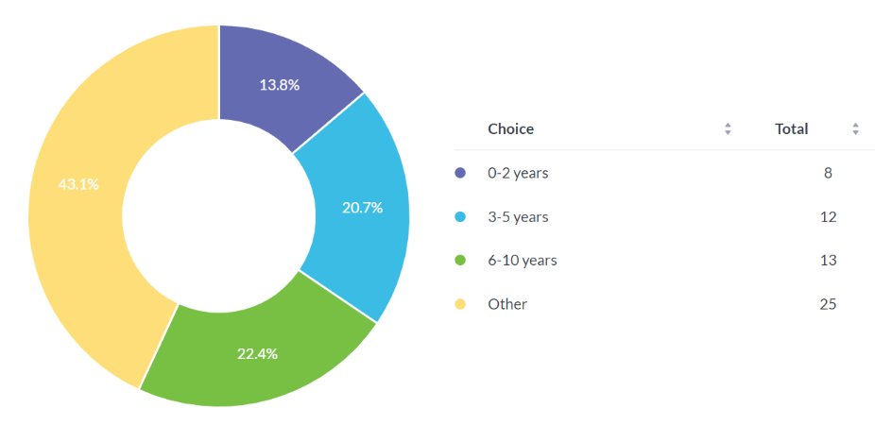

4.3: Establishing if police are believed to be attending more mental health calls.

The questionnaire continued with a question related to police attending mental health calls. Question 4 asked participants if they have attended more mental health calls than crime. 45.8% responded yes, 22.2% responded no and 30.6% responded other. Participants who responded with other had the option to provide further comments.

Do you feel you have attended more mental health calls than crime?
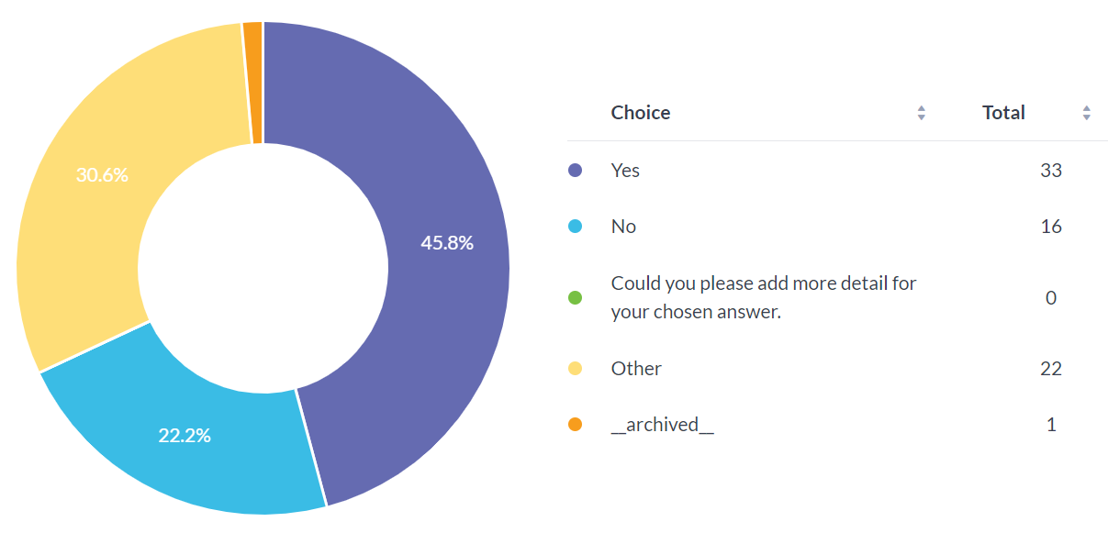
Seven respondents gave further information to support their answers, respondents 4, 5 and 7 answered yes and indicated their roles as response officers and stated how it feels like every call police attend is mental health related and they attend these calls every day.
Respondent 14 answered other, in their role of Force Intelligence Manager (FIM), their personal experience of overseeing every incident reported to the police service, is that the police are attending more mental health incidents, due to the failure with partner agencies.
45.8% of respondents answered yes to attending more mental health calls than crime, research from the researcher’s literature review agrees with the report ‘Everything is connected to everything else’ produced in 2018 by policing in partnership in Wales, how police are attending more mental health incidents than crime. (Wales, 2018)
Notably respondent 28 answered yes and commented “the police service is being over deployed to incidents that should not be attended by police, as we are not equipped to deal with what we face”.
Participant 57 is a Sergeant with over 10 years of experience, answering no, and the only person giving further detail to their answer highlighting how police attend more crime than mental health, however police attend more crime with a mental health element. Further information on answers given are available in the Appendix.

4.4: Questions relating to - are people suffering with their mental health more?

Question 5 asked how many mental health calls are attending monthly. The respondents were given an option of multiple choice to answer the question.
17.5% participants responded by answering with 0-5, 28.1% answered 6-10, 28.1% answered 11-20 and 26.3% answered other. Answering other revealed participants felt they responded to more than 20 mental health incidents a month. Research backs up research John Mcdaniel (2020) highlighting police deal with more mental health incidents since the funding crisis in 2008, as stated in the researcher’s literature review.

How many mental health calls do you believe you attend monthly?
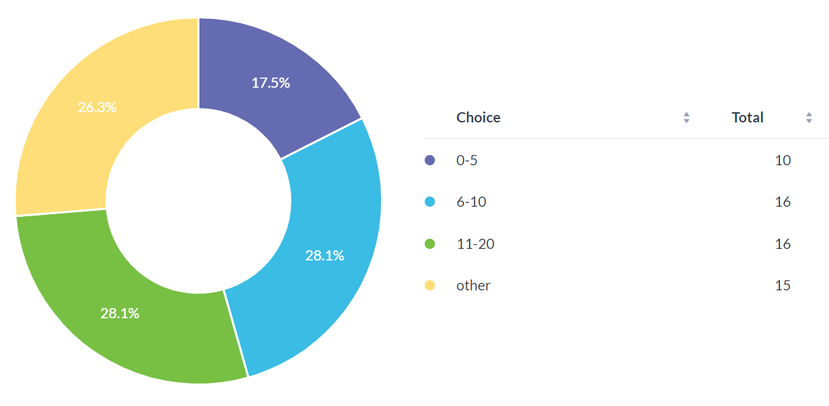

To gain further knowledge related to outcomes of police attending mental health calls, question 6 asked participants what the outcome had been when dealing with a mental health call.
Participants answered by multiple-choice, 40.4% answered they left subject in the care of a family member. 24.6% stated they had taken the subject to Triage/A&E.
2% replied with having to use S136 of the mental health act to detain the individual. 7% of respondents answered that the individual had been arrested for another crime. 24.6%, respondents used the option of answering other but did not comment.

When attending mental health calls what is the usual outcome?
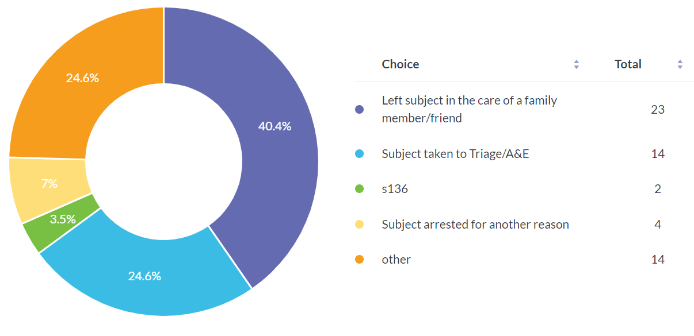

It is noticeable from data collected, that most respondents feel they are attending a lot of mental health calls, suggesting people are suffering with their mental health more.
Question 10 asked participants if they believed police are the correct emergency services to attend mental health calls. Participants were given the option of multichoice to answer their questions and were asked to provide further details to elaborate on their answers. 50.9% respondents responded yes and 47.4% responded no, 1 respondent chose not to answer the question and one answered other. 27 respondents provided the researcher with further detail all highlighting how a medical professional is far more suited to deal with a person suffering with their mental health. Overall participants do not feel they have the expertise and training to deal with mental health, this information is available in the Appendix.

Do you think police are the correct emergency service to attend mental health calls?
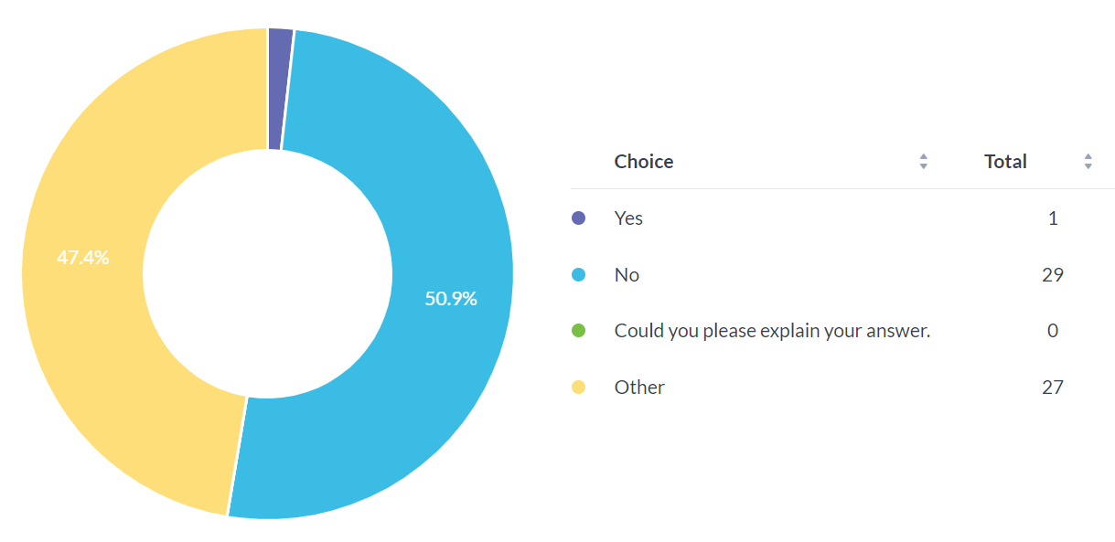
Question 11 asked respondents if they feel police work well with mental health support available. 13 respondents answered yes, and 22 respondents answered no. 22 participants answered using other Notably both no and other received the same response of 22. Other allows participants to add further detail to their answers. Further comments highlighted that the police do not work well with mental health services and officers are left to pick up the pieces for the health service failing. Further information is available in the Appendix.
The researcher has data highlighting that police officers feel they are not adequately equipped to deal with mental health incidents possibly due to very little training they receive, however by referring to the researcher’s literature review, IOPC have praised how police officers have
dealt with these situations, stating officers act calmly and show compassion. (Conduct, 2020)

Do you feel the police work well with the mental health support available?
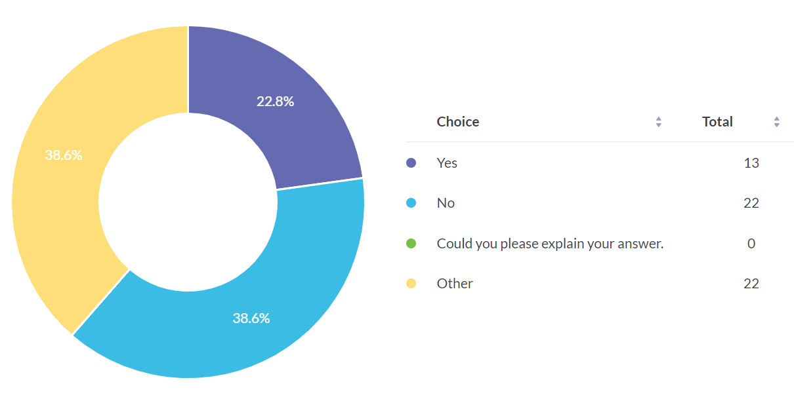
4. 5: What training police officers receive to respond to people suffering with mental health.

To elaborate, what training police officers receive to deal with mental health calls, the researcher included multiple choice questions and open-ended questions in the survey.
Question 12 asked participants if they felt they had received adequate training to deal with mental health incidents. One participant did not answer the question, no respondent answered yes however 68.4 % answered no and 31.6% responded with other, providing further details to their answers. All 31.6% of Respondents who answered other have provided additional comments highlighting how police are not mental health or medical professionals and to deal with mental health incidents it would require police to upskill knowledge. By viewing the data provided from this question It appears to the researcher the participants agree to not having adequate training. All replies to other, are available in the Appendix.

Do you feel police officers have the adequate training to deal with mental health incidents?
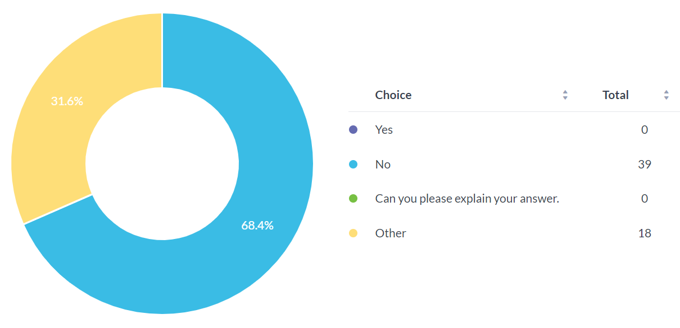

Question 13 asked participants what training they have received to deal with mental health incidents. Respondents had a selection of multiple-choice answers to choose from and could select other to provide further comments. 40.4% of respondents answered with classroom-based training. 0% answered they received practical based training. 40.4% of respondents answered by Ncalt. 19.3% of respondents answered other. Participant 48 highlighted how they have received no further training since joining South Wales Police back in 2000.
Participant 57 who is a sergeant and has over 10 years of experience commented “We teach legislative and form filling, but it is very much throwing staff in at the deep end and learning on their feet”.
Participant 40 who remained anonymous commented “mental health workers spend years training for their role. A couple of NCALT packages will not provide police officers with the training and confidence to resolve these incidents confidently”.
Further comments from participants will be available in the Appendix.
Research shows similarity to previous study’s seen in the literature review, study agrees with Cummins (2022) police officers do not feel adequately trained and possess the knowledge to deal with mental health incidents putting both parties at risk and not providing the support the person suffering should receive.
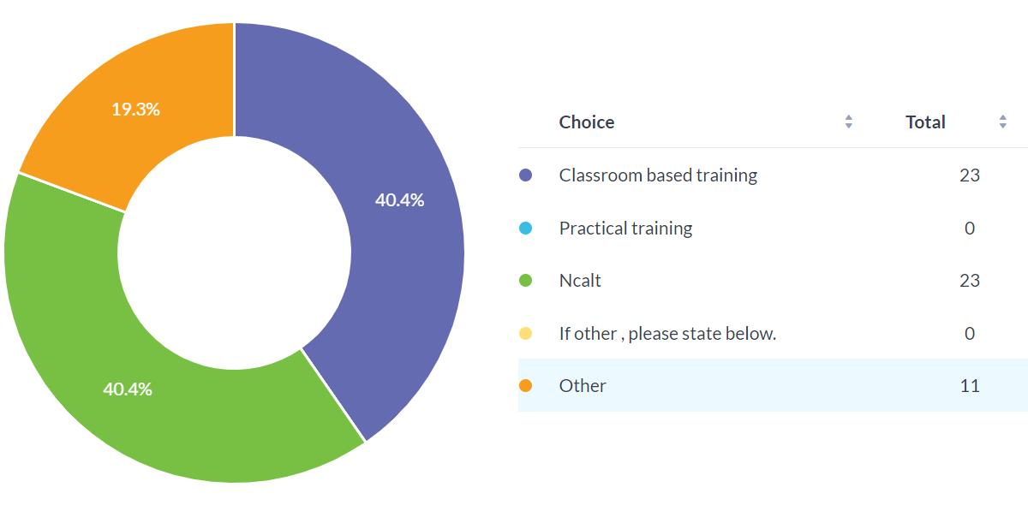

Conclusions and recommendations

5.1: Findings

This chapter will focus on the conclusion based on the findings and data obtained during the research project, as well as reviewing findings from the literature review and highlighting imbalance and gaps and recommendations for further studies.
The researcher accumulated a response of 58 from a survey that only members of South Wales Police had access to. The researcher is aware this is a very small sample size from the organisation however a diverse response due to participants being from different departments within the police force.

The researcher allowed the survey to be accessed by all departments within South Wales police, enabling the researcher to gather data and an insight from different departments, and experience throughout South Wales Police, helping to identifying issues regarding mental health incidents.

The survey asked quantitative and qualitative questions by providing multiple choice and asking respondents to provide additional comments. Additional comments allowed the researcher to critically analyse the respondents’ thoughts and reasons to why the respondent responded to the survey the way they had.

The questionnaire asked respondents if they felt they attended more mental health calls than crime, 33 of respondents answered yes, 22 responded with other adding further comments to their answers, only 16 respondents answered no. This question has provided overwhelming evidence showing police officers are feeling they are being over deployed to incidents and are being used as a plaster to seal the crack for the mental health service. Research by Nicola MCLEAN (2010) highlighted neither police services nor mental health services can provide intervention alone, making it is crucial services work together.
However, 16 respondents answered no, yet the majority of crime police attend has a mental health element attached. Strongly suggesting people are suffering with their mental health more. Or can this be confirmed with (Lane, 2017) research which concluded it to be common knowledge how the mental health service is failing, leaving police officers to pick up the pieces.

It is noticeable how participants believe they are not the correct emergency service to attend mental health incidents, most respondents emphasized a medical professional is far more suited to deal with an individual suffering with their mental health. Participants highlighted how they lack training and expertise to deal with an individual suffering with their mental health. Research from Nicola MCLEAN (2010) shows officers have desire to help and show emotional aspects when dealing with an individual suffering with their mental health. Yet Cummins (2022) notes how police officers feel they lack the expertise and confidence to deal with the mental health demand which has been forced upon them. Evidence suggesting police officers have the desire yet lack confidence due to not having adequate training.

Not one respondent answered yes to receiving adequate training to deal with mental health incidents. It was noted that most respondents have only received classroom and online learning to enable them to deal with an individual suffering with their mental health.
The overall feeling from respondents was the police are not mental health or medical professionals, for police to deal with these incidents they require upskilling and better knowledge. Confirmed with Cummins (2022) research highlighting how police officers do not receive the correct skills to provide the correct care to an individual suffering with their mental health.

The researcher received an email from, a high ranked senior officer regarding the survey, highlighting issues affecting data collection. It was agreed to keep the respondent anonymous. The email highlighted the respondent previously worked as head of the review unit for Single Unified Safeguard Review. The respondent would review and write on behalf of south Wales police on all cold cases, child practices, adult practices, domestic homicides, and mental health incidents.
The respondent identified good and bad practice and highlighted learning and training needs within the organisation, it was noted social services also do this; however, the Welsh Government dictate what and when mental health reviews are to be obtained. The respondent emphasized how no mental health reviews have been completed since 2014/15. The respondent highlighted how there have been occasions when incidents have been wrongly categorized failing to be reviewed meaning a possible error in data collected.

This leaves the researcher with the question, if these mental health reviews have not been completed since 2014/15 how the organisation and social services can learn from good and bad practice, how can training improve to support individuals who suffer with their mental health.

5.2: Conclusion

The aim of this study was to establish if mental health calls have an impact on the police service and to analyse if they are the best service to respond to an individual suffering with their mental health, also address emerging issues regarding police attending mental health incidents.
The researcher collected data from questions being answered by active participants who are employed by South Wales Police. Questions asked if participants felt they are attending more mental health calls, are police the correct service to attend and do the police have adequate knowledge and skills to deal with mental health incidents.
The researcher revealed overwhelming evidence showing police officers feel they are attending more mental health calls than crime and they do not feel they are the best service to respond to mental health incidents due to not being adequately skilled and having the knowledge to support the individual suffering like a mental health practitioner would have.

The results from the literature review conducted by the researcher established from the research carried out, provides the researcher with a mixed opinion highlighting issues with what is the best solution for the individual who is suffering.
The researcher believes officers should attend mental health incidents to establish the threat risk and harm however police officers are not the best service to resolve the incident after establishing there is no threat, no harm and no crime has been committed.
The researcher noted police officers perceive mental health as not their role, however the researcher believes policing has changed and research confirms this, meaning police officers need to change their perception.

The literature review established services are working together to provide the best service, yet officers feel this is not working and they are being forfeited with the incident which should reside with the mental health service. It appears the mental health service is believed to be failing and does not maintain adequate staff due to possible funding cuts, further research needs to be conducted on what has affected mental health services. Research from Cummins (2022) highlighting how the reduction of social and welfare spending for mental health services has causing police attendance to be unavoidable.

There appears to be a knock-on effect of persons suffering with mental health not receiving the mental health support they need, resulting to extra demand, Statistics show 70% to 80% calls for police attendance due to individuals attempting overdoses or trying to commit suicide. (gov.wales, 2018)
Research conducted has noted police officers in uniform can aggravate an individual worsening the situation causing crime to be committed, highlighting how police officers are not the best service to deal with mental health incidents. Research from the literature review identified that police officers are not adequately skilled or have the knowledge to deal with a person suffering with their mental health. John Mcdaniel (2020) highlights police officer are feeling a lack of certainty about what to do, meaning wrong decisions are made, consequently causing a rise in officers using force.

It is the researcher’s sole opinion that police officers are not trained to adequately support an individual dealing with their mental health. Overwhelming evidence conducted by the research questionnaire, revealed that not one participant answered yes to feeling they have received adequate training to deal with an individual suffering with their mental health. I recommend police officers receive further training to deal with mental health incidents, to build both officers and the public’s confidence in dealing with mental health incidents. It is apparent that the demand of mental health is increasing yet police officers do not have the knowledge and skills to deal.

5.3: Recommendations

Having established the results from the findings during this study, the researcher would like to make the following recommendations the researcher believes would be relevant and achievable.
The researcher believes how the relevant research could benefit the police service and mental health services across England and Wales regarding their involvements with individuals suffering with their mental health.

- To gain an understanding and prospective from persons who work within the mental health service, further research should be undertaken from persons who work in mental health services, reviewing their opinions regarding police officers attending mental health calls. This will enable opinions from mental health services to be able to voice their concerns and highlight what they believe could provide a better service for a person suffering with their mental health.

- Research conducted from this study established from the literature review and data collected from questionnaire, provided overwhelming evidence highlighting how police officers feel they do not have the knowledge or adequate training to deal correctly with an individual suffering with their mental health. It has come apparent how modern-day policing involves a high demand of police attending mental health incidents, so why do police officers feel they do not require the skills to deal with mental health incidents. Further research needs to be conducted to establish better training to be introduced in the police service. Police officers currently undergo Ncalt training, which usually consists of a tick box exercise and a video. I recommended training to involve hands-on practical experiences. Police officers attend practical training for officer safety every year, why not extended this and add a practical involving a mental health element. I also recommended training to involve a person who works within mental health services. It is crucial for police officers to work with multiagency, why would further training not consist in involving all services.

- It appears the role of policing is changing, police officers need to accept the role is to attend a mental health call, however Further research needs to be conducted to establish why mental health services appear to be failing in the community for this change to be happening. Only when this research is completed will it be able to support the modern-day policing and discover failures which can help the failing occurring again.

Bibliography
Anon., n.d. [Online].
BILLINGHAM, H. i. o. c. Z., 27 november 2018. The police cannot fix a broken mental health system, s.l.: HMICFRS. Policing and mental health: picking up the pieces (justiceinspectorates.gov.uk) (Accessed 1 October 2022).

BBC, 2022. Planning and organisation. Primary research.
Huffman, I., 2006. Online questionnaire software advantages/disadvantages. pp. 2-46.
Available at: Primary research - Planning and organisation - WBQ National: Foundation KS4 Revision - BBC Bitesize ( Accessed 5 January 2023)

care, D. o. H. a. S., 2022. Mental Health and wellbeing plan: discussion paper, s.l.: Gov.uk.
College of Policing, t. p. b. f. p., 2014. code of ethics. July.
Mental health and wellbeing plan: discussion paper and call for evidence - GOV.UK (www.gov.uk) (Accessed 3 October 2022)

Christopher J. Pannucci, M. a. E. G. W., 2011. Identifying and Avoiding Bias in Research. Plast Reconstr Surg. 2010 Aug, 126(2) ed. University of Michigan Ann Arbor, Michigan: MD Section of Plastic Surgery Department of Surgery 2130 Taubman Center.
Available at: Identifying and avoiding bias in research - PubMed (nih.gov)
(Accessed on 10 February 2023)

commissioners, T. a. o. p. a. c., 2021. custody is not an appropriate place for peple suffering with mental ill health. association of police crime commissioners . APCC - The Association of Police and Crime Commissioners (apccs.police.uk) ( Accessed 6 October 2022)

conduct, I. o. f. p., 2020. investigations, s.l.: independent office for police conduct.
council, n. p. c., 2014. police sign up to new approach in dealing with mental health crisis care, s.l.: national police chiefs council.
Investigations | Independent Office for Police Conduct ( Accessed 10 October 2022)

cummins, i., 2022. challenges in mental health and policing: key themes and prospectives. Great Britain : Police Press, an imprint of Bristol University Press. ( Accessed 29 November 2022)

Cummins, I. (2022). 'Defunding the police': A consideration of the implications for the police role in mental health work. The Police journal, 1-15.
Available at: https://journals.sagepub.com/doi/pdf/10.1177/0032258x211047795
(Accessed 7 February 2023)

Dodd, V., 2016. police say thaey are becoming emergency mental health services. The Guardian.
federation, p., 20 august 2021. Government must end police plugging mental health service gaps. [Online]
Available at: https://www.polfed.org/news/latest-news/2021/government-must-end-police-plugging-mental-health-service-gaps/
[Accessed 20 august 2022].

Federation, P., 2021. Governmanet must end police plugging mental health service gaps. Governmanet must end police plugging mental health service gaps, 20 august, p. 1.
Gov.uk, 2018. Policing and Health Collaboration in Englans and Wales. Lnadscape review, s.l.: Public Health England. ( Accessed 19th November 2022)

gov.wales, 2018. Everything is connected to everywhere, s.l.: Partnership Council of Wales.
HMICFRS, 2018. Police cannot fix a broke mental health system. HMICFRS, 27 November.
Home office, T. R. H. T. M. M., 2014. Speech, Care Not Custpdy speech, s.l.: 2010 to 2015 Conservative and Liberal Democrat Coalition government. 180510-partnership-council-for-wales-meeting-paper2.pdf (gov.wales) (Accessed 19 November 2022)

John Mcdaniel, Kate Moss, Ken Pease (2020). Policing and Mental Health: Theory, Policy and policing. Available at: Policing and Mental Health | Theory, Policy and Practice | John McDani (taylorfrancis.com) (Accessed: 30 November 2022)

JONES, L., 2 SEPTEMBER 2019. Police dealing with more mental health incidents. BBC RADIO 5 LIVE. ( Accessed 10 October 2022)

Lane, R. (2017, September 29). " I'm a police officer not a social worker or mental health nurse": online discourses of exclusion and resistance regarding mental health-related police work.
Available at: https://onlinelibary.wiley.com/doi/pdf/10.1002/casp.2410
(Accessed 1 February 2023)

M.Lakshman, L. Sinha. M. Biswas. M. Charles. . N.K Arora., 2000. Quantative Vs Qualative Research Methods. s.l.:Indian Journal of Pediatrics. ( Accessed 5 January 2023)

Mashizha, S., 2014. The strengths and weaknesses of Research Methodology: Comparison and Complimentary between Qualitative and Quantitative. April, pp. 2-7. Available at:The strengths and weaknesses of quantitative and qualitative research: what method for nursing? - PubMed (nih.gov) ( Accessed 5 January 2023)

Nicola MCLEAN, L. A. (2010, January 26). A front line police perspective of mental health issues and services. Criminal behaviour and mental health.
Available at: https://onlinelibary.wiley.com/doi/pdf10.1002/cbm.756
(Accessed 1 February 2023)

NPCC, 2022. Respond to mental health, s.l.: Mental Health & Policing Stratergy 2022-2025.
policing, c. o., 2016. mental vulnerability and illness. mental vulnerability and illness, 3 august. Available at: All publications (npcc.police.uk) (Accessed 22 November 2022)

Services, H. M. I. o. C. a. F. &. R., 2021. State of policing. The annual assessment of policing in England and Wales 2021, s.l.: Justice inspectorates.gov.uk. Available at: State of Policing: The Annual Assessment of Policing in England and Wales 2021 - His Majesty’s Inspectorate of Constabulary and Fire & Rescue Services (HMICFRS) – Home (justiceinspectorates.gov.uk) ( Accessed 22 October 2022)

social care, l. G. a. C. P. D., 2014. closing the gap: Priorities for essential change in mental health, s.l.: gov.uk. Available at: social care, l. G. a. C. P. D., 2014. closing the gap: Priorities for essential change in mental health, s.l.: gov.uk. ( Accessed 28 November 2022)

POLICECONDUCT.GOV, 2020. investigations. Independant office for police conduct.
policing, c. o., 2016. mental vulnerability and illness. mental vulnerability and illness, 3 august. Investigations | Independent Office for Police Conduct ( Accessed 10 October 2022)

Richard A. Swanson and Elwood F Holton, 2005. Research in Organizations. San Francisco: Bererett-Koehler . ( Accessed 8 January 2023)

Rose, W., 2017. The role of a pragmatist paradigm. pp. 1-29. ( Accessed 8 January 2023)

Ursa Reja, Katja Lozar Manfreda. Valentina Hlebe, and Vasja Vehovor., 2003. Open- ended vs. Close-ended questiona in web questionnaires. pp. 1-19. Avaialble at: (PDF) Open-ended vs. Close-ended Questions in Web Questionnaires (researchgate.net) ( Accessed 8 January 2023)

Appendix

Appendix A- Survey questions.

Dissertation research on police attending mental health incidents.
  - Q1
  - Participants Gender
  - Multiple Choice

  - Q2
  - How many years of service do you have in the police service?
  - Multiple Choice

  - Q3
  - What is your current role?
  - Multiple Choice

  - Q4
  - Do you feel you have attended more mental health incidents than crime?
  - Multiple Choice

  - Q5
  - How many mental health calls do you believe you attend monthly?
  - Multiple Choice

  - Q6
  - When attending Mental Health calls what is the usual outcome?
  - Multiple Choice

  - Q7
  - Do you believe the subject suffering with their Mental Health was influenced by any of the below.
  - Multiple Choice

  - Q8
  - Have you or a colleague been assaulted during attending a Mental Health incident?
  - Multiple Choice

  - Q9
  - Do you feel the police triage support is successful?
  - Multiple Choice

  - Q10
  - Do you think police are the correct emergency service to attend Mental Health calls?
  - Multiple Choice

  - Q11
  - Do you feel the police work well with the Mental Health support available?
  - Multiple Choice

  - Q12
  - Do you feel police officers have the adequate training to deal with Mental Health incidents?
  - Multiple Choice

  - Q13
  - What training did you receive to deal with Mental Health incidents?
  - Multiple Choice

  - Q14
  - Are there any recommendations you believe would help support police officers dealing with mental health incidents?
  - Multiple Choice

Appendix B: Survey response graphs.
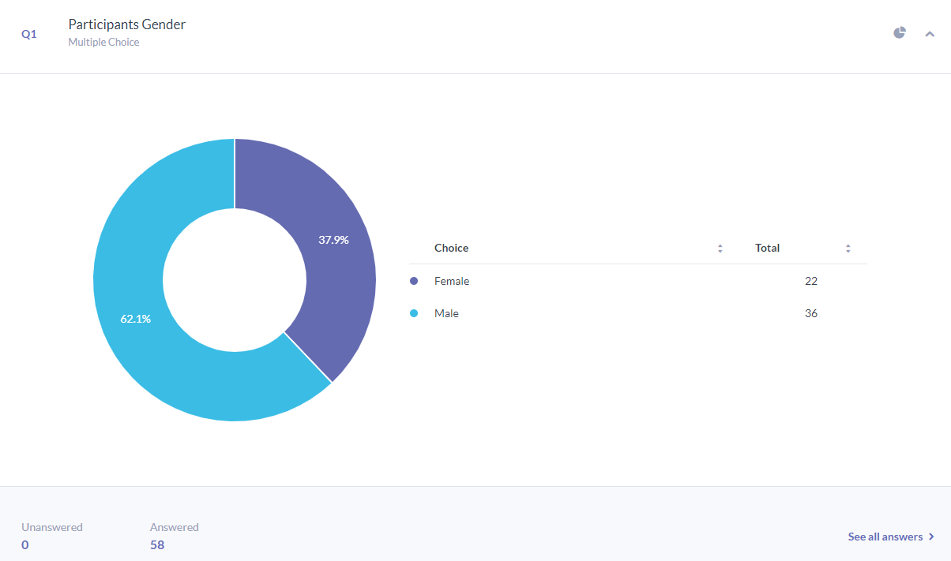
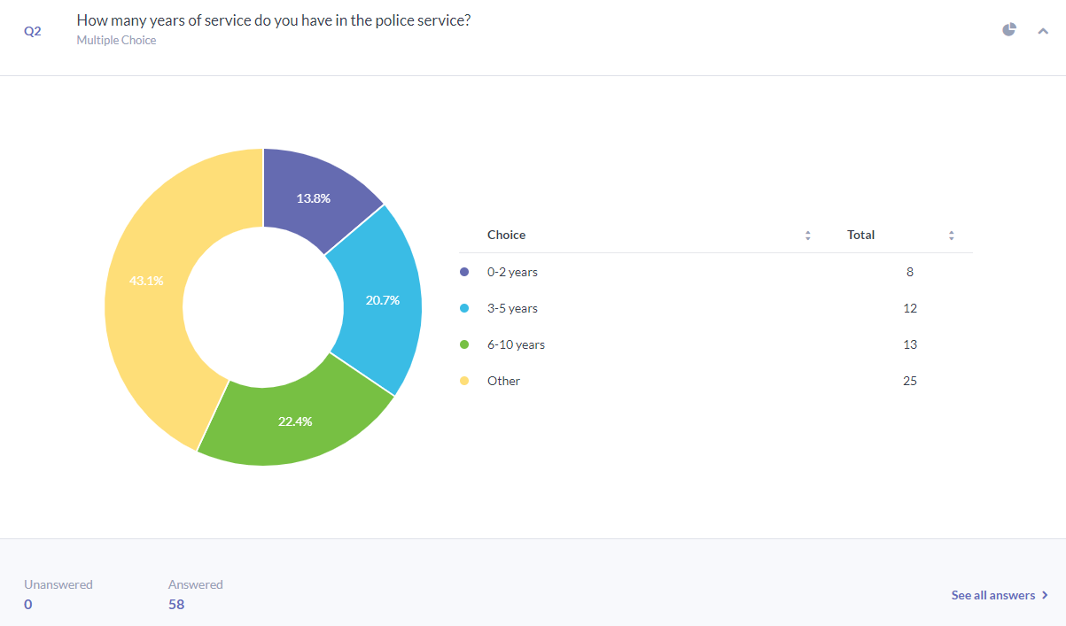
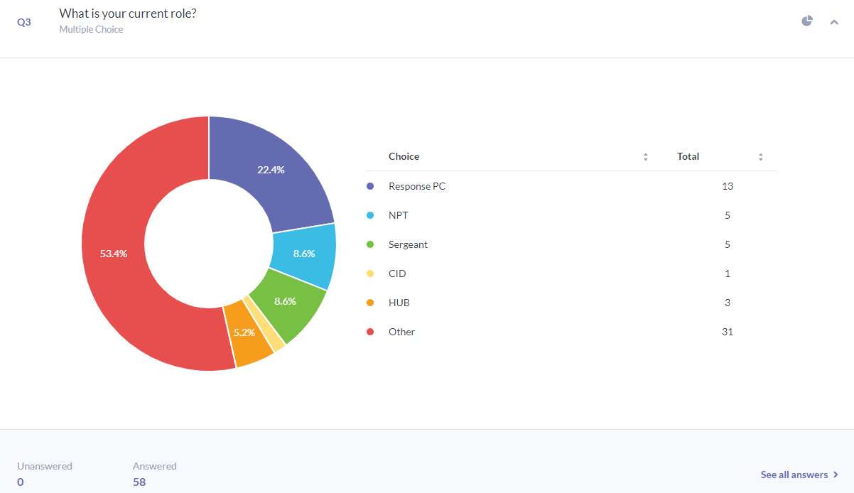

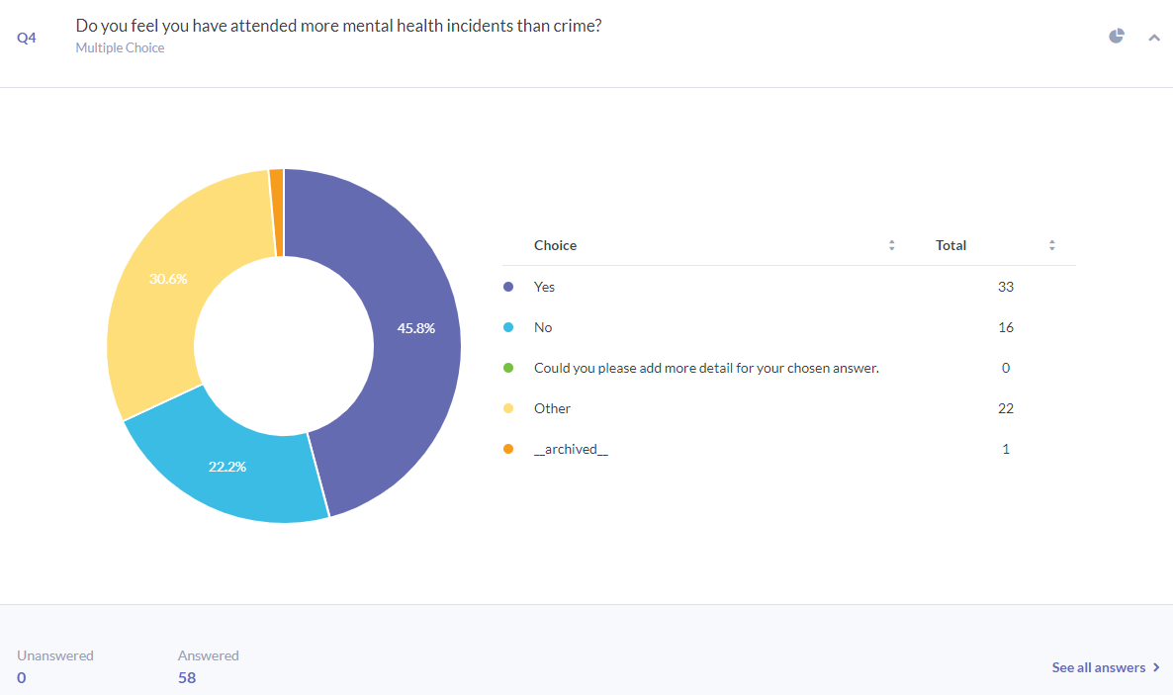

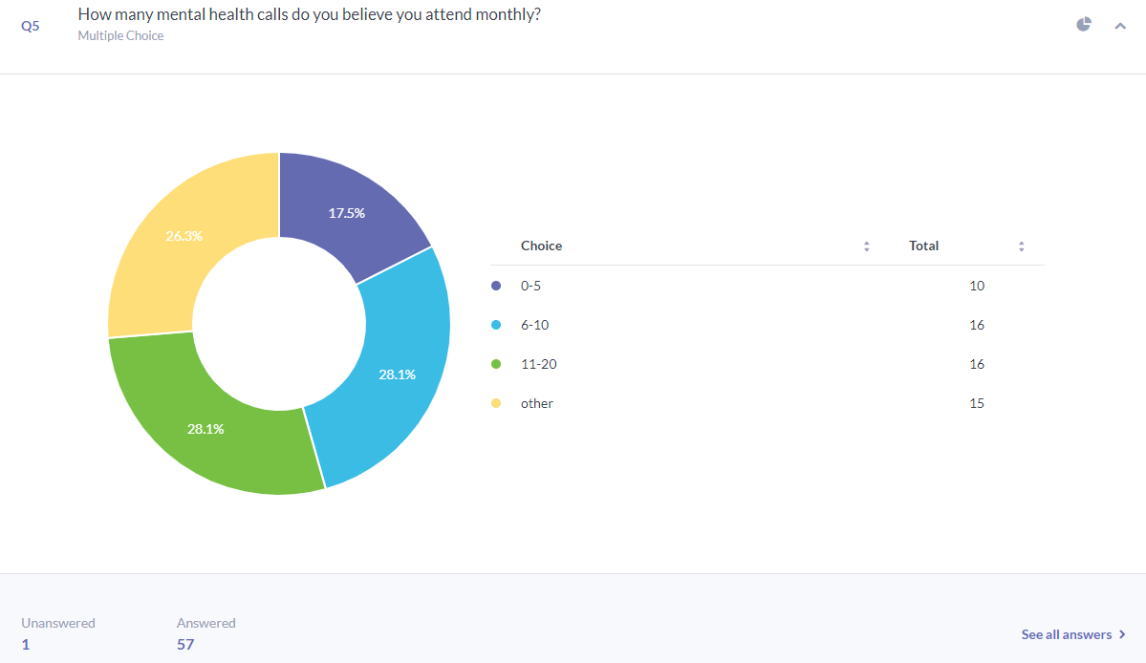

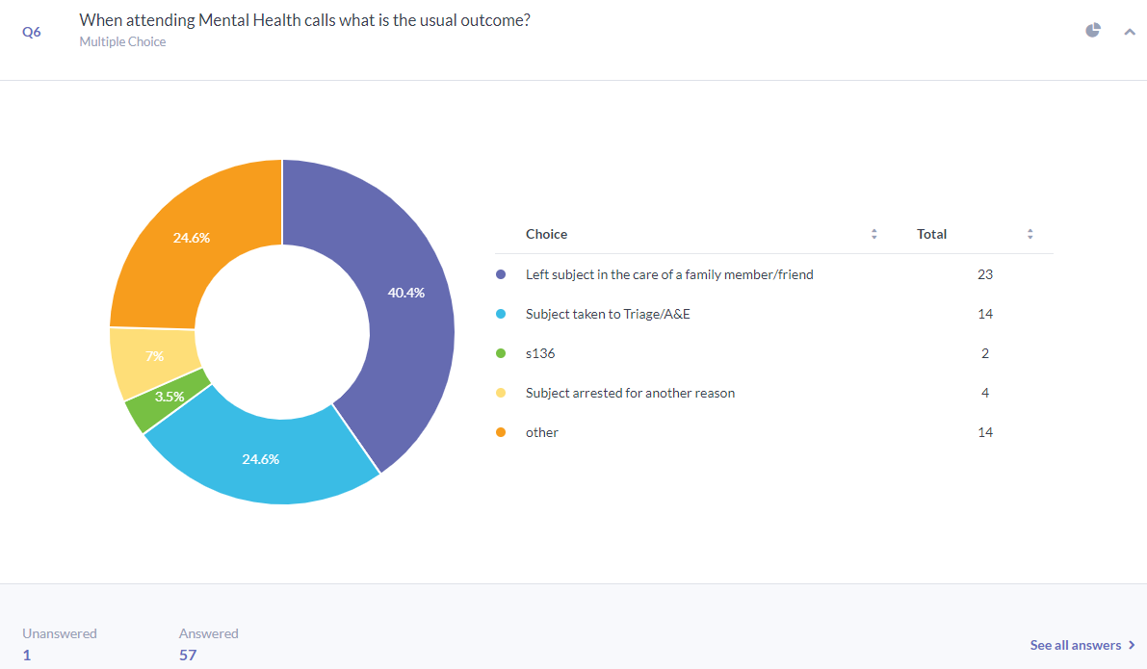

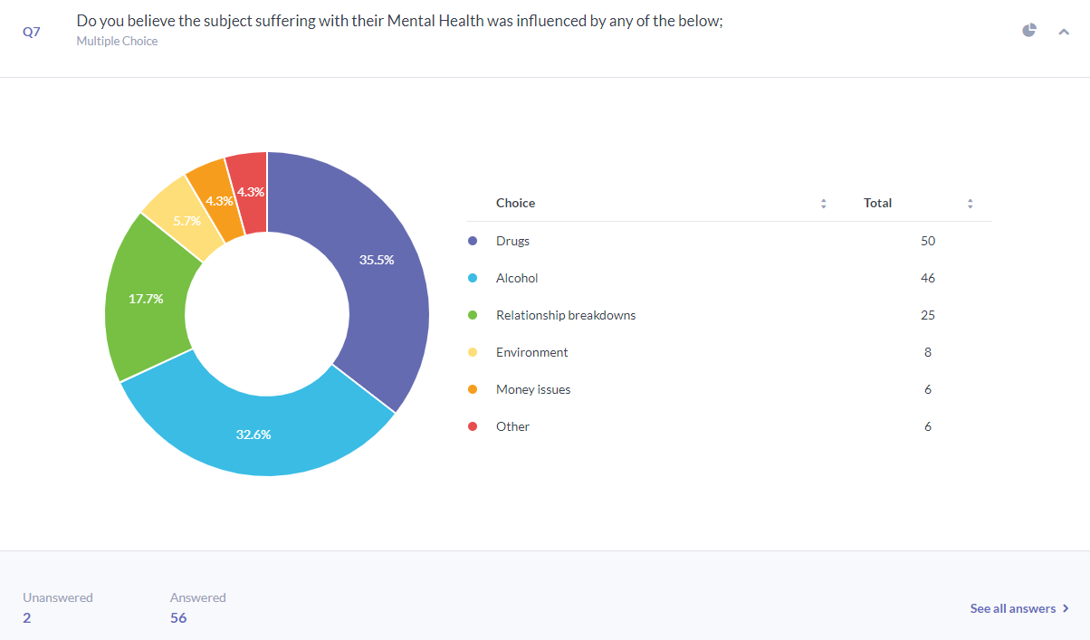
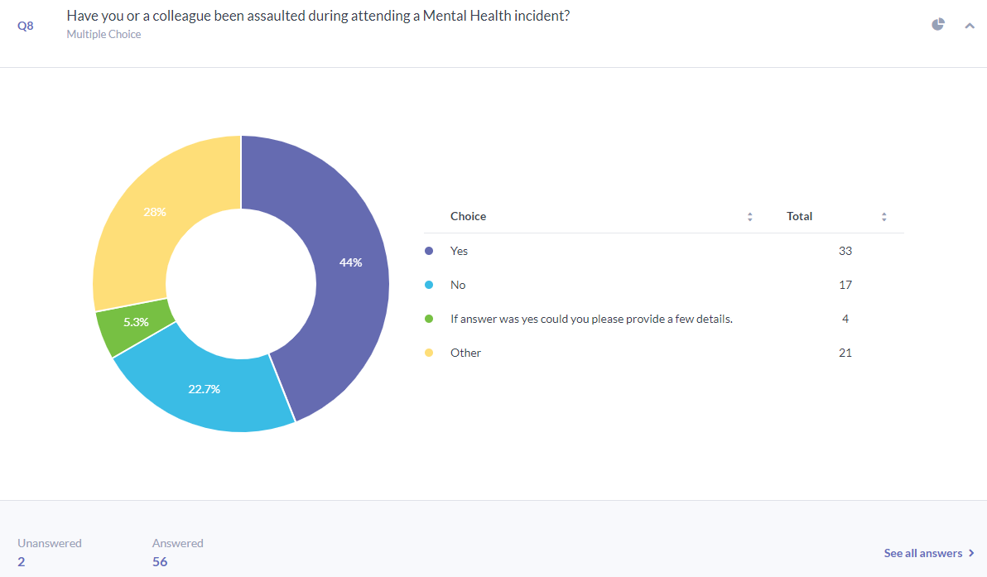
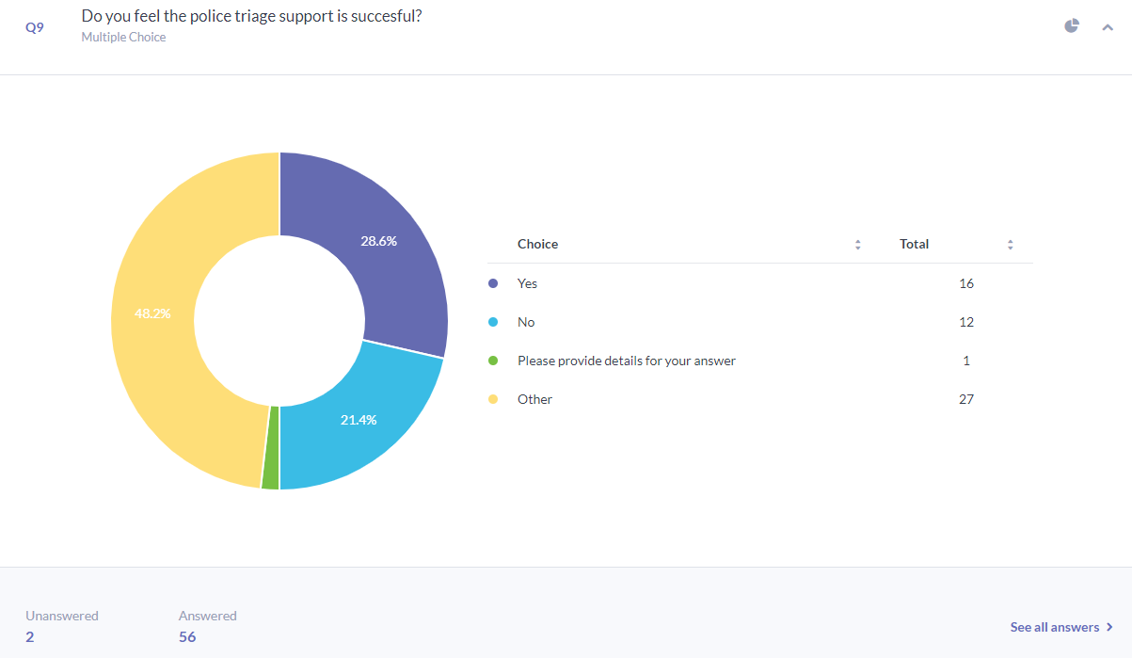

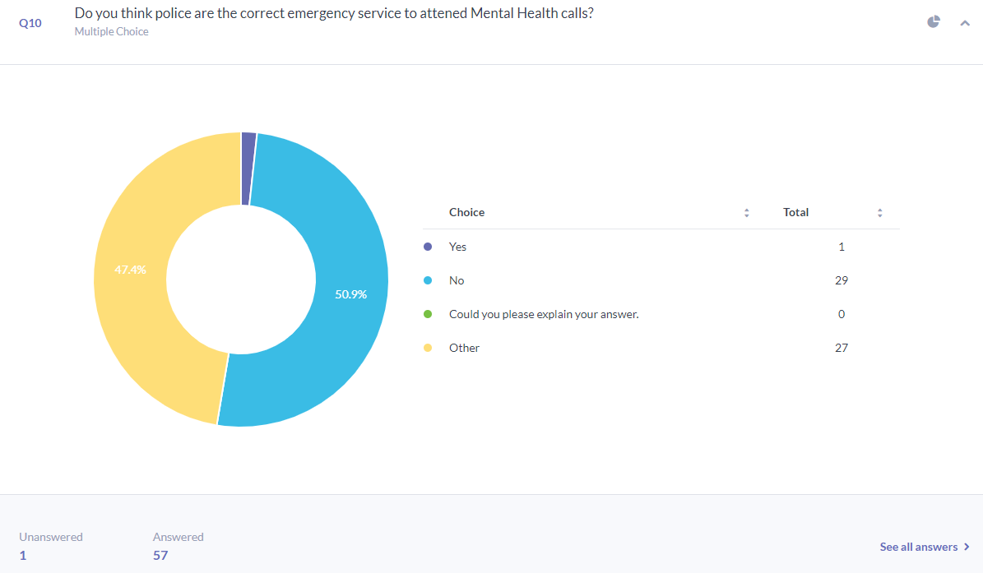
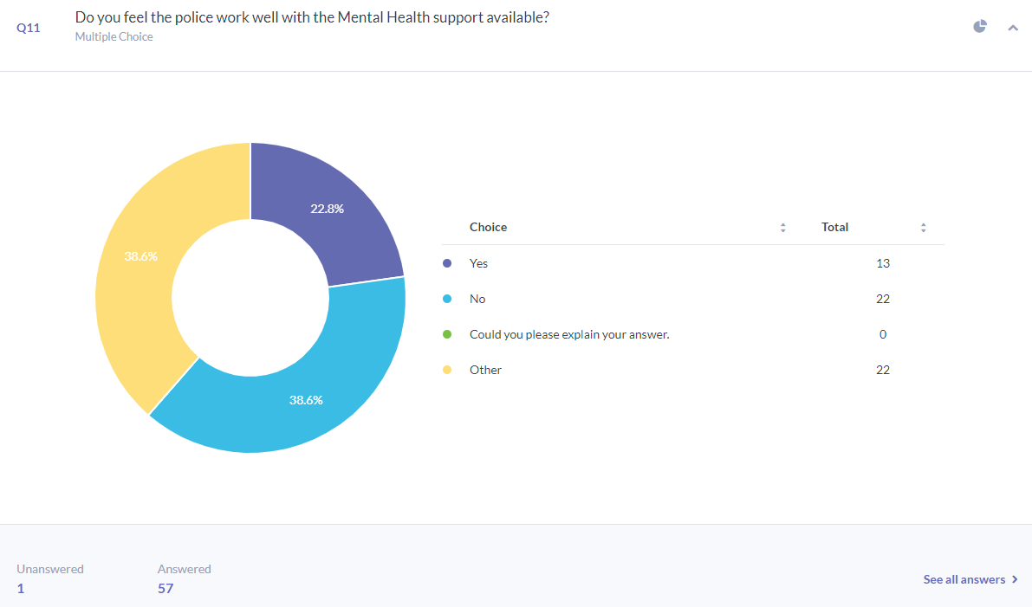
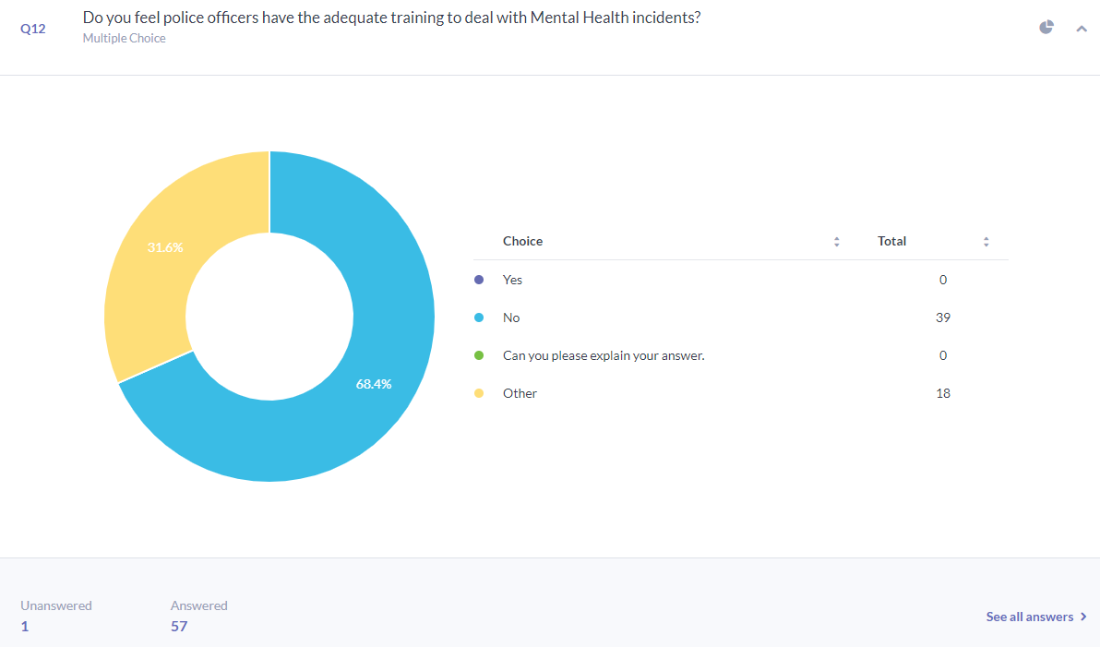

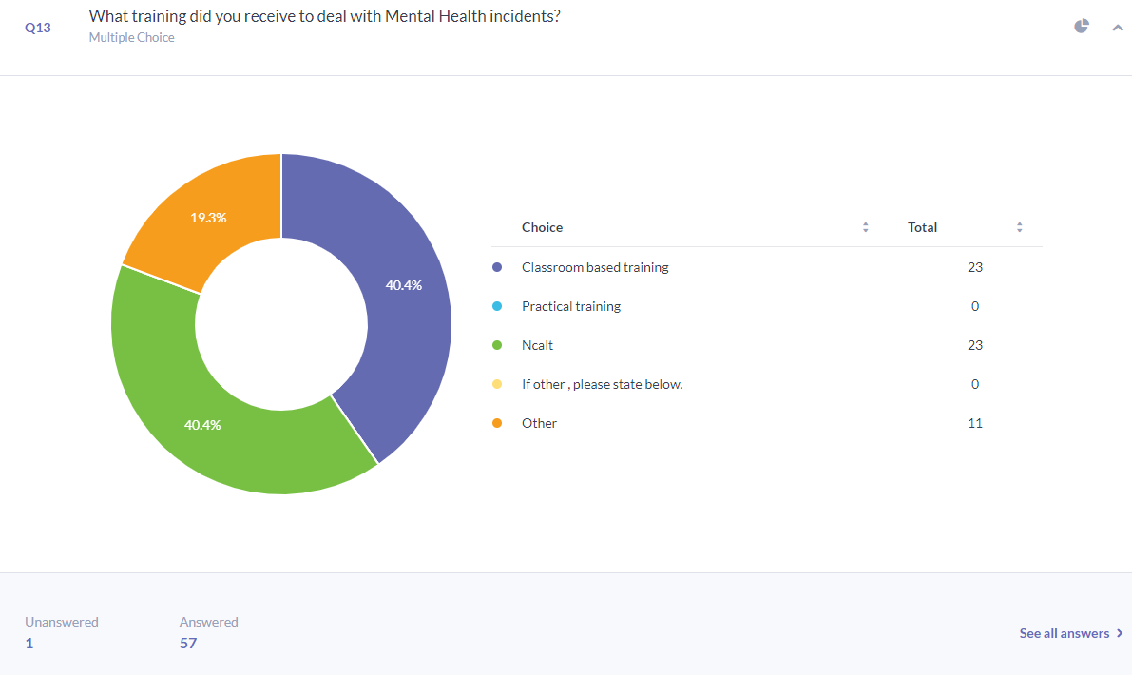

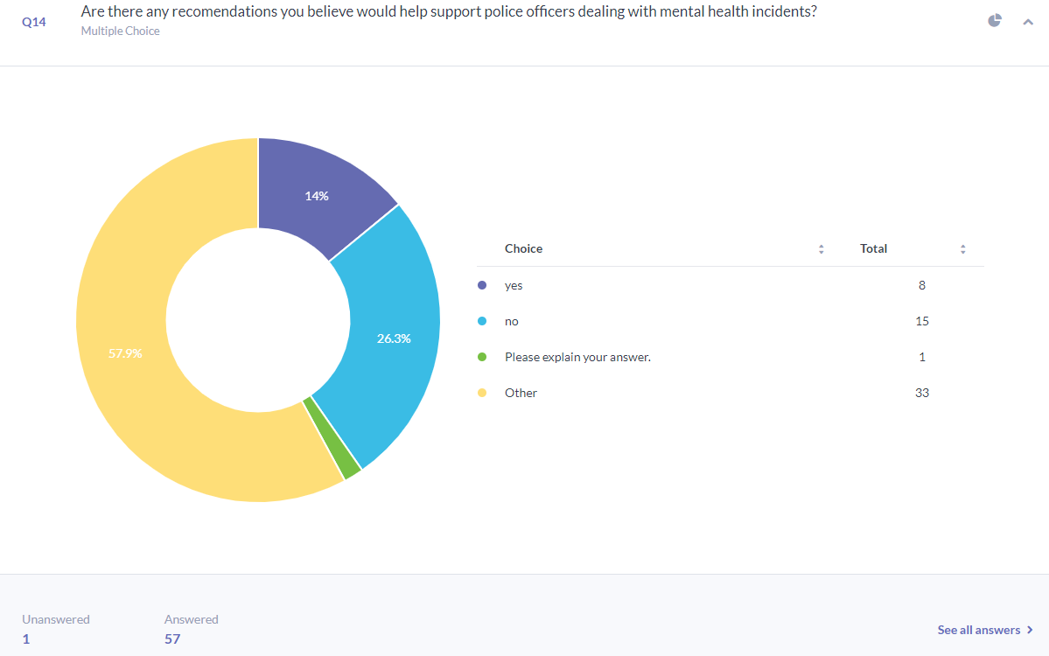

Appendix C: survey written response.

Participants comments to question 1: Participants gender?

- P58
  - Male
- P57
  - Male
- P56
  - Male
- P55
  - Female
- P54
  - Female
- P53
  - Male
- P52
  - Female
- P51
  - Male
- P50
  - Male
- P49
  - Male
- P48
  - Male
- P47
  - Male
- P46
  - Female
- P45
  - Male
- P44
  - Female
- P43
  - Male
- P42
  - Male
- P41
  - Female
- P40
  - Male
- P39
  - Male
- P38
  - Female
- P37
  - Male
- P36
  - Male
- P35
  - Female
- P34
  - Female
- P33
  - Male
- P32
  - Female
- P31
  - Male
- P30
  - Male
- P29
  - Female

Participant Details
  - Male
- P28
  - Male
- P27
  - Female
- P26
- P25
  - Male
- P24
  - Male
- P23
  - Male
- P22
  - Female
- P21
  - Male
- P20
  - Female
- P19
  - Male
- P18
  - Male
- P17
  - Male
- P16
  - Female
- P15
  - Female
- P14
  - Male
- P13
  - Female
- P12
  - Male
- P11
  - Male
- P10
  - Female
- P9
  - Female
- P8

  - Male
- P7
  - Male
- P6
  - Male
- P5
  - Female
- P4
  - Female
- P3
  - Female
- P2
  - Male
- P1
  - Male

Participants comments to question 2: How many years of service do you have in the police service?
- P58
  - 0-2 years
- P57
  - Other
- P56
  - 6-10 years
- P55
  - Other
- P54
  - 6-10 years
- P53
  - Other
- P52
  - Other
- P51
  - 6-10 years
- P50
  - 0-2 years
- P49
  - 3-5 years
- P48
  - Other
- P47
  - Other
- P46
  - Other
- P45
  - Other
- P44
  - 6-10 years
- P43
  - Other
- P42
  - Other
- P41
  - 6-10 years
- P40
  - Other
- P39
  - 3-5 years
- P38
  - 6-10 years
- P37
  - Other
- P36
  - Other
- P35
  - Other
- P34
  - 0-2 years
- P33
  - Other
- P32
  - Other
- P31
  - 6-10 years
- P30
  - 3-5 years
- P29
  - 6-10 years
- P29
  - 6-10 years
- P28
  - Other
- P27
  - Other
- P26
  - Other
- P25
  - 6-10 years
- P24
  - Other
- P23
  - 6-10 years
- P22
  - 0-2 years
- P21
  - 3-5 years
- P20
  - 0-2 years
- P19
  - 3-5 years
- P18
  - Other
- P17
  - 0-2 years
- P16
  - Other
- P15
  - 6-10 years
- P14
  - Other
- P13
  - 3-5 years
- P12
  - Other
- P11
  - 3-5 years
- P10
  - 0-2 years
- P9
  - 3-5 years
- P8
  - 6-10 years
- P7
  - 3-5 years
- P6
  - 3-5 years
- P5
  - 3-5 years
- P4
  - 0-2 years
- P3
  - 6-10 years
- P2
  - 3-5 years
- P1
  - Other

Participants comments to question 3: what is your current roll?

- P58
  - Response PC
- P57
  - Sergeant
- P56
  - Response PC
- P55
  - Sergeant
- P54
  - Sergeant
- P53
  - Other
- P52
  - Other
- P51
  - Other
- P50
  - HUB
- P49
  - HUB
- P48
  - Sergeant
- P47
  - Other
- P46
  - Other
- P45
  - Other
- P44
  - NPT
- P43
  - Other
- P42
  - Sergeant
- P41
  - Other
- P40
  - Other
- P39
  - Response PC
- P38
  - Other
- P37
  - Other
- P36
  - Other
- P35
  - Response PC
- P34
  - Other
- P33
  - NPT
- P32
  - Other
- P31
  - CID
- P30
  - Other
- P29
  - Other

  - Other
- P28
  - Other
- P27
  - Other
- P26
  - Other
- P25
  - Other
- P24
  - Other
- P23

  - NPT
- P22
  - Other
- P21
  - Other
- P20
  - Other
- P19
  - Other
- P18
  - Other
- P17
  - Response PC
- P16
  - Other
- P15
  - HUB
- P14
  - Other
- P13
  - Response PC
- P12
  - Other
- P11
  - Response PC
- P10
  - Response PC
- P9
  - NPT
- P8
  - NPT
- P7
  - Response PC
- P6
  - Response PC
- P5
  - Response PC
- P4
  - Response PC
- P3
  - Other
- P2
  - Response PC
- P1
  - Other

Participants comments to question 4: Do you feel you have attended more mental health incidents than crime?

- P58

  - Yes
  - Other: A lot of mental health calls stating the individual is suicidal
- P57
  - No
  - Other: Many of the people we come into contact with have mental health related conditions, but I wouldn't say the incidents we attend are primarily MH incidents, we attend more crime WITH a MH element than solely MH incidents
- P56
  - Yes
  - Other: I would estimate twice as many MH calls
- P55
  - Yes
  - Other: When on response - not so much now promoted
- P54
  - Yes
- P53
  - Other
- P52
  - No
- P51
  - No
- P50
  - No
- P49
  - No
- P48

  - Yes
  - Other: Been in the force for 23 years and there is a huge disparity in the number of mental health calls we now attend
- P47

Jan 4
  - No
- P46
  - Yes
  - No
  - Other: Bit of both, however always a lot of MH calls on response.
- P45
  - Other: My role does not involve attending incidents
- P44
  - Yes
- P43
- P42
  - No
- P41
  - No
- P40
  - Other: 50% of incidents I deal with are socio-economic or mental health related.
- P39
  - Other: I attend more crimes however the persons involved in the crimes will often have some form of mental health issues
- P38
  - Yes
  - Other: When I was on response it felt like there was a lot of calls which were mental health related.
- P37
  - Other: Not in a front-line role
- P36
  - Yes
- P35
  - Yes
- P34
  - No
- P33
- P32
  - Yes
- P31
  - Yes
- P30
  - Yes
- P29
  - Yes
- P28

  - Other: As a member of the SMT I no longer attend incidents but am acutely aware of the volume of calls that are a public safety welfare incident. This is replicated across the force, and whilst within policing we refer to them as Mental Health incidents from a purely health perspective they do not fall into the health service definition. Whatever you standpoint however the police service are being over deployed to incidents that should not be attended by police, as we are not equipped to deal with what we are faced with
- P27
  - Yes
- P26
  - Other: similar but over the years it has gone from crime to mental health
- P25

  - Yes
  - Other: The majority of calls have some mental health element to it. Including some crime incidents.
- P24

anonymous

Jan 4
  - No
- P23
  - Yes
- P22
  - Yes
- P21
  - No
- P20

  - Other: I AM NOT AN ATTENDING OFFICER (SEO POLICE STAFF)
- P19
  - No
- P18

  - Yes
- P17
- P16
  - Other: I am a Trim assessor and I understand the effects that some incidents have which relate to mental health.
- P15
  - No
- P14
  - Other: As a FIM I oversaw the whole Force and every incident that came in. I would say in my experience that there are definitely more MH incidents attended than crime incidents. A reason for this could be that we close off a lot of crimes at first point of contact or they get dealt with remotely whereas MH is a vulnerability and 9/10 requires officer attendance due to serious failings with our partners
- P13
  - Yes
- P12
  - Yes
  - Other: Misper, suicidal crisis calls, self-harm
- P11
  - Yes
- P10
  - Yes
- P9
  - Yes
- P8
  - Yes
  - If you have answered yes could you please add more detail.
- P7
  - Yes
  - Other: Every we call we go to, even if not actually MH the subject will claim MH issues
- P6
  - Yes
  - Other: It feels like I rarely deal with any crime
- P4
  - Yes
  - Other: Everyday there is a concern call
- P3
  - Yes
- P2
  - Yes
- P1
  - Yes

Participants comments to question 5: How many mental health calls do you believe you attended monthly?

- P58
  - 6-10
- P57
  - other
- P56
  - 11-20
- P55
  - 6-10
- P54
  - other
- P52
  - 0-5
- P51
  - 6-10
- P50
  - 11-20
- P49
  - other
- P48
  - 11-20
- P47
  - 0-5
- P46
  - 6-10
- P45
  - other
- P44
  - 6-10
- P43
  - other
- P42
  - 0-5
- P41
  - 0-5
- P40
  - 0-5
- P39
  - 11-20
- P38
  - other
- P37
  - other
- P36
  - 11-20
- P35
  - other
- P34
  - other
- P33
  - 0-5
- P32
  - other
- P31
  - 0-5
- P30
  - 11-20
- P29
  - 6-10
- P28
  - 6-10
- P27
  - 6-10
- P26
  - 6-10
- P25
  - other
- P24
  - other
- P23
  - 11-20
- P22
  - other
- P21
  - 0-5
- P20
  - other
- P19
  - 0-5
- P18
  - 6-10
- P17
  - 6-10
- P16
  - 6-10
- P15
  - 0-5
- P14
  - other
- P13
  - 11-20
- P12
  - 11-20
- P11
  - 11-20
- P10
  - 6-10
- P9
  - 6-10
- P8
  - 6-10
- P7
  - 11-20
- P6
  - 11-20
- P5
  - 11-20
- P4
  - 11-20
- P3
  - 11-20
- P2
  - 11-20
- P1

  - 6-10

Participants comments to question 6 : When attending mental health calls what is the usual outcome?

- P58
  - Subject taken to Triage/A&E
- P57
  - Left subject in the care of a family member/friend
- P56
  - Left subject in the care of a family member/friend
- P55
  - Left subject in the care of a family member/friend
- P54
  - Left subject in the care of a family member/friend
- P52
  - Subject arrested for another reason
- P51
  - Left subject in the care of a family member/friend
- P50
  - Subject taken to Triage/A&E
- P49
  - Left subject in the care of a family member/friend
- P48
  - Left subject in the care of a family member/friend
- P47
  - other
- P46
  - Left subject in the care of a family member/friend
- P45
  - other
- P44
  - Subject taken to Triage/A&E
- P43
  - Subject arrested for another reason
- P42
  - Left subject in the care of a family member/friend
- P41
  - Subject taken to Triage/A&E
- P40
  - other
- P39
  - Left subject in the care of a family member/friend
- P38
  - other
- P37
  - other
- P36
  - other
- P35
  - Left subject in the care of a family member/friend
- P34
  - Subject taken to Triage/A&E
- P33
  - other
- P32
  - Left subject in the care of a family member/friend
- P31
  - Left subject in the care of a family member/friend
- P30
  - Left subject in the care of a family member/friend
- P29
  - Subject taken to Triage/A&E
- P28
  - Subject arrested for another reason
- P27
  - Subject taken to Triage/A&E
- P26
  - Left subject in the care of a family member/friend
- P25
  - Left subject in the care of a family member/friend
- P24
  - other
- P23
  - Left subject in the care of a family member/friend
- P22
  - Subject taken to Triage/A&E
- P21
  - other
- P20
  - other
- P19
  - other
- P18
  - Subject arrested for another reason
- P17
  - Subject taken to Triage/A&E
- P16
  - other
- P15
  - Subject taken to Triage/A&E
- P14
  - other
- P13
  - Left subject in the care of a family member/friend
- P12
  - other
- P11
  - Subject taken to Triage/A&E
- P10
  - Subject taken to Triage/A&E
- P9
  - Subject taken to Triage/A&E
- P8
  - Left subject in the care of a family member/friend
- P7
  - Left subject in the care of a family member/friend
- P6
  - s136
- P5
  - s136
- P4
  - Left subject in the care of a family member/friend
- P3
  - Subject taken to Triage/A&E
- P2
  - Left subject in the care of a family member/friend
- P1
  - Left subject in the care of a family member/friend

Participants comments to question 7: Do you believe the subject suffering with their mental health was influenced by any of the below?
- P58
  - Drugs
  - Alcohol
- P57
  - Drugs
  - Alcohol
  - Relationship breakdowns
- P56
  - Drugs
  - Alcohol
  - Relationship breakdowns
- P55
  - Drugs
  - Alcohol
  - Money issues
- P54
  - Drugs
  - Alcohol
  - Relationship breakdowns
- P52
  - Drugs
  - Alcohol
  - Relationship breakdowns
- P51
  - Drugs
  - Alcohol
  - Relationship breakdowns
- P50
  - Drugs
  - Alcohol
- P49
  - Drugs
  - Alcohol
  - Other
- P48
  - Drugs
- P47
  - Drugs
  - Alcohol
  - Environment
- P46
  - Drugs
  - Alcohol
  - Environment
- P45
  - Other
- P44
  - Drugs
  - Relationship breakdowns
  - Environment
- P43
  - Drugs
  - Alcohol
  - Relationship breakdowns
- P42
  - Drugs
  - Alcohol
  - Environment
- P41
  - Drugs
  - Alcohol
  - Money issues
- P40
  - Relationship breakdowns
  - Environment
  - Money issues
- P39
  - Drugs
  - Alcohol
  - Relationship breakdowns
- P38
  - Drugs
  - Alcohol
  - Relationship breakdowns
- P36
  - Drugs
  - Alcohol
  - Relationship breakdowns
- P35
  - Drugs
  - Alcohol
  - Relationship breakdowns
- P34
  - Drugs
  - Alcohol
  - Money issues
- P33
  - Drugs
  - Alcohol
- P32
  - Alcohol
  - Relationship breakdowns
  - Money issues
- P31
  - Drugs
- P30
  - Drugs
  - Alcohol
  - Relationship breakdowns
- P29
  - Drugs
  - Alcohol
- P28
  - Drugs
  - Alcohol
  - Relationship breakdowns
- P27
  - Drugs
  - Alcohol
- P26
  - Drugs
  - Alcohol
  - Other
- P25
  - Drugs
  - Relationship breakdowns
- P24
  - Drugs
  - Alcohol
  - Environment
- P23
  - Drugs
  - Alcohol
- P22
  - Drugs
  - Alcohol
  - Relationship breakdowns
- P21
  - Drugs
  - Alcohol
  - Relationship breakdowns
- P20

  - Other
- P19
  - Other
- P18
  - Drugs
  - Alcohol
- P17
  - Drugs
  - Alcohol
  - Relationship breakdowns
- P16
  - Environment
  - Other
- P15
  - Drugs
  - Alcohol
- P14
  - Drugs
  - Alcohol
  - Relationship breakdowns
- P13
  - Drugs
  - Alcohol
  - Relationship breakdowns
- P12
  - Drugs
  - Alcohol
  - Relationship breakdowns
- P11
  - Drugs
  - Alcohol
- P10
  - Drugs
  - Alcohol
  - Relationship breakdowns
- P9
  - Drugs
  - Alcohol
  - Money issues
- P8
  - Drugs
  - Alcohol
- P7
  - Drugs
  - Alcohol
- P6
  - Drugs
- P5
  - Drugs
  - Alcohol
  - Environment
- P4
  - Drugs
  - Alcohol
- P3
  - Drugs
  - Alcohol
  - Relationship breakdowns
- P2
  - Drugs
  - Alcohol
  - Relationship breakdowns
- P1
  - Drugs
  - Alcohol

Participants comments to question 8: Have you or a colleague been assaulted during a mental health incident?

- P58
  - Yes
  - Other: Been spat at.
- P57
  - Yes
  - If answer was yes could you please provide a few details.
  - Other: Several times - However, as mentioned earlier it's difficult to draw a line between MH incidents and solely crime incidents. They overlap
- P56
  - Yes
- P55
  - Yes
  - Other: Struck whilst detaining
- P54
  - Yes
  - If answer was yes could you please provide a few details.
- P52
  - Yes
- P51
  - Yes
- P50
  - No
- P49
  - Yes
  - Other: Assaulted by being punched whilst assisting with a S.135 MHA
- P48
  - Yes
  - Other: Due to manic episodes have been punched etc
- P47
  - No
- P46
  - Yes
  - Other: Female who was due to be sectioned when detaining her assaulted myself and colleague's however no injuries to anyone.
- P45
  - Other: N/A
- P44
  - Yes
  - Other: kicked when trying to section
- P43
  - No
- P42
  - Yes
  - If answer was yes could you please provide a few details.
  - Other: Numerous assaults over the years ranging from pushes and slaps to full-blown aggression with weapons.
- P41
  - No
- P40
  - No
- P39
  - Yes
- P38
  - No
- P36
  - Yes
- P35
  - Yes
  - Other: detaining male for a 135
- P34
  - No
- P33
  - Yes
  - Other: Substance abuse was a factor but althrough MH issues they were charged with the offence
- P32
  - Other: Not Relevant
- P31
  - Yes
- P30
  - No
- P29
  - Yes
- P28
  - Yes
  - Other: Frequently assaulted and regularly encountered active resistance, but rarely recorded as such owing to the overwhelming sense of compassison taht officers tend to try and exhibit at these calls.
- P27
  - No
- P26
  - Yes
- P25
  - If answer was yes could you please provide a few details.
  - Other: Male has kicked out at officers whilst being detained.
- P24
  - Other
- P23
  - No
- P22
  - Yes
- P21
  - No
- P20
  - Other
- P19
  - No
- P18
  - Yes
- P17
  - Yes
  - Other: I was kicked in my shin.
- P16
  - Other
- P15
  - Yes
- P14
  - No
- P13
  - Yes
- P12
  - Yes
  - Other: Bruises from detaining
- P11
  - No
- P10
  - Yes
- P9
  - Yes
  - Other: Kicked and attacked
- P8
  - Yes
- P7
  - No
- P6
  - No
- P5
  - Yes
  - Other: Kicked, hit
- P4
  - No
- P3
  - Yes
- P2
  - Yes
- P1
  - Yes

Participants comments to question 9: Do you feel the police triage support is successful?

- P58
  - No
- P57
  - Other: unfortunately policing has evolved to be a branch of social services and even with triage processes we will always be the default agency to attend and deal where health practitioners are almost always better suited in my opinion
- P56
  - Yes
- P55
  - Other: Would be useful if able to speak direct more often than through control.
- P54
  - Other: sometimes if they are working/available.
- P52
  - Yes
- P51
  - Other: Never accessed
- P50
  - Other: They don't tend to provide concrete advise and are not available at all hours
- P49
  - Other: New to SWP, don't have sufficient experience within this force to comment
- P48
  - Other: Provides vital advice and allows officers to leave person at scene
- P47
  - No
- P46
  - Yes
- P45
  - Other: N/A
- P44
  - Yes
- P43
  - Yes
- P42
  - Yes
- P41
  - No
- P40
  - Yes
- P39
  - Yes
- P38
  - Other: I am not sure I haven’t not been on front line policing for a couple of years.
- P36
  - No
- P35
  - Other: can provide advice and signpost to other services police not aware of
- P34
  - No
- P33
  - Other: It’s a lot better than before
- P32
  - Yes
- P31
  - No
- P30

  - Please provide details for your answer
- P29
  - No
- P28
  - Other: It is useful in understanding history and what services are open to the subjects but, there is nothing to deal with the immediacy of the situation or the threat the person poses to themselves or otherwise, and as a result there remains that overriding fear that when officers walk away from the subject left in the care of another that something may occur, leading to wider issues / IOPC etc
- P27
  - Yes
- P26
  - Other: depends on the situation and how willing the person is to engage
- P25
  - Other: It has improved with the MHT in PSC offering advice and info.
- P24
  - Other
- P23
  - Yes
- P22
Participant Details
  - Other: On occasions however it is not a 24/7 service
- P21
  - Other: Needs to be 24/7
- P20
  - Other: NO KNOWLEDGE OF THIS PROCEDURE, DUE TO JOB ROLE
- P19
  - Other
- P18
  - No
- P17
  - Other: Its successful when they are in however their opening hours are not the best.
- P16
  - Yes
- P15
  - Other: Not used the police triage in current role
- P14
  - No
- P13
  - No
- P12
  - Other: Police should not be initial go to for MH calls
- P11
  - Other: I think the PSC triage can be helpful but has its limitations. It is plugging a gap simply to free up officers from being stuck at MH calls. This helps police resources but doesn't necessarily address the systemic issue for people suffering with MH, which just leads to more MH calls anyway.
- P10
  - Yes
- P9
  - No
- P8
  - Yes
- P7
  - Other: Mht team don't work 24/7 and won't talk to intoxicated people when most of the time people suffering MH resort to alcohol/drugs
- P6
  - Yes
- P5
  - Other: They don’t tell you anything valuable. They just say we’ll you can either leave them or 136 them it’s up to you. Or they say they’re not open to mental health services so we can’t do anything
- P4
  - Other: They are not 24/7
- P3
  - Yes
- P2
  - Other: They are not open at the right hours and won't speak to people if they are intoxicated which is 9x out of 10 the people we deal with!
- P1
  - No

Participants comments to question 10: Do you think police are the correct emergency service to attend mental health calls?

- P58
  - No
- P57
  - Other: Please see previous answer - we are the default but often a medical professional would be far better suited
- P56
  - Other: We do not have the required skills, training or resources to manage these incidents
- P55
  - Other: joint approach required
- P54
  - Other: Absolutely not. mental health is an illness and should be dealt with by the health services.
- P52
  - No
- P51
  - Other: Depends on the circs I suppose. In conjunction with a Rapid Response MH Team.
- P50
  - No
- P49
  - Other: Not usually, but sometimes at least in initial response
- P48
  - Other: This is clearly a health issue
- P47
  - No
- P46
  - No
- P45
  - Other: Other partner agencies could attend with police as a way forward or police attend to support a more relevant agency if required rather than be the first port of call
- P44
  - No
- P43
  - No
- P42
  - Other: I believe that Social Services and NHS Mental Health Services should provide an emergency response capability which Policing supports in order to maintain public safety when the need arises.
- P41
  - No
- P40
  - Other: Police are used to deal with the consequences of the reduction of MH/Care & support services; very often when the subject is vulnerable and showing signs of aggression or self-harm. This shows a total failure of the MH service and Police are left to resolve these problems using the Criminal Justice Service.
- P39
  - Other: we do not have the appropriate training to deal with MH calls
- P38
  - No
- P37
  - No
- P36
  - No
- P35
  - No
- P34
  - No
- P33
  - Other: If that person is a risk to themselves or others. Other agencies simply aren't equipped.
- P32
  - No
- P31
  - No
- P30
  - Other: No. We exist to prevent and detect crime and enforce the law, not to comfort people who are upset.
- P29
  - No
- P28
  - Other: MH is a complex area that requires professional training well beyond what is achievable to deliver to police. The types of incidents require a level of service and commitment that we cannot continue to deliver, if only in the sense if time constraints.
- P27
  - Other: we do not have the expertise to deal and whilst waiting the extremely long time to deal with the incident, there are victims of crime who do not receive the service that they should
- P26
  - No
- P25
  - No
- P24
  - Other: Not always although risk to life / self-harm can often involve use of sharp objects.
- P23
  - No
- P22
  - Other: No - not trained in mental health
- P21
  - Other: It’s a difficult one, we should only attend to ensure the safety of the MH team, if there appears to be T/R/H
- P20
  - Other: SHOULD BE MEDICAL CALL TO AMBULANCE AS THE FIRST POINT OF CALL
- P19
  - No
- P18
  - Other: What are the core roles of a police officer? Save life and limb? doesn’t cover MH
- P17
  - Other: We should be policing crimes.
- P16
  - Yes
- P15
  - No
- P14
  - Other: We are not trained to deal with MH.
- P13
  - No
- P12
Participant Details
  - Other: Other agencies better qualified should be primary contact
- P11
  - No
- P10
  - No
- P9
  - No
- P8
  - No
- P7
  - Other: Not trained, and I wouldn't want to be trained. I joined to deal with crime is not a MH support worker
- P6
  - No
- P5
  - Other: It is an ambulance matter
- P4
  - Other: It's a medical issue not a crime
- P3
  - No
- P2
  - Other: We investigate crimes do not provide medical support. We are being taken advantage of by all other services and then criticised when we can't do our own role, but other services aren't!
- P1
  - No

Participants comments to question 11: Do you feel the police work well with the mental health support available?

- P58
  - No
- P57
  - Other: We work within our capabilities in that our hands are largely tied due to the inaction of other agencies. If we don’t take decisive action incidents could and would escalate and significant harm be caused to the person suffering with mental ill health and also others. We also do not provide sufficient support for our staff in managing their mental ill health - MH champions and phrases such as 'it's ok not to be ok' are largely for optics alone - we don’t not support our staff
- P56
  - Yes
- P55
  - Other: MHT show history but still police decision on how dealt with - some clarification from MH would be useful
- P54
  - Yes
- P52
  - No
- P51
  - No
- P50
  - No
- P49
  - No
- P48
  - Other: There is minimal support available
- P47
  - No
- P46
  - Other: Could all work together more.
- P45
  - Other: Not known from my role / experience
- P44
  - Yes
- P43
  - Yes
- P42
  - Yes
- P41
  - No
- P40
  - Other: Too much emphasis is passed onto the Police by other agencies to come up with an immediate resolution.
- P39
  - Yes
- P38
  - Yes
- P37
  - Yes
- P36
  - No
- P35
  - Other: out of hours services could be better. people don’t always have a breakdown between 9-5
- P34
  - No
- P33
  - Other: Could be better. MH support often need to be pushed by Police taking enforcement action take positive action themselves
- P32
  - Other: Frustrated When Referring regarding response time
- P31
  - Other: The mental health team rely too heavily on the police to sort the situation. It's sad as majority of people need help but the triage team, maybe through poor staffing levels do not help vulnerable people.
- P30
  - Other
- P29
  - Other
- P28
  - Other: As well as can be expected with the resoruces available to each agency. Delays at assessment units etc are not down to the individuals that we deal with professionally it is a capacity issue. The protocols developed are indicative of this, and would work in a perfect world.

- P27
  - No
- P26
  - Other: we try our very best but at the end of the day we can only do so much and don’t have the required training that is often needed
- P25
  - Yes
- P24
  - Other: I retired 2 years ago and am not fully aware of current agreements.
- P23
  - Yes
- P22
  - No
- P21
  - No
- P20
  - Other: FROM WHAT I KNOW, ITS AN US AND THEM SITUATION ON A REGULAR BASIS
- P19
  - No
- P18
  - Other: The police say yes to help and deal with everything
- P17
  - No
- P16
  - Yes
- P15
  - No
- P14
  - Other: NHS in Wales is underfunded and they don’t have the time or resources to deal with MH properly. This is then pushed back to Police.
- P13
  - No
- P12
  - Other: Too much time spent waiting once agencies know police are dealing
- P11
  - No
- P10
  - No
- P8
  - No
- P7
  - Other: Not enough support. Partner agencies always passing the buck and resort to police to step in
- P6
  - No
- P5

  - Other: The mental health support don’t want to help the police
- P4
  - Yes
- P3
  - No
- P2
  - Other: We are left for hours at hospital babysitting until the person is assessed whilst the MH team are sat in the office talking and drinking a hot beverage. I've witnessed this many times!
- P1

Participants comments to question 12:
Do you feel police officers have the adequate training to deal with mental health incidents?

- P58
  - No
- P57
  - Other: We teach legislative and form filling but it's very much throwing staff in at the deep end and learning on their feet
- P56
  - No
- P55
  - No
- P54
  - Other: we are not mental health/medical professionals. we have had inputs and NCALTS but that doesn’t make us qualified to determine the course of treatment for someone's mental health issues.
- P52
  - No
- P51
  - No
- P50
  - No
- P49
  - No
- P48
  - Other: We have limited powers and are being used as the stop gap for other services
- P47
  - No
- P46
  - No
- P45
  - Other: Mental Health is quite a specialist area and so would require upskilling / knowledge
- P44
  - No
- P43
  - No
- P42
  - Other: Primary role of Police is to preserve life and to prevent crime. So far as fulfilling our primary role our training is sufficient, however; The world of mental health is exceptionally complicated and there will always be occasions when officers feel ill-prepared for the circumstances they face. As an organisation we should avoid placing our officers and staff into situations which they are not qualified to deal with and where an alternative and more appropriate resource exists i.e. Mental Health Services from Local Authority and NHS. .
- P41
  - No
- P40
  - Other: MH workers spend years training for their role. A couple of NCALT packages will not provide Police officers with the training or confidence to resolve these incidents confidently.
- P39
  - No
- P38
  - No
- P37
  - No
- P36
  - No
- P35
  - Other: basic training of mental health issues is not enough however more training could be done in other areas as well
- P34
  - No
- P33
  - Other: Front line officers don't but more specialist officers have enhanced understanding/training
- P32
  - No
- P31
  - Other: Not truly applicable - we shouldn’t be dealing with them in the first instance
- P29
  - No
- P28
  - Other: If we train to a higher level then there will be a greater expectation that we continue to fill this void. Society needs to realise that policing has limited powers to deal with people in crisis and we are not and should not be expected to deal with such calls on such a high degree of regularity.
- P27
  - No
- P26
  - No
- P25
  - No
- P24
  - Other: I gained more of an oversight after having extensive training in PPU to assist VA's
- P23
  - No
- P22
  - No
- P21
  - Other: 55 slide PowerPoint and that's it, no training what so ever, any tom, dick or harry could sit in a class and be talked at about a PowerPoint
- P20
  - Other: UNSURE WHAT TRAINING OFFICERS ARE GIVEN
- P19
  - No
- P18
  - Other: Police officers are not trained medical professionals
- P17
  - No
- P16
  - No
- P15
  - No
- P14
  - No
- P13
  - No
- P12
  - Other: Not trained in MH issues
- P11
  - No
- P10
  - No
- P9
  - No
- P8
  - No
- P7
  - No
- P6
  - No
- P5
  - Other: 0 training
- P4
  - No
- P2
  - No
- P1
  - No

Participants comments to question 13: What training did you receive to deal with mental health incidents?

- P58
  - Other: None
- P57
  - Ncalt
- P56
  - Classroom based training
- P55
  - Classroom based training
- P54
  - Ncalt
- P52
  - Ncalt
- P51
  - Classroom based training
- P50
  - Ncalt
- P49
  - Ncalt
- P48
  - Other: Have had no real further training since initial training in 2000
- P47
  - Other: None
- P46
  - Ncalt
- P45
  - Other: N/A
- P44
  - Ncalt
- P43
  - Classroom based training
- P42
  - Other: All of the above.
- P41
  - Ncalt
- P40
  - Other: 1 day class by a trainer that did not know the subject matter and was reading it as they went along.
- P39
  - Classroom based training
- P38
  - Classroom based training
- P37
  - Other: At the time when i attended calls such as this, i received no training. NCALT has come much later
- P36
  - Classroom based training
- P35
  - Classroom based training
- P34
  - Ncalt
- P33
  - Other: External
- P32
  - Ncalt
- P31
  - Ncalt
- P30
  - Classroom based training
- P29
  - Classroom based training
- P28
  - Other: Combination of all the above is available.
- P27
  - Ncalt
- P25
  - Ncalt
- P24
  - Classroom based training
- P23
  - Classroom based training
- P22
  - Classroom based training
- P21
  - Classroom based training
- P20
  - Classroom based training
- P19
  - Ncalt
- P18
  - Ncalt
- P17
  - Classroom based training
- P16
  - Classroom based training
- P15
  - Ncalt
- P14
  - Ncalt
- P13
  - Ncalt
- P12
  - Ncalt
- P11
  - Classroom based training
- P10
  - Ncalt
- P9
  - Classroom based training
- P8
  - Ncalt
- P7
  - Ncalt
- P6
  - Classroom based training
- P5
  - Other: PowerPoint on Microsoft teams
- P4
  - Classroom based training
- P3
  - Classroom based training
- P2
  - Classroom based training
- P1
  - Other

Participants comments to question 14: Are there any recommendations you believe would help support police officers dealing with mental health incidents?

- P58
  - Other: Training and support at the hospital
- P57
  - Other: Talk, honest, frank discussions with colleagues and supervisors in assessing how incidents went but also a more joined up approach with medical practitioners whether this be an area car staffed by police and medics or an adequate triage by call takers
- P56
  - no
- P55
  - yes
- P54
  - Other: Mental health car as trialled in other BCU's previously. a response vehicle containing a paramedic, a mental health worker and a Police officer.
- P52
  - no
- P51
  - no
- P50
  - Other: More support from other services. More support in terms of dedicated teams to relieve pressure
- P49
  - yes
- P48
  - Other: Further training and signposting to support services would be beneficial
- P47
  - Other: Investment in greater social care.
- P46
  - no
- P45
  - Other: Specialised training, involvement of partner agencies
- P44
  - Other: yes support from ambulance or mental health services also more training and more powers around mental health
- P43
  - no
- P42
  - Other: Deal with the Policing priorities first - i.e preserve life, prevent/detect crime. Take control of the situation so that things can be slowed down and mental health issues addressed appropriately. Do the best job you can in the circumstances and it'll go a long way to reducing future demand from the individuals involved.
- P41
  - no
- P40
  - Other: MH services need to attend these calls and take primacy. Police officers should only be needed if there is a threat of violence.
- P39
  - Other: dedicated MH triage car comprising of a police officer and MH practitioner who are supervised by a AMHP
- P38
  - no
- P37
  - Other: In the current climate where all services have virtually no available funding or resources which has the knock on effect of frontline shortages in other services, i think that any solutions to this issue are a long way off.
- P36
  - no
- P35
  - no
- P34
  - Other: qualified mental health professionals attending calls with Officers as has been trialled in other forces
- P33
  - Other: MDT exist and are not utilised enough. referrals requesting to address repeat callers etc are low and needs to be addressed
- P32
  - Other: Better Training
- P31
  - Other: Clear advice on mental health calls, how to deal, when to section. If clearly a mental health call, should not be attending hospital and waiting with victims. Police should be dealing with crime, not sitting down the hospital sitting with people who want to be at the hospital on a voluntary basis. I have previously waited for 8-10 hours with a victim who was compliant, but asked to wait as previously been aggressive. Until police and mental health teams sit down and work together, this will not change.
- P30
  - Other
- P29
  - no
- P28
  - Other: Recognition of decision making. If Triage / mental health professionals make a decision, - that is under their professional judgement. They re responsible for this and will need to justify it. Police need to start to walk away when we do not have the appropriate powers or consent to act.
- P58
  - Other: Training and support at the hospital
- P57
  - Other: Talk, honest, frank discussions with colleagues and supervisors in assessing how incidents went but also a more joined up approach with medical practitioners whether this be an area car staffed by police and medics or an adequate triage by call takers
- P56
  - no
- P55
  - yes
- P54
  - Other: Mental health car as trialled in other BCU's previously. a response vehicle containing a paramedic, a mental health worker and a Police officer.
- P52
  - no
- P51
  - no
- P50
  - Other: More support from other services. More support in terms of dedicated teams to relieve pressure
- P49
  - yes
- P48
  - Other: Further training and signposting to support services would be beneficial
- P47
  - Other: Investment in greater social care.
- P46
  - no
- P45
  - Other: Specialised training, involvement of partner agencies
- P44
  - Other: yes support from ambulance or mental health services also more training and more powers around mental health
- P43
  - no
- P42
  - Other: Deal with the Policing priorities first - i.e preserve life, prevent/detect crime. Take control of the situation so that things can be slowed down and mental health issues addressed appropriately. Do the best job you can in the circumstances and it'll go a long way to reducing future demand from the individuals involved.
- P41
  - no
- P40
  - Other: MH services need to attend these calls and take primacy. Police officers should only be needed if there is a threat of violence.
- P39
  - Other: dedicated MH triage car comprising of a police officer and MH practitioner who are supervised by a AMHP
- P38
  - no
- P37
  - Other: In the current climate where all services have virtually no available funding or resources which has the knock on effect of frontline shortages in other services, i think that any solutions to this issue are a long way off.
- P36
  - no
- P35
  - no
- P34
  - Other: qualified mental health professionals attending calls with Officers as has been trialled in other forces
- P33
  - Other: MDT exist and are not utilised enough. referrals requesting to address repeat callers etc are low and needs to be addressed
- P32
  - Other: Better Training
- P31
  - Other: Clear advice on mental health calls, how to deal, when to section. If clearly a mental health call, should not be attending hospital and waiting with victims. Police should be dealing with crime, not sitting down the hospital sitting with people who want to be at the hospital on a voluntary basis. I have previously waited for 8-10 hours with a victim who was compliant, but asked to wait as previously been aggressive. Until police and mental health teams sit down and work together, this will not change.
- P30
  - Other
- P29
  - no
- P28
  - Other: Recognition of decision making. If Triage / mental health professionals make a decision, - that is under their professional judgement. The re responsible for this and will need to justify it. Police need to start to walk away when we do not have the appropriate powers or consent to act.
- P27
  - yes
- P26
  - Other: be mindful of why you are there and remember your own personal safety first
- P25
  - Other: Get professional advice as early as possible.
- P24
  - Other: Professional debriefs to ensure any chosen actions were the best ones.
- P23
  - yes
- P22
  - Other: A 24/7 on call emergency service dedicated to mental health
- P21
  - no
- P20
  - Other
- P19
  - no
- P18
  - Other: Allow MH trained staff to deal with the incidents
- P17
  - Other: A mental health car where the main focus is to attend such calls to take the pressure off response officers
- P16

  - no
- P15
  - Other: Better training to look for signs
- P14
  - yes
- P13
  - yes
- P12
  - Other: Designated MH team on call to attend incidents via health providers not police
- P11
  - Other: Further funding for MH services to lessen the burden on police
- P10
  - no
- P9
  - Other: More training and the PSC actually telling people NO!
- P8
  - yes
- P7
  - Other: Stop dealing with MH calls. Attend to assist the partner agencies in safeguarding them and the patient but only attend in conjuction with the partner agency
- P6
  - Please explain your answer.
- P5
  - Other: It shouldn’t be a police matter
- P4
  - Other: Sort out NHS
- P3
  - no
- P2
  - Other: Put the onus on the other services!
- P1
  - yes

APPLICATION FOR ETHICAL APPROVAL

In order for research to result in benefit and minimise risk of harm, it must be conducted ethically. A researcher may not be covered by the University’s insurance if ethical approval has not been obtained prior to commencement.

The University follows the OECD Frascati manual definition of research activity: “creative work undertaken on a systematic basis in order to increase the stock of knowledge, including knowledge of man, culture and society, and the use of this stock of knowledge to devise new applications”. As such this covers activities undertaken by members of staff, postgraduate research students, and both taught postgraduate and undergraduate students working on dissertations/projects.

The individual undertaking the research activity is known as the “principal researcher”.

Ethical approval is not required for routine audits, performance reviews, quality assurance studies, testing within normal educational requirements, and literary or artistic criticism.

Please read the notes for guidance before completing ALL sections of the form.

This form must be completed and approved prior to undertaking any research activity. Please see Checklist for details of process for different categories of application.

Delete the Guidance Notes at the end of the form BEFORE submitting your application

SECTION A: About You (Principal Researcher)
Full Name: |  | Rebecca Guiver
Tick all boxes which apply: |  | Member of staff: | ☐ | Honorary research fellow: | ☐
Undergraduate Student | ☐ | Taught Postgraduate Student | ☐ | Postgraduate Research Student | ☒

Institute/Academic Discipline/Centre:
Campus: | Swansea
E-mail address: | 1922462@uwtsd@ac.uk
Contact Telephone Number:
For students:
Student Number: | 1922462
Programme of Study: | Bachelor of science: Professional Policing Practice
Director of Studies/Supervisor: | Michelle Hill (supervisor)

SECTION B: Approval for Research Activity
Has the research activity received approval in principle?  (please check the Guidance Notes as to the appropriate approval process for different levels of research by different categories of individual) |  | YES | ☐ | NO | ☒
 |  |  |  | Date
If Yes, please indicate source of approval (and date where known): Approval in principle must be obtained from the relevant source prior to seeking ethical approval | Research Degrees Committee |  | ☐
 | Institute Research Committee |  | ☐
 | Other (write in) |  | ☐

SECTION C: Internal and External Ethical Guidance Materials
Please list the core ethical guidance documents that have been referred to during the completion of this form (including any discipline-specific codes of research ethics, and also any specific ethical guidance relating to the proposed methodology). Please tick to confirm that your research proposal adheres to these codes and guidelines.
UWTSD Research Ethics & Integrity Code of Practice | ☒
UWTSD Research Data Management Policy | ☒
 | ☐

SECTION D: External Collaborative Research Activity
Does the research activity involve collaborators outside of the University? |  | YES | ☐ | NO | ☒
If Yes, please provide the name of the external organisation and name and contact details for the main contact person and confirmation this person has consented to their personal data being shared.as part of this collaboration.
Institution
Contact person name
Contact person e-mail address

Has this individual consented to sharing their details on this form? |  | YES | ☐ | NO |  |  | ☒
Are you in receipt of a KESS scholarship? |  | YES | ☐ | NO |  |  | ☒
Is your research externally funded |  | YES | ☐ | NO |  |  | ☒
Are you specifically employed to undertake this research in either a paid or voluntary capacity? | Voluntary | YES | ☐ | NO |  | ☒
 | Employed | YES | ☐ | NO |  | ☒
Is the research being undertaken within an existing UWTSD Athrofa Professional Learning Partnership (APLP) | If YES then the permission question below does not need to be answered. | YES | ☐ | NO |  |  | ☒
Permission to undertake the research has been provided by the partner organisation | (If YES attach copy)  If NO the application cannot continue | YES | ☐ | NO |  |  | ☒

Where research activity is carried out in collaboration with an external organisation
Does this organisation have its own ethics approval system? | YES | ☐ | NO | ☒
If Yes, please attach a copy of any final approval (or interim approval) from the organisation

SECTION E: Details of Research Activity
Indicative title: | An investigation to determine how mental health calls are impacting the police service.
Proposed start date: | 15/08/22 | Proposed end date: | 27/03/23
Introduction to the Research (maximum 300 words)
Ensure that you write for a Non-Specialist Audience when outlining your response to the three points below:
- Purpose of Research Activity
- Proposed Research Question
- Aims of Research Activity
- Objectives of Research Activity
Demonstrate, briefly, how Existing Research has informed the proposed activity and explain
- What the research activity will add to the body of knowledge
- How it addresses an area of importance.
Purpose of Research Activity

This research is to investigate to determine how mental health calls are impacting the police service.

This research will explore why police are the first service to be approached for a mental health crisis instead of trained mental health professionals.
During my research project I will highlight, and research emerging issues caused by police officers attending mental health incidents.

This research will explore the thoughts and opinions of dealing with mental health incidents from serving police officers.

This research will explore what training Police officers undergo to deal with mental health incidents and if they believe they are adequately trained.
(this box should expand as you type)
Research Question

- How mental health calls are impacting the police service.
- Why police are the first service to be approached for a mental health crisis.
- What training police officers undergo so they can deal with mental health incidents.
- Are police officers adequately trained and skilled to deal with mental health incidents.
(this box should expand as you type)
Aims of Research Activity

The purpose of this investigation to determine how mental health calls impact the police service.

The research aim is to research the above and to explore the reasons why police are the first service to be approached for a mental health crisis instead of trained mental health professionals.

My research aim is to explore the thoughts and opinions of dealing with mental health incidents from serving police officers.

My second aim is to explore what training Police officers undergo so they can deal with mental health incidents and to analyse if police officers feel they are adequately skilled to be dealing with an individual suffering with their mental health.

(this box should expand as you type)
Objectives of Research Activity

Objective 1: An investigation to determine how mental health calls impact the police service.

Objective 2: To analyse why police are the first service to be approached for a mental health crisis.

Objective 3: To explore what training Police officers undergo so they can deal with mental health incidents.

(this box should expand as you type)
Proposed methods (maximum 600 words)
Provide a brief summary of all the methods that may be used in the research activity, making it clear what specific techniques may be used. If methods other than those listed in this section are deemed appropriate later, additional ethical approval for those methods will be needed.
For the purpose of this research, I will utilise a variety of research methods, I aim to access a range of material that is relevant to police attending mental health incidents.
I will produce a survey to serving police officers to gain an understanding of their thoughts of dealing with mental health incidents.
Participants will be able to access the survey by accessing a link online which will only be available to those who work within South Wales police. The survey can be completed anonymously.

The survey will start by establishing the participants length of service and the department they work in.
The researcher will aim to gather opinions from all areas of South Wales police.
The survey will include questions to establish how many mental health calls police officers go to weekly.
The survey will include questions around the training police officers receive to deal with mental health incidents.
The survey will also ask other questions from emerging issues with police officers dealing with mental health incidents.

I will ensure that my questions aren’t leading and are available to all persons working within South Wales police.

(this box should expand as you type)

Location of research activity
Identify all locations where research activity will take place.
N/A

(this box should expand as you type)
Research activity outside of the UK
If research activity will take place overseas, you are responsible for ensuring that local ethical considerations are complied with and that the relevant permissions are sought. Specify any local guidelines (e.g. from local professional associations/learned societies/universities) that exist and whether these involve any ethical stipulations beyond those usual in the UK (provide details of any licenses or permissions required). Also specify whether there are any specific ethical issues raised by the local context in which the research activity is taking place, for example, particular cultural and/or legal sensitivities or vulnerabilities of participants.
(this box should expand as you type)
Use of documentation not in the public domain: Are any documents NOT publicly available? | NO | ☒
 | YES | ☐
If Yes, please provide details here of how you will gain access to specific documentation that is not in the public domain and that this is in accordance with prevailing data protection law of the country in question and England and Wales.

(this box should expand as you type)

SECTION F: Scope of Research Activity
Will the research activity include: | YES | NO
Use of a questionnaire or similar research instrument? | ☒ | ☐
Use of interviews? | ☒ | ☐
Use of diaries? | ☐ | ☒
Participant observation with their knowledge? | ☐ | ☒
Participant observation without their knowledge? | ☐ | ☒
Use of video or audio recording? | ☐ | ☒
Access to personal or confidential information without the participants’ specific consent? | ☐ | ☒
Administration of any questions, test stimuli, presentation that may be experienced as physically, mentally or emotionally harmful / offensive? | ☐ | ☒
Performance of any acts which may cause embarrassment or affect self-esteem? | ☐ | ☒
Investigation of participants involved in illegal activities? | ☐ | ☒
Use of procedures that involve deception? | ☐ | ☒
Administration of any substance, agent or placebo? | ☐ | ☒
Working with live vertebrate animals? | ☐ | ☒
Other primary data collection methods, please explain in this box  For example, ‘focus groups’. Please indicate the type of data collection method(s) in this box and tick the accompany box. | ☐ | ☐
Details of any other primary data collection method:  (this box should expand as you type) | ☐ | ☐
If NO to every question, then the research activity is (ethically) low risk and may be exempt from some of the following sections (please refer to Guidance Notes).

If YES to any question, then no research activity should be undertaken until full ethical approval has been obtained.

SECTION G: Intended Participants
Who are the intended participants: | YES | NO
Students or staff at the University? | ☐ | ☒
Adults (over the age of 18 and competent to give consent)? | ☒ | ☐
Vulnerable adults? | ☐ | ☒
Children and Young People under the age of 18? (Consent from Parent, Carer or Guardian will be required) | ☐ | ☒
Prisoners? | ☐ | ☒
Young offenders? | ☐ | ☒
Those who could be considered to have a particularly dependent relationship with the investigator or a gatekeeper? | ☐ | ☒
People engaged in illegal activities? | ☐ | ☒
Others (please identify specifically any group who may be unable to give consent) please indicate here and tick the appropriate box. | ☐ | ☒
Other – please indicate here:  (this box should expand as you type) | ☐ | ☒

Participant numbers and source
Provide an estimate of the expected number of participants. How will you identify participants and how will they be recruited?
How many participants are expected? | Approximately 20+  (this box should expand as you type)
Who will the participants be? | Police officers and staff within South Wales police.  (this box should expand as you type)
How will you identify the participants? | Participants will only be identified by choice. All participants have the option to be kept anonymous.  Participants will be able to gain access to the survey via a link which will be placed on an online portal.  (this box should expand as you type)

Information for participants: | YES | NO | N/A
Will you describe the main research procedures to participants in advance, so that they are informed about what to expect? | ☒ | ☐ | ☐
Will you tell participants that their participation is voluntary? | ☒ | ☐ | ☐
Will you obtain written consent for participation? | ☐ | ☐ | ☒
Will you explain to participants that refusal to participate in the research will not affect their treatment or education (if relevant)? | ☐ | ☐ | ☒
If the research is observational, will you ask participants for their consent to being observed? | ☐ | ☐ | ☒
Will you tell participants that they may withdraw from the research at any time and for any reason? | ☒ | ☐ | ☐
With questionnaires, will you give participants the option of omitting questions they do not want to answer? | ☒ | ☐ | ☐
Will you tell participants that their data will be treated with full confidentiality and that, if published, it will not be identifiable as theirs? | ☒ | ☐ | ☐
Will you debrief participants at the end of their participation, in a way appropriate to the type of research undertaken? | ☒ | ☐ | ☐
If NO to any of above questions, please give an explanation
(this box should expand as you type)

Information for participants: | YES | NO | N/A
Will participants be paid? | ☐ | ☒ | ☐
Is specialist electrical or other equipment to be used with participants? | ☐ | ☒ | ☐
Are there any financial or other interests to the investigator or University arising from this study? | ☐ | ☒ | ☐
Will the research activity involve deliberately misleading participants in any way, or the partial or full concealment of the specific study aims? | ☐ | ☒ | ☐
If YES to any question, please provide full details
(this box should expand as you type)

SECTION H: Anticipated Risks

Outline any anticipated risks that may adversely affect any of the participants, the researchers and/or the University, and the steps that will be taken to address them.

If you have completed a full risk assessment (for example as required by a laboratory, or external research collaborator) you may append that to this form.
Full risk assessment completed and appended? |  | Yes | ☐
 |  | No | ☒
Risks to participants
For example: emotional distress, financial disclosure, physical harm, transfer of personal data, sensitive organisational information
Risk to Participant:  (this box should expand as you type) | How will you mitigate the Risk to Participant  (this box should expand as you type)
If research activity may include sensitive, embarrassing or upsetting topics (e.g. sexual activity, drug use) or issues likely to disclose information requiring further action (e.g. criminal activity), give details of the procedures to deal with these issues, including any support/advice (e.g. helpline numbers) to be offered to participants. Note that where applicable, consent procedures should make it clear that if something potentially or actually illegal is discovered in the course of a project, it may need to be disclosed to the proper authorities
(this box should expand as you type)
Risks to investigator
For example: personal safety, physical harm, emotional distress, risk of accusation of harm/impropriety, conflict of interest
Risk to Investigator:  (this box should expand as you type) | How will you mitigate the Risk to Investigator:  (this box should expand as you type)
University/institutional risks
For example: adverse publicity, financial loss, data protection
Risk to University:  (this box should expand as you type) | How will you mitigate the Risk to University:  (this box should expand as you type)

Disclosure and Barring Service
If the research activity involves children or vulnerable adults, a Disclosure and Barring Service (DBS) certificate must be obtained before any contact with such participants. | YES | NO | N/A
Does your research require you to hold a current DBS Certificate? | ☐ | ☒ | ☐

SECTION I: Feedback, Consent and Confidentiality
Feedback
What de-briefing and feedback will be provided to participants, how will this be done and when?
There will be no need to de-brief participants for the survey as this will be confidential and anonymous to ensure people will provide honest feedback.

(this box should expand as you type)
Informed consent
Describe the arrangements to inform potential participants, before providing consent, of what is involved in participating. Describe the arrangements for participants to provide full consent before data collection begins. If gaining consent in this way is inappropriate, explain how consent will be obtained and recorded in accordance with prevailing data protection legislation.
All participants will be briefed on the purpose of my research and made aware that all data collected will be kept confidential.

(this box should expand as you type)
Confidentiality / Anonymity
Set out how anonymity of participants and confidentiality will be ensured in any outputs. If anonymity is not being offered, explain why this is the case.
My survey will have the option of the participants details being kept anonymous.

My research is open and honest, if participants wish to be kept anonymous then they shall be.

(this box should expand as you type)

SECTION J: Data Protection and Storage
In completing this section refer to the University’s Research Data Management Policy and the extensive resources on the University’s Research Data Management web pages (http://uwtsd.ac.uk/library/research-data-management/).
Does the research activity involve personal data (as defined by the General Data Protection Regulation 2016 “GDPR” and the Data Protection Act 2018 “DPA”)? | YES | NO
“Personal data” means any information relating to an identified or identifiable natural person (‘data subject’). An identifiable natural person is one who can be identified, directly or indirectly, in particular by reference to an identifier such as a name, an identification number, location data, an online identifier or to one or more factors specific to the physical, physiological, genetic, mental, economic, cultural or social identity of that natural person. | ☐ | x
If YES, provide a description of the data and explain why this data needs to be collected:
(this box should expand as you type)
Does it involve special category data (as defined by the GDPR)? | YES | NO
“Special category data” means sensitive personal data consisting of information as to the data subjects’ –  (a) racial or ethnic origin,  (b) political opinions,  (c ) religious beliefs or other beliefs of a similar nature,  (d) membership of a trade union (within the meaning of the Trade Union and Labour Relations (Consolidation) Act 1992),  (e) physical or mental health or condition,  (f) sexual life,  (g) genetics,  (h) biometric data (as used for ID purposes), | ☐ | x
If YES, provide a description of the special category data and explain why this data needs to be collected:
(this box should expand as you type)
Will the research activity involve storing personal data and/or special category data on one of the following: | YES | NO
Manual files (i.e. in paper form)? | ☐ | ☒
University computers? | ☐ | ☒
Private company computers? | ☐ | ☒
Home or other personal computers? | ☐ | ☒
Laptop computers/ CDs/ Portable disk-drives/ memory sticks? | ☐ | ☒
“Cloud” storage or websites? | ☐ | ☒
Other – specify: | ☐ | ☒
For all stored data, explain the measures in place to ensure the security of the data collected, data confidentiality, including details of password protection, encryption, anonymisation and pseudonymisation:
(this box should expand as you type)
All Data Storage
Will the research activity involve any of the following activities: | YES | NO
Electronic transfer of data in any form? | ☐ | ☒
Sharing of data with others at the University? | ☐ | ☒
Sharing of data with other organisations? | ☐ | ☒
Export of data outside the European Union or importing of data from outside the UK? | ☐ | ☒
Use of personal addresses, postcodes, faxes, emails or telephone numbers? | ☐ | ☒
Publication of data that might allow identification of individuals? | ☐ | ☒
Use of data management system? | ☐ | ☒
Data archiving? | ☐ | ☒
If YES to any question, please provide full details, explaining how this will be conducted in accordance with the GDPR and DPA (and/or any international equivalent):
(this box should expand as you type)
List all who will have access to the data generated by the research activity:
Data will not be shared during this research.
All data will be stored on my work laptop. My laptop is password protected.

(this box should expand as you type)
List who will have control of, and act as custodian(s) for, data generated by the research activity:
N/A

(this box should expand as you type)
Give details of data storage arrangements, including security measures in place to protect the data, where data will be stored, how long for, and in what form. Will data be archived – if so how and if not why not.
Data collected will be confidential and anonymous. No personal identifying data will be stored.

(this box should expand as you type)
Please indicate if your data will be stored in the UWTSD Research Data Repository (see https://researchdata.uwtsd.ac.uk/ ). If so please explain. (Most relevant to academic staff)
(this box should expand as you type)
Confirm that you have read the UWTSD guidance on data management (see https://www.uwtsd.ac.uk/library/research-data-management/) | YES | ☒
 | NO | ☐
Confirm that you are aware that you need to keep all data until after your research has completed or the end of your funding | YES | ☒
 | NO | ☐

SECTION K: Declaration
The information which I have provided is correct and complete to the best of my knowledge. I have attempted to identify any risks and issues related to the research activity and acknowledge my obligations and the rights of the participants.

In submitting this application I hereby confirm that I undertake to ensure that the above named research activity will meet the University’s Research Ethics and Integrity Code of Practice which is published on the website: https://www.uwtsd.ac.uk/research/research-ethics/
Signature of applicant: | Rebecca Guiver | Date:  14/08/2022

For STUDENT Submissions:
Director of Studies/Supervisor: |  | Date:
Signature: |  | Date:

For STAFF Submissions:
Academic Director/ Assistant Dean: |  | Date:
Signature: |  | Date:

Checklist: Please complete the checklist below to ensure that you have completed the form according to the guidelines and attached any required documentation:
☒ | I have read the guidance notes supplied before completing the form.
☒ | I have completed ALL RELEVANT sections of the form in full.
☒ | I confirm that the research activity has received approval in principle
☐ | I have attached a copy of final/interim approval from external organisation (where appropriate)
☐ | I have attached a full risk assessment (and have NOT completed Section H of this form) (where appropriate) ONLY TICK IF YOU HAVE ATTACHED A FULL RISK ASSESSMENT
☒ | I understand that it is my responsibility to ensure that the above named research activity will meet the University’s Research Ethics and Integrity Code of Practice.
☒ | I understand that before commencing data collection all documents aimed at respondents (including information sheets, consent forms, questionnaires, interview schedules etc.) must be confirmed by the DoS/Supervisor, module tutor or Academic Director.
☒ | I have deleted the guidance notes before submitting the PG2 for consideration

RESEARCH STUDENTS AND STAFF ONLY
All communications relating to this application during its processing must be in writing and emailed to pgresearch@uwtsd.ac.uk , with the title ‘Ethical Approval’ followed by your name.
You will be informed of the outcome of your claim by email; therefore it is important that you check your University and personal email accounts regularly.

STUDENTS ON UNDERGRADUATE OR TAUGHT MASTERS PROGRAMMES should submit this form (and receive the outcome) via systems explained to you by the supervisor/module leader.

This form is available electronically from the Academic Office web pages: https://www.uwtsd.ac.uk/academic-office/appendices-and-forms/

Application Process

All staff research projects and all research students must submit the Ethical Approval Form to the University Research Ethics Committee via the Academic Office (pgresearch@uwtsd.ac.uk). Staff research directly in relation to personal study for taught undergraduate or Masters programmes should be submitted via the Institute procedures explained below.

Taught masters and taught undergraduate research Ethical Approval Forms are considered within Institutes. Institutes will provide details of the specific processes for this. Where the Ethical issues within any single ethical application are of particular concern the Institute will refer these to the University Research Ethics Committee. Any student activity that involves the collection of primary data needs to undergo Ethical approval, this includes assignment work as well as dissertations.

Notes for guidance in completion of this form

Section A: About You
Please complete all relevant sections

Section B: Approval for research activity
Research proposals must be approved in principle before applying for Ethical Approval. The proposal approval only becomes final when the ethical approval is received.

The process for proposal approval varies according the individual and programme of study:
- Research students, by application on form PG1 to the Research Degrees Committee
- Taught students by review of research proposal within Institutes (Institutes provide specific details of these processes)
- Staff, by agreement by the Academic Director/Assistant Dean

Section C: External Ethical Guidance materials
Many discipline areas are required to operate with the discipline specific codes of research ethics (for example health, psychology, education etc.), any such codes must be listed and you must tick to confirm that you have consulted with these.

Section D: External Collaborative Research Activity
Provide details of the external collaborative partners, where appropriate you might want to submit a copy of the external collaboration agreement with the Ethical Approval Form. If the partner requires the research to be subject to its own internal Ethical approval process then please provide details of that process and a copy of any final (or interim) approvals received from the organisation.

Section E: Details of Research Activity
Remember that the individuals reviewing this Ethical Approval Form may not have seen your research proposal, and also may not be experts in the specific area of your research. The information provided should therefore be jargon free and clearly stated.
Indicative Title: please use the same title as used on the research proposal.
Purpose: the Ethical approval process will want to ensure that the methods you propose are adequate and appropriate to address the research aims and objectives. Excessive additional data collection can be seen as unethical.
Proposed Methods: the Ethical approval process seeks to ensure that you understand the methods that are intended, and that the implementation of those methods will be appropriate and without unnecessary impact on respondents. This section must explain how the methods described will lead to the collection of necessary and sufficient data, but not excessive data. Please be specific.
Location: this needs to mention geographical location and also local situation (for example, within Local Authority Offices in Cardiff, using a private room but close to other individuals). If you are collecting data within an organisational setting then you need to explain the permissions that you have obtained to do this.
Research Activity outside of the UK: please complete this section in detail, and note any guidance you have received. Also describe your own familiarity (or not) with the location that you will be utilising.

Section F: Scope of Research Activity
Please tick ALL of the research activities that might be undertaken. If any additional types of activity are intended then please add an extra box and describe these.
If you have answered no to all questions in F then sections G and J do not need to be completed. Section H should be considered, and may be completed. Signatures are still required in section K.

Section G: Intended Participants
Please tick all categories that might apply.
Numbers & Source: if you are using a series of different methods or research activities please list numbers for each stage/phase. Be clear about how you will find respondents. Will you use intermediaries, and if so how? How will you ensure compliance with your sampling strategy?
Information for participants: all participants should be appropriately informed about the research, what is expected of them and what will happen to the information that they provide. The Ethical review process does not ask to see this documentation, but requires this to be reviewed and approved by the Director of Studies in the case of research students, the supervisor/module tutor in relation to students on taught programmes and the Academic Director/Assistant Dean in relation to staff research.

Section H: Anticipate Risks
All research carries some level of risk. The answers you provide to questions in this section will be reviewed to ensure that you have an appropriate understanding of the type of risks involved and how you can mitigate against these risks. If you have completed a full risk assessment, as required for example for laboratory work, field work, clinical tests, diving operations, or by a collaborative partner, you may append that to this form. In that case, please tick the box indicating this has been provided. You will not then be required to complete Section H.
Risk to participants Think very carefully about how your actions/questions/discussions might affect the people you are involving as participants. You might identify the risk as small but it would still be a risk. Many types of question have the potential to make respondents less content with their life / job; you need to recognise and try to ameliorate any such effects
If these are business owners, time with you may reduce profit.
In some locations physical risk is very real to both participants and yourself, please consider this.
Risk to you, the researcher Think about where you will meet people, if there are any dangers involved in the location. If you are meeting people as individuals think about using a public place. In general do not visit people in their own homes or remote locations. If you are talking to individuals about certain issues think about how their responses might affect you emotionally. What about the risk of collecting insufficient data?
Risk to the University When undertaking your research, you are acting as a member of the University (student or staff). Professionalism is important, so it is important to be well organised and well prepared. Punctuality, clarity etc. are all part of this. What will you do to ensure this? You must ensure you do not harm the good name of the University in any way and do nothing to undermine the reputation of the research it conducts and sponsors. Upholding high standards of conduct and integrity are vital in this regard. You must also conduct the research in such a way to minimise the potential for claims of negligence made against the University, its researchers and any collaborating individual or organisation. In this respect you should always comply with ethical, legal and professional frameworks, obligations and standards as required by statutory and regulatory authorities, as well as the university’s Research Integrity and Ethics Code of Practice. Research misconduct in this respect can take many forms, including:
- fabrication: making up results or other outputs (eg, artefacts) and presenting them as if they were real
- falsification: manipulating research processes or changing or omitting data without good cause
- plagiarism: using other people’s material without giving proper credit
- failure to meet ethical, legal and professional obligations: for example failure to declare competing interests; misrepresentation of involvement or authorship; misrepresentation of interests; breach of confidentiality; lack of informed consent; misuse of personal data; and abuse of research subjects or material
- improper dealing with allegations of misconduct: failing to address possible infringements such as attempts to cover up misconduct and reprisals against whistle-blowers

Adverse Outcomes. Think carefully about the possibilities, and cover here

Section I: Feedback, Consent and Confidentiality
Feedback to participants: outline your approach. Will interview transcripts be shared with respondents to check accuracy? Will summaries of questionnaire analysis be made available to respondents in some way? Will an overview report be provided? How and when?
Informed consent: Draft letter / e-mail / or heading (or footer) section of questionnaire must be approved by DoS/supervisor (if research student), supervisor/module tutor if taught student, or Academic Director / Assistant Dean if a member of staff.
Confidentiality/Anonymity. Explain clearly how you will ensure confidentiality and anonymity.

Section J: Data Protection and Storage
Before completing this section it is necessary to read the University’s Research Data Management information. The questions that follow are designed to ensure compliance with the Data Protection Act as well as established research protocols.

Many research activities will involve electronic transfer of data and use of data management systems in the summarisation and analysis of data. You will need to explain these in relation to compliance with the Data Protection Act.
Think carefully about who will have access to your data, this will include supervisors and examiners. Also that a thesis will be made available via the University library and the British Library system. If you are seeking an access bar for a period of time after completion then mention it here. If you will provide a copy of your findings, or intend to give a presentation, to a facilitating/ supporting/accessing organisation then explain that in this section. But also think about the general principle of data sharing, as explained in the Research Data Management information.
In terms of storage of data please ensure security, and also mitigate against loss of data.

Section K: Declaration
Ensure the appropriate countersignatures have been provided
Look carefully at the checklist and ensure that you comply with and tick all that are relevant to your research.

