Introduction to Web and Database Concepts
University of wales trinity saint david | Student No: 2526458
HTML & CSS Web development
Christian Evans
2026

Table of Contents
Introduction 2
Requirements 3
Implementation 4
Validation 5
Page 1 5
Page 2 5
Page 3 6
CSS File 6
Evaluation 7
References 8
Appendices 9

Introduction
This report introduces the design & implementation of a three-page website created using HTML and CSS best practices. The following sections outline the implementation of each webpage, followed by an evaluation focusing on the key web development principles: usability, accessibility and search engine optimisation (SEO), explaining how these concepts were considered in the creation of my website.

Requirements
For my website I have decided to design this based upon the band AC/DC as a personal favourite of mine, this website is intended for fans of AC/DC or rock music in general. This website explores the band’s rigorous history, including how they came to be, a historical timeline going through their iconic years as a band and some of their studio albums the band is well-known for.

Implementation
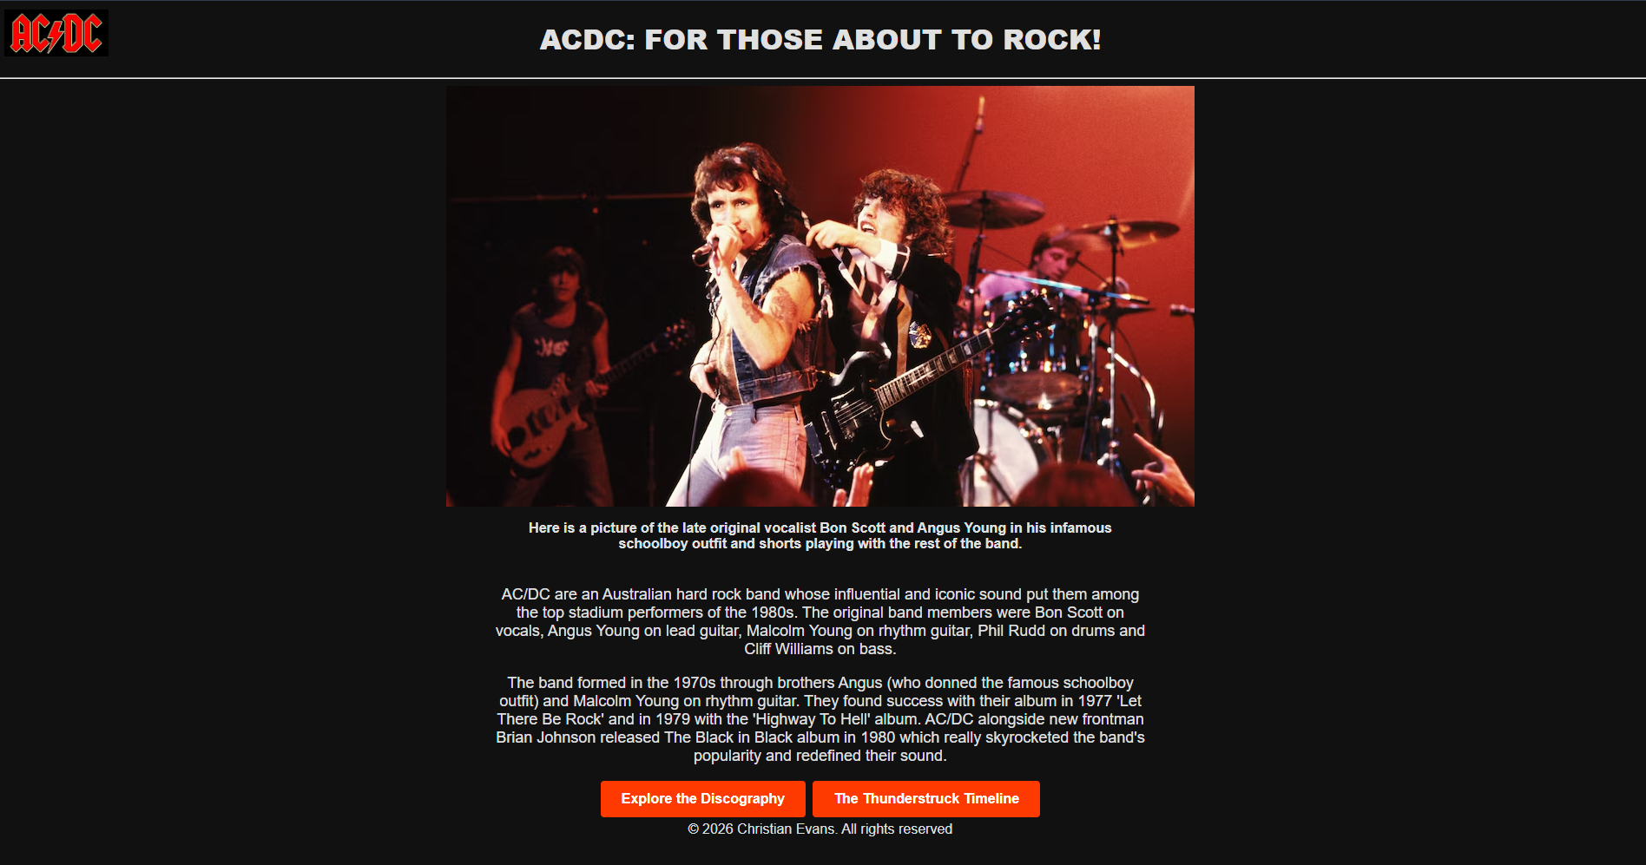
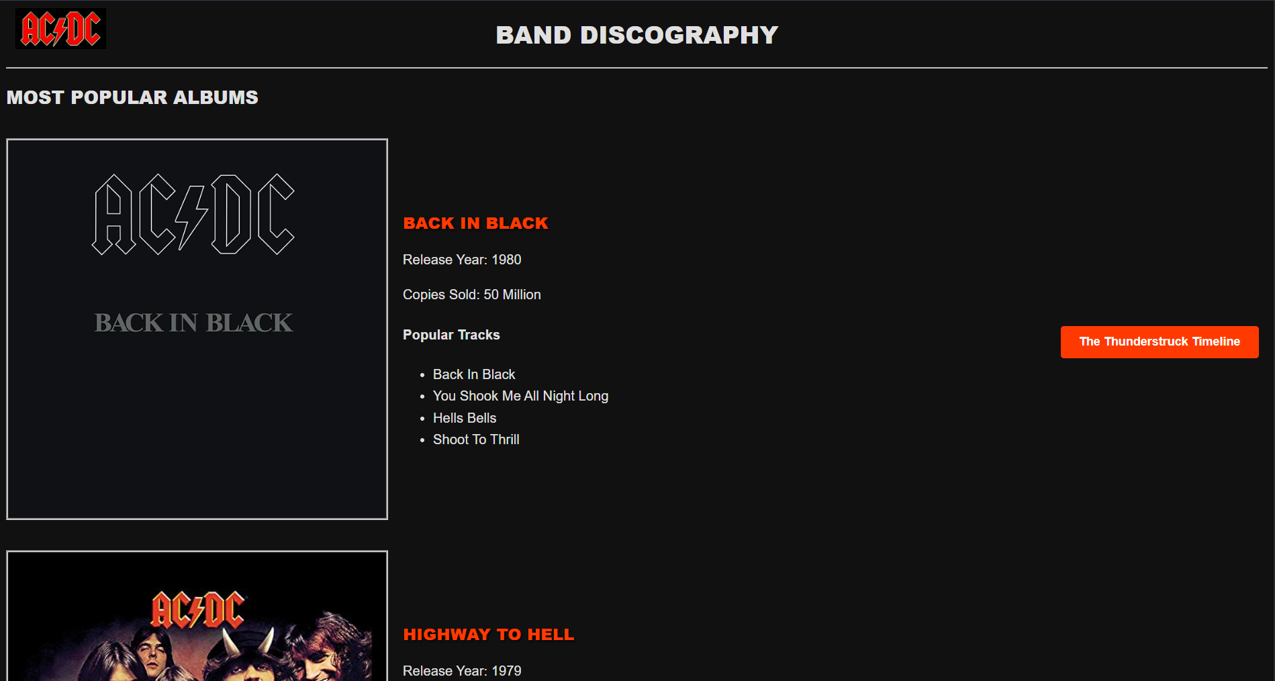
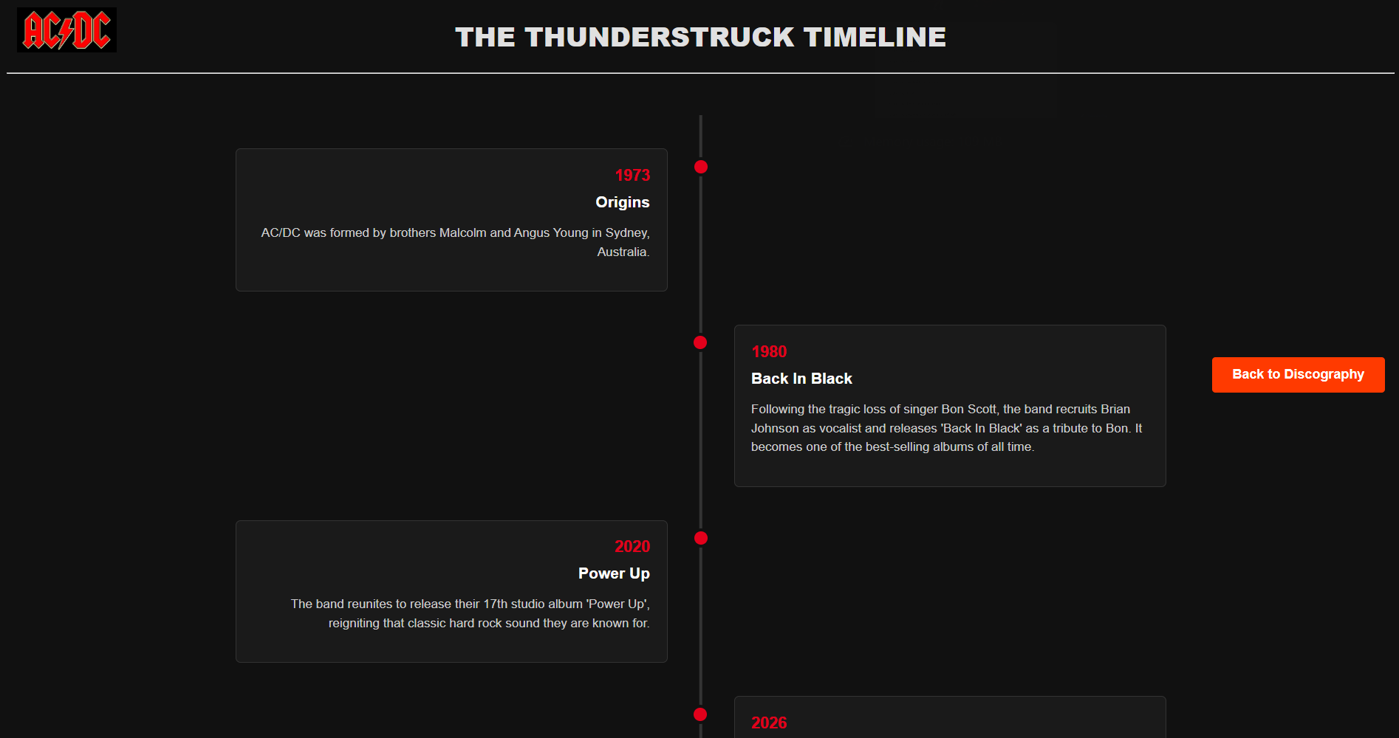

Validation

Page 1
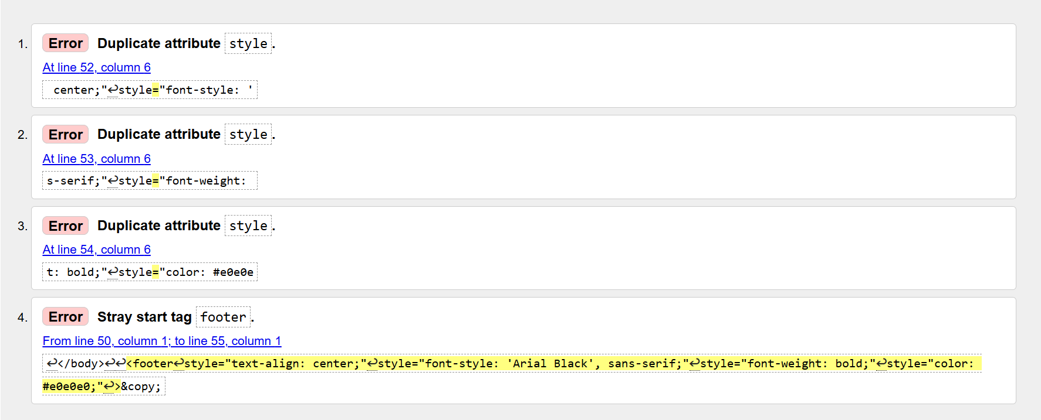
I corrected these errors by using footer tag within my CSS stylesheet and adding my stylings from there so it would be the same for the 3 web pages. I also brought my footer tag within the body and not outside it.

Page 2
No warnings or errors.

Page 3
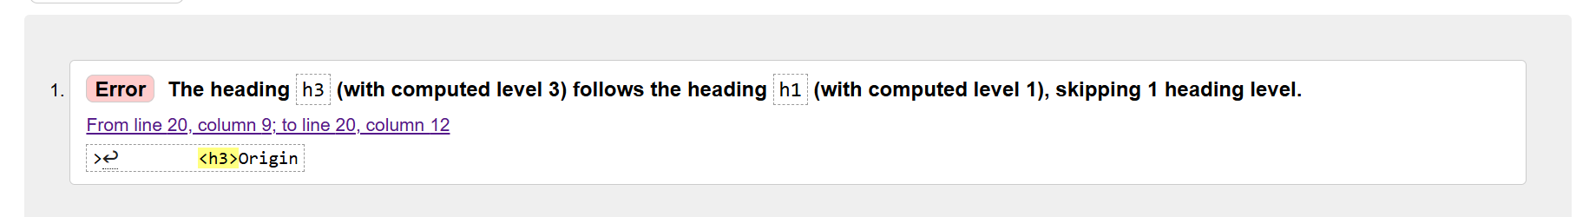
To correct this error, I will correct all H3 tags to H2, following accessibility guidelines.

CSS File
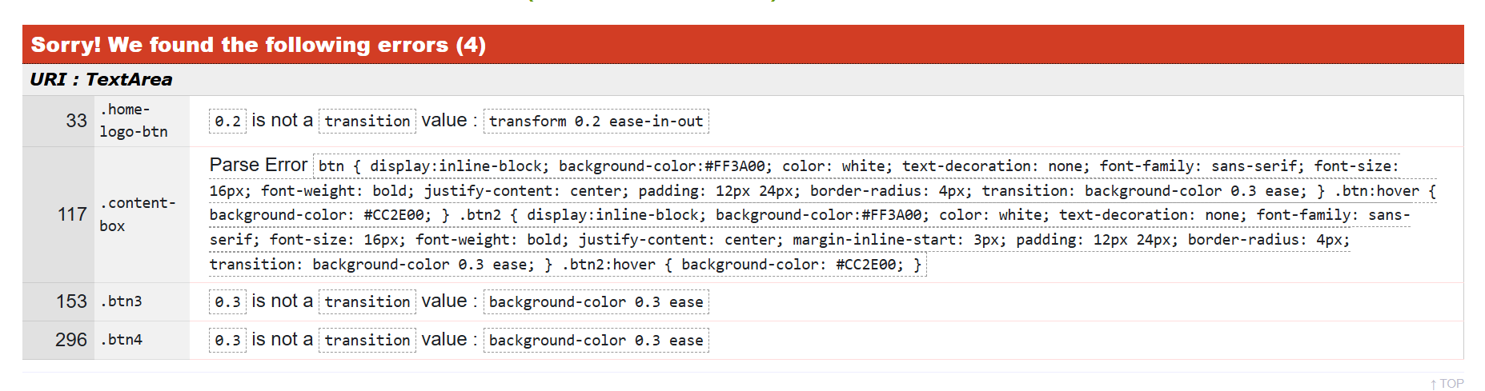
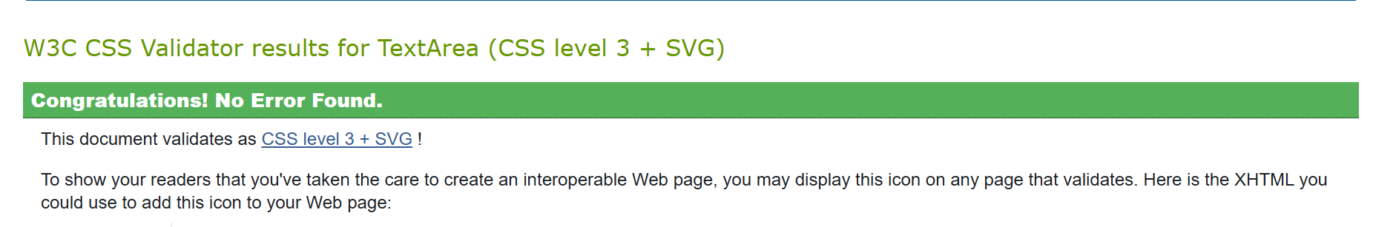
To correct these errors, I took out the 0.3 and 0.2 out of the transform element within my buttons as it doesn’t affect anything and is not a transition value. I removed buttons from parent div .content-box and amended the transform elements for those.

Evaluation

Research

Usability
Website usability can be described from how easy it is to understand a website, the functions and content that can be observed by the end user. Key components include the simplicity of the website in terms of use, content that is easily accessible. The ability for the end user to be in control of what they are doing and where they currently are on the website [1].
evaluating website usability is a crucial part of web design and optimisation [2]. For a website to be successful they must not only be insightful but provide content in an efficient easy to access manner. Website usability is heavily correlated with end user online surfing habits.

Accessibility
In layman’s terms accessibility is all about ensuring that a webpage is easily accessible to the person who is accessing it. Accessibility plays an integral role in website development as it allows people with disabilities to do ordinary things. Web accessibility covers visual, auditory, physical and many other disabilities. Accessibility also benefits non-disabled users as it leads to more flexible websites. Something as simple as including alternative text (alt tags) for images ensures individuals can still interpret the visual information [3].
Furthermore, accessibility extends to language; multilingual accessibility affects usability for end users [4]. Recent studies suggest that “digital health platforms” should put user centric design above all else. It concludes that by maintaining digital health platforms are accessible in multiple languages, companies can ensure they reduce the number of health inequities, improve engagement with patients and overall enhance the user experience.
Information is important to accessible tourism, for websites to be accessible the focus should be on making information accessible to all visitors. Websites should accommodate people with visual, hearing, cognitive disabilities. Web accessibility is all about aiming for maximal inclusion both in terms of the people who access it and the technologies that can be used to support users [5].

Search Engine Optimisation
Search engine optimisation (SEO) focuses on improving the ranking of a website in search results providing the user enters keywords. This is generally achieved through two primary approaches: off-page optimisation where you look at creating links on other highly ranked websites to boost search engine results and on-page optimisation which looks at including keywords in titles, subtitles and within the text [6].
By optimising website content and structure, you can directly improve the efficiency of online marketing strategies. Brand image can have a positive impact on search engine results due to the search engine rankings. Brand image and search engine optimisation are heavily correlated, big corporations often rank among the highest in search results due to the algorithm and because they have a high brand image [7].

Personal Website Evaluation

Usability
Examining the 3 web pages I have created, I think the design stands out as the colours contrast well with each other, particularly the red on black. Functionality wise the website performs as expected, buttons take you to the correct page and there are buttons to take you back a page and a home button located in the top left corner.
Where you place navigational elements is important, older adults report difficulty if navigational elements are placed in the periphery rather than centred. [8]
I think the content I have included in my website is well informed but not too wordy. The content features a mixture of both text and images as well as content boxes. Usability wise it is straightforward to use and easy to get around.
If I were to make improvements to my website, I would maybe add another page to stretch out the content and perhaps include audio through the HTML5 audio tag which would enhance usability of my website.

Search Engine Optimisation
Search Engine Optimisation is extremely important in the development of a website. It’s the link between the company and consumers. Most of the traffic from search engines comes through using internal links within your website. [9]
After doing some research into the topic, I started incorporating these techniques into my website. The first page includes keywords in header 1 regarding the band with an image below it to boost search results. Another use of the on-page SEO techniques I have applied is by sticking to a hierarchical logical structure to organise sections within the webpage for example sticking to H1, H2, H3 structure.
I used semantic anchor tags styled as buttons to ensure search engine crawlers can easily index the web pages. I have increased the likelihood of my website appearing in the top search results, including images of the band’s albums on page 2 alongside the information with H3 titles of the album names is another sure way I have used SEO techniques. Search intent alignment was considered when making my website as the buttons directly align to the content being shown on the page, e.g. page 2 navigation button “The Thunderstruck Timeline” links to the 3rd page.

Accessibility
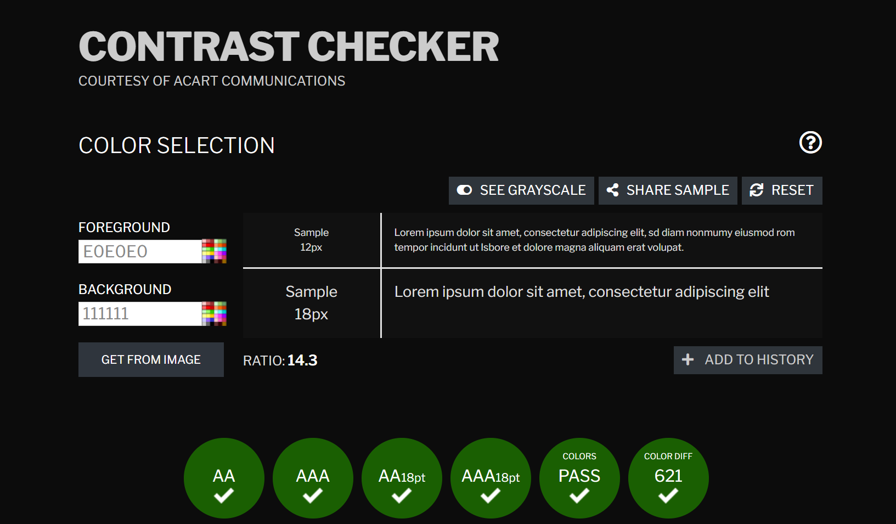
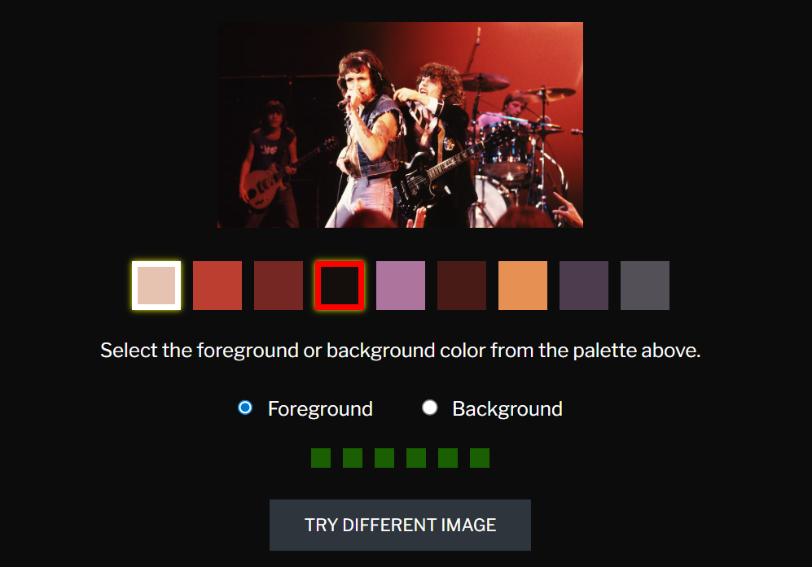
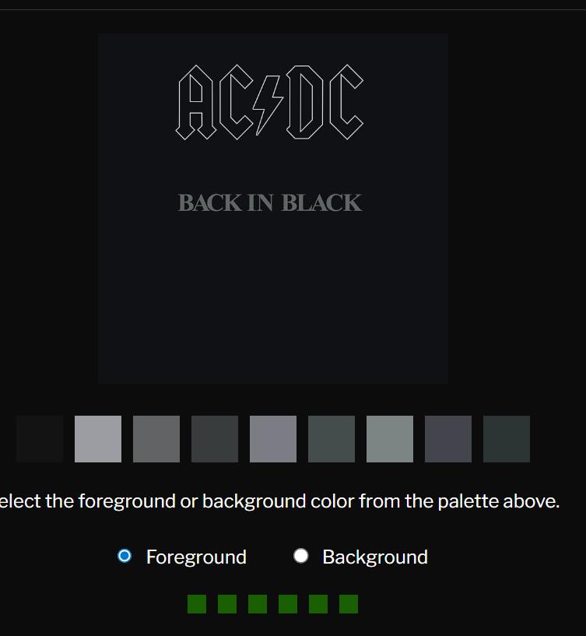
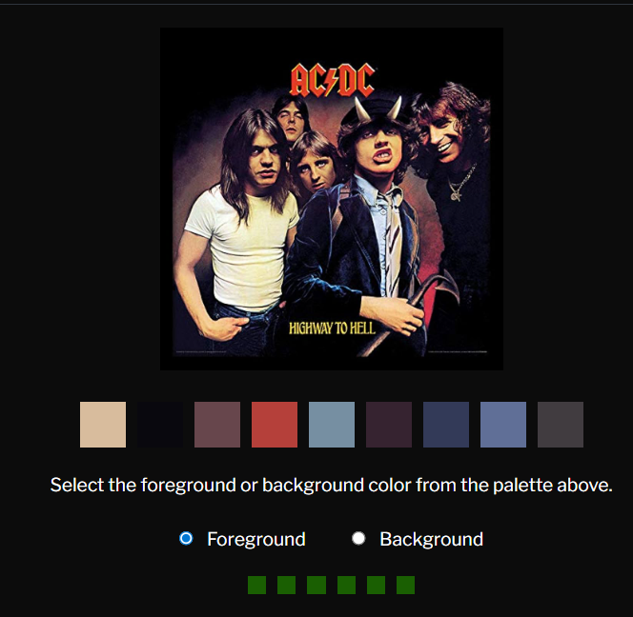
With respect to the four main principles of accessibility, my website meets the principle Perceivable as I have used alternative text (alt tags) for my images, which is important as the non-text content can be changed into other forms that people use such as braille, speech etc [10]. The contrast checker tool was used to determine whether the core content of my website was accessible, my text, background and images meet the minimum requirements set out by the WCAG. My website meets the principle Operable as my website as you can navigate site using a keyboard or mouse, you can use the arrows to scroll down and tab and enter to use the buttons and home button navigation while some users may wish to use the mouse only.
I have achieved the principle of Understandable by using clear concise information for buttons, the buttons take you to the intended page and I have provided alt tags for the buttons to clear up any confusion. From the home page there are 2 buttons indicating to the user from the start that there are 3 pages. The home button is situated in the top left like many other websites.
I think my website meets the principle robust as it can be used in conjunction with assistive technologies such as screen readers, zoom tools. Although I haven’t addressed the resizing aspect which may cause issues if you are viewing my website through a mobile phone as opposed to a laptop. To address this issue, I would implement a CSS flexbox and media queries to ensure the website scales across phone screens as well.

Website Comparison – Comparative Analysis
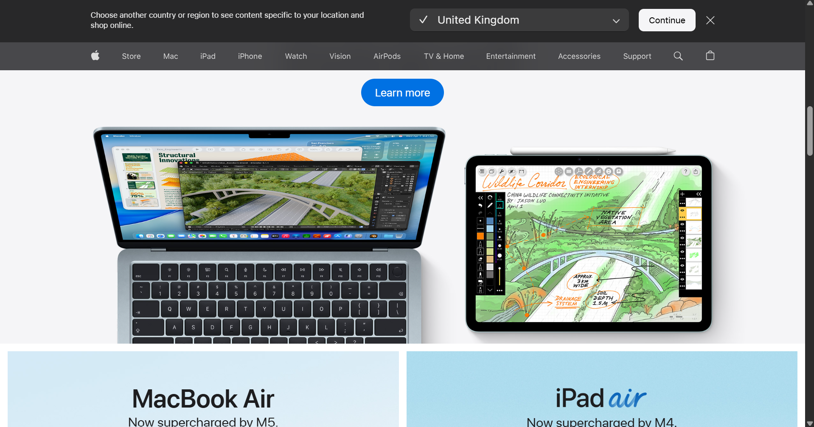
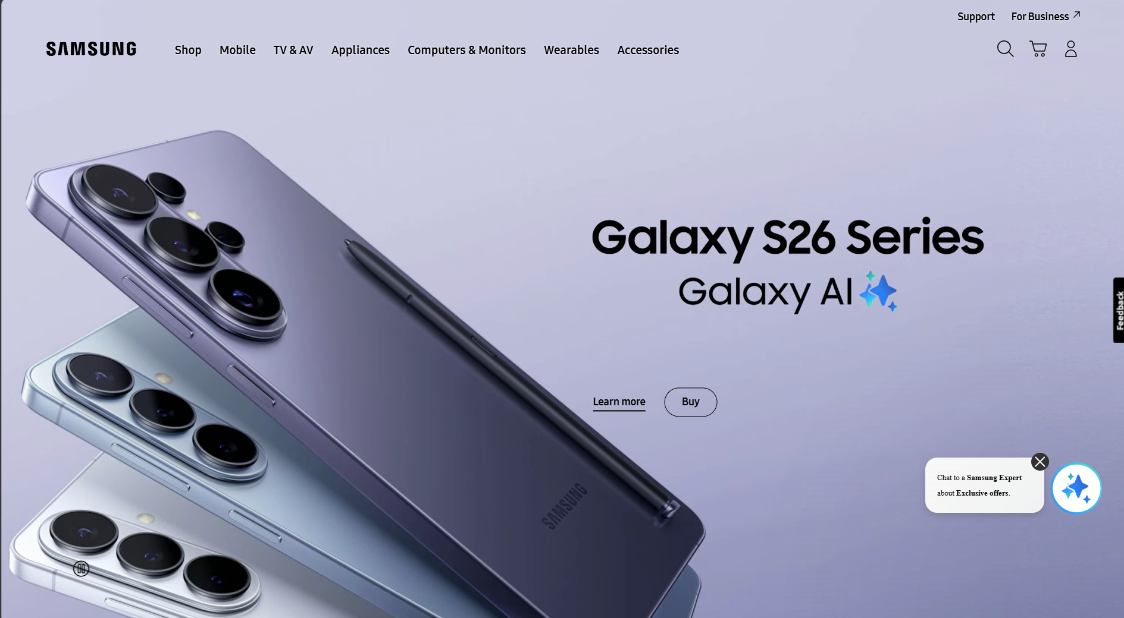

Usability
In terms of usability, both websites have layouts that are front and centred, navigation icons are at the top of the screen so easily identifiable. In terms of readability, I would say Apple is more readable at normal screen size 100%, this improves user comprehension and makes content understandable for the user reducing time locating products. Both websites use responsive scaling, maintaining usability when zooming or adapting to different screen sizes.

Accessibility
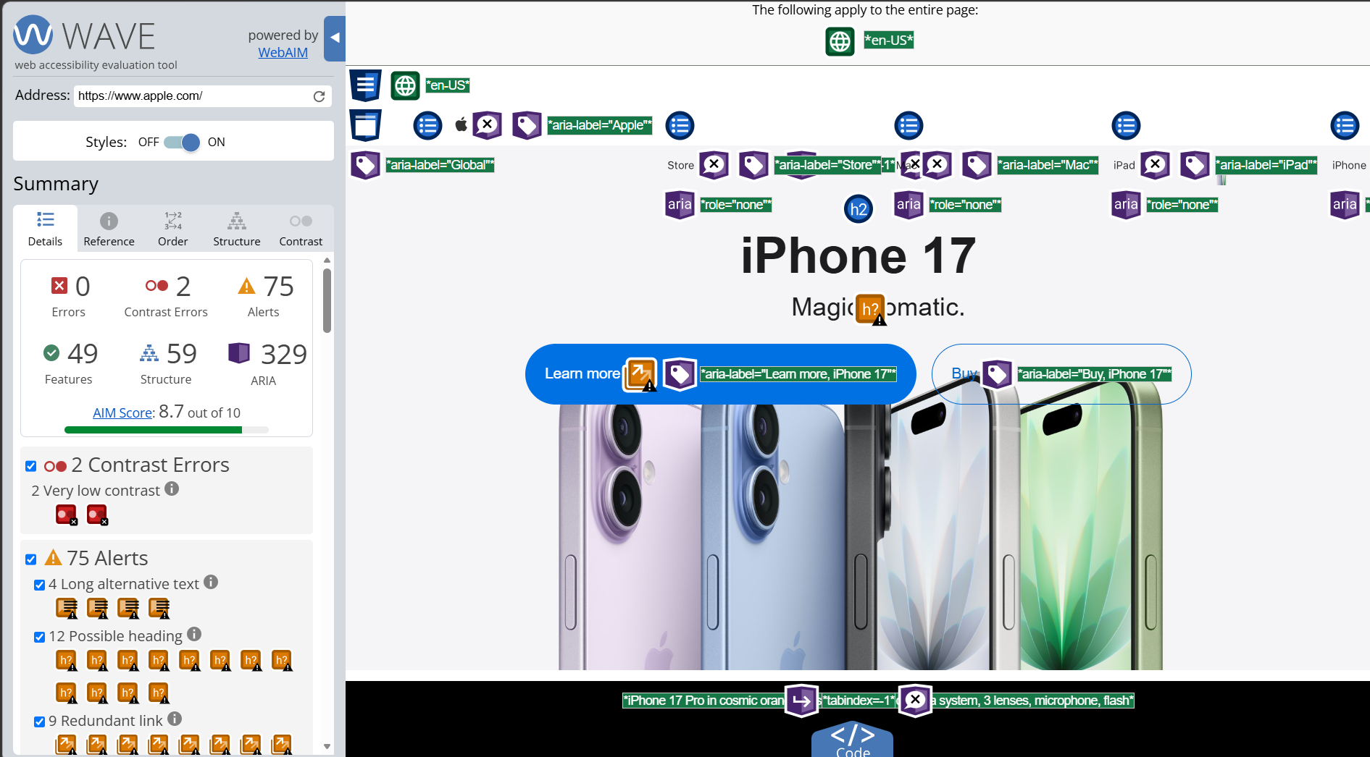
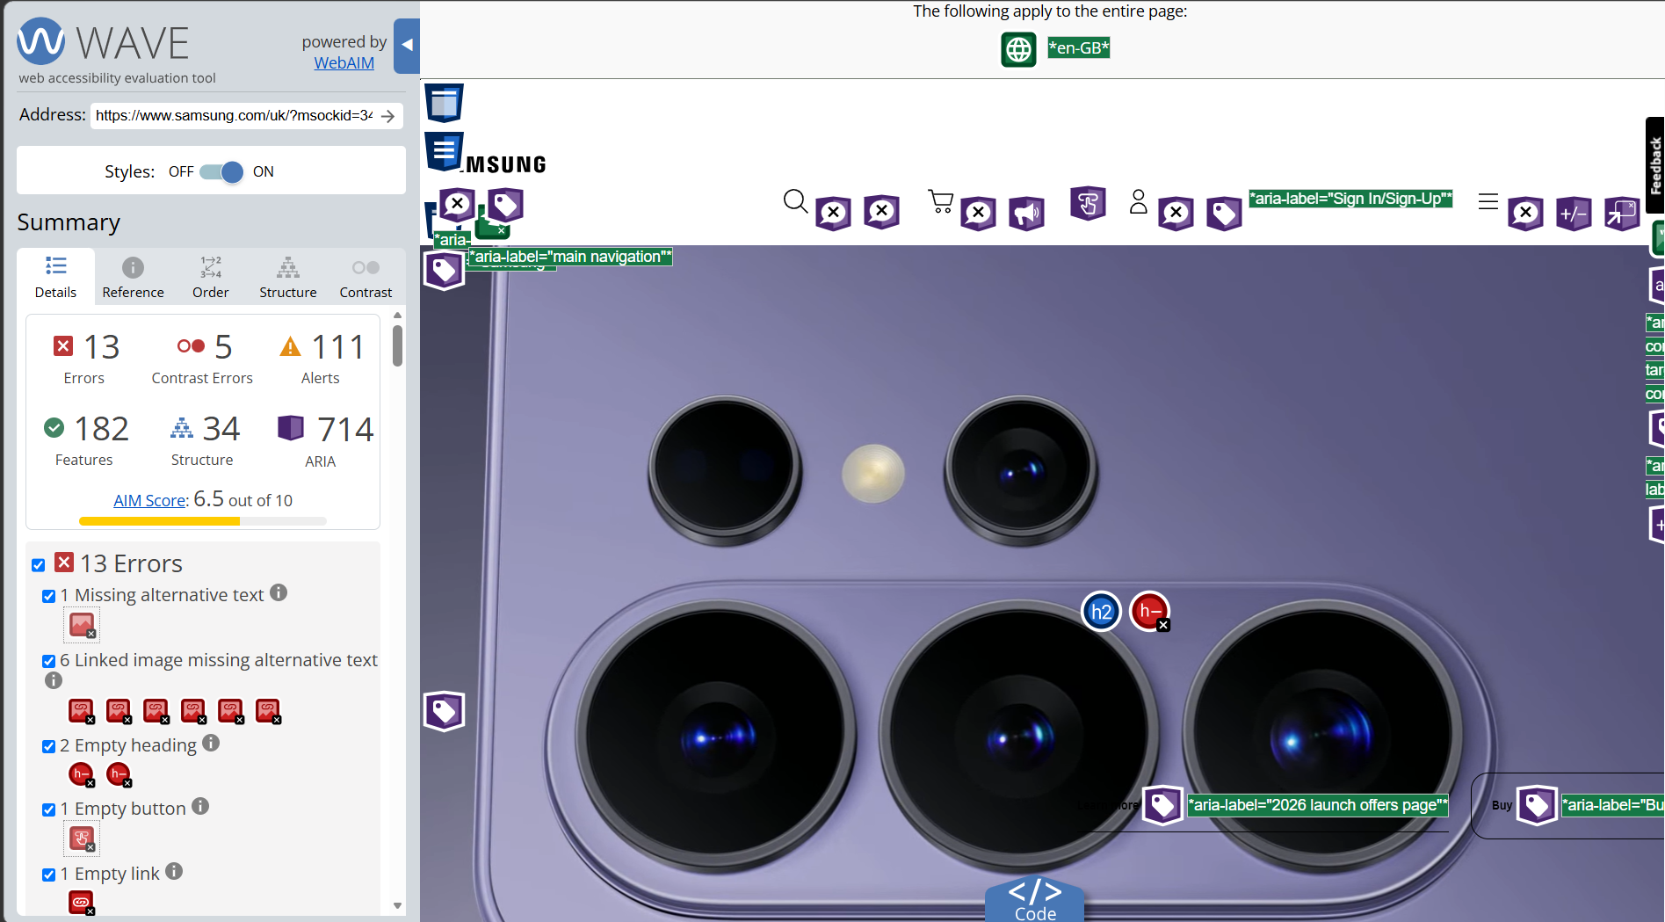
In terms of accessibility, Apple far outperforms Samsung scoring an 8.7 compared to Samsung’s 6.5. Apple’s design and implementation adheres more to the WCAG guidelines, especially in areas such as alternative text for non-text content and colour contrast.
The Samsung homepage lacks alternative text on several images (1 standalone image and 6 linked images), This creates a noticeable limitation to people using screen readers which impacts the inclusivity and accessibility of the website.
Although both websites achieve strong colour contrast ratio’s exceeding the minimum requirement set out by the WCAG, Samsung presents low-contrast errors in certain elements. Apple passes the accessibility guidelines for contrast with a contrast ratio of 8:59:1 which matches Samsung’s contrast ratio. Apple’s more consistent use of alternative text and structured content enhances user navigation experience and provides a more inclusive experience. [11]

SEO
Apple displays a stronger on-page and technical SEO presence compared to Samsung. The website displays a plethora of meta tags, keeping a clean and logical heading structure using H1, H2, H3 headings. Apple incorporates a high volume of internal links (approximately 123), strengthening site navigation and crawlability for search engines, they serve not only to improve usability but to enhance the user experience.
Apple’s use of descriptive meta tags and alt tags for non-text content further enhance its SEO performance. In contrast, Samsung’s inconsistent use of alt text and weak structure reduce optimisation.
Using the Google PageSpeed Insights tool, in terms of technical SEO both websites Apple eclipses Samsung recording a performance score of 93 compared to Samsung’s 61. This indicates faster loading times and better optimisation, which are critical factors in search engine ranking and user retention. Overall SEO scores favour Apple at 92 and Samsung at 77, reinforcing its technical advantage. [12]

Mobile Friendliness
Both these websites adjust nicely when switching to a phone promoting a responsive design, the content of the page adjusts accordingly to the phone screen without sacrificing on content. Navigation remains intuitive as you can search for items quickly and effectively using the search bar at the top.
However, Apple’s design once again provides an overall better user experience in my opinion with its use of high contrast visuals and minimal but effective layout, making products stand out more clearly during scrolling. This enhances user engagement and improves the browsing experience on mobile devices.

Conclusion
Overall, Apple.com is the superior website in my opinion, not only due to its stronger performance in usability, accessibility, and SEO, but also its clean design, consistent accessibility features and efficient navigation making it easy for users to find products quickly, which can positively impact user satisfaction and web traffic.
While Samsung.com remains a functional and well-designed website, where it falls short is in accessibility and performance scores. Improvements in alt text, contrast consistency and page optimisation would significantly enhance its overall quality.

References

[1] | D. Belanche, L. V. Casalo and M. Guinaliu, “Website usability, consumer satisfaction and the intention to use a wbesite: The moderating effect of perceived risk,” Journal of retailing and consumer services , pp. 124-132, 2012.
[2] | Q.-X. Qu, F. Guo and V. G. Duffy, “Effective use of human physiological metrics to evaluate website usability: An empirical investigation from China,” Aslib journal of information management, vol. 69, no. 4, pp. 370-388, 2017.
[3] | J. Thatcher, Web accessibility : web standards and regulatory compliance, Berkeley: FriendsofED, 2006.
[4] | S. He, N. A. Ibrahim and M. S. Kang, “Website Language Accessibility Checklist: A Tool for Assessing the Multilingual Accessibility of Health Websites,” International journal of e-health and medical communications, vol. 16, no. 1, pp. 1-22, 2025.
[5] | P. Teixeira, C. Eusebio and L. Teixeira, “How diverse is hotel website accessibility? A study in the central region of Portugal using web diagnostic tools,” Tourism and hospitality research, vol. 22, no. 2, pp. 180-195, 2022.
[6] | C.-J. Luh, S.-A. Yang and T.-L. D. Huang, “Estimating Google's search engine ranking function from a search engine optimization perspective,” Online information review, vol. 40, no. 2, pp. 239-255, 2016.
[7] | J.-C. Chen and S. Senechal, “The reciprocal relationship between search engine optimization (SEO) success and brand equity (BE): an analysis of SMEs,” European business review, vol. 35, no. 5, pp. 860-873, 2023.
[8] | J. C. Romano Bergstrom, E. Olmsted-Hawala and M. E. Jans, “Age-Related Differences in Eye Tracking and Usability Performance: Website Usability for Older Adults,” International Journal of Human-Computer Interaction, vol. 29, no. 8, pp. 541-548, 2013.
[9] | A. Erdmann, R. Arilla and J. M. Ponzoa, “Search engine optimization: The long-term strategy of keyword choice,” Journal of business research, vol. 144, pp. 650-662, 2022.
[10] | S. Abou-Zahra, E. Eggert, G. Vanderheiden, L. G. Reid, B. Caldwell, S. L. Henry and G. Lemon, “How to Meet WCAG (Quickref Reference),” W3C , 22 September 2025. [Online]. Available: https://www.w3.org/WAI/WCAG22/quickref/. [Accessed 24 June 2026].
[11] | WebAim, “WAVE Web Accessibility Evaluation Tool,” WebAim, [Online]. Available: https://wave.webaim.org/. [Accessed 25 June 2026].
[12] | Google, “PageSpeed Insights,” Google, [Online]. Available: https://pagespeed.web.dev/. [Accessed 25 June 2026].

Appendices

First page
<!DOCTYPE html>
<html lang="en">
<head>
<meta charset="UTF-8">
<meta name="viewport" content="width=device-width, initial-scale=1.0">
<title>Home</title>
<link rel="stylesheet" href="styles.css">
</head>

<body>
<h1>ACDC: FOR THOSE ABOUT TO ROCK!</h1>
<hr>

<div class="center-image">
<img src="Images/acdc2.avif" alt="This is a picture of the ACDC logo" title="ACDC">
</div>

<div class="image-text">
<p>Here is a picture of the late original vocalist Bon Scott and Angus Young in his infamous schoolboy outfit and shorts playing with the rest of the band.</p>
</div>

<div class="content-box">

<p>
AC/DC are an Australian hard rock band whose influential and iconic sound put them among the top stadium performers of the 1980s. The original band members were Bon Scott on vocals, Angus Young on lead guitar, Malcolm Young on rhythm guitar, Phil Rudd on drums and Cliff Williams on bass.
</p>

<p>
The band formed in the 1970s through brothers Angus (who donned the famous schoolboy outfit) and Malcolm Young on rhythm guitar.
They found success with their album in 1977 'Let There Be Rock' and in 1979 with the 'Highway To Hell' album. AC/DC alongside new frontman Brian Johnson released The Black in Black album in 1980 which really skyrocketed the band's popularity and redefined their sound.
</p>

<a href="index.html" class="home-logo-btn">
<img src="Images/ACDC-Logo-red.webp" alt="AC/DC Home Logo/Button">
</a>

<a href="page2.html" target=_self title="This takes you to page 2" class="btn">
Explore the Discography
</a>

<a href="page3.html" target="_self" title="This takes you to page 3" class="btn2">
The Thunderstruck Timeline
</a>
</div>

<footer>&copy; 2026 Christian Evans. All rights reserved</footer>
</body>

</html>

Second page
<!DOCTYPE html>
<html lang="en">
<head>
<meta charset="UTF-8">
<meta name="viewport" content="width=device-width, initial-scale=1.0">
<title>Page 2</title>
<link rel="stylesheet" href="styles.css">

</head>
<body>
<h1>Band Discography</h1>
<hr>

<h2>Most Popular Albums</h2>
<br>

<div class="row-container">
<div class="image-box1">
<img src="/Images/backinblack.jpg" alt="Back In Black Album Cover">
</div>
<div class="text-box1">
<h3>Back In Black</h3>
<p>Release Year: 1980 </p>
<p>Copies Sold: 50 Million</p>

<h4>Popular Tracks</h4>
<ul>
<li> Back In Black</li>
<li> You Shook Me All Night Long</li>
<li> Hells Bells</li>
<li> Shoot To Thrill</li>
</ul>
</div>
</div>

<div class="row-container">
<div class="image-box2">
<img src="/Images/highwaytohell.jpg" alt="Highway To Hell Album Cover">
</div>
<div class="text-box2">
<h3>Highway To Hell</h3>
<p>Release Year: 1979</p>
<p>Copies Sold: 15 Million</p>
<h4>Popular Tracks</h4>
<ul>
<li> Highway To Hell</li>
<li> If You Want Blood (You've Got It)</li>
<li> Shot Down In Flames</li>
<li> Touch To Much</li>
</ul>
</div>
</div>

<div class="row-container">
<div class="image-box3">
<img src="/Images/razorsedge.jpg" alt="Razors Edge Album Cover">
</div>
<div class="text-box3">
<h3>Razor's Edge</h3>
<p>Release Year: 1990</p>
<p>Copies Sold: 12 Million </p>
<h4>Popular Tracks</h4>
<ul>
<li>Thunderstruck</li>
<li>The Razors Edge</li>
<li>Moneytalks</li>
<li>Are You Ready</li>
</ul>
</div>
</div>

<div class="row-container">
<div class="image-box4">
<img src="/Images/highvoltage.jpg" alt="High Voltage Album Cover">
</div>
<div class="text-box4">
<h3>High Voltage</h3>
<p>Release Year: 1976</p>
<p>Copies Sold: 4 Million</p>
<h4>Popular Tracks</h4>
<ul>
<li>It's a Long Way to the Top (If You Wanna Rock 'N' Roll)</li>
<li>TNT</li>
<li>The Jack</li>
<li>High Voltage</li>
</ul>
</div>
</div>

<a href="index.html" class="home-logo-btn">
<img src="Images/ACDC-Logo-red.webp" alt="AC/DC Home Logo/Button">
</a>

<a href="page3.html" target="_self" title="This takes you to page 3" class="btn3">
The Thunderstruck Timeline
</a>

<footer>&copy; 2026 Christian Evans. All rights reserved</footer>
</body>

</html>

Third page
<!DOCTYPE html>
<html lang="en">
<head>
<meta charset="UTF-8">
<meta name="viewport" content="width=device-width, initial-scale=1.0">
<title>Page 3</title>
<link rel="stylesheet" href="styles.css">
</head>

<body>
<h1>The Thunderstruck Timeline</h1>
<hr>

<div class="timeline-control">

<div class="timeline-item left">
<div class="timeline-dot"></div>
<div class="timeline-content">
<span class="date">1973</span>
<h2>Origins</h2>
<p>AC/DC was formed by brothers Malcolm and Angus Young in Sydney, Australia.</p>
</div>
</div>

<div class="timeline-item right">
<div class="timeline-dot"></div>
<div class="timeline-content">
<span class="date">1980</span>
<h2>Back In Black</h2>
<p>Following the tragic loss of singer Bon Scott, the band recruits Brian Johnson as vocalist and releases 'Back In Black' as a tribute to Bon. It becomes one of the best-selling albums of all time.</p>
</div>
</div>

<div class="timeline-item left">
<div class="timeline-dot"></div>
<div class="timeline-content">
<span class="date">2020</span>
<h2>Power Up</h2>
<p>The band reunites to release their 17th studio album 'Power Up', reigniting that classic hard rock sound they are known for. </p>
</div>
</div>

<div class="timeline-item right">
<div class="timeline-dot"></div>
<div class="timeline-content">
<span class="date">2026</span>
<h2>Present</h2>
<p>Still rocking stadiums worldwide.</p>
</div>
</div>

</div>

<a href="index.html" class="home-logo-btn">
<img src="Images/ACDC-Logo-red.webp" alt="AC/DC Home Logo/Button">
</a>

<a href="page2.html" target="_self" title="This takes you to page 2" class="btn4">
Back to Discography
</a>

<footer>&copy; 2026 Christian Evans. All rights reserved</footer>
</body>

</html>

Styles.css
/* Titles and General Theme */
h1{
text-align: center;
color: #e0e0e0;
font-family: 'Arial Black', sans-serif;
text-transform: uppercase;
}

h2{
color: #e0e0e0;
font-family: 'Arial Black', sans-serif;
text-transform: uppercase;
}

footer{
font-family: sans-serif;
color: #e0e0e0;
text-align: center;
font-weight: bolder;
}

body{
background-color:#111111;
font-family: sans-serif;
color: #e0e0e0;
}

.home-logo-btn {
position:absolute;
top: 10px;
left: 20px;
z-index: 1000;
transition: transform ease-in-out;
}

.home-logo-btn img {
width: 120px;
height: auto;
display: block;
}

.home-logo-btn:hover {
transform: scale(1.05);
filter: drop-shadow(0 0 8px #e3001b);
}

/* Page 1 */
.center-image {
display: flex;
justify-content: center;
align-items: center;
}

.center-image img {
height: auto;
max-width: 100%;
}

.image-text {
font-size: medium;
max-width: 750px;
margin: 0 auto;
padding: 0px;
text-align: center;
font-weight: bolder;
}

.content-box {
max-width: 750px;
margin: 0 auto;
padding: 5px;
text-align: center;
font-size: large;

}

.btn {
display:inline-block;
background-color:#FF3A00;
color: white;
text-decoration: none;
font-family: sans-serif;
font-size: 18px;
font-weight: bold;
justify-content: center;

padding: 12px 24px;
border-radius: 4px;

transition: background-color ease;
}

.btn:hover {
background-color: #CC2E00;
}

.btn2 {
display:inline-block;
background-color:#FF3A00;
color: white;
text-decoration: none;
font-family: sans-serif;
font-size: 18px;
font-weight: bold;
justify-content: center;
margin-inline-start: 3px;

padding: 12px 24px;
border-radius: 4px;

transition: background-color ease;
}

.btn2:hover {
background-color: #CC2E00;
}

/* Page 2 */

.row-container {
display: flex !important;
align-items:center;
gap: 20px;
margin-bottom: 40px;
width: 100%;

}

.btn3 {
position: absolute;
right: 20px;
top: 50%;
transform: translateY(-50%);
z-index: 100;

background-color:#FF3A00;
color: white;
text-decoration: none;
font-family: sans-serif;
font-size: 18px;
font-weight: bold;
justify-content: center;

padding: 12px 24px;
border-radius: 4px;

transition: background-color ease;
}

.btn3:hover {
background-color: #CC2E00;
}

.image-box1 img,
.image-box2 img,
.image-box3 img,
.image-box4 img {
width: 500px;
height: auto;
display: block;
border-style: groove;
}

.text-box1,
.text-box2,
.text-box3,
.text-box4 {
color: #e0e0e0;
font-size: large;
line-height: 1.6;

}

.text-box1 h3,
.text-box2 h3,
.text-box3 h3,
.text-box4 h3 {
font-family: 'Arial Black', sans-serif;
color: #FF3A00 !important;
text-shadow: 2px 2px 4px rgba(0, 0, 0, 0.8);
text-transform: uppercase;
margin-bottom: 8px;
letter-spacing: 0.5px;

}

/* Page 3 */

.timeline-control {
position: relative;
max-width: 1200px;
margin: 50px auto;
padding: 20px 0;
}

.timeline-control::before {
content: '';
position: absolute;
width: 4px;
background-color: #333333;
top:0;
bottom: 0;
left: 50%;
transform: translateX(-50%);
}

.timeline-item {
position: relative;
width: 50%;
padding: 20px 40px;
box-sizing: border-box;
}

.timeline-item.left {
left: 0;
text-align: right;
}

.timeline-item.right {
left: 50%;
text-align: left;
}

.timeline-dot {
position: absolute;
width: 16px;
height: 16px;
background-color: #e3001b;
border: 4px solid #111111;
border-radius: 50%;
top: 30px;
z-index: 1;
}

.timeline-item.left .timeline-dot {
right: -12px;
}

.timeline-item.right .timeline-dot {
left: -12px;
}

.timeline-content {
padding: 20px;
background-color: #1a1a1a;
border: 1px solid #333333;
border-radius: 6px;
}

.timeline-content .date {
display: inline-block;
color: #e3001b;
font-weight: bold;
font-size: 1.5rem;
margin-bottom: 5px;
}

.timeline-content h2 {
margin: 5px 0;
color: #fff;
font-family: sans-serif;
text-transform: none !important;
}

.timeline-content p {
color: #cccccc;
font-size: 18px;
line-height: 1.5;
}

.btn4 {
position: absolute;
right: 20px;
top: 50%;
transform: translateY(-50%);
z-index: 100;

background-color:#FF3A00;
color: white;
text-decoration: none;
font-family: sans-serif;
font-size: 18px;
font-weight: bold;
justify-content: center;

padding: 12px 24px;
border-radius: 4px;

transition: background-color ease;
}

.btn4:hover {
background-color: #CC2E00;
}

