

Data Handling & Business Intelligence
LCBB5000
Assessment 2: Data Analysis and Visualisation

Lecturer: Xavier Matieni

Student Name: Alina-Paula Manolache
Student ID: 2114609
Table of Contents
Introduction 3
Part 1: Hotel Reservation 4
Assessment of Microsoft Excel 4
Pre-processing 4
Analysing 4
Visualising 5
IF Function 6
Increase or Decrease Calculation 7
Pivot table 9
Graph 15
Part 2 A Local School 16
Male and Female Calculation 16
‘Qualifies’ and ‘Does Not Qualify’ 18
Mean And Median of Students 20
Mean And Median Differences of Pre-Test and Post-Test Scores 25
K-Means Clustering 28
K- means Clustering 31
Data Mining and Text Mining Methods 36
Advantages And Disadvantages of SPSS and Excel 37
Conclusion 39
Reference 40

Introduction

This paper covers two separate statistical analytics and modelling initiatives, the initial of which involves determining to what extent the mean value of reservations for hotels had decreased or increased from 2017 to 2021 using the spreadsheet's statistical mining capabilities. The study evaluates the efficacy of using spreadsheet software from Microsoft for data preparation, evaluation, and presentation. Additionally, it provides insights into students’ pre and post-test scores which are supposed to be influenced by the variables such as free lunch, gender and so on. Mean, median, and K-means clustering of the scores has been performed to find the meaningful observation for the local school to offer assistance to students for better educational achievement. SPSS 27 and MS Excel 365 are the main tools used in this data analysis.

Part 1: Hotel Reservation

Assessment of Microsoft Excel

Microsoft Excel is a part of Microsoft Office products which allow users to deal with data to a certain extent even though its massive popularity set a standard for basic data handling skills.
Pre-processing: As a result of its adaptability, user-friendliness, and accessibility, it has become a popular computing application for pre-processing datasets. Excel's tabular data structure makes it well-suited for operations including data cleansing, filtering, sorting, and transformation. The capacity to manage massive datasets efficiently is a major benefit. It can accommodate large datasets (up to 1 million rows and 16,000 columns). Pivot tables, charts, and statistical functions are just a few of the pre-processing tools and built-in features of Excel that may be used to swiftly analyse and visualise data. It may also straighten up existing data by finding and getting rid of duplicates, filling in blanks, and fixing formatting issues. For additional evaluation and modelling, it is crucial that the data be accurate and consistent, and these attributes may assist assure that. It's also quite flexible in terms of importing and exporting data, so it's simple to combine with other programmes and databases. CSV, TXT, XML, and ODBC databases are just some of the formats that Excel can read in (Microsoft, 2023a). Excel also has the ability to export information to various formats, such as CSV, TXT, PDF, and HTML, which facilitates data sharing and collaboration. Excel's usefulness for pre-processing data is limited by a few issues, despite its numerous advantages. The inability to process textual or graphical information that is not organised is a significant drawback.
Analysing: Furthermore, it might not be the optimal tool for complicated data manipulation activities such as data combining or complicated modifications, which may call for more sophisticated tools or computer dialects. Because of its adaptability, pre-installed features, and general availability, it may be used for data analysis. provides a variety of statistical, graphical, and tabular tools for examining large amounts of data and extracting meaningful insights. Users may summarise and examine massive datasets with the help of these tools since they can categorise and aggregate data according to various criteria (Microsoft, 2023b). They are also quite adaptable, so users can easily make complicated computations and visuals. It provides a number of mathematical operations, including standard deviation, and association, that may be leveraged to do data analysis and produce statistical findings, which are particularly helpful for spotting correlations and movements in data and making choices based on that analysis. Excel also has a number of built-in chart types (including bar charts, line charts, and pie charts) that may be used to graphically depict data and make it simpler to analyse, making them a vital tool for any data analyst (Microsoft, 2022). Data visualisation techniques, such as sparklines and conditional formatting, may be integrated into Excel charts to help users produce polished visuals that draw attention to interesting patterns and trends. These capabilities allow users to rapidly spot abnormalities and outliers in data, allowing them to zero in on the most crucial insights. Finally, it provides integration with various additional instruments and information sources, making it simple for users to bring in and send out data for analysis from a wide range of different sources. This facilitates teamwork in the analyses of information and the use of Excel in conjunction with other applications.
Visualising: With its flexible charting and graphing options, data visualisation software makes complex information more accessible. Column charts, line charts, pie charts, and scatter charts are just a few of the chart kinds available in Excel, and they can all be formatted to suit your requirements. Excel's ability to make interactive charts is a great tool for displaying data. By letting users pick and filter individual data indications, dynamic charts facilitate the exploration of the data and the identification of emerging patterns and trends. its chart formatting choices include changing the colours, designations, and typefaces to create a more aesthetically pleasing and legible presentation of data. Excel's sparkline functionality also helps with data visualisation (Zhang et al., 2018). Small, rooted charts called "sparklines" make spotting patterns and trends in a spreadsheet's massive data set a breeze. Stock price or visitor volume patterns are two examples of time series data that benefit greatly from being shown using sparklines. Data visualisation techniques like heat maps and conditional formatting are also available in Excel. Users may visualise information in a matrix structure using heat maps, where the values of individual data points are represented by different colours. Finding patterns and tendencies in huge datasets may benefit from this. Cells may be highlighted if their values are more than or less than a predetermined threshold, for example, thanks to conditional formatting (Microsoft, 2023b). Excel also allows you to generate dashboards, which are groups of charts and graphs that sum up your most important information quickly. Key performance indicators and other vital data may be easily monitored with the help of dashboards since they might be tailored to match individual requirements and maintained in the immediate moment.

Use and application of IF Function

Following it has displayed the results from applying the AVERAGEIF function to determine the average annual price for the years 2017 through 2021.
In a new spreadsheet called "IF," the data analyst has added two columns with the labels "Year" and "Average Prices" in columns A and B, respectively. The "Year" column has been manually filled with the years 2017 through 2022.
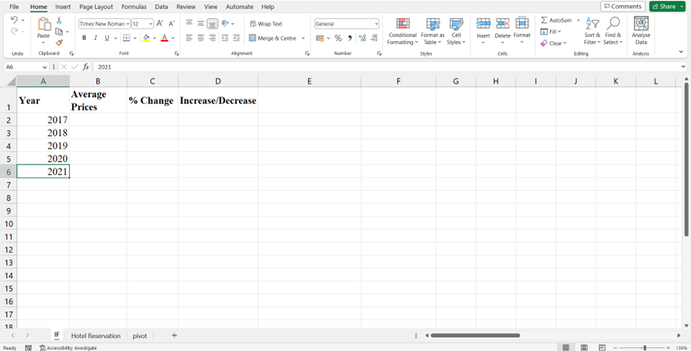
The computation for the average price for 2017 is then done using the method "=AVERAGEIF('Hotel Reservation'!J:J,IF_Function!Hotel reservation in A2!Q:Q)”. In this formula,
The terms "'Hotel Reservation'!J:J", "IF_Function!A2", and "'Hotel Reservation'!Q:Q" refer to the ranges of the terms "Arrival_year," "Average_price," and the years 2017 and respectively.
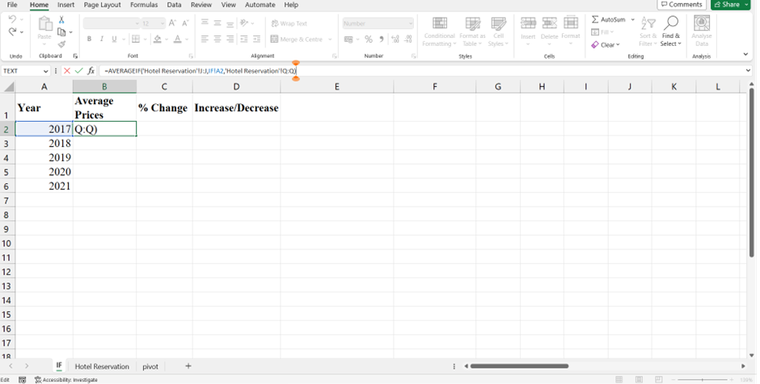
The average price through 2022 was then obtained by moving the pointer down to B6.
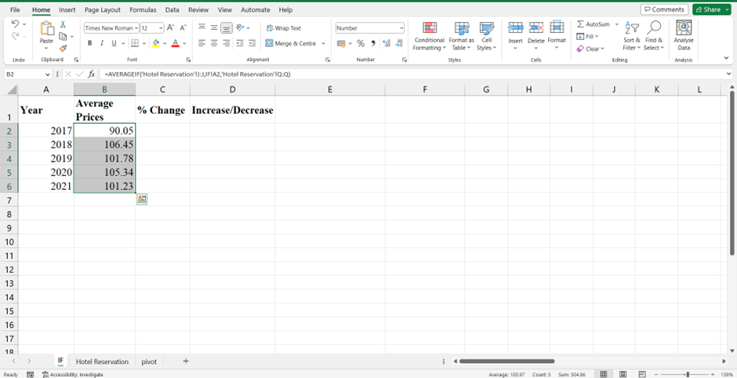

Increase or Decrease Calculation
The accompanying procedures have been taken in MS Excel to establish if the average price (room reservation price) has decreased or increased during the years from 2017 to 2021:
Step 1
Adding a new column to determine the annual percentage increase or decrease in average pricing. A formula of "=(B3-B2)/B2*100" is entered into cell C3.
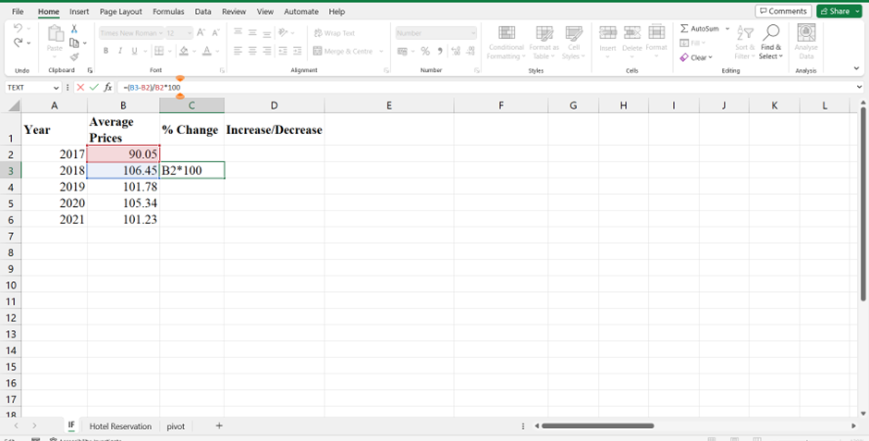
Step 2
Moved the focus to cell C6.
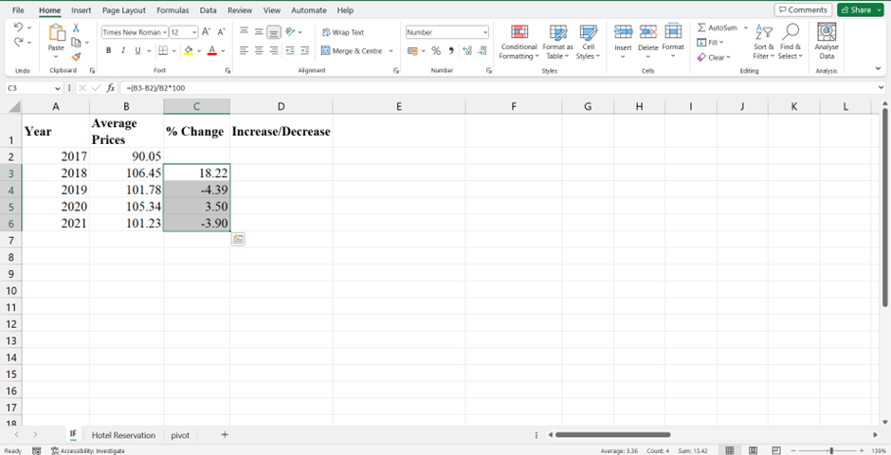
Step 3
The formula "=IF(C3>=0,"Increase","Decrease")" is employed and dragged to D6 to determine if the fourth column represents an increase or decrease.
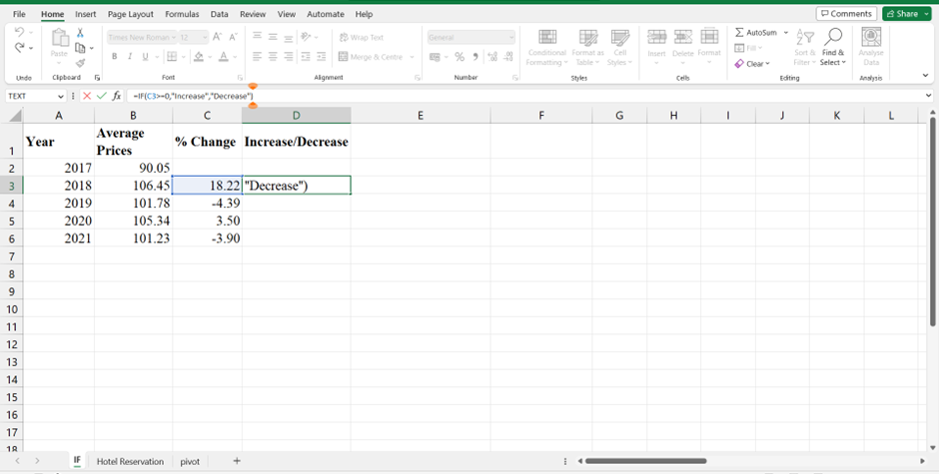
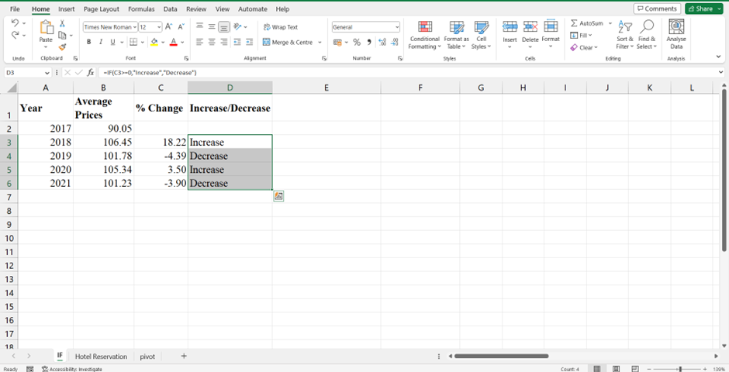

Use and application of pivot table
Step 1
To begin, a brand new worksheet titled "Pivot" has been produced and placed just next to the "Hotel Reservation" page. After opening the freshly made worksheet, the A1 cell is chosen, and the pointer is then transferred to the "Insert" tab, where it is then clicked on the "PivotTable" button and "Existing Worksheet" is selected. The "OK" button can be found in the "Create PivotTable" dialogue box.
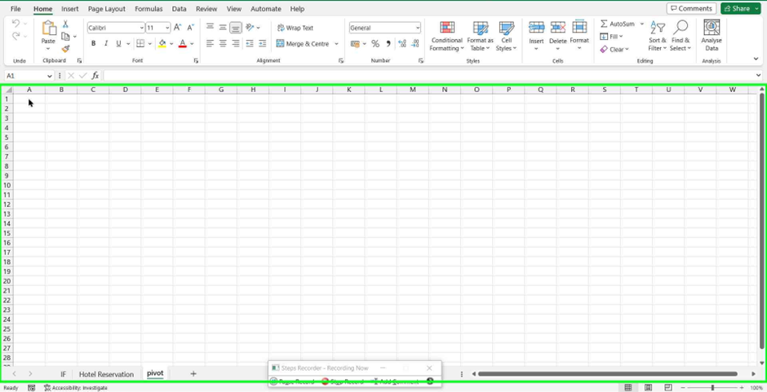
The letters A through S have been chosen to form the range, and it is written as "Hotel Reservation!"$A:$S," and then the user clicks the left mouse button on "OK (Button)" in the section titled "PivotTable from table or range".
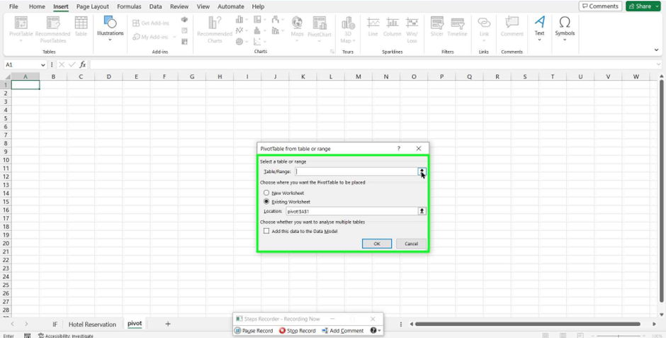

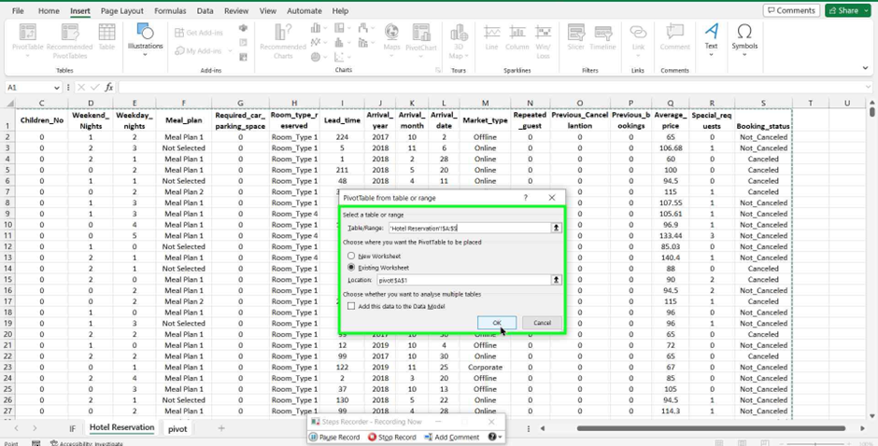
then User left click on "OK (Button)" in "PivotTable from table or range".
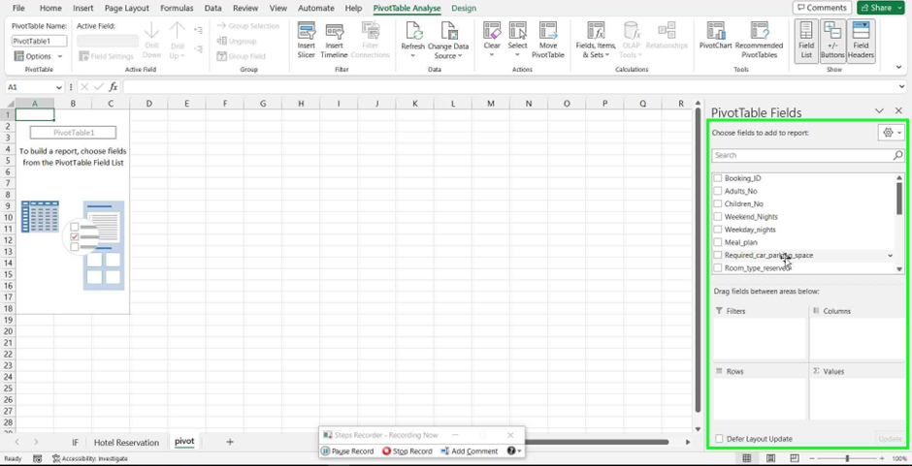
On the right-hand side, the above PivotTable field is shown, while on the left, the A1 cell has a blank Pivot Table. The next step in setting up the PivotTable fields required the user to drag the "Arrival_year" column to the "Rows" section and the "Average_price" field to the "Values" area respectively. He made sure that the value field settings for "Average_price" were changed to read "Average".
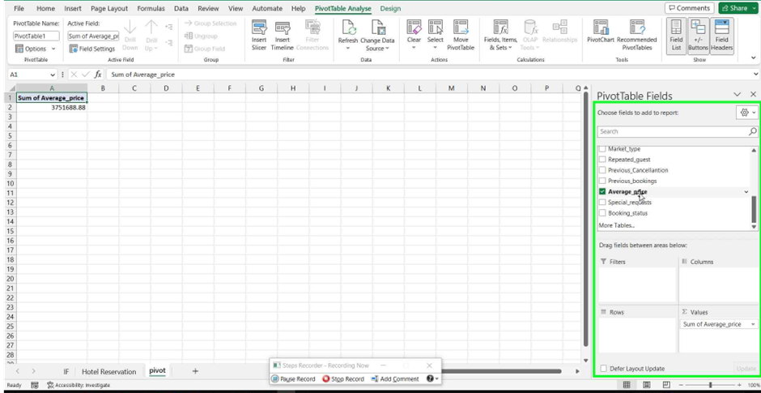

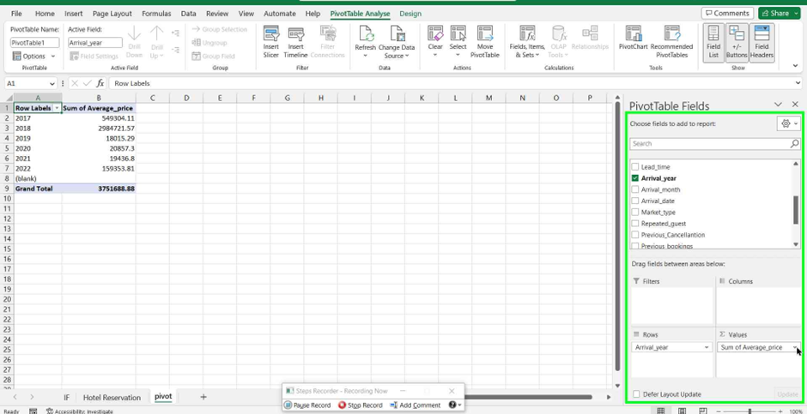

Value field settings
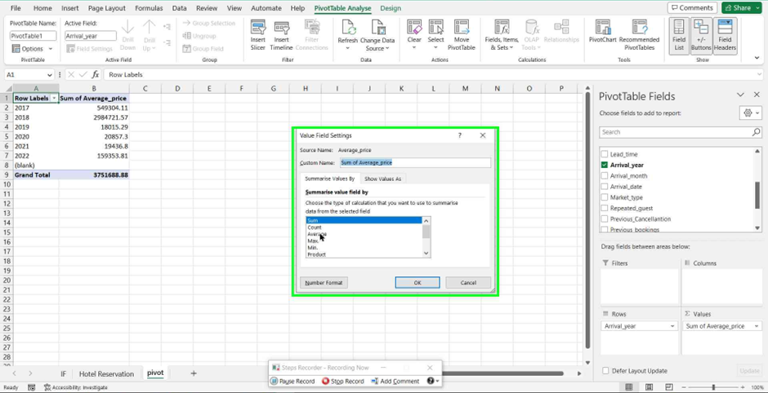
He made sure that the value field settings for "Average_price" were changed to read "Average". Then, it showed the average prices from 2017 to 2022.
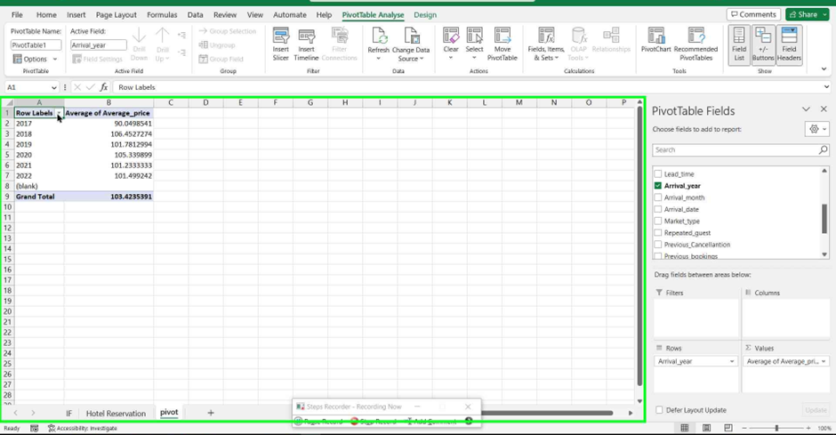
The "Row Labels" drop-down menu, the Year 2022, and "(blank)" are deselected before hitting the "Ok" button after choosing the "Row Labels" drop-down menu.
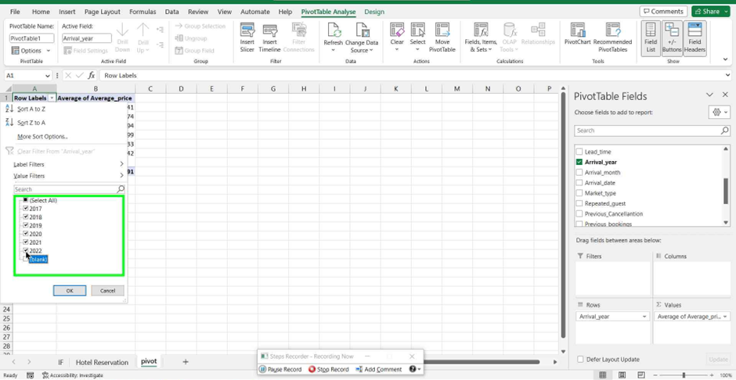
Finally, The Pivot Table showed the average prices for each year from 2017 to 2021.
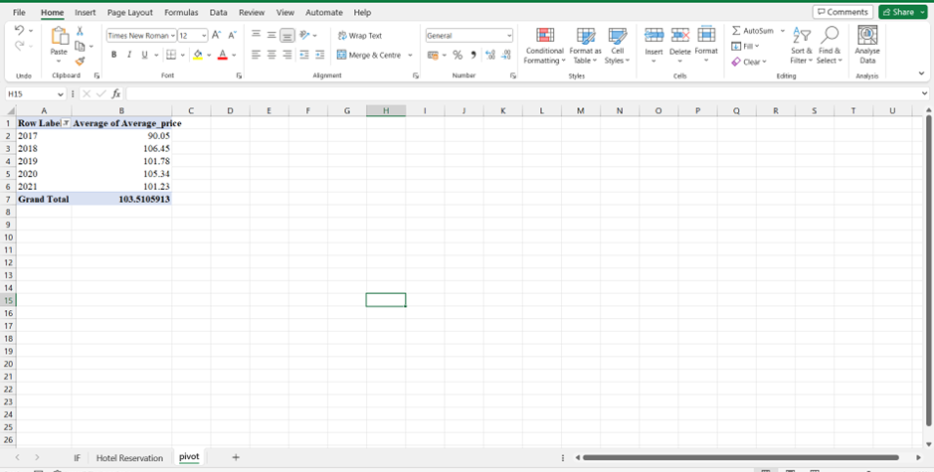

Graph of average increase and decrease in price with explanation

Figure 1: Average increase and decrease in price
Source: Author
The provided chart displays the typical hotel room rates from the years 2017 through 2021. The average cost was $90.05 in 2017; it rose to $106.45 in 2018, an increase of 18.22%. The average price dropped to $101.78 in 2019, a 4.39% decline from the previous year, in contrast to the year before. The average price rose once again in 2020, rising to $105.34—a 3.50% rise from the year before. Finally, the average price dropped to $101.23 in 2021, a 3.90% drop from the year before. The changes in hotel room costs might have been caused by several different variables. Growth in demand for hotel rooms might be one cause for the increase in 2018. This demand could be the result of things like more people visiting the region, important events happening in the area, or a healthy economy. However, the 2019 decline may be attributable to a decline in demand for hotel rooms due to, among other things, a drop in tourism, shifts in the economy, or other external factors like Covid 19. There may be an uptick in demand for hotels in 2021 due to the lifting of COVID-19 limitations in certain places, but there may be a decline in 2020 due to rekindled fears of the pandemic and additional regulations (Rubio and Chen, 2021).

Part 2 A Local School

Male and Female Calculation
Step 1
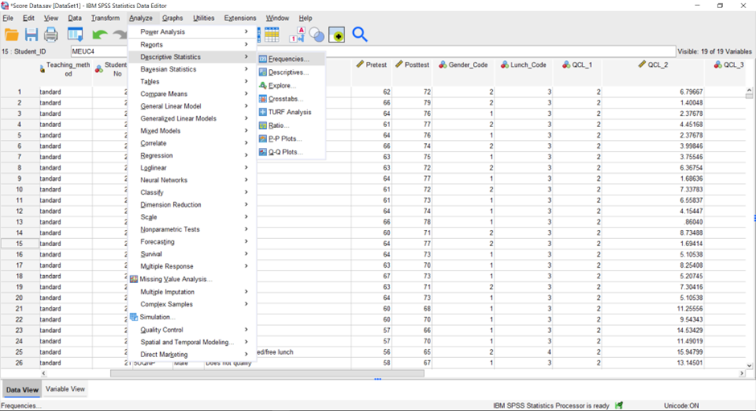
Step 2
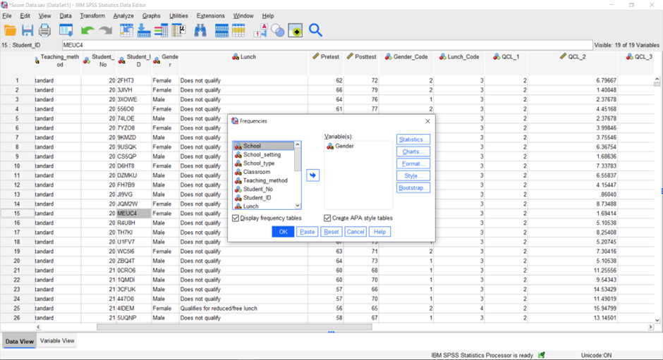
Output
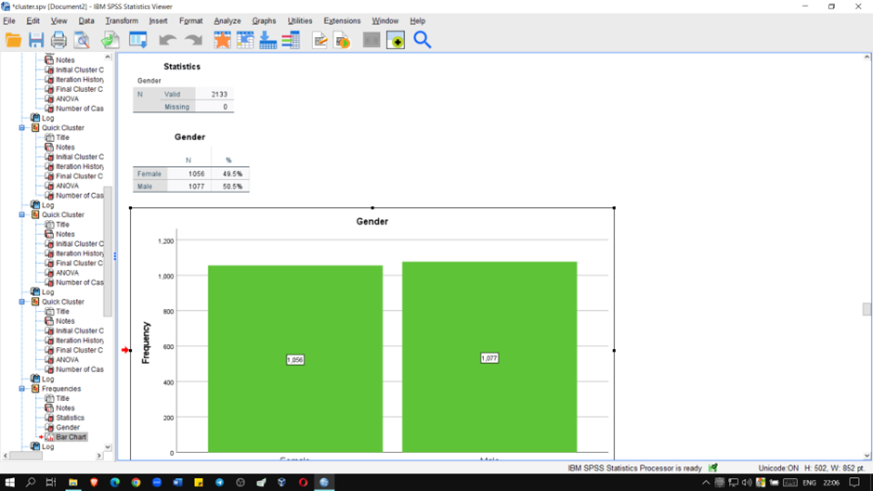
Graph
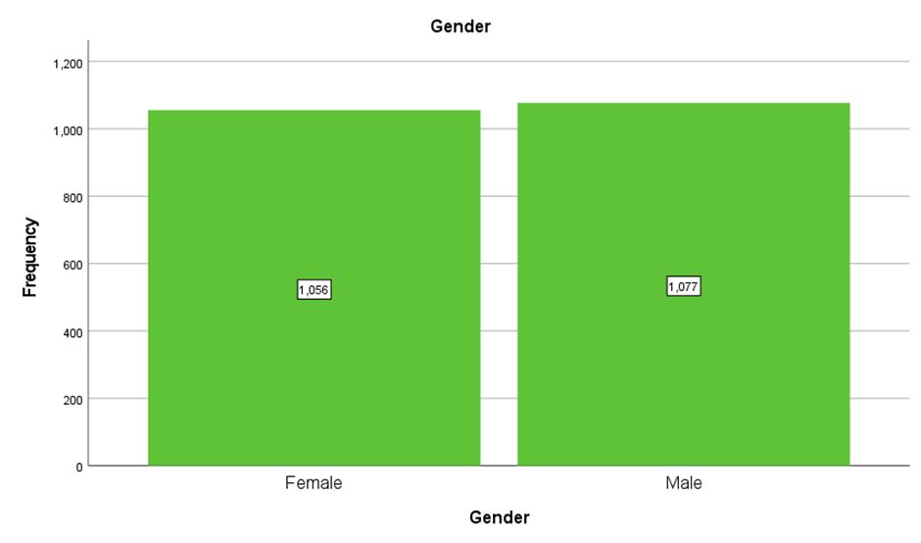
The total number of Male and Female students is 1077 and 1056.

Qualifies’ and ‘Does Not Qualify’
Step 1
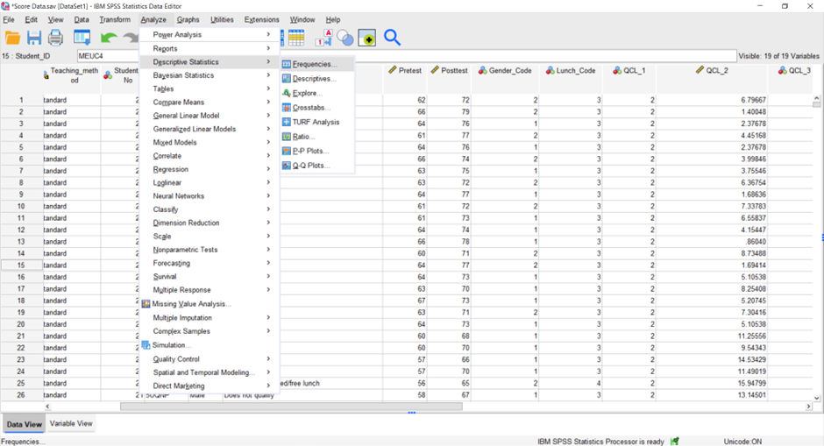
Step 2
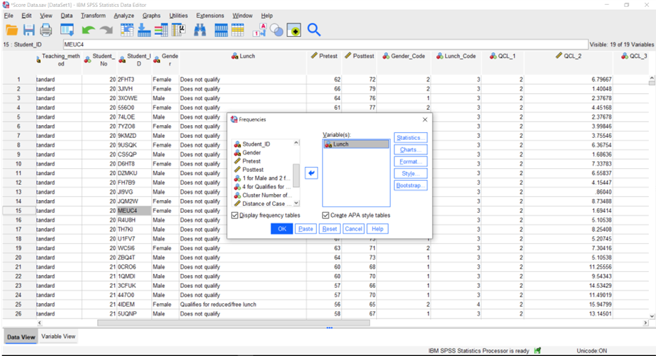

Output
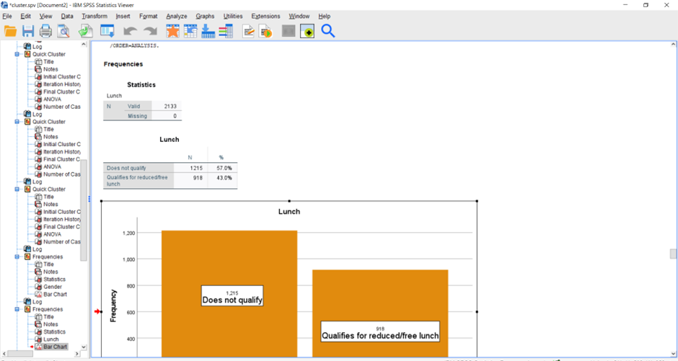
Graph
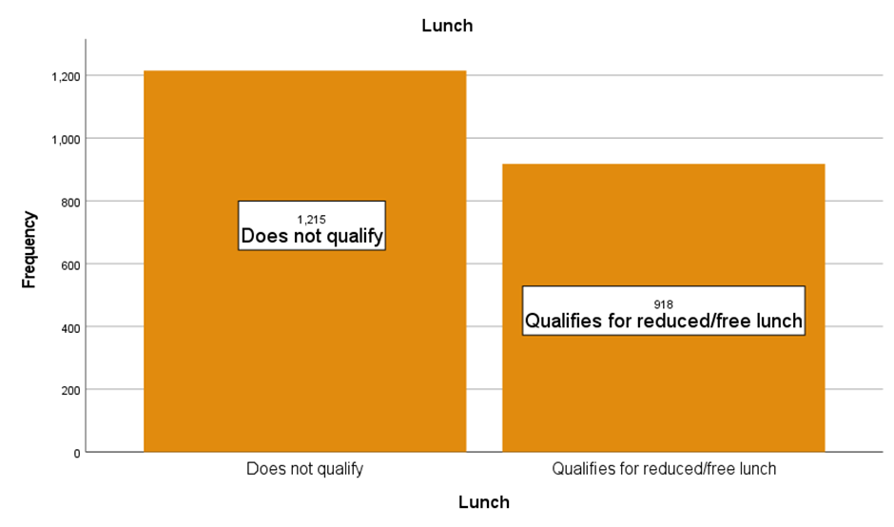
The total number of students who do not qualify for reduced/free lunch is 1215 whereas those who qualify are 918.

Mean And Median of Students
Step 1
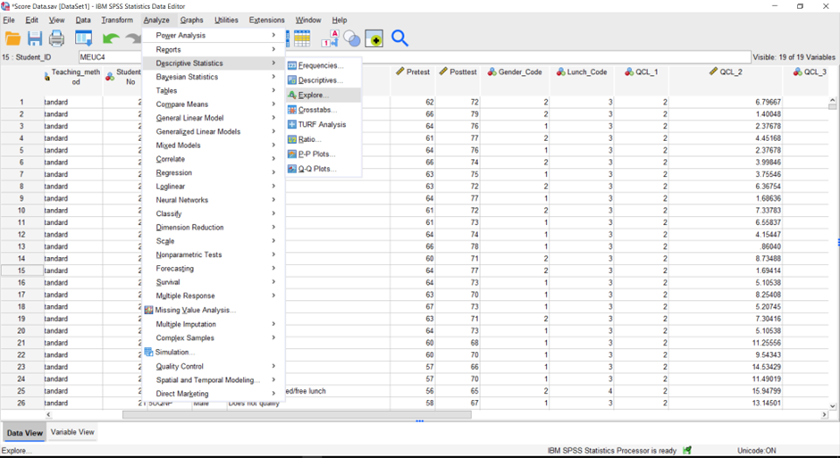
Step 2
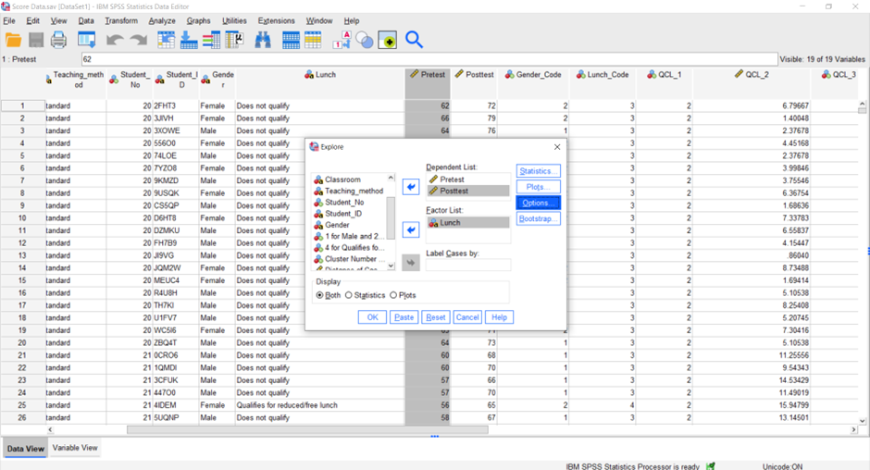

Output
A
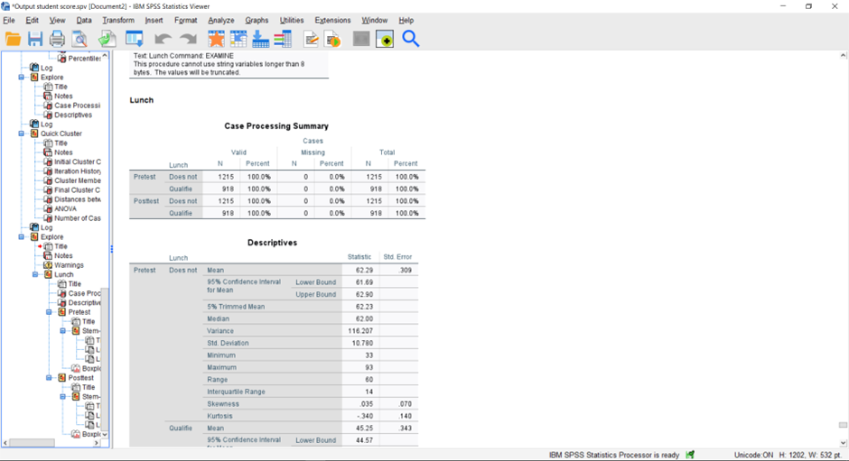

B
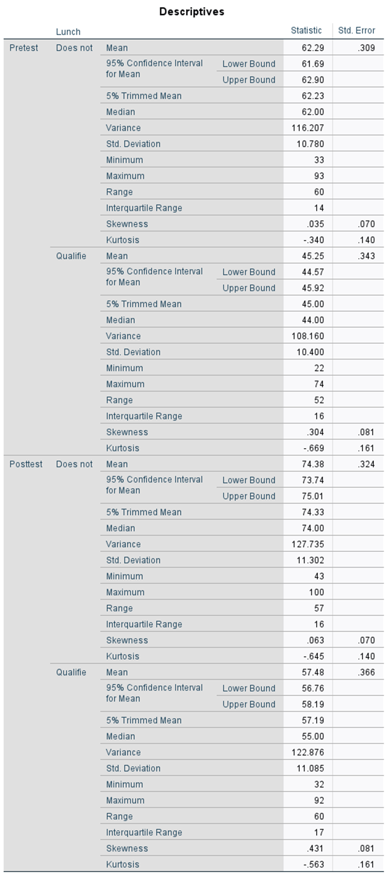
The above table shows that the mean score of students in the pre-test, who didn’t qualify for reduced/free lunch is 62.29 whereas 45.25 is found for those who qualify. On the other hand, the mean score increased to 74.38 in Post-test for the students who didn’t qualify for reduced/free lunch and 57.48 in the qualifying section.
C (Plot)
Pretest

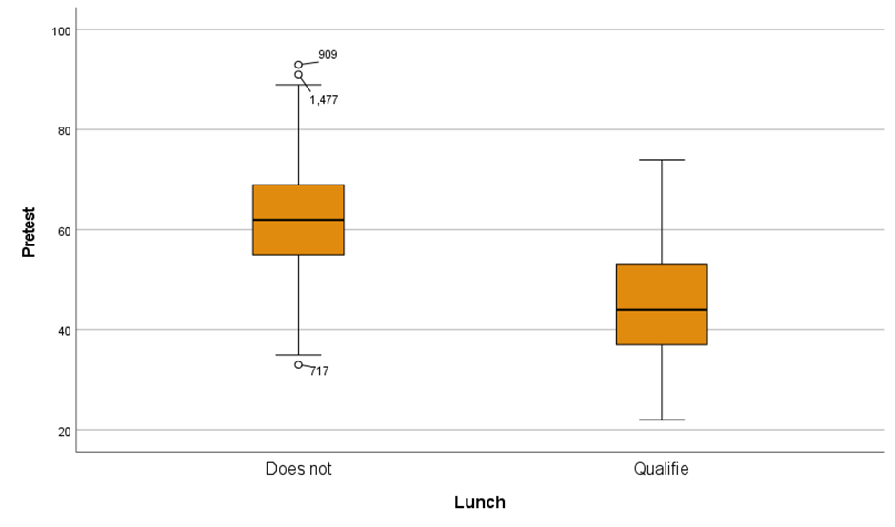
Post-test
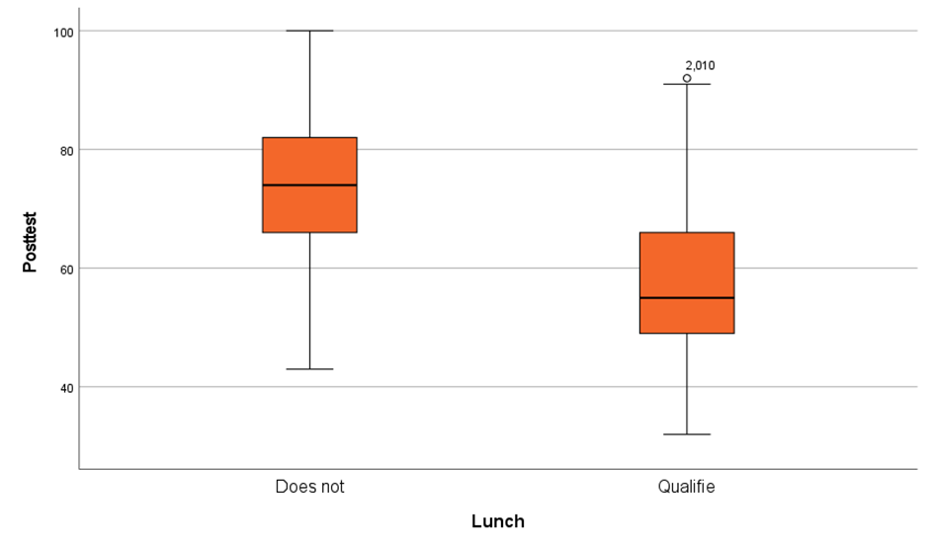
D (Bar Chart)
Pretest
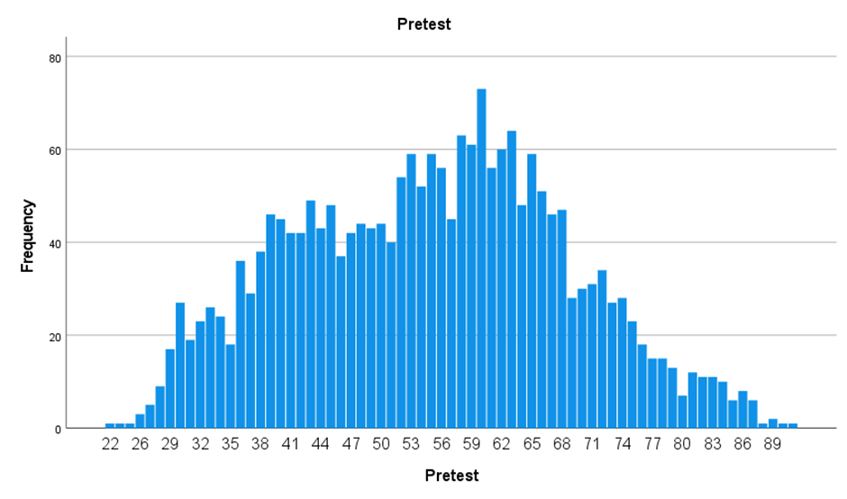
Post Test
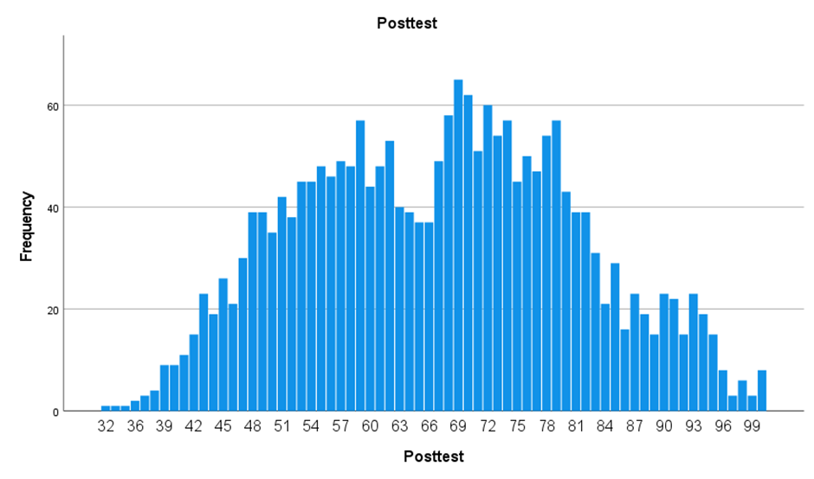

Mean And Median Differences of Pre-Test and Post-Test Scores
Step 1
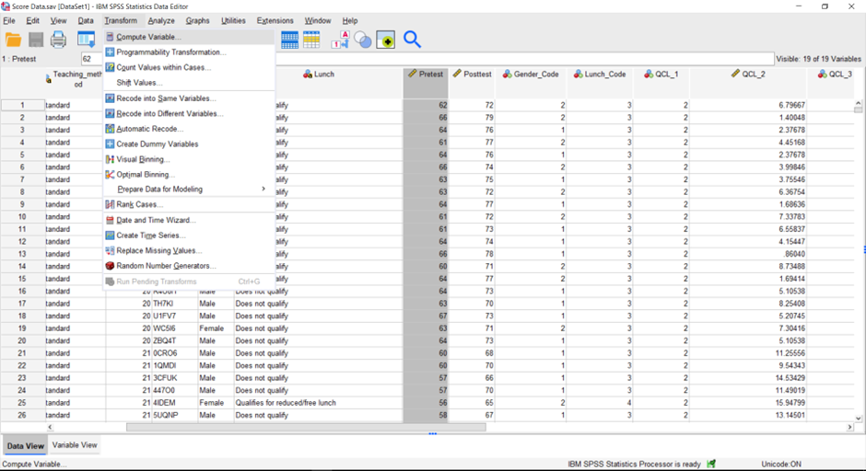
Step 2
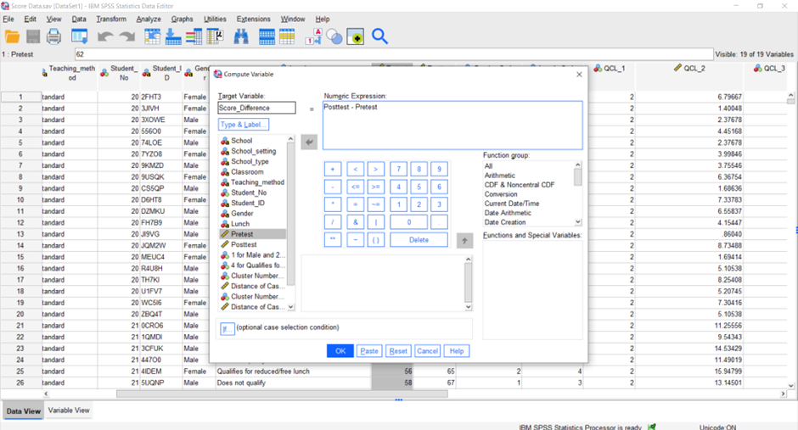
Step 3
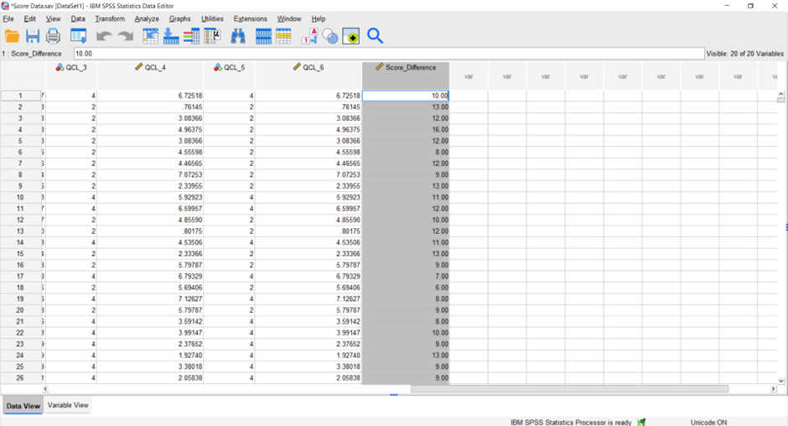
Step 4
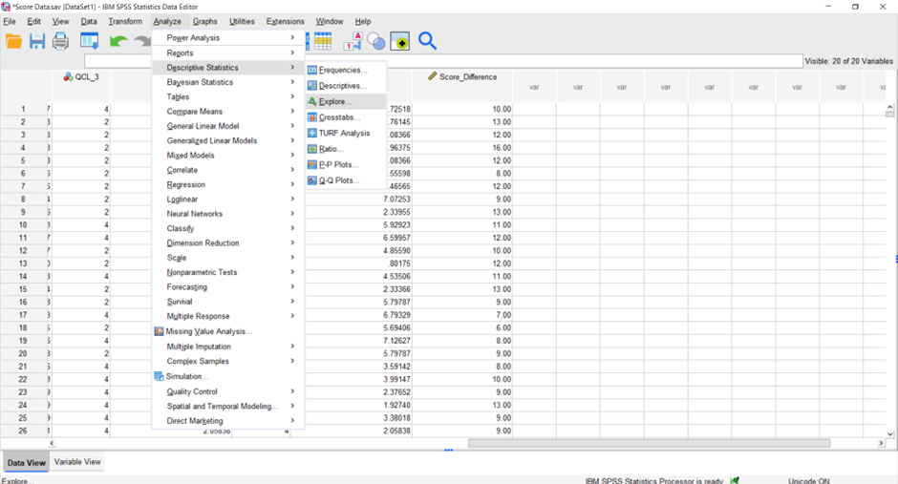
Step 5
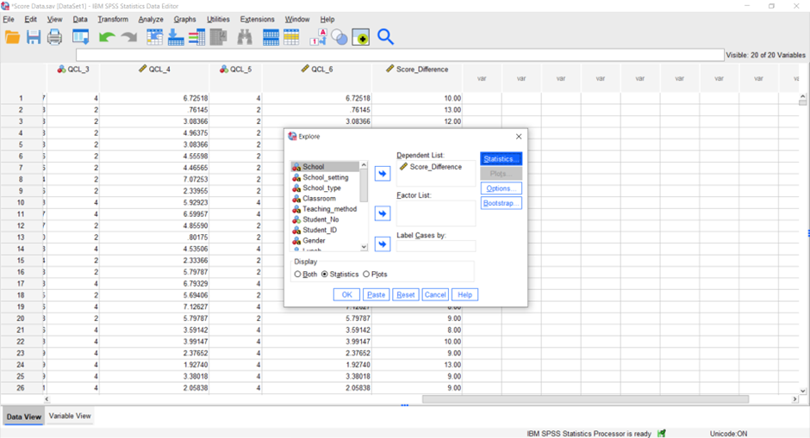

Output
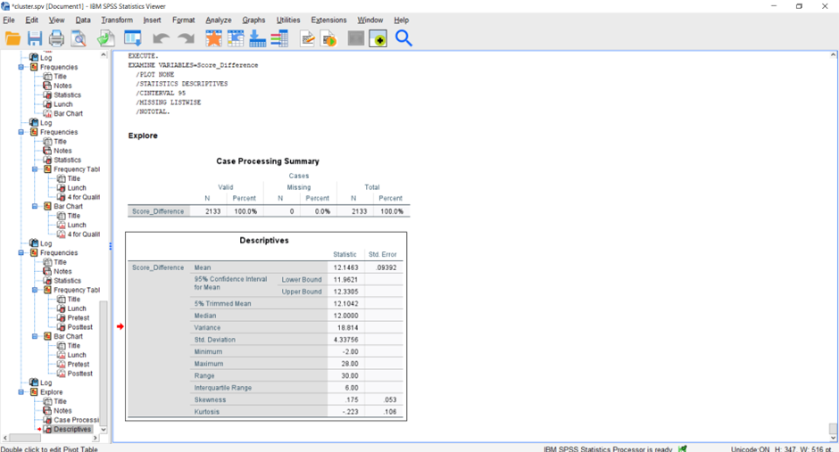
The output indicates that the mean difference between pre and post-test scores is 12.14 while the median is 12.

K-Means Clustering

Before running the K-means clustering, the categorical "Gender" and "Lunch" variables must be converted to numerical variables through one-hot encoding so that a numerical code may be used to represent the category. This work involves using SPSS 27's 'Transform' function to change the 'Gender' variable into a new variable column called 'Gender_Code,' where a value of 1 indicates 'Male,' and a value of 2 indicates 'Female,' respectively. However, the 'Lunch' variable will be transformed into a new column called 'Lunch_Code,' with values of 4 for 'Qualifies for reduced/free lunch,' and 3 for 'Does not qualify,' respectively (Shi and Lee, 2021).

Step 1
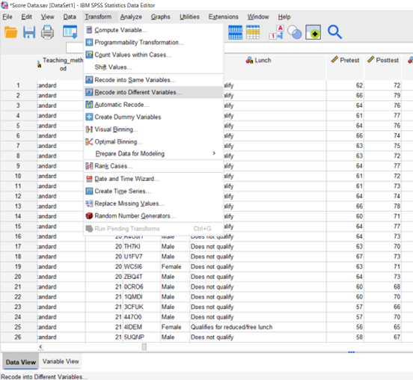
Step 2
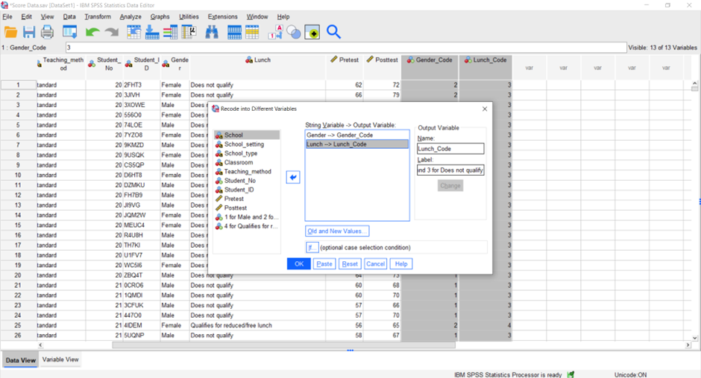

Step 3
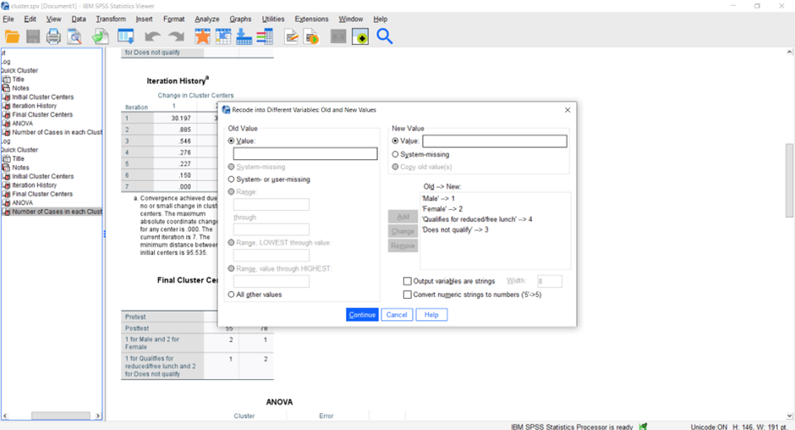
Step 4
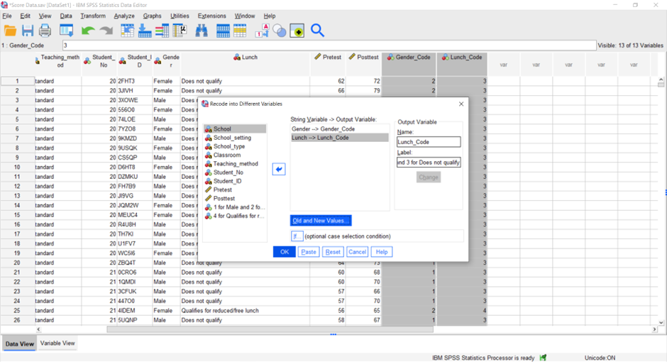
Step 5 (output)
After it confirms the selection with the OK button, it will create two new variables and give them the names "Gender_Code" and "Lunch_Code".
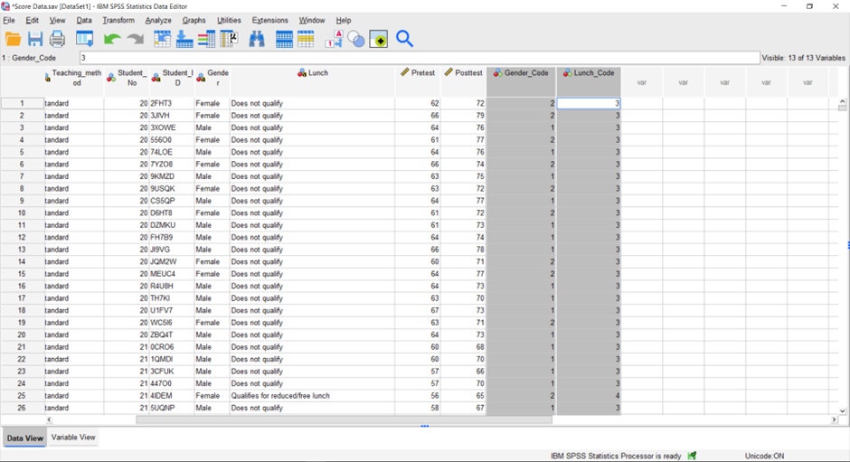

K- means Clustering
Step 1
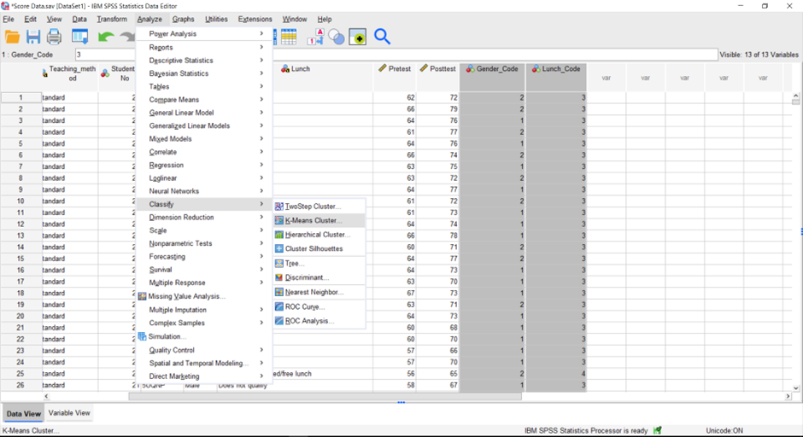

Step 2
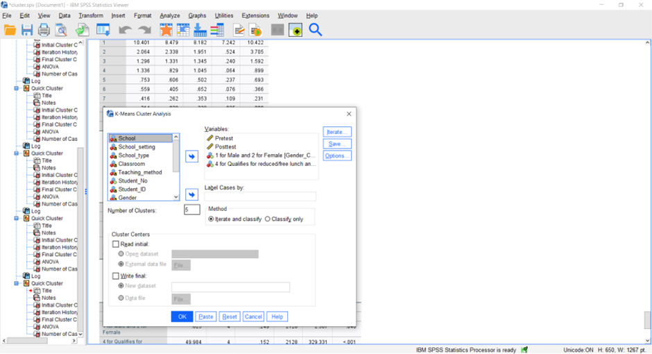
Step 3 (Output)
A
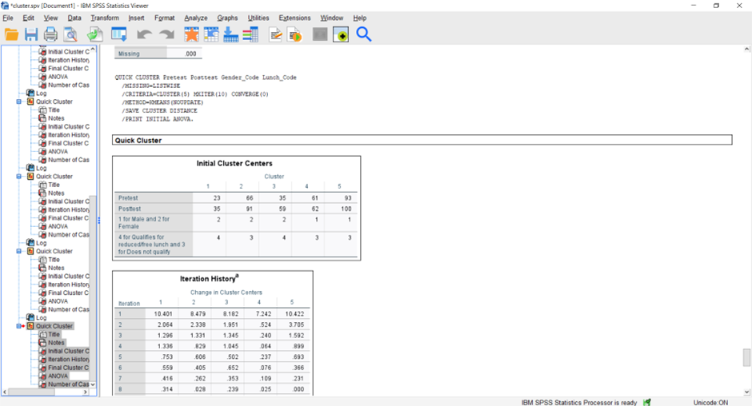

B
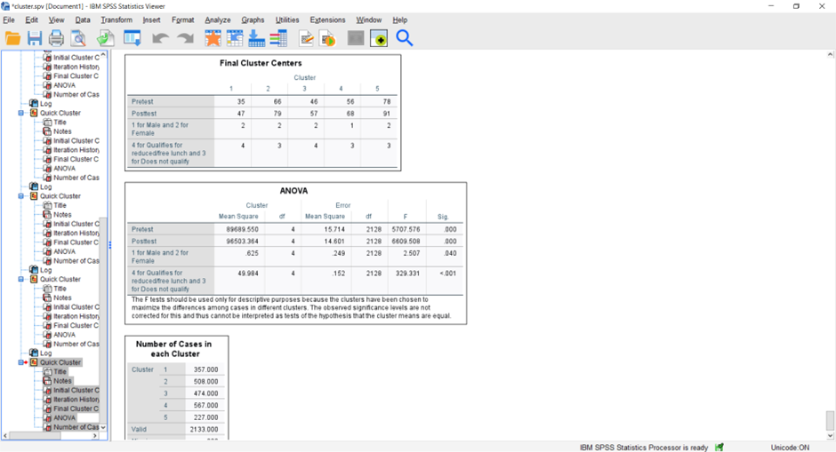

Analysis
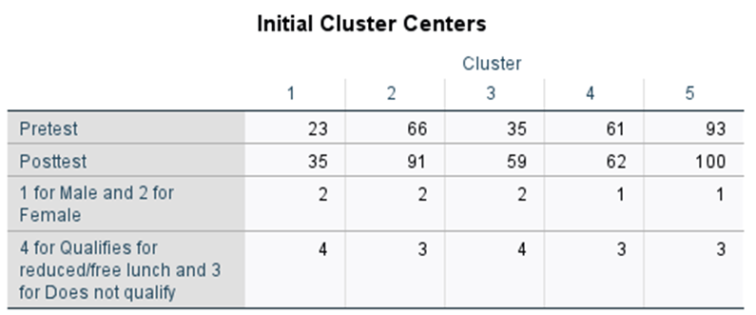
The beginning positions for each cluster centre are shown in this table under the heading "Initial Cluster." Each of the five clusters is numbered from one to five, and the centre of each cluster is portrayed by the mean values of the scores on the pre-test and the post-test, as well as gender and lunch status. For instance, the initial centre for cluster 1 is located at (23, 35, 2, 4), which indicates that the average score on the pretest for this cluster is 23, that the average score on the posttest for this cluster is 35, that the cluster is composed of predominantly females, and that the majority of the children in this cluster are eligible for reduced or free lunch (Zhang et al., 2018).
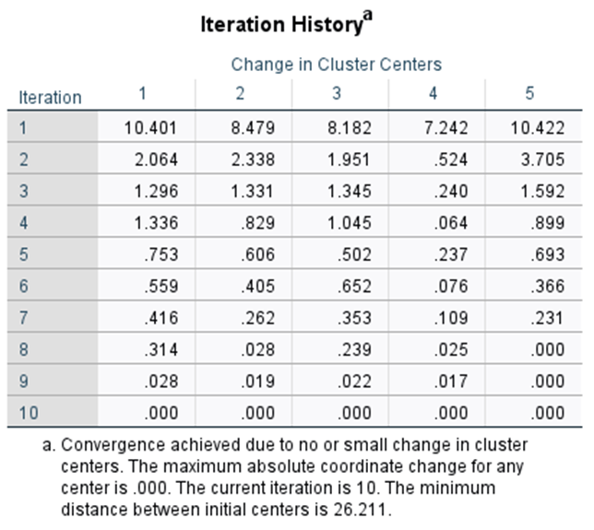
It illustrates how the K-means algorithm causes a shift in the centres of the clusters throughout the course of its rounds. The goal of the procedure is to reduce the distance gap that exists between the observations and the cluster centres to which they have been allocated. If the numbers in this table are lower, it indicates that the clusters are more consistent. Iterations 1 through 10 show a progressive decrease in the amount of change that occurs in the centres of the clusters, which is an indication that the procedure has settled on stable clusters (IBM, 2021).
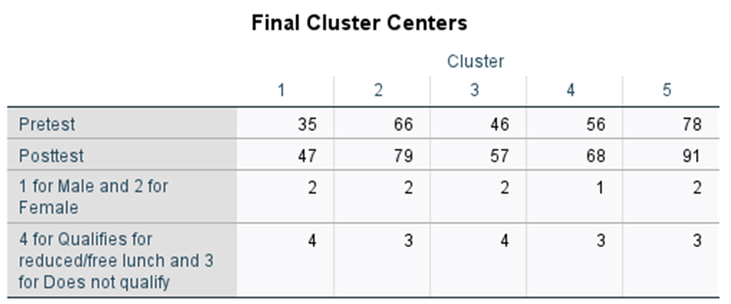
After the algorithm has reached a point of convergence, the final cluster centres are shown in this table. The fact that the algorithm was able to correctly group the observations into clusters depending on their pre-test and post-test scores, gender, and lunch status is shown by the fact that the original cluster centres have been superseded by new cluster centres with new mean values for each cluster centre (IBM, 2022b).
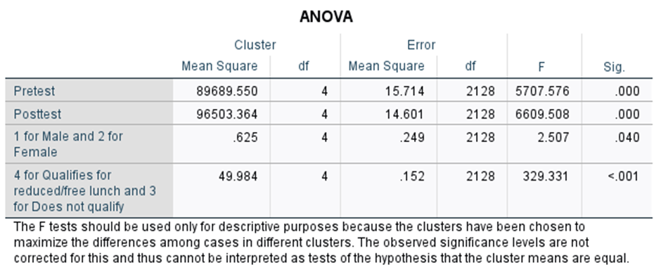
The findings of an analysis of variance (ANOVA) for each of the factors that were included in the study can be seen in the table labelled "ANOVA." These variables include pre-test score, post-test score, gender, and lunch status. The analysis of variance (ANOVA) may be performed to determine whether or not there are discernible variations in the means of the clusters for every factor. In this particular instance, the p-values for each variable are lower than 0.05, which indicates that there are statistically substantial variations between the means of the clusters for each variable (Shi and Lee, 2021).

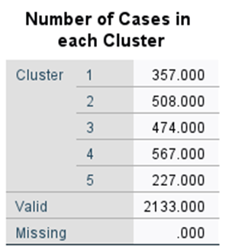
The number of observations in each grouping is listed below. The greatest number of instances can be found in Cluster 4 (567), while the fewest can be found in Cluster 5 (227). The research showed that there were substantial disparities in pre-and post-test results, gender, and lunch availability across the groups. The technique begins with the five seed cluster centres and iteratively searches for better clusters from there. The procedure's convergence to a sustainable resolution is shown in the iteration history by a decreasing rate of shifts within the cluster centres. Findings from the analysis of variance showed that there are considerable changes in pre-and post-test scores across clusters, indicating that the clusters have unique features based on the data. Gender is another factor that varies significantly across clusters, suggesting that the proportion of sexes varies widely (Valente et al., 2020). The percentage of students who are eligible for reduced or free lunch varies significantly among clusters, as shown by the lunch status variable.

Data Mining and Text Mining Methods

Sentiment analysis is a technique used in text mining that entails examining large amounts of text for an underlying emotional tone. This technique is frequently utilised in today's enterprises for a broad range of tasks, including market studies, consumer opinion analysis, and corporate image management. A retailer, for instance, may employ sentiment analysis to track mentions of its items and brand on Twitter (Purohit and Bhargava, 2017).
Topic modelling, on the other hand, is a data mining technique for discovering overarching themes in a corpus of texts. Companies in the modern day frequently employ this strategy for tasks including content evaluation, segmenting clients, and analysing trends.One possible use of topic modelling is in the analysis of consumer evaluations and social networking postings by a telecoms firm. The organisation may boost customer loyalty by creating segmented marketing campaigns based on prevalent concepts and challenges (Rubio and Chen, 2021).
Using factors like consumer characteristics and volatility, an online retailer might employ regression to find the sweet spot for selling prices according to previous sales information, rival costing, and other factors. The corporation may maximise earnings and maintain an edge over others via regression-based price optimisation. As a last application, demand assessment might benefit from regression (Scott and Lu, 2016).
Predictive maintenance is yet another use for time-series analysis. Using data from sensors and other sources, an aeroplane maker, for example, may utilise time-series analysis to track engine efficiency. The producer can ensure the aircraft's safe and dependable operation by employing time-series analysis to identify abnormalities and forecast probable equipment failures, allowing for proactive maintenance scheduling and reduced downtime (Valente et al., 2020).
Finding and extracting named things like individuals, companies, and places from text data is the goal of the text mining technique known as named entity recognition (NER). A retailer, for instance, may utilise NER to glean information about its rivals' products and services from customer reviews and social media postings. The business may learn from this data about its rivals' tactics and use that knowledge to improve its own marketing strategy (Ashton et al., 2020).

Advantages And Disadvantages of SPSS and Excel

A significant advantage is that the statistical analysis is done using SPSS, which was quite thorough. It is well-suited to the complex evaluation of information due to its wide range of analytical procedures and its pulverised design for that purpose. They are able to do complicated calculations such as statistical regression, components, and analysis of variance. An additional useful capability of SPSS is that it may assist researchers in arranging the data in a more logical fashion. The user's experience is enhanced by the simplification of data purification, recording, and conversion, which is particularly useful when dealing with massive databases (IBM, 2021).
Microsoft Excel
Advantages | Disadvantages
Proficiency with data, as well as its modification | Restricted statistical methods
presentation, and charting | insufficient sample sizes

Some consumers might have to put in an extensive amount of research and attention to become familiar with the application and its foundational mathematical theories. Although SPSS is a powerful mathematical bundle, it might not have the flexibility and programmability of other options (IBM, 2022). Nevertheless, complicated information evaluations which require elaborate mathematical techniques might be beyond Excel's capabilities. It might not be considered as efficient as alternative programming tools for managing enormous data, yet it contains particular constraints in this area. (IBM, 2022b) Excel is prone to making errors while doing complex calculations on huge numbers. The repercussions of such slipups could prove quite serious when working with sensitive data (IBM, 2022a).
SPSS
Advantages | Disadvantages
Superior statistical analytical power | costly
intuitive design, and adaptability | few alternatives for data visualisation

Conclusion

The report has identified that the average prices of hotel reservations have increased constantly even though there were factors like Covid-19 and the economic recession. On the other hand, the local school might take into account more intervention for the students especially males to further improve academic achievement. The clustering has shown that the female students performed well with regard to the qualification for free/reduced-priced lunch. Through this analysis, it proved that SPSS is more convenient to deal with large data compared to Excel which further set a criterion for the skill of data analyst.

Reference

Anderson, C.B. and Craiglow, H.A. (2017). Text mining in business libraries. Journal of Business & Finance Librarianship, 22(2), pp.149–165. doi:https://doi.org/10.1080/08963568.2017.1285749.
Ashton, T., Paswan, A., Prybutok, V.R. and Pavur, R. (2020). Assessing text mining algorithm outcomes. Journal of Business Analytics, 3(2), pp.1–15. doi:https://doi.org/10.1080/2573234x.2020.1785342.
IBM (2019a). SPSS Statistics - Support. [online] Ibm.com. Available at: https://www.ibm.com/products/spss-statistics/support [Accessed 4 May 2023].
IBM (2019b). SPSS Statistics - Support. [online] Ibm.com. Available at: https://www.ibm.com/products/spss-statistics/support [Accessed 4 May 2023].
IBM (2021). SPSS Statistics - Overview. [online] Ibm.com. Available at: https://www.ibm.com/products/spss-statistics [Accessed 5 May 2023].
IBM (2022a). SPSS Statistics - Features. [online] www.ibm.com. Available at: https://www.ibm.com/products/spss-statistics/features [Accessed 4 May 2023].
IBM (2022b). SPSS Statistics - Features. [online] www.ibm.com. Available at: https://www.ibm.com/products/spss-statistics/features [Accessed 4 May 2023].
Microsoft (2022). Compare All Microsoft 365 Plans | Microsoft. [online] www.microsoft.com. Available at: https://www.microsoft.com/en-ww/microsoft-365/business/compare-all-microsoft-365-business-products [Accessed 5 May 2023].
Microsoft (2023a). Microsoft Excel, Spreadsheet Software, Excel Free Trial. [online] www.microsoft.com. Available at: https://www.microsoft.com/en/microsoft-365/excel [Accessed 5 May 2023].
Microsoft (2023b). What is Microsoft Office and Microsoft 365 | FAQs. [online] www.microsoft.com. Available at: https://www.microsoft.com/en/microsoft-365/microsoft-365-for-home-and-school-faq [Accessed 5 May 2023].
Purohit, R. and Bhargava, D. (2017). An illustration to secured way of data mining using privacy preserving data mining. Journal of Statistics and Management Systems, 20(4), pp.637–645. doi:https://doi.org/10.1080/09720510.2017.1395183.
Rubio, I. and Chen, J. (2021). COVID-19 impact on the operational efficiency of a downtown hotel. Anatolia, 5(2), pp.1–14. doi:https://doi.org/10.1080/13032917.2021.1997774.
Scott, W.F. and Lu, S. (2016). Orthogonal polynomials, repeated measures, and SPSS. Communications in Statistics - Theory and Methods, 46(7), pp.3342–3364. doi:https://doi.org/10.1080/03610926.2015.1060345.
Shi, H. and Lee, W.-L. (2021). Image segmentation using K-means clustering, Gabor filter and moving mesh method. The Imaging Science Journal, 69(5-8), pp.407–416. doi:https://doi.org/10.1080/13682199.2022.2161159.
Shi, X., Xu, D., Zhuang, H. and Liu, C. (2021). How unsafe acts occur: an automatic text mining study. Maritime Policy & Management, 6(3), pp.1–11. doi:https://doi.org/10.1080/03088839.2021.1894363.
Valente, M.J., Rijnhart, J.J.M., Smyth, H.L., Muniz, F.B. and MacKinnon, D.P. (2020). Causal Mediation Programs in R, Mplus, SAS, SPSS, and Stata. Structural Equation Modeling: A Multidisciplinary Journal, 5(2), pp.1–10. doi:https://doi.org/10.1080/10705511.2020.1777133.
Zhang, S., Li, S., Hu, J., Xing, H. and Zhu, W. (2018). An iterative algorithm for optimal variable weighting in K-means clustering. Communications in Statistics - Simulation and Computation, 48(5), pp.1346–1365. doi:https://doi.org/10.1080/03610918.2017.1414244.

