LEVEL 5 ASSESSMENT SPECIFICATION
Programme: | BA (Hons) Leadership and Management Skills for the Workplace
Module: | Developing Relationships and Workplace Achievements
Module code: | BMSW 5102 | Contribution to Overall Module  Assessment (%): | 50%
Module Leader: | Nishi M Ramsurrun | Internal Verifier: | Md Kalam
Assignment Title: | Individual Report on -  “Development of a plan by meeting the identified personal development needs and expectations of individual employees in a  chosen organisation | Word count (or equivalent): | 2,500 words (+ ) 10%
Student Name: | Md Sajjadur Rahman | Student ID: | 2011252

Table of Contents
Introduction 3
Organisation Overview 3
Evaluating the development vehicles that are available in British Airways and also explaining the effectiveness of those performance appraisal tools and tactics. 4
360-degree feedback 4
540-degree feedback 6
Management by objectives (MBO) 7
Individual Pay Related performance (IPRP) 8
A constructive professional development plan (PDP) for British Airways for meeting the development needs of the individual workers. 10
Conclusion and Recommendation 15
References 16

List of Figures
Figure 1: Weekly Flights of BA by Region 3
Figure 2: Different Performance Appraisal Tools 4
Figure 3: 360-degree feedback 5
Figure 4: 540-degree feedback 6
Figure 5: Management by objectives (MBO) 8
Figure 6: Individual Pay Related performance (IPRP) 9
List of Tables
Table 1: Professional development plan (PDP) 10

Introduction
The success of a particular business firm is highly dependent on the activities of the workers. Here if the workers work appropriately within the organisation, the business objectives can be achieved easily by the firm. On the other, if the workers cannot provide services according to the expectations of the firm, the objectives of the firm will not be achieved. Therefore, performance appraisal tools are needed to be used by the firm (Smith, 2020). This report will bring information on different performance appraisal tools and a personal development plan. All the information will be provided based on British Airways.

Organisation Overview
British Airways is one of the largest carriers around the world and is the second largest in the UK. This firm has been operating successfully throughout the world and connecting the UK with the rest of the nations around the world for more than 105 years as this organisation has founded in 1916.
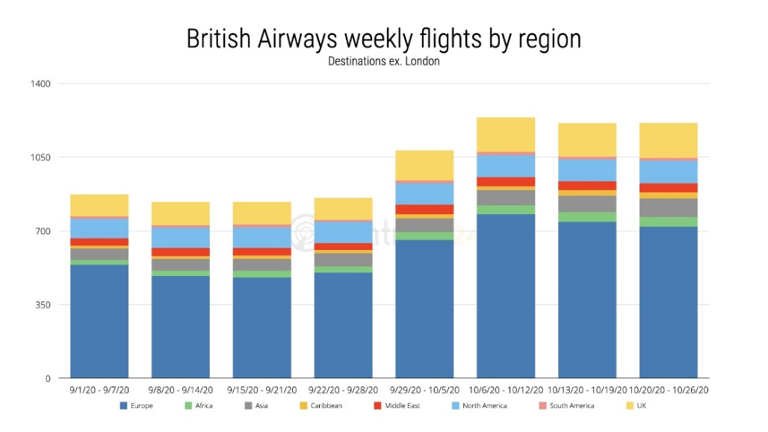
Figure 1: Weekly Flights of BA by Region
Source: (BA, 2022)
British Airways is a global firm in the airline business that has brought together people, regions, and differentiated cultures for years. Serving society and the globe is at the core of all that they do, as well as they are also interested to share with everyone their new sustainability programs.

Evaluating the development vehicles that are available in British Airways and also explaining the effectiveness of those performance appraisal tools and tactics.
There are different feedback or performance appraisal methods available that British Airways can use for measuring the competence of the employees of the firm. Here the effectiveness of these performance appraisal tools also varies from each other based on different situations (Olsen, 2019). Here British Airways can use any of the performance appraisal tools available in the market.

Figure 2: Different Performance Appraisal Tools
Source: (Johnson, 2018)

360-degree feedback
It is an evaluation technique performed by British Airways that gets input about an individual from a lot of other individuals that understand him or her. This type of feedback is sometimes referred to as basically 360 feedback or multi-rater evaluation. In most cases, this might be co-workers, people who report directly to the individuals who seek feedback. The primary advantage is that it provides individuals with better documentation about their abilities, performance, and professional relationships than more conventional appraisal structures that are based solely on the evaluation of line managers (Newhouse, 2021). This is because it is normally utilized as a tool for learning and advancement. The person who is interested in receiving an evaluation, known as the appraisee, often fills out a self-perception questionnaire before asking between six and ten other individuals, known as the responders, to provide feedback using the same questionnaire.
It is a common practice of British Airways to divide the participants into groups based on the nature of their relationship with the person being evaluated; for instance, senior, colleague, junior, or customer respondents. This provides the person being evaluated with a perspective of his or her accomplishment from every angle, or 360 degrees. It is especially useful in British Airways with a high degree of flexibility, in which the person being evaluated may be a member of numerous groups or work alone, and the line supervisor may not have a complete awareness of the dedication that the appraisee makes (Harrington, 2018).
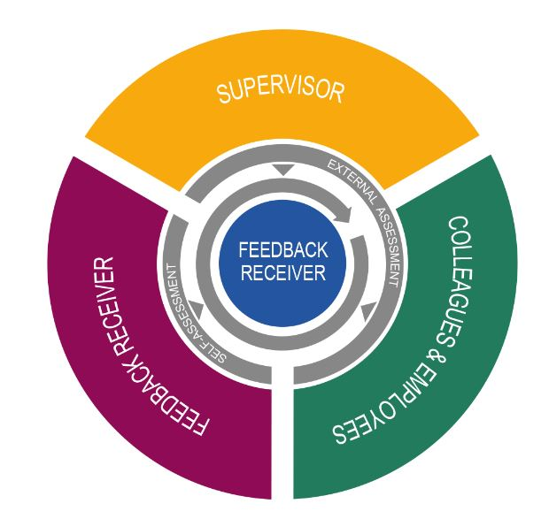
Figure 3: 360-degree feedback
Source: (Thornton and Byham, 2022)
For 360-degree feedback to be effective in British Airways, it is necessary to compile the responses of a large number of individuals to a series of competency-based questions. These include a mix of scored questions based on a collection of management abilities and open-ended inquiries, the latter of which is meant to provide individuals with the freedom to provide feedback outside of the limits imposed by the scored questions. When both the person being evaluated and the participants have finished filling out their surveys, the results are collected into a document called a 360-degree feedback assessment (Henderson, 2020). In the report, it is not possible to determine the specific responses provided by each respondent.
The personal feedback assessment analyses the appraisee's self-perception in comparison to the feedback received from others and indicates any discrepancies that are found. Important aspects of personal growth are frequently brought to people's attention. The report becomes an important piece of evidence that can be used to support plans for professional growth. The individual must be allowed to retain as much of a degree of control over the process as is reasonably practicable, as well as sensitivity and fairness in the execution of the 360-degree feedback. It is necessary for there to be sufficient planning done in advance, as well as the support provided after the event for the participant of British Airways. Those who provide feedback ought to be incentivized to do so in a manner that is both objective and constructive. Individuals who have been trained in feedback procedures should be responsible for summarizing the feedback and delivering it to the receiver (East, 2020). At the same time, the privacy of all respondents should be maintained by British Airways. The people being evaluated should always be assisted to act on the feedback they receive.

540-degree feedback
Besides the 360-degree feedback method, British Airways can also use the 540-degree feedback which comes with some more benefits for the firm to measure the employee’s ability. 540-degree feedback is a way of worker performance evaluation in which numerous appraisers evaluate the performance of an individual (Woolfrey, 2021). In addition to superiors, colleagues, subordinates and themselves, 540-degree feedback also encompasses suppliers and subcontractors. People who have engaged with the person during the operation of the person's job duties provide different feedback.
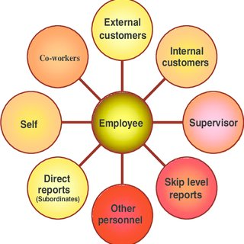
Figure 4: 540-degree feedback
Source: (Smith, 2020)
The 540-degree feedback method can be used by British Airways to identify a person's weak points as well as their strong points, and it can also be utilized to motivate that individual. Other stakeholders, such as consumers or clients of British Airways of the target individual, are also involved. External appraisers refer to these consumers and clientele. In addition to the standard 360-degree feedback, there is now 540-degree feedback. As far as workers that engage with consumers or clients are concerned, supervisors must use 540-degree feedback. Providing personnel with this feedback serves to enhance their level of service to customers.
This allows British Airways to analyse the productivity of its personnel in whatever way that it can. In today's competitive business environment, 540-degree feedback is an important addition to the 360-degree feedback paradigm since it helps firms to better understand their customers' perspectives and hence better align their workforce to achieve high consumer satisfaction. Consumer perception data can be used to acquire a competitive edge or to develop a Unique Selling Proposition for a firm (Dilts and Haber, 2021). 540-degree e feedback can also assist in orienting training programs and methodologies so that staff can achieve improved customer satisfaction, resulting in greater income and discovering issues that would not have been accessible with conventional feedback systems.
Any time a flight attendant of British Airways exhibits a preference for a few clients or demonstrates biases while serving them, getting feedback from consumers is critical to figuring out and fixing the problem before future customers, and the company's reputation and income are jeopardized (Nancy, 2019). In such a situation, 540-degree feedback would be of great assistance in identifying problematic behaviours or workers and removing them from the workforce. Customer feedback can be obtained in the shape of a survey or a simple rating mechanism for employees who are performing well. Customers can also complain about delivery personnel's appearance or demeanour by filling out a form or survey provided by the company.

Management by objectives (MBO)
It is a well-liked approach to employee evaluation of British Airways, particularly for positions that require unambiguous quantifiable output from their occupants. Even though the MBO idea involves more than just the procedure of appraisal, the application of this concept that we will be focusing on here is its limited application to assessing the results of employees. There is a strong connection between MBO and the goal-setting concept of motivation (Ayers, 2019).
Under the MBO framework, individual workers of British Airways collaborate with their direct manager to determine the goals and responsibilities that will fall under their purview throughout the following calendar year. These goals are articulated in straightforward language and are connected to responsibilities that fall under the purview of the employee.
MBO has been proven to have some beneficial effects on British Airways. These include the capability to do better preparatory work; improved encouragement as a result of the understanding of results; fairer assessments made based on outcomes rather than individuality; improved contribution as a result of involvement; and improved supervising skills in areas such as paying attention, counselling, and evaluating (Newhouse, 2021). On the other hand, MBO has been questioned for the fact that it places an excessive amount of emphasis on quantitative objectives at the cost of qualitative objectives and frequently results in an excessive amount of paperwork.
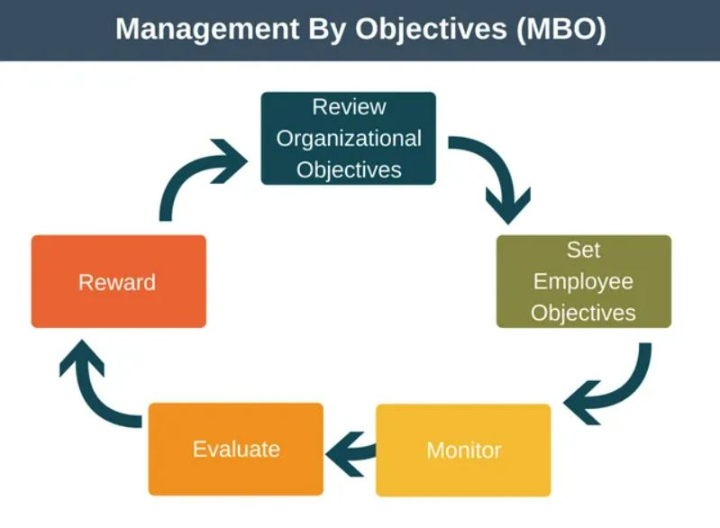
Figure 5: Management by objectives (MBO)
Source: (Johnson, 2018)
Because most workers are accountable for a variety of distinct goals, it can be challenging to compare the performance levels of different individuals. There are times when the aims of the MBO are implemented in an authoritarian manner, which makes them inefficient or even detrimental. According to what was discovered in research on what motivates people, for objectives to be successful, they need to be acknowledged. In conclusion, the adoption of MBO needs to have the continuous attention and support of senior management to be effective because MBO does not operate itself (Olsen, 2019). The method loses its validity and frequently becomes less effective when this support is not provided, and as a result, it typically falls into disrepair.

Individual Pay Related performance (IPRP)
This concept of assessment is mainly related to the payment system of a particular organisation. Here British Airways can use this assessment procedure for measuring the required wages or salary that is necessary to provide to the workers of the firm. This procedure of appraisal can be also used for progress or increment of the salary of the workers (Harrington, 2018). According to this concept, the workers of British Airways will get the rewards and salary based on their activities rather than the group as a whole and therefore, it is necessary to work for their increment in payment rather than depending on the group activities of the firm.
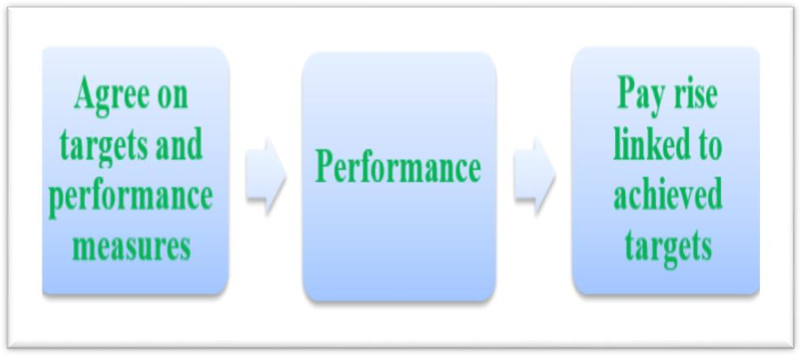
Figure 6: Individual Pay Related performance (IPRP)
Source: (Smith, 2020)
There are certain advantages of using this concept of performance appraisal that British Airways can get. Since according to this concept, the reward or wage benefits will be provided to the employees of British Airways, the employees will feel more motivated while conducting business activities and dealing with the customers during the flights. Moreover, the number of absent workers will be lower also as they will be provided benefits based on their regular activities within the firm. The objectives of British Airways that the firm has discussed with the employees while hiring them, will be achieved during the business operation as the workers will be loyal to the organisation for achieving the business objectives (Henderson, 2020).
There are certain disadvantages too of using this concept of performance appraisal. Here the employees can engage themselves in several disputes for achieving their objectives and the employees can also avoid group activities more as they will be provided benefits based on their activities. So, in this case, the group success will be lower for British Airways.

A constructive professional development plan (PDP) for British Airways for meeting the development needs of the individual workers.
Table 1: Professional development plan (PDP)
Development Objectives | Priority | Activities to be undertaken | Resources | Target Start Date | Target End Date | Criteria for Success
Communication skill | Most | For improving the communication skills of the workers of British Airways, it is necessary to make sure that a proper seminar has been taken. Further, the workers must be pushed for involvement in group discussion. Online lectures can also be supportive in this case. | Seminars, Online lectures | 1st August 2022 | 31st October 2022 | Workers of the firm will be capable of communicating with the customers and will be able to build interactions with them (Woolfrey, 2021).
Interpersonal skill | Moderate | All the necessary skills that are required for improving the skill of interacting with the customers must be put through different training programs (Thornton and Byham, 2022). Further, the seminars can also support this case to provide certain rules and regulations to the workers. Again, online lectures can be also supportive in this case to improve the interpersonal skills of the workers (Greengarten and Hundert, 2022). | Seminars, Online lectures | 1st August 2022 | 30th November 2022 | For interacting with the customers of the airline, the flight attendants will be very fluent and they will be capable of influencing the customers to take their services again.
Adaptability | Moderate | All the employees of British Airways must be put under certain group activities and here the group must be made with multicultural situations so that the members of the group can learn to adapt to different cultures. | Different situations | 1st August 2022 | 31st October 2022 | The customers who have come from different cultures and different norms will feel comfortable as the flight attendants will be flexible enough with the customers (East, 2020).
Problem-solving | Most | All the employees must be put under certain real-life problems that may arrive while they will be incorporating with the customers in their real life and certain issues and problems must be introduced there so that the workers can learn the ways of solving problems. | Group involvement, group discussion. | 1st August 2022 | 31st December 2022 | The workers will be capable of solving the problems arising from the customers during the flight and before or after the service provided.
Time management | Most | Some strict rules must be put so the workers feel pressure to follow the schedule and before appointing a worker to a particular flight the worker must go under certain training programs so that he or she can properly handle the time and can manage them properly too. | Seminars and online lectures. | 1st August 2022 | 30th September 2022 | All the services will be provided on time and the customers will not provide any complaints regarding the schedule of the flights or any services provided to the customers (Dilts and Haber, 2021).

Conclusion and Recommendation
Since the success of the organisation is highly dependent on the business activities done by the employees of a particular firm, here the business firms should be careful about using performance appraisal tools (Ayers, 2019). Employees are key inputs which affect organizational output most. For a service-providing company like British Airways, employees play a key role while delivering desired services to the client and their service quality helps the organization to attain a competitively advantageous position as well. Some recommendations are provided here which may help BA to retain its employee satisfaction and engagement through proper development and appraisal of the employees:
- Here British Airways should make proper utilisation of the performance appraisal tools as these tools can support the firm to measure the business activities done by the employees.
- Further, the firm should provide increments based on the feedback obtained from using the performance appraisal tools as these tools can be also supportive to set the salary scale of the workers working within the firm.
- Moreover, further benefits and promotions must be also provided based on the feedback obtained for a particular employee.
- British Airways should ensure that all the members within the firm are actively participating in providing feedback for others.

References
Ayers, R., 2019. Building Goal Alignment in Federal Agencies' Performance Appraisal Programs. Academy of Management Proceedings, 2012(1), p.11813.
BA, 2022. The Definitive Guide to British Airways' Direct Routes from the U.S. [Plane Types and Seat Options]. [online] UpgradedPoints.com. Available at: <https://upgradedpoints.com/travel/airlines/british-airways-us-routes-plane-types/> [Accessed 17 July 2022].
Dilts, D. and Haber, L., 2021. Assessing what professors do. Westport, Conn.: Greenwood Press.
East, J., 2020. A Review of the Introduction of Individual Performance Review and Performance Related Pay. British Journal of Occupational Therapy, 52(4), pp.149-150.
Greengarten, M. and Hundert, M., 2022. Individual Pay-for-Performance in Canadian Healthcare Organizations. HealthcarePapers, 6(4), pp.57-61.
Harrington, S., 2018. Management performance appraisal programs. Washington: Bureau of National Affairs.
Henderson, B., 2020. Evaluating performance appraisal programs in APS departments and agencies. Canberra: A.G.P.S.
Johnson, S., 2018. Individual performance-related pay (IPRP). [Wellington, N.Z.]: New Zealand Council of Trade Unions.
Nancy, M., 2019. Employee performance appraisal programs. Chicago: AHA.
Newhouse, J., 2021. Using social science experiments to improve the appraisal of social programs. Project Appraisal, 1(1), pp.39-42.
Olsen, T., 2019. The Rise of Individual Performance Pay. Journal of Economics &amp; Management Strategy, 21(2), pp.493-518.
Smith, D., 2020. Training Programs for Performance Appraisal: A Review. Academy of Management Review, 11(1), pp.22-40.
Thornton, G. and Byham, W., 2022. Assessment centres and managerial performance. New York: Academic Press.
Woolfrey, C., 2021. Approaches to performance-related pay. SecEd, 2013(11), pp.23-27.

