Leon Mathias
2013015
Computing (Software engineering)
Student University of Wales Trinity St David, Swansea, Wales
Data Security and Compliance (ACCA5034)
Date of submission: 05/12/2021

Table of Contents
Abstract 2
1.0 Research in Data Security and Compliance 2
1.1 Introduction 2
1.2 Effect of Covid-19 2
1.3 Confidentiality, Integrity and Availability 3
1.4 Cryptography 3
1.4.1 Symmetric and Asymmetric Encryption 3
1.4.2 Man In The Middle Attack 4
1.4.3 Digital Signature 4
1.5 Physical Security 5
1.5.1 Forces of Nature 5
1.5.2 Encrypting Hardware 5
Conclusion 6
2.0 FlowTech case scenario 7
2.1 Introduction 7
2.2 Organisation structure 7
2.3 Polices 7
2.3.1 Employees knowledge on policies 8
2.3.2 Policy recommendations 8
2.4 Compliance (Laws and Ethics) 8
2.5 Strategic Planning for Security 9
2.6 Risk Management 9
2.6.1 Risk identification 9
2.6.2 Risk Assessment 9
2.6.3 Risk Control 10
2.7 Contingencies Planning 10
2.8 Protection Mechanisms 10
2.9 Conclusion 10
References 12

Figure 1: CIA Triad 3
Figure 2: Symmetric-key encryption 3
Figure 3: Asymmetric-key encryption 4
Figure 4: Man in the middle attack 4
Figure 5: Top-Down and Bottom-Up Approach 7
Figure 6: Risk Management 9
Figure 7: Risk Assessment table 10

Abstract
Data security is crucial for organizations. The purpose of the first section of this paper is a to describe of how cryptography and physical security can help protect data and the consequences if these security measures are not taken seriously or implemented effectively. The second half of this paper is to demonstrate how to put theses security measures in place and how they can help a real organization. Also explaining how an organization must comply with data security and the importance of the whole company understanding information security.

1.0 Research in Data Security and Compliance

1.1 Introduction
In todays modern world the internet is available almost everywhere and it would be hard for many people to go without this for a single day, but not only do people rely on the internet for everyday use it is a huge importance for many organizations around the globe. There were 4.66 billion active users of the internet worldwide as of January 2021 [1], that is about 59.5 percent of the world population. With those numbers in mind and the rapid rate technology is changing modern organizations must take security very seriously in order to protect themselves against any threats and attacks they may face. In this report there is an explanation of how Covid-19 effects organizations and techniques on how to help protect data and a organizations infrastructure. These techniques are cryptography which help protect data while in transit. The other technique is physical security which safeguards the hardware from thing such as theft and damages.

1.2 Effect of Covid-19
With COVID-19 many organizations were force to work from home, a survey done by Owl Labs [2] found that 69% of full time workers were working remotely during the pandemic between June and July 2020, they also found that 1 in 2 people wont return to jobs that don’t offer remote work. With employees working from home many problems arise as there are many types of attacks that can be used on people working remotely. During Covid-19 unique Cyber-attacks also were on the rise with the UK and the USA making up 14% each of all attacks [3] meaning with attacks on the rise and new types of attacks securing data is becoming more difficult. Also 75% of organizations have no working at home security measures [4] as due to Covid-19 working from home quickly became an option for many business’ that had no intention of allowing remote working.

1.3 Confidentiality, Integrity and Availability
There is a security model called CIA Triad which is very important and a great guide to organizations to keep their data protected [5]. The CIA is an acronym for the following.
- Confidentiality which ensures that unauthorized uses cannot access information but users with the rights to view the data will have access.
- Integrity, this ensures the data is trustworthy, accurate and consistent and therefore has not been altered.
- Availability which involves making sure the information required is ready to access by the authorized users when needed.
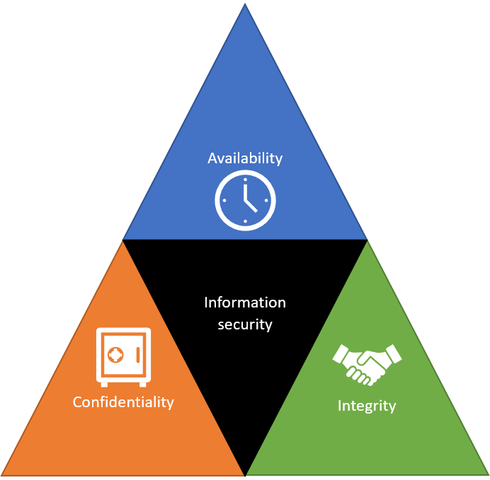
Figure 1: CIA Triad
There is two reasons for using encryption: protecting the data at rest and protecting the data in motion. Data at rest includes data stored on computer or laptop hard drives where as data in motion is when data is moving form one location to another, that could be from one computer to another or through a network that is public or private.

1.4 Cryptography
Cryptography is a good security measure that ensures all three of the CIA triad. There are five goals of cryptography alongside CIA. [6] Authentication which creates trust by proving that the sender is who they say they are. Also Non-repudiation which is proof the message was sent as the receiver or the sender of the message cannot deny the message.
Cryptography is a technique that attempts to make communicating secure by only allowing the sender and the recipient to view the message and it contents. There are different techniques in cryptography one of those is encryption and decryption. As explained here [7] The way this works is to take readable text that is not encrypted called plaintext, then turn that into a non readable text called ciphertext by encrypting the plaintext so that the message is unreadable while in transit to the intended recipient through a non secure channel for example whether that be a wireless network or the internet. The intended recipient will then decipher the ciphertext back into plaintext to view the message.

1.4.1 Symmetric and Asymmetric Encryption
There are two types of encryption [8]. One being single key encryption or symmetric-key encryption algorithm which uses one key that both the sender and receiver knows for both encryption and decryption. 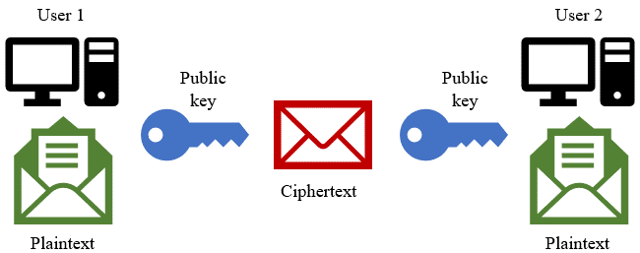
Figure 2: Symmetric-key encryption
The other method of encryption is public key or asymmetric encryption algorithms, which uses two different keys one being a public key used by the sender of the message to encrypt it and a private key which only the receiver knows and therefor is used by the recipient to decrypt the message. 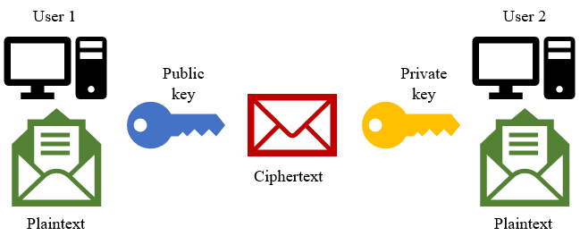
Figure 3: Asymmetric-key encryption
One of the problems of symmetric-key algorithm is for both parties to get the private key a way to combat this problem is by using an algorithm called Diffie-Hellman [9] and this is a good way to exchange private keys as it creates a secure channel where the keys can securely be exchanged without the worry of an attacker which is called a man in the middle attack getting access to the private keys. Although still a good solution as explained by Eric Järpe [10] this could be outdated and therefore no longer be a perfect solution to the exchanging of keys.

1.4.2 Man In The Middle Attack
There are many types of attacks that can do harm to organizations one of these attacks is called the man in the middle (MITM) attack, this can be especially dangerous while working remotely. This type of attack usually contains three people. The first being the person who is attempting to communicate with the receiver who is another person, and the attacker known as the man in the middle.
The man in the middle intercepts the communication between the two parties and then eavesdrops [11]. The attacker can alter communications without either of the parties knowing. This then means that whatever is being sent looses confidentiality and integrity.
With people working remotely this makes the man in the middle attack easier as many people might be using a public Wi-Fi because of the convenience in a study the number of public Wi-Fi spots around the word would rise to 549 million by 2022 [12] as in a coffee shop for example allows users to connect without the need for a password. This Wi-Fi might not use WPA2 or WPA, it might use the less secure and outdated WEP [13] [14]. In a paper by Andrew Zafft and Emmanuel Agu [15] they found only one major city in the United States of America had over 70% secure Wi-fi networks while the average of unsecured Wi-Fi networks in the whole country was 55%. If the attacker manages to intercept the connection they can then act as one of the participants and send malicious links to the other participant and this will look legitimate.
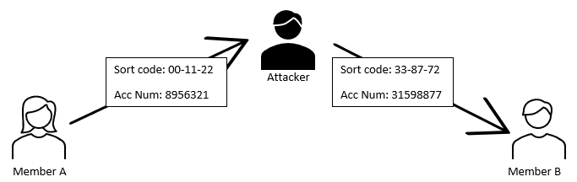
Figure 4: Man in the middle attack
One example of this attack that could cause harm to an organization is if the member A of the party attempts to send an bank account number to member B the attacker could intercept the message and alter the account number acting as member A, meaning member B would send money to the attacks account rather than the account intended.

1.4.3 Digital Signature
Another useful feature for organizations to help integrity in documents and to ensure the knowledge of the origin of the document are digital signatures. This is a mathematical way to prevent tempering during sending and receiving the information and verifies the authenticity of that information and also non repudiation meaning that the sender or the receiver cannot deny receiving the message [16]. Digital signatures use asymmetric cryptography, therefore as long as the senders private key has not been shared with anyone else the digital signature is safe [7]. These give the receiver a good reason to trust that the document or message has been sent by the sender who claims to have sent it and it has not been altered or while on its way to them. This will help with the example of the man in the middle attack above as it will tell receiver that the message is as intended by the receiver and has not been altered in transit therefore ensuring no loss of data or money [17].
Its is good to think of a digital signatures as the equivalent of a handwritten signature on a document as a digital signature is also legal in many countries which gives the document the same importance legally as would a hand signed document, some of these places include the U.S.A and the European Union [18] and because of the 2002 Electronic Communications Act they also legal here in the UK [19].

1.5 Physical Security
Physical security is important for organizations infrastructure for many reasons as it helps protect not only data but things such as equipment and personal against things such as theft of devices or human error and if data gets lost or stolen that can damage a organization therefore not only is logical security important physical security should also be a priority. Another threat to organizations is forces of nature also called acts of god.

1.5.1 Forces of Nature
Protecting the infrastructure against forces of nature is important to organizations because forces of nature come unexpectedly and are unavoidable, some forces of nature include fires or floods which can damage hardware therefore causing loss of data. In the Natural Hazards scholarly journal [20] they found that Europe had losses up to $317,275,000 from 1950-2010 due to great natural catastrophes which shows there is a huge amount of money is lost due to natural disasters. Natural disasters can affect even the large organizations as in December of 2016 Vodafone UK data centre suffered disruption due to severe floods [21]. One of Googles European data centres got struck by lighting four consecutive times and therefore caused a permanent loss of data even though it might only be less than 0.000001% but that data recovery isn’t possible [22] . Physical security can help prevent or at least minimise this. Another reason physical security is important is to prevent theft or vandalism. Although these are covered by insurance this will only ensure there is no loss in terms on financially it is still important not because of money but because of time and data, these cannot be brought back by the insurance and this is why physical security is important.

1.5.2 Encrypting Hardware
Cryptography can also help physical security by encrypting hardware, explained above is how to protect data in transit but its also important to protect the data at rest.

1.5.2.1 Laptop Theft
As explained by Carly Schulaka [23] laptops have a lot more data on them in comparison to a mobile phone but can still be easily stolen therefore make sure the laptop is encrypted. Protecting the hardware by using usernames and passwords is a good idea and even having biometrics to enter your computer or laptop is a better idea again and is becoming more favourable than password as a factor of identification [24]. This is no good if a thief manages to get their hand on the device it is easy for them to access the disks withing the device and if the data sensitive or not is stored as clear text the theft of the device will lead to documents being easily accessed [25].
Royce D. Burnett et al [26] explain the long term consequences of laptop theft with things such as loss of reputation for an organization and this and also the short term effects like loss of data. Which could be difficult to restore without proper frameworks in place and as we have spoken about many organizations were not ready for remote working meaning many organizations don’t have to correct polices in place and could easy have devastating consequences if data gets lost.

1.5.2.2 Encryption of devices
This is where encrypting your devices is important not only for organizations but for everyone. Encrypting disks does not protect the device completely as a hacker can still access the data through network attacks similar to the man in the middle attack or through phishing and then could lead to installation of malware which could lead to devastating consequences for an organization. But encrypting devices lowers the risk significantly of data being accessed by physical theft of a device. Encrypting a device is simple to do as explained by Microsoft [27] you simply go into settings and turn device encryption on.

1.5.2.3 Self Encryption drives
There are such things as self-encrypting drives as stated by Joseph Souren [28]. these are hard disk drives or solid state drives that eliminate the need for a user to encrypt the disk, these do that automatically by using a Data Encryption Key which is stored in the drive somewhere and is used to encrypt all of the data on the drive. The self encrypting drives also use a Authentication Key in order to unlock the drive and decrypt the data [29].

Conclusion
In conclusion the last few years has been difficult and will continue to be difficult for organizations as working from home is becoming more popular and not being prepared can damage a organization. Therefore organizations must put measures in place in order to help prevent data loss. Encryption is an important step to take to keep messages hidden while in transit. Using digital signatures would also be a good security measure to take while sending important and confidential documents in order to keep the integrity of the document. In order to keep employees devices safe from any data loss encrypting devices is a simple yet effective way to prevent any stolen hardware from leaking confidential data.

2.0 FlowTech case scenario

2.1 Introduction
In this paper there about many topics mentioned that are important to FlowTech in order to provide them with relevant information they will need to keep they’re data safe. First of all the structure in which the organization will implement security.
There are policy recommendations along with why it is important to enforce them. A brief description of what laws FlowTech should be complying with. As well as an explanation of why planning security is important, how to manage risk and to be ready for worst case scenarios. There are also protection mechanism that will be of use to FlowTech if they decide to follow the advice in this paper.

2.2 Organisation structure
In order for FlowTech secure information efficiently they must first understand the roles and responsibilities each member of the organization has when it comes to security. This should be clearly documented therefore the correct persons are held accountable.
To decide who establishes security policies is a important decision. The two approaches are called bottom-up and top-down.
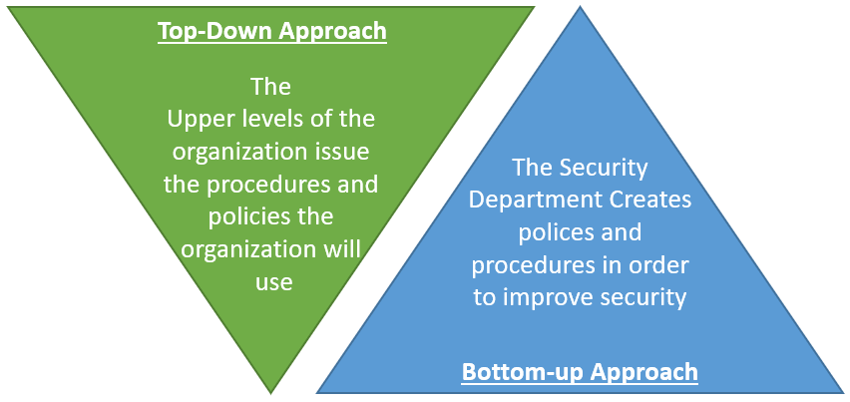
Figure 5: Top-Down and Bottom-Up Approach
The bottom-up approach is where there is a responsibility on either a single employee or security department to successfully implement information security. The advantages of this approach is the individuals implementing the security will have the expertise and knowledge to implement the information security effectively. On the other hand by using this approach FlowTech miss out on using the top-level management who have a better understanding of the organization as a whole.
The more popular top-down approach is the opposite to the bottom-up where to upper levels of management are responsible for creating and implementing FlowTechs strategy for protecting data. This approach allows for greater overview of the organizations concerns which provides more efficient information management [30] as the whole of FlowTech make security a responsibility rather that just one team.
If using the top-down approach this would be brief description of the responsibility the C-level roles would take on.
- The Chief Executive Officer (CEO) is the highest ranking person in the organization who’s responsibility includes having a understanding of what is needed to secure the organization.
- Chief Information Officer (CIO) is responsible for the management of any type of computer technologies.
- The Chief Information Security Officer (CSIO) is responsible for implementing procedures and polices.

2.3 Polices
For any organization polices are extremely important because they are a set of rules or guidelines for employees to follow in order to explain what is expected by the organization.
Cyber security polices are most important when it comes to keeping data secure within the organization.
While cyber security might only be an extremely important topic for the executives of the organization and the IT department it is important that every employee is aware of what they should and should not be doing when it comes to any type of data belonging to the organization and their customers especially for FlowTech. employees as they will need to display an good understanding of cyber security in order to keep a good reputation for the organization as they deal directly with customers about cyber security.

2.3.1 Employees knowledge on policies
According to research in Computer Fraud & Security journal [31] 28% of employees don’t if the organization they work for has a cyber security policy. Meaning over a quarter of employees are not following a policy.
A policy must be read and understood by every member in the organization for it to be effective all it takes is one person to not read a policy therefore not following the policy for data to get lost or hurt the organization in some way. This is why it is important that the policy is easily accessible by all members of the organization and distributed to every member.

2.3.2 Policy recommendations
Some simple policies to be put in place are as follows
- Keep all devices password protected.
- Ensure devices are no left exposed or unattended.
- Lock devices when leaving the desk.
- Refrain from downloading unauthorized or illegal software on company devices.
Many more simple policies should be in place but for less obvious but still important policies.
One cyber security polices that could be enforced would be not allowing employees to work remotely from a security prospective this is effective but this is a policy that can effect the way the organization works. As explained in 1.2 of the research paper working from home is becoming more popular and many employees already working remotely that would be unrealistic and unreasonable.
After reviewing the importance of encryption in the research paper it would be beneficial for FlowTech to enforce a encryption policy. Especially with employees working remotely.
A policy that should be enforced is that all employees must encrypt any devices that they work on remotely as explained in 1.5.2.1 in the research above laptop theft is common and not all laptop theft is about taking the hardware many thieves could view sensitive data if the laptop is not encrypted such as corporate finances or private customers data therefore encrypting the hardware lowers the chance of any of this data getting leaked and FlowTech will be able to keep a good reputation.
Employees should also encrypt any sensitive information such as credit card numbers and personal information while sending that data whether it be via email or any other type of communication channel.
While confirming deals with customers digital signatures should be used in order to keep the integrity of the documents for more on benefits of digital signatures read 1.4.3 in the above report.
Although cryptography is important it is also should be made clear that employees should only use the forms of cryptography that has been approved by FlowTech.

2.4 Compliance (Laws and Ethics)
Here in the United Kingdom the Data Protection Act 2018 is the UK’s implementation of the General Data Protection Regulation (GDPR) [32] which is the data privacy law for collecting and processing personal data. The UK GDPR sets rights obligations and key principals of processing personal data in the UK with the exception of law enforcement processing and intelligence services processing. If FlowTech decide to offer their services to customers in Europe they will also have to comply with the EU GDPR which is what the UK GDPR is based off of [33]. As a result of the UK leaving the EU the EU GDPR would no longer protect UK citizens personal information leading to why the UK Government had to make the UK GDPR with some changes.
If FlowTech continues to grow quickly the need for more employees might arise. Therefor it is important to understand what data they are allowed to keep with and without their permission.
As stated in the above report in section 1.4.3 the use of a digital signature has the same importance legally as would a hand signed document in the UK therefore they would be suitable for FlowTech to implement.

2.5 Strategic Planning for Security
It is important to plan for security because if planned poorly many problems can occur such as not having the correct procedures in place, not having enough ways to minimise threats to the organization or on the contrary maybe having to much security in place where the cost of security is worth more than the item itself.
It is important to also weigh up the security and the access and find the correct balance. For example it would be an inconvenience to use a digital signature on every document sent as this could take a while and not be needed. Therefor the digital signature should only be used when necessary in order to improve access. This also includes access controls being correctly set to allow only certain people to access the data but also not restricting people who should be able to view the data.

2.6 Risk Management
There are three parts to managing risk efficiently that work together as shown in figure 6, these will be explained below and shown how these can help FlowTech.
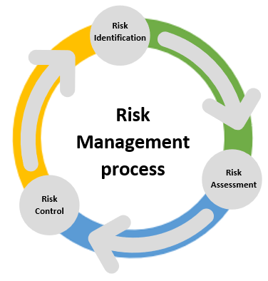
Figure 6: Risk Management

2.6.1 Risk identification
Identifying risks is the first step to risk management. FlowTech must know what information assets they must protect. To do this you must understand what data is stored. Then you must identify what would be the consequences if something was to happen to that data.
An effective way to decide the consequences would be to use the CIA Triad as spoken about in 1.3 in the above report. Protecting the confidentiality, Integrity, and Availability is a good way to identify consequences of loosing information assets. Another step in identifying risks is to identify threats.
Identifying threats is where you must find anything that can hurt the information assets. This could be many things from forces of nature, some of the risks and effects of this is mentioned in 1.5.1 in the report above. Other threats would be hackers and cyber attacks such as the man in the middle attack a reason why encryption is mentioned in the polices is to help mitigate theses types of threats, read 1.4.2 for more information on man in the middle attacks. Another threat that is common but could be surprising is your own employees
After identifying the threats FlowTech must be able to identify how they are vulnerable to said threats for example the threat could be a man in the middle attack therefore FlowTech would be vulnerable if employees were to work remotely using a unsecure network.

2.6.2 Risk Assessment
After identifying the risks the next step is to assess the impact of those risks. A good place to start while assessing risks it to identify the impact of the risk and the likelihood of it happening. A good way to find out what is most important to protect is to use a risk matrix which is shown in Figure 7. Where you multiply the impact by the likelihood to get severity of the risk.
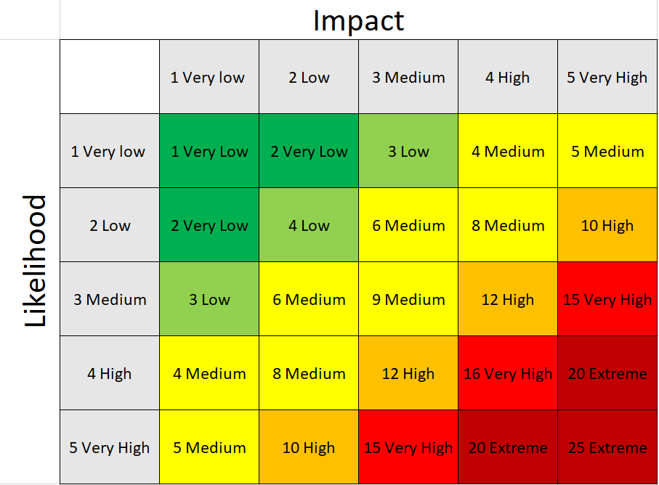
Figure 7: Risk Assessment table

2.6.3 Risk Control
To control risks FlowTech must identify possible cybersecurity risk mitigation measures. Once the risks have been identified and assessed the organization must do something to mitigate those risks including but not limited to threat hunting software, encryption and firewalls.

2.7 Contingencies Planning
Even though risk management can significantly reduce the risk of any sort of damages being caused to the organization it does not fully eradicate it. This is why planning for the worst case scenario is important. FlowTech should plan for disaster recovery in case uncontrollable things happen.
The first example is if a natural disaster was to effect FlowTech’s office this can cause the loss of data. Refer to 1.5.1 in the report for examples of loss due to forces of nature. Therefor having the data backed up can help reduce the loss of data.
An example of this could be if a thief steals an employees laptop that is encrypted and secured with a password even though the thief cannot view or use that data. The data on that laptop is gone which could result in a loss of important data that cannot be recovered.
The two examples above imply that even if you have controls in place to reduce risks it is important to have important data backed up in order to help reduce the loss of data.

2.8 Protection Mechanisms
Protection Mechanisms must be put in place in order to allow some of the polices spoken about above be accessible to the employees and other types of data security mentioned above.
Encryption is a protection mechanism which is important for FlowTech to implement as mentioned many times in this paper it can be very helpful in securing data that is being used by employees of FlowTech working remotely.
Digital signatures is another protection mechanism that should be put in place in order for employees of FlowTech to stick to the polices set by the higher management. As this gives a good incentive for employees to follow procedures if they are easily accessible.
The security mechanisms that FlowTech should consider putting in place are authentication whether that be password on their devices or fingerprint authentication to unlock they’re device so it is difficult for someone to access that device if stolen. Also the encryption of devices should be implemented in case the thief manages to get access to the drives with private data on.
FlowTech should implement the use of virtual private networks (VPNs) for employees working remotely and need remote connection to the office. A VPN uses encryption methods that can reduce the risk of data leaks while accessing files from withing FlowTechs network.
Some more protection mechanisms that should be in place but have not been mentioned much in this paper are access controls in order to lower the amount of people who have access to private data in order to lower the risk of data leaks. Also backups should be regularly made and kept updated for worst case scenarios.

2.9 Conclusion
To conclude FlowTech must understand what approach they are going to take to combat security issues and who is responsible for the implementing the security factors. They must also be aware of data protection laws and how they affect the organization as they grow. Not only is implementing policies are of great importance in order to secure any private information across the whole organization it is just a must that all members of FlowTech understand and follow the polices to ensure they are effective. It is also implement the correct protection mechanisms to be able to combat the risks that arise. In order to do this FlowTech must also understand how to manage risk effectively and efficiently by following the 3 step risk management process but also having contingency plans in place in case a unforeseen event hurts the organization.

References

[1] | J. Johnson, “Global digital population as of January 2021,” Statista, 10 September 2021. [Online]. Available: https://www.statista.com/statistics/617136/digital-population-worldwide/. [Accessed 11 October 2021].
[2] | O. Labs, “STATE OF REMOTE WORK,” Owl Labs, 2020. [Online]. Available: https://resources.owllabs.com/state-of-remote-work/2020. [Accessed 26 October 2021].
[3] | H. S. Lallie, L. A. Shepherd, J. R. N. A. Erola, G. E. C. M. and X. B. , “Cyber security in the age of COVID-19: A timeline and analysis of cyber-crime and cyber-attacks during the pandemic,” Computers & Security, vol. 105, 2021.
[4] | S. Furnell and J. N. Shah, “Home working and cyber security – an outbreak of unpreparedness?,” Computer Fraud & Security, vol. 2020, no. 8, pp. 6-12, 2020.
[5] | M. Warkentin and C. Orgeron., “Using the security triad to assess blockchain technology in public sector applications,” International Journal of Information Management, vol. 52, 2020.
[6] | S. Rani and H. Kaur, “Technical Review on Symmetric and Asymmetric Cryptography Algorithms,” International Journal of Advanced Research in Computer Science, vol. 8, no. 4, pp. 11-21, 2017.
[7] | B. Kapoor, P. Pandya and J. S. Sherif, “Cryptography,” Kybernetes, vol. 40, no. 9/10, pp. 1422-1439, 2011.
[8] | A. A. Abhishek Guru, “A Study of Cryptography to Protect Data from Cyber-crimes,” Research Journal of Engineering and Technology, vol. 11, no. 2, pp. 45-48, 2020.
[9] | A. Joux, “A One Round Protocol for Tripartite Diffie–Hellman,” Journal of Cryptology, vol. 17, no. 4, pp. 263-376, 2004.
[10] | E. Järpe, “An Alternative Diffie-Hellman Protocol,” Cryptography, vol. 2, 2020.
[11] | D. Glăvan, C. Răcuciu, R. Moinescu and S. Eftimie, “Man in the middle attack on HTTPS protocol,” Scientific Bulletin "Mircea cel Batran" Naval Academy, vol. 23, no. 1, pp. 199-201, 2020.
[12] | Statista, “Number of public Wi-Fi hotspots worldwide from 2016 to 2022,” Statista, 22 January 2021. [Online]. Available: https://www.statista.com/statistics/677108/global-public-wi-fi-hotspots/#statisticContainer. [Accessed 05 November 2021].
[13] | H. Valchanov, J. Edikyan and V. Aleksieva, “A Study of Wi-Fi Security in City Environment,” IOP Conference Series. Materials Science and Engineering, vol. 618, no. 1, 2019.
[14] | T. Krausz and J. Sztrik, “Wireless Networks Speed Depending on the Encryption using Windows 8.1 x64 Operating System,” Carpathian Journal of Electronic and Computer Engineering, vol. 7, no. 2, pp. 3-5, 2014.
[15] | A. Zafft and E. Ague, “Malicious WiFi networks: A first look,” 37th Annual IEEE Conference on Local Computer Networks, pp. 1038-1043, 2012.
[16] | N. Kundu, S. K. Debnath, D. Mishra and T. Choudhury., “Post-quantum digital signature scheme based on multivariate cubic problem,” Journal of Information Security and Applications, vol. 53, 2020.
[17] | I. V. Puthoor, R. Amiri, P. Wallden, M. Curty and E. Andersson, “Measurement-Device-Independent Quantum Digital Signatures,” 2017.
[18] | Adobe, “Are electronic signatures legal? Absolutely.,” Adobe, [Online]. Available: https://www.adobe.com/uk/sign/compliance/electronic-signature-legality.html. [Accessed 05 November 2021].
[19] | E. &. I. S. Department for Business, “Electronic signatures,” GOV.UK, 8 September 2014. [Online]. Available: https://www.gov.uk/government/publications/electronic-signatures. [Accessed 11 October 2021].
[20] | A. Wirtz, W. Kron, P. Löw and M. Steuer, “The need for data: natural disasters and the challenges of database management,” Natural Hazards, vol. 70, no. 1, pp. 135-157, 2014.
[21] | M. Smolaks, “Vodafone UK data center suffers outage due to floods,” data center dynamics, 05 January 2016. [Online]. Available: https://www.datacenterdynamics.com/en/news/vodafone-uk-data-center-suffers-outage-due-to-floods/. [Accessed 04 November 2021].
[22] | Google, “Google Compute Engine Incident #15056,” Google , 16 08 2015. [Online]. Available: https://status.cloud.google.com/incident/compute/15056#5719570367119360. [Accessed 04 November 2021].
[23] | C. Schulaka, “Steven Ryder on Protecting Client Data, Preventing Phishing Scams, and Encrypting Devices,” Journal of Financial Planning, vol. 30, no. 8, pp. 14-17, 2017.
[24] | A. A. Chebotareva and V. E. Chebotarev, “Hardware, Biometric and Passwordless Authentication: Vulnerability and Cybercrime Issues,” IOP Conference Series. Materials Science and Engineering, vol. 1069, no. 1, 2021.
[25] | X. L. Huang and H. C. Yang, “Two-Way ID Authentication and Hardware Encryption-Based Security Design of Mobile Hard Disk,” Applied Mechanics and Materials, Vols. 58-60, pp. 573-579, 2011.
[26] | R. D. Burnett, M. Friedman and R. P. R. Jr, “Managing laptop security,” Journal of Corporate Accounting & Finance, vol. 22, no. 5, pp. 53-61, 2011.
[27] | Microsoft, “Device encryption in Windows,” Microsoft, [Online]. Available: https://support.microsoft.com/en-us/windows/device-encryption-in-windows-ad5dcf4b-dbe0-2331-228f-7925c2a3012d#ID0EBBD=Windows_10. [Accessed 05 November 2021].
[28] | J. Souren, “Security by design: hardware-based security in Windows 8,” vol. 2013, no. 5, pp. 18-20, 2013.
[29] | Trusted Computing Group, “Enterprise SED Presentation,” September 2010. [Online]. Available: https://www.trustedcomputinggroup.org/wp-content/uploads/SWG_TCG_Enterprise-Introduction_Sept2010.pdf. [Accessed 05 November 2021].
[30] | PeterGrundke, “Top-down approaches for integrated risk management: How accurate are they?,” European Journal of Operational Research, vol. 203, no. 3, pp. 662-672, 2010.
[31] | GraysonKemper, “Improving employees' cyber security awareness,” Computer Fraud & Security, vol. 2019, no. 8, pp. 11-14, 2019.
[32] | Gov.uk, “Data protection,” 2018. [Online]. Available: https://www.gov.uk/data-protection. [Accessed 26 November 2021].
[33] | “Guide to the UK General Data Protection Regulation (UK GDPR),” Information Commissioner's Office, [Online]. Available: https://ico.org.uk/for-organisations/guide-to-data-protection/guide-to-the-general-data-protection-regulation-gdpr/. [Accessed 01 December 2021].
[34] | K. D. V. P. Michael Nieles, “An Introduction to Information Security,” NIST, 2017.

