A report focussing on:

Lighting layout and Sound Index Calculation (Module: Material Science and Building Services – ACBA4006)


Prepared for:
A.Nantel

Created by:
Natalie Jopling
1911296

Date completed:
3rd April 2020

Table of Contents
Page Number
1.0 Executive Summary 3

2.0 The Calculation of lighting layout 3
2.1 Room index 3
2.2 The Utilisation Factor 4
2.3 The Number of Lamps Required 4
2.4 A suitable layout (value of S) for the lamp fittings 5

3.0 Scale drawing of the plan layout of lamps allowed 4

4.0 The calculation of the sound reduction index of the entire wall 4-5

5.0 Implications of frequency and wavelength in internal sound management 5
5.1 Partition Wall Construction technique and insulation choice 5 - 6

6.0 Conclusion 6

7.0 References 6

1.0 Executive Summary

This Report aims to firstly find the calculation of the Luminous Flux that would be suitable within a production area of a factory and the number of lamps that are required. Once the Author has calculated the number of lamps required, a plan will be presented by scale.
A calculation for the overall sound reduction index for the entire wall will then be presented and the Author will explain the implications of frequency and wavelength and will explain what will be the best construction technique and insulation choice for internal sound management.

- The Calculation of Lighting Layout

2.1 The Room index

RI = L x W
= 60 x 24
7 x (60 + 24)
- / 588 = 2.449

2.2 Ceiling reflectance 0.3 Ceiling 0.5 Walls
= 0.46

2.3 The number of lamps required
N = Number of lamps
E = Illuminance level required (lux)
A = Area M2
F = Initial luminous flux output of each lamp
IF = Utilization factor (from table)

UF = Light less factor

N = E x A 200 x 1440 = 288,000
F x UF x LLF 18,000 x 0.46 x 0.75 = 6,210

288,000 / 6,210

N = 46.38 Rounded to 48 lamps due to the 70% maximum illumination level
allowed

2.4 A suitable layout (value of S) for the lamp fittings
1.5 x Hm2 = 7m
S = 1.5 x 7 = 10.5m apart

- Scale drawing of the plan layout of lamps allowed

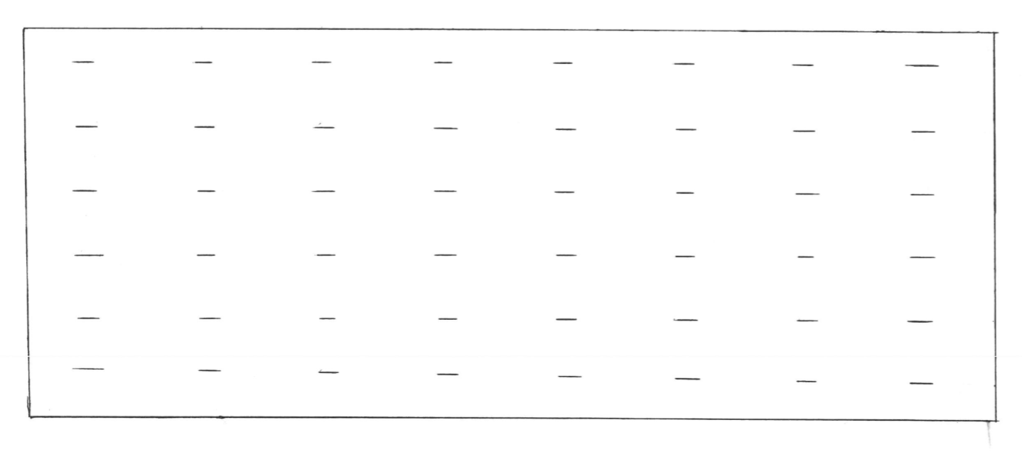

- The calculation of the sound reduction index of the entire wall

Brick Wall Area 20m2
Window Area 4m2

Sounds reduction:-
50 db for brick
10db for window

Brickwork = T1 = ? A1 = 20 – 4 = 16m2 SRI = 50db
T2 = ? A2 = 4m2 SRI = 10db

SRI formula: SRI = 10 x (log10 (1xT))

Brick Window

SRI = 10 x (log10(1/T)) SRI = 10 x (log10(1/T))
50 = 10 x (log10(1/T1)) 10 = 10 x (log10(1/T2))
5 = log 10 x (1/T1) 1 = log10 x (1/T2)
1/T1 = 105 1/T2 = 101
T1 10 -5 T2 = 10-1
= 0.00001 = 0.10

TO = (T1xA1) + (T2xA2)
A1 + A2
= (10-5x16) + (10-1x4)
16 + 4
20
SRI = 10 x (log10 (1/0.020008)
SRI = 10 x (log10 (49.980008)
SRI = 10 x 1.698796321
SRI = 16.99db
17db

5.0 Implications of frequency and wavelength in internal sound management

Sound is a study which has properties known as sound waves (sound | Properties, Types, & Facts, 2020). In air, the sound wave speed is usually approximately 340 metres a second and can be caused by various vibrations in the air which can be related to moving objects or moving air, such as aeroplanes or car horns. Sound waves are measured by how many times they complete a cycle in a second, and these are measured in a unit of measurement called Hertz (Hz) (Staniulis, 2020). Humans hear frequencies within sound usually at between 20Hz to 20,000Hz and there are two types of frequencies that have disturbances in the air. Infrasound frequencies which are measured as below 20Hz and are too low and ultrasound frequencies which are measured above 20,000Hz and are too high. A low frequency of sound could cause implications due to the sound having significant acoustic energy within the frequency and it acts as an annoyance to the normal comfort level for a human, such as a ferry horn being blown. A reverberation, also known as an echo, is the prolongation of a reflected sound. It is when a sound source ceases into a space and the sound waves will continue to hit the floor and ceiling until it loses its energy (Definition: Reverberation | Acoustical Surfaces, 2020).

5.1 Partition Wall Construction technique and insulation choice

Within buildings, sound has to be measured and is broken into four titles. They are airborne sounds such as traffic, Impact sounds such as falling objects, installation noise such as heating from pipes or a radiator and reverberation time which is the measurement of in rooms such as auditoriums. If a sound passes through a wall or partition, it is either known as an impact or airborne sound. If someone was to knock on our front doors or drop an object upstairs, this is known as an impact sound and this can be heard as a vibration. In order to control these sounds from causing implications to internal rooms, certain construction details need to be applied. Regarding the different frequencies noted above, there are three materials which can be used as control dependant devices when needed. For high frequencies, porous absorbers can be used for high frequencies, panel absorbers for lower frequencies and cavity absorbers for specific frequencies.
For any frequencies above 1kHz, porous absorbers are most effective as they have cellular network of interlocking pores where sound energy is converted into heat. For lower frequencies, panel absorbers are most effective as they are constructed from sheets which are fixed of continuous materials which will have a space behind them. This space could contain a porous absorber. The panel absorbers convert the sound waves into mechanical vibrations and lose their energy as friction within the clamping system of the panel. Cavity absorbers are usually enclosures of air which have one narrow opening. Other than air, the cavity may possibly contain other material such as a perforated acoustic tile. It can provide high absorption over a narrow band of frequencies. All of this depending on the internal design of the room. Relating to echo’s, the reverberation time could be amended due to the various frequencies in a room. Shorter reverberation times are perfect for people making speeches or lecturers teaching a class and longer reverberation times are used to enhance the quality of music, such as a music hall or venue.

6.0 Conclusion

Within this report I have calculated and explained the room index, utilisation factor, number or lamps required and the suitable layout for lamp fitting within a factory area. I have drawn, using a scale ruler; the best fit design for the luminaire installation and indicated the position of the lamps. I have calculated the sound index for an entire wall and have also explained the implications of frequency and wavelength within internal sound and what the options for construction technique and insulation.

- References

Acoustical Surfaces. 2020. Definition: Reverberation | Acoustical Surfaces

Encyclopedia Britannica. 2020. Sound | Properties, Types, & Facts

Staniulis, A., 2020. Understanding Frequencies: How To Describe What You're Hearing To Your Sound Tech

Youtube.com. 2020. Youtube

