Qualification: CIPD Diploma in Applied Human Resources

Module Name: Understanding Employee Engagement

Word Count: 3303

Student Name: Stephanie Rayner
Student Number: 1907192
CIPD Membership Number: 55478507

By signing below, I confirm that the work/evidence presented is my own, unaided work. I understand the regulations pertaining to candidate malpractice and the action that may be taken as a result.

Signed:

Date: 26th October 2020

Understanding Employee Engagement

Understand the concept of employee engagement

Employee Engagement should not be assumed, it does not form part of an employment contract and as such, employees are not automatically engaged with the organisation. (Kahn, 1990) as cited in (Woodhams, 2016), focuses on engagement as a three dimensional concept being physical engagement, cognitive engagement and emotional engagement.

This relating closely to individual’s behaviour ‘going the extra mile.’
- Physical engagement – the amount of exertion an employee puts into their job.
- Cognitive engagement – become engrossed in work and as such could have difficulty in detaching themselves from their work.
- Emotional engagement – passionate and proud about their work.

According to (CIPD, 2019), most definitions of engagement ‘describe employees who are healthier, happier, more fulfilled or more motivated’. Research evidences the positive effect employee engagement has on the organisation including, increased productivity, staff-retention and customer satisfaction.

(Engage for Success, 2020) refers to a definition by David McLeod ‘This is about how we create the conditions in which employees offer more of their capability and potential’.

Employee engagement is about employees understanding their contribution to the organisation objectives, feeling valued as an individual and having a meaningful contribution to the team and organisation as a whole. Performance management is clearly linked to employee engagement providing individuals with regular constructive feedback, supportive in training and development opportunities showing appreciation and a basic ‘thank you’ for the contribution they are making, (Engage for Success, 2020).

An organisation should aim to be an ‘employer of choice’ where individuals have pride and loyalty for whom they work. Employee engagement is about utilising employee’s strengths, listening to their ideas to improve and be innovative in the way in which they work. Employees who are committed to the organisation will have reduced sickness absence, lesser conflict, grievances, and an increase in productivity.

Compare and contrast employee engagement with other related concepts

Whilst there are clear connections between employee engagement and job satisfaction, there are also some key differences in the determination of each. Engagement is about how employees feel, demonstrating behaviours such as being enthusiastic, focussed showing a sense of urgency and going ‘above and beyond’ within their job roles. In contrast, satisfied employees are happy, content and satisfied. An organisation may have more control over the level of job satisfaction as it is related to pay, terms and conditions and job security. Whereas engagement levels are influenced by Line Managers through effective communication, building a trusting working environment and providing reward and recognition for the efforts of the employee, (SHRM, 2020).

As referred to in (Woodhams, 2016), another concept closely linked to employee engagement is organisational commitment, which refers to psychological attachment an individual has to an organisation. There are three ‘mindsets’ to describe an individual’s commitment:
- Affective commitment – Positive emotional attachment, committed to the organisation because they ‘want to’. Individual’s don’t want to let their colleagues down and aim to provide the best possible service. This being similar to the CIPD’s definition of employee engagement in that it is something that the employee has to offer and therefore cannot be form part of the contract of employment.
- Continuance commitment – Commit to the organisation due to the perceived ‘costs’ of leaving including both financial and social costs, remain within the organisation because they ‘have to’. An example of which could be seen in the public sector due to their terms and conditions and perceived job security.
- Normative commitment – Committed with a feeling of obligation, remain within the organisation because they ‘ought to’. This is more likely with longer serving employees, the younger generation do not remain with an organisation because they ought to.

When employees are engaged with an organisation, they are willing to go the ‘extra mile’ and as such work more effectively which in turn improves performance, increases productivity meeting the overall business objectives.

Describe the typical HR, leadership and cultural elements likely to be found in an organisation characterised by high levels of employee engagement.

As referenced by (ACAS, 2014), Organisations regarded as having high levels of employee engagement branded as an ‘employer of choice’, have a clear vision that everyone feels part of, understanding what motivates employees, giving employees a voice, ensuring equality within the workplace. This will enable employees to understand the connections between managers and employees, the aspirations of the individual and the organisation, see below diagram:

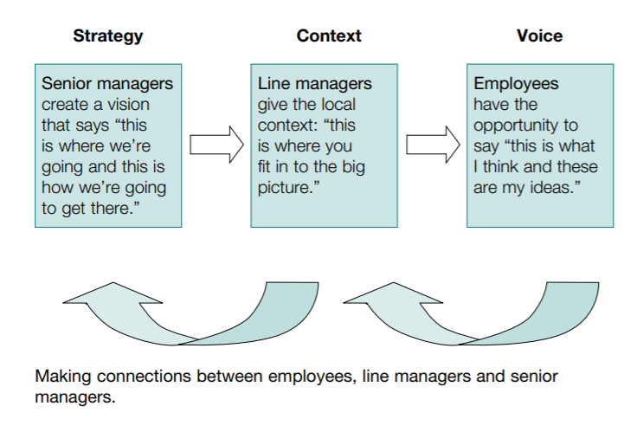
From a HR perspective, there is a legal requirement to issue a contract of employment clearly outlining terms and conditions relating to practical issues e.g. pay, sick leave entitlement, contractual policies which is in addition to a psychological contract which describes the expectations formed within the workplace e.g. maintain trust and confidence.

Having an effective communication strategy in place enabling consistent messages to the workforce and also communication channels which encourage ‘employee voice’, an organisation whereby employees feel their views are valued. This can be expressed via 121’s, team meetings or via Trade Union representatives. If employee’s feel they are listened to, they are more likely to be engaged with the organisation.

Organisations with effective policies and procedures in place evidences the commitment employers are making to employees and as such, employees feel valued and more committed to their job. The important factor however is how such policies and procedures are perceived by the workforce, it is therefore vital for managers to have a consistent approach when implementing and communicating with employees.

Employers are responsible for setting the culture within an Organisation, which is another important factor for employee engagement. Senior Managers should make themselves visible and approachable to the workforce. Conduct workshops, surveys to understand how employees are feeling and encouraging a trusting working environment. Analyse survey responses effectively and consider things that make a difference to the way people feel e.g. Wellbeing initiatives, flexible working, office environment. With this approach, employees are more likely to be truthful as they have trust in management to listen.

(ACAS, 2020) state that Organisation success is built on people. If Organisations attract, recruit and retain the correct people, they are more likely to have a happier, motivated and productive workforce. There are four key elements, which enable this:
- Leaders with a vision who value the contribution of its workforce
- Line managers who invest in employees
- Values which are meaningful and evidenced in practice, leading to trust and confidence
- Encouraging employee voice

If organisations get the fundamental elements of its people wrong, it could have a negative impact and result in low morale and motivation and increased levels of sickness absence. In addition, there will be less opportunity for innovation and creatively which again will have a negative impact on the customer.

Evaluate the need for alignment between employee engagement and other organisational factors.

There is clear evidence linking employee engagement with increased performance and productivity and as such, it is important for employee engagement to be aligned to other organisational factors. (MacLeod, 2009, p6) as cited in (Woodhams, 2016) states ‘it is our firm belief that (engagement) can be a triple win: for the individual at work, the enterprise or service, and for the country as a whole’. This suggesting that having a collective approach to engagement is beneficial for all.

With this in mind, organisations should create an overall engagement strategy requiring input and ‘buy in’ from employees, leadership and identified stakeholders who will have a particular interest. The strategy should be considered in line with organisational outcomes, clearly demonstrating the positive impact of employee engagement on meeting business objectives and outcomes, (SHRM).

According to (SHRM), employee engagement should form part of the organisational culture and is viewed as a fundamental factor benefiting the organisation as a whole. A number of factors to consider are the views of employees, gain leadership support, and the integration of engagement objectives into policies with the ultimate goal of making employee engagement a core value within the organisation.

A number of research reports demonstrate the link between high engagement and high performance, one of which was (Towers Perrin 2007/2008 Global Workforce study 2009) as cited in (Woodhams, 2016) found that organisations with high engagement had a 19% increase in income whereas organisations with low levels of engagement saw a 32% drop. Again evidencing the value employee engagement brings to an organisation.

Research has also demonstrated how employees who feel engaged within the organisation, experience greater job satisfaction and improved wellbeing, (Schaufeli et al 2008; Alfes et al 2010). Engaged employees show commitment and play a vital role in promoting the organisation as an employer of choice.

Whilst the benefits of employee engagement speak for themselves, employers need to be cautious and shouldn’t make an assumption that employee engagement will automatically improve performance and productivity, (Woodhams, 2016).

Explain why employee engagement is an increasingly vital dimension of HR strategy and practice.

(CIPD, 2020) recognises communication as a vital part of employee engagement, which helps the workforce to understand the organisation purpose and how they contribute to the overall business purpose. Consideration must be taken regarding access to technology and the appropriate communication methods to ensure the information is relayed to the whole workforce.

HR play a vital role in providing clear methods of communication providing reassurance to staff in relation to any changes which could have an impact on their contract of employment. The future for organisations is uncertain with the unknown implications of Brexit, COVID-19, 2nd lockdown all of which have an impact on HR strategy and practice. Effective communication will enable HR to support both Senior Managers and employees during these uncertain times. HR practices should be continuously reviewed to align with external and internal factors relating to employment.

The role of HR is to discourage senior managers from a ‘top down’ approach outlining the benefits of collaborative working where people have meaningful opportunities to relay their views and feel they are listened to. HR may need to provide support and training to enable managers to be clear and transparent in their communication also encouraging feedback to the workforce regarding decisions in relation to employee suggestions.

HR need to consider the ever changing shift in technology, and whether the use of social technology could be used as a way of communication where employees are able to interact effectively and therefore have a sense of belonging. Is communication received differently dependant on the demographics of the organisation? What will be most effective for the organisation?

Thinking about the present time, due to the COVID-19 pandemic, organisations should acknowledge the impact on employees and consider supporting mechanisms ensuring continued engagement. Whilst HR are dealing with new demands which are still the unknown, organisations have an interest in how to keep the workforce engaged during such unprecedented times.

A collaborative approach with all departments across the organisation is critical to develop and implement new employee engagement practices to reflect the working practices during the current time and sustain engagement in an environment which is challenging for employees but also for managers who are required to manage a virtual team, (HR Magazine, 2020).

Evaluate the potential benefits, for different parties, of high employee engagement.

It is evident that high performance engagement benefits various organisational stakeholders. Employee engagement is an important factor for an organisation in order for them to understand the views of their workforce, (Deloitte, 2020).

Research has shown that being creative with employee engagement can enhance customer satisfaction, which in turn increases performance and productivity. (People Management, 2020) refer to Apple who took a creative approach to employee engagement asking their staff to ‘enrich people’s lives’ by relaying their knowledge of the product which influenced buying decisions and increased sales.

Research detailed within (SHRM, 2018) demonstrates how social responsibility is another key factor of employee engagement. However, organisations needs to have a dedicated resource to monitor such initiatives and as such less than 10% use this approach to drive employee engagement. There are however opportunities via volunteering and fundraising events which engage employees with people they may not have an opportunity to liaise with and they have an instant connection as they are all working towards a common goal.

If employees are happy and engaged with their work, this will reflect on how they interact with customers. Engaged employees are likely to have received the appropriate training to enable them to be effective in their roles and as such 28% of employees feel they are more productive with better training. Investing in employees will provide a unique, first class customer service and in turn achieve the required outcomes for the organisation, (Human Resources Today, 2018).

The benefits of high employee engagement is a key link to customer satisfaction, reputation of the organisation and the value of its stakeholders, (SHRM, 2020).

Identify key sources of employee engagement related data.

A key source of data by the (CIPD, 2020), is the Labour Market Outlook Report, Summer 2020 which provides an oversight of recruitment, redundancy and pay. It is clear within the report that COVID-19 has resulted in a fall of employment within the hospitality sector and a rise within the Health Care Sector. The table below shows the impact on employment within different industries between Spring and Summer of 2020. It may be difficult for Organisations to maintain employee engagement during such unknown times.

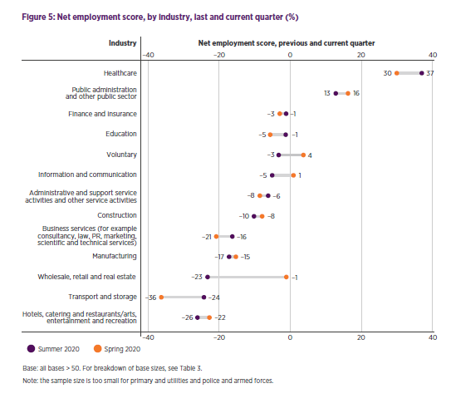

Recruitment within the private sector is inevitably lower (44%) than that of the public sector (72%).

The following graph evidences the increase of potential redundancies within all sectors however, the biggest increase is seen within the voluntary and private sectors. This in itself shows the uncertain times faced by organisations and therefore employee engagement should be a vital factor for consideration.
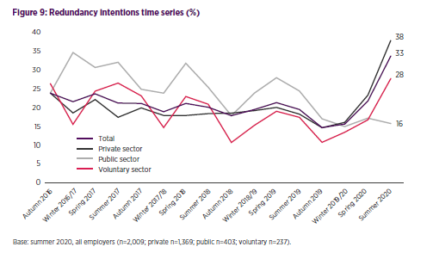

A key factor aligned to high employee engagement is flexible working. A mega trends report produced by the (CIPD, 2019), covers a various flexible working practices. The below diagram shows how part time workers were more satisfied with their jobs.

Job satisfaction was slightly higher of those employees with access to flexible working arrangements irrespective of whether they utilise them. This allowing employees flexibility within their roles resulting in high employee engagement.

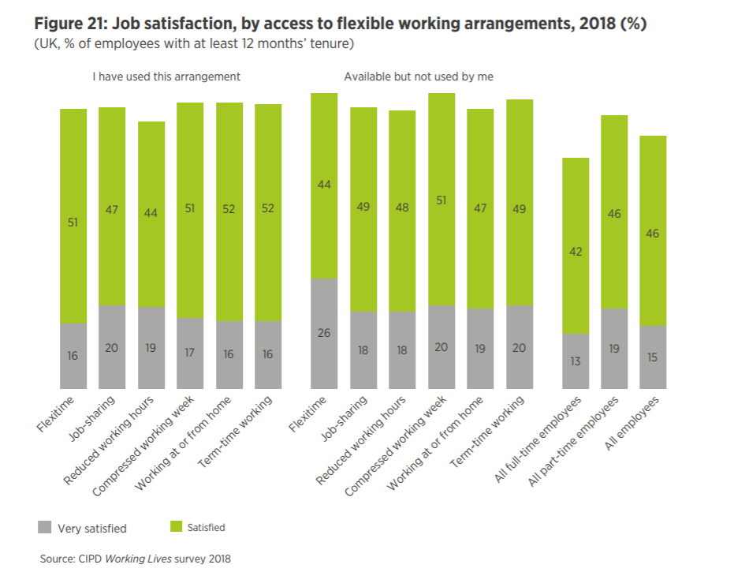

The Information and Consultation of Employees Regulations (ICE Regs) were introduced in 2005 applying to organisations with 50 employees or more. These regulations mean organisations have to inform and consult with their employees on any changes within the organisation. This is an important factor, which enables effective communication whereby managers talk and listen to their employees. This being a key part of employee engagement, (ACAS, 2020).

Describe key trends in employee engagement and differences linked to gender, demographic and other factors.

Organisations should recognise that the workforce if ever changing acknowledging the rapid changes in technology, demographics and individual lifestyles. Individuals want more than ‘just a job’, they are looking at motivational factors e.g. flexible working. Employees no longer need to physically be in the office to be in work, and the enhancement of technology allows more flexibility and work life balance, this attracting millennials who are more vocal and expect to have a career, which fits within their lifestyle, (Forbes, 2019).

Agile working is another factor to engage employees enhancing ways in which work can be undertaken. Having an agile working policy in place allows employees to have a flexible approach to work where they feel trusted and as such have higher levels of engagement.

The demographic change has to be a consideration when linking with employee engagement. Different generations think differently and as such, employers need to adopt the workplace accordingly. The (2013/14 CIPD Employee Outlook survey) (Engage for Success, 2020), identified that 26% of respondents felt improved personal wellbeing would be beneficial to extending their working life. As a result, organisations need to consider both the growth of millennials but also the aging workforce when planning for the future.

Organisations need to consider whether they are serving their workforce i.e. aging workforce may be offered less training and development opportunities. Whereas millennials are far more vocal, understand their needs and wants and are more likely to move from one job to another.

Organisations need to understand the needs of their workforce and predict the future wellbeing demands. Identify the appropriate wellbeing initiatives for the organisation and how they will align to the engagement strategy, (Engage for Success, 2020).

The CIPD Employee Outlook Survey, (Woodhams, 2016) indicated that employee engagement levels within the UK are stable with around 35-39% of employees being engaged within their organisation. Overall, the study found that over a third of employees were actively engaged within their work.

Key results from the research found that individuals working within the public sector were more engaged then those within the private sector as they felt senior managers has a clear vision for the organisation and as a result had trust and confidence in the leaders of the organisation. This is also evidenced within (XpertHR, 2020), whereby a survey revealed that 69% of private sector employees felt senior management had a clear vision of the direction of the organisation compared to that of 61% of public sector workers.

Evaluate the future for employee engagement, based on current trends.

2020 has brought a number of changes to both personal and working lives. An annual employee engagement report carried out by (Human Resources Today, 2020) found how this year has impact on employee engagement going forward.

The overall employee engagement levels shows an increase in those not engaged but a decrease in those actively disengaged, this may be as a result of engagement being a top priority for most organisations.

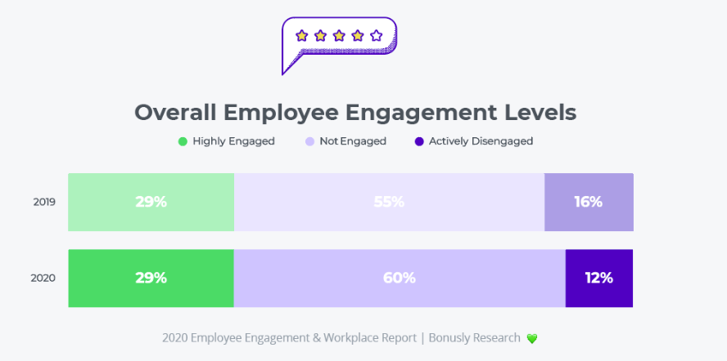

The future of employee engagement should focus on four key themes:
- Maintain human connections – whilst there are challenges due to the COVID-19 restrictions, organisations need to utilise technology for regular video calls with Teams, Individuals and also recognise that the pandemic affects people in different ways and as such should be communicated with in accordance with their individual needs. Employees who are engaged need to understand the value they bring to the organisation. 88% of highly engaged employees are provided with feedback regarding their contribution opposed to 37% of actively disengaged employees.
- Address anxiety – During 2020, everyone is experiencing different challenges with employees becoming more anxious at work. Employees who work on a team who are able to openly discuss their concerns, are more likely to be engaged with their employer. Organisations should consider the health and wellbeing initiatives offered to support their workforce and whether they meet the current ever changing challenges for employees. 79% of highly engaged employees reported to having access to a wellbeing programme. Looking to the future, employers need to encourage a healthy lifestyle and work life balance.
- Employee recognition – Employees are currently working outside of their comfort zones expected to have flexibility to meet business priorities. 86% of highly engaged employees were recognised for going ‘above and beyond’ compared to 31% of actively disengaged employees. Again this proving the impact on recognition and reward to employee engagement. Going forward organisations need to consider what motivates their employees and review their reward and recognition policy accordingly having the flexibility to hopefully meet the needs of the workforce.
- Flexible and adaptable approach – Organisations and employees have dealt with an instant change to society and the way in which they work. Whilst many individuals have returned to the workplace, all businesses have been adapted to the pandemic some of which will be required to change for the future. Home working has become the norm with an increase from 27% in 2019 to 61% in 2020.

The future of the working environment remains unknown however, employers should focus on the opportunities for employee engagement. By focusing on the above, employers can create opportunities which will hopefully keep employees engaged for the future.

As stated in (Human Resources Today, 2020),’Let’s learn from the challenges we face to come together and build a better future’.

Bibliography

ACAS (2014) ‘The People Factor – engage your employees for business success‘. Available at: https://moodle.uwtsd.ac.uk/pluginfile.php/255715/mod_resource/content/1/Advisory-booklet-The-People-Factor.pdf (Accessed 24th October 2020)

ACAS (2020) ‘Employee Engagement’. Available at: https://archive.acas.org.uk/engagement (Accessed 24th October 2020)

ACAS (2020) ‘Information and Consultation of Employees’. Available at: https://archive.acas.org.uk/index.aspx?articleid=1598. (Accessed 26th October 2020)

CIPD (2019) ‘Employee Engagement and Motivation’. Available at: https://www.cipd.co.uk/knowledge/fundamentals/relations/engagement/factsheet (Accessed 23rd October 2020)

CIPD (2019) ‘Mega Trends Flexible Working’. Available at: https://www.cipd.co.uk/Images/megatrends-report-flexible-working-1_tcm18-52769.pdf (Accessed 26th October 2020)

CIPD (2020) ‘Employee Communication’. Available at: https://www.cipd.co.uk/knowledge/fundamentals/relations/communication/factsheet (Accessed 24th October 2020)

CIPD (2020) ‘Labour Market Outlook Summer 2020’.

Deloitte. (2020) ‘The voice of the workforce and other stakeholders within the boardroom’. Available at: https://www2.deloitte.com/uk/en/pages/risk/articles/employee-voice-and-stakeholder-engagement.html (Accessed 25th October 2020)

Engage for Success (2020) ‘People Trends – Demographic change’. Available at: https://engageforsuccess.org/people-trends-demographic-change (Accessed 25th October 2020)

Engage for Success (2020) ‘What is Employee Engagement’. Available at: https://engageforsuccess.org/what-is-employee-engagement. (Accessed 23rd October 2020)

Forbes (2019) ‘4 Employee Engagement Trends that Leaders need to know’. Available at: https://www.forbes.com/sites/danabrownlee/2019/08/18/4-employee-engagement-trends-that-leaders-need-to-know/#4208b23f33f7 (Accessed 25th October 2020)

HR Magazine (2020) ‘Maintaining engagement in a post-COVID workplace’. Available at: https://www.hrmagazine.co.uk/article-details/maintaining-engagement-in-a-post-covid-workplace (Accessed 25th October 2020)

Human Resources Today (2018) ‘Top four benefits of employee engagement’. Available at: https://www.humanresourcestoday.com/?query=benefits%20of%20employee%20engagement&open-article-id=7873761&article-title=top-4-benefits-of-employee-engagement&blog-domain=achievers.com&blog-title=achievers- (Accessed 25th October 2020)

Johns, T, Ellis, C. ‘Employee Engagement’, in Taylor 2, Woodhams C (ed) Human Resource Management: People and Organisations, 2nd Edition, London:CIPD

People Management (2020) ‘Employee Engagement: time to shake things up’. Available at: https://www.peoplemanagement.co.uk/voices/comment/employee-engagement-time-to-shake-things-up (Accessed 25th October 2020)

SHRM (2018) ‘How Community Involvement can Boost Employee Engagement’. Available at: https://www.shrm.org/hr-today/news/hr-magazine/book-blog/pages/how-community-involvement-can-boost-employee-engagement.aspx (Accessed 25th October 2020)

SHRM (2020) ‘Developing and Sustaining Employee Engagement’. Available at: https://www.shrm.org/resourcesandtools/tools-and-samples/toolkits/pages/sustainingemployeeengagement.aspx. (Accessed 24th October 2020)

SHRM ‘Developing and Employee Engagement Strategy’. Available at: https://www.shrm.org/foundation/ourwork/initiatives/resources-from-past-initiatives/Documents/Developing%20an%20Employee%20Engagement%20Strategy.pdf (Accessed 24th October 2020)

XpertHR (2020) ‘Private sector leads on employee engagement’. Available at: https://www.xperthr.co.uk/editors-choice/private-sector-leads-on-employee-engagement/55865/ (Accessed 25th October 2020)

