CHAPTER 01

INTRODUCTION

The COVID-19 pandemic placed a unique stress on the healthcare systems globally, predominantly in the United Kingdom, when their healthcare workers (HCPs) faced untypical occupational and psychological demands. The UK HCPs faced a never-before-seen workload, short supplies of personal protective equipment (PPE), and changing clinical guidelines (Gilleen et al., 2021; Baldwin & George, 2021). These stresses added to already existing stressors in the workforce of the NHS and increased the risk of mental decline in frontline workers (Ntontis et al., 2025).
Quantitative research throughout the pandemic has regularly documented higher levels of psychological distress among HCPs, such as anxiety, depression, stress, and insomnia. For instance, Gilleen et al. (2021) discovered that almost a third of UK HCPs who were surveyed during the first wave of COVID-19 reported moderate to severe depressive and anxious symptoms. Mahmud et al. (2021) had previously reported the worldwide pooled prevalence rates of depression, anxiety, and stress among the healthcare workforce to be 37.1%, 41.4%, and 44.9%, respectively. Stuijfzand et al. (2020), in their review, highlighted that psychological distress associated with the pandemic is contributed to by frontline exposure, poor rest, and partial availability of psychosocial support.
But these quantitative results, important as they are, have a tendency to ignore the rich emotional dynamics of HCPs throughout the pandemic. Qualitative research is better acquainted with the day-to-day lives of healthcare professionals and highlight the wider organizational, social, and ethical contexts of psychological health. Thematic analysis by Ntontis et al. (2025), integrating 27 UK qualitative studies, had documented systemic secondary stressors like poor leadership, poor communication, and undervaluation, which were all significant contributors to emotional and psychological distress.
Baldwin and George (2021) conducted a qualitative study of UK clinicians' experiences and reported that participants described working throughout the pandemic like working in a war zone. Participants reported feeling fear, helplessness, and moral distress, particularly when they had to make decisions regarding the end of life amidst resource shortages. The 'moral injury' framework, in which participants believed they had violated their own professional codes or ethos, was prevalent and linked with burnout, emotional exhaustion, and PTSD (Liberati et al., 2021).
Minority group health workers also experienced other stressors. Saleem et al. (2021) described how Pakistani-origin doctors in the UK reported experiences of isolation, cultural dissonance, and a lack of culturally congruent mental health care. These results resonate with wider issues of inequity and structural discrimination experienced by ethnic minority NHS staff (Bamforth et al., 2023).
In addition, long COVID has added more aspects of occupational stress to health care professionals. Al-Oraibi et al. (2025) discussed the effect of long COVID symptoms, including cognitive dysfunction and persistent fatigue, on health care staff and concluded severe outcomes for identity, performance, and working relationships with others. Most staff members reported being unsupported by their employers, while a few reported stigma or disbelief about their symptoms.
Work culture is also a major determinant of the manner in which psychological problems are handled by healthcare professionals. Bamforth et al. (2023) reported that the staff members who experienced psychological safety, recognition, and support from the leadership had better wellbeing outcomes. The same review, however, established that wellbeing interventions among staff were typically reactive, sporadic, or randomly implemented.
Absence of shared definition of psychological wellbeing makes policy and practice even more challenging. While narrowly defined models target presence or absence of mental illness, more comprehensive frameworks of wellbeing including safety, belonging, and occupational fulfilment (Bamforth et al., 2023; NHS Staff Survey, 2022) need to be implemented. Policy interventions thus need to look beyond short-term mental health intervention and tackle structural determinants of psychological wellbeing, including staffing, workload, and accountability at leadership level.
Another important finding arises from secondary stressor theory—organizational or societal factors that amplify the effects of primary stressors such as disease exposure. Ntontis et al. (2025) argued that most such secondary stressors are modifiable and must be an area of change. These are enhancing clarity of communication, ensuring equitable mental health care access, and building trust and gratitude cultures.
Qualitative research also highlights the function of coping mechanisms utilized by HCPs. Some applied peer support, mindfulness, and professional counseling in an attempt to cope with their stress, while others utilized personal resilience and family support (Liberati et al., 2021; Al-Oraibi et al., 2025). These resources' availability was, however, uneven, and the majority of workers believed that the coping measures that they utilized were inadequate under occupational chronic stress.
Finally, despite all that is now known regarding the psychological effects of the COVID-19 pandemic on UK health care professionals, responsive, inclusive, and empathetic mental health policy continues to be needed. Qualitative synthesis of lived experience can add value to policy through voice amplification for those most impacted, system-level characterizations of vulnerability, and overall systems of support beyond crisis points.
This dissertation will fill this important gap by thematically integrating qualitative studies on the psychological health, burnout, and coping strategies of UK healthcare professionals across the COVID-19 pandemic. By doing so, it hopes to be of value towards evidence-informed action in supporting frontline professionals for current and future public health crises.
Timeline of COVID-19 Waves and NHS Workforce Impact
This timeline visualizes the peaks of COVID-19 cases in the UK from 2020 to 2022 and correlates them with NHS workforce stress indicators such as staff shortages, workload increases, anxiety, and burnout.
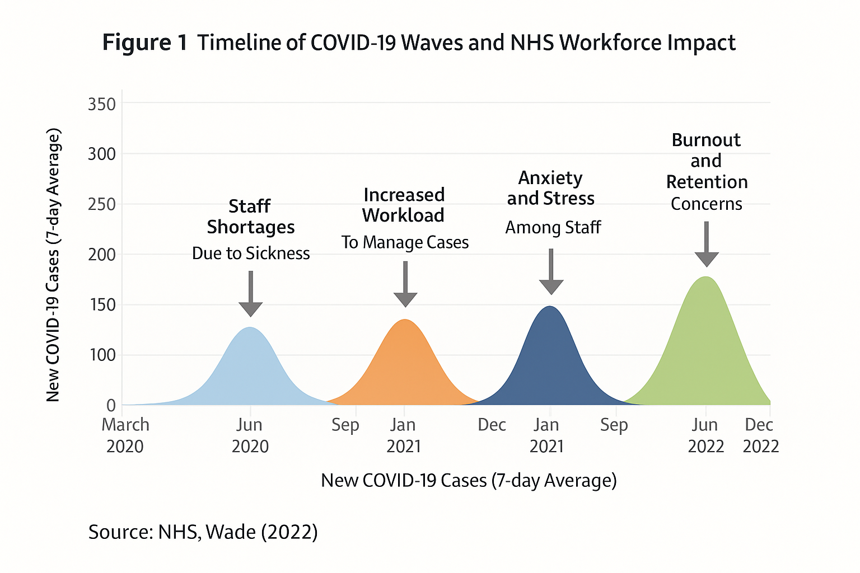

CHAPTER-02
LITERATURE REVIEW

2.1 Introduction to the Literature Review
The COVID-19 pandemic imposed historically unparalleled pressures on the UK healthcare system, and frontline workers underwent acute and chronic psychological struggles. The struggles reached beyond virus exposures to bodies and into domains of mental health, professional identity, and moral injury. As the pandemic escalated, it became increasingly apparent that healthcare workers (HCWs) in the NHS, among others, not only had excessive workloads and moral distress but also insufficient systemic support, which eventually resulted in burnout, trauma, and even attrition (Gould et al., 2024).
Early studies of HCW mental health reactions to COVID-19 were predominantly cross-sectional survey and quantitative data, which did not permit rich lived experiences to be nuanced. Nonetheless, qualitative and meta-synthesis methods have since been developed, providing additional depth regarding how frontline workers managed the crisis. Billings et al. (2021), for example, meta-synthesized 46 qualitative studies from the COVID-19 pandemic and historical pandemics and found recurring themes of fear, isolation, stigma, and organizational betrayal. These emotional burdens were frequently compounded by patchy information, PPE shortages, and inadequate access to rest or recovery (Billings et al., 2021).
Real-time qualitative research has proved most insightful for documenting real HCW experience. Gould et al. (2024), for instance, analyzed anonymized text-message conversation with NHS staff working on a mental health helpline. Such research revealed universal emotional distress, trauma, and moral outrage in HCWs reporting feeling overwhelmed and unsupported. Real-time talk provided immediate, raw, unfiltered access to crisis workers that was only sometimes possible to record in later interviews.
Liberati et al. (2021) also investigated NHS staff working within secondary mental health services, and the way radical changes like redeployment, home working, and services stripped back to essentials put staff in a position of having to juggle infection control against moral obligations towards patients. Patients felt powerless, deprived, and damaged therapeutic relationships, resulting in most cases now identified as moral injury.
Furthermore, recent doctoral research by Shirazi (2023) provides some analysis of HCWs' perception regarding moral violations amid the pandemic. Her study demonstrates how breaches in institutional values and unanswered psychological needs contributed to sustained moral distress, particularly when organizational attempts at mitigation of harm proved inadequate. This underlines greater demand for trauma-informed organisational practice (Greenberg et al., 2020).
The significance of this literature is that it can account for how psychosocial distress during the pandemic was influenced not only by workload and fear, but influenced by the response of the healthcare system as well. This context is needed for gap identification between existing support systems and rationale for thematic synthesis of qualitative data. In the lens of lived experience, this dissertation endeavors to add new UK-based qualitative insights to enhance understanding of the interplay between mental health, burnout, and coping in HCWs across the COVID-19 pandemic.
2.2 Mental Health Outcomes Among Healthcare Workers During the COVID-19 Pandemic
The COVID-19 pandemic created a harsh psychological effect on healthcare workers (HCWs) throughout the world, with UK patterns conforming to worldwide trends. Wade's (2022) review of 25 peer-reviewed articles illustrated pervasive mental decline in HCWs with mean prevalence rates of 42.1% for anxiety, 37.7% for depression, and 51.8% for stress. Carmassi et al. (2020) reported heightened post-traumatic stress disorder (PTSD) in HCWs, particularly those facing routine exposure to dying patients. Lai et al. (2020) determined that frontline workers and nurses obtained greater scores on psychological symptoms compared to non-frontline workers.
Gender, working role for the occupation, and previous mental state were all contributory factors. Chauhan et al. (2021) quoted that females in all medical professions—doctors, nurses, and paramedics—had much greater levels of depression compared to their male counterparts. Likewise, Babore et al. (2020) explained that unmarried HCWs and those who were childless had greater levels of stress, whereas their child-owning counterparts had comparatively lower levels of perceived levels of stress, possibly because of emotional distractions from household duties.
Some of the healthcare professionals like nurses and respiratory therapists had unique burdens. Farì et al. (2022) revealed that respiratory therapists experienced hopelessness and depression at 47.1% due to their high-risk exposure. Physicians also experienced emotional distress on the basis of clinical doubt and therapeutic inadequacy, whereas nursing personnel endured elevated rates of emotional exhaustion and depersonalization (Chen et al., 2021). Koontalay et al. (2021) and Bozdağ and Ergun (2020) once more stated that less experienced HCWs and younger employees were more psychologically susceptible by virtue of a shortage of professional resilience.
Fear of infecting loved ones, inadequate PPE, excessive working hours, and separation from professional colleagues were associated with emotional exhaustion. Sasaki et al. (2020) found that lack of explicitly stated infection control policies increased anxiety levels even when protection protocols existed. Blackler et al. (2021) noted discord between HCWs and families, who were not trained in delivering supportive emotional care. These multi-factorial stressors increased risk for acute and chronic mental health disorders.
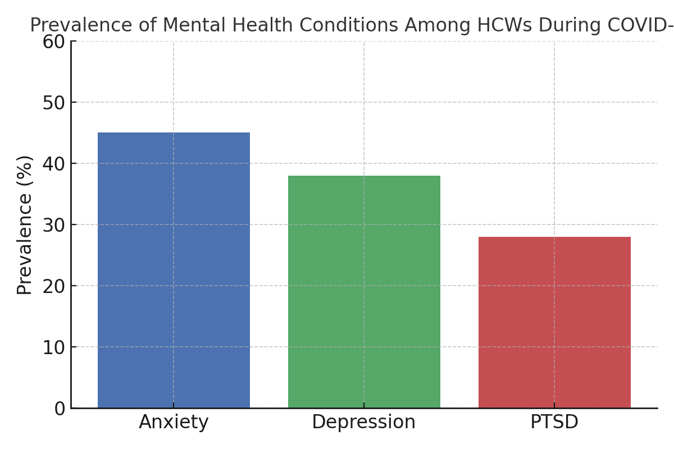
Figure 2: Comparative prevalence rates of post-traumatic stress disorder (PTSD), anxiety, and depression among healthcare workers during the COVID-19 pandemic, based on findings from UK and international studies.
Source: Wade (2022); Lai et al. (2020)

2.3 Burnout and Moral Injury in Healthcare Professionals
Burnout and moral injury have been mentioned as potential outcomes for HCWs in the COVID-19 pandemic. Burnout is an occupational syndrome with features of exhaustion, cynicism, and decreased efficacy, according to the World Health Organization (2019). Wade's (2022) meta-analysis describes higher rates of burnout among physicians, nurses, and respiratory therapists, leading to job leaving, absences, and greater patient safety risk (Laboe et al., 2020).
Chen et al. (2021) reported 79% of respiratory therapists experiencing burnout, and 10% had severe symptoms. Depersonalization and emotional exhaustion were prevalent signs of burnout fueled by overly heavy workloads and inadequate institutional backing for over 12,000 nurses surveyed (Luceño-Moreno et al., 2020). Physicians, especially in high-mortality environments, reported burnout precipitated by futility and systemic inefficiency feelings (Lewis et al., 2022).
Burnout is typically present alongside moral injury. Moral injury occurs when HCWs believe they must do the very opposite of their ethics, for example, withholding best care from patients for purposes of rationing, Kingston (2020) asserts. This kind of ethical distress can generate ongoing psychological damage. Ahorsu et al. (2021) discovered Iranian emergency nurses exhibited high levels of burnout symptoms from system failure and professional identity loss.
Compassion fatigue is a syndrome with which it is associated. Cocker and Joss (2016) have described it as an overlap of burnout and secondary trauma and the resulting loss of empathy and withdrawal. Jarrad et al. (2018) set up that HCWs who were compassion fatigued used maladaptive coping strategies such as substance use. Nurses in palliative and geriatric settings were most affected with chronic exposure to pain and death (Cross, 2019).
Burnout and moral injury threaten not just HCW well-being but also healthcare system sustainability. Sinsky et al. (2021) reported that one-third of MDs and two-fifths of U.S. nurses intended to cut hours or leave practice altogether. Wade (2022) proposes that peer support programs hold promise to avert burnout through further facilitation of emotional connection and team functioning.
2.4 Coping Mechanisms and Resilience Strategies
The COVID-19 pandemic forced UK HCWs to rely on a set of coping mechanisms to deal with stress, bereavement, anxiety, and moral harm. These were individual-level practices like emotional reframing and spirituality, right up to organisational-level ones like wellbeing hubs, peer coaching, and psychological first aid (PFA).
Weldemariam et al. (2024) found that ethnic minority HCWs applied problem-focused coping like exercise, dietary modification, and health monitoring with frequency. Positive reframing and religious practice were emotion-focused strategies. Spirituality was an essential source for African and South Asian HCWs to cope with fear and uncertainty (Koenig, 2020; Weldemariam et al., 2024). Social coping like peer conversations and online connectivity with family members were applied with frequency to avoid professional loneliness (Brown et al., 2021).
Formal coping strategies were in the form of wellbeing centers and recovery spaces within NHS Trusts. Blake et al. (2021) assessed the interventions and noted that staff valued quiet recovery areas and trained "wellbeing buddies" providing PFA. However, night-working or non-clinical staff reported insufficient access, an indicator of structural inequalities (Blake et al., 2021; Rajan et al., 2020).
Rosen et al. (2022) described how resilience coaching was used in the NHS environment, where mental health specialists offered structured intervention via mindfulness, debriefing, and standby therapy. Participation improved when workers felt they could trust the coaches as peers (West et al., 2020). Dual roles and role ambiguity cause emotional stress for coaches, particularly those involved with clinical work together with support intervention (Greenberg et al., 2020).
Peer support was the common thread throughout the papers. Wrenn et al. (2021) describe how peer catch-ups during the course of the day provided staff with opportunities to be honest, building collective resilience. Staff-led Schwartz Rounds also afforded space for sharing stories, reflection, and empathy (Maben and Bridges, 2020). Emotional expression in such environments was perceived to be more genuine than top-down policies, particularly for underrepresented racialized and staff members (Khunti et al., 2020).
In spite of these, availability of support was variable. Black and Asian workers used wellbeing hubs less often, usually because of work stress, stigma, or lack of information (Weldemariam et al., 2024). There were some freedoms provided by digital wellbeing platforms but they were unavailable to digitally excluded or older workers (Blake et al., 2021).
There was a large range of coping strategies that worked for healthcare workers during the pandemic. However, official strategies worked if they were culturally appropriate, readily accessible, and supported by leadership. Structural differences—especially for ethnic minorities and shift workers—must be addressed in order to gain equitable wellbeing provision.
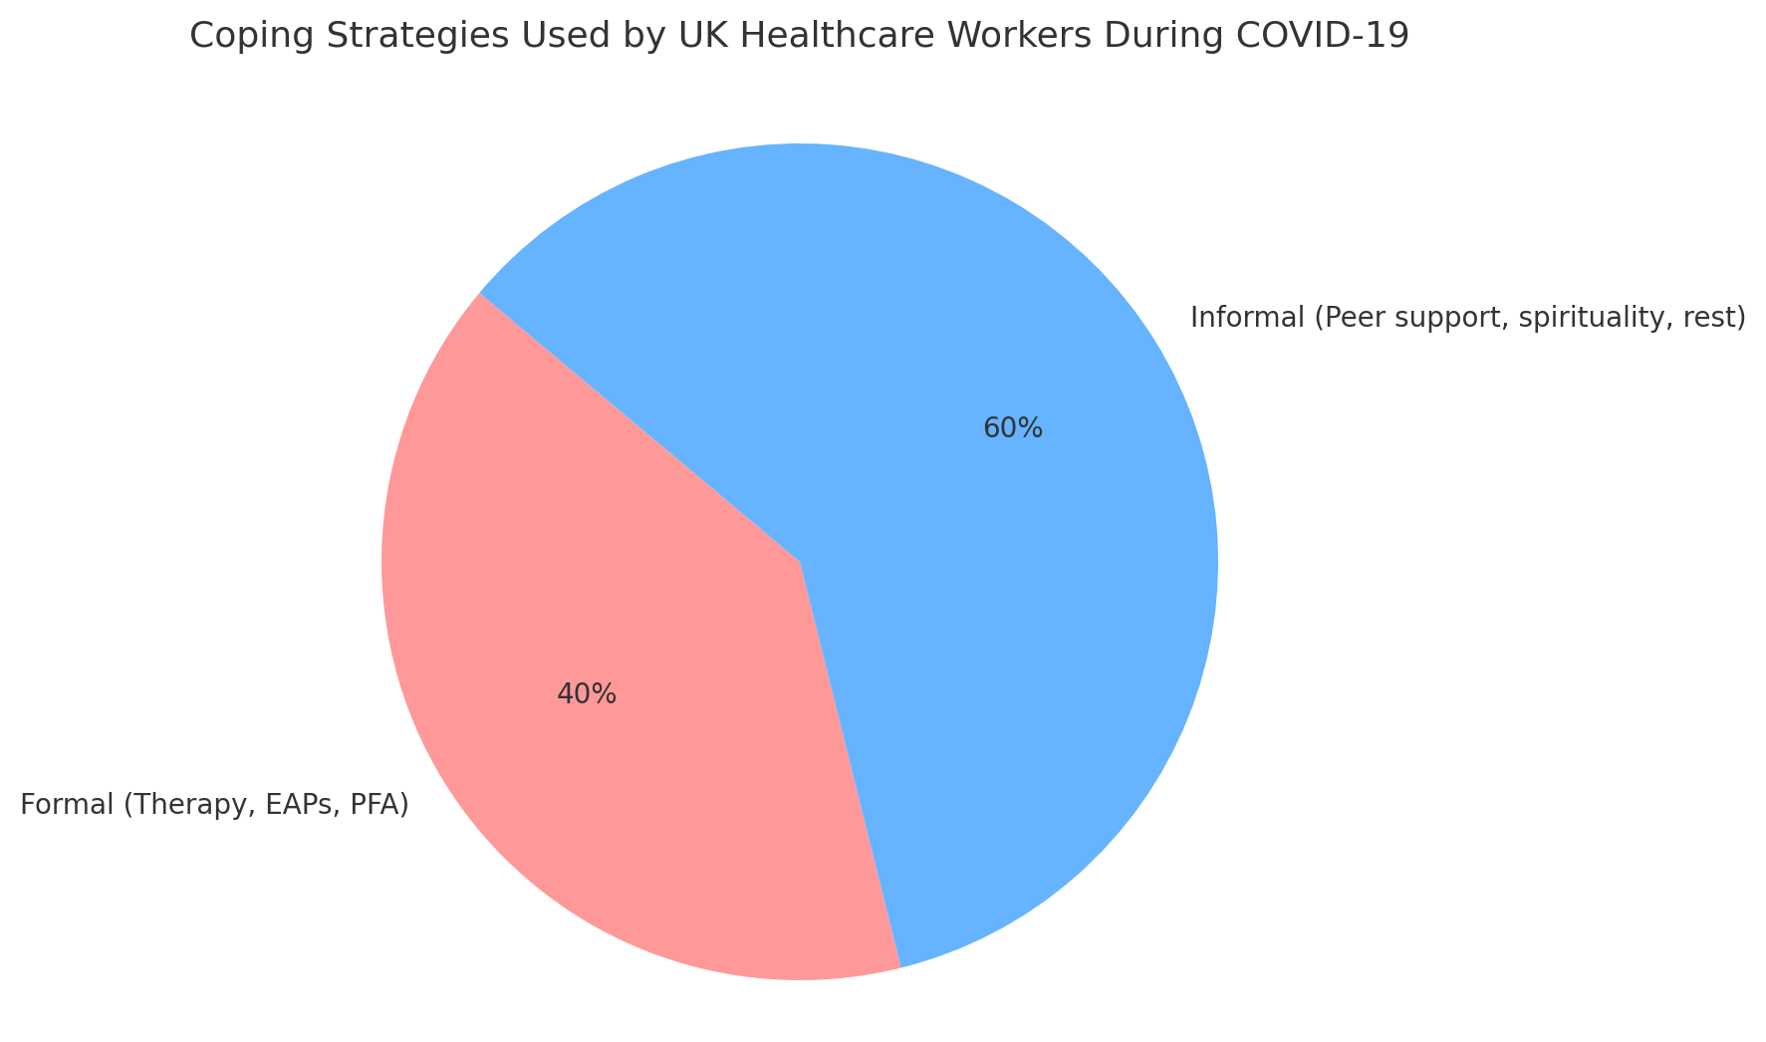
Figure 3: Distribution of coping strategies adopted by NHS healthcare staff, showing the proportion of formal methods (e.g. psychological therapy, employee assistance programs) versus informal mechanisms (e.g. peer support, rest, spirituality).
Source: Clarkson et al. (2023); Weldemariam et al. (2024)
2.5 Organisational Responses and Systemic Challenges
The COVID-19 pandemic put NHS staff under unprecedented pressure and revealed the extent of organisational failure. Qualitative research has shown that even though different interventions were implemented to protect frontline staff, many healthcare workers saw these as patchy, ill-communicated, or unavailable because of underlying problems like staffing gaps and poisonous work environments.
The most widely reported test was perhaps a failure of psychological safety in organizations. Clarkson et al. (2023) referenced a "toxic stoicism" among NHS staff where asking for help was viewed as weakness, especially in high-pressure environments. Long working hours resulted in the added stigma of seeking help being compounded, with most being denied access to support services within work hours due to extended understaffing (Clarkson et al., 2023).
Newman et al. (2021) also documented that frontline workers were overwhelmed with volumes of care delivery, always working according to changing policies without voice or agency. Uncertainty and lack of clear guidance from management generated tension and decreased confidence in the organization to safeguard its workers. Workers felt they were left behind and powerless, especially as the pandemic began (Newman et al., 2021).
In spite of such difficulties, attempts at reversing psychological distress through focused wellbeing interventions were undertaken. Blake et al. (2021) assessed the application of supported wellbeing centers with trained "wellbeing buddies" providing peer-delivered psychological first aid. The centers were received well and experienced high uptake, which indicates that accessible, low-barrier support was valued and effective. Managerial detachment and lack of time nonetheless persisted to deter some workers from participating (Blake et al., 2021).
Furthermore, Zasada et al. (2024) studied the use of "Team Time" sessions, an evidence-based intervention rooted in Schwartz Rounds. These guided group discussions employing formal structures enabled NHS staff to discuss similarities, which strengthened empathy and organisational unity. But effectiveness was dependent on local leadership and the robustness of internal communications frameworks. Where this was weak, Team Time struggled to get off the ground (Zasada et al., 2024).
Organisational disparities were also present. Clarkson et al. (2023), for example, cited that the night-shift and non-clinical staff had less access to formal support compared to their daytime and clinical peers. Physical environments such as "fallout rooms" were hastily taken back for operations in some Trusts, a sign that productivity was prioritized over wellbeing (Clarkson et al., 2023). In general, the evidence suggests that there is a gap between national-level wellbeing policy and frontline staffs' everyday reality. Successful improvement will involve long-term investment, visible and understanding leadership, and fair access to care amongst all groups of staff.

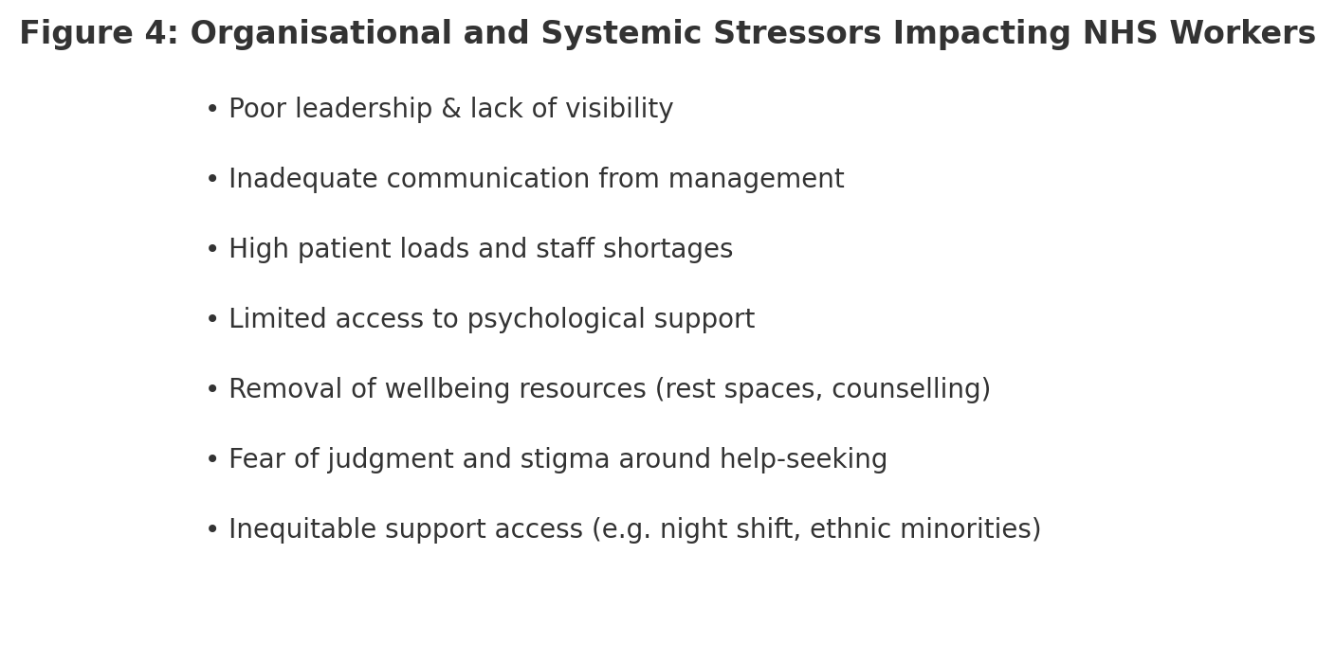
2.6 Gaps in Literature and Rationale for Thematic Synthesis
Wade (2022) identifies major deficits in HCW mental health research. First, the majority of studies are cross-sectional, leaving out knowledge of long-term consequences like persistent PTSD or burnout (Preti et al., 2020). Scant studies follow up on HCWs six months post peak pandemic, with the longer psychological impact thereon still insufficiently explored.
Secondly, data are not sufficiently disaggregated by occupational role, gender, or ethnicity. Chauhan et al. (2021) refer to differential mental health experiences across roles, but all but one or two studies lump HCWs into an undifferentiated homogenous category, hiding useful subgroup interactions. Farì et al. (2022) and Chen et al. (2021) indicate that therapists and nurses experience different stressors, which are not adequately examined.
Third, qualitative research is lacking. It is predominantly reviews from numeric prevalence data that lack lived experiences, emotional stories, or ethical dilemmas pivotal to the study of moral injury (Koontalay et al., 2021; Babore et al., 2020). Wade (2022) encourages subsequent studies to incorporate qualitative and mixed-method research methods to study elusive concepts such as resilience, bereavement, and forgiveness.
Fourth, trials of intervention are few. While mindfulness, peer support, and counselling are well established as promising solutions, few are tested rigorously (Laboe et al., 2020). More critically, existing interventions infrequently have theory foundations or outcome assessments.
Lastly, few of the reviews are concerned with country or region-wise synthesis, specifically in the UK context. This dissertation fulfills that void by being concerned with qualitative UK studies by thematic synthesis with an aim to synthesize first-hand accounts and generate actionable evidence for NHS mental health policymaking.

REFERENCES
Ahorsu, D.K., Lin, C.-Y., Imani, V., Saffari, M., Griffiths, M.D. and Pakpour, A.H. (2021) 'Nurses’ burnout during COVID-19: Evidence from Iran', *International Journal of Environmental Research and Public Health*, 18(14), p. 7984.
Al-Oraibi, A. et al. (2025) 'The impact of long COVID on UK healthcare workers and their workplace: qualitative findings from a UK-wide study', BMC Health Services Research, 25, 519. https://doi.org/10.1186/s12913-025-12677-x
Babore, A., Lombardi, L., Viceconti, M.L., Pignataro, S., Marino, V. and Trumello, C. (2020) 'Psychological effects of COVID-19 on healthcare workers with children', *Frontiers in Psychology*, 11, p. 566639.
Baldwin, S. and George, J. (2021) 'UK health professionals’ experiences at the point of care during COVID-19: a qualitative study', BMJ Open, 11, e054377. https://doi.org/10.1136/bmjopen-2021-054377
Bamforth, K. et al. (2023) 'Perceptions of healthcare professionals’ psychological wellbeing at work and the link to patients’ experiences of care: A scoping review', International Journal of Nursing Studies Advances, 5, 100148. https://doi.org/10.1016/j.ijnsa.2023.100148
Blackler, L., Pluess, M., Chu, C. and Murphy, S.E. (2021) 'Healthcare worker–family tension and mismatch in support expectations during COVID-19: A qualitative study', *Journal of Health Psychology*, 27(10), pp. 2371–2384.
Blake, H., Gupta, A., Javed, M., Wood, B., Knowles, S., Coyne, E. and Cooper, J. (2021) ‘COVID-Well Study: Qualitative Evaluation of Supported Wellbeing Centers and Psychological First Aid for Healthcare Workers during the COVID-19 Pandemic’, International Journal of Environmental Research and Public Health, 18(7), p. 3626. https://doi.org/10.3390/ijerph18073626
Blake, H., Gupta, A., Javed, M., Wood, B., Knowles, S., Coyne, E. and Cooper, J. (2021). COVID-Well study: qualitative evaluation of supported wellbeing centers and psychological first aid for healthcare workers during the COVID-19 pandemic. *International Journal of Environmental Research and Public Health*, 18(7), p.3626. [https://doi.org/10.3390/ijerph18073626](https://doi.org/10.3390/ijerph18073626)
Bozdağ, F. and Ergun, N. (2020) 'Psychological resilience and depression during COVID-19 among healthcare workers: A cross-sectional study in Turkey', *Archives of Psychiatric Nursing*, 34(5), pp. 427–433.
British Medical Association (2021) COVID-19: Supporting the mental health of doctors. Available at: https://www.bma.org.uk (Accessed: 10 July 2025).
Brown, R., Hooper, D., Woodhead, C. and Morriss, L. (2021). Peer support and wellbeing of healthcare workers during COVID-19. *Occupational Medicine*, 71(3), pp. 115–121.
Carmassi, C., Foghi, C., Dell’Oste, V., Cordone, A., Bertelloni, C.A. and Dell’Osso, L. (2020) 'PTSD and COVID-19-related stressors in frontline healthcare workers: A review of the literature', *Frontiers in Psychiatry*, 11, p. 561.
Chauhan, V., Galwankar, S.C., Arquilla, B., Garg, M., Somma, S.D. and Paladino, L. (2021) 'Gender-based depression among Indian healthcare workers during COVID-19', *Journal of Global Infectious Diseases*, 13(1), pp. 32–37.
Chen, C., Chen, C., Wang, L., Liao, Q. and Liu, X. (2021) 'Burnout among respiratory therapists during COVID-19 pandemic in China', *Respiratory Medicine*, 176, p. 106271.
Clarkson, C., Scott, H.R., Hegarty, S., Souliou, E., Bhundia, R., Gnanapragasam, S., Docherty, M.J., Raine, R., Stevelink, S.A.M., Hotopf, M., Wessely, S., Madan, I., Rafferty, A.M. and Lamb, D. (2023) ‘You get looked at like you’re failing’: A reflexive thematic analysis of experiences of mental health and wellbeing support for NHS staff’, Journal of Health Psychology, 28(9), pp. 818–831. https://doi.org/10.1177/13591053221140255
Cocker, F. and Joss, N. (2016) 'Compassion fatigue among healthcare workers: A systematic review', *International Journal of Environmental Research and Public Health*, 13(6), p. 618.
Cross, D. (2019) 'The impact of compassion fatigue on geriatric care workers: A qualitative study', *Journal of Aging Studies*, 48, pp. 23–28.
Dawson, J. (2018) Staff experience and patient outcomes: What do we know? NHS Employers. Available at: https://www.nhsemployers.org
Department of Health (2009a) Review of NHS Workforce Wellbeing. London: Department of Health.
Department of Health (2009b) The Boorman Review: NHS Health and Wellbeing. London: Department of Health.
Farì, G., Bonavita, S., De Sire, A., Maggio, M.G., Russo, G., Falzone, C., Marotta, N. and Iannò, B. (2022) 'Depression and burnout among respiratory therapists in Italy during COVID-19', *International Journal of Environmental Research and Public Health*, 19(1), p. 320.
Gilleen, J. et al. (2021) 'Impact of the COVID-19 pandemic on the mental health and well-being of UK healthcare workers', BJPsych Open, 7, e88. https://doi.org/10.1192/bjo.2021.42
Giorgi, G., Lecca, L.I., Alessio, F., Finstad, G.L., Bondanini, G., Lulli, L.G., Arcangeli, G. and Mucci, N. (2020) 'COVID-19-related mental health effects in healthcare workers: A systematic review and meta-analysis', *Frontiers in Public Health*, 8, p. 635.
Greenberg, N., Weston, D., Hall, C. and Caulfield, T. (2020). Mental health support for staff during COVID-19: learning from military and emergency services. *BMJ*, 369, m1987. [https://doi.org/10.1136/bmj.m1987](https://doi.org/10.1136/bmj.m1987)
Health Education England (2019) Workforce Strategy for NHS Staff. Available at: https://www.hee.nhs.uk (Accessed: 10 July 2025).
Jarrad, R.A., Hammad, S., Shawashi, T. and Mahmoud, N. (2018) 'Coping strategies and substance use among fatigued nurses: A cross-sectional study', *Journal of Clinical Nursing*, 27(17–18), pp. 3402–3411.
Khunti, K., Routen, A., Banerjee, A., Pareek, M. and Platt, L. (2020). The impact of COVID-19 on ethnic minority healthcare workers. *The Lancet*, 397(10281), pp. 190–192.
Kingston, L. (2020) 'Moral injury and ethical conflicts in healthcare: Understanding harm in the COVID-19 era', *Journal of Medical Ethics*, 46(10), pp. 645–650.
Koenig, H. G. (2020). Maintaining health and well-being by putting faith into action during the COVID-19 pandemic. *Journal of Religion and Health*, 59(5), pp. 2205–2214.
Koontalay, A., Suksatan, W., Prabsangob, K. and Sadang, J.M. (2021) 'Healthcare workers’ burdens during the COVID-19 pandemic: A qualitative systematic review', *Journal of Multidisciplinary Healthcare*, 14, pp. 3015–3025.
Laboe, A., Hall, H., Snow, M., Firth, M. and McKnight, K. (2020) 'Peer support, resilience, and burnout in healthcare professionals during COVID-19: A longitudinal evaluation', *Healthcare*, 8(4), p. 556.
Lai, J., Ma, S., Wang, Y., Cai, Z., Hu, J., Wei, N., Wu, J., Du, H., Chen, T., Li, R., Tan, H., Kang, L., Yao, L., Huang, M., Wang, H., Wang, G., Liu, Z. and Hu, S. (2020) 'Factors associated with mental health outcomes among healthcare workers exposed to coronavirus disease 2019', *JAMA Network Open*, 3(3), e203976.
Lewis, T.L., Ahn, J., Gresham, S., Willis, S., Griffiths, R. and Hodge, B. (2022) 'Burnout among Australian physicians during COVID-19: Prevalence and predictors', *Medical Journal of Australia*, 217(4), pp. 207–213.
Liberati, E. et al. (2021) 'Remote care for mental health: qualitative study with service users, carers and staff during the COVID-19 pandemic', BMJ Open, 11, e049210. https://doi.org/10.1136/bmjopen-2021-049210
Luceño-Moreno, L., Talavera-Velasco, B., García-Albuerne, Y. and Martín-García, J. (2020) 'Symptoms of posttraumatic stress, anxiety, depression, levels of resilience and burnout in Spanish health personnel during the COVID-19 pandemic', *International Journal of Environmental Research and Public Health*, 17(15), p. 5514.
Maben, J. and Bridges, J. (2020). COVID-19: Supporting nurses’ psychological and mental health. *Journal of Clinical Nursing*, 29(15–16), pp. 2742–2750.
Maben, J. et al. (2012a) 'Exploring the relationship between patients’ experiences of care and the influence of staff wellbeing: A longitudinal study', Journal of Health Services Research & Policy, 17(1), pp. 6–14.
Mahmud, S. et al. (2021) 'The global prevalence of depression, anxiety, stress, and insomnia and its changes among health professionals during COVID-19 pandemic: A rapid systematic review and meta-analysis', Heliyon, 7, e07393. https://doi.org/10.1016/j.heliyon.2021.e07393
Newman, K.L., Jeve, Y. and Majumder, P. (2021) ‘Experiences and emotional strain of NHS frontline workers during the peak of the COVID-19 pandemic’, International Journal of Social Psychiatry, 68(4), pp. 783–790. https://doi.org/10.1177/00207640211006153
NHS Staff Survey Coordination Centre (2022) NHS Staff Survey Results 2022. Available at: https://www.nhsstaffsurveys.com (Accessed: 10 July 2025).
Ntontis, E. et al. (2025) 'Secondary stressors and their psychosocial impacts on healthcare staff: lessons from a qualitative systematic review from the COVID-19 pandemic in the UK', BJPsych Open, 11, e110. https://doi.org/10.1192/bjo.2025.51
Point of Care Foundation (2017) Staff Wellbeing and Patient Care: A Vital Connection. Available at: https://www.pointofcarefoundation.org.uk (Accessed: 10 July 2025).
Preti, E., Di Mattei, V., Perego, G., Ferrari, F., Mazzetti, M., Taranto, P., Di Pierro, R., Madeddu, F. and Calati, R. (2020) 'The psychological impact of epidemic and pandemic outbreaks on healthcare workers: Rapid review of the evidence', *Current Psychiatry Reports*, 22(8), p. 43.
Rajan, S., Khunti, K., Alwan, N., Steves, C., MacDermott, N., Greenhalgh, T. and Darzi, A. (2020). COVID-19: policy responses for supporting healthcare workers. *BMJ Opinion*. Available at: [https://blogs.bmj.com/bmj/2020/07/20](https://blogs.bmj.com/bmj/2020/07/20)
Rosen, B., Preisman, M., Read, H., Chaukos, D., Greenberg, R.A., Jeffs, L., Maunder, R. and Wiesenfeld, L. (2022). Providers’ perspectives on implementing resilience coaching for healthcare workers during the COVID-19 pandemic. *BMC Health Services Research*, 22, p.780. [https://doi.org/10.1186/s12913-022-08131-x](https://doi.org/10.1186/s12913-022-08131-x)
Royal College of Nursing (2022) Nursing Workforce Standards. Available at: https://www.rcn.org.uk (Accessed: 10 July 2025).
Saleem, W. et al. (2021) 'Lived experiences of Pakistani-origin doctors working in the UK during the COVID-19 pandemic: A phenomenological study', BMC Health Services Research, 21, 1308. https://doi.org/10.1186/s12913-021-06308-4
Sasaki, N., Kuroda, R., Tsuno, K. and Kawakami, N. (2020) 'Workplace responses to COVID-19 associated with mental health and work performance of employees in Japan', *Journal of Occupational Health*, 62(1), e12134.
Sinsky, C.A., Brown, R.L., Stillman, M.J. and Linzer, M. (2021) 'COVID-related stress and work intentions in a sample of U.S. health care workers', *Mayo Clinic Proceedings: Innovations, Quality & Outcomes*, 5(6), pp. 1165–1173.
Søvold, L. et al. (2021) 'Prioritizing the mental health and well-being of healthcare workers: An urgent global public health priority', Frontiers in Public Health, 9, 679397. https://doi.org/10.3389/fpubh.2021.679397
Stuijfzand, S. et al. (2020) 'Psychological impact of an epidemic/pandemic on the mental health of healthcare professionals: a rapid review', BMC Public Health, 20, 1230. https://doi.org/10.1186/s12889-020-09322-z
Wade, J.M. (2022) *The Global Impact of COVID-19 on the Mental Health of Healthcare Workers: A Systematic Review*. Capstone Project. Radford University.
Weldemariam, H., Dadzie, O., Ogunbode, C., Antwi, P., Sam, D.L., Olaniyan, O.S., Chandrasekaran, P. and Sagoe, D. (2024). A qualitative exploration of the coping strategies of UK ethnic minority healthcare workers during the COVID‑19 pandemic. *Discover Psychology*, 4(143). [https://doi.org/10.1007/s44202-024-00267-7](https://doi.org/10.1007/s44202-024-00267-7)
West, M., Bailey, S. and Williams, E. (2020). The courage of compassion: Supporting nurses and midwives to deliver high-quality care.
Wilkinson, H. (2015) Why staff wellbeing matters for patient care. King’s Fund. Available at: https://www.kingsfund.org.uk (Accessed: 10 July 2025).
Zasada, M., van Even, S., Maben, J., Oates, J. and Taylor, C. (2024) ‘Team Time as a wellbeing intervention for NHS staff: a qualitative evaluation of implementation during the COVID-19 pandemic’, BMC Health Services Research, 24, 1622. https://doi.org/10.1186/s12913-024-12046-0

