Matthew Macpherson
Bsc Civil Engineering
1804910
Soil Mechanics Practical

Contents
- Atterberg Limits………………………………………3
  - Introduction……………………………………………………..3
  - Methodology…………………………………………………….3
- Liquid Limit Procedure…………………………………………………..3
- Plastic Limit Procedure…………………………………………………..5
  - Results and Analysis…………………………………………..6
- Liquid Limit…………………………………………………………6
- Plastic Limit………………………………………………………..7
- Plasticity Index……………………………………………………8
- Classification………………………………………………………8
  - Conclusions……………………………………………………….9
- Constant Head Permeameter…………………..10
  - Introduction………………………………………………………10
  - Methodology…………………………………………………….10
  - Results and Analysis………………………………………….11
  - Conclusions………………………………………………………14
- References……………………………………………….15

- Atterberg Limits

  - Introduction
The main aim for this experiment is to determine the liquid and plastic limit of the given sample and with that classify the soil also. We followed the guidelines set out through the British Standards (BS EN ISO 17892-12) when conducting the experiment, using the Casagrande Method to do so. The procedures for both the liquid and plastic limit tests are in the following section. The apparatus used was tested and calibrated beforehand and all additional equipment used throughout was to the specifications as written in BS EN ISO 17892-12 to ensure that the experiment was done in line with these standards.
Key Definitions for the Atterberg Limit Tests
- According to the BS EN ISO 17892-12 the liquid limit is defined as ‘water content at which a soil passes from the liquid to the plastic state, as determined by the liquid limit test’ (BIS, 2018).
- The plastic limit is defined in BS EN ISO 17892-12 as ‘water content at which a specimen ceases to be plastic when dried further, as determined by the plastic limit test’ (BIS, 2018)
- As per BS EN ISO 17892-12 Plastic Index is defined as ‘numerical difference between the liquid limit and the plastic limit of a soil’ (BSI, 2018)

  - Methodology

    - Liquid Limit Procedure

- Choose the four containers that are to be used, label them to give them a sample number and then weigh them as they all could be slightly different (therefore effect results).
- Next get a soil sample of around 250g (to give you plenty) in a metal mixing bowl and then proceed to add very little amounts of water (1-2ml) mixing the sample by using methods such as:
  - Stirring
  - Kneading
  - Chopping
The above methods are to be carried out using a spatula. The aim is to mix the sample to give a consistency that will require 30-35 drops when using the Cassagrande Apparatus which should cause a groove gap closure of 12mm.
- It is important that this consistency is reached to begin with, so it becomes a process of trial and error if the required consistency isn’t achieved to begin with.
- Once the correct consistency is achieved, put some of the sample into the cup bowl, pressing the sample down using the spatula and then spreading it out making it as flat as possible.
- It should have a depth of approximately 10mm across the base and air bubbles should be avoided as they can alter the accuracy of the test.
- Then return all excess soil back into the mixing bowl to be used again.
- From back to front, use the gauging groove tool to create a groove through the sample to the cup base.
  - This should be completed in three gentle swipes of the tool to avoid any tearing of the sample.
- Set the drop counter to zero on the apparatus
- Lift and drop the cup by turning the crank handle at a rate of 2 revolutions per second, until the two halves of the sample close 12mm across the gap created using the gauge tool.
- Record the number of drops that was required to close this 12mm gap.
- Remove a slice of the sample, this slice should be the width of the spatula and should go from edge to edge along the sample, cutting through the groove.
- Place the sample into one of the marked containers and then weigh the sample to give you the wet soil + container figure.
- Repeat the above process, but slowly increase the moisture content to reduce the number of blows required to close the gap.
- The number of drops should range between 35-15
- Once all four samples have been collected, they must be placed in an oven for 24 hours in order to dry the material out and give accurate results.
- After 24 hours take the samples out of the oven and then weigh the samples with the container to determine moisture contents.
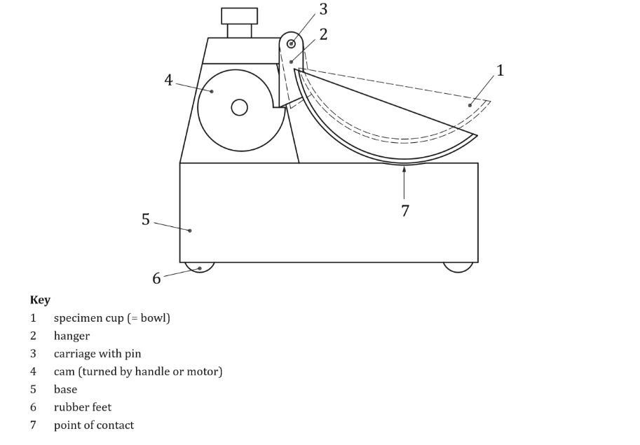
Note: Some of the figures may be different from that of BS EN ISO 17892-12 so that it works in the university lab, however the procedure is as written in the standards.
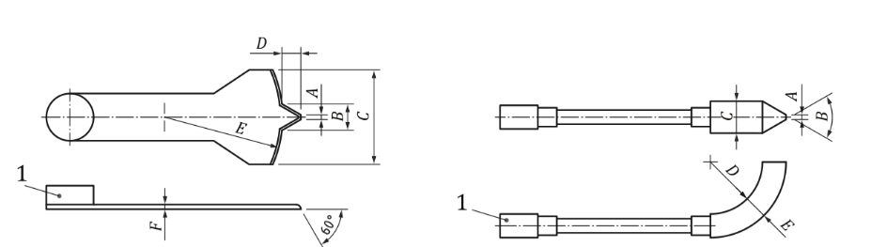
Figure 2 – Grooving Tool (BSI, 2018)

Figure 1- Casagrande Apparatus (BSI, 2018)

Note: Sizes, Dimensions and Tolerances of the above are found in BS EN ISO 17892-12

    - Plastic Limit Procedure

- Choose the three containers that are to be used, label them to give them a sample number and then weigh them as they all could be slightly different (therefore effect results).
- Knead the clay sample.
  - If needed add water or dried clay in order to adjust the moisture content to the required boundaries.
- Mould the clay into small ball using your fingers and then roll the ball between the palms of your hands so the warmth generated dries the clay slowly.
- Once cracks begin appearing in the sample, spilt it into three equal parts that should weigh about 10g each.
  - Keep the three balls separate as these are the different samples being used.
- Use the glass rod provided as a guide for the diameter that the sample should be, then roll each sample into a thread on the glass plate provided.
  - The sample should end with a diameter of 6mm
  - The thread must be intact and homogenous.
- Then apply steady rolling pressure with the palm of the hand. Reducing the diameter of the thread from 6mm to 3mm.
- Repeat this process until the sample begins to ‘crumble’ (typically around the 3mm mark)
  - It’s vital that a uniform rolling pressure is maintained throughout.
  - Crumbling of the sample is when it shears both longitudinally and transversally when it is rolled.
- Crumbling must occur due to the reduction of moisture as a result of rolling directly and not as a result of mechanical breakdown due to excess pressure during the rolling phase.
- The crumbling point of the sample is the Plastic Limit moisture content.
- Once the crumbling point of the sample is achieved, get the crumbs together, place them into one of the containers and weigh the wet soil + container.
- Repeat the above steps for the other two samples.
- Once all three samples have been collected, place all three in the oven for 24 hours.
- When dry, weigh each of the samples and with that gives you the moisture content them. Take the average of all three results to obtain the moisture content mean.
- This moisture content mean is the Plastic Limit moisture content indicator.
Note: Some of the figures may be different from that of BS EN ISO 17892-12 so that it works in the university lab, however the procedure is as written in the standards.

  - Results and Analysis

    - Liquid Limit
The results for the Atterberg Liquid Limit Test are as follows in the table below:
Sample Number | Weight of Wet Soil+ Container (g) | Weight of Dry Soil+ Container (g) | Weight of Container (g) | Weight of Moisture (g) | Weight of Dry Soil (g) | Moisture Content (%) | Number of Blows
1 | 9.43 | 8.02 | 4.72 | 1.41 | 3.3 | 42.72 | 32
2 | 13.35 | 10.66 | 4.69 | 2.69 | 5.97 | 45.06 | 22
3 | 13.39 | 10.68 | 4.69 | 2.71 | 5.99 | 45.24 | 19
4 | 12.89 | 10.24 | 4.72 | 2.65 | 5.52 | 48.01 | 15
Table 1 – Data Received from the Liquid Limit test
Moisture Content above calculated using the following equation:
$w=\frac{M_{w}}{M_{s}}×100$ [Equation 1]
Where:
$$w=Moisture Content$$
$$M_{w}=Mass of Wet Soil$$
$$M_{s}=Mass of Solids (Dry Soil)$$

Once the moisture content for each of the 4 samples you then plot them on a graph alongside the number of blows to find the liquid limit of the sample. For the moisture content of the sample you use the 25 blow mark to allow you to work out the liquid limit. See the following graph for clarification of the liquid limit.

A Graph to Show the Liquid Limit for the Samples
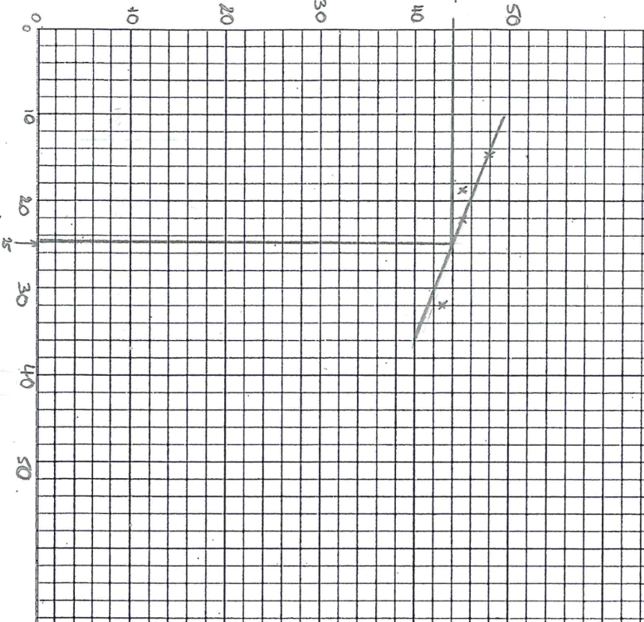
Liquid Limit =44%

Moisture Content

Number of Blows

Graph 1 – Liquid Limit for the Sample

    - Plastic Limit
The Results for the Atterberg Plastic Limit Test are as follows in the table below:
Sample Number | Weight of Wet Soil+ Container (g) | Weight of Dry Soil+ Container (g) | Weight of Container (g) | Weight of Moisture (g) | Weight of Dry Soil (g) | Moisture Content (%)
1 | 8.01 | 7.24 | 4.73 | 0.77 | 2.51 | 30.68
2 | 9.4 | 8.31 | 4.73 | 1.09 | 3.58 | 30.45
3 | 8.18 | 7.39 | 4.81 | 0.79 | 2.58 | 30.62
Table 2 – Data Received from the Plastic Limit Test

Using Equation 1 it gives you the moisture content for the plastic limit test for the 3 samples.
To get the Plastic Limit you average the 3 Moisture Content Values from Table 2, therefore:
$$\frac{30.68+30.45+30.62}{3}$$
$$Platsic Limit=30.58\%$$

    - Plasticity Index

The Plasticity Index (PI) of a material is found by taking the range between the Liquid Limit and Plastic Limit.
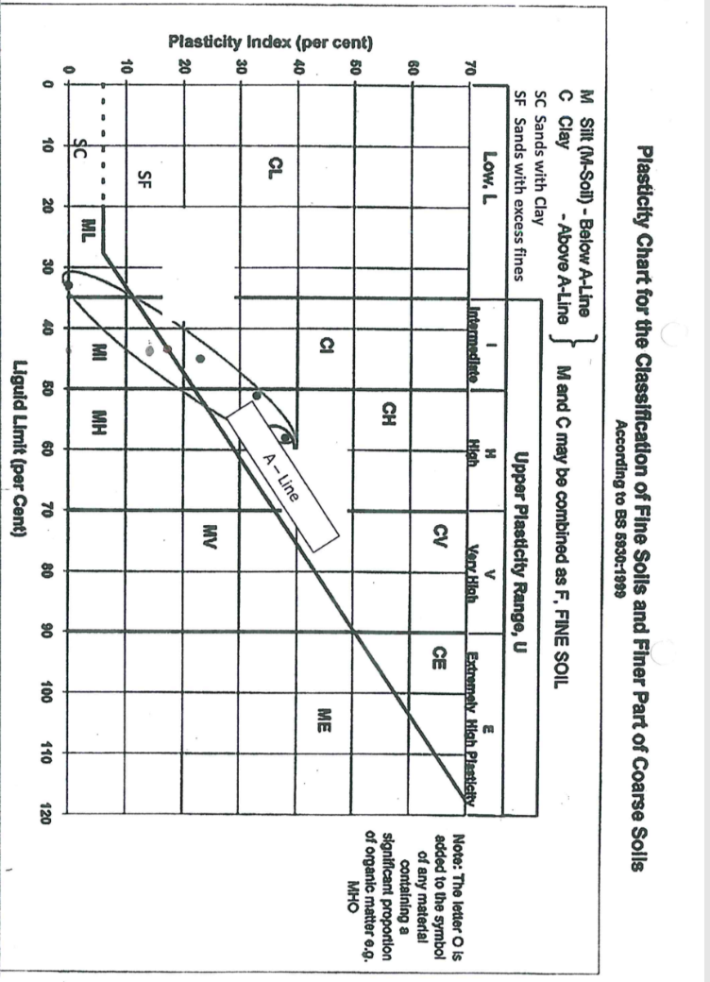
Therefore, the PI is 14.58% due to the Liquid Limit being 44% as per graph 1 and the Plastic Limit being 30.58%.
    - Classification

Graph 2 – Plasticity Chart for the Classification of the Sample

Once you have the Plasticity Index and the Liquid Limit of the sample you can then use graph 2 to establish what type of soil the sample is, this graph is according to BS 5930:1999. It shows that the sample is below the ‘A-Line’ meaning that it is a silty soil, it’s also in the intermediate band for plasticity range.

  - Conclusions
The categorisation for the plastic limit of a material is the percentage of moisture that it takes for a soil to change. The plastic limit is lower boundary of plasticity, it is the point where a thread of soil can be rolled out to a diameter 3mm (as per method in part b), with the smallest amount of moisture compromising the soil and therefore destroying the strength of it (Plastic Limit of Soil | The Construction Civil, n.d.). The plastic limit for a soil is also significant in the way that it can help categorise the sample of soil that you are investigating, as only clays, silts and colloids possess the properties that give it a plastic limit it can immediately show you important information regarding the soil type (Plastic Limit of Soil | The Construction Civil, n.d.). A sample that has a high clay content tends to have a high plastic limit as well as a high liquid limit, however a less cohesive soil has gives low readings (Plastic Limit of Soil | The Construction Civil, n.d.).
The liquid limit state of a soil is significant because it gives you the point of which the soil loses all cohesive strength losing its shape as a result as it can no longer hold its own weight. It is important to understand the liquid limit of materials due to the reasons as follows:
- “Liquid limit of soil is a very important property of fine-grained soil (or cohesive soil)
- Value of liquid limit is used to classify fine grained soil.
- It gives us information regarding the state of consistency of soil on site.
- Liquid limit of soil can be used to predict the consolidation properties of soil while calculating allowable bearing capacity & settlement of foundation.
- Liquid limit value of soil is also used to calculate activity of clays and toughness index of soil.”
(LIQUID LIMIT OF SOIL – WHAT, WHY & HOW? - CivilBlog.Org, n.d.)
Both the Liquid Limit and the Plastic Limit have big implications when it comes to soil slopes. Using our experiment as an example the liquid limit of the sample was 44% which suggests that there is the potential that the soil has a high expansion potential (Kushwawa, Bidyashwari, Chandra and Okendro, 2017). Also, throughout the results the moisture content is higher than the plastic limit, this means that deformation of a slope (with the soil sample as per this experiment) is a possibility, this would also make the slope unstable (Kushwawa, Bidyashwari, Chandra and Okendro, 2017).
Having an area where the liquid limit of the soil is at the level where it makes the soil ‘unstable’ becomes a real issue if things such as earthquakes occur, it causes a process called ‘liquefaction’ which effectively is when the soil gets shaken so that it loses its molecular stability and therefore acts as though it is a liquid, which can have devastating effects as shown in the 1976 Tangshan Earthquake in China (Rafferty, n.d.). Scientists believe that there was an area of more than 2400km² that was subjected to liquefaction which caused high levels of damage to the southern parts of the city (Rafferty, n.d.). The majority of buildings in the city were built on the Luanhe river’s flood plain so the soil was extremely moist and as a result made it unstable and made liquefaction inevitable when such a huge earthquake hit the area (The Earthquake That Shook up Maoism in Tangshan, China, n.d.). It levelled 85% of buildings in Tangshan and showed the issues with soils that are unstable and susceptible to such issues (The Earthquake That Shook up Maoism in Tangshan, China, n.d.).

- Constant Head Permeameter

  - Introduction

The aim of this experiment is to find the classification for the soil sample being used, you first must work out the coefficient of permeability to be able to translate the figure calculated to Darcy’s Table.

Darcy was a French Engineer who studied movement of water through sand and was revolutionary in his findings when it came to flow, and found that this flow of water was proportional to a coefficient which we know as the coefficient of permeability and as stated above this is the key aspect of this experiment. The coefficient can be influenced by the following:
- Pore Size
- Soil Structure
- Viscosity of the pore fluid
Due to technical issues the experiment wasn’t completed by ourselves in the lab but the process of the experiment would be completed following the guidelines of BS EN ISO 17892‑11:2019 and all relevant tests would be taken to ensure that the equipment was up to the specifications and calibrate them so that they give accurate readings throughout the experiment. This would be completed using the constant head permeameter, which is the method used for soils that have a higher permeability up until k = $10^{-4}$.
All results given in part c are as if the experiment had been completed taking the steps as per the method that will be described in part b.

  - Methodology

- First pour water into the permeameter
- Once the water is in the permeameter pour the test sand into the permeameter through the water.
- Next open the valve to allow you to see the constant head difference, which for the equating is labelled ‘h’
  - This head difference is the head used up in pushing the water through the permeameter a length (labelled ‘l’ in the equation) of the test sample.
- Then collect the water passing through the sample over a time (seconds).
- Repeat this process two more times to give you three samples, gradually increasing the time for collecting the water per sample.
- The hydraulic gradient is the height difference in the two manometer tubes divided by the height difference between manometer connections in the cell itself.
Note: The experiment was carried out as per the BS EN 17892-11 guidelines

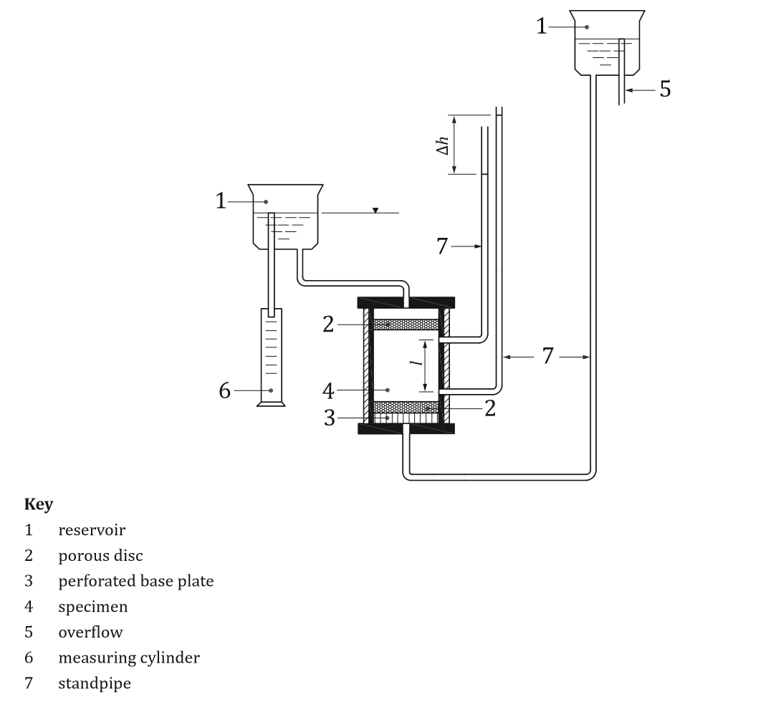
Figure 4 – Constant Head Permeameter Apparatus (BSI, 2019)

Note: Sizes, Dimensions and Tolerances of the above are found in BS EN ISO 17892-11

  - Results and Analysis
Sample = 0.1m Diameter
Head Difference = 0.068m
The Head Difference was measured between points 0.2m apart
Results
Test Number | Water Collected (m³) | Time (Minutes)
1 | $$920×{10}^{-7}$$ | 2:45
2 | $$185×{10}^{-6}$$ | 5:30
3 | $$36.8×{10}^{-5}$$ | 11:00
Table 3 – Results for the Constant Head test
Once the test is complete the next step is to determine the Coefficient of Permeability in m/s for each of the tests above.

The Standard Equation to be used is:
$K=\frac{Q×L}{A×h×t}$
Where:
- Q = Flow of Water in m³/s
- A = Area of Flow
- K = Coefficient of Permeability
- L = Length of Flow Line
- h = Hydraulic Head Difference
- t = Time in Seconds

Test Number | Calculation
1 | $$K= \frac{Q×L}{A×h×t}$$  $$K= \frac{(920×{10}^{-7})×0.2}{πr^{2}×0.068×165}$$  $$K=\frac{(920×{10}^{-7})×0.2}{(π×{0.05}^{2})×0.068×165}$$  $$K=2.088×{10}^{-4}$$
2 | $$K= \frac{Q×L}{A×h×t}$$  $$K= \frac{(185×{10}^{-6})×0.2}{πr^{2}×0.068×330}$$  $$K=\frac{(185×{10}^{-6})×0.2}{(π×{0.05}^{2})×0.068×330}$$  $$K=2.099×{10}^{-4}$$
3 | $$K= \frac{Q×L}{A×h×t}$$  $$K= \frac{(36.8×{10}^{-5})×0.2}{πr^{2}×0.068×660}$$  $$K=\frac{(36.8×{10}^{-5})×0.2}{(π×{0.05}^{2})×0.068×660}$$  $$K=2.088×{10}^{-4}$$
Table 4 – Calculations for the Coefficient of Permeability

Once the coefficients have been calculated for each test an average must be taken. This is as follows:
$$\frac{\left(2.088×{10}^{-4}\right)+\left(2.099×{10}^{-4}\right)+(2.088×{10}^{-4})}{3}$$
$$=2.0916×{10}^{-4}$$
$$=2.092×{10}^{-4}$$

You then apply this final number to Darcy’s Table to give the sample its Classification. See below for Darcy’s Table and the classification:
10²  10  1  $${10}^{-1}$$ | Clean Gravels
$${10}^{-2}$$  $${10}^{-3}$$  $${10}^{-4}$$ | Clean Sands  Gravel – Sand Mix
$${10}^{-5}$$  $${10}^{-6}$$ | Very Fine Sands  Silts and Salty Clays
$${10}^{-7}$$  $${10}^{-8}$$  $${10}^{-9}$$ | Clay Silts $(± 20\% Clay)$  Unfissured Clay
Table 5 – Darcy’s Table for Classification

From the table above you can work out the classification of the sample used for this experiment, given that the final ‘average’ coefficient was $2.092×10^{-4}$ it shows that the sample is a gravel-sand mix as that’s it has a permeability value of ‘$10^{-4}$’ which is shown in Darcy’s Table above.
  - Conclusions
As touched upon in the introduction the constant head permeameter test is ideal for soils that have a permeability of up to $10^{-4}$so is better for coarser soils, many of which will be present on sites and give an understanding into the soil type from a civil engineering perspective. It could also be useful when determining flow rates through pipes as and what effect the any excess material may have if it gets into the pipe. It is important that in a constant head that the inlet level and outlet level are the same as per BS EN ISO 17892-11 (BSI, 2019) to ensure that the procedure is carried out with the upmost accuracy and the classification of the material through Darcy’s Table is accurate as the coefficient makes all the difference.
It is one of many methods for measuring the coefficient of permeability, as stated above it is used for coarser materials whereas methods such as the falling head permeameter is used for the finer materials and therefore wouldn’t have been effective for this particular sample that was used during this experiment.

- References
The Construction Civil. n.d. Plastic Limit Of Soil | The Construction Civil. [online] Available at: <https://www.theconstructioncivil.org/plastic-limit-of-soil/> [Accessed 19 March 2020].
CivilBlog.Org. n.d. LIQUID LIMIT OF SOIL – WHAT, WHY & HOW? - Civilblog.Org. [online] Available at: <https://civilblog.org/2015/03/07/liquid-limit-of-soil-what-why-how/> [Accessed 21 March 2020].
Kushwawa, R., Bidyashwari, H., Chandra, M. and Okendro, M., 2017. [online] File.scirp.org. Available at: <https://file.scirp.org/pdf/IJG_2017112315342427.pdf> [Accessed 21 March 2020].
Rafferty, J., n.d. Soil Liquefaction | Definition, Examples, & Facts. [online] Encyclopedia Britannica. Available at: <https://www.britannica.com/science/soil-liquefaction> [Accessed 21 March 2020].
ThoughtCo. n.d. The Earthquake That Shook Up Maoism In Tangshan, China. [online] Available at: <https://www.thoughtco.com/the-great-tangshan-earthquake-of-1976-195214> [Accessed 21 March 2020].
BSI, 2018. [online] Www-ihsti-com.ezproxy.uwtsd.ac.uk. Available at: <https://www-ihsti-com.ezproxy.uwtsd.ac.uk/tempimg/BFCA69-CIS888614800323008.pdf> [Accessed 22 March 2020]. (BS EN ISO 17892-12)
BSI, 2019. [online] Www-ihsti-com.ezproxy.uwtsd.ac.uk. Available at: <https://www-ihsti-com.ezproxy.uwtsd.ac.uk/tempimg/6E5818-CIS888614800325401.pdf> [Accessed 24 March 2020]. (BS EN ISO 17892-11)
BSI, 1990. [online] Www-ihsti-com.ezproxy.uwtsd.ac.uk. Available at: <https://www-ihsti-com.ezproxy.uwtsd.ac.uk/tempimg/BFCA69-CIS888614800071768.pdf> [Accessed 24 March 2020]. (BS 1377-5 1990)

