Design Thinking and Innovation through Digital Transformation
LCLM6002

Tutor: Navid Nasirpourosgoei
Student: Svetlana Boaghe 2332687

Table of Contents
Design Thinking and Innovation through Digital Transformation 0
Table of Contents 1
Introduction 2
1. Digital Transformation in UK Rural SMEs. 3
1.1 Digital Transformation in Contemporary Organisations 3
1.2 Challenges Facing Rural SMEs 4
1.3 Coordination as an Emerging Innovation Opportunity 4
2. Critical Review and Justification of Innovation Frameworks 4
2.1 Design Thinking 4
2.2 Systems Thinking 5
2.3 Framework Justification 5
Task 1 6
3. Problem Investigation and Opportunity Identification 6
3.1 User pain points 6
Task 2 10
4. Venture Development and Evaluation 10
4.1 Empathising with affected users (e.g., small retailers, rural consumers, delivery partners, etc.) 11
4.2 Defining a Clear Problem Statement 11
4.3 Generating Innovative Solution Ideas 12
4.4 Proposing a Prototype or Minimum Viable Product (MVP) 13
4.5 Explaining How the Solution Would Be Tested and Refined 14
5. Conclusion 17
References 18

Introduction
Digital transformation has reshaped how organisations create value, engage customers and compete, requiring organisations to integrate digital technologies into their core business strategies (Westerman, Bonnet and McAfee, 2014; Vial, 2019; Verhoef et al., 2021). Yet its benefits remain unevenly distributed across the UK economy. Rural small and medium-sized enterprises (SMEs) continue to face significant barriers despite improvements in digital technologies and infrastructure. While existing research often attributes these challenges to limited connectivity, digital capability and financial constraints, these explanations only partially account for the uneven outcomes of digital transformation. Increasingly, fragmented coordination between SMEs, customers, suppliers, logistics providers and support organisations has emerged as an important factor influencing organisational performance and innovation (Brown, 2009; Adner, 2017; Liedtka, 2018).
This portfolio argues that sustainable digital transformation requires not only the adoption of digital technologies but also improved coordination across the wider stakeholder ecosystem. To investigate this proposition, the study adopts an integrated Design Thinking and Systems Thinking approach, combining user-centred enquiry with system-level analysis to identify innovation opportunities and develop a practical venture concept.
The aim of this portfolio is to critically evaluate digital transformation opportunities within the UK rural SME context and apply Design Thinking to develop and assess CoNexus, a proposed digital coordination ecosystem designed to improve communication, collaboration and information sharing among key stakeholders. The portfolio first examines the digital transformation context and evaluates appropriate innovation frameworks before investigating stakeholder needs and identifying innovation opportunities. It then develops and evaluates the CoNexus concept through the Design Thinking process, assessing its desirability, feasibility and viability as a response to the coordination challenges affecting rural SMEs.

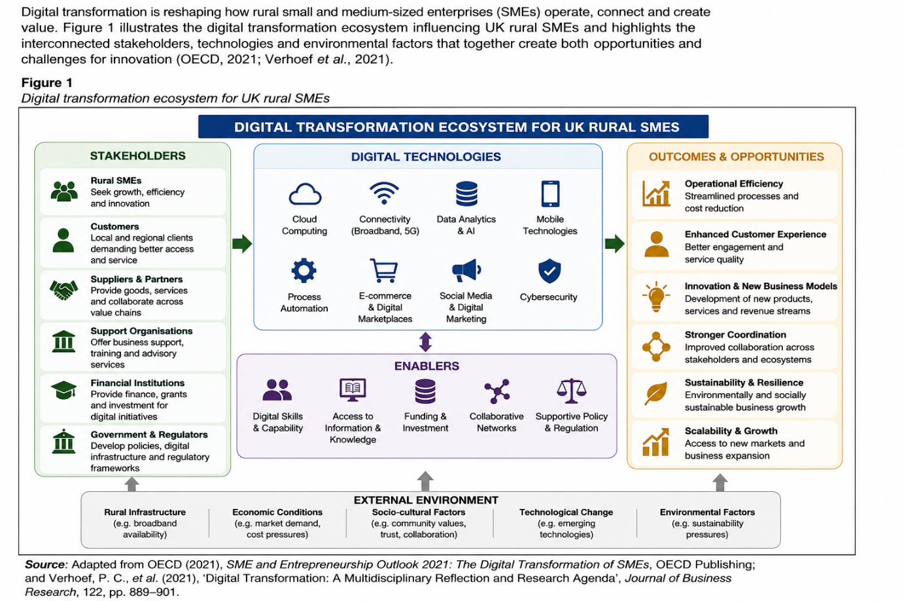
Figure 1 presents the conceptual framework underpinning this portfolio. It illustrates how the study progresses from understanding the context of digital transformation in UK rural SMEs and the challenges they face to identifying fragmented stakeholder coordination as the central research problem. The framework also demonstrates how Design Thinking provides the methodological approach for investigating user needs, identifying innovation opportunities and developing a proposed digital venture. Consequently, the figure provides a roadmap for the portfolio and explains the logical progression of the analysis presented in the following sections.

1. Digital Transformation in UK Rural SMEs.
Digital transformation has created significant opportunities for organisational innovation, yet its benefits remain unevenly distributed across the UK economy. Digital technologies have enabled organisations to improve operational efficiency, customer engagement and market accessibility; however, these benefits have not been realised consistently across sectors or geographical regions (Vial, 2019; Verhoef et al., 2021). Rural SMEs continue to experience persistent challenges despite improvements in digital infrastructure, suggesting that successful transformation depends on more than technology adoption alone.

1.1 Digital Transformation in Contemporary Organisations
Contemporary research increasingly defines digital transformation as organisational change rather than simply the implementation of digital technologies, requiring digital capabilities to become integral to business strategy (Bharadwaj et al., 2013; Vial, 2019). Sustainable transformation requires organisations to redesign business models, operational processes and customer interactions while integrating technology with organisational capabilities and stakeholder relationships (Verhoef et al., 2021). Consequently, digital technologies should be viewed as enablers of value creation rather than objectives in themselves.

1.2 Challenges Facing Rural SMEs
Rural SMEs continue to face barriers including limited broadband connectivity, digital capability, financial constraints and restricted access to skilled labour (OECD, 2021). While these factors influence technology adoption, they do not fully explain why many digitally enabled SMEs still experience fragmented operations, inconsistent customer experiences and inefficient collaboration. Research increasingly suggests that digital transformation outcomes are also shaped by the quality of interactions between businesses, customers, suppliers, logistics providers and public institutions operating within interconnected ecosystems (Adner, 2017; Vargo and Lusch, 2016).

1.3 Coordination as an Emerging Innovation Opportunity
If technology access is regarded as the primary barrier, innovation efforts should continue to prioritise infrastructure and digital capability. However, if fragmented stakeholder relationships significantly constrain organisational performance, innovation must also focus on improving coordination across the wider business ecosystem. This perspective identifies stakeholder coordination as an underexplored opportunity capable of enhancing operational efficiency, customer experience and collaborative value creation. Consequently, this portfolio investigates whether improving ecosystem coordination offers greater innovation potential than technology adoption alone, providing the basis for evaluating alternative innovation frameworks in the following section.

2. Critical Review and Justification of Innovation Frameworks
The coordination challenges identified in the previous section represent a complex organisational problem that cannot be understood through a single innovation perspective. Different innovation frameworks are based on different assumptions about how problems should be defined, investigated and addressed. This section therefore critically evaluates Design Thinking and Systems Thinking, while considering Lean Startup as a complementary approach, to justify the most appropriate methodology for investigating stakeholder coordination within rural SMEs.

2.1 Design Thinking
Design Thinking is widely recognised as a human-centred approach that prioritises understanding stakeholder needs before developing and refining solutions through iterative experimentation (Brown, 2009; Lewrick, Link and Leifer, 2020). Rather than assuming problems are clearly defined, it encourages organisations to explore user experiences, challenge assumptions and generate innovative responses to complex situations (Liedtka, 2018). This emphasis on empathy and iterative learning makes it particularly valuable where stakeholder needs are uncertain.
However, Design Thinking has been criticised for focusing primarily on individual users while giving comparatively less attention to wider organisational relationships and system complexity (Johansson‐Sköldberg, Woodilla and Çetinkaya, 2013). Consequently, although it provides a strong foundation for investigating stakeholder experiences, it requires complementary approaches to explain ecosystem-level coordination challenges.

2.2 Systems Thinking
Systems Thinking addresses this limitation by examining how relationships, interdependencies and feedback loops shape organisational outcomes (Meadows, 2008). Rather than viewing problems in isolation, it considers how interactions between businesses, customers, suppliers, logistics providers and public institutions influence digital transformation. This perspective is particularly relevant to rural SMEs, where organisational performance depends on effective collaboration across interconnected stakeholders.
Despite these strengths, Systems Thinking provides limited guidance for generating and refining user-centred innovations. It therefore complements, rather than replaces, Design Thinking by providing a broader understanding of the system within which innovation occurs (Arnold and Wade, 2015).

2.3 Framework Justification
Lean Startup contributes valuable methods for rapid experimentation and prototype validation (Ries, 2011) but assumes that the underlying problem has already been defined. As this portfolio focuses first on investigating a complex coordination challenge, an integrated Design Thinking–Systems Thinking approach is more appropriate. Design Thinking provides the structure for understanding stakeholder needs and developing solutions, while Systems Thinking explains the relationships and interdependencies that influence digital transformation. Lean Startup is subsequently used to support prototype refinement and testing.
Table 1. Critical Comparison of Innovation Frameworks
Framework | Primary Focus | Strengths | Limitations | Role in this Portfolio
Design Thinking | User-centred innovation | Empathy, creativity, iterative learning (Brown, 2009; Liedtka, 2018) | Limited systems perspective (Brown, 2009; Liedtka, 2018) | Investigates stakeholder needs and supports solution development
Systems Thinking | System relationships | Explains complexity, interdependence and feedback loops (Meadows, 2008; Arnold and Wade, 2015) | Less prescriptive for innovation implementation | Investigates coordination across the rural SME ecosystem
Lean Startup | Venture experimentation | Rapid testing and validated learning (Ries, 2011) | Assumes the problem is already defined (Ries, 2011) | Supports later prototype refinement rather than problem investigation
Following the comparison presented in Table 1, this portfolio adopts an integrated Design Thinking–Systems Thinking approach because it combines user-centred enquiry with system-level analysis, providing an appropriate methodological foundation for investigating stakeholder coordination and developing an evidence-based innovation concept.

Task 1

3. Problem Investigation and Opportunity Identification
Building on the methodological framework established in the previous section, this investigation examines the coordination challenges affecting UK rural SMEs through stakeholder analysis, problem definition and opportunity evaluation. The analysis develops an evidence-based understanding of the factors contributing to fragmented digital transformation before identifying the most appropriate innovation opportunity. Rather than assuming stakeholder coordination is the optimal solution, alternative opportunities are critically evaluated against user needs, market demand, technological capability, scalability and sustainability.

3.1 User pain points
Understanding stakeholder experiences is fundamental to identifying the factors that constrain digital transformation within rural SMEs (Brown, 2009; Liedtka, 2018). Digital transformation is influenced not only by technology adoption but also by interactions between organisations within the wider business ecosystem (Vargo and Lusch, 2016). The principal stakeholders include rural SME owners, customers, suppliers, logistics providers, digital platform providers and local authorities, each with different objectives but a shared need for effective communication and information exchange.
SME owners seek greater operational efficiency and business growth, while customers value reliable, transparent and convenient services. Suppliers and logistics providers depend on timely information sharing to coordinate inventory and deliveries, whereas public agencies and digital service providers influence the infrastructure and support available to rural businesses.
These differing priorities frequently result in fragmented communication, duplicated administrative activities and limited visibility across supply chains. Consequently, SME owners spend considerable time coordinating disconnected systems, while customers experience inconsistent information and service delays. These findings indicate that the central challenge extends beyond technology adoption to ineffective stakeholder coordination.
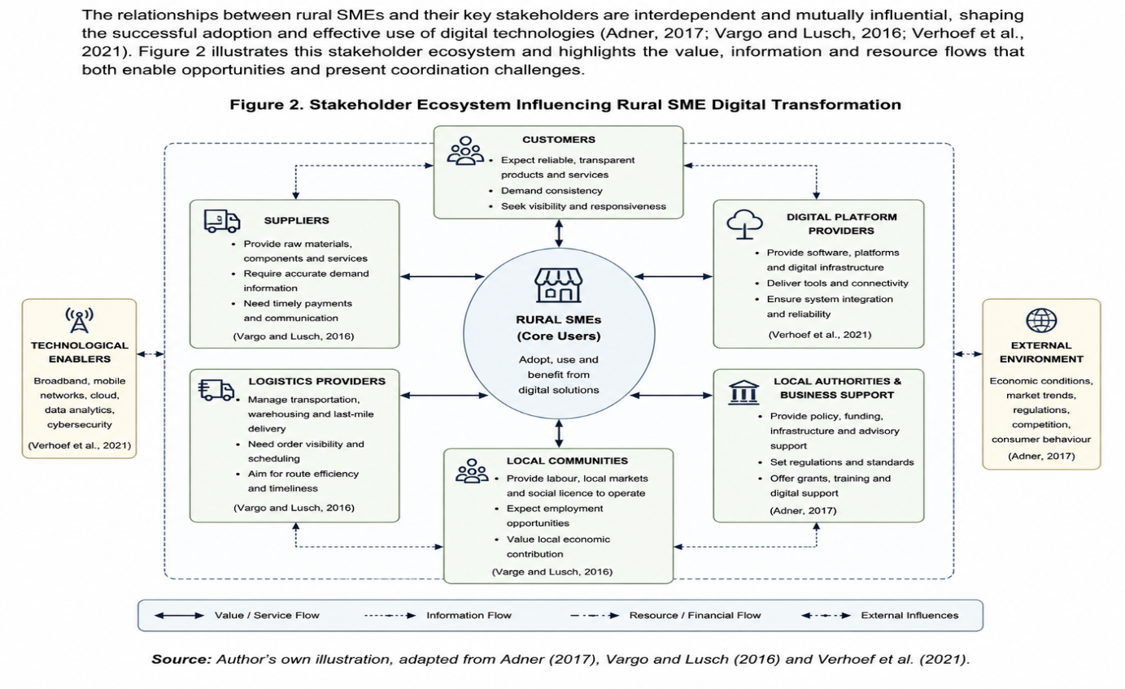
Figure 2. Stakeholder Ecosystem Influencing Rural SME Digital Transformation
3.2 Market gaps
Insights from the stakeholder analysis were synthesised to identify the principal market gap and the underlying causes of the coordination challenges (Brown, 2009; Liedtka, 2018). Customer journey mapping (Figure 3) shows that rural SMEs often rely on multiple disconnected digital platforms to manage enquiries, inventory, payments and deliveries. Although these technologies support individual business functions, limited integration creates duplicated processes, inconsistent communication and poor visibility throughout the customer journey. As a result, businesses experience operational inefficiencies while customers receive inconsistent service.
The causal analysis (Figure 4) identifies fragmented stakeholder coordination as a key driver of these challenges. Limited information sharing between interdependent actors contributes to communication failures, duplicated activities and delayed decision-making, reducing both operational performance and customer satisfaction (Meadows, 2008; Arnold and Wade, 2015). While infrastructure, digital capability and financial constraints remain important, the analysis demonstrates that these factors interact with coordination failures rather than acting independently (Adner, 2017; Vargo and Lusch, 2016). This reframes the problem from one centred solely on technology adoption to one focused on improving coordination across the rural business ecosystem.

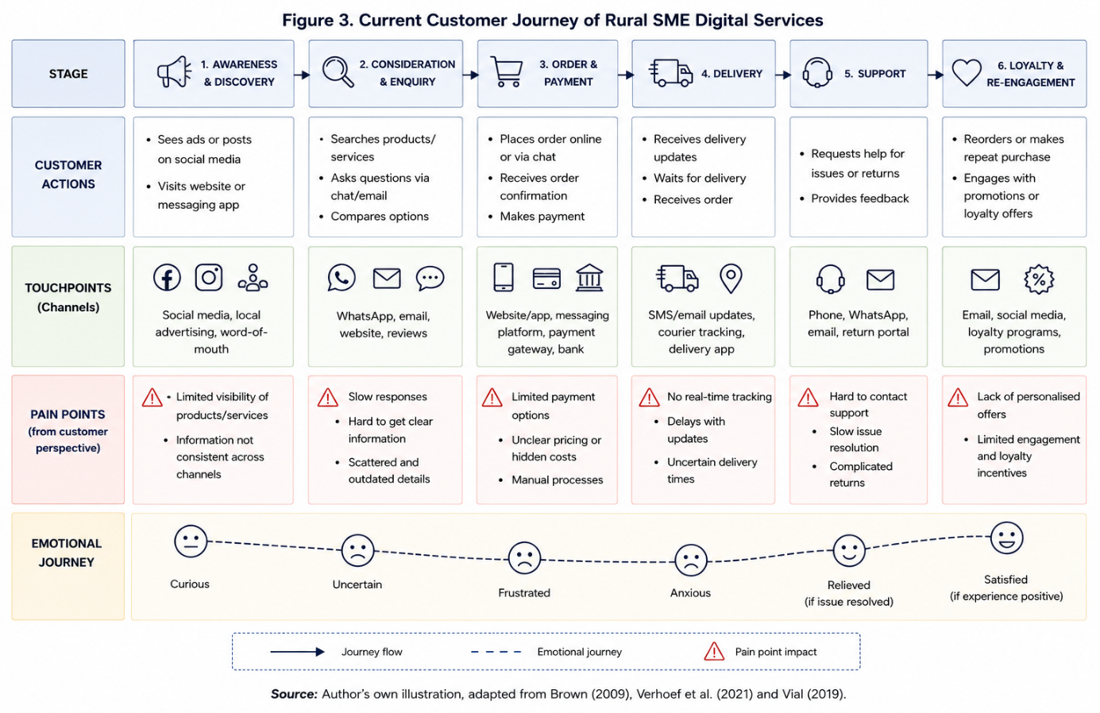
Source: Author’s own illustration, adapted from Brown (2009), Adner (2017), Vargo and Lusch (2016), Vial (2019), Liedtka (2018) and Verhoef et al. (2021).
Figure 4. Causal Analysis of Coordination Challenges Affecting Rural SMEs
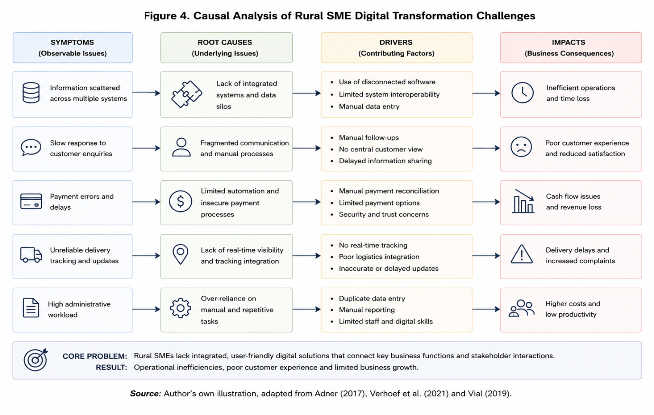
Source: Author's own illustration, adapted from Meadows (2008), Arnold and Wade (2015), Adner (2017), Vargo and Lusch (2016), and Verhoef et al. (2021).
Figure 4 demonstrates that the challenges experienced by rural SMEs are not the result of a single organisational weakness but emerge from interconnected systemic factors. While limited digital capability and disconnected digital platforms contribute to operational inefficiencies, the analysis indicates that fragmented stakeholder coordination amplifies these challenges by restricting information sharing and collaborative decision-making (Meadows, 2008; Arnold and Wade, 2015). These findings support the portfolio's central thesis that improving coordination across the stakeholder ecosystem represents a more effective innovation opportunity than focusing solely on technology adoption. Consequently, the following section evaluates alternative innovation opportunities before justifying the most appropriate solution.
3.3 Technological enablers
The Ideate stage of Design Thinking focuses on generating and evaluating alternative solutions capable of addressing the problem defined through stakeholder and causal analyses (Brown, 2009; Liedtka, 2018). Rather than selecting a predetermined solution, this stage considers multiple innovation opportunities before identifying the option that most effectively responds to user needs and the wider market context. Based on the preceding analysis, five opportunities were identified: digital marketing support, logistics optimisation, integrated payment systems, digital skills development and a stakeholder coordination ecosystem.
Digital marketing support could improve the online visibility of rural SMEs and strengthen customer engagement, while logistics optimisation may reduce delivery delays and improve supply chain efficiency. Similarly, integrated payment systems simplify financial transactions, and digital skills programmes enhance organisational capability and digital confidence (OECD, 2021). Although these opportunities address important operational challenges, they primarily focus on individual business functions rather than the fragmented interactions between stakeholders that characterise rural digital transformation. Consequently, they are unlikely to resolve the recurring communication failures, duplicated activities and information gaps identified through the customer journey and causal analyses (Adner, 2017; Verhoef et al., 2021).
The comparative evaluation presented in Table 2 indicates that a stakeholder coordination ecosystem offers the greatest potential to address user pain points while responding to an identifiable market gap. Advances in cloud computing, digital platforms, mobile technologies and data integration provide the technological enablers necessary to support such an ecosystem, enabling information sharing and collaboration across customers, suppliers, logistics providers and rural SMEs (Verhoef et al., 2021). Furthermore, improving coordination has the potential to increase operational efficiency, enhance customer experience and strengthen organisational resilience, while providing a scalable and sustainable solution applicable across different rural sectors.
Consequently, stakeholder coordination is identified as the most viable innovation opportunity because it addresses the systemic causes of fragmented digital transformation rather than isolated operational symptoms. This evidence-based evaluation provides the rationale for developing CoNexus as a digital coordination ecosystem, which is critically developed and evaluated in Task 2.
3.4 Potential for Scalability and Sustainability
The comparative evaluation presented in Table 2 demonstrates that the proposed CoNexus platform represents the most viable innovation opportunity for addressing the digital transformation challenges faced by UK rural SMEs. Unlike alternative solutions that focus on isolated issues, such as digital marketing or logistics optimisation, CoNexus adopts an ecosystem-based approach that strengthens coordination between SMEs, customers, suppliers, logistics providers and local authorities. This integrated approach addresses the underlying causes of fragmented collaboration identified in the previous sections while supporting broader digital transformation objectives.

The proposed venture also demonstrates considerable potential for scalability. As a cloud-based digital platform, CoNexus can accommodate increasing numbers of users and expand across different rural communities without requiring substantial additional physical infrastructure. The use of application programming interfaces (APIs) and interoperable digital technologies enables integration with existing business systems, supporting flexibility and future growth while reducing implementation barriers for participating SMEs (Verhoef et al., 2021). Furthermore, as stakeholder participation increases, the platform can generate network effects, whereby the value of the ecosystem grows through enhanced collaboration, information sharing and resource coordination (Adner, 2017).
From a sustainability perspective, CoNexus contributes to long-term economic, operational and collaborative resilience. Improved coordination between stakeholders has the potential to reduce operational inefficiencies, strengthen local supply chains and enhance service delivery within rural communities. In addition, continuous knowledge exchange and collaborative value creation support a more adaptive and resilient business ecosystem capable of responding to future technological and market changes (Meadows, 2008; Vargo and Lusch, 2016). Consequently, the evaluation indicates that CoNexus offers the strongest combination of innovation potential, scalability and sustainability, providing a robust foundation for the venture development presented in Task 2.

Task 2

4. Venture Development and Evaluation
The preceding analysis identified fragmented stakeholder coordination as the principal constraint affecting rural SME digital transformation and justified this as the most viable innovation opportunity. Building on these findings, this section develops and critically evaluates CoNexus, a proposed digital coordination ecosystem designed to improve information sharing, collaboration and service integration across rural SME stakeholders. Consistent with the remaining stages of Design Thinking, the concept is presented as a prototype and critically assessed against the criteria of desirability, feasibility and viability to determine its potential to address the identified coordination challenges in a sustainable and scalable manner.

4.1 Empathising with affected users (e.g., small retailers, rural consumers, delivery partners, etc.)
Understanding stakeholder experiences is essential to developing solutions that address the underlying causes of fragmented coordination within rural SME ecosystems (Brown, 2009; Liedtka, 2018). Building on the analysis undertaken in Task 1, stakeholder ecosystem analysis and customer journey mapping highlighted how fragmented communication and disconnected information flows affect multiple participants across the rural business environment.
The analysis identified rural SME owners, rural consumers, suppliers, logistics providers and local support organisations as the principal stakeholders affected by fragmented digital coordination. Although each stakeholder group has different objectives, they share a common need for reliable communication, timely information exchange and efficient collaboration. SME owners require greater operational visibility and reduced administrative burden, while rural consumers expect transparent communication, accurate order information and reliable service delivery. Suppliers and logistics providers depend on coordinated information sharing to manage inventory, fulfilment and delivery schedules, whereas local authorities and business support organisations require greater visibility to provide effective support for rural businesses

4.2 Defining a Clear Problem Statement
Building on the stakeholder analysis, the evidence indicates that the principal barrier to digital transformation among rural SMEs is fragmented stakeholder coordination rather than a lack of digital technologies (Brown, 2009; Liedtka, 2018). Ineffective communication, disconnected information sharing and limited collaboration between SMEs, customers, suppliers, logistics providers and support organisations create operational inefficiencies that constrain business performance and customer experience.
This conclusion is supported by the causal analysis presented in Figure 4, which demonstrates that these challenges are interconnected and reinforce one another across the rural business ecosystem. Rather than addressing isolated operational issues, the analysis highlights that improving stakeholder coordination offers greater potential to enhance communication, information exchange and collaborative decision-making across the ecosystem.
Based on these findings, the following problem statement was formulated:
How might we improve stakeholder coordination among rural SMEs through an affordable, scalable and accessible digital ecosystem that enhances communication, information sharing and collaborative decision-making?
This problem statement reframes the challenge from one of technology adoption to one of ecosystem coordination, ensuring that subsequent solution development addresses the systemic causes of operational inefficiencies rather than their symptoms. By focusing innovation on stakeholder needs and the integration of the wider rural business ecosystem, the following stage is directed towards solutions that are user-centred, practically feasible and capable of creating sustainable value (Brown, 2009).

4.3 Generating Innovative Solution Ideas
Building on the problem statement developed in the previous section, several digital innovation opportunities were evaluated to improve stakeholder coordination within the rural SME ecosystem (Brown, 2009; Liedtka, 2018). Rather than selecting an immediate solution, alternative concepts were assessed against their ability to address stakeholder needs, technical feasibility, scalability and long-term sustainability.
Table 2 presents a comparative evaluation of the identified innovation opportunities. Although each concept offers potential benefits, their capacity to resolve the systemic coordination challenges experienced by rural SMEs differs considerably. Solutions focused on individual operational functions, such as digital marketing or logistics, were considered less effective because they improve specific business activities without strengthening communication and collaboration across the wider stakeholder network
Table 2. Comparative Evaluation of Innovation Opportunities
Innovation Concept | Description | Strengths | Limitations | Evaluation
Digital Marketing Hub | A digital platform providing marketing support and online promotional tools for rural SMEs. | Enhances business visibility, customer engagement and online presence. | Primarily addresses marketing activities and does not improve collaboration across stakeholders. | While this concept strengthens digital marketing capabilities, it has limited potential to resolve the wider coordination challenges affecting rural SMEs (Kotler et al., 2021).
Smart Logistics Platform | A platform designed to improve delivery scheduling, route optimisation and communication with logistics providers. | Improves operational efficiency, delivery reliability and cost management. | Focuses mainly on logistics and provides limited integration with customers, suppliers and support organisations. | This concept enhances logistics performance but does not address fragmented communication across the wider business ecosystem (Christopher, 2016).
CoNexus Digital Ecosystem (Selected) | An integrated digital ecosystem connecting SMEs, customers, suppliers, logistics providers and support organisations through a shared collaboration platform. | Facilitates communication, information sharing, collaborative decision-making, scalability and long-term sustainability. | Requires stakeholder commitment, user adoption and initial investment during implementation. | CoNexus was selected because it addresses the root cause of fragmented stakeholder coordination while providing the greatest potential for scalable, user-centred and sustainable innovation, consistent with Design Thinking principles (Brown, 2009; Osterwalder and Pigneur, 2010).
Source: Author's evaluation based on Brown (2009), Christopher (2016), Kotler et al. (2021), and Osterwalder and Pigneur (2010).
Among the evaluated concepts, CoNexus emerged as the preferred solution because it directly addresses the root cause of fragmented stakeholder coordination by integrating SMEs, customers, suppliers, logistics providers and support organisations within a shared digital ecosystem. This integrated approach enables real-time communication, information sharing and collaborative decision-making while leveraging existing cloud-based technologies to minimise implementation complexity and support future scalability. Furthermore, its platform-based design creates value for multiple stakeholder groups rather than addressing isolated organisational needs.
Consequently, CoNexus was selected as the most appropriate innovation concept to address the identified challenge. The following section develops this concept into a Minimum Viable Product (MVP), demonstrating how the proposed solution could be implemented to improve stakeholder coordination and support digital transformation within rural SMEs

4.4 Proposing a Prototype or Minimum Viable Product (MVP)
Following the evaluation of alternative innovation concepts, CoNexus was developed as a Minimum Viable Product (MVP) to address the fragmented stakeholder coordination identified in the previous sections (Brown, 2009; Liedtka, 2018). The prototype demonstrates how an integrated digital ecosystem can facilitate communication, information sharing and collaborative decision-making among rural SMEs and their wider stakeholder network. Figure 5 illustrates the proposed CoNexus MVP, which integrates SMEs, customers, suppliers, logistics providers and support organisations within a single cloud-based platform.
This integrated platform approach reflects the growing importance of connected digital products and services in creating value across organisational ecosystems (Porter and Heppelmann, 2014). The prototype incorporates key functionalities, including real-time communication, shared information management, order and logistics coordination, and stakeholder collaboration tools. By consolidating these functions into one digital ecosystem, CoNexus reduces fragmented communication, improves operational visibility and enables more efficient coordination across the rural business environment.
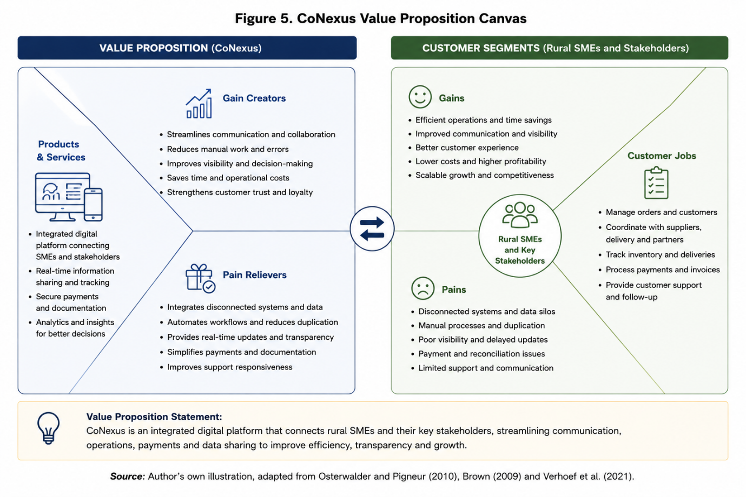
The proposed MVP was intentionally designed with simplicity and scalability in mind. Rather than developing a fully featured commercial platform at the outset, the MVP focuses on the essential functions required to validate stakeholder needs, user adoption and operational feasibility. This iterative approach enables early feedback to inform future development while reducing implementation risks and resource requirements (Ries, 2011). Furthermore, the cloud-based architecture supports scalability, allowing the platform to expand as additional SMEs and stakeholders join the ecosystem.
The CoNexus prototype demonstrates how Design Thinking principles can be translated into a practical innovation that responds directly to the defined problem statement. By focusing on user needs and ecosystem-wide collaboration, the MVP provides a practical foundation for improving stakeholder coordination and supporting sustainable digital transformation within rural SMEs. The following section explains how the prototype would be tested, evaluated and refined before wider implementation.

4.5 Explaining How the Solution Would Be Tested and Refined
Evaluating the proposed solution is essential to determine whether CoNexus effectively addresses stakeholder needs while identifying opportunities for continuous improvement (Brown, 2009; Liedtka, 2018). Rather than assuming the prototype is complete, the CoNexus MVP would be tested through pilot implementation with a representative group of rural SMEs and key stakeholders to assess its usability, functionality and overall effectiveness. User feedback would provide valuable insights into communication efficiency, ease of use and stakeholder collaboration, informing subsequent refinements before wider deployment.
Table 3 presents the evaluation of the CoNexus MVP using the Desirability–Feasibility–Viability (DFV) framework. This assessment indicates that the proposed solution demonstrates strong potential to satisfy stakeholder needs, can be implemented using existing digital technologies and offers opportunities for long-term value creation through an integrated digital ecosystem.
The effectiveness of the proposed CoNexus MVP would be assessed through an iterative testing process involving representative users and key stakeholders. In line with Design Thinking, the objective of testing is to evaluate whether the solution is desirable, technically feasible and capable of creating sustainable value while identifying opportunities for continuous improvement (Brown, 2009; Liedtka, 2018). Table 3 outlines the proposed testing strategy, success criteria and refinement actions for the CoNexus MVP.
Table 3. Testing and Refinement Strategy for the CoNexus Minimum Viable Product (MVP)
Testing Objective | Evaluation Method | Success Criteria | Refinement Actions
Validate user desirability | Pilot testing with rural SMEs, customer feedback and semi-structured interviews (Brown, 2009). | Users report improved communication, collaboration and ease of use. | Refine the user interface, simplify navigation and improve onboarding based on stakeholder feedback.
Assess technical feasibility | Functional testing, system integration testing and security assessment (Ries, 2011). | Stable platform performance, secure data exchange and successful integration across stakeholders. | Optimise platform functionality, strengthen cybersecurity measures and improve interoperability with existing digital systems.
Evaluate business viability | Monitor stakeholder adoption, platform usage and operational performance using key performance indicators (Osterwalder & Pigneur, 2010). | Increased stakeholder participation, improved coordination and evidence of operational value. | Refine the value proposition, strengthen strategic partnerships and enhance scalability for wider implementation.
Source: Author's evaluation adapted from Brown (2009), Osterwalder and Pigneur (2010), and Ries (2011)
Although the evaluation demonstrates the potential of CoNexus, further refinement would be required before full-scale implementation. Feedback gathered during pilot testing would inform improvements to platform usability, system integration, user onboarding and cybersecurity measures, ensuring that the solution continues to align with stakeholder requirements while supporting sustainable digital transformation. This iterative approach reflects the principles of Design Thinking, where continuous testing and refinement contribute to the development of innovative, user-centred solutions (Brown, 2009; Ries, 2011). Furthermore, continuous refinement of the platform and its value proposition supports the development of dynamic capabilities necessary for long-term competitive advantage (Teece, 2018).

5. Conclusion
This portfolio critically examined the proposition that the limited digital transformation of UK rural SMEs is influenced not only by technological constraints but also by fragmented stakeholder coordination. Through the application of Design Thinking and Systems Thinking, the investigation moved beyond conventional explanations centred on infrastructure, digital capability and financial resources to identify coordination failures as a significant barrier to sustainable digital transformation. The stakeholder analysis, customer journey mapping and causal analysis demonstrated that ineffective information sharing and fragmented collaboration reduce operational efficiency and customer experience across the rural business ecosystem.
The comparative evaluation of innovation opportunities identified stakeholder coordination as the most viable area for new venture creation, providing the foundation for the development of CoNexus as a digital coordination ecosystem. Rather than presenting CoNexus as a definitive solution, the portfolio critically evaluated its potential through the Desirability–Feasibility–Viability framework, recognising that successful implementation depends upon stakeholder adoption, organisational readiness and iterative refinement. This balanced evaluation highlights both the opportunities and limitations associated with the proposed venture.
Overall, the portfolio demonstrates that sustainable rural digital transformation requires innovation that strengthens relationships between interconnected stakeholders, creating shared value for businesses, customers and rural communities (Porter and Kramer, 2011). Consequently, integrating Design Thinking with Systems Thinking provided an appropriate methodological foundation for investigating complex coordination challenges and developing an evidence-based innovation concept capable of supporting future rural SME development.

References
Adner, R. (2017) ‘Ecosystem as structure: An actionable construct for strategy’, Journal of Management, 43(1), pp. 39–58.
Arnold, R.D. and Wade, J.P. (2015) ‘A definition of systems thinking: A systems approach’, Procedia Computer Science, 44, pp. 669–678.
Brown, T. (2009) Change by Design: How Design Thinking Creates New Alternatives for Business and Society. New York: Harper Business.
Johansson‐Sköldberg, U., Woodilla, J. and Çetinkaya, M. (2013) ‘Design thinking: Past, present and possible futures’, Creativity and Innovation Management, 22(2), pp. 121–146.
Lewrick, M., Link, P. and Leifer, L. (2020) The Design Thinking Toolbox: A Guide to Mastering the Most Popular and Valuable Innovation Methods. Hoboken, NJ: John Wiley & Sons.
Liedtka, J. (2018) ‘Why design thinking works’, Harvard Business Review, 96(5), pp. 72–79.
Meadows, D.H. (2008) Thinking in Systems: A Primer. White River Junction, VT: Chelsea Green Publishing.
OECD (2021) The Digital Transformation of SMEs. Paris: OECD Publishing.
Osterwalder, A. and Pigneur, Y. (2010) Business Model Generation: A Handbook for Visionaries, Game Changers, and Challengers. Hoboken, NJ: John Wiley & Sons.
Porter, M.E. and Heppelmann, J.E. (2014) ‘How smart, connected products are transforming competition’, Harvard Business Review, 92(11), pp. 64–88.
Ries, E. (2011) The Lean Startup: How Today's Entrepreneurs Use Continuous Innovation to Create Radically Successful Businesses. New York: Crown Business.
Vargo, S.L. and Lusch, R.F. (2016) ‘Institutions and axioms: An extension and update of service-dominant logic’, Journal of the Academy of Marketing Science, 44(1), pp. 5–23.
Verhoef, P.C., Broekhuizen, T., Bart, Y., Bhattacharya, A., Dong, J.Q., Fabian, N. and Haenlein, M. (2021) ‘Digital transformation: A multidisciplinary reflection and research agenda’, Journal of Business Research, 122, pp. 889–901.
Vial, G. (2019) ‘Understanding digital transformation: A review and a research agenda’, The Journal of Strategic Information Systems, 28(2), pp. 118–144.
Westerman, G., Bonnet, D. and McAfee, A. (2014) Leading Digital: Turning Technology into Business Transformation. Boston, MA: Harvard Business Review Press.
Bharadwaj, A., El Sawy, O.A., Pavlou, P.A. and Venkatraman, N. (2013) ‘Digital business strategy: Toward a next generation of insights’, MIS Quarterly, 37(2), pp. 471–482.
Hevner, A.R., March, S.T., Park, J. and Ram, S. (2004) ‘Design science in information systems research’, MIS Quarterly, 28(1), pp. 75–105.
Norman, D.A. (2013) The Design of Everyday Things. Revised and Expanded edn. New York: Basic Books.
Porter, M.E. and Kramer, M.R. (2011) ‘Creating shared value’, Harvard Business Review, 89(1–2), pp. 62–77.
Teece, D.J. (2018) ‘Business models and dynamic capabilities’, Long Range Planning, 51(1), pp. 40–49.

