

Student name: Maria Miguel
Student ID: 2232112
Module name: Independent Project
Module code: BMHP6020
Supervisor’s name: Konstantina Mari

I confirm that I have not used any AI tools in the research and creation of this assignment. I confirm that I have not presented any AI-generated materials as my work. I can confirm I have copies of my drafts, notes, and other resources I used, which I may be asked to provide in evidence.

  Source: Cacioppo et al. (2015) |  | Impact of loneliness on older Adults living in Residential care homes in the UK  Aim  The main aim of this research is to comprehend the scope and effect of loneliness on elderly adults living in residential care homes in the UK. This involves examining the emotional, psychological, and physical effects of loneliness and linking approaches to alleviate its impacts.  Objective  - To examine the Incidence and Aspects Causing Loneliness for elderly People living in Residential Care homes.  - To evaluate the Psychological and Emotional Effect of Loneliness for elderly People living in Residential Care homes.  - To assess the Physical Health Effects of Loneliness for elderly People living in Residential Care Homes.  - To Develop Suggestions for Appropriate Interventions for elderly People living in Residential Care Homes |  | 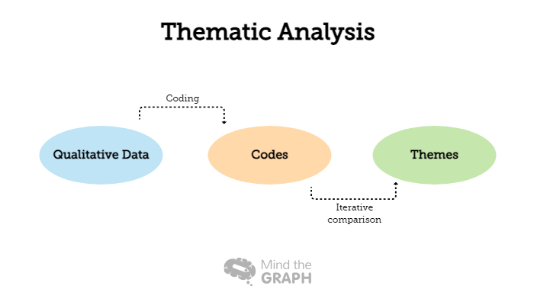  Source: Gardiner et al. (2020)
Methodology and Methods  - This is a quantitative research approach (Smith, 2020).  - Interpretivism will be used as the philosophy of the research, as it highlights understanding social phenomena from the viewpoint of those facing it, making it appropriate for inspecting the effect of loneliness on elder adults in residential care homes in the UK (Bryman, 2016).  - Ten peer-reviewed empirical papers will be chosen on the topic after following the PRISMA analysis.    Source: Bryman (2016). |  |  |  | Data Analysis  - Descriptive analysis will be used.  - Descriptive analysis is vital in research for the summary and understanding of the elementary features of a dataset and offers a basis for more advanced statistical approaches.  - I will analyse the ten empirical papers initially by looking at the sample size, demographic characteristics of the participants, setting, methodology, conclusions and recommendations.  - Based on this analysis, I will find out patterns that appear often and I will summarise the information in relevant themes.  - I also try to find out any possible contradictions to report and discuss.  Ethical Considerations  - Data privacy and confidentiality, as the researcher will comply with the UK's Data Protection Act 2018.  - Respect for privacy, particularly when names of individuals related to their health issues are involved, requires the researcher to keep all information anonymous, in accordance with GDPR (Beaver and Kerridge, 2018).
Data Collection Method

- Secondary data collection will be used.
- This strategy is important since it offers access to complete, large-scale information that primary research could not realise in the same timeframe (Creswell and Poth, 2018).


Source: Creswell and Poth (2018).

Inclusion Criteria:
• Articles concentrating on older adults aged 65 and above living in residential care homes in the United Kingdom.
• Research published in peer-reviewed journals from 2016 to the present.
• Studies that exclusively address the emotional effect of loneliness on older adults.
• Qualitative or quantitative study offering empirical information on isolation in residential locations.

Exclusion Criteria:
• Studies concentrating on younger people or those not living in residential care locations.
• Articles not issued in the English language.
• Research that does not particularly measure isolation or linked to emotional results.
• View pieces, editorials, or non-peer-reviewed sources.
• Research that is conducted before 2016.

References

Beaver, M., & Kerridge, I. (2018). The Ethical Management of Data. London: Routledge.
Bryman, A. (2016). Social Research Methods. 5th ed. Oxford University Press.
Creswell, J. W., & Poth, C. N. (2018). Qualitative Inquiry and Research Design: Choosing Among Five Approaches (4th ed.). SAGE Publications.
Smith, J. (2020). Understanding Loneliness: A Comprehensive Analysis. London: Health Press.

