Ovidiu Carp
2222611

11/06/2023
Effective Teamworking and Communication

BMSW4002_CARD
1000 words - actual 1133

Contents Page

Contents Page 1
Terms of Reference 2
Procedure 3
Introduction 4
Main Findings 5
Effective Communication 5
Berlo’s SMCR Model of Communication 6
Shannon and Weaver Model of Communication 7
Schramm's model of communication 8
Workplace communication issue example 9
Conclusions 10
Reference List 11

Terms of Reference

This report has two main goals. The first is to help students learn about ways to work well in teams. The second goal is to help students understand the many different communication skills they need to be successful at their jobs. The report was required by James Squire from University of Wales Trinity Saint David and the submission deadline is June 16, 2023.

Procedure

This report was compiled through a multi-step process that involved a combination of Moodle lectures, literature review, analysis of communication models, and reflective observation of real-life workplace communication.

Introduction

Every workplace's ability to function successfully depends on effective communication. It serves as the cornerstone of a stable work environment by promoting mutual respect, trust, and productivity. Clear and efficient communication helps prevent misunderstandings, boosts productivity, and upholds a positive work atmosphere.
At its foundation, workplace communication is a tool that makes sure all staff members are aware of the objectives, plans, and standards. Also, it helps to raise motivation, work satisfaction, and staff engagement. Without clear communication, important details could be ignored or misunderstood, which could result in missed deadlines, disagreements, and other problems at work.
In his famous book, "The 7 Habits of Highly Effective People", Stephen Covey tells us that it’s important to listen and truly get what someone is saying before we try to make them understand us, and he sums it up as, "Seek first to understand, then to be understood" (Covey, 1989).
This report aims to examine deeper into the mechanics of effective communication in the workplace. The following areas will be addressed:
- The Essence of Effective Communication
- Critical Examination of Communication Models: Berlo’s SMCR, Shannon-Weaver, and Schramm
- Real-world workplace Application and Example

Main Findings

Effective Communication

In today's diverse business world, communication is often regarded as the crucial foundation. Despite the fact that managers allocate the majority of their time to communication activities, such as transmitting and receiving data, it's a mistake to presume that all these interactions result in meaningful communication (Dunn, 2002). People often mistake the act of sending a memo, letter, fax, or email as successful communication. However, actual communication only transpires when the conveyed information and comprehension are effectively shared between the sender and the intended recipient.
Organizations prioritize effective communication as one of their most vital objectives (Spillan, Mino, & Rowles, 2002). Recent studies indicate that managers who allocate significant time to staffing, motivating, and reinforcing tasks tend to be more effective (Luthans, Welsh, & Taylor, 1988). On the other hand, when there is an internal communication gap within an organization, it often leads to an interruption in the flow of information from the sender to the receiver.
Effective communication is a fundamental component of success in the workplace. It contributes to fostering productive teams, promoting mutual understanding, and ensuring that organizational objectives are achieved. This report examines into what constitutes effective communication in the workplace and critically appraises three communication models: Berlo’s SMCR Model, Shannon-Weaver Model, and Schramm’s Model of Communication.

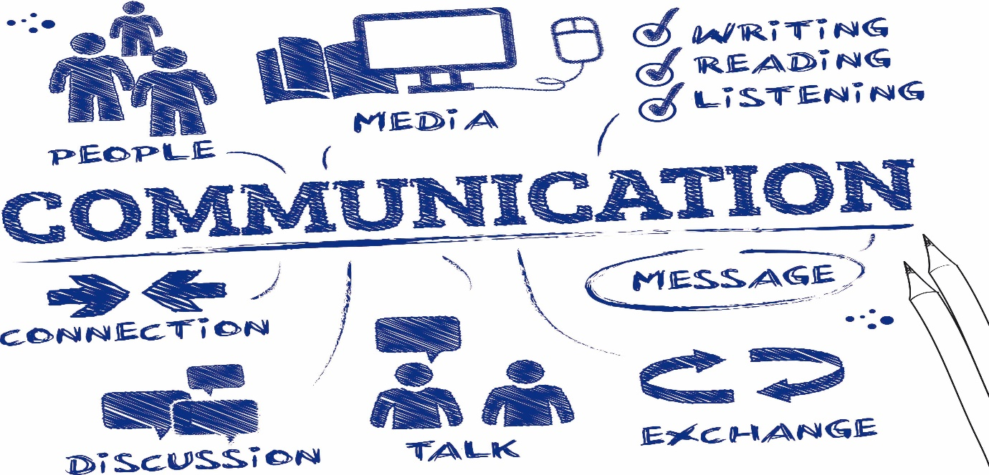

Berlo’s SMCR Model of Communication

Berlo’s model stresses the importance of the Source, Message, Channel, and Receiver. For communication to be effective, the source must be credible, the message must be relevant and clear, the channel must be appropriate, and the receiver must be attentive. However, the model does not account for the feedback mechanism, which is crucial in ensuring the effectiveness of communication (Mehrabian, 2017).

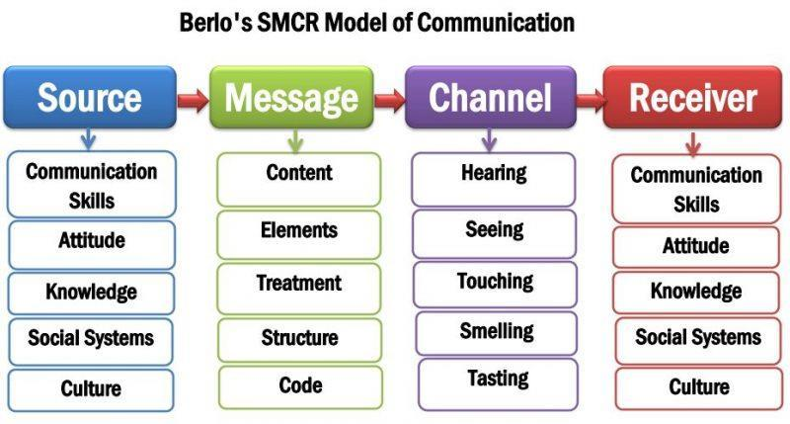

Shannon and Weaver Model of Communication

With its advantages in simplicity, clarity, and quantitative approach, the Shannon and Weaver Model of Communication makes it simpler to identify and fix noise or faults in a communication system. The drawbacks of this approach, however, are its linear, one-way communication perspective, which ignores the complexity of interpersonal interactions, as well as its disregard for feedback and group dynamics (Awan, 2023).



Schramm's model of communication

According to Schramm's approach, communication occurs through a process including an encoder and a decoder. This model, most critically, considers how individuals understand the message. According to Schramm, an individual's history, experience, and knowledge might affect their ability to understand. Moreover, Schramm thought that a medium is used to transfer the signals. The decoder will also be able to provide feedback regarding the message to show that it has been received. He maintained that without input from the recipient, communication is insufficient. Encoding and decoding are essential for effective communication, according to Schramm's approach. Any communication that does not involve decoding or feedback is not complete or effective (Wrench, Punyanunt-Carter and Thweatt, 2020).

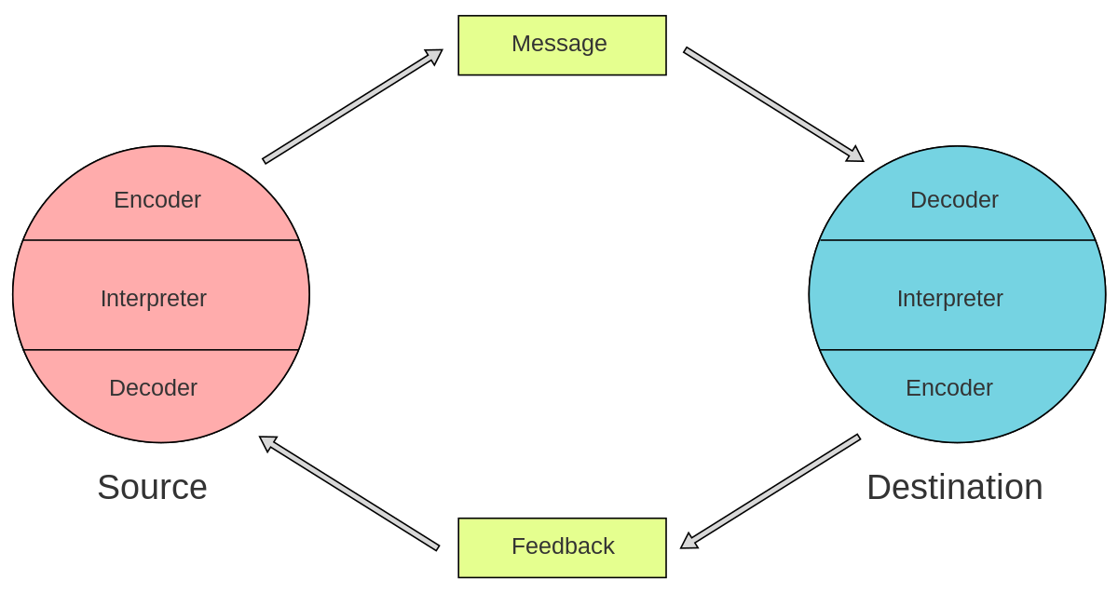

Workplace communication issue example

In my time at a large corporation, I encountered a communication issue regarding my work hours. My schedule deviated from the conventional start time, as I commenced work an hour or two later. Initially, my manager gently brought this up on several occasions, urging me to align my schedule with the rest of the team. However, his amiable approach did not communicate the gravity of the issue effectively, causing me to underestimate its importance.

A turning point occurred when my manager changed his communication style, adopting a firmer tone and attitude. This shift conveyed the seriousness of the matter and led me to realize that my unconventional schedule might be impacting the team and the workflow negatively. Consequently, I adjusted my schedule to synchronize with the team’s standard hours.

From this experience, I extracted valuable insights. Firstly, as an employee, I learned the importance of being receptive and adaptive to feedback, regardless of its delivery style. Understanding that feedback is aimed at growth and alignment with organizational objectives is crucial. Secondly, I understood the significance of communication styles. A change in tone and attitude can sometimes be a necessary catalyst for conveying urgency and importance, effectively instigating change where gentler communication may not have succeeded. This experience also highlighted the importance of teamwork and how adapting personal preferences can contribute to a harmonious and efficient work environment.

Conclusions

Communication is paramount to any workplace. Not only does it assist in achieving organizational goals, but it also fosters healthy relationships between team members. As explored in this report, the models by Berlo, Shannon-Weaver, and Schramm each contribute to our understanding of effective communication by emphasizing key components like message clarity, appropriate channels, and the necessity for feedback.

As we continue to navigate the complex landscape of workplace communication, it becomes more apparent that effective communication is more of an art than a mere skill. It is an art that can be refined through practice and adaptation to specific contexts.

Moving forward, organizations should focus on enhancing communication skills through training and development programs, creating efficient feedback channels, and fostering a communication-friendly environment. As Deborah Tannen notes, “to overcome the ubiquitous human tendency for miscommunication, we need more than good will: We need awareness of how others interpret us” (Tannen, 1990).

Reference List

Awan, S. (n.d.). SU LMS. [online] lms.su.edu.pk. Available at: https://lms.su.edu.pk/lesson/2492/shannon-and-weaver-model-of-communication-components-explanation [Accessed 11 Jun. 2023].
Communication Theory (2014). Shannon and Weaver model of communication. [online] Communication Theory. Available at: https://www.communicationtheory.org/shannon-and-weaver-model-of-communication/ [Accessed 15 Jun. 2023].
Covey, S.R. (1989). The 7 habits of highly effective people: powerful lessons in personal change. New York: Fireside Press.
Dunn, J.C., Lewandowsky, S. and Kirsner, K. (2002). Dynamics of communication in emergency management. Applied Cognitive Psychology, [online] 16(6), p.719. Available at: https://www.academia.edu/13403601/Dynamics_of_communication_in_emergency_management [Accessed 11 Jun. 2023].
Luthans, F., Welsh, D.H.B. and Taylor, L.A. (1988). A Descriptive Model of Managerial Effectiveness. Group & Organization Studies, [online] 13(2), pp.148–162. doi: https://doi.org/10.1177/105960118801300203.
Malkan, K. (2022). Schramm’s Model of Communication Example | Uses and More. [online] Cannibals Media. Available at: https://cannibals.digital/schramms-model-of-communication-example/ [Accessed 15 Jun. 2023].
Mehrabian, A. (2017). Nonverbal communication. London; New York, N.Y.: Routledge.
Pinto, J.P. (2023). BERLO’S COMMUNICATION MODEL. [online] issuu. Available at: https://issuu.com/paposhit/docs/purposivecommunication-module2-bshm-1f/s/18404062 [Accessed 15 Jun. 2023].
Spillan, J. E., Mino, M. and Rowles, M. S. (2002). Sharing Organizational Messages through Effective Lateral communication. Qualitative Research Reports in Communication, pp.3(4), 96–104.
Tannen, D. (1990). You just don’t understand: women and men in conversation. New York: William Morrow.
Wrench, J.S., Punyanunt-Carter, N.M. and Thweatt, K.S. (2020). 2.4: Models of Interpersonal Communication. [online] Social Sci LibreTexts. Available at: https://socialsci.libretexts.org/Bookshelves/Communication/Interpersonal_Communication/Interpersonal_Communication_-_A_Mindful_Approach_to_Relationships_(Wrench_et_al.)/02%3A_Overview_of_Interpersonal_Communication/2.04%3A_Models_of_Interpersonal_Communication [Accessed 11 Jun. 2023].

