Sustainable Living: A Deep Green Critical Analysis

Sustainable living is an extremely broad topic to explore, while this assignment will focus on two approaches to sustainable living in two separate countries, it worth noting that the theory used to critique these approaches can be applied to a variety of communities globally. Using Arne Naess theory of ecology, this assignment will explore and critique two approaches to sustainable living. The first will be examples or permaculture as general practice globally with an example In Portugal, this will then be followed by an example of an eco-village in Ireland. Before giving some context to permaculture and eco-villages here is brief overview of ecology. Ecology can be classified as a theory, but it is much more than that. Naess (1989, p. 4) believed philosophy was the way forward for society and using philosophy as a foundation Naess (1989, p. 4) coined ‘Ecophilosophy’ as a theory, movement, and solution. Naess’s theory can take on many names such a deep green, ecosphy, ecology etc, and can be interpreted in many ways. At the core of Naess ideology is balance, balance between humans and nature and balance within society in areas such as ‘anti-ecological, political and social structure’ Naess (1989, p. 4).
Firstly, according to Rhodes (2015) permaculture is built on three main principles – ‘earth care, people care and fair share’. The first aims to ‘reconnect humans with nature’, the second aims to promote a lifestyle ‘in which humans exert a profound impact on the planet’, and the last reinforces the notion that ‘each of us should take no more than what we need’. To be put simply, many permaculture practitioners see humans and the planet as elements of the same cycle, the planet first provides humans with resources, and humans use these resources in a eco-friendly manner through sustainable methods and the cycle continues. This assignment will have a Portuguese example of permaculture for a focus, it should be noted that choice does not reflect the geographical impact / reach of the permaculture practice, it is a practice demonstrated globally as seen from the definition from Rhodes (2015) which was done in reference to a international conference on permaculture held in London. In a valley in Portugal a permaculture project has been providing ‘off grid permaculture education and research’ for anyone interested (Terra Alta, 2019). The purpose of this project is not to establish a permaculture-based community in Portugal but to promote permaculture to the wider society through education and experience, with the hope that those who have left will go on to establish this practice into their everyday lives and possibly even into communities in their hometowns. Although they do not go into detail about the course breakdown, they do provide the topic names that are taught. For example, ‘zero waste strategies’, ‘natural building’, and ‘plant care and seed saving’ (Terra Alta, 2019). These are just a few of the many topics they state to teach. Upon first glance, their general ideology aligns perfectly with ecology-based methods and lifestyles. Upon further investigation, from an ecological perspective their authenticity can be questioned. Firstly, their project is promoted through an online website, online magazine, Facebook account, Instagram account, and TikTok account, this is interesting as their main message displayed is that they are a ‘off the grid’ environment. While being ‘off the gird’ can be interpreted in many ways, commonly one would assume that would include reduced / minimal access to the internet. This is of course on the severe end of eco-friendly living, it would be inappropriate to dismiss all the pros due to internet usage considering they also have not stated how much internet is used. The entire course costs 890 euros which on the not so severe end of deep green ideology can be argued to be excessive, on the opposite end of the argument it is worth noting they have stated they only use recycled materials to build tents, tools, and furniture, and as this is a course not permanent residence they are not using materials and resources throughout the entire year, only during the periods of the course, again an opposing argument can be made that if they are not living a permaculture lifestyle or at least a somewhat sustainable lifestyle outside of course periods then this entire project could be interpreted as contradictory.
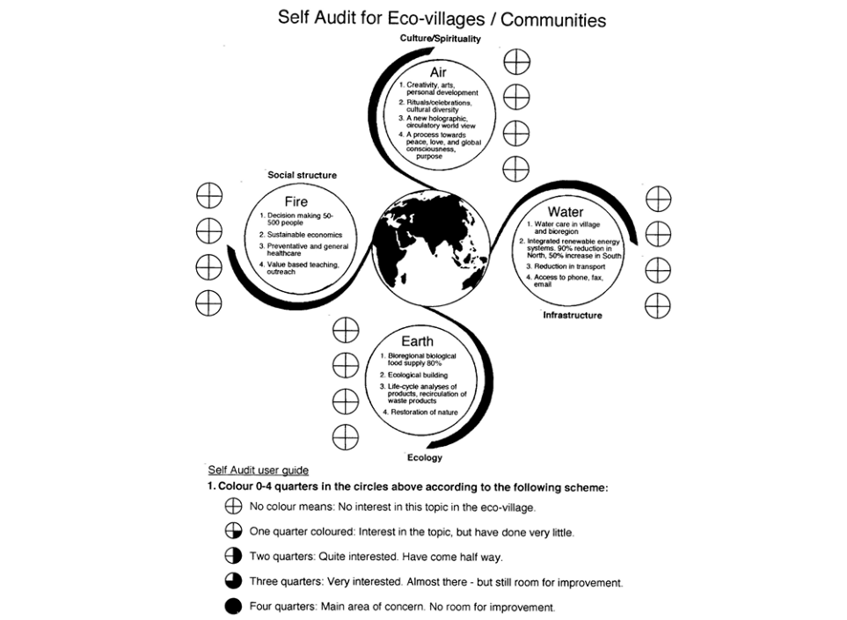
Just as permaculture is a methodology that can be applied to various communities globally, eco-villages hold the same universal standing. It is important to note that this assignment will be focusing on an eco-village in Ireland, but the concept, understanding, and definitions of eco-villages can vary from community to community, and country to country. Taken from an article exploring various definitions of eco-villages here is a self-audit user guide many communities, or even local authorities might use to build an eco-village (Jackson, 1998, p. 4. Fig. 1). According to (Cloughjordan Ecovillage, 2025) Cloughjordan Ecovillage project began in 1999. Their main ideology of course was sustainable living, but they focused on three key elements, eco-friendly housing, community facilities, and renewable energy. Although they did not reference planning to the self-audit guide above (Jackson, 1998, p. 4. Fig 1), these three elements are factored into the air, water, and fire sections. According to (Cloughjordan Ecovillage, 2025) they’ve maintained these elements by following their own guidelines such as – using sustainable materials for housing with high insulation and solar panels, promoting the use of shared facilities and reducing the need for private means/amenities, this is also good community culture, lastly their energy source is renewable powered by biomass and solar energy. This project while sustainable in the surface has faced some challenges. Fox (2018) wrote an article on how the financial crisis in the UK in 2008 affected Cloughjordan economically, after interviewing one of the founders of Cloughjordan ecovillage, Fox (2018) wrote that the project lost 50% of its staff and its deposits / endorsements, the company that was funding the project had ‘gone bust’ during the recession. Deep green ideology is a spectrum of personalised comfortability, a critical analysis of this project will vary depending on how extreme one’s view of eco friendly living is. It can be argued that relying on a third party organisation/company to fund an entire project is not sustainable, the economy is unpredictable and investors will commonly focus on the importance of profit gained from a project over the project itself and those it affects. Furthermore, Fox (2018) had stated that the community had to resort to using electricity mains in conjunction with the solar panels temporarily due to the unforeseen circumstances regarding the investors pulling funding. Again, on the severe end of deep green ideology it can be argued that investment was the problem, true sustainability should rely on the resources provided by the land of chosen residence, in conjunction with eco-friendly methodology, and honed environmental skills sets. Of course, this community and the project founders are not at fault for the financial set back, from a ecology perspective it would’ve probably been wiser to design a eco-village that was built on the foundation of sustainable living with reduced/minimal need for financial assistance or the need for financial aid.
Both the permaculture methodology in Portugal and the implantation of an eco-village Ireland have shown to have many benefits based on the evidence. In Portugal, they focused on living off necessities only, making sure not to overstep into a category of deprivation, some could argue what level of necessity is important but on Maslow’s Hierarchy of needs under physiological needs the first and most basic of needs are ‘breathing, food, water, shelter, clothing, sleep’ (Simply Psychology, 2024) all of these needs were met. Since they do not live at the location permanently, they are able to continuously reuse materials for a much longer period of time, the course they are offering provides skills to spread awareness and help establish communities globally. As mentioned earlier permaculture is a method of living not limited to Portugal, with that in mind it can be argued that this particular example may lose effectiveness if applied to another part of Portugal or other rural areas globally. For longevity and sustainability, the established community would need access to local resources that were reusable but also not scarce such as specific types of trees for building, climate would also need to be factored in if the plan was to have an efficient agricultural system of living. On the extreme end of deep green ideology, it can be argued that while the skills from this example are transferable in some areas of day to day living, this specific example is to narrow to be applied globally or even nationally, because of that the positive impact it could’ve had on the planet is to limited to be considered the answer/solution sustainable living. Looking at the eco-village in Ireland, it is clear they took a closer step towards urban living through heating systems and solar panels, though they did emphasise that all energy used is renewable and monitored. They focused on building highly insulted homes with eco-friendly materials to reduce the amount of heating needed, the majority of the fruit and vegetables grown were fruit and vegetables that could be stored long term and grow throughout the year, the community only relied on necessity while just like the course in Portugal still meeting Maslow’s Hierarchy of needs basic elements. On surface everything could not have gone any more perfect, it can be argued that they failed at the most basic element – a community sustainably living without financial dependence on the government or investors. As stated in Fox (2018) article due to their investors no longer being able to support the project the community ended up temporally using electricity mains until a more sustainable method could be found. From a extreme deep green viewpoint, a sustainable community should be able to support themselves financially, that could be through agriculture means or other environmentally friendly means, relying on investors or economic support defeats the entire purpose independent sustainable living. This of course is an extreme view point, this was a model eco-village installed and financially held up by investors and the local council, though Fox (2018) stated the village was able to remain active, this financial set back has resulted in the community being stunted in terms of population growth, geographical growth, and ideology.
After reviewing facts about both examples, it is fair to argue that neither one is more effective than the other. Firstly, critically analysing a sustainable approach to living will vary in accordance with your position on the spectrum of deep green ideology. This assignment has chosen to use deep green theory to explore these approaches but has remained unbiased, as well as remaining unbiased this assignment has not taken a firm position on where on the spectrum of environmentally friendly living is best to remain. The purpose of this assignment was to explore both approaches in weakness and strength. A noticeable factor shared between both approaches was a lack of flexibility. In the eco-village Ireland they lacked the flexibility within the planning and contingencies of what would happen should they not be able to rely on the investors and what would be the best sustainable way moving forward should that happen. In Portugal while permaculture was effective, again it lacked the flexibility needed to be applied on a national level or even in other countries. Adapting a purely nature based lifestyle nationally or globally may be considered idealistic, however society has come to far in regards to urban living and techno-centric living to adopt deep green methodology that cannot be adapted and dissected to meet modern day living sustainably. There is no perfect answer, but a system that can closely meet the needs of urban living, without economic investment, and remain eco-friendly while having gaps for change to meet the needs of various communities is step in the right direction to an ecology utopia.
Reference List:
Cloughjordan Ecovillage (2025) Building Sustainable Community. Available at: https://www.thevillage.ie/about-us/our-story/ (Accessed: 05 February 2025).
Fox, K. (2018) ‘Paradise lost? What Happened to Ireland’s Model Eco-Village’, The Guardian, 10 August. Available at: https://www.theguardian.com/world/2018/aug/10/paradise-lost-what-happened-to-irelands-model-eco-village (Accessed: 05 February 2025).
Jackson. H. (1998) ‘What is an Eco Village’, Gaia Trust Education Seminar, 204.
Naess, A. (1989) Ecology, Community, and Lifestyle: Outline of an Ecosphy. Cambridge: Cambridge University Press.
Rhodes, C. J. (2015) ‘Permaculture: Regenerative – not merely sustainable’, Science Progress, 98(4), pp. 403-412. Available at: https://doi.org/10.3184/003685015X14467291596242 (Accessed: 04 February 2025).
Simply Psychology (2024) Maslow’s Hierarchy of Needs. Available at: https://www.simplypsychology.org/maslow.html (Accessed: 05 February 2025).
Terra Alta (2019) Off the Grid Permaculture Courses – Europe. Available at: https://www.terralta.org/permaculture-courses (Accessed: 04 February 2025).

Notice of AI:
I confirm that I have not used any AI tools in the research and creation of this assignment. I confirm that I have not presented any AI generated materials as my own work. I confirm I have copies of my drafts, notes, and other resources I used, which I may be asked to provide in evidence.

