Safety Management & Legislation
ACDA 6022
By John Gallacher

12/12/2025

Declaration

The work of this report completed under the supervision of Safety Services Organisation who supported this module as part of the University of Wales Trinity Saint David. I declare this that this report is the product of my own work and is not being submitted for any other degree etc.

Signature:
J.Gallacher (Signed electronically)

Acknowledgement

I would like to thank Safety Services Organisation for supporting this module and providing the necessary information, resources and experience to enhance the module and allow for this assignment to be completed.

Contents

1. Introduction. 1
2. Background 3
2.1 Personnel 3
2.2 What is an ESH? 4
2.3Vulnerable Building Distance 6
2.4 Inhabited Building Distance 6
2.5 Public Traffic Route Distance 8
2.6 Hazard Types 9
2.7 Compatibility Groups 11
3. Safeguarding Map 14
3.1 Safeguarding Calculations 15
3.2 UN Safeguard Map 15
4. Storage Potential 18
5. Explosive License 18
6. Options 19
7. Assessment and Recommendation 21
8.Conclusion 22
9. Appendices 23
10 References 33

Tables

Table 1- Site Responsibility Table 4
Table 2- Where and who Risk Table 4
Table 3- Hazard Classification [10] [11] 11
Table 4- Compatibility Group Descriptions [11] 13
Table 5- QD Comparison Table 17
Table 6- Revised QD table removing HD 1.1 21

Figures
Figure 1- ESH Planning Application Area [1] 1
Figure 2- Earth Covered Magazine housing Fire Division 1.4 [6] 5
Figure 3- Aluminium Glazing with wooden beams [9] 7
Figure 4- Swansea Overview, Marinas, housing etc 9
Figure 5- IATG Compatibility Group Table 14
Figure 6- UN Safeguard mapped on google earth 16
Figure 7- UN Safeguard Values 16
Figure 8- UN Safeguard Explosives License Limit 19
Figure 9- Directional Blast Effects if ESH directed towards the Water line 20

Equations
Equation 1- Range Calculation 6
Equation 2- Gurney Equation 21

Abstract

This report examines the planning, safety, and regulatory considerations associated with a proposal to construct a new explosive storage facility in the City and County of Swansea. The assessment focuses on the quantities and hazard divisions of explosives to be stored, the stated safety distances provided by the applicant, and the potential impact on nearby residential, commercial, and maritime environments. Although the applicant has supplied indicative safety distances, the analysis identifies that local authorities cannot verify these without specialist Ordnance Munitions and Explosives (OME) expertise and must therefore rely on independent regulatory standards, including the Explosives Regulations 2014, the Planning (Hazardous Substances) Regulations 2015, and wider emergency planning duties under the Civil Contingencies Act 2004. The report sets out the categories of personnel responsible for the safe operation, regulation, and emergency management of the site, and identifies those who may be affected by its establishment, including marina users and nearby residents. An appendix provides a structured set of safety and governance questions for the council to raise with the applicant to ensure that risk reduction, regulatory compliance, and transparent public communication are fully addressed. Overall, the report demonstrates the importance of multi-agency involvement, independent technical assurance, and clear risk management processes when considering planning applications involving explosives storage.

- Introduction

The City and County of Swansea Council has received a planning application for the construction of five Explosive Store Houses (ESH) to accommodate a range of ammunition hazard divisions at a site adjacent to a coastal and marina area (Figure 1) the red circle and black crosshair detail the approximate area in which the ESH will develop once the application is accepted. Due to the nature and sensitivity of the materials proposed for storage, this development is considered to present a potentially high level of risk and therefore requires careful and structured technical review. Consideration must be given to issues of public safety, environmental impact, and compliance with relevant national and international explosives safety standards.
The International Ammunition Technical Guidelines (IATG) are utilised throughout this report, as they provide established technical guidance, international recognition, and a public-safety-focused methodology appropriate for the assessment of ammunition storage and explosive safety risks in a civilian planning context.

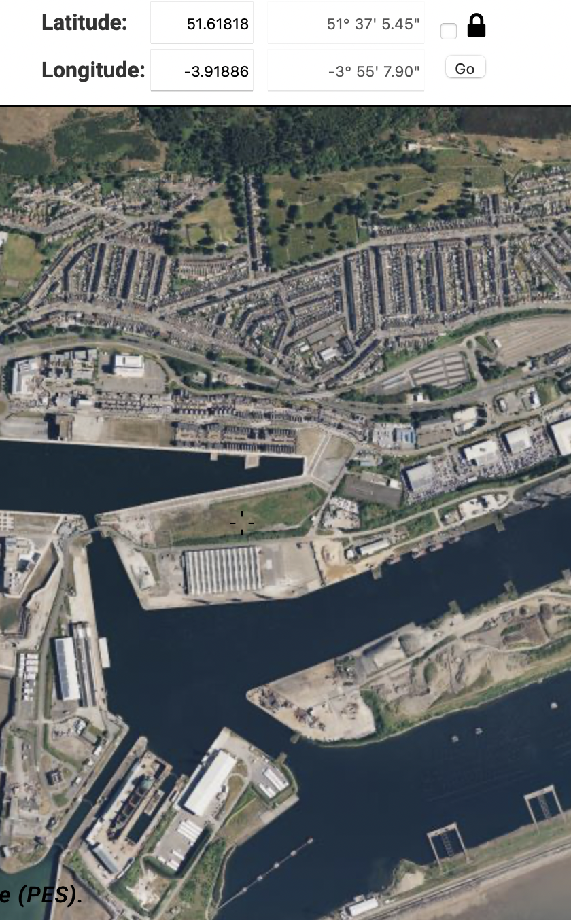
Figure 1- ESH Planning Application Area [1]

The Council does not currently employ Ordnance, Munitions and Explosives (OME) specialists and is therefore unable to independently verify the safety distances, storage arrangements, and risk assumptions provided by the applicant, ‘BigBang’ Storage Solutions. As an independent OME professional, the purpose of this report is to provide an initial high-level assessment of the information supplied in support of the application, to consider whether the stated Quantity Distances (QDs) and orientation assumptions appear reasonable in principle, and to identify additional risks relevant to nearby communities, infrastructure, transport networks, and maritime users.
This report also highlights key public-safety considerations and presents a set of critical technical questions that must be addressed by the applicant before the proposal can be considered suitable for approval.
Should appropriate specialist review and risk assessment not to be undertaken, there is potential for non-compliance with relevant legislative and regulatory requirements, including:
- The Dangerous Substances and Explosive Atmospheres Regulations 2002 (DSEAR), which require employers to assess and mitigate risks associated with dangerous substances and explosive atmospheres.
- The Management of Health and Safety at Work Regulations 1999, which require suitable and sufficient risk assessment and implementation of preventive and protective measures.
- The Control of Major Accident Hazards Regulations (COMAH), where applicable, relating to the management of significant risks to people and the environment arising from hazardous materials. [2]
The information provided to date indicates that high explosives may be stored in proximity to populated and publicly accessible areas, including a regularly used marina. This significantly elevates the potential consequences of an incident and reinforces the necessity for a thorough, expert-led assessment to identify, evaluate, and mitigate risk to all potentially vulnerable receptors. Based on the UN Safeguard risk reduction checklist it shows the facilities at a Risk Reduction Process Level (RRPL) Level 1 to be RED (Appendix 1), requiring significant improvement before the OME facility can be operated safe, secure and effectively. This report will help support this goal by developing its storage, safeguarding and management capabilities.

- Background

As per the information provided by ‘Big Bang’ storage solutions the key details in the proposed building application are as follows:

- Each ESH will be able to hold up 1000 kg of each type of hazard division (pallets stacked 3 high), thereby requiring no more than 5 x ESH built east to west along the waste land.
- The Vulnerable building distance is no more than 300 m for each ESH.
- The Inhabited building distance is no more than 125 m for each ESH
- The Public traffic route distance is 270 m for each ESH
- HD 1.1 is divided as follows:
  - HD 1.1B – 50 kg
  - HD 1.1D – 3200 kg
  - HD 1.1E – 1250 kg
  - HD 1.1F – 500 kg
- HD 1.2 is divided as:
  - HD 1.2C – 350 kg
  - HD 1.2D – 100 kg
  - HD 1.2F – 50 kg
- HD 1.3C – 1000 kg
- HD 1.4S – 1000 kg

  - Personnel
To ensure the site is safe and secure, the organisation must have the right people in the right roles to meet regulatory requirements and reduce risks to an acceptable level. Any remaining risk should be formally acknowledged and accepted by the Head of Establishment. It is also essential to identify and inform anyone located within the hazard-safeguarding distances, including both staff and members of the public, so that safety measures protect everyone who could be affected by the facility.

Responsible | Roles
Site Operators | - Head of Establishment  - Explosive Safety Representative/Officer  - Security Manager  - Environmental Health & Safety Manager  - Transport and Logistics
Regulatory Bodies | - UK Health & Safety Executive  - Defence Ordnance Safety Group (DOSG) (If appropriate)  - Marina Authority (If Marina is operational)
Emergency Response | - Ambulance, Fire Service and Police,  - Local Planning Authority (Emergency Team)  - Coastguard
Table 1- Site Responsibility Table

Areas at Risk | Those at Risk
Residents & Households | - Personnel living nearby  - Those within vulnerable areas ie schools, hospitals etc.
Marina | - Leisure boat users  - Commercial maritime operators  - Marina staff  - Visitors and tourists
Road Users | - Pedestrians  - Driver  - Passengers
Business | - Local Businesses  - Workers
Environment | - Wildlife
Table 2- Where and who Risk Table
This table highlights the roles and responsibilities within the regulations such as Explosive Regulations 2014 and gives “Big Bang” Storage Solutions an understanding of the roles and responsibilities that should be held accountable on site and allow them to understand that it’s their duty to protect those at risk. [3]
  - What is an ESH?
An Explosive Store House (ESH) or in military terms a ‘magazine’ [4] is a purpose-built, reinforced structure designed for the safe storage of munitions and explosives. It is constructed to reduce the risk of accidental initiation and to mitigate the effects of blast, fire, and fragmentation to protect personnel, infrastructure, and the surrounding environment. The design, siting, and construction of ESH facilities typically follow established international standards, such as the IATG, and commonly incorporate features including strengthened walls, reinforced roofs, directional blast venting, and earth-covered protection to limit external effects and enhance overall safety to the environment and personnel.
Further information was provided by ‘Big Bang’ Storage Solutions detailing the design of the ESH, in which details it to be ‘earth covered with directional effects for blast described as Side of magazine perpendicular to the direction of the ES’
An earth covered building is defined as any structure apart from an igloo featuring at least 600mm of earth on the roof, as well as covering the side and rear walls. Doors must meet specifications such as 16mm mild steel plate as per the IATG specifications [5].

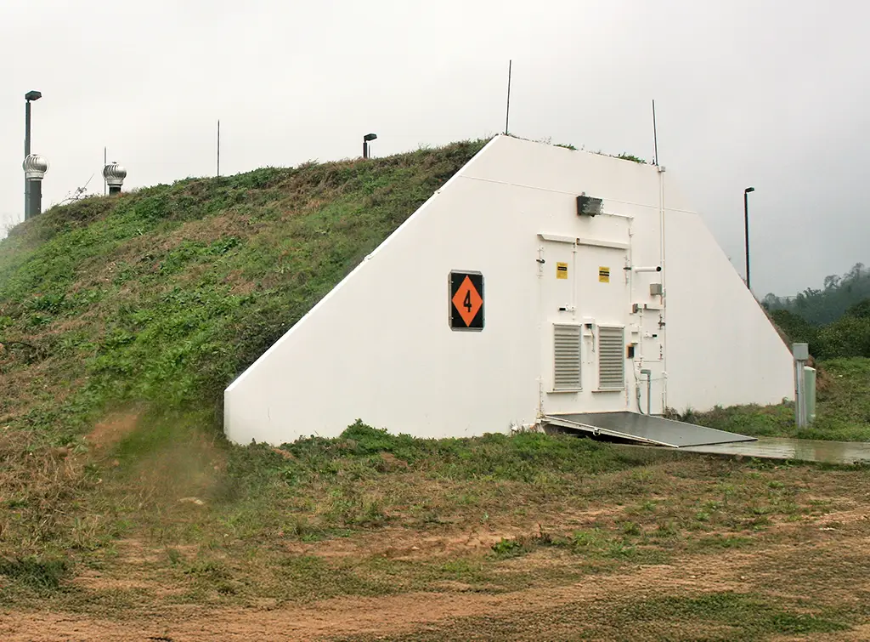
Figure 2- Earth Covered Magazine housing Fire Division 1.4 [6]

Furthermore, Directional effects mean the magazine is engineered so that blast vents through a weak face or roof away from ES. Therefore, the side of the magazine is perpendicular to the ES, ensuring the vented blast does not point toward populated areas.

  - Vulnerable Building Distance (VBD)
When an inhabited building is constructed of lightweight or fragile materials or is a large facility of special importance (such as hospitals, schools, or critical infrastructure), a greater separation distance is required for HD 1.1 to provide equivalent protection. This distance is normally calculated using the formula:
$$R=Z ×W^{\frac{1}{3}}$$
Equation 1- Range Calculation
- R – Range
- Z- Safety Factor (Also referenced as the K-Factor)
- W- Net Explosive Quantity (NEQ) Kilograms
- $W^{1/3}$- cube root of the explosive Weight

As per DSA 03.OME Part 2 Chapter 6, a Z-Factor of 44.4 is typically used to provide equivalent protection for vulnerable buildings against HD 1.1 mass detonation effects. This ensures that the risk to such structures and their occupants is minimised. [7].

  - Inhabited Building Distance (IBD)
Inhabited Building Distances (IBD) are a representation of the minimum separation distances that must be maintained at the Potential Explosion sites (PES) defined as:
“A PES is any stock of explosives, however or wherever stored (building, stack, vehicle, railway wagon, berth, transit shed etc), the explosion of which will affect an Exposed Site” [8] a term that uses Potential in consideration of the risk factor but will cause an explosion if not managed appropriately this also applies to the VBD.
The maintenance of other locations where members of the public or personnel not directly involved in explosive handling, work, or gather. These distances are designed to prevent significant damage to standard building types such as solid brick or equivalent builds such as caravans, thereby reducing and mitigating the likelihood of fatalities and injuries to occupants. These distances provide protection to individuals in open areas as they would not experience direct harm from blast effects and or radiant heat. However, the risk of injury from projections such as broken glass, tiles, or similar threats is not eliminated with minor injuries to occupants still able to occur. An important technique used is glazing (Figure 3) it plays a critical role in protecting building occupants, and these can be implemented relatively easily. For Exposed Sites (ES) defined as:
“An ES is any facility, service or civilian, exposed to and thus hazarded by the effects of an explosion or fire at a PES. These facilities include:
(1) Any stock of explosives, however or wherever stored.
(2) Process Buildings and explosives workshops.
(3) Inhabited buildings and places of assembly.
(4) Public traffic routes, including roads, footpaths, railways, canals and civil aircraft facilities, etc.
(5) Other Hazardous Installations, e.g. electrical sub-stations [8]”
Guidance can be sought from defence estates via Ministry of Defence (MOD) staff.

Figure 3- Aluminium Glazing with wooden beams [9]

Commercially, IBD principles may be applied in industries handling explosives or hazardous materials to ensure public safety, but specific regulations and standards would depend on the country and industry. For the Swansea County and council this would be under the United Kingdom, commercial entities would typically follow the Health and Safety Executive (HSE) guidelines or other relevant regulatory frameworks.
Similarly to the VBD, the IBD blast range can be calculated using the formula provided in section 2.2, however the Z-Factor is considered 22.2 for an HD 1.1 mass explosion.

  - Public Traffic Route Distance
Public Traffic Route Distances (PTRD) are the minimum separation distances required between a Potential Explosion Site (PES) and public routes, such as roads, railways, waterways, or public rights of way. The required distance depends on the traffic density, which is categorised as follows:
- High-Density Usage: Full Inhabited Building Distance (IBD).
- Medium-Density Usage: Two-thirds of the IBD.
- Low-Density Usage: Half of the IBD.
Due to the lack of detailed information provided by 'Big Bang' Storage Solutions and the storage application being located within Swansea city—a densely populated area with town centres, housing, hospitals, and universities—the high-density usage category will be applied. This ensures the worst-case scenario is captured in the assessment. Consequently, a Z-Factor of 14.8 will be adopted for HD 1.1 mass explosion hazard


Figure 4- Swansea Overview, Marinas, housing etc

  - Hazard Type
Hazard type (HT) is a key factor in determining both safety measures and licensing requirements. Also known as Hazard Divisions which is more commonly used as an international recognised system focused on transport and handling safety under the UN guidelines.
Both specify and characterise the nature of the hazard posed by explosives under manufacturing, storage and transport conditions.
Based on the information provided by “Big Bang” Storage Solutions, we can identify the Hazard Types and their characteristics to be:

UN Hazard Division Symbol | Hazard Type | Hazard Division  (HD) | Characteristics | Present on Site  (Yes/No)
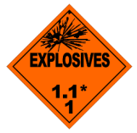 | Type 1 | Hazard Division 1.1 | “An explosive which, because of, or because of any effect of, the conditions of its storage or process of manufacture have a mass explosion hazard” [10] | Yes
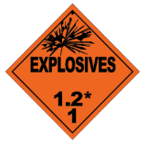 | Type 2 | Hazard Division 1.2 | “An explosive which, because of, or because of any effect of, the conditions of its storage or process of manufacture has a serious projectile hazard but does not have a mass explosion hazard” [10] | Yes
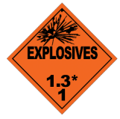 | Type 3 | Hazard Division 1.3 | “An explosive which, as a result of, or as a result of any effect of, the conditions of its storage or process of manufacture has a fire hazard and either a minor blast hazard or a minor projection hazard, or both, but does not have a mass explosion hazard- ie those explosives which give rise to considerable radiant heat or which burn to produce a minor blast or projection hazard” [10] | Yes
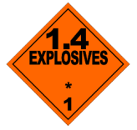 | Type 4 | Hazard Division 1.4 | “an explosive which, as a result of, or as a result of any effect of, the conditions of its storage or process of manufacture has a fire or slight explosion hazard, or both, with only local effect- ie those explosives which present only a low hazard in the event of ignition or initiation, where no significant blast or projection of fragments of appreciable size or range is expected” [10] | Yes
 | N/A | Hazard Division 1.5 | “Very insensitive substances,  which have a mass  explosion hazard.” [11] | No
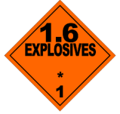 | N/A | Hazard Division 1.6 | “Extremely insensitive articles  which do not have a mass  explosion hazard.” [11] | No
Table 3- Hazard Classification [10] [11]

  - Compatibility Groups
Compatibility groups are designed to classify explosives based on their storage and transport characteristics, with the aim of minimising the risk of incidents when stored or transported alongside other energetic materials and items.
As part of the United Nations (UN) classification system of explosives, managed under the UN Committee of experts on the Transport of Dangerous Goods (UN TGD). They have come up with the compatibility groups, they are labelled A-S representing each specific explosive or material. The following Compatibility labels and description are said to be:

Compatibility Group | Description | Present on Site  (Yes/No)
A | Primary Explosive Substance. | No
B | Articles containing a primary explosive substance without two or more effective protective features. Includes items like detonators for blasting, detonator assemblies for blasting, and cap-type primers, even if they do not contain primary explosives. | Yes
C | Propellant or deflagrating explosive substances, or articles containing such substances. | Yes
D | Secondary detonating explosive or black powder, or articles containing them without initiation means or propelling charge. Includes articles with primary explosives that have two or more effective protective features. | Yes
E | Article with a secondary detonating explosive and a propelling charge, but no means of initiation, excluding those with flammable liquids, gels, or hypergolic liquids. | Yes
F | Article with a secondary detonating explosive, its own means of initiation, and a propelling charge (excluding flammable liquids, gels, or hypergolic liquids) or without a propelling charge. | Yes
G | Pyrotechnic substance, or article containing a pyrotechnic substance, or article containing both an explosive substance and an illuminating, incendiary, tear- or smoke-producing substance (other than a water activated article or one containing white phosphorus, phosphides, a pyrophoric substance, a flammable liquid or gel, or hypergolic liquids). | No
H | Article containing both an explosive substance and white phosphorus. [11] | No
J | Ammunition containing an explosive substance combined with a flammable liquid or gel. | No
K | Articles containing an explosive substance and a toxic chemical agent. | No
L | Explosive substance or article with special risks (e.g., water activation, hypergolic liquids, phosphides, or pyrophoric substances) requiring isolation by type. | No
N | Articles containing exclusively extremely insensitive detonating substances (EIDS). | No
S | Substance or article designed to confine hazardous effects within the package, with limited blast or projection impact during a fire to not hinder emergency response. | Yes
Table 4- Compatibility Group Descriptions [11]

2.7.1 Mixing Rules
Table 2 outlines all possible compatibility categories and their descriptions. However, it is critical to adhere to the mixing rules to maximise the efficiency of the storage space available, in this case, the five ESHs, while maintaining the highest level of safety. Ideally, OME should be stored separately, but if this is not possible, the mixing rules must be followed. The IATG provides a table that details these mixing rules and visually illustrates which compatibility groups can be stored together, as shown below:
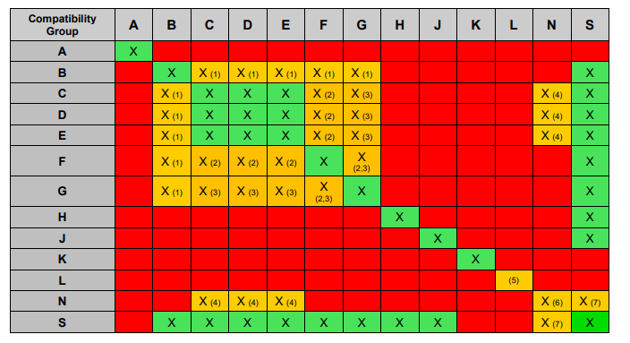
Figure 5- IATG Compatibility Group Table
For example, this shows that compatibility Group A (primary explosive substances) cannot be stored with Compatibility Group B (articles containing a primary explosive) because both groups involve primary explosives, which are highly sensitive to stimuli such as impact, friction, heat, or electrostatic discharge. Storing them together increases the risk of accidental initiation, as the presence of articles in Group B could amplify the effects of an accidental detonation in Group A, leading to a more severe explosive event.
Utilising the description and noting the compatibility groups that we will have on site as provided by the “Big Bang” Storage Solutions and the mixing rules table we can develop the storage potential on with additional input from explosives regulations and safeguarding principles highlighted previously.

- Safeguarding Map
A Safeguarding Map defines the safety zones around a PES to prevent inappropriate development from encroaching too close. It sets out the key distances which were highlighted previously (Para 2.3,2.4,2.5) in pictorial form:
- Inhabited Building Distance (IBD) – also known as the Yellow Line. This marks the area within which inhabited buildings must not be located.
- Vulnerable Building Distance (VBD) – also known as the Purple Line. This identifies the area where more vulnerable development (such as schools, hospitals, large public buildings, etc.) is not permitted.
- Public Traffic Route Distance (PTRD) – a specified distance to ensure that public roads, railways or other transport routes are not placed too close to the explosive site.
Safeguarding Maps are required for all PESs except those operating under an Authorised Quantity Licence or HD 1.4, and they ensure that land-use planning around explosive sites maintains an appropriate level of public safety.
The UN Safeguard system provides software that calculates and generates a Safeguarding Map, displaying the required distances visually. Before using this software, a theoretical calculation can be completed to validate and compare the results against those provided by “Big Bang” Storage Solutions and the UN Safeguard tool.
3.1 Safeguarding Calculations
3.1.1 Vulnerable Building Distance

$$R=Z ×W^{\frac{1}{3}}$$
$$R=44.4 ×{1000}^{\frac{1}{3}}$$
$$R=444m$$
3.1.1 Inhabited Building Distance

$$R=Z ×W^{\frac{1}{3}}$$
$$R=22.2 ×{1000}^{\frac{1}{3}}$$
$$R=222m$$

3.1.2 Inhabited Building Distance
$$R=Z ×W^{\frac{1}{3}}$$
$$R=14.8 ×{1000}^{\frac{1}{3}}$$
$$R=148m$$
3.2 UN Safeguard Map
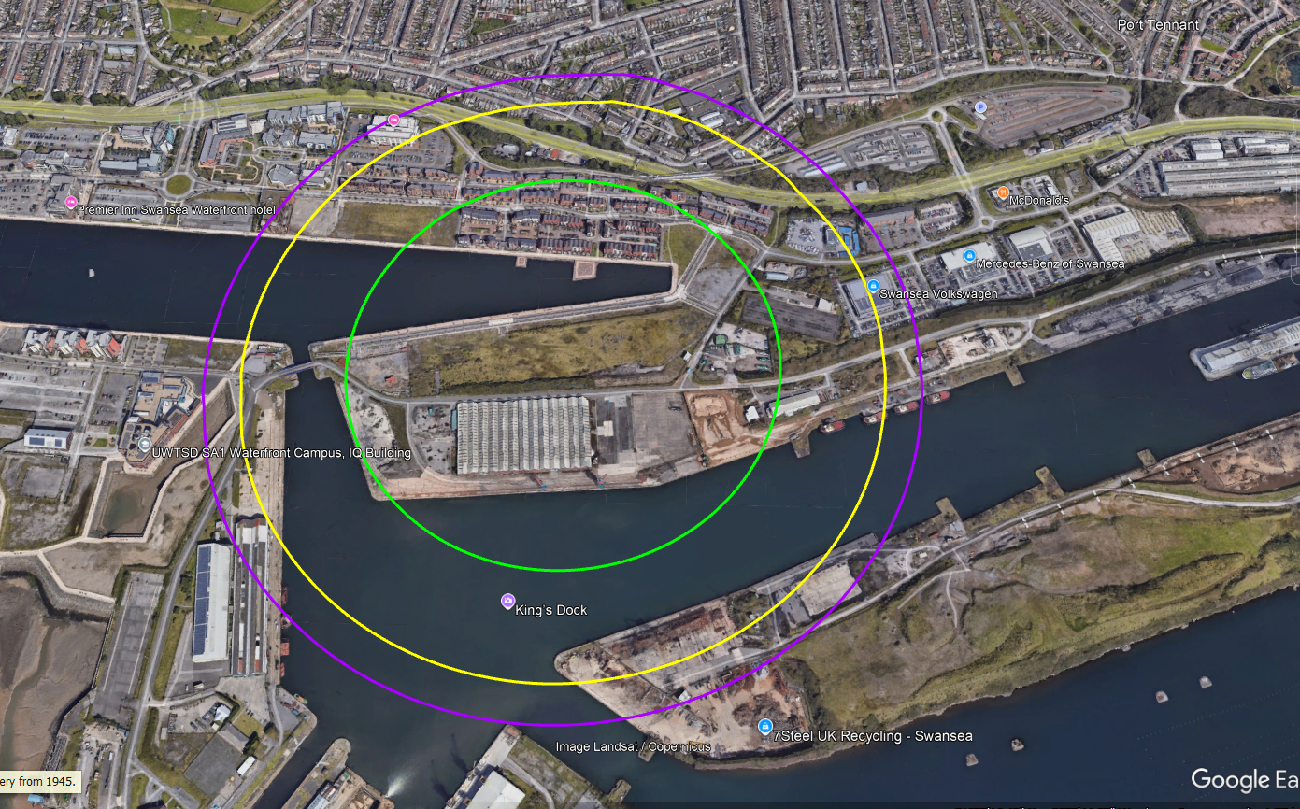
Figure 6- UN Safeguard mapped on google earth

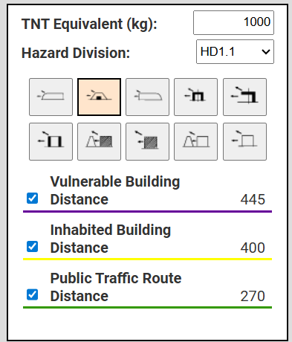
Figure 7- UN Safeguard Values

Source | VBD (m) | IBD (m) | PTRD (m)
“Big Bang” Storage Solutions | 300 | 125 | 270
Theoretical | 444 | 222 | 148
UN Quantity Distance Calculator (Appendix 2) | 444 | 222 | 148
UN Safeguarding Map | 445 | 400 | 270
Table 5- QD Comparison Table

The table above presents all sources and associated QDs derived from the various analytical techniques and methodologies employed. The QDs supplied by “Big Bang” Storage Solutions were identified as erroneous and are therefore highlighted in red. These inaccuracies represent a potential unmitigated risk to individuals or assets situated outside the boundaries proposed by the supplier but within the correctly calculated safeguarding limits.
Furthermore, the Theoretical and UN Quantity Distance Calculator show the same values, these calculations are the correct values and would be the suitable values if it was the QD for blast effects without consideration of any other factors and methodologies therefore it has been highlighted yellow.
The UN Safeguarding Map applies the principles set out in both the theoretical framework and the UN Quantity Distance (Q-D) calculator, while incorporating additional conservatism to account for potential fragmentation hazards. In the absence of detailed analyses, such as specialist blast modelling or access to authorised fragmentation assessment tools, including those aligned with NATO AASTP-1. The UN Safeguarding Map values and associated visual outputs will be used as the primary reference. This approach ensures that all potential risk areas are treated with an appropriately precautionary margin of safety, given that no alternative validated method is currently available to guarantee that outlying areas would remain unaffected.
The map and reference points out various areas at risk, these include housing estates, university establishments, hotels and a Marina.

- Storage Potential
Based on the 5 ESHs and explosives required for storage we can use the information gathered to determine how these will be split appropriately:
ESH Number | Hazard Divisions/(kg) | NEQ (kg)
1 | 1.1B/(50) + 1.1D(1000) + 1.4S(1000) | 2050
2 | 1.1D/(1000) + 1.1E/(1000) | 2000
3 | 1.1D/(1000) + 1.1F/(500) | 1500
4 | 1.1D/(200) + 1.1E(250) + 1.2C(350) + 1.2D(100) + 1.2F(50) | 950
5 | 1.3C | 1000

- Explosive License
Using the previous information, we can develop an explosive license that will be distributed to each individual ESH. Using the UN Safeguard software, it provides the tools to pick the appropriate PES and ES for the license.
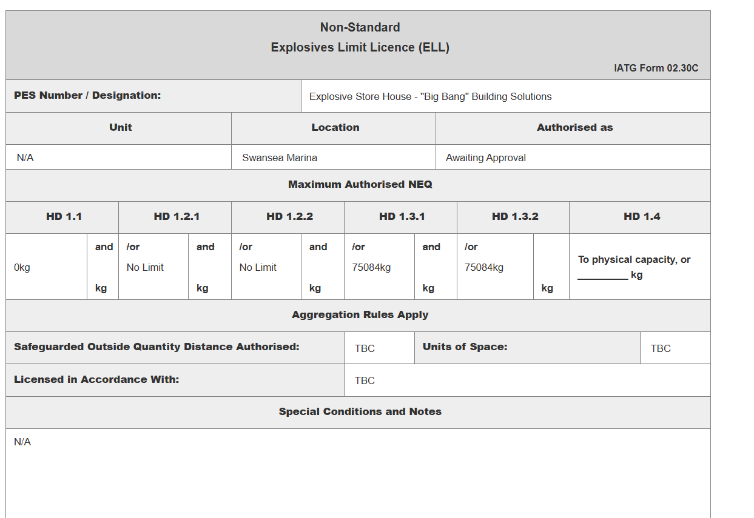
Figure 8- UN Safeguard Explosives License Limit

The completed licence indicates that 0 kg of HD 1.1 would be authorised based on the information submitted. This reflects the licensing system’s application of the upper regulatory limit rather than the results of the theoretical Q–D assessment. As demonstrated in Table 3.2, the calculated siting distances place all surrounding buildings beyond the required Inhabited Building, Vulnerable Building and Public Traffic Route distances, including a PTRD of 270 m, which exceeds the minimum requirement by approximately 120 m. Despite this, the licence still returns an authorised quantity of zero for HD 1.1. This outcome likely arises from conservative constraints within the licensing framework particularly those related to fragmentation effects, construction type, or unvalidated assumptions which override the theoretical Q–D compliance and default to a non-acceptance position for HD 1.1 until further detailed assessment is completed.

- Options
Option A:
Option A involves relocating the explosives to an alternative site that is already licensed and suitably configured for the required Hazard Divisions. This option ensures continued compliance with regulatory controls while the new licence application is prepared and processed. By utilising an existing authorised facility, all storage remains within established safety parameters, avoids introducing additional risk at the proposed site, and provides a temporary but fully compliant solution until formal approval is granted for the intended location.
This also allows “Big Bang” Storage Solutions to identify what a facility should be and how it is operated, not only increasing the quality of its output but increasing the staff and producing Suitably Qualified Experiences Personnel (SQEP) before producing its brand-new facility.

Option B:
Use the current storage potential identified in section 4 and utilise planning permission space and the ESH design to justify the blast and fragmentation radius to be directional towards the water line.

Figure 9- Directional Blast Effects if ESH directed towards the Water line
This would result in a full assessment on the ESH to determine if the directional blast was vented correctly and resulted in a directional blast away from the perpendicular ES. If confirmed it will be considered a 150-degree [8]blast radius significantly reducing the effects of the explosion (See Appendix 3).
Furthermore, investment would need to be made in blast modelling to really understands the effects blast and fragmentation would have in this environment. Utilising equations such as the gurney equation for the initial velocity however alone doesn’t provide enough evidence without the modelling:
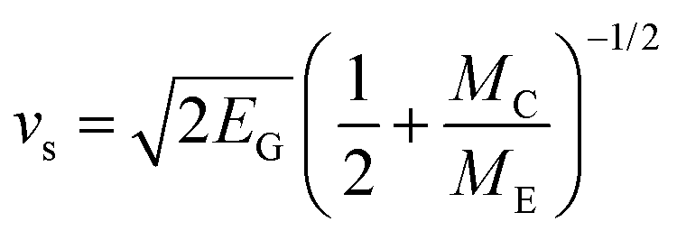
Equation 2- Gurney Equation

Option C:
Option C involves removing all HD 1.1 explosives from the current storage facilities and relocating them to a licensed alternative facility until the new licence application is approved or a permanent solution is identified. This approach ensures that all remaining explosives are stored in compliance with the licence limits and within the prescribed Quantity–Distance (Q-D) tolerances, eliminating any regulatory non-compliance associated with HD 1.1.

ESH Number | Hazard Divisions/(kg) | NEQ (kg)
1 | 1.4S(1000) | 1000
2 | - | -
3 | - | -
4 | 1.2C(350) + 1.2D(100) + 1.2F(50) | 500
5 | 1.3C | 1000
Table 6- Revised QD table removing HD 1.1
- Assessment and Recommendation

- Option A, while compliant, does not provide a sufficiently practical solution in terms of operational continuity or staff development, as it relies solely on relocation without addressing the existing site configuration.

- Option B represents the likely end-goal configuration, involving directional blast venting towards the waterline and extensive modelling to assess blast and fragmentation effects. However, it requires significant investment in modelling, site modifications, and validation before it can be considered safe and compliant.

- Option C provides a practical, interim solution that ensures immediate compliance with licence restrictions, maintains explosives within safe Q-D limits, and avoids introducing additional risk at the current site. It also preserves operational continuity and provides a foundation for eventual implementation of the more complex Option B configuration if desired.

- Conclusion
The proposed ESH development presents significant safety risks due to proximity to populated areas and public infrastructure. Assessment of the submitted Quantity–Distance data indicates that HD 1.1 storage is not compliant with licence restrictions. Of the options considered, Option C, removing HD 1.1 to a licensed facility while retaining other explosives within safe Q-D limits, is the preferred interim solution. This approach ensures regulatory compliance, mitigates risk to the public and environment, and allows future implementation of long-term solutions such as directional blast venting. A further list of questioning has been forwarded to “Big Bang” Storage Solutions in addition to this report for further self-assessment (See Appendix 5)

7.Appendices

  - Risk Reduction Process Level (RRPL) [12]:
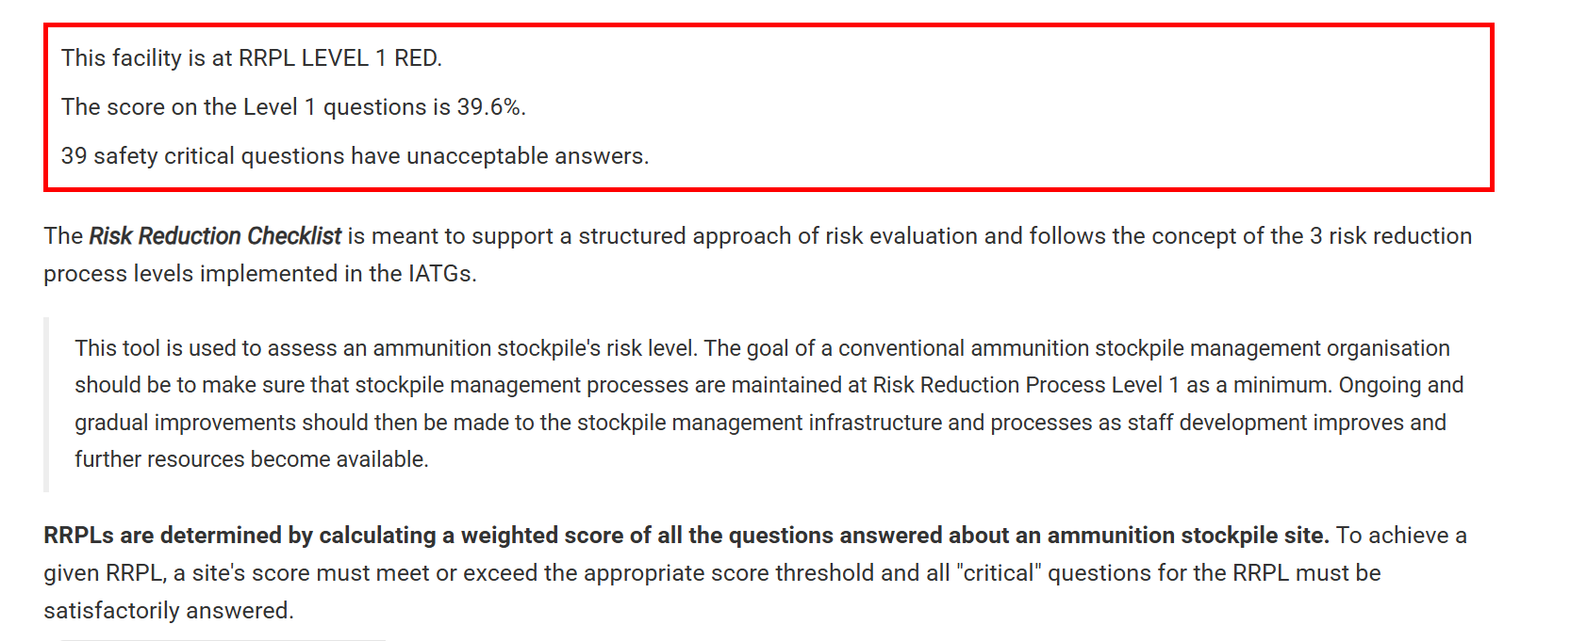
  - UN Safeguard Calculations
VBD Calculation:
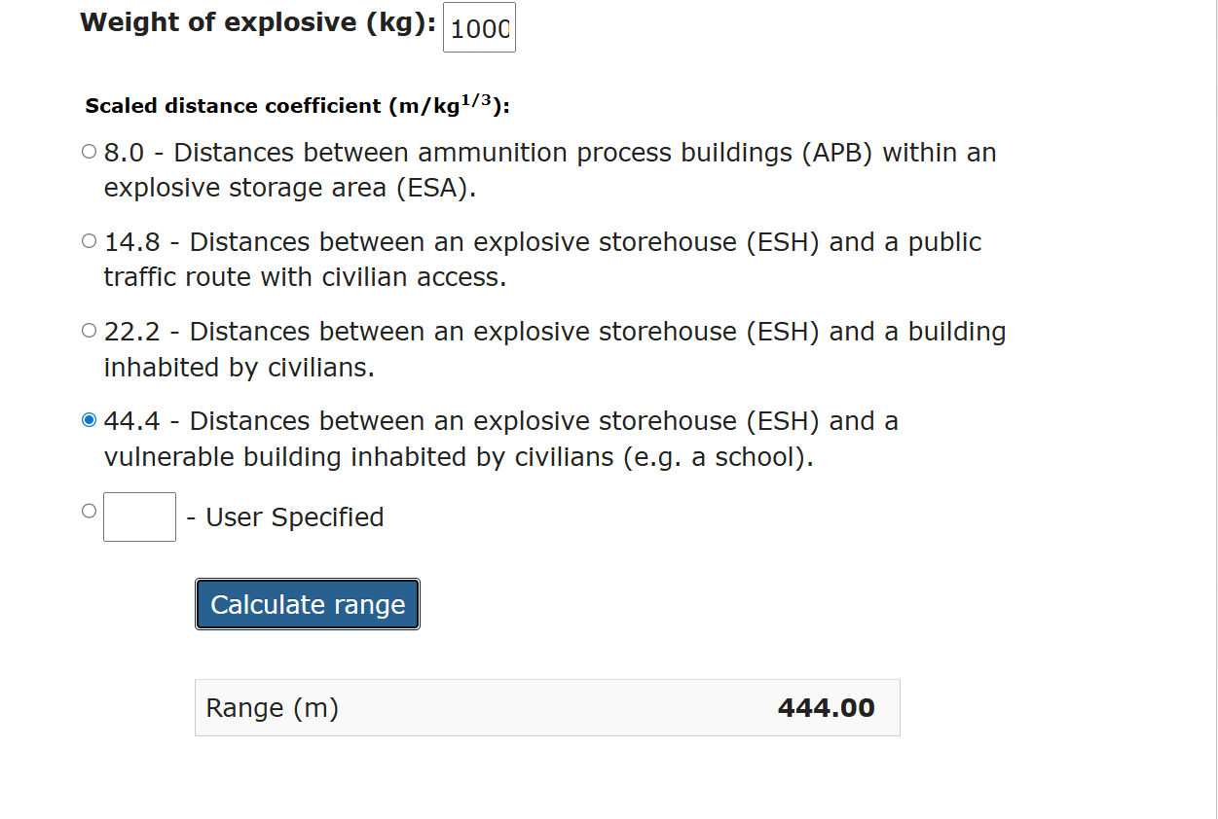
IBD Calculation:
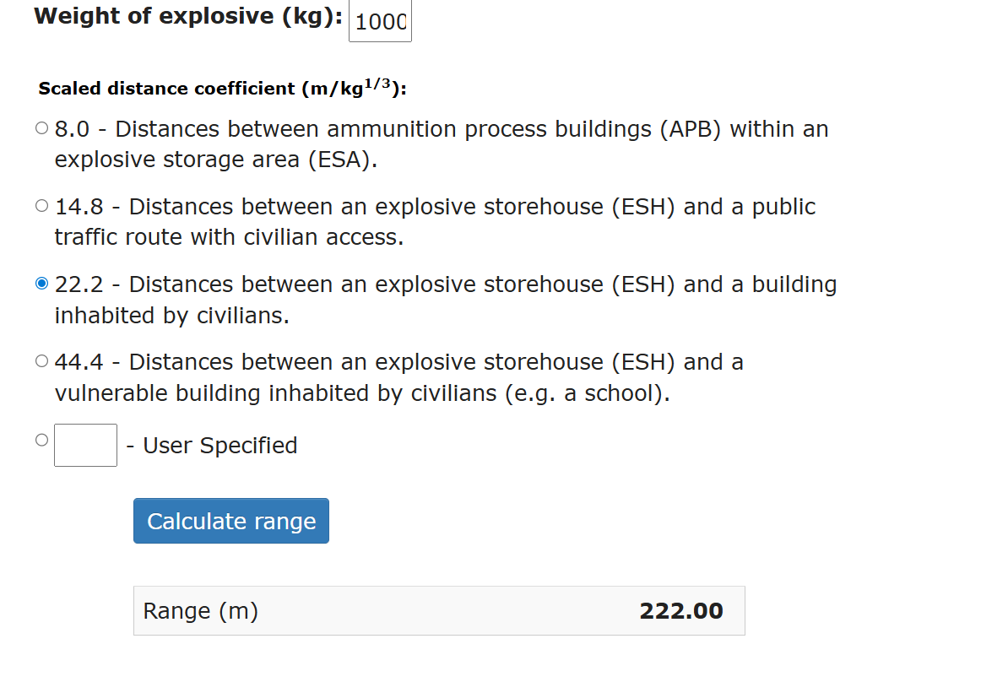

PTRD Calculation:
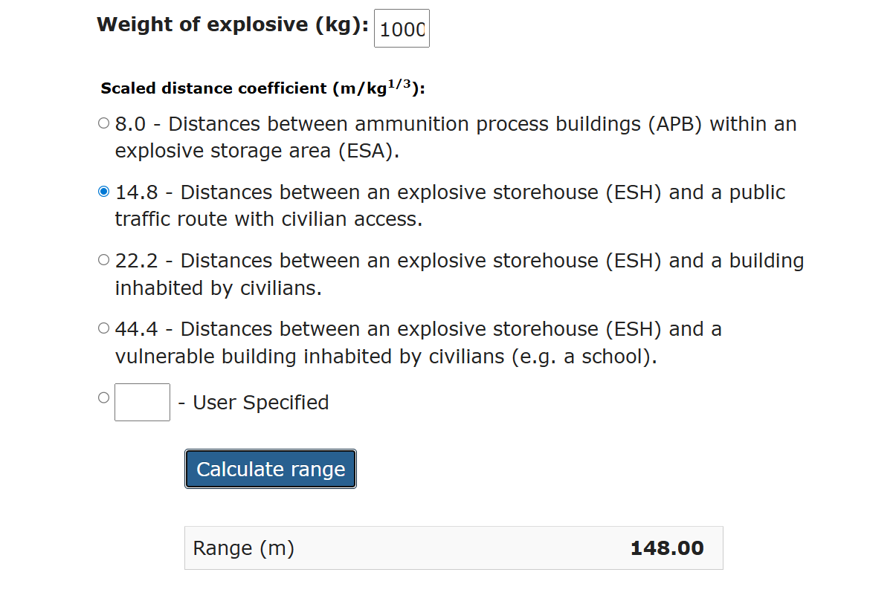

  - ESH Blast Effects
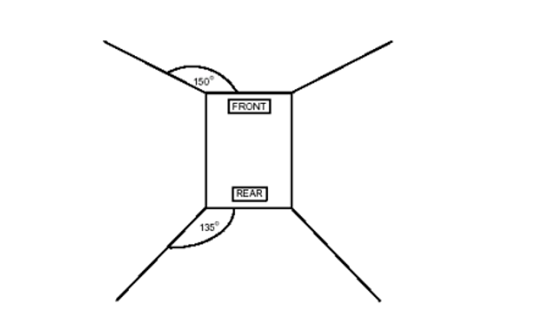
  - UN Gurney Equation Software
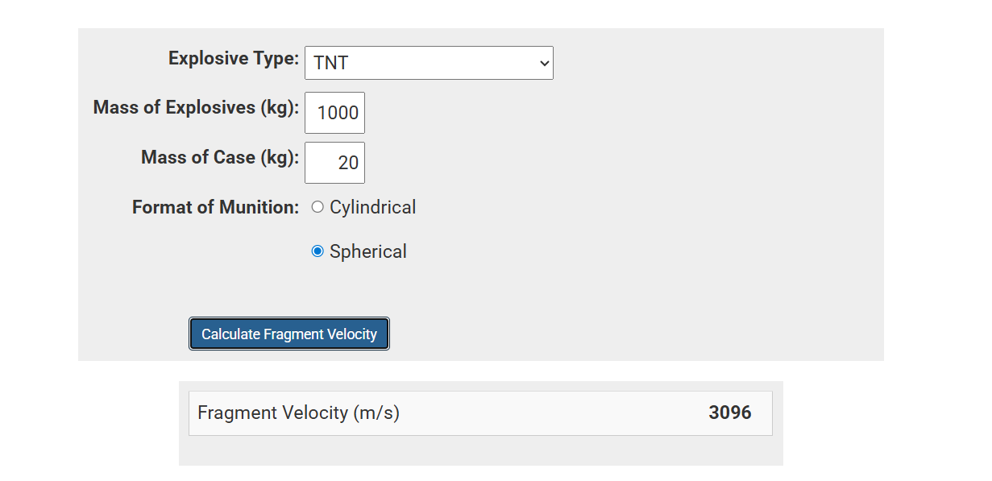

  - Further RRPL Questions for “Big Bang” Storage Solutions [12]

Ammunition Management Policy
- Is there a formal system in place to routinely determine surplus stocks of ammunition and explosives?
- Are all ammunition facilities independently and formally inspected at least annually?
Health and Safety at Work
- Have any formal Risk Assessments been completed and recorded?
- Has the Risk Assessment estimated the Risk based on Probability?
- Has the Risk Assessment estimated the Risk based on Explosion Consequence Analysis?
- Has the Risk Assessment estimated the Individual Risk?
- Has the Residual Risk been formally accepted in writing by a higher level of command?
- Has the Residual Risk been formally communicated to the local civilian community?
- Is there a formal system in place within the government system for use of land to extend current explosive facilities?
- Is there a formal system in place within the government system for the identification and authorization of new land for explosive facilities?
Explosives Limit Licensing
- Have formal Explosive Limit Licences been prepared for all PERMANENT storage locations in accordance with IATG 02.30?2
- Have formal Explosive Limit Licences been prepared for all TEMPORARY storage locations in accordance with IATG 04.10?
- Have appropriate External Safety Distances been identified based on a Quantity Distance System for PERMANENT storage locations?2
- Have appropriate Internal Safety Distances been identified based on a Quantity Distance System for PERMANENT storage locations?
- Have appropriate External Safety Distances been identified based on a Quantity Distance System for TEMPORARY storage locations?1
- Have appropriate Internal Safety Distances been identified based on a Quantity Distance System for TEMPORARY storage locations?
- Is there a formal and legal system to safeguard external danger areas?
- Are Logbooks or Record Cards formally kept for each explosive storehouse
- Are the Logbooks or Record Cards signed on a regular basis.
- Are copies of all appropriate publications (including IATG or equivalent) kept at each storage depot?
Inventory Management
- Is the national stockpile formally divided between operational, training, surplus and unserviceable categories?
- Are Ammunition Management Policy Statements (AMPS) (or equivalent) used to assist the through life management of each ammunition type?
- Does a national authority for ammunition management exist?
- Are the roles and responsibilities of the national ammunition management authority formally recorded?
- Is there a formally established unit responsible for the storage of ammunition and explosives?
- Is there a formally established independent organization responsible for the technical inspection of ammunition stock holding units
- Is there an effective ammunition accounting system that can account by type, quantity and location of ammunition?
- Is there an effective ammunition accounting system that can account by type, quantity, lot number, batch number and location of ammunition?
- Is there an effective ammunition accounting system that can account by type, quantity, lot number, batch number, technical condition and location of ammunition?
- Is regular independent stocktaking and audits carried out?
- Is ALL ammunition marked in accordance with a coordinated national system of marking?
- Does the national marking of ammunition system comply with that contained within the UN (Orange Book) and IATG 06.40?
Lotting and Batching
- Does a formal system for the effective Lotting and Batching of ammunition exist?
- Does a formal system for the effective LOGISTIC Lotting and Batching of ammunition exist?
- Infrastructure - Design
- Are the current PERMANENT explosive storehouses in compliance with the design principles in IATG 05.20 or to NATO Standards?
- Is there a formal system in place to ensure that all NEW PERMANENT explosive storehouses are constructed in compliance with the design principles in IATG 05.20 or to NATO Standards?
- Are the current PERMANENT traverse and barricades for the explosive storehouses in compliance with the design principles in IATG 05.30 or to NATO Standards?
- Is there a formal system in place to ensure that all NEW traverse and barricades for PERMANENT explosive storehouses are constructed in compliance with the design principles in IATG 05.30 or to NATO Standards?
- Is there any significant subsidence in the barricades or traverses to a level that may impact on their effectiveness?
- Is there a formal system in place to ensure that all NEW Lightning Protection Systems for PERMANENT explosive storehouses are constructed in compliance with the design principles in IATG 05.40?
- Are the current Lightning Protection Systems for PERMANENT explosive storehouses are constructed in compliance with the design principles in IATG 05.40?

Infrastructure - State of Repair
- Are their any breaches in security fence?
- Are their any damaged or corroded security lights?
- Is any building structure damaged?
- Are the doors serviceable?
- Are their any broken windows?
- Is their any lightning protection in place?

Infrastructure - Cleanliness (Fire Risk)
- Are there any wind-blown combustibles outside explosive storehouses?
- Is their any loose packaging or rubbish inside explosive storehouses?
- Are all empty boxes, pallets etc removed at the end of a day's work?
- Are all rags and waste material removed at the end of a day's work?
- Is there any accumulation of explosive or propellant dust in explosive storehouses or ammunition process areas?1
- Infrastructure - Windows
- Is the glass of acceptable standard?
- Are there any cracked or broken panes?
- Can sunlight shine directly onto explosive stores?
- Are guard bars fitted and free of corrosion?
Infrastructure - Drains and Gutters
Are all drains and gutters free of grass cuttings, leaves, wind-blown foliage, rubbish etc?
Infrastructure - Heating, Ventilation and Air Conditioning
- Are ventilators (normally) left open?
- Are ventilators free from corrosion?
- Do ventilators open and close properly?
- Do ventilators require protective paint, oil or grease?
- Are any thermal links or automatic opening device present? Serviceable?
- Are hygrometers / thermometers present and serviceable?
- Is there any heating / air conditioning present and serviceable?
- IATG 05.40 - Safety Standards for Electrical Installations - Clause 5.3.1
- Do radiators have sloped guards?
Security
- Are security keys serviceable and rotated?
- Is there a system in place to control the issue of keys to the Explosive Storage Area and Bunkers?
- Are the locks in working condition?
- Are staff working at ammunition storage facilities subject to routine security vetting?
- Is access to ammunition storage location keys restricted to authorised personnel?
- Is there a system in place to Control Entry to the Explosives Storage Area?
- Is access to ammunition storage areas controlled and limited to authorised personnel only?
- Are the doors and gates secured with padlocks?
- Do padlocks should comply with European Standard EN 12320:2001, Building hardware - Padlocks and padlock fittings - Requirements and test methods?
- Is the perimeter fitted with intrusion detection systems (IDS)?
- Is there Class 1 security fencing present to provide basic security?
- Is there Class 2 security fencing present to provide adequate security?
- Is there Class 3 security fencing present to provide medium security?
- Is there Class 4 security fencing present to provide maximum security?
- Is perimeter illumination present to allow for detection of intruders?
- Is there a guard response force deployed to check integrity of ammunition storage areas during non-working hours?
Safety - Explosive Contents
- Is a system of Compatibility Groups for the safe mixing of ammunition during storage present?
- Is the UN Hazard Division marking system used?
- Is a National Hazard Division marking system used if the UN system is not?
- Does the marking system show HCC, HD, UN Serial Number, Ammunition Type, Lot/Batch Number and Quantity?
- Is there an explosive test capability for the allocation of UN Hazard Division codes?
- Are ESH stacking systems (Stack Tally Cards) in place?
- Do Stack Tally Cards contain HD, Batch/Lot Number, and Quantity?
- Is constrained or unserviceable stock clearly marked and segregated?
- Are unsealed boxes clearly marked with remaining quantity?
- Are the contents of unsealed boxes free of corrosion, damage or dampness?
- Is there a formal system of ensuring that ammunition packaging or ammunition components is Certified as Free from Explosive (CFFE) by qualified personnel and that a 'CFFE Certificate' accompanies such items wherever they go?
- Is there a formal system of ensuring that ammunition is Certified as Safe to Move (STM) by qualified personnel and that a 'STM Certificate' or equivalent accompanies the ammunition wherever it goes?
- Is ammunition of Compatibility Group (CG) 'H' or equivalent stored separately to all other ammunition types?
- Are tools and first aid available where CG 'H' equivalent (White Phosphorous) is being stored?
- Are non-palletised stores on battens or racking or equivalent?
- Are gangways between stacks in place and adequate?
Safety - Fire Fighting (Equipment)
- Is an Emergency Water Supply (EWS) present?
- Is the EWS full, clear and free of wind-blown debris?
- Are fire hydrants present?
- Are fire hydrants serviceable and at correct water pressure?
- Is immediate firefighting equipment present in ESH (extinguishers, sand etc)?
- Is immediate firefighting equipment regularly function checked and recorded?
- Are fire appliances and equipment accessible, clearly marked and painted?
- Are fire beaters serviceable and in sufficient quantity?

Safety - Fire Fighting (Response)
- Is there a formal and written Fire Plan and Fire Orders?1
- Is a fire alarm system in place and operable?
- Are fire alarm systems maintained, tested and recorded?
- Is the vegetation around the Explosive Storage Area and the Explosive Storehouses regularly cut?
- Are there fire breaks within the Explosive Storage Area?
- Are regular fire practices held and recorded?
- Are Fire Division Signs and Supplementary Fire Signs displayed, legible and serviceable?
- This question is critical for RRPL LEVEL 1.
- Do Fire Division Signs and Supplementary Fire Signs correctly reflect the stocks?
- Is there a Formal Liaison and Meetings with the Local Authority Fire Service?
- Does the local authority fire service know what is stored in depot and what inherent risks are?
- Is the local authority fire service informed of any major changes to storage conditions or types of ammunition being stored?
- Are regular exercises held with the local fire authority?
- Empty boxes are a potential fire hazard. Is there a designated area for them? Are they free of paints, oils, greases, solid waste, wood scraps etc?
- Have all labels been removed from empty boxes?
Safety - Fire Fighting (Vegetation)
- Is there a 1m sterile area around each ESH?
- Is it clear of grass, foliage, shrubbery, gorse and heather?
- Are grassed areas inside and outside the depot sufficiently mown and all grass cuttings removed?1
- Is the grass cut at least bi-monthly during spring/summer months?1
- This question is critical for RRPL LEVEL 1.
- Are there trees inside the depot for camouflage?
Safety - Operations
- Are all Explosives Limits Licences (ELL) displayed?
- Do the ELL reflect actual stock levels?
- Are all tools, equipment and cleaning utensils allowable correctly listed and authorised?
- Is there a system operable to ensure the Exclusion of Prohibited Articles from the Explosives Area?1

- Is there a contraband notice at entry to Explosives Area?
- Is there a contraband box at entry to the Explosives Area?
- Is it MANDATORY that ALL contraband is left in a contraband box upon entry to the Explosives Area with NO EXCEPTIONS whatsoever?
- Is there a designated smoking area?
- Is the designated smoking clearly signed and are ashtrays available?
- Are 'actions on event of fire' posters or instructions posted around the depot?
- Are there mechanisms for reporting accidents and incidents?
- Are Man Limits clearly established, recorded and displayed for all buildings that store or process ammunition and explosives?
- Are Accident Procedures clearly established, documented and displayed in all buildings that store or process ammunition and explosives?
- Is the appropriate Personal Protective Equipment (PPE) available to all staff working in explosive facilities?
- Is the 'Breakdown' of ammunition and explosives permitted?
- Are comprehensive technical instructions covering the activity and safety for each ‘Breakdown’ operation?
Safety - Equipment (Lifting)
- Are mechanical hoists present?
- If yes, are chains and cables in good condition and lubricated?
- Are electrical hoists present?
- If yes, are chains and cables in good condition and lubricated?
- If yes, is it to a Category C equivalent standard?
- Have the hoists had a mechanical / electrical inspection within the last 12 months? Is it recorded?
Safety - Equipment (Electrical Installations)
- Is there a formal national system of allocating different Electrical Safety Categories to buildings and equipment dependent on their purpose?
- Is there a formal system of allocating different Electrical Safety Categories to buildings and equipment dependent on their purpose in full compliance with IATG 05.50?
- Is the safety standard (e.g. Category C) shown next to the Master Switch?
- Is the Master Switch serviceable?
- Are all lights, alarms, telephones, switches and electrical switch boxes functional and free from corrosion and storm damage etc?
- Are formal electrical tests regularly carried out and are they formally recorded? Can each component be easily identified from the record of tests?

- Are Earth Leakage Circuit Breakers present?
- Are Earth Leakage Circuit Breakers functional and tested?
Safety - Equipment (Lightning Protection)
- Are lightning conductors present?
- Are the current Lightning Protection Systems for PERMANENT explosive storehouses constructed in compliance with the design principles in IATG 05.40?
- Is the integrity of bonding of lightning conductors, correct? (Above and below each switch box to the air and ground terminals).
- Is there any evidence of lightning strikes?
- Is the internal bonding correctly connected to benches, terminals, structures, earth points and electrical hoists?
- Are all lightning protection systems regularly tested and recorded?
Safety - Equipment (Conducting and Anti-Static Floors)
- Is the anti-static flooring in compliance with the requirements of IATG 05.40?
- Have all floors been electrically (resistance) checked and results recorded?
- Are the floors free of cracks, large indentations, excessive wear, oil or grease?
- Is there a cleaning plan in place and used?
- Ammunition Faults and Performance Failures
- Is there a formal system in place for the reporting of ammunition faults and performance failures as a routine task?
- Is written guidance available for users to follow in the event of an ammunition fault or performance failure?
- Does a formal Investigating Authority exist for the investigation of ammunition faults and performance failures?
- Are there formal Cause and Closure Codes allocated to ammunition faults and performance failures?
Bans and Constraints
- Is there a formal system in place for imposing bans and constraints at the national level as a routine task?
- Is there a formal system in place to immediately inform user units of all bans and constraints?
Surveillance and Proof
- Does a formal system exist for the physical inspection of all ammunition in storage on a routine basis?
- Is there a formal proof schedule for the in-service proof firing of ammunition?
- Is there a formal surveillance programme for the determination of propellant stability through chemical analysis by lot or batch number?

8.References

[1] | UWTSD, “Safety & Managment Legislation Module,” University of Wales Trinity Saint David, Swansea, 2025.
[2] | “The Dangerous Substances and Explosive Atmospheres Regulations 2002,” HSE, 2002. [Online]. Available: https://www.hse.gov.uk/fireandexplosion/dsear.htm#:~:text=Fire%20and%20explosion-,The%20Dangerous%20Substances%20and%20Explosive%20Atmospheres%20Regulations%202002,and%20what%20the%20risks%20are.
[3] | “Explosibe Regulations 2014,” [Online]. Available: https://www.legislation.gov.uk/uksi/2014/1638. [Accessed 2025].
[4] | Y. Z. Mingjun Liu, “Investigation on a novel shallow buried explosive magazine and its shock wave safety separation distance,” Advances in Structural Engineering, vol. 1, no. 1, 2025.
[5] | “BUILDINGS ASSOCIATED WITH MILITARY EXPLOSIVES,” 2013. [Online]. Available: BUILDINGS ASSOCIATED WITH MILITARY EXPLOSIVES .
[6] | “Armag 3-Bar Earth Covered Magazine,” [Online]. Available: https://www.armagcorp.com/military-explosives-storage/3-bar-earth-covered-magazine/. [Accessed 09 2025].
[7] | “DSA 03.OME Part 2 (JSP 482) - Defence Code of Practice (DCOP) Chapter 6,” Defence Safety Authority, 2025.
[8] | Defence Safety Authority, “DSA 03.OME Part 2 (JSP 482) Chapter 10-1 - Defence Code of Practice (DCOP) and Guidance Notes for In-Service and Operational Safety Management of OME,” Defence OME Safety Regulator, 2025.
[9] | R. Clayton, “Innovative Ways to Use Aluminium Glazing With Wooden Beams,” IQ Glass, 03 August 2022. [Online]. Available: https://www.google.com/search?safe=active&sca_esv=a1c87ef6032d7104&udm=2&fbs=AIIjpHxU7SXXniUZfeShr2fp4giZ1Y6MJ25_tmWITc7uy4KIeioyp3OhN11EY0n5qfq-zEMZldv_eRjZ2XLYc5GnVnME7glWodDcaQwvGYJtospyF4hao4VocMoniUVvlzzwRcB_gh46MHhrDPH5NOVwPivjadeakFm05zxnpGxC0pvMBL.
[10] | Health and Safety Executive, “Hazard Type,” HSE, [Online]. Available: https://www.hse.gov.uk/explosives/licensing/hazard-classification.htm. [Accessed 2025].
[11] | IATG, “UN explosive hazard classification system and codes,” INTERNATIONAL AMMUNITIION TECHNICAL GUIDELINES, March 2021. [Online]. Available: https://data.unsaferguard.org/iatg/en/IATG-01.50-Explosive-hazard-classification-system-IATG-V.3.pdf.
[12] | IATG, “Risk Reduction Checklist,” UN Safeguard, [Online]. Available: https://unsaferguard.org/un-saferguard/risk-reduction-process-levels. [Accessed 10 November 2025].

