

LOCATION: Swansea | LLEOLIAD: abertawe
LEVEL 6 | LEFEL 6
EXAMINATION PERIOD | CYFNOD ARHOLIADAU
January 2020 | ionawr 2020

MODULE CODE:
M6X00420: Advanced Stress & FEA (PART TIME)
TIME: 2 HOURS

answer THREE out of FOUR QUESTIONS

Equipment or materials required – None
Adnoddau neu ddefnyddiau sydd eu hangen – Dim

University approved calculators are permitted.

Assume ‘g’ = 9.81 m/s².

Question 1

- Discuss what strain energy is.

[3 marks]

The below diagrams show a bar of length L in pure tension in figure 1.1, a small slither of that bar in figure 1.2 and the load against extension graph for that slither in figure 1.3

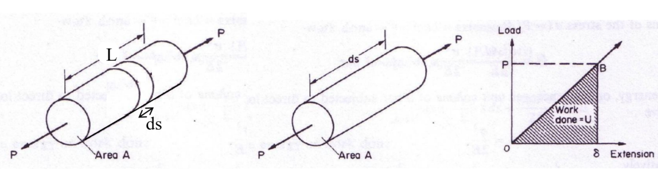

Figure 1.1 Figure 1.2 Figure 1.3

- From the relationship $E=\frac{σ}{ε}$, show that for the slither of the bar $δ=\frac{Pds}{AE}$

[2 marks]

- Hence, from c, show that the strain energy for the entire bar is given by $U=\frac{P^{2}L}{2AE}$

[2 marks]

- Discuss, in the context of stress, what is meant by the term resilience.

[2 marks]
- Hence, from d, show that resilience can be defined as $resilience= \frac{σ^{2}}{2E}$

[2 marks]

- A steel rod has a square cross section that is 15mm x 15mm and a length of 1m. Calculate the strain energy when a stress of 200MPa is produced by stretching it.

[4 marks]

- Discuss, with the aid of a diagram considering the strain energy, why great care must be used in the design of machine parts if there is the possibility of suddenly applied loads.

[5 marks]

Question 2

- Discuss four reasons why a crack may be initiated that could then go on to cause a fatigue failure.
[4 marks]

- Discuss what three areas are typically seen in the cross section of a component that has failed due to fatigue.
[3 marks]

- A fatigue test may be carried out under conditions of rotating-bending with a zero mean stress on a machine such as a Wohler machine. Discuss how this could be used to generate an Sn curve.
[3 marks]

- Using the relationship, $σ_{r}^{a}N_{f}=k,$ where $σ_{a}$ is the stress amplitude, $N_{f}$ is the number of cycles to failure and both a and k are constants, find the constants for a sample where it is known that $N_{f}$=10⁹ when $σ_{r}$ = 100MPa and $N_{f}$=10⁶ when $σ_{r}$ = 200MPa. Hence determine the number of cycles that you would expect this sample to fail at if $σ_{r}$ = 150MPa
[6 marks]

- With the aid of a diagram, discuss the Goodman, Geber and Soderberg relationships that have been developed to link the mean stress and the stress amplitude, for samples where the mean stress is non zero.
[4 marks]

Question 3

a.
During FEA, meshing your part is an important step in the Pre-Processing stage. The quality of your mesh will significantly influence your results. Discuss this, stating checks that you should preform, why these are important and why the error that the checks are looking for may be present.
[15 Marks]

b.
FEA models are normally correlated to physical tests in order to gain confidence in the model. Discuss tools that may be used in order to do this.
[5 Marks]

Question 4

a.
When carrying out FEA, the process can broadly be split into pre-processing, processing and post processing. Discuss each of these tasks.
[6 marks]
b. Discuss the following statement

“It is often less time consuming to build a large model by using an automatic mesher, and increased computer capacity has lessened the need to use special techniques to minimize the number of elements.”
[14 marks]

