Title Page

Module- Changemakers: Building your Personal Brand for Sustainable Employment
Programme- BSc Health and Social Care
Module code - BMHP5015
Assignment Title – Component 1, Online Portfolio of Set Exercises
Student name – Dorota Maciulewicz
Student nr - 2321008
Lecturer – Raheela Shaikh
Submission deadline – 18th November 2025 (14.00 pm)

Contents Page

- Personal Brand……………………………...3
- Conclusion…………………………………...4
- Network Map and Rationale……………….5
- Mind Map…………………………………….6
- Blog…………………………………………...10
- NHS Equality, Diversity and Inclusion ……13
- A Letter to Yourself………………………….16
- GANTT Chart………………………….........17
- Changes Report …………….....................19
- Self-Reflection……………………………….20
- Reference…………………………………….21

Personal Brand

My presentation of my values, interest, and strengths to the outside world is known as my personal branding. My physical and mental well-being depends on the exercise, yoga, and a balanced diet, which keeps me alert, focused, and self-assured (Walker, 2020).
Helping orders enhance their physical and mental well-being via yoga, fitness, and a balanced diet is my ideal carrier. To accomplish this, I must build a solid personal brand that demonstrates my experience, expertise enthusiasms, aunt dependability in this field. I may accomplish this, for example, by sharing my personal fitness journey, diet advice, in 30 years yoga poses on social media. By doing this, I will be able to establish a community and demonstrate my value to prospective client or employers. To effectively guide an inspired order, I also wish to strengthen my leadership and communication abilities (Mind Tools,2023).

Conclusion

Focusing on developing a solid and seen sincere personal brand will help me stand out and pursue my objective of batting our fitness and wellness coach that genuinely assist individuals in leading healthier lives.

Network Map and Rationale

Action Plan: Developing My Career in Health and Wellbeing

I will concentrate on growing my network and improving my abilities to progress in my professions in health and well-being primarily, I want to improve my bonding social capital by strengthening My bones with my present mentors and coach work. To encourage my continued improvement, I will plan frequent check-in to get input, especially in critical areas like exercises and nutrition (Putman 2000). Second, I want to establish breaking social capital by contacting expert outside of my immediate circle, Like fitness trainers, yoga instructors, and dietitians. According to Granovetter (1973), this relationship my present fresh viewpoints, employment prospects, and cooperative project that I would in professional advertisement. I will look for workshop, online discussion boards, and regular health event to help with those exchanges.

Mind map and healthy food


(Dorota, 2025) Healthy food.


(Dorota, 2025) Healty food.

(Dorota,2025) Healty food.
Mind Map

Blog

- Impact of Telemedicine on rural communities.

- Introduction.

Wellbeing is dependent on having access to healthcare, yet many rural communities continue to confront significant obstacles, including transportation issues, a lack of specialist, and the distance to clinics. Telemedicine, or the remote provision of medical treatment through digital channels, is becoming a potent instrument to close those gaps. It entails shorter travel time, quicker access to specialists,’ and more continuity of care for people living in remote areas.

- Main Body

Rurer location frequently lack adequate general practitioners or specialists and have inadequate infrastructure. Telemedicine provides a synchronous messaging, remote monitoring, and video consultations. For example, a patient can consult with a specialist for managing chronic disease who lives far from the closed hospital without having to pay for a day’s travel. (Deloitte,2025).
Such digital care methods were vital for remote areas during the COVID-19. Telehealth integration into rural health care was associated rates and higher patients’ satisfaction, according to studies (Smith et al.,2020).

- Conclusion

However, there are significant to full adoption. Certain communities are unable to use telehealth technologies because many rural locations lack constant mobile network coverage or dependable broadband. Another barrier is older persons or others with little tech expertise feel alienated. Additionally, the framework for regulations and reimbursement are still developing, with may deter providers in telemedicine infrastructure.

- Visuals

In summary, telemedicine has enormous potential for promoting health equity in rural areas, but it is not a panacea.
These tools have the potential to become enduring care pillars with focused investment in digital infrastructure, training, and enabling legislation. I urge health and social care readers to support the growth of telehealth in underprivileged area by thinking about how the company, local government, or professionals’ network could contribute to closing the digital divide.

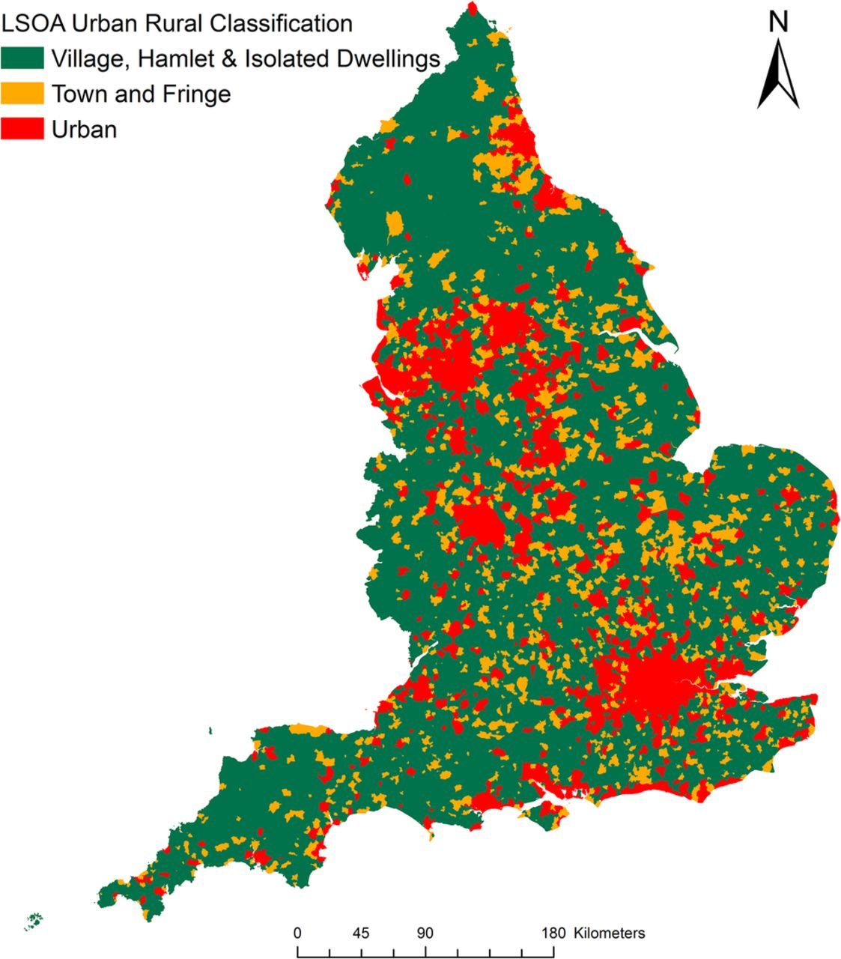

NHS DIGITAL (2022) / Map of England

The LSOA (Lower Layer Super Output Area) Urban-Rural Classification categorizes areas in England by settlement type, ranging from urban towns a fringe area to villages, hamlets, and isolated dwelling. In 2022, the NHS used this classification to help analyse healthcare access and population distribution.

NHS Equality, Diversity, and Inclusion/Quiz.

- What is the primary goal of the NHS Equality, Diversity, and Inclusion Improvement plan?

Bye tackling systemic inequities and guaranteeing fair treatment and opportunities for all employees, the NHS Equality, Diversity, and Inclusion (EDI) Improvement Plan aims to establish a more inclusive and equitable NHS workforce.

- How does the NHS EDI Improvement Plan propose to tackle the gender pay gap?
The NHS EDI Improvement Plan suggests addressing the gender pay gap by encouraging fair hiring, carrier advancement, and compensation policies as well as by boosting accountability and transparency through frequent reporting and monitoring.

- What is the meant by the term’ intersectionality’ as used in the NHS EDI Improvement Plan?

The term “intersectionality” describes how a person’s ethnicity, gender, sexual orientation, and disability combine to produce overlapping experiences of disadvantage or discrimination within the NHS.

4) What is the important to the NHS to create a psychologically safe work environment ?

Employees are more likely to speak out, share ideas, and voice concerns in a psychologically safe workplace, which enhance teamwork, employee well-being,
and patient care results.
5) How does the NHD EDI Improvement Plan suggest improving the experience of internationally recruited staff?

The NHS EDI Improvement Plan Recommend enhancing the experience of foreign-hired employees through equitable career advancement opportunities, continuous assistance, inclusive onboarding, and discrimination prevention.

- What role does leadership play in advancing EDI objectives according to the NHS Improvement Plan?
The NHS Improvement Plan states that by setting an example of inclusive behaviour, taking responsibility for advancement, and integrating EDI into organisational culture and decision-making procedures, leadership plays a crucial part in achievement EDI goals.

- Identify one way the NHS EDI Improvement Plan aims to reduce health inequalities within the workforce?
By providing equitable recruiting, development, and promotion opportunities for employees from all backgrounds-especially those from under-represented group-the NHS EDI Improvement Plan, seeks to lessen health disparities which the workforce.

- Why does the NHS EDI Improvement Plan emphasise the importance of collecting and analysing data on protected characteristics?
The Plan places a strong emphasis on gathering and examining data on protected characteristics to spot inequalities, track advertisements, and create focused initiatives that support inclusion and equality among NHS employees.

- Explain how flexible working policies can contribute to equality and inclusion in the NHS workforce?

By addressing a range of demands, including caregiving duties, impairment, or religious practices, flexible working rules can enhance equality and inclusion in the NHS workforce and make the workplace more accessible and encouraging for all employees.

- What is one strategy mentioned in the NHS EDI Improvement Plan to combat bullying and harassment in the workplace?

Increasing accountability by making sure managers and leaders respond quickly and effectively to reports of bullying and harassment is one tactic outlined in the NHS EDI Improvement Plan.

A letter to Yourself

There passed me!

You were full of doubt and uncertainty when you started your Health and Social Care degree two years ago. It felt like you know so little, and it was overwhelming to enter a new system in the UK. However, as someone who survived, I am writing to you today with pride and encouragement.
Emotional intelligence might have assisted you in controlling the anxiety and self-doubt TO frequently experienced back then. In health and social care where empathy, active listening, and emotional regulation are crucial, it is crucial to comprehend both your own and older people’s feeling (Goleman, 1995). You could have provided yourself with better support during trying times an act if you had understood how to think radar then react.
Additionally, you were developing resilience without even recognising it. You gained the ability to adjust and mature each time you come up, even when it was challenging. Developing resilience entails viewing obstacles as chances rather than failures (Windle,2011). It might have served as a reminder that you passion-helping people via strength, food, and fitness-was worthwhile despite the challenges of learning and developing.
Your confidence has grown now that you have 20 years of experience under your belt and our bright future as a yoga instructor and therapist.
Continue utilising resilience and emotional intelligence to support orders as well as to take care of yourself. You are a living example of the possibility to growth. Web pride and care, your future self! Thank you.

GANTT CHART

 | Goals and Task | Description | Timeframe  (Months) | Timeframe  (Years)
1 | Research CPD opportunities | Identify accredited course on inclusive yoga, fitness, mental health and nutrition | 1 -2 | x
2 | Attend professional workshop | Register for chosen CPD or certification programmes | 3 -4 | x
3 | Enrol in specialised training | Participate in yoga, welling and mindfulness session | 4 -10 | x
4 | Apply new learning in practice | Integrate inclusive and holistic strategies into client training | 6 12 | + 1
5 | Develop professional brand | Build online presence, promote service and publish reflective insights | 12 | 1,5
6 | Reflect and evaluate | Use Gibbs (1988) Model to assess professional progress and client outcomes | x | 1
7 | Finish University UWTSD, level 6 | Health and Social Care/Undergraduate | x | 1
8 | Master’s, level 7 | Theoretical knowledge into effective/Postgraduate | x | 2

My objective of becoming a professional yoga trainer and health expert is outlined in a Gantt chart. It entails earnings my degree in Health and a Social Care from university, becoming certified to teacher yoga, and taking part in courses to improve my practical abilities. To obtaining practical experience and hone my leadership, communication, and client- care skills, I have scheduled time for job placements. Future objectives like starting my own wellness practise and pursuing ongoing professional development, are also included in the graphic. This methodical schedule keeps me motivated, organised, and focused on achieving my professional goals.

Making Changes – Report

Report: enhancing mental health in our residential facility, as the manager of a care facility, are you would like to implement a new reform that will enhance our residents’ emotional health. A lot of senior citizens experience anxiety, loneliness, or disconnection. I think we can significantly they quality of life by putting more of an emphasis on their emotional well-being. I intend to implement weekly session for mental well-being to accomplish this. Including one on one time with staff members who have received active listening training, mint fullness exercises, and small group discussion.
To conduct this chance, we will employ Cotter’s 8- Steps Change Model. We will start by generating organ see by sharing first hand accounts and resident input. After that, a group of activity coordination and care providers will be assembled to spare hands that transformation. Together, we will create a vision, make sure staff and families understand it, and began small with experimental project. Basic introduction in empathy, communication, and identifying emotional discomfort will be required to the staff. A qualified triangle will be also present to providing guidance.
Stop resistance brought on by time consistent could be a barrier. To address this, we will demonstrate how improved mental health can less stress-relate actions, Terry Breen seems simply find they work WHO state that emotional health is essential for ageing in healthy way (WHO,2017). Research indicate that is also lower medicine use an and enhance physical health (Age UK, 2020).

Self -Reflection

Using the Gibbs Reflective Cycle to Self-Reflection (1988), I have Learned more about myself and how I can use my experience to benefit the world throughout this program on change- makers and creating a professional brand for sustainable employment. Having practiced yoga for more than 20 years, I have always been a firm believer in its ability to enhance mental and physical health. Through this learning, I become aware of how my love of yoga, exercises, and healthy diet can help prevention, wellbeing, and sustainable lives, all of which can benefit in UK health and social care system.
Emotions – at first, I was not sure how to turn my personal practise into a professional career path? I became more self-assured and motivated as the module went on. I began to see myself, as a change agent who could assist people in taking charge of their health by leading balanced, conscious lives.
Evaluation - Learning about sustainability and professional branding inspired me to consider ways to convey my values of authenticity, balance, and care in my work. I now realise that professional development requires more than just knowledge; it also calls for communication, flexibility, and desire to serve others. My confidence as a future trainer and wellness specialist has increased because of this information.
Action Plann and Condition. I Went to learn more about inclusive practise, mental health, and nutrition in the future. As a yoga, fitness, and wellness trainer who help people achieve long-term health and harmony, are you want to build a strong and genuine professional brand. (Gibbs, 1988).

Reference
Age UK. (2020). The Importance of emotional wellbeing. https://www.ageuk.org.uk/
Deloitte (2025) Virtual health and telemedicine in rural areas. Available at: Deloitte Insights (accessed,15.10.25).
Dorota (2025), Screenshot showing a healthy food preparation, sandwiches and pickles. Screenshot,16 November 2025.
Goleman, D. (1995). Emotional Intelligence. New York: Bantam Books.
Greenwood, D., et al. (2020)’Telehealth and Rural Healthcare Access’, Journal of Telemedicine and Telecare,26 (4), pp.243-248.
Granovetter, M.1973.The strength of weak ties. American Journal of Sociology,78 (6), pp.1360-1380.
Mind Tools. (2023) Personal Branding: Crafting an Image to Match Your Career Aspirations. Available at: https://www.mindtools.com.
NHS Digital (2022) Map showing rural versus urban access to GP in the UK: LSOA Urban Rural Classification. [Image]. Available under CC BY-NC licence.
NHS Digital. (2022) Digital Transformation in Health and Care.
Available at: https://digital.nhs.uk/
Putnam, R.2000.Bowling Alone: The Collapse and Revival of American Community. New York: Simon and Schuster.
Prospects. (2023). How to build your personal brand. Available at: https://www.prospects.ac.uk
Walker, D. (2020). The power of personal branding. Harvard Business Review.
Windle, G. (2011). What is resilience? A review and concept analysis. Reviews in Clinical Gerontology,21 (2),152-169.
World Health Organization. (2017). Mantal health of older adults. https://www.who.int/news-room/fact-sheets/detail/mental-health-of-older-adults
Smith, R., et.al. (2021) ‘Impact of Telemedicine on Rural Health’, MJ Open,11 (3),

