

Postgraduate/Distance Learning
Assignment coversheet & feedback form

THIS SHEET MUST BE THE FIRST PAGE OF THE ASSIGNMENT YOU ARE SUBMITTING (DO NOT SEND AS A SEPARATE FILE)

For completion by the student:
Student Name: Steven Burr

Student University Email: 2206586@student.uwtsd.ac.uk
Module code: HPCA7015  Module title: Foundations in Cultural Astronomy and Astrology | Student ID number:  2206586 |  |  | Educational support needs:  Yes/No
Assignment title: Essay Based on a Sky Journal
Assignment due date: 1 December 2022
This assignment is for the 1st 2nd 3rd 4th 5th 6th module of the degree
I confirm that this is my original work and that I have adhered to the University policy on plagiarism.
Signed ……………………………………………………………
Email submission:if you are submitting this form via email, please tick this box X
(as a substitute for your signature) to confirm that you agree to the above declaration.
Assignment Mark
1st Marker’s Provisional mark
2nd Marker’s/Moderator’s provisional mark
External Examiner’s mark (if relevant)
Final Mark

NB. All marks are provisional until confirmed by the Final Examination Board.

For completion by Marker 1 :
Comments:

Marker’s signature: |  |  | Date:
For completion by Marker 2/Moderator:

Comments:

Marker’s Signature: |  | Date:
External Examiner’s comments (if relevant)

External Examiner’s Signature: |  | Date:

University of Wales Trinity Saint David
Institute of Humanities and Education

Foundations in Cultural Astronomy and Astrology
HPCA7015
Essay Based on a Sky Journal
The Night Sky
(Word Count: 2149)

Submitted by
Steven Burr
2206586
2206586@student.uwtsd.ac.uk

Submitted to Professors:
Dr. Nicholas Campion
Dr Bernadette Brady
Dr Darrelyn Gunzburg

Date of Submission
December 1st, 2022

Introduction
Anyone seeing the wonders of Saturn’s rings for the first time can become awe struck. I can attest to this fact myself. At sixteen, I purchased my first telescope and trained it on Saturn and what an amazing revelation it was! From this point on, I was hooked. Artists throughout history have also marvelled at the night sky. Van Gogh for example painted the Starry Night, one of the most famous paintings around. The following essay is based upon my written and photographic observations of the night sky taken during the period September 9th, to October 29th, 2022. In this composition, I will delve into my observations and impressions as it relates to Van Gogh’s statement, ‘Be clearly aware of the stars and infinity on high. Then life seems almost enchanted after all.’ Gogh, Vincent van, and Ronald de Leeuw. The Letters of Vincent Van Gogh. London: Penguin Books, 1997, p.392. Taken into consideration is the viewpoint of an amateur astronomer and that of the post-impressionist painter as it relates to the night sky. For clarity, I have divided this essay into the following parts: the painter, the observer, observations, and Interpretations.
The Painter
Vincent van Gogh was a Dutch post-impressionist painter (1853 – 1890). During his lifetime, he wrote many letters to his brother Theo. In one such letter dated 11 August 1888, Vincent wrote the statement, ‘Be clearly aware of the stars and infinity on high. Then life seems almost enchanted after all’. But how did Van Gogh interpret or think of the night sky? His most famous night painting ‘Starry Night’ is one of the best-known paintings in the world. In referring to Van Gogh, the author known as “B” states, ‘The swirling sky, the sun-bright moon, the milky way turned to comets, the exploding stars-these reveal the unique and overwhelming vision of a mystic, a man in ecstatic communion with heavenly forces’. Soth will argue that , ‘the Starry Night is a religious picture, a sublimation of impulses that, since Van Gogh’s loss of faith in the Church, could not find their outlet in conventional Christian imagery’. However, as Gedzelman sees Van Gogh. ‘His astronomical paintings are not literal renditions of the sky at any given place or moment, but they do legitimately represent the night-time sky’. Gedzelman also went on to explain, ‘The other is the more famous Starry Night. It was in these that he first revealed the plastic nature of the universe. We have a wide range of thought concerning Van Gogh’s view of the night sky from communion with nature, religious expression to legitimate representations.

The Observer
As the observer, I can be considered an amateur astronomer, almost to the point of astrophilia. My love of the night sky goes back to my childhood, and yes of course, the influence of the TV series Star Trek. My first telescope was a three-inch reflector. The mount was cheap and cumbersome, but the scope provided great views of the moon, Jupiter, and Saturn. Since that time, I have joined the Royal Astronomical Society of Canada (RASC) and have become active in the local amateur astronomy community. My interest has grown over the years to include astrophotography.
All observations were taken from a location in Prince Edward County (PEC), Ontario - 43°56’ 11” N 77° 00’ 40” West at 80 m above sea level. The night sky in this area is rated Bortle Class 3 – rural sky. All observations were made visually while the photographs were taken with an 8” Schmidt Cassegrain Telescope (SCT), 2x Barlow lens, Mallincam DS16C CMOS colour camera on an equatorial mount for planets, or an 11” RASA astrograph, Mallincam DS16C CMOS colour camera and equatorial mount for wide field pictures. Observation details were recorded in my observation logbook.
The Observations
September 9th, 2022. The harvest moon was shining bright at 99.60% illumination, at 2048 hrs (L). Situated in Aquarius, it displayed a reddish glow as it rose close to the Southeastern horizon (See Fig 1 below). In accordance with the Farmer’s Almanac, ‘the Harvest Moon relates to the timing of the autumnal equinox (September 22, 2022), with the full Moon that occurs nearest to the equinox being the one to take on the name “Harvest Moon”. The rising moon was spectacular this evening and the weather was perfect for observing. Saturn at 21:33 hrs (L) was situated in Capricornus (Fig 2), while Jupiter was just breaking the Eastern horizon in Pisces. The Milky Way was arching from the NE to the SW, with Cygnus, Lyra, and Aquila almost directly overhead.
I see the universe as a magnificent display of light, a milky band and moving planets, but how did Van Gogh see it? In referring to the painting Starry Night, David Levy states, ‘Van Gogh confronts his universe with celestial objects marked of contrast; the sharp most violent images of Moon and stars, the silent dagger of the cypress tree, all opposed by the graceful swirls of the Whirlpool’. There is indeed contrast in the universe as depicted by Van Gogh, however as I see it, the cypress tree and church spire are directing or focusing our view towards the heavens. I certainly don’t see the image as violent, but in motion and mysterious as the heavens are.
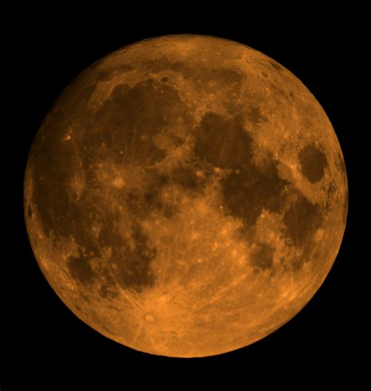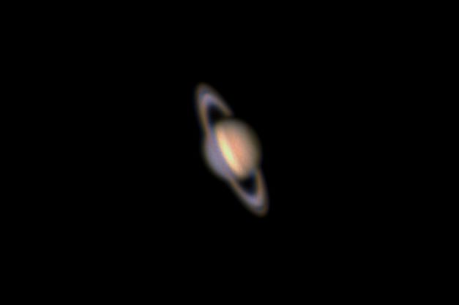
Fig. 1 - Harvest Moon Fig. 2 - Saturn

September 24th, 2022. M31 Andromeda Galaxy in the Constellation of Andromeda was almost directly overhead and a mere hazy smudge to my eyes. It is a spiral galaxy and a close neighbour of the Milky Way, see fig 3 for a close up. Van Gogh displayed swirling imagery in his painting Starry Night similar to that of Andromeda and the Pleiades, see fig 5. M45 Pleiades an open cluster is just coming into view out of the East with Mars trailing below it. See fig 4 below for a picture of this cluster. The Ojibwe refer to this cluster as Bagone’giizbig (hole in the sky) as the seven primary stars relate to the seven poles used to make the shaking tent, a spiritual doorway. The Ojibwe and their star knowledge was an important connection to the heavens. This connection also seems to coincide with Van Gogh’s view, ‘Be clearly aware of the stars and infinity on high’. We can also note the swirling imagery of the Pleiades similar to Van Gogh’s work.
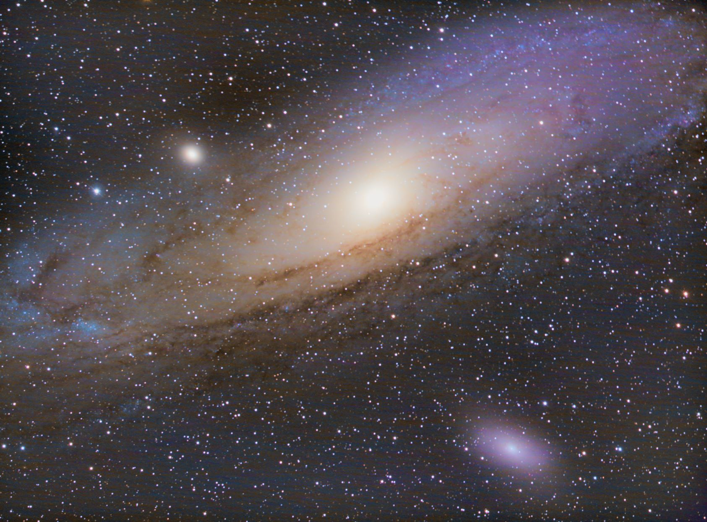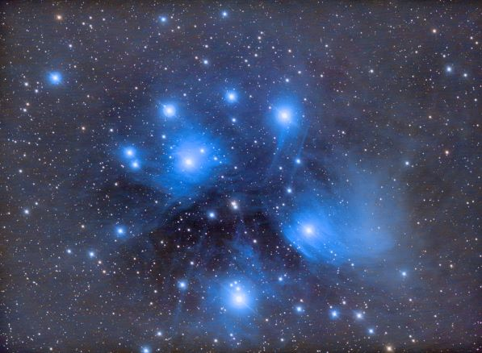
Fig 3 – M31 Andromeda Fig 4 – M45 Pleiades
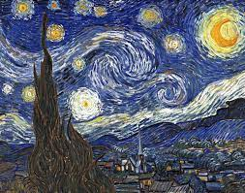
Fig. 5 - Starry Night.
October 2/3, 2022. The First quarter Moon appeared with a disk illumination 50.05%. Located in Sagittarius, the moon was ripe for picture taking, see fig 6. The quarter moon is amazing to photograph with the terminator casting shadows upon the lunar surface. It is almost hypnotising. Jupiter at 01:30 hrs (L) on October 3rd, was in Pisces. It is high enough in the sky now to be photographed, see fig 7. Jupiter is always an interesting object to view with its swirling cloud bands and eddies. Again, we can see similarities in Vah Gogh’s work. It is as if, Van Gogh saw this swirling nature in the cosmos with his own eyes. His statement, ‘Be clearly aware of the stars and infinity on high’, seemed to point his brother to the night sky and all its beauty. This I can attest to, lying back and looking up at the millions of stars shining above me each with their own system of planets is something to be aware of and orienting us to our place in the cosmos. Thus, realizing our own insignificance, life does indeed seem almost enchanted after all!
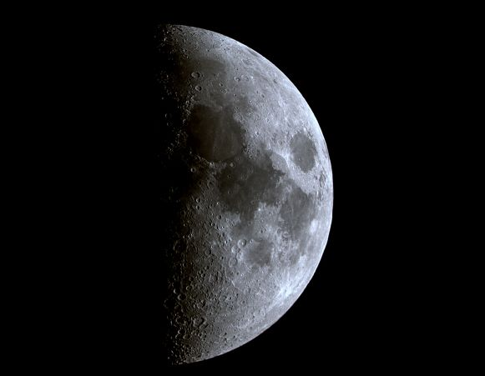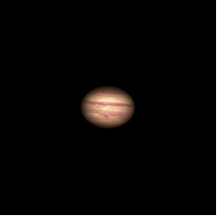
Fig. 6 – First Quarter Moon Fig. 7 – Jupiter

11 October 2022. The sun has set revealing Saturn in Capricornus and Jupiter is dazzling in the Southeast while the wanning gibbous moon shines brightly. I am certainly enchanted with the night sky and accept myself as living within a cosmic system similar to the thoughts of Lucien Lévy-Bruhl. It is certainly not a hierophany as outlined by Mercea Eliade, ‘the break in the homogeneity of space’, but I do find a personal orientation as the night sky reveals itself to me. In the end I must confess I am beguiled by it all.

22/23 October 2022. Jupiter was even higher in the sky, and still located in Pisces. In fig. 8, Jupiter can be seen with two of its moons. While Saturn was making its move westward it was located in Capricornus. Mars appeared later at 0146 hrs (L), in Taurus. See fig 9 for a pic of the Roman god of war. It was not a great night for photography as the wind was steady, vibrating the scope. The constellations of Perseus and Auriga, my old friends, have returned to the heavens, and I was treated to a display of falling stars streaking across the sky. The Milky Way is now stretching from the SE to NW across the sky as the fall season progresses. In accordance with Olcott, ‘The ancient Akkadians regarded the Milky Way as “a Great Serpent,’ or “the River of the Shepherd’s Hut,” and “the River of the Divine Lady.” Olcott goes on further to explain that the most popular notion of the Milky Way is that of a Highway amid the stars for the souls of the departed. Maybe that was what Van Gogh was trying to express with his swirling imagery, connection to the divine.

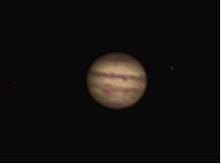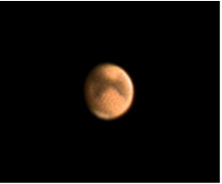
Fig. 7 – Jupiter Fig. 8 – Mars

29th October 2022. A lovely waxing crescent moon illuminated at 24.45% (see fig 9). We can see similarities with Van Gogh’s painting Starry Night (fig 5) and my photo of the moon albeit reversed. Jupiter is still shinning brightly, and it would have been an excellent target however, I was using a wide field scope due to the quickly setting moon and lack of moonshine for the night. In accordance with Levy, it has been pointed out that Van Gogh’s painting is similar to Lord Rosse’s 1845 drawing of Messier 51, which Van Gogh would have been familiar with. Maybe this drawing of Lord Rosse had an impact on Van Gogh. I’ve included an old shot of M51 as this galaxy was not in a position to be photographed that night (fig 10). Van Gogh’s swirling imagery matches the reality of the cosmos and in doing so, makes us aware of the stars and infinity on high and thus our connection to it. His letter to is brother subsequently reinforces this notion.

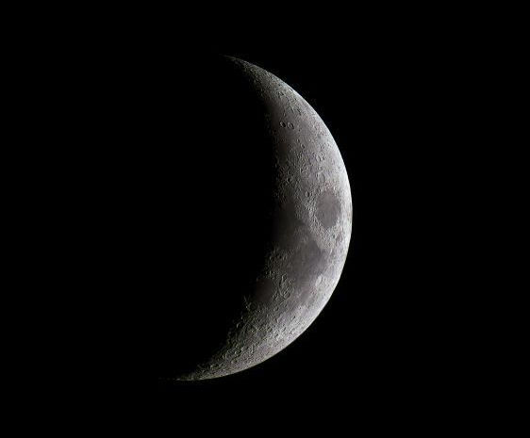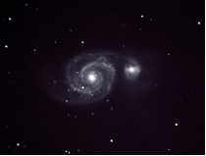
Fig. 9 - Waxing Crescent Moon Fig. 10 - M51

Interpretation
As I interpret Van Gogh’s statement, ‘Be clearly aware of the stars and infinity on high. Then life seems almost enchanted after all’, it becomes apparent to me through my observations, that paying attention to the night sky allows one to connect to and orient themselves to their place in the universe. It is this realization of our place in the universe which allows us to perceive life as being enchanted. Van Gogh through his art and letters, appears to be echoing Plato, ‘the God invented sight and gave it to us so that we might observe the orbits of intelligence in the universe and apply them to the revolutions of our own understanding’. It is through our observing the night sky we can place ourselves within creation for a better understanding of ourselves. We are no longer separate from the universe, but part of it swirling through space and time as a participatory being. The enchantment I experience is therefore similar to what Willis and Curry outlined, ‘It is an experience of the world as intrinsically meaningful, significant, and whole in a way that is fundamentally mysterious and includes oneself, not observing it from the outside but participating in it’. Life still holds mystery, and it is this gaze into the abyss of space that allows my sense of participation.
I am also partial to Gedzelman’s view of Van Gogh’s work. As Gedzelman states, ‘His inimitable and highly personal distortions attract us all the more because they are rooted firmly in empirical observations. Although they may momentarily distract us from the world of nature, in the end they provide us with fresh insights and new tools for seeing vigor, beauty and wonder in the world about us, when before we may have gazed only dimly with desensitized eyes’. Van Gogh in his letter to his brother and through his paintings point our attention to that of the night sky, its mystery and its beauty. Hopefully in doing so, one can rejoice in their enchanted life and openly participate in its magic.

Bibliography

Gogh, Vincent van, and Ronald de Leeuw. The letters of Vincent Van Gogh. (London: Penguin
Books, 1997), P.392.

B. “Van Gogh’s ‘Starry Night.’” The Bulletin of the Museum of Modern Art 9, no. 2 (1941): 2–3.
Available from: https://doi.org/10.2307/4057833.

Soth, Lauren. “Van Gogh’s Agony.” The Art Bulletin 68, no. 2 (1986): 301–13. Available from:
https://doi.org/10.2307/3050939.

Van Gogh Museum [online]. Vincent’s Life, n.d. [cited 26 October 2022]. Available from:
https://www.vangoghmuseum.nl/en/art-and-stories/vincents-life-1853-1890

Gedzelman, Stanley David. “The Meteorological Odyssey of Vincent van Gogh.” Leonardo 23,
no. 1 (1990): 107–16. https://doi.org/10.2307/1578474.

Light Pollution Map [online]. N.d. [cited 26 October 2022]. Available from:
https://www.lightpollutionmap.info/#zoom=6.00&lat=43.7920&lon=-
76.6216&layers=B0FFFFFFFTFFFFFFFFFFF

Burr, Steven. “Astronomy Logbook” (PEC, 2022), Sep – November 2022.

Lee, Annette, and others, Ojibwe Sky Star Map Constellation Guide, (North Rocks, CA:
Lightning Source-Ingram Sparks, 2014)

Schaaf, Fred. ‘What is the Harvest Moon’, Almanac, 9 August 2022 [cited 26 October 2022],
Available from: https://www.almanac.com/what-harvest-moon

Van Gogh, Vincent. Starry Night. Available from: https://www.vangoghmuseum.nl/en/art-and-
stories/stories/where-is-the-starry-night

Olcott, William T., Star Lore of All Ages: A Collection of Myths, Legends, and Facts Concerning
the Constellations of the Northern Hemisphere (New York: G.P. Putnam’s Sons, 1911)

Levy, David H., Starry Night: Astronomers and Poets Read the Sky, (New York: Prometheus
Books, 2001)

Lévy-Bruhl, Lucien. The Notebooks on Primitive Mentality Trans. Peter Riviére (San Francisco:
Harper & Row Publishers, 1975)

Eliade, Mircea, The Sacred and the Profane: The Nature of Religion (New York: Harcourt,1959)

Plato, Timaeus, ed. John M. Cooper, trans. Donald J. Zeyl, ed., Plato Complete Works
(Cambridge: Hackett Publishing Company, 1997)

Willis, Roy, and Patrick Curry, Astrology, Science and Culture: Pulling down the Moon (New York: Berg
Publishers, 2004)

Van Gogh Museum [online]. Vincent’s Life, n.d. [cited 26 October 2022]. Available from: https://www.vangoghmuseum.nl/en/art-and-stories/vincents-life-1853-1890
Vincent van Gogh, and Ronald de Leeuw. The letters of Vincent Van Gogh. (London: Penguin Books, 1997), P.392.
B. “Van Gogh’s ‘Starry Night.’” The Bulletin of the Museum of Modern Art 9, no. 2 (1941), 2–3 (p. 3).
Lauren Soth. “Van Gogh’s Agony.” The Art Bulletin 68, no. 2 (1986): 301–13 (p. 302).
Stanley Gedzelman, “The Meteorological Odyssey of Vincent van Gogh.” Leonardo 23, no. 1 (1990), 107–16 (108).
Gedzelman, 107-116 (p. 110).
Light Pollution Map [online]. N.d. [cited 26 October 2022]. Available from: https://www.lightpollutionmap.info/#zoom=6.00&lat=43.7920&lon=-76.6216&layers=B0FFFFFFFTFFFFFFFFFFF
Fred Schaaf. ‘What is the Harvest Moon’, Almanac, 9 August 2022 [cited 26 October 2022], Available from: https://www.almanac.com/what-harvest-moon
David H. Levy, Starry Night: Astronomers and Poets Read the Sky, (New York: Prometheus Books, 2001), p. 44.
Annette Lee, and others, Ojibwe Sky Star Map Constellation Guide, (North Rocks, CA: Lightning Source-Ingram Sparks, 2014), p. 22.
Vincent van Gogh, and Ronald de Leeuw. The letters of Vincent Van Gogh. (London: Penguin Books, 1997), P.392.
Vincent Van Gogh. Starry Night. Available from: https://www.vangoghmuseum.nl/en/art-and-stories/stories/where-is-the-starry-night
Vincent van Gogh, and Ronald de Leeuw. The letters of Vincent Van Gogh. (London: Penguin Books, 1997), P.392
Lucien Lévy-Bruhl, The Notebooks on Primitive Mentality Trans. Petr Riviére (San Francisco: Harper & Row Publishers, 1975), p. 134.
Mircea Eliade, The Sacred and the Profane: The Nature of Religion (New York: Harcourt,1959), p. 21
William Olcott T., Star Lore of All Ages: A Collection of Myths, Legends, and Facts Concerning the Constellations of the Northern Hemisphere (New York: G.P. Putnam’s Sons, 1911), p. 391.
Olcott, p. 392.
Levy, pp. 42-43.
Vincent van Gogh, and Ronald de Leeuw. The letters of Vincent Van Gogh. (London: Penguin Books, 1997), P.392
Plato, Timaeus, ed. John M. Cooper, trans. Donald J. Zeyl, ed., Plato Complete Works (Cambridge: Hackett Publishing Company, 1997), 47b-c.
Roy Willis and Patrick Curry, Astrology, Science and Culture: Pulling down the Moon (New York: Berg Publishers, 2004), p. 88.
Gedzelman, 107-116 (p. 116).

