

Student name: Bozica Katic
Student ID: 2008115

Module name: Complementary Therapy
Module code: BMHP5001_LON
Lecturer name: Mentesnot Mengesha

Table of contents

- Introduction ………………………………………………. 1
- History, Uses, Efficacy and Contraindications
  - History …………………………………. 2
  - Uses ……………………………………. 2
  - Efficacy ………………………………… 4
  - Contraindications ……………………… 6
- Self-regulatory Systems …………………………………. 7
- Ethical considerations ……………………………………. 7
- Recommendations ……………………………………….. 8
- Conclusion ………………………………………………… 8
- References ………………………………………………...10
- Appendix …………………………………………………...12

- Introduction

Complementary therapy is the name for all types of therapies used as an adjunct to the treatments of conventional medicine to improve the health and well-being of patients. It has a holistic approach to the patient because, in addition to acting on the visible physical body, it also acts on the invisible social, environmental, mental, emotional, and spiritual body of the patient. We must not confuse complementary medicine with alternative medicine because these are two different concepts. While complementary medicine serves as an adjunct to conventional medical treatments and is often used on the recommendation of physicians and under the supervision of a practitioner, alternative medicine serves as a substitute for conventional medical treatments. It is used independently of conventional medicine. Patients use it as an alternative to conventional medicine in cases when they are dissatisfied with the results of conventional medical treatments. Nowadays, the most commonly used complementary therapies are: acupressure, traditional Chinese medicine (acupuncture and tai chi), Alexander technique, aromatherapy, autogenic training, Ayurveda, chiropractic, herbal medicine, homoeopathy, hypnosis, massage, meditation, nutritional therapy, osteopathy, reflexology, reiki, relaxation and visualization, native American healing (storytelling, music, plants …) shiatsu, therapeutic touch, yoga … Many complementary therapies are based on the belief that the body can only heal itself and maintain a healthy state if it is in the right conditions; the whole person should be treated not only the disease or its symptoms; it takes some time to establish balance in the body, so there is no quick recovery; the use of natural substances for healing instead of synthetic substances. Nowadays, although they are introduced as additional methods of treatment, many types of complementary therapies are not statutorily regulated. Only two are regulated: chiropractic and osteopathy. They are legally recognized and have their statutory regulatory bodies - General Councils. All others have voluntary registers of practitioners or professional associations that practitioners can join if they wish.
As a long-term practitioner (over 30 years of daily practice) of integral meditation, I chose to write about meditation as a complementary therapy. Although, I would like to emphasize here that, meditation is also used by healthy people as a technique of spiritual development, ie as a method of maintaining spiritual hygiene.

- History, Uses, Efficacy and Contraindications

  - History

We cannot know when the history of meditation begins, but it is believed that people in India practised it for more than 5000 BC. The first written evidence is in the Vedas around 1500 BC. The Hindu tradition explains meditation as a method of removing irrelevant knowledge and acquiring higher (hidden) knowledge, enlightened wisdom, and union with God. At that time, learning and knowledge were transmitted orally. In the 6th and 5th centuries BC, other types of meditation developed, such as Chinese and Buddhist Indian. In the Middle Ages, some religions introduced a meditative approach to prayer. In the 12th century, Sufi practitioners included the repetition of sacred words and breath control in their meditative prayers. Later, both Eastern and Western Christianity also introduced some elements of meditation into their practice. Herein lies the main reason why many people, even today, identify religiosity with the human need for spirituality, although these are two opposite concepts. Humans may or may not be religious. It is a matter of choice, belief, upbringing, or habit. Humans can believe in whatever they want: in Goddess, God, love, fire, partner, children, etc. Human spirituality is the highest need of every human being and is at the very top of Abraham Maslow's triangle needs. He calls it "self-actualization" and explains that human becomes more aware of it after satisfying all "lower needs". And that is common to all people of all religions as well as people who are not religious. The growing interest of Western countries in East meditative techniques began to grow again in the 1960s. Some people have shifted their interest from a limited religion to their own experience of meditation and transcendental states of consciousness. Nowadays, meditation has been introduced into conventional medicine as an adjunct, complementary therapy in the treatment of stress-related illnesses.

  - Uses

There are many different types of meditation (mindfulness, transcendental, integral, loving-kindness, yoga, breath meditation and others) that are practised. It is a skill that is improving over time. Meditation is a deep inner journey that benefits our emotional growth and makes us discover something new about ourselves and human inner power (Kornfield,2021). It can be practised individually and in a group. When we say meditation, the first association is a static sitting position of the body with eyes closed. It is a static, male type of meditation. But there is also a female type of meditation and that is meditation in motion or dance! Dance movement is well-known psychotherapy that can improve quality in all fields of life (Lindberg, 2021). Meditation is available to anyone and everywhere. Meditation costs nothing, and along with physical activity and a healthy diet, it helps for human wellbeing (Lauche, R. et al. 2016). It can be learned by attending a beginner's course, reading instructions, listening to practitioners' experiences, or simply closing your eyes and starting to meditate. The technique seems so simple and is very difficult for a beginner. The essence of meditation is to calm the mind and achieve a conscious state of mind without thoughts. This is the main benefit of this practice and also a fundamental goal. The mind reaches a state of relaxation which positively affects the body. For that reason, thanks to meditation, worries go away and repetitive thoughts are gradually put aside. This is the hardest part of meditation and that is why many give up.
The following table shows the results of scientific research from 2012 in the US, National Health Interview Survey (NHIS), on why people practice meditation, (a, b), health care provider interaction (d), and information sources (c).
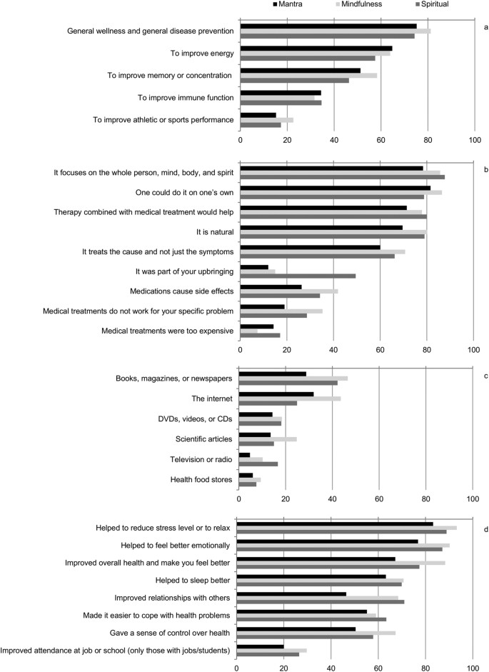
(Cramer et al, 2016)

  - Efficacy

Meditation, as Complementary therapy, together with Relaxation, Guided imaginary and Hypnotherapy belongs to the mind-body technic. This means that the body and the mind are one whole and that every change in the mind results in a change in the physical and emotional body. Scientific research is being carried out to prove the role of meditation in improving people's general health, leading to the treatment of some challenging diseases (George et al, 2019). Improving mental health, according to some research, can be achieved by practising yoga, conscious breathing, and meditation (YoBaM). Over the past decade, the rate of practitioners of yoga, conscious breathing, and meditation has increased significantly in the U.S. population (Schröter, 2021). Meditation is the fastest growing health trend in America. In 2012, 9,5% population practised yoga and 4,1% meditation, while in 2017, 14,3% practised yoga in the last 12 months, and 14,2% used meditation (Tlalka,2018). The meditation application market is expected to grow to $ 4,377.95 million by 2027 (Cramer et al, 2016).

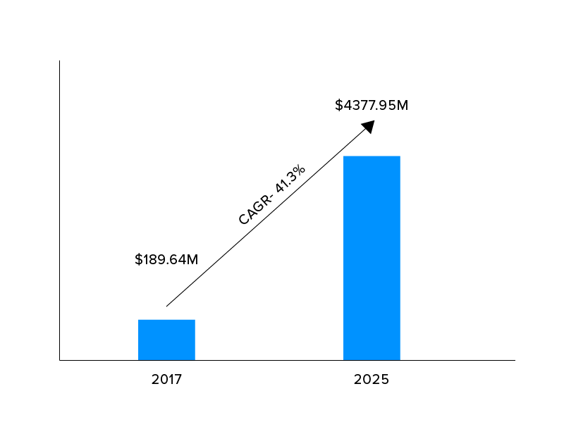

Some confirmatory research has also been conducted that meditation therapy helps to treat perpetrators of crimes: improving mental well-being, reducing substance use, and reducing recidivism (Himelsten, 2010).
Many people use meditation to relieve stress and reduce anxiety (Yogi, 2019). It can help eliminate negative thoughts and improve depression. Self-examination and related meditation styles can help you "know yourself." This can be a trigger for other desirable changes. Meditation may improve concentration and focus, and it can improve mental clarity and memory, so it is good for slowing down risk factors of aging and for dementia (Chetelat et al, 2018). Some types of meditation can increase the level of positive feelings towards yourself and others which increases empathy and compassionate behaviour. Meditation increases the grey matter of the brain in the hippocampus, where the mechanisms of memory and learning begin (Rakocevic, 2021) Meditation increases awareness and can help raise awareness of harmful unconscious reactions such as unhealthy eating, various types of addictions and unwanted habits. Also, meditation can improve sleep quality, it can reduce the perception of pain in the brain, which can help treat chronic pain when used as an adjunct to medical care or physical therapy. Blood pressure decreases during meditation, and for those who meditate regularly after. It helps prevent heart disease (Healthline,2020). One of the easiest effects of meditation is to release the tension on a physical and emotional level. Meditation in particular helps the body to be filled with energy. Staying calm while meditating relaxes, calms the mind and our body benefits from enjoying a moment of calm and relaxation.

2.4. Contraindications

The appearance of contraindications occurs at the very beginning of the practice of meditation and then the symptoms are strongest. Many practitioners are confused because meditation seems to do them more harm than good. Instead of the expected beautiful feelings, harmony with oneself, inner peace, and balance, as by-products there is confusion in the mind, vague and painful feelings, painful memories, difficult dreams, and even psychosomatic symptoms. This happens because in meditation we consciously direct our attention to our inner world which brings us into contact with the unconscious and repressed contents of our mind and body. And it's not just beautiful there. Many things that are painful, painful, and traumatic have been suppressed. We all have such content only in different intensities. By directing our attention inwards, we come into contact with repressed content. Thus, meditation leads us to the "bottom" of our minds. When unconscious contents are raised to the conscious mind some people get lost carried by heavy feelings that they do not understand where they come from or what to do with them. Meditation is a powerful technique, so these phenomena are often powerful. Therefore, for beginners, a few hours of psychotherapy or coaching is desirable to understand and arrange their inner contents that come to the surface through meditation. With long-term proper meditation, the intensity of these contraindications decreases, and the benefits increase. This can take several years. Many people give up meditation because they are not patient enough in anticipation of the desired results.
After, any negative side effect of meditation can only occur if the meditation is done incorrectly. It means mental strain or resistance to thoughts that try to stay concentrated. This effort prevents the mind from spontaneously moving towards self-awareness - the goal of meditation. If the practitioner is emotionally upset before starting the meditation, then it is best to lightly practice breathing or pranayama (a specific method of breading) for a few minutes to calm the mind and start the meditation. While meditating, not recommended to suppress thoughts or feelings. If the practitioners feel that has stopped meditating, need simply and effortlessly return their mind to practice.

- Self-regulatory Systems

Meditation can be characterized as self-taught, self-regulated and hidden health treatment available to every individual. It gives the greatest benefits when practised in primary prevention. Meditation is also used by patients with chronic health problems as a holistic approach to chronic health care. Because there are many different types of meditation the understanding of the concept of meditation can vary from person to person. Therefore, in meditation, as in most other complementary therapies, there is the problem of standardization. This shortcoming is a problem for the medical community as it makes it difficult to establish fixed guidelines and General Counsel. For patients to feel safe when they use meditation for medical purposes, formal regulation is needed. Greater regulation of complementary medicine is needed to ensure its safe use. I'm sure that the principles on which the regulation of conventional medicine is based cannot be a model for the regulation of complementary medicine. Meditation, as a Complementary therapy has not yet gained legal recognition and is not statutorily regulated. It is voluntary self-regulated. There are registries (Federation of Holistic Therapies (FHT), British Register of Complementary Practitioners (BRCP) and Complementary & Natural Health Care Council (CNHC)) or professional associations to which practitioners can join. Some are accredited by the Professional Standards Authority Health and Social Care which regulate their work and has established standards for voluntary and self-regulated complementary therapies (PSA,2021).

- Ethical considerations

Each registry body has its code of conduct, work, and work ethic but the basic principles are common to them. Every practitioner must respect the privacy and dignity of the client, must respect the client's right to be involved in the decision on his care, must be honest and fair in work, must implement good standards of practice and care, must protect clients and colleagues from any kind of damage, must collaborate with colleagues in their own and other professions... Practitioners who teach meditation to others do not have to be registered doctors. It can also be people with personal experience of practising but must work following legal provisions. Since they are allowed to practice medicine without professional education, they are expected to have experience, a high degree of ethics and responsibility in their work and also and work in accordance with legal provisions. If the actions of a person who are not statutory regulated lead to abuse or harm to someone, they are still subject to criminal law (Stone &Matthews, 1996).

- Recommendations

As the use of most complementary therapies has persisted for thousands of years in the nation (sometimes hidden, suppressed, and belittled for lack of scientific evidence), it has its value and today. And researchers are increasingly proving the impact of meditation on the brain, which can make us happier, emotionally resilient, and reduce pain (Urist, 2014). Statistics show that the number of practical meditations in the world is growing from year to year, which is certainly one of the indicators of the effectiveness of its application. For many, meditation is foreign and repulsive because they do not know of it since it is not traditionally practised in their culture. No one taught them about it in school so it’s foreign to them. But when an individual starts meditating, when he gains some experience and insight into the benefits of meditation, he changes his attitude. Many years of meditation practise has improved the quality of my life in every field. Therefore, my recommendation, as a person with many years of experience, is to bring meditation to life as soon as possible. One does not have to wait for the onset of acute or chronic illness for meditation to begin to be practised. It is recommended that meditation be practised 2 times for 20 minutes a day. For me, meditation is the most effective complementary therapy of all.

- Conclusion

Meditation has a thousand-year history. There are several meditation techniques. We can read books on meditation or attend a meditation course and then choose the type that suits us. Meditation is a deep inner journey that benefits our emotional growth and makes us discover something new about ourselves. As future meditation practitioners, we need to be aware of the appearance of contraindications that appear at the beginning and learn to manage them. By practising meditation daily, the contraindications decrease, and the benefits increase. The implication of meditation in clinical practice is a significant contribution of a holistic approach to health care because consciously and intentionally paying attention to oneself is an integral part of the healing process (Shapiro & Carlson, 2017)

- Reference:

Chetelat et al, (2018), Why could meditation practice help promote mental health and well-being in ageing, Alzheimer's Research & Therapy, Available at: https://alzres.biomedcentral.com/articles/10.1186/s13195-018-0388-5#citeas, (Accessed: 20. December 2021)

Cramer, H., et al, (2016), Prevalence, patterns, and predictors of meditation use among US adults: A nationally representative survey, Scientifics reports, Available at: https://www.nature.com/articles/srep36760#citeas, (Accessed: 20 December 2021)
George, A. et al. (2019) Holistic healthcare. Volume 2, possibilities, and challenges. Oakville, ON, Canada; Apple Academic Press
Healthline, (2020), 12 Science-Based Benefits of Meditation, Available at: https://www.healthline.com/nutrition/12-benefits-of-meditation, (Accessed: 19 December 2021)

Himelstein, S., (2010), Meditation Research: The State of the Art in Correctional Settings, International Journal of Offender Therapy and Comparative Criminology, 55(4), p.p. 646-661.

Kornfield, J. and True, S. (2021) Introduction to Mind Like Sky Meditation. Carpinteria, CA: linkedin.com

Louche, R. et al. (2016) ‘Associations between yoga/meditation use, body satisfaction and weight management methods: Results of a national cross-sectional survey of 8009 Australian Women’, Nutrition (Burbank, Los Angeles County, Calif.), 34, pp. 58–64.

Lindberg, S., (2021), What Is Dance Therapy? Very well mind, Available at:
https://www.verywellmind.com/dance-therapy-and-eating-disorder-treatment-5094952, (Accessed: 20 December 2021)
Professional standards authority, (2021), Professional Standards Authority Business Plan 2021/22, Available at: https://assets.publishing.service.gov.uk/government/uploads/system/uploads/attachment_data/file /997020/professional-standards-authority-for-health-and-social-care-business-plan-2021-to-2022-web-accessible.pdf, , (Accessed, 24. December 2021)

Rakicevic, M., (2021), 27 Meditation Statistics for Your Well-Being in 2021, Available at: https://disturbmenot.co/meditation-statistics/, (Accessed: 20 December 2021)
Schröter, M. and Cramer, H. (2021) ‘Prevalence and predictors of yogic breathing and meditation use – A nationally representative survey of US adult yoga practitioners’, Complementary therapies in medicine, 56, pp 102617–102617. Doi: 10.1016/j.ctim.2020.102617.
Shapiro, S.L., Carlson, L.E. and Kabat-Zinn, J. (2017) The art and science of mindfulness : integrating mindfulness into psychology and the helping professions. Second edition. Washington, District of Columbia: American Psychological Association.

Stone, J. & Matthews, J. (1996), Complementary Medicine and the Law, Oxford University press, Available at: https://global.oup.com/academic/product/complementary-medicine-and-the-law-9780198259718?cc=us&lang=en&, (Accessed: 21 December 2021)

Tlalka, S., (2018), Meditation is the Fastest Growing Health Trend in America, Mindful healthy mind healthy life, Available at: https://www.mindful.org/meditation-is-the-fastest-growing-health-trend-in-america/ (Accessed: 20 December 2021)

Urist, J., (2014), We Need to Take Meditation More Seriously As Medicine, Time, Available at: https://time.com/1148/we-need-to-take-meditation-more-seriously-as-medicine/, (Accessed: 20 December 2021)
Yogi, D. (2019) De-stress: Meditation and Movement for Stress Management. Carpentaria, CA: linkedin.com.

- Appendex:

- Female meditation (in motion)


- Male meditation (static)


