  Component One: Student Journal (learning log) 750 words +/- 10%  Contribution to Overall Module  Assessment: 25% | Student No:2219781  Module BMIH4004 James Scott  Module  Code:  Lecturer: JJJames

HIntroduction
The hospitality industry is a dynamic sector that gives the professional full opportunity to grow but it can be only achieved with the help of academic skills (Hoang et al., 2023). Skills like communication, problem-solving, and active listening help professionals to improve their work efficiency. I have included my own experience of learning these skills in this assignment.

Skills required for the Front Desk

Communication Skills
Communication skills are considered to be one of the most important skills for the hospitality management professional (Elshaer and Saad, 2022). The hospitality professional needs communication skills to make effective communication with the customers and the co-workers.
Reflective Account
Description- One day my teacher assigned me a task to prepare a presentation on hospitality management. I have started to prepare my assignment by taking help from different resources. After completing my presentation I submitted my assignment and gave an oral description of my task. My teacher observed the entire presentation and told me that I had to work on both my verbal and writing skills. Communication skills help to express thoughts or knowledge in work workplace (Tavitiyaman et al., 2023).
Experience- I have had the opportunity to recognize my strengths and my weaknesses. According to (Liu et al., 2022) communication skills helps to boost the confidence of hospitality professional. My overall experience regarding this assignment is excellent.
Evaluation- I faced difficulties during the initial part of my assignments when I was preparing my presentation. According to (Cuic Tankovic et al., 2023)writing skills are essential for making effective content and I have realised that I lacked those skills which caused problems during the making of presentation.
Analysis- I have realised that due to a lack of writing a oral skills I have messed up my presentation
Conclusion- This assignment made me realised that I need to improve both my oral and writing skills which will enhance my academic performance.
Action Plan- There are many business management journals related to business communication and writing. I will read them to develop verbal skills and writing skills which will help me to get the front Desk management job at Hotel Premiere Inn.

Active Listening
Active listening skills are necessary skills for hospitality management to hear the queries and demands of the customers. Active listening skills help to listen and understand the problems of others (Stoyanova-Bozhkova et al., 2022).
Reflective account
Description- One day my teacher asked me to attend a class related to sustainable tourism and after that, she assigned me a project. I attended the class and then started to work on my project. I have submitted my assignment but my teacher told me that I have missed some important subtopics that she told me to include in the project. According to (Johnson et al., 2022) active listening skills are important to maintain the quality of work and I have realized that I lack it. Active listening will help me to understand the problems of the customers in the hospitality sector.
Experience- My overall experience regarding the project was pleasurable as it helped me to realize my weaknesses and strengths.
Evaluation- My experience regarding the class t was fine but I have faced some serious problems during the preparation of my assignment.
Analysis- I have understood that I have missed some important points which spoiled my entire assignment.
Conclusion- I have realised that I lack active listening skills and I have decided to improve them by developing an active listening habit.
Action Plan- I will improve my active listening skills by increasing my listening ability, concentration, and memory.

Problem- Solving skills
Problem-solving skills are crucial for solving the problems of the customers in the hospitality industry (Marneros et al., 2022). Problem-solving skills can be developed through reasoning and critical thinking ability.
Reflective Account
Description- I have realised the importance of the problem- solving skills during the course work. One day my teacher assigned me a critical assignment related to customer relationship management. The assignment was full of critical questions and I tried to solve them and submitted the assignment but got poor feedback from my teacher. Problem-solving skills are necessary for solving critical problems in the workplace (Bavik and Kuo, 2022)
Experience- This task was challenging for me But I have been able to learn through my mistakes.
Evaluation- The questions of the tasks were not hard but it required problem-solving ability to answer those questions.
Analysis- I made a wrong answer due to a lack of problem-solving skills which spoiled the assignment
Conclusion- I have realised that I lack problem-solving skills and I have decided to improve it.
Action plan- I have decided to improve my problem-solving skills by taking help from online and offline resources.

Conclusion
This assignment includes a brief account of the skills that I have acquired during the course work and how they will help me to improve my work efficiency. Communication skills can help me to make effective conversations with the customer, listening skills will help me to understand customer's queries and problem-solving skills will help me to solve customer problems.

References
Bavik, A. and Kuo, C.F., (2022). A systematic review of creativity in tourism and hospitality. The Service Industries Journal, 42(5-6), pp.321-359.
Cuic Tankovic, A., Kapeš, J. and Benazić, D., (2023). Measuring the importance of communication skills in tourism. Economic research-Ekonomska istraživanja, 36(1), pp.460-479.
Elshaer, I.A. and Saad, S.K., (2022). Entrepreneurial resilience and business continuity in the tourism and hospitality industry: The role of adaptive performance and institutional orientation. Tourism Review, 77(5), pp.1365-1384.
Hoang, G., Yang, M. and Luu, T.T., (2023). Ethical leadership in tourism and hospitality management: A systematic literature review and research agenda. International Journal of Hospitality Management, 114, p.103563.
Johnson, E.M.S., Thompson, E.G.M. and Paul, N.I., (2022). Preparing the post-pandemic workforce for the cruise and hospitality industry. Worldwide Hospitality and Tourism Themes, 14(2), pp.137-146.
Liu, Y., Liu, J. and King, B., (2022). Intercultural communicative competence: Hospitality industry and education perspectives. Journal of Hospitality, Leisure, Sport & Tourism Education, 30, p.100371.
Marneros, S., Papageorgiou, G. and Efstathiades, A., (2022). Developing Hospitality Management Core Competencies Framework. Hosted By The School of Hospitality and Tourism.
Stoyanova-Bozhkova, S., Paskova, T. and Buhalis, D., (2022). Emotional intelligence: a competitive advantage for tourism and hospitality managers. Tourism Recreation Research, 47(4), pp.359-371.
Tavitiyaman, P., Tsui, B. and Ng, P.M.L., (2023). Effect of Hospitality and Tourism Students’ Perceived Skills on Career Adaptability and Perceived Employability. Journal of Hospitality & Tourism Education, pp.1-12.

Component Two
Contribution to Overall Module Assessment: 25%
Trip Advisor Review Response 150 words +/-10%

Tripadvisor Review
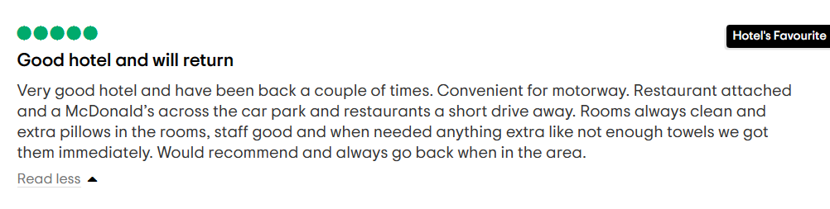
Source: (Tripadvisor, 2022)
The review is very gladly accepted and received from the end of Premier Inn Bridgend Hotel. The services have been maintained completely optimised and seamless to deliver the best guest experience. The location of the hotel offers ease of access and convenience for any sort of transportation. Facilities of eating outlets and car parking have been maintained to enhance the experience of the guests who visit the hotel. The staff here at Premier Inn Bridgend Hotel has maintained the experience to provide and supply guests with everything they need for their convenience (Tripadvisor, 2022). Guests are provided with every need to help them remain happy and satisfied at all moments during their stay and improve their stay experience at Premier Inn Bridgend Hotel. This helps to showcase the brand loyalty towards the guests. Hoping to provide a better experience on the next visit and it would be obligatory if the stay and reviews serve as a referral.
References
Tripadvisor, (2022). Premier Inn Bridgend (M4, J35) Hotel. [Online] Available at: https://www.tripadvisor.co.uk/Hotel_Review-g552073-d570213-Reviews-Premier_Inn_Bridgend_M4_J35_Hotel-Pencoed_Vale_of_Glamorgan_South_Wales_Wales.html#REVIEWS [Accessed 06 October 2023].

Screen shot of referenced Trip Advisor review used:
Letter of complaint response 500 words +/- 1-%

Letter of Complaint Review
Mr. Ronald Federick,
17 Trinity Court,
Swansea SA1 2AR
Date: October 07, 2023
Subject: Response to Letter of Complaint
Sir,
With due respect, Premier Inn Bridgend Hotel thanks you for sharing your reviews and considerations. The hotel regrets all the inconveniences which you had to face and handle during your stay at the hotel. The complaint was received on account of proper standards of food, privacy and noise, and hygiene-related issues. This response is to assure you about the steps to be taken to improve these issues with proper ethical measures to improve the living and service standards at the hotel.
The hotel will be earnestly trying to improve the service standards through effective maintenance, recruitment of better, professional, and dedicated workers, and effective monitoring of the services which are provided to all the guests. It will try its best to prepare strategies and recruit better chefs, waiters, and room attendants who will serve better services to all the customers (Forbes, 2023). The chefs will be recruited as on their knowledge and skills in cooking different foods of different cuisines. The foods cooked will be tasted before it is served to the guests to maintain quality standards while maintaining safety, taste, aroma, and hygiene in the cooking process (Food Standards Agency, 2023). The waiters and room attendants will be recruited and will also be provided with proper training to deliver services effectively to all the guests. They will also be taught to maintain the safety and hygiene standards of the hotel, which would add to an effective guest experience. The hotel will take complete and immediate charge of making improvements in the different fields as reported by you. It is promised to deliver you a better experience and service the next time you visit the hotel and also appreciate the critics or negative reviews of the guests, to adapt to better improvements. The problems of cleanliness and hygiene will be effectively considered to maintain the safety and health of the guests (Decon7 Team, 2021). The noise and privacy-related issues will be addressed in the development of soundproof rooms shortly. Meanwhile, it shall be best tried to protect the living conditions of the guests, through proper measures of noise reduction. The administration of the hotel will look after the food standards and quality issues and will ensure that proper warm food with proper taste and quality shall be provided to the guests (UNWTO, 2023). The hotel promises to provide effective solutions to the problems which you have faced and also shall try to make your upcoming experiences countable and enjoyable. The different problems which you have encountered during your stay at the Premier Inn Bridgend Hotel shall be regretted and administered with proper monitoring and improvement.
It is very generous of you to have informed us about the different problems to be addressed and improved. Your opinion has been helpful for Premier Inn Bridgend Hotel (Premier Inn, 2023). The hotel shall be trying its best to mitigate these problems and ensure a better experience for you the next time you visit the place.
Thanking You.
Yours sincerely,
Premier Inn Bridgend Hotel.

References
Decon7 Team, (2021). Understanding The Importance of Sanitation and Hygiene in Hotel and Restaurant Operations. [Online] Available at: https://blog.decon7.com/blog/understanding-the-importance-of-sanitation-and-hygiene-in-hotel-and-restaurant-operations [Accessed 07 October 2023].
Food Standards Agency, (2023). Cooking your food. [Online] Available at: https://www.food.gov.uk/safety-hygiene/cooking-your-food [Accessed 07 October 2023].
Forbes, (2023). 14 Strategies To Help Companies Improve Their Recruiting And Hiring Procedures. [Online] Available at: https://www.forbes.com/sites/forbeshumanresourcescouncil/2023/03/13/14-strategies-to-help-companies-improve-their-recruiting-and-hiring-procedures/?sh=c4b60d57505f [Accessed 07 October 2023].
Premier Inn, (2023). Contact us. [Online] Available at: https://www.premierinn.com/gb/en/contact-us.html [Accessed 07 October 2023].
UNWTO, (2023). GLOBAL CODE OF ETHICS FOR TOURISM. [Online] Available at: https://www.unwto.org/global-code-of-ethics-for-tourism [Accessed 07 October 2023].

Component Three:
Contribution to Overall Module Assessment: 50% (1000 words +/- 10%)
Writing in essay format
Element 1 – Pre-Arrival

Introduction
The hotel guest cycle can be understood as the complete end-to-end experience that a guest can get during their association with a hotel. It includes the experience of the brand from the point of booking till after their departure (Alemar, 2022). The essay will elaborate on the key elements of managing hotel guests in the organisation. The essay will elaborate on the importance and relevance of these stages in controlling and handling the needs and requirements of the customers in the hotel.

Discussion
There are four stages in the hotel guest cycle and these steps are crucial to ensure quality customer service in the hotel, Premier Inn M4 J25 Bridgend. The first stage of the cycle is, Pre-arrival is the stage where the guest contacts the hotel and seeks questions to clarify their doubts and questions. It is essential to ensure that the customers feel welcomed and not ignored since the behaviour and the tone of the employee communicating with the customers impact their decision-making (forbes, 2021). Questions about the hotel facilities like rooms, room service, pool area details, booking packages and other different amenities are asked by the customers. The way the facilities are told before the customers impact the decision of the customer. Once the doubts and questions have been answered, the step is followed by the reservation or making the booking on behalf of the customer. Following the reservation, a reconfirmation message or mail is sent to the guest to ensure that all the details provided by them are correctly noted and registered. The customers make a pick-up request to know if they would like to take the service and accordingly, the pickup locations are taken from them (Campos et al., 2022). Finally, a pre-arrival letter is sent to the customers through mail or e-mail that briefs the customer with the complete details of their booking and their pick-up details and timings, add-on services, and breakfast timings. It also mentions the essential details like contact numbers and other relevant details (refer to appendix 2).
Element 2 – Arrival
Arrival is the step where the guests reach the hotel premises and they are welcomed in the hotel building. At this point, it is essential to make sure that the guests are provided assistance with managing their luggage and helping them carry it into the hotel area. Following this, a review of the reservation status and other details are checked and then the registration process is initiated. Finally, the room assignment process is made. The front office staff takes the responsibility to ensure that the guests are aware of the hotel representative and aid in the process of clarifying the doubts of the guests. A registration card is made to ensure that the guests are able to track the check-in time, reservation details, number of adults and children occupying, address, passports, address and other such essential details of the guests. This documentation will help the brand to ensure that the checkout process is easy and smooth. Once the documentation has been made, the guests are made to sign the registration papers and make the payment. This helps to ensure that the guests have provided the details and documents on their own accord to avoid any legal situations later. Once all these processes have been ensured the hotel can provide the guest with the keys (hospitalitynet, 2021) (refer to appendix 3).
Element 3 – Duration of stay
Occupancy is the stage when the guest checks into the room the occupancy stage begins and this is where the behaviour and the customer service play the most important role. During this stage, the customers are provided with a welcome hamper and are provided a brief detail on the front desk numbers, Wi-Fi passwords and other relevant details that might be required by the guests. At this stage, the responsibility of the front desk is major since they need to be attentive towards the needs of the guests and should some query arise, they need to be addressed as soon as possible. During the guest's stay, security is a major factor that should be considered and maintained. The proper management of guest keys, property surveillance, guest personal security, safety boxes, and others are some of the factors that the front desk should consider important. The front desk takes into account the various charges like internet, travel desk, telephone and others and adds them to the guests’ account. They would check the guest's account against the guest's credit limit (easyhotelmanagement, 2020).
Element 4 – Departure
Departure, in this stage the guest cycle is complete once the guests reach the fourth and final stage of the guest staying time period. During this stage, the guests have completed their stay with the hotel and they vacant the room. Once the guests reach the front office the guests are provided with a final billing of all the services that they availed during their stay. Once the guest verifies payment against the raised bill is made, the keys to the room are handed over. With this, the room is verified by the housekeep to ensure no damages are made or the guests have not left behind any items in the room. With this confirmation, the guests can leave the hotel. Although at times the guests can choose to get a drop service from the hotel as well. Often the guests are requested to leave feedback on their stay experience with the hotel. This further helps in the process of ensuring that the management is able to evaluate their own performance (premierinn, 2023) (refer to appendix 4).

Conclusion
The essay has helped to understand the different stages that are related to the Hotel Guest Cycle which has helped to understand how the hotel communicates with their guests. Further, the essay helps to understand the relevance and importance of the various steps. The feedback from the guests further assists in understanding how the hotel can improve its performance in the near future. The essay helps to understand the importance of body language and communication in the hospitality industry. It further helped to understand how this could influence the decision-making of the customers.

References

References
Campos, F., Lima Santos, L., Gomes, C. and Cardoso, L., (2022). Management Accounting Practices in the Hospitality Industry: A Systematic Review and Critical Approach. Tourism and Hospitality, 3(1), pp.243-264.
Alemar, S., (2022). The Hotel Guest Cycle & Why It Matters. [Online]Available at: https://www.canarytechnologies.com/post/the-hotel-guest-cycle-why-it-matters [Accessed 07 October 2023].
easyhotelmanagement, (2020). https://www.easyhotelmanagement.com/2020/06/front%20office%20department%20and%20its%20functions.html. [Online]Available at: https://www.easyhotelmanagement.com/2020/06/front%20office%20department%20and%20its%20functions.html [Accessed 08 October 2023].
forbes, (2021). How Hotels Can Improve Communications With Guests During The Holidays. [Online]Available at: https://www.forbes.com/sites/forbescommunicationscouncil/2021/12/10/how-hotels-can-improve-communications-with-guests-during-the-holidays [Accessed 07 October 2023].
hospitalitynet, (2021). The Top Four Front Office Controls Every Hotel Must Have. [Online]Available at: https://www.hospitalitynet.org/news/4103752.html [Accessed 08 October 2023].
premierinn, (2023). Reviews. [Online]Available at: https://www.premierinn.com/gb/en/hotels/wales/glamorgan/bridgend/bridgend-m4-j35.html [Accessed 07 October 2023].

Appendices
Appendix 1 The Hotel Guest Cycle
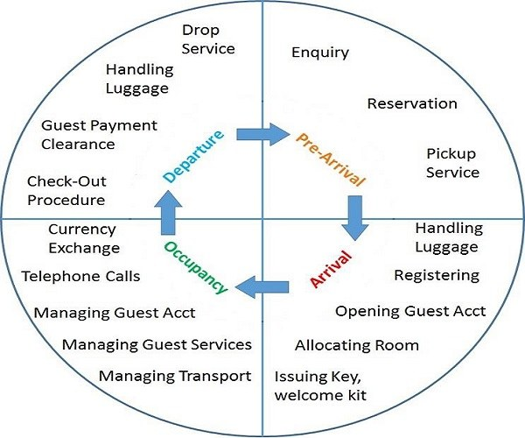

Appendix 2 Re-conformation text from the hotel to the Guest
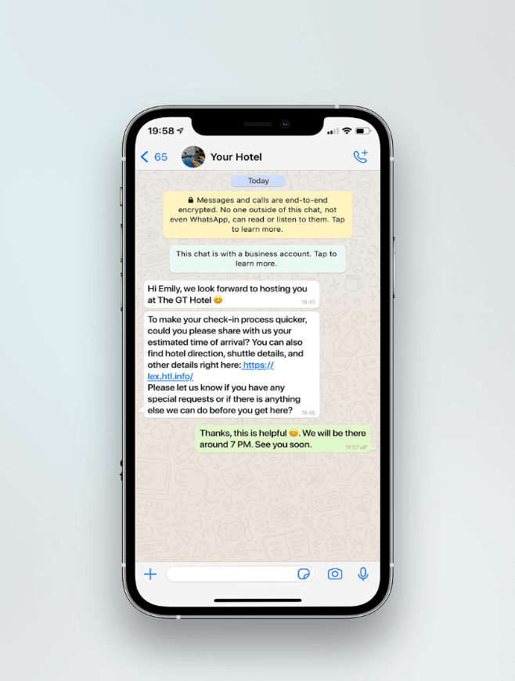

Appendix 3 Front Desk Executive Attending to the Guest
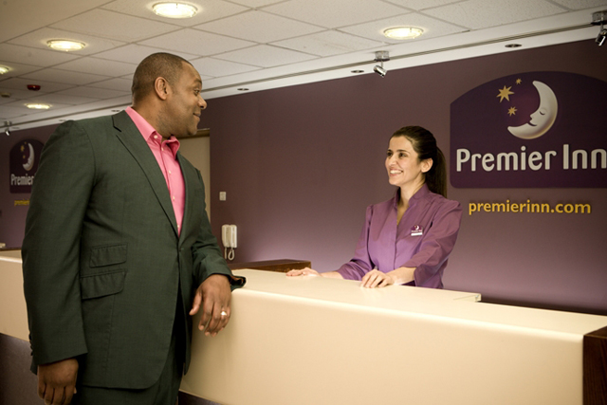

Appendix 4 Customer Review


