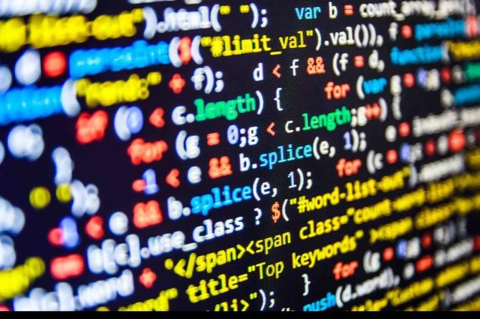

PROGRAMMING

P1, P2, P3, M1, D1

UNIT 4

Lecture on Programming.

Marvin Kyei

Learning Aim A
–

To

Examine the computational
thinking skills and principles of computer
programming

Table of Contents
Computational Thinking Skills 10
Decomposition 10
Pattern Recognition 11
Pattern Generalisation and Abstraction 12
Representing parts of a problem or system in general terms (Algorithms) 13
Uses of Software Applications 13

Features and Characteristics of Programming Languages .................................................................... 0
Uses and applications of high- and low- level languages ..................................................................... 0
Programming Paradigms ........................................................................................................................ 1
Comparing and contrasting programming languages ........................................................................... 5
Hardware and software needed for running and developing a program ........ Error! Bookmark not defined.
Special devices required ..................................................................... Error! Bookmark not defined.
Performance ........................................................................................ Error! Bookmark not defined.
Preferred application areas ................................................................ Error! Bookmark not defined.
Development time .............................................................................. Error! Bookmark not defined.
Ease of development ........................................................................... Error! Bookmark not defined.
Programming constructs and techniques and their implementation in different languages ..... Error! Bookmark not defined.
Command Words ................................................................................. Error! Bookmark not defined.
Identifiers ............................................................................................ Error! Bookmark not defined.
Data types ............................................................................................ Error! Bookmark not defined.
Statements .......................................................................................... Error! Bookmark not defined.
Control Structures ............................................................................... Error! Bookmark not defined.
Logical operations ............................................................................... Error! Bookmark not defined.
Subroutines, functions and procedures ............................................. Error! Bookmark not defined.
Data structures .................................................................................... Error! Bookmark not defined.
String (or text) ..................................................................................... Error! Bookmark not defined.
Array (one-dimensional) ..................................................................... Error! Bookmark not defined.
Array (two-dimensional) ..................................................................... Error! Bookmark not defined.
Stack (LIFO) .......................................................................................... Error! Bookmark not defined.
Stack (FIFO) .......................................................................................... Error! Bookmark not defined.
Record (or structure) ........................................................................... Error! Bookmark not defined.
String handling .................................................................................... Error! Bookmark not defined. File handling ........................................................................................ Error! Bookmark not defined.
Event handling ..................................................................................... Error! Bookmark not defined.
Documentation of code ...................................................................... Error! Bookmark not defined.
Principles of logic applied to program design ........................................ Error! Bookmark not defined. Mathematical logic .............................................................................. Error! Bookmark not defined.
Completeness ...................................................................................... Error! Bookmark not defined.
Use of Sets ........................................................................................... Error! Bookmark not defined.
Quality of Software Applications ........................................................ Error! Bookmark not defined.
Efficiency or Performance ................................................................... Error! Bookmark not defined.
Maintainability .................................................................................... Error! Bookmark not defined.
Portability ............................................................................................ Error! Bookmark not defined.
Reliability ............................................................................................. Error! Bookmark not defined.
Robustness .......................................................................................... Error! Bookmark not defined. Usability ............................................................................................... Error! Bookmark not defined.

P1 – Explain how computational thinking skills are applied in finding solutions that can be interpreted into software applications.
Learning to utilise a programming language that is popular or in great demand at the time is not the only thing that is required to become a programmer. Understanding what a programming language is, what it can accomplish, and how it is used are all key components of learning to programme. Programming is essentially just a way to practise logical problemsolving.
Contrasting hardware and software requirements for selected programming languages (Preferred requirements for popular programming languages).
My supervisor at OasisZone (the small development company I work for) provided me a portfolio of computer programs and I have completed research into the concepts that were exploited to improve my foundation of knowledge. I will present only a few of the code that were present in the portfolio by comparing or contrasting the programming languages involved and how and which more efficiently completes the same task.
Java to Python
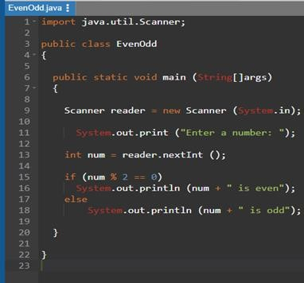
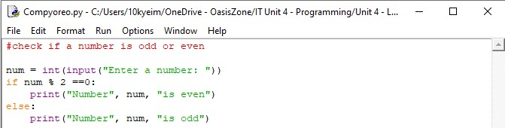
The comparison in the preceding code demonstrates Java’s static typing in which variables of the right data type must be declared before they may be used. In contrast, the python program doesn’t require the type of variables to be declared (the data type will be determined at run time since python is a dynamically typed language). Similarities:
The code here shares some similarities; they both make the code display “Enter a number: “using the print command and the user in both is given the ability to enter a number. In both examples the entered value must be an integer. They both use IF and ELSE statements in analogous ways; Num % 2 ==0, for example is the same in both. The IF/ELSE statements will show what is to be displayed based on their input.
Differences:
The differences lie in the earlier section of the Java code wherein which they had to be a class declared using the ‘main’ method – due to the class being public the file name had to be likewise - the file name had to be EvenOdd.java. Each Java statement must be followed by a semicolon, and if there weren’t present the syntax would be invalid, this is not a requirement that is shared with Python.
Java vs Python:
The Java syntax is strict. Errors occur when a semicolon is omitted at the end of a sentence or when curly brackets are mismatched. Python, however, has a simpler syntax that’s easy to understand. There is no requirement for a semicolon or curly brackets and instead puts an emphasis on indentation. Java is a compiled as well as an interpreted language. After the code is compiled and transformed into bytecode, I will be collected or interpreted by the Java Instant Messenger (which extracts identifier names from Java source code files to be analysed). Python on the other hand, is an interpreted language and compiles and executes its commands line by line: this makes Java faster than Python The user doesn’t have to describe the exact type of variables when typing them into Python as opposed to Java which requires variables to be strongly typed and defined. Code length is massively longer in Java than Python and it is common for Java to have several more lines of code to produce the same result. Everything in Java begins and ends with the object – to print even simple string will require a class. There are objects in Python, but programs can be written without them. Both languages are very portable however Python slightly has the edge. Java has a more popular and commonly used database: JBDC – it outshines and outperforms Python’s.
Despite these differences the execution at the end of both programs is the same
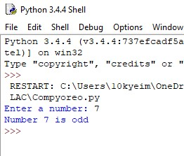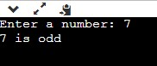

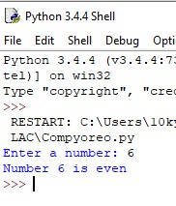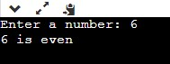
(EvenOdd program executed in Python)
In terms of choosing one for presentation there isn’t much to debate about as their completely similar. They both are easy to understand, although Python is clearly the easier of the two which can easily be seen in the comparison above as there simply isn’t even as much required to produce the same result. Although Java is faster (because it’s a compiler) than Python (as it’s an interpreted language). Due to Java’s verbose syntax, there isn’t much reason to choose Java over Python for a simple code like this. Python has simpler more concise syntax than Java and can perform the same functions in Java in fewer lines of code. This makes it more efficient for development time. Java also remembers the object type of retrieved objects for containers, and this contributes to memory usage, for a program like this Python’s simplicity is more valued over the speed.

A program such as this could be used in business when dealing with money and calculating financial reports that may benefit from numbers being divisible by 2 such as averages.

C to Java (REPLIT)
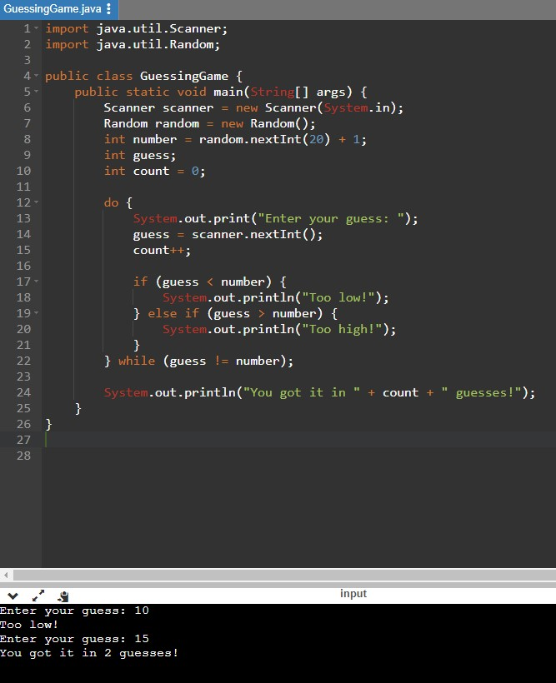
Similarities:
There are a substantial proportion of similarities between C and Java especially in this example, for instance, they both force values entered to be integers only and have a counting feature using int also. There are slight differences in what will be displayed however they achieve the same goal. Another commonality between the two languages is that they both use IF/Else statements to print results to the user based on the values they enter, and a WHILE statement is used to initiate iteration and create a while loop. The display the count alongside some congratulating words if the condition for the WHILE loop is met (ELSE). Both languages are high-level and quite easy to follow and are identical in some formatting.
The result has the C program show “I’m thinking of a number between 1 and 20”, before allowing the user to input the guess, while the Java program allows the user to enter their guess immediately.
C vs Java:
C is a procedural programming language while Java is an object-oriented programming language. C is platform dependant under the concept Write Once Compile Anywhere while Java is platform-independent under the concept Write Once Run Anywhere. C is a middlelevel language as it binds the bridges between machine and high-level languages (only compiled). Java is a high-level language as the translation of Java code is compiled and/or interpreted from machine code (compiles and interprets). C has support for pointers which is absent in Java. Garbage collection is automatic with Java which isn’t a liberty available with C. Java is more secure than C. Java is far more robust and portable than C and follows a bottom-up approach in contrast to C’s top-down approach.
If the programming language needs to give better performance and must be used in systems where high speed and performance are of utmost value, then C is the better choice to Java. However, for most cases of building software products or Distributed Systems, Java’s rich libraries and plethora of features offer a better alternative. In relation to the program above C may be the stronger option as high performance and speed are in its favour in this comparison.
A program like this may be used in a game to calculate how much damage is dealt to a player or enemy and it’s important for this to be recorded as quickly as possible as to not hinder the player’s experience.
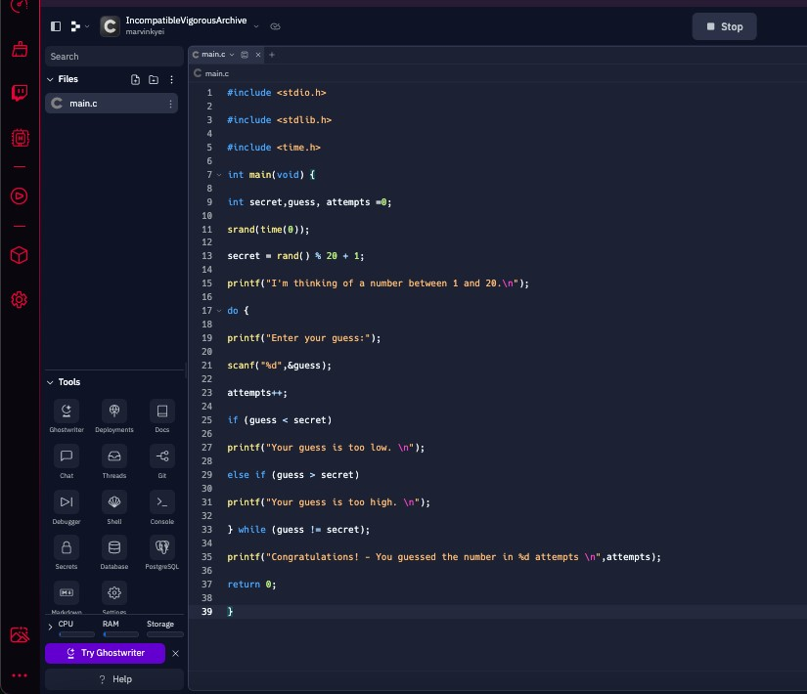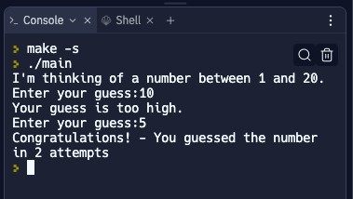
(Guessing game code in Replit (C))
Python to HTML
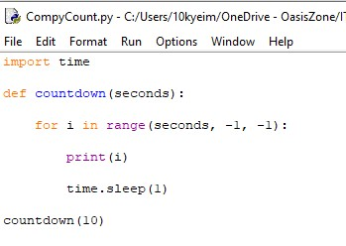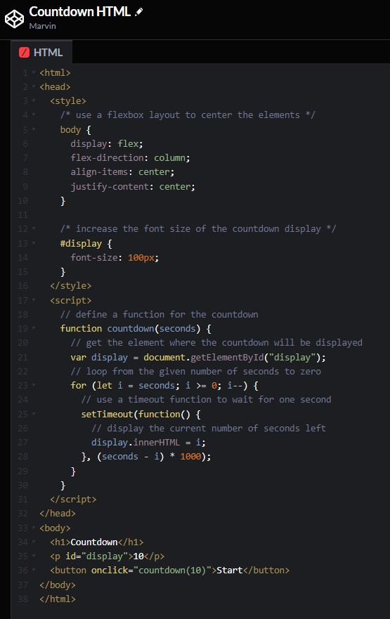
Countdown program in Code
pen.io

Briefly, Python and HTML code are incomparable. The difference in the length of code is large, the functions involved are different barring the “for” command; there is an extremely minimal number of similarities between the code. HTML takes a more visual approach to Python, making the user must define and create a GUI – Including images, buttons, and pointers. Python however will just run the countdown and this code there isn’t any way the user can interact with the program. Infact the HTML code isn’t even purely HTML and contains JavaScript and CSS code namely in the middle section of the program.
Python and HTML are completely different programming languages and aren’t analogous as they are different technologies used in different cases. HTML is an easy-to-learn and easyto-use text-based markup language used most specifically in the web design and development industry. With it, the structures and layouts of a web page or web app can be built. Alternatively, Python is a beginner-friendly programming language used for building apps, as a backend web programming language, and building games, it is incredibly useful in Machine learning and data science. HTML can’t build logic or implement any dynamic functionality with it – something that Python strives in. HTML works with CSS and JavaScript to create appealing frontend parts of websites and apps. HTML is the easier programming language to learn as it doesn’t require the various computational operations and mathematical readings that Python does.
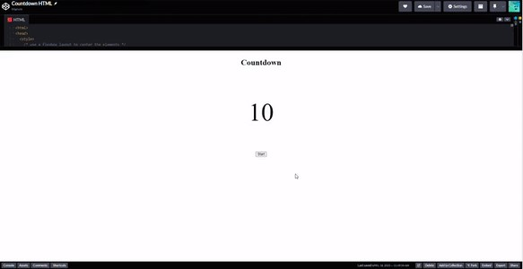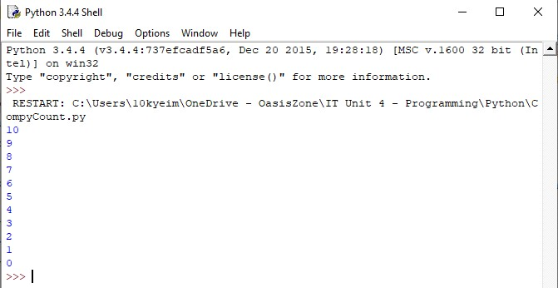
(
Countdown code
executed in Codepen.io
(
))
HTML

(
Countdown code
executed in Python)

The HTML code is more suitable to run this program as it’s visual nature and GUI more suitably and simply complete its task. Having a button that the user clicks to start the program allows for more control in comparison to Python which executes the countdown immediately. It is also more visually appealing to see the countdown table and the numbers change than it is to see the numbers in the listed format. Had the countdown been longer Python would have many lines while the HTML countdown will stay identical.

A program like this can be used in an alarm or clock application for mobile devices.

Computational Thinking Skills
You must practise your computational thinking abilities if you want to write successful computer code. These abilities will enable you to thoroughly research a topic, assess it systematically, and find probable answers that you can then turn into functional software programmes. Four distinct but connected phases can be used to conceptualise computational thinking abilities. Following are the steps:
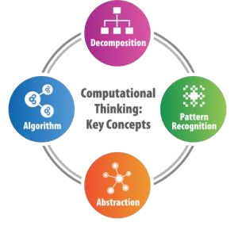

Decomposition
Decomposition is the process of disassembling complicated concepts into simpler, easier-tomanage components. This procedure may also be known as factoring. In general, it is harder to solve problems that have not been broken down. The likelihood of success is frequently increased by the practise of splitting a major difficulty into multiple smaller challenges. This is mostly since it enables you to concentrate on only one subject at a time, allowing for a closer examination of its features. Decomposition occurs often in everyday life, even in noncybernetic operations like making a cake.
- Grease & flour pans and preheat the oven
- Prepare all ingredients (eggs, baking powder, flour, butter, sugar, etcetera)
- Whisk all ingredients
- Cream butter and sugar
- Add eggs
- Combine ingredients
- Pour batter into a pan
- Bake the cakes in the oven
- Decorate the cake to your liking
In this approach, a single difficulty (making a cake) may be broken down into at least nine smaller problems, each of which can be further broken down if necessary to make the methods to solving it more understandable. Decomposition in programming comprises the following four phases:

Identifying and describing problems and processes
At this point, you will succinctly summarise issues and procedures using terminology appropriate to the problem's origin. For instance, if you are working on a financial issue, you should utilise phrases from the financial industry correctly. This implies that you must be conversant with the technical jargon used in the industry or business where the issue is present.

Breaking down problems and processes into distinct steps
At this stage, you will break down complicated issues and procedures into constituent parts that, when combined, can be correctly put back together. There is no set restriction on the number of steps or layers you can decompose to. Just keep breaking down each step until you have a sufficient degree of comprehension.
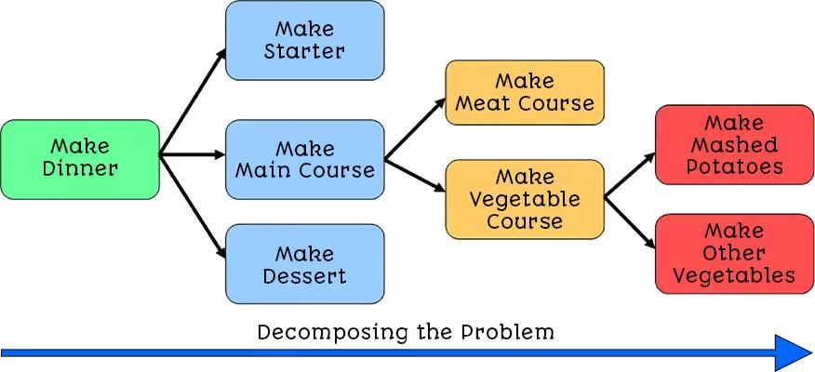

Describing problems and processes as a set of structured steps
At this point, you will outline the issues and procedures that you have broken down into a series of organised steps. This ought to be simple enough for you or others to follow.

Communicating the key features of problems and processes to others
You will now consult with others about the issues and procedures. This might apply to the client or other programmers. It is feasible to start examining the actions taken to determine if there are any repeated patterns once you have broken down a difficult problem.

Pattern Recognition
The capacity to identify recurrent characteristics both inside and between issues is known as pattern recognition. By evaluating data, searching for patterns and trends, and looking for repeated sequences, one might find similarities between contemporary issues and problems that have already been experienced and resolved. Finding these recurring patterns can be extremely helpful because it can give you a good place to start when solving problems.
Here are five principled that form the basis of the process of pattern recognition:

- recognising recurring components or characteristics in issues or systems, this entails:
  - analysing issues or systems.
  - listing the components or characteristics of each.
  - highlighting those that can be found in several places.
  - Being recognised as patterns.
- detecting and analysing typical distinctions across processes or issues, this entails:
  - analysing issues and procedures
  - listing the components or characteristics of each
  - highlighting the aspects that are particular to each
  - identifying these distinctions
- locating certain components inside issues, this entails:
  - examining issues to determine the inputs, processes, selections, and outcomes that are present.
- Identifying patterns and describing them
- generating forecasts based on recognised patterns:
  - Determine the potential applications or potential manifestations of each pattern that was found.

Pattern Generalisation and Abstraction
Abstraction is a notion in computing where systems are divided into layers, each layer masking the complexity of the layer below it. They do this by simplifying a problem, eliminating irrelevant information, and making a single solution applicable to a variety of issues. As a result, the complex and unnecessary mechanisms are 'abstracted' away or eliminated, enabling a programmer to use a feature without needing to fully understand how it operates. Back to the baking example, when baking a cake, there are some general characteristics that are present among baking any cake regardless of its type. For example:
- A cake needs ingredients
- Each ingredient needs a specified quantity
- A cake needs timings
When abstracting, we remove specific details and keep the general relevant patterns.

When links between patterns can be found and straightforward inferences may be made, pattern generalisation occurs. Even though there don't seem to be many similarities at first, patterns can still be found.
We have phones, televisions, and computers as examples of household gadgets. All their designs share features in common, such as displays, storage systems, SoCs, etc. Look past the obvious (in this case, highlighting the physical distinctions between the three modes of transportation) to properly solve a problem. Instead, look for the pieces that are similar and the connections between them.
This stage of computational thinking is divided into two parts: identifying the data necessary to address a problem. This entails:
- recognising the data, you require.
- understanding why you require this information.
- understanding the format in which this data must be presented.
- To avoid a delay in the solution, you must be aware of how quickly this information is needed.
removing the information needed to address an issue that has been found. This entails:
- Knowing what knowledge is unnecessary will prevent distractions.
- Understanding (and defending) your decision to exclude this information.

Representing parts of a problem or system in general terms (Algorithms)
Here, we identify the actions required to resolve a problem and provide step-by-step guidance on how to accomplish so. To achieve this, you must recognise the:
- Variables are the values in an issue or system that can vary; they are often provided by the user or are the outcome of a computation that is necessary.
- Constants are the values in an issue or system that don't change frequently or stay constant for enough time.
- The processes that are essential to comprehending an issue or the operation of a system are known as key processes.
- Processes that take place repeatedly inside an issue are known as repeated processes.
- The values submitted into the system are referred to as inputs, and they may include the units utilised as well as any potential valid values or ranges.
- Outputs: This is information that is sent to the user in a format that has been predetermined by the client as part of their specifications.

Uses of Software Applications
Software applications are programmes created to carry out certain activities, address issues, and meet defined user demands. They are frequently referred to as "applications" or "apps." Applications can be categorised in a variety of ways, including by usage, computer platform (desktop, mobile, etc.), and kind of software licencing (free, commercial, etc.).
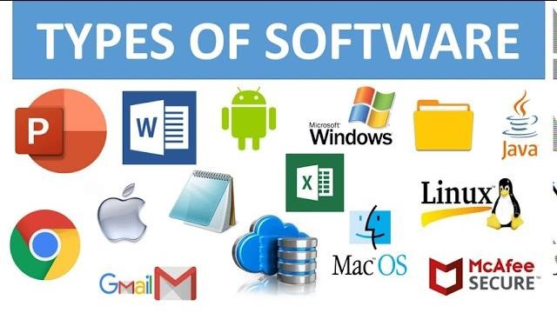

Application | What they fulfil | Examples | Implications
Gaming | Videogames can be used to entertain, educate, or help recuperate after trauma | From software -Bloodborne  Toby Fox – Undertale  Scott Cawthon – FNAF  Naughty dog – The last of us | Potential social isolation Health issues (has an impact on physical exercise)  Mental wellbeing (as relaxation tool)  Potential addiction
Entertainment | Helps users relax and enjoy various forms of media whether they’re music, video, books through downloading, streaming or both | Spotify  Netflix  Audible | Potential Social Isolation Ad hoc viewing/listening (more flexible consumption)
Productivity | Applications such as spreadsheets, databases, word processors and presentation software which may help workers complete tasks more efficiently, typically when working in administrative roles. | Microsoft Office  Adobe Creative Suite | Improved productivity  New work skills  Innovative ideas and problem-  solving techniques  Greater efficiency  Reduced costs
Information Storage and management | Application used to store and manage information safely (preventing loss) and enable rapid retrieval, typically via the internet. | Dropbox  Google Drive  Apple iCloud  AWS | Less risk of data loss  Redundancy of data  Flexible access to data
Repetitive or dangerous tasks | Applications used to automate equipment in environments which are hazardous to people, or which replace monotonous manual tasks. | Self-driving vehicles  Car manufacture  Chemical processing | Reduced physical risk to individuals  More job satisfaction (Fewer menial, repetitive jobs)  Redundancy  New work skills  Improved productivity  Reduced Costs

4 - Programming 2022-2023
Social media | Applications designed to connect you to other people, to aid communication and share ideas, events, pictures, and videos. | Twitter  Facebook  Snapchat  WhatsApp  Pinterest  Instagram  TikTok  LinkedIn | Changes to communication skills Ability to discuss and share problems with others  Ability to exchange ideas with  others Security risks  Risks to minor and vulnerable adults  Potential addiction  Improved contribution to critical issues
Search Engines | Application that provides a facility for users to search the world wide web quickly and accurately for specific terms, returning meaningful results. | Google  Microsoft edge  Yahoo! Search  Opera  Firefox | Improved access to information Products and services found faster  Less time wasting  Risk of tracking and/or targeted advertising

1

P2 – Explain how principles of computer programming are applied in different languages to produce software applications.
Features and Characteristics of Programming Languages
Since the middle of the 20th century, numerous programming languages have been created. The first programmes were created using machine code (binary) instructions that instructed the computer's processor precisely what to do, but this was time-consuming and extremely difficult for the programmers to master. Despite being quick and effective when used, such programmes took a while to make, and complex applications were viewed as a significant undertaking. Programming became easier to grasp when additional low-level and high-level languages were developed over time. As a result, they sped up the development of increasingly complex systems and applications.
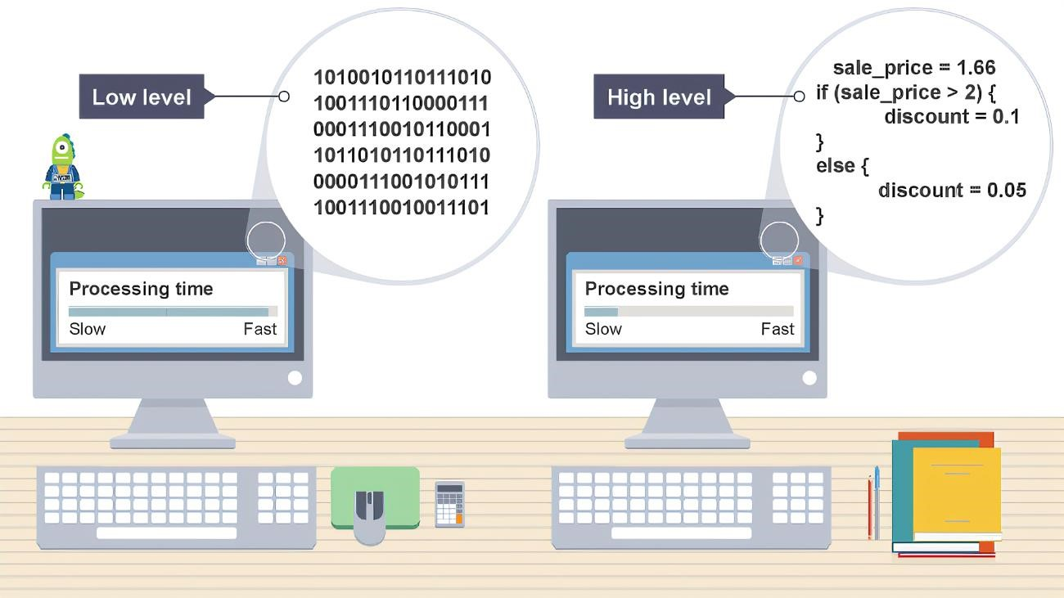
A computer can interpret the low-level equivalent more quickly because its machine code instructions speak directly to its central processing unit (CPU), even if we find high-level languages to be more comfortable to read. In contrast, before the CPU can use the highlevel code, it must correctly translate it into machine code using a compiler.
Uses and applications of high- and low- level languages
The architecture of a computer is intricately designed. Little of this complexity is concealed from the programmer by low-level programming languages like machine code (often written in binary, which is a base-2 system, or hexadecimal, which is a base-16 system), or assembly language. The developer must be intimately familiar with the processor's architecture to programme the computer at this level. In contrast, high-level languages like C++ and Microsoft Visual Basic.NET employ abstraction to shield the programmer from the architecture's complexity. A single command in these languages may convert into hundreds of intricate low-level instructions that the processor can comprehend.

High-level programming languages make up the vast majority of those now in use for commercial purposes. Because of the following, high-level languages;
- Boost the efficiency of programmers when developing code.
- Make the code easier to read.
- Make your code simpler to debug. Debugging is the process of finding and fixing programme code errors.
- Make it possible to employ more adaptable programme development tools.
- Create code that can be ported (also known as cross-compiling), which is the process of writing code for one computer architecture but compiling it for usage on another.
Binary, commonly referred to as "base 2," is a numbering system that exclusively employs the digits 0 and 1. Binary representation of '5', for instance, is 101 (1 4 + 0 2 + 1 1). 'On' and 'off' states in computer circuits can be utilised to represent binary 0s and 1s.
The phrases "low-level" and "high-level" in programming relate to a language's ability to be comprehended by a machine (for example, binary is low-level) and by a person (for example, natural languages like English are high-level).
The most comprehensive control over computer hardware is offered by low-level languages. However, using them takes time and is challenging. High-level languages, on the other hand, provide prospects for more fast software creation while abstracting the challenges of speaking to the computer hardware directly. However, compared to what it might be if created in a low-level language, the final programme is frequently less effective, slower, and larger.
The central processing unit (CPU) is the "brain" of a computer. Typically, it manages the computer's resources, inputs, and outputs as well as, and most significantly, the processing commands and information retrieved from RAM.
A special programme called a compiler converts high-level language programme code into binary instructions that the CPU can understand.
Programming Paradigms
Programming approaches have evolved in response to many sorts of difficulties. Each paradigm, often referred to as a style, seeks to address an issue in a unique manner, frequently to satisfy various user demands. Multi-Paradigm Languages are programming languages that can be used in more than one paradigm. Multi-Paradigm programming is supported by several programming languages. Parlog is a parallel and logic programming language, while C++ is both an imperative and an object-oriented language.
Programming Paradigm | Programming Languages
Procedural | All programming languages are procedural
Features and Characteristics
Programmers frequently study procedural languages initially. They are utilised to develop a wide range of application kinds and are frequently thought of as a general-purpose tool. Usually, they are presented as a series of clear actions that address a certain issue.  The programmer may decide to partition the processes into different procedures, each with a particular purpose that may be utilised several times, if the steps become too intricate, protracted, or repetitive.  This style of language is also referred to as "imperative," however this phrase does not translate well because it is less procedural. |  | 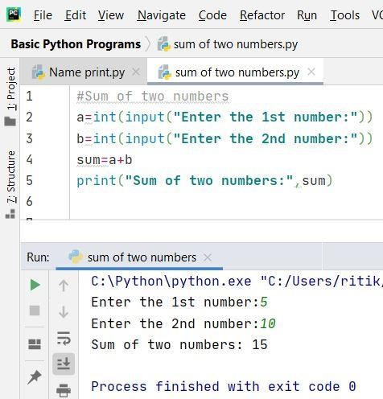

Programming Paradigm | Programming Languages
Object-Oriented (OO) | - C++  - Microsoft C#  - Oracle Java  - PHP  - Ada
Features and Characteristics
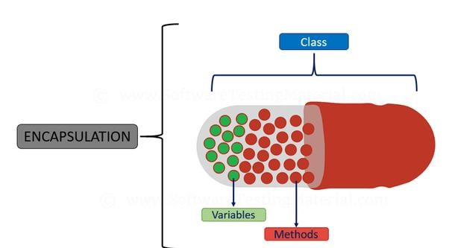
A common current method of programming is object-oriented programming. To address practical issues, OO languages rely on the ideas of "classes" and "objects." They are frequently used to create videogames, e-commerce websites, database systems, and user interfaces because of this methodology. In OO, objects are made from classes that are typically based after actual "things" from the outside world, such as clients, bank accounts, goods, and orders, etc. Each class serves as a blueprint for a piece of software, enclosing (or containing) the state (its data or attributes) and behaviour (its functions or methods) of the object in computer code.

To address the issue, the programmer designates interactions between assorted items. Each class is distinct, allowing for easy modification or adaptation to reflect changes taking place without having a detrimental impact on the entire solution. Developers find OO languages to be particularly appealing when they think about the difficulties of dealing with continuous maintenance because of this.

Programming Paradigm | Programming Languages
Event-driven (ED) | • Microsoft Visual Basic .NET, Python, Ruby, Java
Features and Characteristics
This is a well-liked paradigm for creating graphical programmes that react to user or systemgenerated events, including mouse clicks or system clock events. Instead of requiring users to adhere to the pre-set inputs of a stricter programme structure, event-driven programmes often operate in a non-sequential manner with users being allowed to choose the activities they wish to carry out. Event handlers, or the code that describes the actions to do when a certain event is triggered by a listener, are the focus of programming for developers. A process that listens for a certain event is called a listener. For instance, a file open dialogue will appear if the File->Open menu option is selected.

Programming Paradigm | Programming Languages
Machine | - Machine code  - Assembly language (sometimes informally referred to as ‘assembler’
Features and Characteristics
These are the machine's fundamental hardware's lowest level programming languages, providing control. A particular CPU family, such as Intel's x86 (32-bit) or x64 (64-bit), must be catered for when writing machine code. It cannot be easily executed on other systems without being converted to the CPU instructions of the new platform or being emulated using the instructions of the original CPU.

Basic CPU instructions are represented in assembly language by a collection of mnemonics that are simple to remember. Mnemonics are tools for remembering information, usually in the form of images, rhymes, or sayings that are simple to recall. Mnemonics boost efficiency and readability in assembly language.
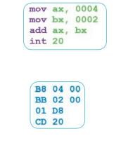
For example, when adding 4 + 2 in assembly language:
- mov stands for "move," add "add," and int "interrupt" (int 20 ends the programme).
- The CPU has registers (high-speed memory locations) called ax and bx.

These shortcuts take the form of operands and opcodes. Opcodes are terms used to define the operation, and operands are the values that the operation is processing.

Using a specialised programme called an assembler, assembly code must be converted into machine code to be executed. When speed is essential, low-level access to computer hardware is required, or it is crucial to communicate with linked devices, machine languages are frequently utilised. It may be utilised, for instance, in videogames, head-up displays, and vending machines.

Programming Paradigm | Programming Languages
Markup | - HTML (Hypertext Markup Language)  - XML (Extensible Markup Language)
Features and Characteristics
Using specific tags, markup is a type of language used to define the structured layout of a document's content. Platform-independent representation of complicated data structures is possible using other Markup languages.
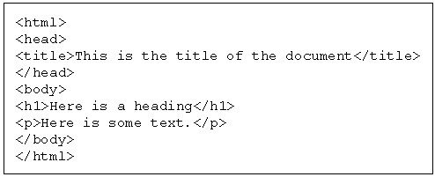
When transferring data between various computer systems and applications, such as when exporting and importing information between relational database systems that are typically incompatible, XML is frequently used as the preferred format. Example: In HTML <p> is used to denote the start and end of a paragraph.

Programming Paradigm | Programming Languages
Scripting | - Perl  - JavaScript  - Ruby  - PHP
Features and Characteristics
Various kinds of scripting languages are employed for various tasks.  By connecting and performing operations that may have previously been done independently by a user, the programming languages Perl and Ruby are frequently used to automate system processes on computers.  JavaScript is used in website design to create interactive elements and automate procedures. |  | Ruby program to check if the inputted number  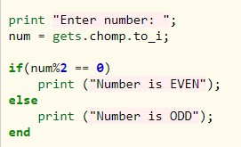  is even or odd

Comparing and contrasting programming languages
When evaluating various programming languages, there are numerous things to compare. These consist of the specifications (such as hardware, software, and special devices), performance, and development simplicity.
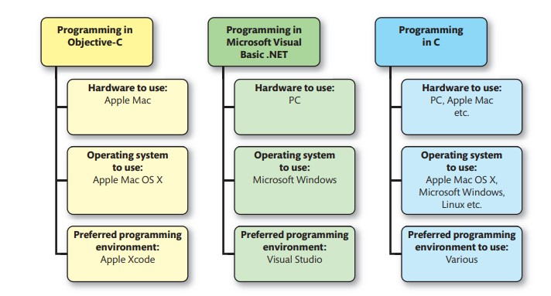

Hardware and software needed for running and developing a program
Specific hardware and software are needed to run and create programmes in some programming languages. Some programming languages are "cross-platform," like C. This indicates that it is compatible with a wide range of hardware and operating system setups. This explains why, even though it was first launched back in 1972, it is still so well-liked among commercial programmers.

Special devices required
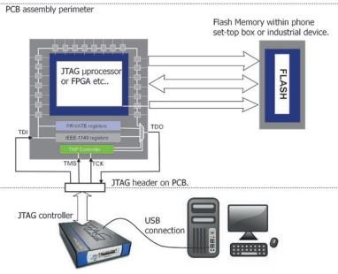
It is extremely customary to link a desktop PC to a particular device, often a Serial Programming Interface (SPI) or Joint Test Action Group (JTAG), when developing software for external hardware. This unique tool enables the developer to carry out a procedure known as in-system programming (ISP), which is often connected to the desktop PC by a universal serial bus (USB), serial, or parallel connection. ISP enables reprogramming of devices without removing them from their original circuit. For instance, reprogramming a mobile phone to "unbrick" (repair) or unlock its functionality is a typical application of ISP.

Performance
Compared to one another, programming languages can perform more effectively. Performance is frequently assessed by timing how quickly a language can complete complicated algorithms. For instance, certain programming languages have more effective translators that produce tightly optimised machine code, allowing for improved CPU utilisation.
By employing aggressive trash collection techniques, some computer languages manage RAM more effectively than others. Garbage collection is not a requirement, and some programming languages, like C, require the programmer to remember to deallocate memory that is no longer needed manually. While aggressive garbage collection may speed up the language, it also increases the possibility of memory "leaks." An automatic operation called garbage collection tries to recover RAM that has been reserved for a programme but is no longer required.

Preferred application areas
Some programming languages are better suited for some areas of application.
- C is a general-purpose language, but due to its low-level control over the computer system, it works well for manipulating external hardware and electronics.
- Applets for websites and Android mobile apps are made with Java. Because of its "write once, run anywhere" (WORA) philosophy, it is used in many diverse types of home entertainment equipment, including TV set-top boxes and Blu-ray players.
- Server-side applications for e-tail, e-commerce, etc. firms are made with PHP.
- The simplicity of use of C# with Microsoft's XNA, a well-liked collection of tools used in videogame production and administration, makes it a popular choice for making videogames for Microsoft Windows and major gaming consoles.
- The iPad, iPhone, and other iOS devices from Apple are developed using Objective-C.

Development time
When selecting a programming paradigm, development time is a crucial factor. As an illustration, we can see that while programmes written in machine code and assembly are effective and run swiftly, their development times might be significantly greater than those of high-level languages used in contemporary integrated development environments.
Writing dependable code as rapidly as possible with the fewest flaws is a top priority in commercial programming since time directly equates to money. As a result, programming languages with feature-rich development tools that promise to shorten development times are widely used.

The measurement of development time might be challenging, though. This is due to the difficulty in determining and reaching an industry-wide consensus on acceptable metrics, a measuring method that allows for comparison and assessment. For instance, you may accept the number of lines of code (LOC) written per hour as a statistic, but this may not consider the quantity of associated defects that are produced. A programmer may also write unduly verbose code (using more words/code than necessary) if they are aware that their productivity is determined by the amount of LOC they produce in an hour.

Ease of development
Some programming languages are simpler to use than others. This is since certain programming languages provide the software developer sophisticated tools that can provide tips or automatically produce programme code. For instance, Microsoft Visual Basic.NET instantly transforms input forms made using drag-and-drop capabilities into programme code.
The effectiveness of various tools included in a programming language editor can also affect how simple development is and how productive a programmer is. These tools include syntax highlighting, help systems, and debugging tools.
Syntax highlighting is a feature in many programming language editors which displays different programming constructs in specific colours. For example, a comment may appear in green, a string of text in red and so on. Most developers find the resulting code easier to read, understand and debug.
Debugging tools offer the programmer a range of features that help them to identify bugs in their code and remove them. Popular debugging tools include traces, watches, and breakpoints.
Programming constructs and techniques and their implementation in different languages
A programme is constructed using constructs from a programming language. They may be implemented using a variety of methods and strategies to solve issues. It is simple to transfer information between languages since many structures and approaches are similar across many different languages.

Command Words
The foundation of most programming languages is the idea of command (or reserved) words. Programmers are not permitted to name things using these restricted terms (see Identifiers). They are utilised to direct a certain activity, such as "open a file," "clear the screen," or "put text on the screen." Although the number and function of reserved words can vary between programming languages, as a developer you will start to recognise recurring concepts.

Identifiers
An amount stored in the RAM of the computer is represented by an identifier, a term that is understandable to programmers. Programmes utilise a variety of identifier kinds, but some of the more used types include:
- A constant is an identifier for a value that will not change.
- A variable is a name for a value that may change.
For instance, since each user would have a unique name and password when logging into a programme, this information is normally saved as variables. To guarantee that the current rate of value added tax (VAT) is applied to the price, a programme calculating the cost of a new television at a store's electronic till would need to take this into account. This figure may be set as a constant because it wouldn't vary with each sale.
You must provide the programming language two items to create (or declare) a constant or a variable:
- a name
- a data types
Always pick a name that makes sense and has some significance. For instance, "username" might be a suitable variable name to store the user's name. Because they are reserved by the language for a specific use, usually because they are command words, some names cannot be used. Be cautious since some restricted terms change between programming languages.
Programming uses a wide variety of naming conventions. The two most popular case types used in modern programming are camelCase and snake_case.
camelCase | Int userAge; | The first word is in lower case. The initial letter of each successive word is capitalised.
Snake_case | Int user_age; | All words are in lower case. Words are linked with an underscore symbol.

The concepts of local and global variables are also present in most programming languages. Remembering that global variables may be utilised everywhere in your programme code is the simplest method to approach this. Local variables can only be utilised within the code block (such as a function) in which they were declared.

Data types
Data types are a notion that is supported by all computer languages. A variable's or constant's behaviour inside the programme, the sort of value it may contain, the operations that can be applied to it, and other characteristics are all determined by the data type. Most computer languages provide a wide variety of data types for programmers to employ.
The most frequently used data types are:
- Character – This stores a single character (such as a letter of the alphabet, a digit, blank space, punctuation mark).
- String – this stores a collection of characters.
- Integer – this stores a whole number (number without decimal places).
- Real/Floating point – this stores a number with decimal places.
- Boolean – logical value which stories either true (1) or false (0).
The data types are widely used and similarly implemented across several computer languages. While others are weakly (or loosely) typed, some languages are said to be strongly typed. This significantly alters how formal the programming language is. Data and data types must always be consistent when utilised with strongly typed programming languages.
If a variable is declared an integer, for instance, it should only be used to hold other integer variables; otherwise, problems may arise. Java is a heavily typed language, which explains this. C is a flexibly typed language, though, and will implicitly transform data to the right data type that a variable expects without the programmer having to write any special code. Although it is a useful feature, it may have unintended consequences.

Statements
The fundamental unit of many programming languages is the statement. They specify the fundamental operations that may be carried out and frequently integrate several linguistic constructions. They share a lot of characteristics, such the fact that they are all highly case sensitive, but only some of them need for semicolons to indicate the conclusion of the statement.
 | Programming language implementation in…
What to declare | C | C++ | Microsoft Visual Basic.NET
Initial (character) | char initial; | char initial; | Dim initial As Char
Username (string) | char username [20]; | string username | Dim initial As String
Age (integer) | int age; | int age; | Dim initial As Integer
Length (float) | float length; | float length; | Dim initial As Double
Correct (Boolean) | N/A | Bool corrects; | Dim initial As Boolean

Statement type | Purpose
Assignment | Store a value in an identifier (Variable or Constant).
Assignment | Microsoft C# | C++ | Ruby
Assignment | userAge = 17; | userAge = 17; | userAge = 17
Input | Allow input from the user, typically from the keyboard or a file.
Input | Microsoft C# | C++ | Ruby
Input | username = console.Readline(); | Cin >> username; | username = gets
Output | Generate output for the user, typically to the screen, a printer, a speaker, a file and so on.
Output | Microsoft C# | C++ | Ruby
Output | Console.WriteLine(“Hello”); | Cout << “Hello;” | Puts “Hello”
Case-sensitive – When a programming language recognises the differences between uppercase and lower-case characters, such as ‘a’ and ‘A.’ Most modern programming languages prefer lower case.

Control Structures
The algorithms that control programs are typically built using a combination of three basic programming building blocks known as control structures. These control structures are sequence, selection and iteration.
Sequence – one action after another, none missed, none repeated.
Selection – actions chosen based on a supplied condition which it evaluated to true or false.
Iteration – actions repeated several times, typically until a condition is no longer true.

Logical operations
Operators are special symbols used to perform special tasks in a program. Logical operations such as ‘And,’ ‘Or,’ ‘Not’ etc. operate on Boolean principles. They are used to combine conditions in ‘if’ statements and various loops. For example, down below, the logical ‘And’ operator is shown in Python using the ‘if’ statement condition. A customer will ONLY get free shipping if both conditions are met (their order is worth more than £50 AND if their address is less than 25 miles away).
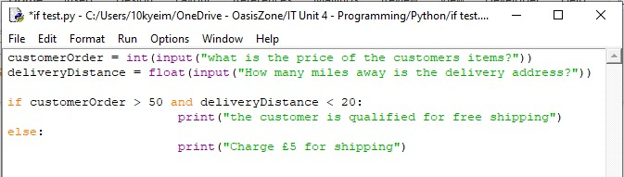

Care should be taken when moving between languages. For example, in some languages (e.g., Visual Basic .NET) the single ‘=’ sign is used to test for equality, while in other languages (Python, Java, C, C++, C#, PHP) the ‘==’ is used instead.

Subroutines, functions, and procedures
In procedural programming, when code is divided into several separate modules, words like subroutines, functions, and procedures are utilised. Depending on the programming language used, each module may also be referred to as a subroutine, function, or
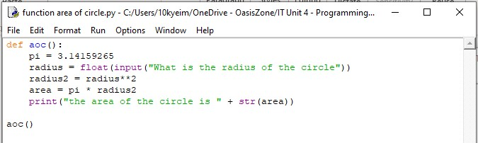
procedure. Each module normally has between 5 and 50 lines of code and oversees carrying out a specific job.
Code tends to be simpler to create, read, and debug when these modules are used. By allowing a single application to be separated and worked on by numerous programmers concurrently, code created in this manner typically allows for reuse through different solutions, which reduces the amount of time needed for development.

Data structures
A data structure is a programming technique used to gather and arrange data elements in a formal framework, assisting in the effective processing of the data. While some data structures are more readily available in some programming languages than others, many are quite widespread. The string, array (one and two dimensions), stack, queue, and record are some examples of typical data structures. When paired with iteration control structures (loops), choosing, and using data structures can sometimes result in more productive programming. Software developers learn about several programming languages and various data structures along the way. Some of the most popular data structures are listed here.

String (or text)
This data structure is used to hold a group of characters, with each character taking just one byte of RAM at most. Strings can have a "fixed length" (for instance, a maximum of 10 characters), or they can utilise a special "terminator" character to indicate their conclusion. This may imply that a string needs an extra character, but it also permits strings to have variable lengths.
Instead of employing a specialised string data type, several languages emulate strings with a static one-dimensional array of characters. But they are used in very similar ways.
Simple text submitted by the user, such a username, is frequently stored as strings. To process more complicated text, such as the contents of an email, instant chat, or tweet, strings may also be employed.

Array (one-dimensional)
This data is often static, which implies that its size is constant. Modern programming languages, on the other hand, tend to be more adaptable and include array resizing. An array often only has room for one kind of data. Any kind of data is acceptable, including characters, integers, and Booleans. An array of seven decimal values may be made if we needed to store the weight of seven different people.
Weight
Marv | John | Skye | Ekin | Lee | Jack | Emily
71.2 | 77.7 | 83.9 | 62.8 | 99.0 | 88.6 | 69.0

Array (two-dimensional)
In contrast to a one-dimensional array, a two-dimensional array can store multiple rows of data. Imagine if we still wanted to record the weights of seven different people for the neighbourhood doctor, but we wanted to do it over the course of three consecutive weeks. In this instance, a two-dimensional array of seven by three decimal integers would be constructed.
Weight
 | Marv | John | Skye | Ekin | Lee | Jack | Emily
Week 1 | 71.2 | 77.7 | 83.9 | 62.8 | 99.0 | 88.6 | 69.0
Week 2 | 70.1 | 79.5 | 79.9 | 67.8 | 92.3 | 88.4 | 72.2
Week 3 | 73.4 | 77.5 | 75.9 | 72.8 | 86.3 | 88.8 | 71.0

Even greater dimensions are possible for arrays. For instance, seven weight samples for various GPs may be stored in a three-dimensional array.
You may divide and combine arrays. This is referred to as imploding arrays and bursting arrays in various languages. The separation of substrings and the concatenation of several strings are useful applications of these sorts of operations in languages where strings are stored as arrays of characters.

Stack (LIFO)

The latest in, first out (LIFO) data structure is referred to as a stack. Accordingly, the last piece of data that is pushed on is also the first piece that can be pulled back off. Push and Pull (sometimes referred to as Push and Pop) are its two fundamental operations. Stacks are
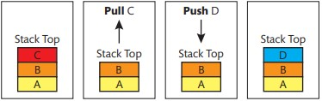
an essential component of the operating system of every computer platform and are frequently used by programmers to create solutions. Conceptually, stacks are regarded vertically.
A stack may only be accessed in a last-in, first-out order, in contrast to an array, where items may be accessed in any order. When processing recursive algorithms (code that iterates until it reaches an end condition where the calculated result can be returned), this can be especially helpful. Stacks and the required processing techniques are frequently provided in the library of a programming language.

Stack (FIFO)
In contrast to a stack, a simple queue is known as a FIFO (first in, first out) data structure and has two basic operations:
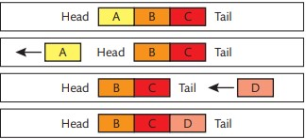
- add (to tail of queue) or ‘enqueue.’
- remove (from head of queue) or
‘dequeue.’
Only information at the front of the queue is accessible and erasable. The first piece of data may also be the first piece of data eliminated.
Like stacks, queues play a crucial role in the operating system of every computer platform. They are a great tool for a programmer to control task processing. Conceptually, queues are seen horizontally.

Record (or structure)
An array and a record both refer to the same thing. It varies, though, in that a variety of data types may be stored within its structure.
Student
StudentID | Forename | Surname | Age | Enrolled
2005 | Marvin | Kyei-Boadu | 17 | True
In this illustration, "StudentID," "Age," "Forename," and "Surname," together with the Boolean "Enrolled," are all saved as numbers.
To keep several copies of a record, you may alternatively build an array of structures. A record (or "struct") can be thought of as the foundation for basic record storage in a database table or a binary data file for this reason.

String handling
Strings are only a collection of characters, but they could still require processing. Programmers refer to this activity as string handling often. Most high-level languages contain specialised library functions to assist with the operations that programmers frequently need to perform on strings.

Length check in string
The length of the ‘firstm’ string object is used to access the string’s number of characters. The string is January.
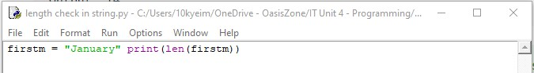

Examining single characters in a string
The output will be “the first character of January is J.”
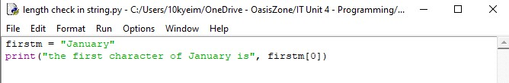

Extracting a substring
The substring is ua, it will output this from January. It will start after from the 3rd character which is “n “. It will stop at the fifth character which is the second “a.”
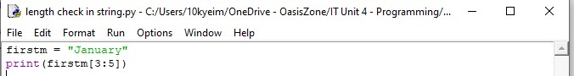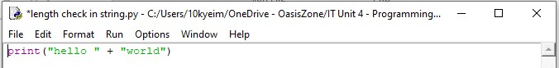

Concatenating two strings
Concatenation is the process of joining things together. In programming, it is used to describe the process of joining shorter strings together to form longer ones, for example ‘Hello’ and ‘World!’ to form ‘Hello World!’

File handling
file management Modern programming requires extensive use of data storage. It is crucial for programmers to be able to access data files to read (i.e., obtain data from a file) and write (i.e., send data to a file). A file must be opened to be used, and it must be closed after you are done. To carry out these tasks, specific instructions are needed in some programming languages. For instance, fopen() and fclose() are used in C.
Reading data from an ASCII or text file is a basic kind of file handling.
Relational databases like Microsoft SQL and MySQL are supported by most contemporary programming languages, including Microsoft C#, PHP, Ruby, and others. This facilitates the processing of more complicated data.

Event handling
When a user event or system event is triggered, a sophisticated mechanism known as "event handling" is used to invoke a specifically created function or class method and carry out predetermined actions. The output of a calculation's result in response to a button click on a screen form and the display of a confirmation message in response to a change in screen resolution are two examples of this.
Events are more frequently seen in form-based applications, including those that employ GUI components to let users interact with the programme. It is feasible to develop straightforward command line interface (CLI) or console-based event-handling apps.
Using a mouse and a pointer or cursor, a graphic user interface, or GUI, is a contemporary user interface made up of windows and icons. Examples include Apple OS X and Microsoft Windows 10.
The older, still-used Command Line Interface (CLI) is a text-based user interface. By typing commands into the keyboard, users communicate with the computer. Microsoft Command Prompt and a Linux terminal are two examples.

Documentation of code
Program code should always be documented to good standards. Doing this will:
- make the code more readable
- help other programmers understand the code
- help when programmers are debugging the code aid with maintenance of the program code, especially if this will be performed by another developer.
Programmers can use various techniques to document their code. These techniques include:
- self-documenting identifiers – this means using meaningful names which explain the purpose (and sometimes the data type) of the value represented by the identifier
- single-line comments – these are short comments that explain the purpose of a line of code
- multi-line comments – these are longer comments that explain the purpose of a more complex section of code or preface a separate section of code, such as a function, procedure, or class
- use of constants – this means replacing multiple instances of fixed ‘literal’ values (numeric, text etc.) scattered throughout a program with named identifiers which may be modified at a single point in the program code.
Documentation Concept | Microsoft C#
Self-documenting identifiers | Int userAge;
Single-line comments | //stores user’s age
Multi-line comments | /*  This section of code validates the user’s age when entered */
Use of constants | Const double PI = 3.14159

P3 – Explain how the principles of software design are used to produce high-quality software applications that meet the needs of users.
M1 – Analyze how computational thinking skills can impact software design and the quality of the software application produced.
Principles of logic applied to program design
In computing, logic is the collection of rules that underpin the many components of a programme or system and enable it to operate. The use of straightforward reasoning is beneficial for successful programme design. This matters more than knowing how to think in a certain programming language. Thinking logically will enable you to process data correctly, create intricate conditions that allow you to test data properly, and create potent algorithms to handle even the most challenging situations.
Iterations, propositional logic, mathematical logic, and the usage of sets are some of the logic principles employed in computing. These ideas aid programmers in developing the logic that goes into their programmes and in better comprehending challenges.

Mathematical logic
Developers can use mathematical reasoning to comprehend and precisely characterise the fundamental elements of an issue and how they relate to one another. For instance, drawing a logical conclusion from premises (situations) that are assumed or known to be true is known as inference. This is demonstrated in the following example:
- Premise: If all beef comes from animals
- Premise: And calves come from cows
- Inference: Then all calves come from animals
Cows are animals; thus, this conclusion is accurate. Fallacies are erroneous conclusions. When utilising programming languages like prologue (see "Programming and Logic") to create basic knowledge bases that can be queried to uncover new facts, the idea and use of inference are crucial.
Other logical ideas can be considered. When determining if a statement contains contradictions, consistency, for instance, looks to check if the statement and its opponent are both true.
Iteration: Applying a computer method to a prior application's output.

Completeness
The idea of completeness holds that everything that is true may be "proven." Connectives allow for the creation of more intricate proposals. Five fundamental connectives are available. There are word and symbol forms for each. The following lists the five symbols:
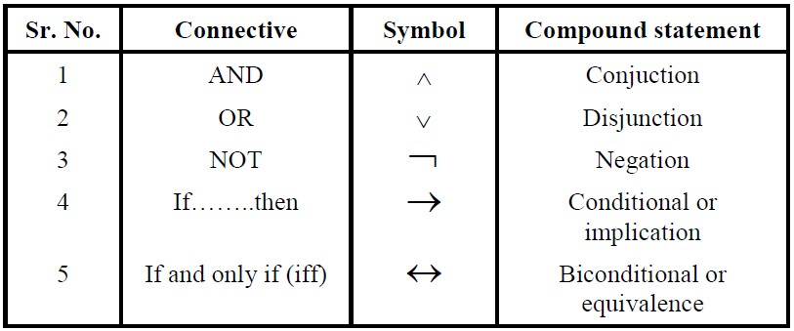
These basic connective symbols allow us to represent complex expressions in a very mathematical fashion.
For example, the expression, ‘If I have a Remote or Phone then I can change the Channel’ could be expressed as: ‘(R V P) → C.’ In other words: C is true if R or P is true. In another example, the expression, ‘If I have no money, then if direct debit is due, a bank fine must occur’ could be expressed as: ‘M (DD BF).’ In other words: if M is false, then if DD is true, BF must be true.
Before any programme code is created, it is feasible to examine the correctness of such straightforward logic assertions since they make use of a formal mathematical language. Propositional reasoning may also be used to infer added information from known facts.
The use of an additional revision known as propositional dynamic logic (PDL) is used to illustrate how algorithms work. PDL is intended to provide mathematically understandable notation for the states and occurrences of dynamic systems (like operating programmes). Its capability to verify if finished algorithms can be completed with the intended state, that is, compute the right result, is one of its most crucial qualities.

Use of Sets
A group of unique things is called a set. They can include anything (such as names, numbers, colours, or alphabetical letters), and many of them have several members. groups may be used to establish the links between several groups of data and to help arrange data. This makes it simple to find and filter potentially difficult data. Use permissions can be created using reasoning that is supported by some data types in programming languages that offer set-style functionality.
As an example, you may have two groups of people with different access rights in a particular program, taking a school as our example. Set A is the Admin Group, which contains Mohammed, Skye, and Marvin. This can be expressed as set A = {Mohammed, Skye, Marvin}. Set B is the Teaching group, which contains Sharon, Marvin, Seth, and Calum. This can be expressed as Set B = {Sharon, Marvin, Seth, Calum}. We can represent these sets as a Venn diagram, as shown below:
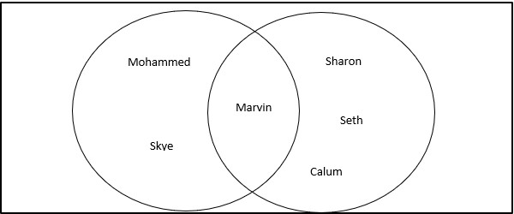
There is a particular function in the program that can only be accessed by administrators (members of the admin group) who also work as teaching staff (Members of the teaching group). This means that only Marvin has access to this function.
D1 – Evaluate how computational thinking skills can impact software design and the quality of the software applications produced.
How the design and implementation of a software application affects quality:
Different programmers can produce quite different solutions for the same issue. This frequently happens because finding answers to problems is a very individualised process, and most programming languages are flexible enough to allow for a range of approaches to the same issue. However, the quality of the software solution directly depends on how it is designed and implemented. A software solution's efficiency or performance, maintainability, portability, dependability, robustness, and usability are all evaluated to determine its quality.
Factors that affect quality, Include:

Efficiency/Performance
The concept of software quality is nuanced. It is essential and necessary to have quality. A delivery should not only be able to fulfil the needs of the client, but also go above and above those needs. There are both internal and external customers. One of the most important aspects of software quality is performance efficiency; if performance efficiency is increased, the software's quality will also increase. The resources that a programme uses up on the system are typically measured to determine how well an application performs. For instance, the amount of RAM allotted, CPU clock cycles, processor time, and the speed at which storage media is read from and written to. A complicated procedure could need a lot of CPU power. The programme code may be rewritten to be more resource-efficient, which might enhance performance (work quicker) and utilise less resources (Ram, etc.). This kind of revision is frequent in applications that depend on speed, like videogame programming (where poor coding can cause screen frame rates to suffer) or communicating with external devices in real-time systems where timing issues can be crucial, like traffic control or missile guidance systems.
Maintainability
The capacity of a programme to be adjusted by current or future developers to do corrective, perfective, or adaptive maintenance is known as maintainability. For instance, maintainable code will be simpler to adapt or alter, which will cut down on both the time and cost of development. There is always a trade-off between creating code effectively to save down on early development expenses and considering how long maintenance will take in the future.
Corrective maintenance involves identifying errors or bugs and correcting them.
Perfective maintenance is the process of enhancing a program's functionality.
Adjusting a programme by adding, modifying, or eliminating functionality to suit evolving demands is known as adaptive maintenance.
Portability
The amount of different computer platforms that the source code may support, including hardware, operating systems, and other components, is referred to as portability. Because they have compilers that convert the existing code to the necessary target machine code on a variety of platforms, some programming languages, like C, are particularly portable. A programme created in Microsoft Visual Basic.NET, for instance, might only run on Microsoft operating systems, but programmes created in C can be converted to run on Linux or Microsoft operating systems with little platform-specific coding modifications.

Anyone involved in transferring new software versions between environments will benefit from portability in terms of time and mental effort savings. For security concerns, a lot of clients choose to use vendor software on their own property. When a company creates stiff software that demands operating systems, embedded security, etc., it unintentionally restricts the market it may reach to clients who meet these requirements. These limitations on a company's addressable market are lifted by the shipping of portable software. Building portable software fosters design patterns that support a variety of other valuable characteristics. Engineers from various teams and organisations will be able to run the programme locally or remotely in a variety of settings. It is simpler to develop on top of an application that offers complete portability and is simple to use.

Reliability
The total correctness and consistency of an application's results over several runs define how reliable it is. Testing for dependability must be consistent. Even if a programme may compute results with extreme accuracy, it is not deemed dependable if it cannot consistently achieve this. This is even more crucial in situations when a program's dependability affects people's safety, such in power plant safety systems or collision detection in air traffic control systems.
Software reliability aims to guarantee that software operates consistently and as intended when used under certain circumstances. The programme should function securely or reach a safe state in the presence of mistakes, depending on the amount of fault or tolerance required. Planning and implementing reliable software require a systems-level perspective. The software must be created and maintained in a way that allows for the identification of flaws and the use of robust remedies to address them. The operating system's maintainability ensures that all updates and modifications are appropriately scoped, developed, tested, and implemented. For software to be dependable, several basic tasks supported by software assurance must be satisfied, at least in part.

Robustness
Robustness is a metric of a program's code quality, especially when the programme is examined to see if it can handle severe and false data without crashing. When a piece of software can handle unexpected or wrong input, it is said to be robust. Because of human mistake or when they get inaccurate data from other files, programmes are likely to come across wrong or unexpected data. Clear error warnings should be included in input validation methods so that users may learn what to do to provide proper data. Testing regular, exceptional, and severe data is crucial when accepting data from a range. It is advisable to develop the practise of testing values that are just beyond the permissible range when testing extraordinary data since programmes with weaker security may accept data that is slightly outside the extremes.
Usability
Productivity may suffer from poor usability. It can be challenging for users to complete activities effectively and confidently when the interface is designed poorly. Your organisation will gain from more involvement by concentrating on people and their requirements.

An application's usability gauges how user-friendly it is to use. If the user-centred design (UCD) principles have been adhered to, users will have been included at every stage of the design process. They will have provided continual feedback that has helped the design be improved several times before it was finally adopted. Popular methods, such rapid application development (RAD), allow the developer to make quick changes to an application's structure, flow, and interaction schemes to get accurate interface input from the user. Although the targeted user receives a realistic "look and feel" of the application quite early in the development process, this type of rapid prototyping typically lacks the full functionality of the final product.

The inputs, navigation, and output standards of a programme are all parts of its usability. This may also be influenced by the application's overall look. For instance, if the typefaces or colours are chosen improperly, usability may deteriorate. When thinking about usability, accessibility for users with disabilities or special needs should also be considered, especially for those who might use assistive technologies and have physical, visual, or hearing impairments. The design of application interfaces can benefit from the larger study of human-computer interaction (HCI), which considers how the user's psychology and behaviour impact how well they utilise the programme.

Bibliography
What is binary? - arkvictoria.org, https://arkvictoria.org/sites/default/files/Year%207%20Data%20Rep%20Booklet%201.2.docx.
Decomposition - KnowItAllNinja, https://www.knowitallninja.com/lessons/decomposition/.
How to abstract - Abstraction - KS3 Computer Science Revision - BBC Bitesize

Central Processing Unit - an overview | ScienceDirect Topics, https://www.sciencedirect.com/topics/engineering/central-processing-unit.

C++ Vs Java: Top 30 Differences Between C++ And Java With Examples, https://www.softwaretestinghelp.com/cpp-vs-java/.

Difference Between C and Java - InterviewBit, https://www.interviewbit.com/blog/differencebetween-c-and-java/.

Python vs. Java Performance - SnapLogic, https://www.snaplogic.com/glossary/python-vs-javaperformance.
https://www.scaler.com/topics/difference-between-java-and-python/ https://www.interviewbit.com/blog/difference-between-c-and-
java/#:~:text=C%20is%20a%20middle%2Dlevel,using%20a%20compiler%20or%20interpreter.&text= C%20is%20only%20compiled%20and,is%20both%20compiled%20and%20interpreted.
A Pen by Marvin (codepen.io)

Copy of Unit 4 Programming Book - Programming 4 Jenny, P ... - Studocu,
https://www.studocu.com/en-gb/document/the-chancellor-masters-and-scholars-of-the-universityof-cambridge/concurrent-programming/copy-of-unit-4-programming-book/23105458.

Data Structure in Java – A Complete Guide for Linear ... - TechVidvan, https://techvidvan.com/tutorials/data-structure-in-java/.

Impact of design patterns on software quality: a systematic literature review - Wedyan - 2020 - IET Software - Wiley Online Library

(PDF) SOFTWARE DESIGN AND ITS EFFECT ON QUALITY (researchgate.net)

(PDF) The Impact of Software Development Process on Software Quality: A Review (researchgate.net)

Enhancing the efficiency and effectiveness of application development | McKinsey
The importance of software portability - Architect.io

Impact of design patterns on software quality: a systematic literature ..., https://ietresearch.onlinelibrary.wiley.com/doi/10.1049/iet-sen.2018.5446.

Why is analysis important in software engineering?, https://short-q.com/why-is-analysis-importantin-software-engineering/.

The importance of software portability - Architect.io, https://www.architect.io/blog/2020-03-24/theimportance-of-portability/.

8.2 - Software Reliability - SW Engineering Handbook Ver C - NASA, https://swehb.nasa.gov/display/SWEHBVC/8.2+-+Software+Reliability.

National 5 Computing Science Revision - BBC Bitesize, https://www.bbc.co.uk/bitesize/guides/z94ymsg/revision/6.
The Importance of Usability in Software Design | ITBE - IT Business Edge,
https://www.itbusinessedge.com/development/the-importance-of-usability-in-softwaredesign/.

