mentorinG, Performance & WORK CULTURE
Effectiveness WithinThe Workplace

STUDENT: DENISE MILLER
STUDENT NO.: 1604710
SUPERVISOR: Dr Jaya Gopalkrishnan

DATE: 23RD JUNE 2023
UWTSD London Campus
LCMB7020

ABSTRACT

Workplace challenges include excessive workload and student stresses, which promote adversity and hardship that could decrease performance. Meanwhile, individual qualities could force the volume of motivation and add to the enhancement of performance in the face of difficulties; attributes of the workplace could impact performance by their influence on the level of satisfaction. Consider workplace attributes as modifiable and, subsequently, could be tuned to increase performance. (Kairuz, et al., 2019)
Disassembling the constructs of Employee performance, work culture, and mentoring in an organisational setting will always be an area of focus in an ever-changing environment. Encouraging the intrinsic qualities of employees through mentoring to meet the organisation’s needs and grow a holistic work culture, and promote participation in the mentoring program.
Intrinsic values, can these values be birthed through mentoring? As stated by (Mahmood, et al., 2019), employee engagement in creative organisational endeavours will differ depending on the influence of the manager on an individual, as well as on the communication with their stage of intrinsic motivation, the innovation support of the organisation and the nature of task complexity.
This research aims to discover how managers can utilise their human capital and determine a mentoring model that benefits the organization and employees’ work life; therefore, touching on work-life balance will help envisage the challenges that employees may face. However, there is a lack of literature about the lack of interest in employees partaking in mentorship programs; the research will investigate this phenomenon using the HATS Group (Healthcare and Transport Services) employees.
The Inductive approach of qualitative research was chosen for the questionnaire, including the one-to-one interviews. A quantitative approach was added for a variable viewpoint, an uncommon occurrence in mentoring. The study aims to determine the encouraging potential of a mentor and mentee relationship and work culture utilising individual skills by linking employee performance.
Results show an effective mentoring program within the HATS Group organisation, the employees have benefited dramatically. The company culture has a compassionate nature, and the culture values employee growth. There are vast opportunities for the company culture to build a contemporary framework suitable for the company ethos. A continued mentorship program is encouraging for future company growth.

ACKNOWLEDGEMENTS

I want to thank my supervisor, Jayalakshmi Gopalkrishnan, for her supreme knowledge, guidance, understanding, patience, motivation, and support during the whole process; I could not have done this without her.
To Carol Vaughn Roberts, a true example of friendship and encouragement, thank you for helping me become my best version.
To Junior Richard, Bart Plange, and Abi Luck, thank you for supporting me through the challenges of student life.
I want to thank the HATS Group and its employees who participated in the study; thank you for giving me your time so that I could complete the dissertation.
My heartfelt thanks to my family and friends who supported and believed in me on this journey.
I am most thankful to God, as I would not have reached this point of my journey without Him blessed by His unfailing love.

Table of Contents
ABSTRACT 1
ACKNOWLEDGEMENTS 2
INTRODUCTION 5
BACKGROUND 5
COMPANY INFORMATION 6
RESEARCH RATIONALE 6
RESEARCH PROBLEM 7
RESEARCH QUESTIONS 8
THE PHILOSOPHY of METHODOLOGY 8
MENTORING 10
RELATIONSHIPS 12
Amalgamating these concepts as a framework 13
EMPLOYEE PERFORMANCE 14
According to (Dr. Rozen, 2017), profitable companies utilize seven characteristics of organisational culture: Company culture in which the employees have an avid sense of being goal driven. Effective communication patterns have three significant factors: clarity, courtesy, and proactivity. A feedback culture is a valuable source. Fostering a feedback culture is critical to the success of every organisation because feedback encourages an elevated level of performance. 15
Celebrating teamwork, improving, and being creative is at the core of every prosperous company that exudes culture. A culture of positive teamwork that focuses on team accomplishments instead of individual actions encourages collaboration—rapid completion of tasks, and improved efficiency. Having cultural sensitivity brings about an awareness of cultures and habits that differ from yours. A culture that embodies diversity is aware of different cultures and how to approach and communicate with them. 15
Loyalty and engagement made employees feel worthy and made a significant difference. Psychologically confident: a feeling of value, acceptance, respect, and ability to perform their role in an open-minded working environment. They feel a sense of security and self-confidence with their powers, allowing them to perform their job. Company cultures typically offer employees opportunities for personal growth in terms of training to mature and flourish within their respective teams as an individual enabling them to procure new skills and create possibilities. 15
Some authors believe; personal mindsets can affect motivation, behaviour, and employee goals. For example (Canning, et al., 2020) cover decades of exploration of how people’s mindset beliefs envisage their behaviour and motivation instead of focusing on how the perceptions of other people’s organisation’s mindset beliefs anticipate the social norms within the organisation. Fixed mindset beliefs, when personally sanctioned by the Person, there is cause more significant concerns in demonstrating and proving one’s ability and talent, inviting people to elude fresh challenges and hide their errors (Blackwell, Trzesniewski, & Dweck, 2007; Burnette, O’Boyle, VanEpps, Pollack, & Finkel, 2013; Hong, Chiu, Dweck, Lin, & Wan, 1999; Nussbaum & Dweck, 2008; Pollack, Burnette, & Hoyt, 2012). In particular, this view is supported by various authors, stating; in organisations, fixed mindset beliefs of people impact how managers appraise their employees, the approaches used to oversee conflict, and the effectiveness of peoples leadership (Heslin, Latham, & VandeWalle, 2005; Heslin & VandeWalle, 2011; Hoyt, Burnette, & Innella, 2012; Kray & Haselhuhn, 2007). These studies suggest that a personal mindset belief can influence employees’ motivation, goals, and behaviour. (Canning, et al., 2020) 15
Learning new technological skills is vital for digital transformation. Is this sufficient? Employees should be motivated to use their abilities to generate fresh opportunities. A digital mindset is a necessity. (Neeley & Leonardi, 2022) 16
Moreover, the effectiveness of mentoring is mirrored better in subordinates’ job performance through their positive communication, better relationship value, and knowledge quotient. (Jeevan & Sharma, 2017) 16
PERFORMANCE MANAGEMENT 16
PERFORMANCE THEORIES 17
The Death of Performance Management? 17
WORK CULTURE 19
LITERATURE REVIEW 20
Reflections of mentors and mentees on a national mentoring programme for pharmacists in the United Kingdom: An examination into organisational culture and systems 20
Development and retention of Generation Y employees: a conceptual framework 23
DATA COLLECTION METHODS 27
ANALYSIS OF RESULTS 28
Sample Size 28
DISCUSSION 29
FINDINGS 29
CONCLUSION and RECOMMENDATIONS 31
RECOMMENDATIONS 31

INTRODUCTION

Is it possible to disassemble the constructs of mentoring, employee performance, and work culture in an organisation to build a better discipline that reflects the performance of individuals to identify a work culture that improves the organisation? Mentoring is optional. Thus, how is the personal want or need to be encouraged for those who do not prioritise the opportunity?

BACKGROUND
This dissertation/research explores how managers change human and entrepreneurial capital and renewal through precise organisational learning practices into more excellent innovation performance—drawing on the implications for managing organisational guiding and learning from companies on ways to produce innovation-based competitive advantages rooted in the human characteristics of intellectual capital. (Sladana & Dahms, 2020)
What does the workforce look like today? (Sruk, 2020) The most significant diversity of generations is characterised in today’s workforce and subsequently in history. Along with this comes about new trials for organisations. Consequently, cross-generational diversity is prompt, bringing new interest amongst organisations, business executives, and academics. (2020)
The researcher focused on mentoring as the trajectory that combines work culture and employee performance. The researcher’s interest in this field stems from the desire to become a transformational coach and use mentoring as a springboard while focusing on the organisation, HATS. Before this study, the literature highlighted how beneficial mentoring is in an organisation, the models, and the frameworks to produce an effective employee structure; however, building a steadfast universal framework or methodology has yet to be determined for organisational mentoring.

The researcher adds to the small body of mentoring literature in two ways; First, why is there insignificant information or study on the lack of interest in taking up mentorship? According to (Clercq & Belausteguigoitia, 2017), comparatively little research explores the possible harmful result of employees’ (POP) perceptions of organisational politics, explained as beliefs that self-serving behaviors drive corporate decision-making (Kacmar & Ferris, Reference Kacmar and Ferris1991; Hochwarter, Kacmar, Perrewé, & Johnson, Reference Hochwarter, Kacmar, Perrewé, and Johnson2003) on their organizational citizenship behavior (OCB) or how this may be qualified. Suppose the stress and uncertainty emerging from personal, organisational politics (POP) is strong enough. In that case, there’s a probability it may reduce employees’ motivation or ability to steer personal energy toward voluntary undertakings that can add to their organisation’s well-being (Crawford, LePine, & Rich, Reference Crawford, LePine and Rich2010). Therefore the need for a deeper grasp of how employees may respond negatively to (POP) in reducing (OCB) and how to contain this harmful effect.

Secondly, employee performance; is it possible to measure the effectiveness of employee performance without investigating job performance measurement (JPM)? According to the authors (Yunsoo & Young Lee), career development responsibility should not fall exclusively on the individual or organisation; preferably, it must be a combined effort (McDonald and Hite, 2016; McElroy and Weng). (Yunsoo & Young Lee, 2018).

The intrinsic qualities of employees cannot be seen as the statement above indicates.

The research focused on the HATS Group (Healthcare and Transport Services), patient healthcare, and home-to-school transport service. The HATS organisation specialises in creating a dedicated facility that ensures patients and passengers get safely and sound to and from their destinations. HATS company values include; teamwork and executing a dependable service on which passengers and patients can rely and depend.

COMPANY INFORMATION
HATS is an industry-leading provider of transport services. HATS delivers a high-quality, complex service tailored to the needs and requirements of the service user. The company connects with other service providers to facilitate; patient, client, and customer care supported by a fleet of environmentally friendly and accessible vehicles. The company operates across London, the home counties, and North West England.
HATS employs a skilled team of technicians, paramedics, drivers, customer service, and passenger care assistants. There are 2,700 members of staff predominantly based in London.
HATS is a company that recognises that staff is what makes the difference. For this reason, HATS invests in a robust, diverse learning and development program that offers formal training and outreach mentoring sessions to encourage staff to specialise in areas of personal interest. HATS created a new role within the organisation to positively impact their staff’s daily lives to address diversity and inclusion issues. This dissertation will highlight the benefit of the additional position in the company and how it has altered employees’ perception of being supported.
The company has a mentoring philosophy and program to support continued growth and expansion. Therefore this research will highlight the effectiveness of the amalgamation of these two variables due to continued growth within the company.
The methodology that will determine the benefits of this research will be a mixed methodology to interpret the phenomenology of the analysis of employees. (UWES) scale add

RESEARCH RATIONALE

This study aims to determine whether informal mentoring is effective and if employees participate effectively to assess the value of an organisational mentorship scheme. Should HATS, the organisation the research is focused on, introduce a formal mentoring program? Performance and trust, according to (Alfes, et al., 2012), several studies have emphasised the prominence of trust in promoting positive effects for their employing organisation and individuals. (Dirks and Ferrin, 2001). Albeit this journal is a little outdated, it takes into consideration many of the aspects the researcher believes supports a mentorship program for employees and organisational growth.
The mentor has been commissioned outside and independently of the organisation. This paper’s research focuses explicitly on mentoring’s effectiveness in organisational constraints, work culture, and employee performance. This research determines the effects on employees as individuals, how they align themselves as a person representing the organisation with HATS core values, how they (employees) identify with their culture amid workplace culture, and should unique individual cultures take the lead. In addition, the study will discover if mentoring is a justifiable tool for improving organisational performance and personal growth and employee interest in the scheme. The research was formed on primary and secondary data.
The motivation for this study is that the researcher has read literature on the effectiveness of mentoring within organisations, which shows it is positive. Throughout the literature, mentoring is generally claimed to be an influential asset to organisational growth. Still, little is known about employee participation or the lack of concerning informal mentoring.
With the importance given to management development, it is necessary to deliberate tactically appropriate approaches to learning experimentation for this particular audience. Adult learning literature traditionally accentuates that mature students favour active learning and prefer self-direction that pulls on their experiences; they also want to see the worth of knowledge and be ready to learn (Knowles, 1980). (Becker & Bish, 2017)

RESEARCH PROBLEM
Therefore, exploring the current state of mentoring will benefit the literature surrounding organisational mentoring and highlight the gap according to employee involvement and structured mentoring solutions.

The research aims were to determine the encouraging potential of a mentor and mentee relationship that will encompass work culture, reflect individual skills and actions under the flag of employee performance, and bridge the gap between the variables. With this evidence, the researcher will seek to offer a more contemporary outlook that leads to a circulatory process or framework that benefits the organisation, employees regarding progress and well-being, and future mentorship programs that align with the organisational culture.
The significance of the problem draws attention to employee performance and mindset through culture and organisational culture. Can all these aspects find alignment and balance?
According to (Canning, et al., 2020), research shows individuals who sanction fixed mindset beliefs. The authors state; research demonstrates that individuals who endorse fixed mindset ideas attempt to prove their capabilities by prioritising performance goals and competitive behaviour (Burnette et al., 2013; Dweck & Leggett, 1988; Molden & Dweck, 2006). Considering fixed mindset beliefs at the organisational level could motivate individuals to spotlight and recognise their talent and to compete for top status (Murphy & Dweck, 2010). Hence it is feasible that employees in fixed-mindset environments are more likely to concentrate on reaping recognition for their performance instead of sharing it with the team to gather constructive recognition of their ability. (2020)

The above discussion raised some interesting topics for the researcher to question or focus on.

RESEARCH QUESTIONS
The research questions that the researcher will examine are
- What are the effects of mentorship programs within organisations?
- Can an individual uphold their values without compromising organisational core values?
- On the staff/employees participation rate, do mentorship programs help employees define who they are, or are they based solely on what they want?
- Is mentoring enough on its own?

THE PHILOSOPHY of METHODOLOGY

The overall research for the HATS organisation’s case study is a mixed methodology. The research is structured to collect data regarding employees who have partaken in the mentoring scheme. The participants were guaranteed that this was private and confidential, and each employee remained anonymous. This research began by discussing the pros and cons of mixed methods.
The purpose overall and central evidence of mixed readings is that using qualitative and quantitative methodologies in combination offers a greater understanding of complex phenomena and research problems instead of either approach as a stand-alone (Creswell & Plano Clark,2007). (Azorin-Molina, 2016)
The researcher will distribute a questionnaire to all staff members who wish to participate; to understand the positive or negative qualities and how they have presented themselves using the data. According to (Heeneman & de Grave, 2019), a dual-purpose questionnaire captures the perceptions of the mentor and mentee on the preferred and actual mentoring purposes. Performing principal component analysis (PCA) using statistics of mentors and mentees of a medical course as evidence, alignment of changes and needs in mentoring observations in mentee groups of different annuals were determined (2019).
(Heeneman & de Grave, p. 4) Go on to state; in these questionnaires career support is defined as the private interest of the mentor in the career and direction of professional goals. A safe environment characterizes psychosocial support where the mentee can share private problems and interchange confidence. Additionally, the mentor is an excellent example of conduct and is valued for their ability to teach and motivate others. However, in the educational field of the health profession, there is not a recognised universal framework for mentoring yet to be found.

While the principles of this model are beneficial to the research, having looked at the measurement model of coaching skills (MMCS), the researcher believes this model will support the dissertation reasoning alongside the job performance measurement (JPM) model.
The researcher invited staff members to talk freely about their mentoring experiences and two randomly selected employees for a one-to-one interview to determine their response on how favourable mentoring has been in the organisation. The positive and negative results are highlighted through this sequence of events. After analysing the study’s results, the researcher made recommendations to improve the standard of the mentor and mentee relationship by classifying which qualities would be of value to the organisation and future mentoring programs in the hope of changing any areas of mentoring around the organisational culture. The intention was to open up a more holistic approach that complements employee performance, employee culture, and mentorship support. That breeds success
As stated by Bigler et al. (2019), using mixed methods is practically inevitable when taking a holistic approach to tackling a research problem. The reason is reality is generally too multifaceted to be approached one-dimensionally. Using mixed methods research that expands the understanding of generalised quantitative analysis and crafting generalised results from a qualitative methodology is more suitable for those sections of the social sciences that endeavour to produce almost solidly useable results for policies and interventions. (Strijker, et al., 2020)
Qualitative comparative exploration is applied progressively more in organisation research and strategy. The primary reason for the essay is to back up the increasing community of qualitative by-comparison analysis scholars by recognising top practices that guide and help researchers via the critical phases of a qualitative by-comparison analysis pragmatic study (reporting, calibration, data analysis, sampling, model building, interpretation of findings) bringing instances of practices taken from organisation studies and strategy. (Greckhamer, et al., 2018)
Mixed methods research combines and integrates quantitative and qualitative in the same study. Even though researchers have joined quantitative and qualitative information for several years, the existing hypothesis of mixed methods research did not come out until the eighties. Combined methods research has rapidly developed in the last few years, evolving as a research method recognised with a distinct identity and name (Dencombe, 2008), specifically in fields like health sciences, psychology, sociology, and education. (Azorin-Molina, 2016).
The researcher will use a few of the tools discussed to investigate and validate the effectiveness in all research areas and the relationship between these three variables. A questionnaire was constructed to – build conceptual frameworks that offer an effective and more robust mentoring scheme that combines – employee performance and work culture, aligning with today’s external environment. The researcher also had the opportunity to view the HATS group staff survey and one-to-one interviews.
The researcher interviewed two members of HATS employees on a one-to-one basis to compare their perspectives and assumptions of mentoring within the organisation. On the authority of Kram, authors (Chang, et al., 2022) state the notion of mentorship has continually grown since Kram’s seminal work piloted in the 1980s, where she primarily defined the essential practices for mentoring, which has consequently been utilised as the source for many organisational programs. Mentoring programs are beneficial for organisations, mentors, and mentees to promote learning by enabling personal development, improving job performance, and improving job satisfaction.

MENTORING

The work of David Clutterbuck is a vital influence on this research. A prolific writer on business and management, he is also a thought leader, an advocate, and a visionary in mentoring.
In accordant with this research (Eissner & Gannon, 2018) state; exploring the advantages of mentoring schemes is central to where companies need to govern the knowledge gap, and skills are coping with increasingly diverse workforces, a need to capitalize on the resources keen to developing their individuals and people themselves, and ardent in understanding the virtues of mentor and mentee engaging (Ayres, 2006; Garvey et al., 2014; Megginson, Clutterbuck, Garvey, Stokes, & Garrett-Harris, 2006). (2018, p. 296)

What is mentoring? Mentoring is creating trusting relationships. Mentors serve as a soundboard when a mentee faces difficult circumstances and challenges. Mentoring is not so much about problem-solving or giving advice. Mentoring aligns more with supporting the mentee, encouraging them, and allowing them to reflect. In that respect, mentors are to listen intently rather than speak; a safe ratio is about twenty-five percent or less in communication. However, the mentor should challenge assumptions and hasty impulses when they arise. (Baker, et al., 2021)

The organisation HATS; has a mentoring program conducted under an informal program. According to (Janssen, et al., 2016), this review centres on casual relationships. The formal relationship differs in four dimensions (Baugh and Fagenson-Eland 2007). Firstly informal mentoring relationships are started by the employees and are likely to be driven by the desires of the mentee and mentor, whereas formal mentoring relationships are paired by a third party to align with the organisational needs (Blake-Beard et al. 2007; Ragins and Cotton 1999). (2016, p. 499)

To answer a commonly thought question, the similarity between mentoring and coaching, according to the authors (McKevitt & Marshall) in the entrepreneurial literature, mentoring and coaching are clear-cut relationships. Mentoring is a voluntary association concentrating on capabilities and long-term goals (D’Abate et al., 2003; Clutterbuck, 2004; Audet and Couteret, 2012). (McKevitt & Marshall, 2015)
There has been a sizeable provision for the affiliation between mentoring and employee performance. Still, an experimental study has yet to fully explore this rapport’s credible, psychological, positive, and enlightening mechanisms. (Carter & Youssef- Morgan, 2019)
Many research plans have reiterated that mentoring is a powerful tool for emergent human capital. (Małgorzata & Zarzycki, 2021) As the statement indicates, mentoring is a worthwhile learning resource for overcoming significant organisational changes. It brings about value for everybody involved in the working relationship: the organisation, the mentees, and the mentor. (2021)
In the age of global competition, rapid technological changes, restructuring, and controlled resources, companies seek ways to utilise staff, particularly in the human resource (HR) department. (Dominguez and Hager,2013). Organisations have responded by starting mentoring programs to assist their business’s purpose and meet employee developmental needs. Mentoring is a valued resource for learning and supporting significant organisational change (Kram and Hall, 1996). (Jyoti & Sharma, 2015)

According to (Cherono, et al., 2016), mentorship is a partially structured approach in which a person or group uses their skills, knowledge, and experience to help others develop in their careers and personal lives. This exercise encourages employees and empowers people to identify with their strengths and accomplish organisational goals and targets. Mentorship allows the mentee to connect with the best mentor as a source of energy to nurture interpersonal and intrapersonal understanding.
Mentoring over the years has been a topic of extensive educational interest; various scholars defined mentoring with their conceptualisation. Nonetheless, most definitions are constructed on Kram’s (1985) seminal work on mentoring. (Mohammad & Usha, 2018)
The researcher points out that although mentoring favors employee development, some authors argue against weak descriptives and unrealistic frameworks or practices.
In terms of mentoring, (Dawson) highlights where operational descriptions exist, they are primarily vague; in addition, they are indeterminate to the people of interest or centered largely on programmatic issues (Crisp & Cruz, 2009, p. 533) instead of the sort of assistance provided to mentees. Short of a framework to stipulate what mentoring means, we risk laborious studies limited to practitioners or researchers because they search for an unexplained phenomenon. (Dawson, 2014)
The underpinning theory and tools by which mentors can improve mentee capability are misunderstood. Therefore, mentors will always have a more multifaceted view of practice, learning, and knowledge than their mentees; mentoring is expected to be a suboptimal performance at best and predestined to fail at worst lest critical contemplation is given to the precise nature, goal, and progression of this association. Therefore, this article critically debates the mentor’s part in coach development, the heart of the mentor-mentee relationship, and how mentee capability may best be advanced.
(Olsson, et al., 2017)

Several definitions of mentoring exist (Haggard et al., 2011). Mentoring shares a conceptual area alongside developing relationships that include coaching (D’Abate et al., 2003). In formative research on mentoring, coaching is a practice that can be utilised in a mentoring affiliation (Kram, 1983).
The authors go on to say; for this study, we concern ourselves with mentoring: “a process for the informal transmission of knowledge, social capital, and psychosocial support perceived by the recipient as relevant to work, career or professional development.” (Bozeman and Feeney, 2007, p.731). (McKevitt & Marshall, 2015)

RELATIONSHIPS
It is vital to note that mentoring can help the mentee’s psychosocial development. ‘Mentoring relationships can be life-changing and influential in people’s lives’ (Hansman, 2003, p. 14). (Hudson, 2016).
The HATS organization mentor emphasizes that ‘mentoring can only work if both the mentee and mentor feel the dial shifting.
Human Resources is a valued intangible resource in an organisation because of the accumulative size of the industry and the intricacy linked to the human element and operations. Organisational wants, and needs are diverse and not easy to understand. A lot of organisations have implemented mentoring programs. Mentoring aids in increasing the employees’ morale and motivates workers to accomplish organisational aims. By mentoring, organisations view their workers individually and acquire knowledge about their personal and work-related needs, like a line incorporating organisational-based and individual goals. Organisations can accomplish multiple benefits from employee mentoring. (Allen, Eby, Poteet, Lentz, & Lima, 2004; Ismail et al., 2009; Ismail & Ridzwan, 2012; Washington, 2011). (Jeevan & Sharma, 2017)

In this section, the researcher views the relationship between the three variables.
The authors suggest focusing on mentoring as an effective social learning process that allows employees to share ideas and skills with work colleagues based on collaboration and trust. Additionally, mentoring affords employees cognitive and technical knowledge, allowing them to confront emerging difficulties and implement tasks more adequately (Majewska and Szulczynska, 2014). (Al-Zoubi, et al., 2020)

One of the responses from the one-to-one interviews emphasised the ‘New drive to knowledge sharing in the HATS organisation. As the focus is to build a more inclusive system, steering toward voluntary undertakings that add to their organisation well-being



Though there is a commonality that threads and weaves these two themes, they each have distinct theories and pragmatic literature standpoints. In essence, we review these works of literature separately while identifying connection points between both. Our topics exist at the juncture of the organisation and individuals. For instance, socialisation includes organisational strategies designed to mold employees to meet the needs of the organisation in conjunction with employees’ attempts to define themselves inside of the organisation (Bauer, Bodner, Erdogan, Truxillo, & Tucker, 2007).
Similarly, mentoring is a significant developmental experience for individuals, and mentoring programs are regularly part of an organisation’s career and training development hard work (Allen, Finkelstein, & Poteet, 2009). Therefore we deliberate the perspective of the organisation and the individual in our study. (Allen, et al., 2017, pp. 324-325)

Regarding work culture, the authors seem to suggest that; their treatment of these themes also identifies the marvels of attention that reside on multiple levels. Perhaps mentoring comprises individuals and their traits rooted within an organisational setting. In the same way, socialisation practices transpire at the team, individual and corporate levels. (Allen, et al., pp. 324-325) Although the organisational climate may mirror the characteristics of an organisation and inspire employees’ behavourial motives and work performance through their perception, the association between the corporate environment and employees over some time has not gained sufficient research attention. 2020 brought about a new word, involution, which emerged as a buzzword in the office and directly came to the list of the top ten buzzwords of the Yao Wen Jiao Zi magazine. The authority of the involution culture on organisations has transformed employees’ perception of the traditional organisational culture. (Yang & Niu, 2022)

Amalgamating these concepts as a framework
Figure 1
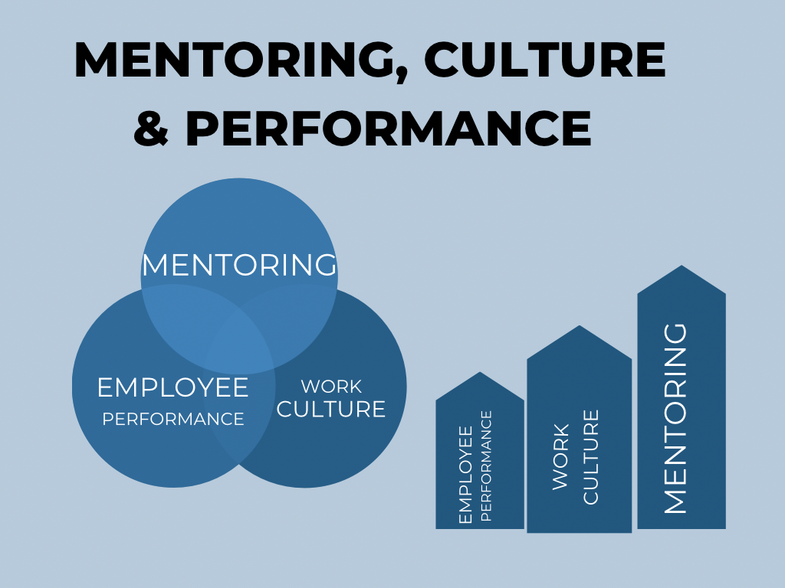
By Student: Denise Miller 1604710

EMPLOYEE PERFORMANCE

Performance is the level of genuine work an individual performs (Shore and Tetrick, 1990). Performance is the result workers achieve according to specific criteria attached to one job. Robins (1998) indicated that employee performance is a purpose of interaction between motivation and ability. Employee performance calls attention to a person’s achievement, measured by the criteria or standards agreed upon by the company. Performance management is a level of success or predominant ruling of a person in performing duties compared to standard work, targets, goals, and criteria that have been predetermined and agreed upon (Rivai,2004). Rivai added that performance does not stand alone but relates to rewards and job satisfaction, subjective to individual traits, skills, and abilities. That is to say, environment, desire, and ability determine performance. As a result, to perform well, a person must desire to do well and know their work; if there is conformity in capacity and job, it can be increased. (Sahat, et al., 2018)
How important are these characteristics in an organisation? Skill set, culture, and mindset benefit organisational growth and employee performance.
Figure 2
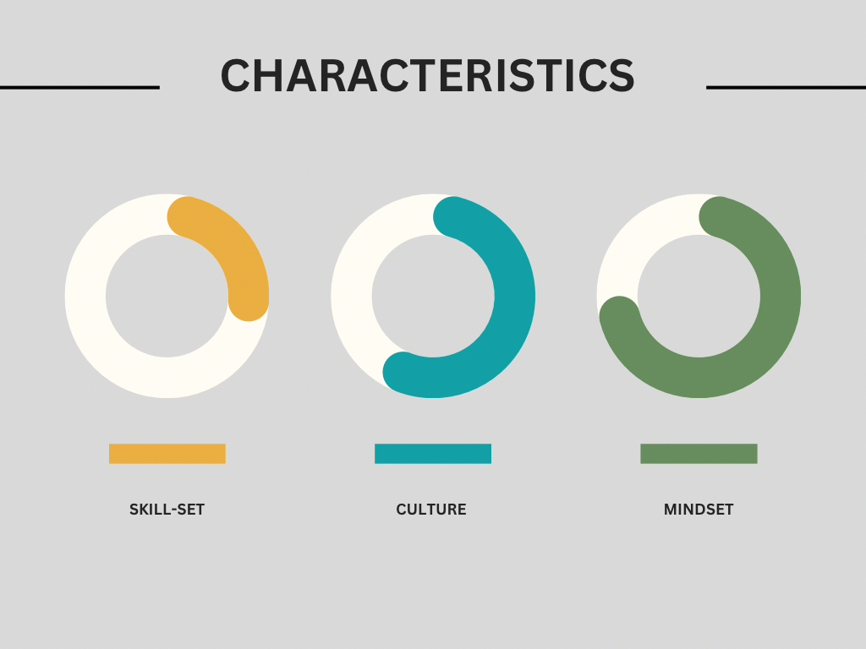 By Student: Denise Miller 1604710

According to (Dr. Rozen, 2017), profitable companies utilize seven characteristics of organisational culture: Company culture in which the employees have an avid sense of being goal driven. Effective communication patterns have three significant factors: clarity, courtesy, and proactivity. A feedback culture is a valuable source. Fostering a feedback culture is critical to the success of every organisation because feedback encourages an elevated level of performance.

Celebrating teamwork, improving, and being creative is at the core of every prosperous company that exudes culture. A culture of positive teamwork that focuses on team accomplishments instead of individual actions encourages collaboration—rapid completion of tasks, and improved efficiency. Having cultural sensitivity brings about an awareness of cultures and habits that differ from yours. A culture that embodies diversity is aware of different cultures and how to approach and communicate with them.

Loyalty and engagement made employees feel worthy and made a significant difference. Psychologically confident: a feeling of value, acceptance, respect, and ability to perform their role in an open-minded working environment. They feel a sense of security and self-confidence with their powers, allowing them to perform their job. Company cultures typically offer employees opportunities for personal growth in terms of training to mature and flourish within their respective teams as an individual enabling them to procure new skills and create possibilities.
HATS created a new role within the organisation to positively impact their staff’s daily lives to address diversity and inclusion issues. This dissertation will highlight the benefit of the additional position in the company and how it has altered employees’ perception of being supported.

Some authors believe; personal mindsets can affect motivation, behaviour, and employee goals. For example (Canning, et al., 2020) cover decades of exploration of how people’s mindset beliefs envisage their behaviour and motivation instead of focusing on how the perceptions of other people’s organisation’s mindset beliefs anticipate the social norms within the organisation. Fixed mindset beliefs, when personally sanctioned by the Person, there is cause more significant concerns in demonstrating and proving one’s ability and talent, inviting people to elude fresh challenges and hide their errors (Blackwell, Trzesniewski, & Dweck, 2007; Burnette, O’Boyle, VanEpps, Pollack, & Finkel, 2013; Hong, Chiu, Dweck, Lin, & Wan, 1999; Nussbaum & Dweck, 2008; Pollack, Burnette, & Hoyt, 2012). In particular, this view is supported by various authors, stating; in organisations, fixed mindset beliefs of people impact how managers appraise their employees, the approaches used to oversee conflict, and the effectiveness of peoples leadership (Heslin, Latham, & VandeWalle, 2005; Heslin & VandeWalle, 2011; Hoyt, Burnette, & Innella, 2012; Kray & Haselhuhn, 2007). These studies suggest that a personal mindset belief can influence employees’ motivation, goals, and behaviour. (Canning, et al., 2020)

Learning new technological skills is vital for digital transformation. Is this sufficient? Employees should be motivated to use their abilities to generate fresh opportunities. A digital mindset is a necessity. (Neeley & Leonardi, 2022)

Moreover, the effectiveness of mentoring is mirrored better in subordinates’ job performance through their positive communication, better relationship value, and knowledge quotient. (Jeevan & Sharma, 2017)

PERFORMANCE MANAGEMENT

What is performance management? The authors (Maley, et al.) state; Performance management (PM) was introduced in the early nineties to look at the incontestable limitations of performance appraisal (Avery and Murphy, 1998). (PM) the process includes a broader compass of management methods that provides training and development, career management, reimbursement considerations, and regular feedback. (Aguinis, 2007). (Maley, et al., 2021)

According to (Jeevan & Sharma) their study evaluates the role of self-efficacy between mentoring and its outcomes, namely, relationship quality, communication satisfaction, and personal learning. It also examines the mediating role of relationship quality, communication satisfaction, and individual learning between mentoring and job performance. (Jeevan & Sharma, 2017)
Marcus Buckingham claims that performance management is two things and discusses the idea that we all live inside a performance management system, and understanding each one allows us to improve our workforce.
Mentoring gives mentees a sense of capability and effectiveness in their role, identity, and learning skill that helps enhance individual learning. Additional individual learning is a valuable and essential asset for performance. Mentee’s performance is affected by competence and skill, which develop through individual learning. A mentor supports their mentee at every phase, and their support is highlighted in three ways. First, through career support, it helps the mentee to develop their career. Second by, psychosocial support, in terms of regular information sharing and discussion, helps increase a mentee’s sense of identity, competence, and work-role effectiveness. Third, a mentor is a role model in building the right attitudes, behaviours, and values for mentees.
Furthermore, a mentor’s behaviour comprises building trust, shared vision, emphasising development, and encouraging creativity. This good relationship between the two parties helps to improve job performance. It enables a mentee to get the necessary talents and experiences to perform work and protect them from doubt. (Jeevan & Sharma, 2017)

PERFORMANCE THEORIES
The ability, motivation, and opportunity theory (AMO) theory argues the concept of work motivation, ability, organisational commitment, and discretionary conduct that can influence levels of employee engagement. (Imdad, et al., 2022)
Leading on from Marcus Buckingham’s statement, the principles of this theory introduce two factors; Performance Acceleration – How to get more performance out of employees. Coaching is formed and framed around team leader, talking to team leader conversation, and Communication (quantitative). Performance Measurement – How can it be reliably measured for every team member? They must be solved separately.
The measurement tools that are of interest to this study are:
The Utrecht Work Engagement Scale (UWES) is one of the most standard measures of engagement. Nevertheless, while the ( MSIT) Master of Science in Information Technology has leveraged by combining psychosocial health measures, including burnout and the (UWES) with criteria of work stress, a lone study has gaged the (MSIT) as a predictor of engagement. (Ravalier, et al., 2015)
The literature meta-analysis described a series of affirmative outcomes (skills and performance, coping, work attitudes, goal-directed self-regulation, and well-being) as being encouraged by workplace coaching (Teeboom, Beersma, & van Vianen, 2014).
The Measurement Model of Coaching Skills (MMCS) scale and the Utrecht Work Engagement Scale (UWES) are validated in the literature, even though the second is more comprehensive. (Ladyshewsky & Taplin, 2017)
Job performance measurement (JPM). As stated by (Russell, et al., 2022), job performance connects to work-related behaviour – things that are said or done and actions persons take (Campbell et al., 1993). A job performance taxonomy puts behaviours that correlate to broader paradigms that have significance to the organisation (Binning & Barrett, 1989).

The Death of Performance Management?

A simple design and application of a performance management system (PMS) in the public domain are proposed to improve performance, motivate employees and reassure the general public assurance in the capability of the public sector to provide a service of excellence. Nonetheless, implementing the (PMS) in Botswana has not produced the necessary results, as service provision and student performance continue to wain. This research answers the requisite to scrutinise why implementing performance management in the public domain in Botswana has not generated the anticipated results to improve employee performance. (Bester & Hofisi, 2020)

The hype is now, and the talk is that performance management is gone. Accenture, Deloitte, Microsoft, and General Electric (GE) have done away with the outdated performance management review. So should you. That is what the headlines say. Before we all hop on the trend and follow in the footsteps, pause as it is not what it seems. Some headlines are incorrect. The change to performance reviews is desirable and overdue; however, they are far from dead. (Kinley, 2016)

WORK CULTURE

Culture is the character and personality of the organisation; it adds a uniqueness –
Numerous organisations now realise their advancement in this area is inadequate for the contemporary world, and all that is to come. Organisations learn their determination to enrich awareness, change, and understanding with their organisations, similarly influencing what persons do in their collective, affecting not only bottom-line short-term interests but prospects for long-term feasibility (Katz & Miller, 2018; Miller et al., 1998). (Miller & Davis-Howard, 2022)
Thompson et al. (1999) stipulated work-life balance (WLB) supportive culture as the shared expectations, values, and beliefs concerning the degree to which the organisation values and supports the combination of employees’ family and work lives. Organisations that establish a (WLB) promising culture in the workplace create a work setting that helps employees embrace (WLB) practices as delivered. An organisation with a robust (WLB) culture of support is considered a norm that inspires employees to steady resources dedicated to work and non-job related areas, supports using (WLB) practices. Managers are insightful to employees’ need for balance; a full awareness of (WLB) culture in the workplace will influence employees’ approach toward an organisation and will determine whether or not to utilise the (WLB) practices (Major et al. 2008). (Krenn, 2017)

LITERATURE REVIEW

(Mullen & Klimitis, 2019)
This article is a timely framework that defines contemporary mentoring by the explorative issues, applications, and types. Taking discriminatory action to differentiate mentoring from other developmental relationships is the leading edge. Definitions for mentoring multiply as trends alter and the expansion in these modern times. If research is to benefit from the increase of outdated methodological models, then research needs to overcome its limitations; for example, there is the tendency to rely on self-perception/report data overtly. Broadly, it is agreed that mentoring is developmental and relational. These phases are cultivation, initiation, made of career, instrumental, and psychosocial, relational. These are the functions identified by Kram. This piece of literature identifies a solution to lessen the gap in mentoring definitions.
(Chang, et al., 2022)

Reflections of mentors and mentees on a national mentoring programme for pharmacists in the United Kingdom: An examination into organisational culture and systems
However, there is no consistent or accepted model for delivering mentoring programs, which manifests in some debates surrounding the best beneficial system. Evidence suggests that successful mentoring programs should be uplifted and have an intent, process, resources, and structure. Formal programs created around a fixed process instill a robust culture of mentorship among mentees who proceed to mentor others; in regards to mentors, there is an improvement and modification of their skills.
This piece of literature supports the evidence of the lack of structure concerning mentoring.

(Cherono, et al., 2016)
Influence of Mentorship Practices on Employee Performance in Small Manufacturing Firms in Garissa County, Kenya
(Clutterbuck et al. 2012) found the effect that remains from enhancing the capability of a mentee; it provides psychological backing, job satisfaction, and motivation which improves performance for the employee and the organisation overall, which might translate into a competitive positioning advantage for the organisation.
In this article, The authors link different perspectives; study variables.
Olsen et al. (1999) established that in the knowledge economy, where the business environment is considered turbulent and complex, knowledge is the primary source of creating both a sustainable competitive advantage and innovation. Therefore it is necessary to acknowledge the link between knowledge identification, creation, mentorship, transfer, and application of knowledge, to improve employees’ competencies and capabilities by acquiring relatable knowledge, decision-making strategies, and skills.

(Murrell et al. 2012) the authors have distinguished these two relationships – formal and informal mentorship across three dimensions: process, structure, and initiation. Where a formal mentorship affiliation is assembled externally, informal collaboration is instigated when two people naturally connect because of interest, need, or apparent similarity. The authors say traditional mentorship connections are provided for a pre-arranged time, frequency, and location. Understanding the mentorship approach requires important planning before deciding on the style of mentorship that best suits your organisation. If a mentorship program is to succeed, top-level executives’ support must be tenable. A communication channel must be open to all employees to encourage participation, but not enforced (Schooley,2010).
A significant relationship was established through the study, talent development mentorship, innovative mentorship, knowledge transfer mentorship, leadership mentorship, and employee performance.
(Jyoti & Sharma, 2015)
Impact of Mentoring Functions on Career Development: Moderating Role of Mentoring Culture and Mentoring Structure.
Jyoti and Sharma (2015) the authors discuss in this article that; mentoring is a prized resource for coping with significant organisational changes. There is a reward value for everyone involved in the relationship of mentees, mentors, and organisations. Jyoti and Sharma focus on career development, mentoring functions, and the overall impact of both areas (p. 1)

(Montgomery, 2017)
Mapping a Mentoring Roadmap and Developing a Supportive Network for Strategic Career Advancement
This article presents a proactive, individual-centered mentoring model that meets a recognized need for defined, practical support methods.

(Gołaszewska-Kaczan, 2015)
Action For Promoting Work-Life Balance As An Element Of Corporate Social
environmental changes, which include knowledge improvement, technological progress, social and cultural growth, or competitiveness, have forced organisations to pursue a workforce that has the capabilities to address these challenges. Aside from owning particular competencies, willingness to learn, experience, and motivation, employees’ expectations are to be committed fully and display dedication to their company’s goals. Staff members sacrifice holidays, work overtime, and prioritize work over family life and personal time to earn approval from their employers. (2015, p. 58)

(Jenkins, 2013)
David Clutterbuck, Mentoring and Coaching
Clutterbuck points to a deficiency in clarity in differentiating when mentoring are formal or informal. There are two aspects, the level, and context, in how the relationship is planned, formalised, and structured. There is limited data and few case studies that justify note-taking or references, written contracts between mentor and mentee, and formal agendas. The notion in most research and writing on mentoring is that the relationship works with a great degree of relaxed attitude, irrespective of whether it is a formal or informal aspect.
A problem: the relaxed manner in mentoring shows you cannot separate the two constraints of formal or informal mentorship.

Mentorship Behaviors and Mentorship Quality Associated With Formal Mentoring Programs: Closing the Gap Between Research and Practice
The authors (Allen, et al., 2006) discuss formal mentoring programs and the continuation of growing popularity within organisations. Although limited empirical research to determine how programs ought to be designed to achieve the maximum effect. This study scrutinised the perceived design structures of formal mentoring programs and the results from protégé and mentor viewpoints. The variables were professional and psychosocial mentoring, mentorship quality, and role modeling. The outcomes specified that the training and mentoring process was of a high standard and related to the variables. Suggestions for the design of formal mentorship programs and theory are leading future discussions.
Although this journal is a little dated, its value highlights the differentiating factors of mentorship in today’s society.

(Dawson, 2014)
Beyond a Definition: Toward a Framework for Designing and Specifying Mentoring Models
The author attested that; In 1991, Maryann Jacobi’s critical review of the undergraduate mentoring literature complained about the shortage of definitions of mentoring, citing Wrightsman’s (1981) then a decade-old concern that.
“there is a false sense of consensus, because at a superficial level everyone “knows” what mentoring is. But closer examination indicates wide variation in operational definition, leading to conclusions that are limited to the use of particular procedures …
The result is that the concept is devalued , because everyone is using it loosely, without permission, and it may become a short-term fad.
(Wrightsman, 1981, pp. 3-4, in Jacobi, 1991, p. 508)”

The author says that without a precise definition, Jacobi argued arduous research on mentoring was impossible. Argument If the purpose cannot be outlined, do we have an accurate outline of the effectiveness of what mentoring means?

Development and retention of Generation Y employees: a conceptual framework
(Mohammad & Usha, 2018)
Authors (Mohammad & Usha) profess over the years that there has been a paradigm shift in the demographical workforce, a continued arrival of Generation Y employees (born between 1981- 2000) (Lancaster and Stillman, 2010), alongside the retirement of Baby Boomers. Cohort theory is modeled on this, a generation comprised of members born in the same era and experiencing everyday formative events during their developmental period that lead to similar attitudes, value systems, and perceptions (Kupperschmidt, 2000)
Is mentoring changing with the times? The attitudes, perceptions, and values have changed, and the habits and goals have changed. The need for clarity is beneficial.

Valuaing change: differential measurement of workplace culture shift
(Coutts, 2021) From the author’s perspective, change in any organisation can be multifaceted, including policy and processes, education, shifts in structure, and culture (Davis, 20116, p.2). However, contemporary quantitative measurement methods are not best suited to unloading the distinctive cultural framework of a given organisation. Starting positions are vague and, in reality, may not adapt to experimental design. Furthermore, many approaches regularly try to measure existing and preferred workplace cultures in terms of the best forms; therefore, comparison results are not easily determined across alternative change contexts.
(Yunsoo & Young Lee, 2018)
A multilevel analysis of individual and organizational factors that influence the relationship between career development and job performance improvement

Career development is able to create synergistic effects, increasing the productivity of employees when the employees’ career development experiences and the organization’s succession planning are aligned (Gaffney, 2005). McLagan (1989, p. 52) defined career development as “the alignment of individual career planning and organizational career management processes to achieve an optimum match of individual and organizational needs.” Gilley, Eggland, and Gilley (2002, p. 94), on the other hand, defined career development as “a process requiring individuals and organizations to create a partnership that enhances employees’ knowledge, skills, competencies, and attitudes required for their current and future job assignments.”

(Zheng, et al., 2017)
Machiavellian and utilitarian (practical) thinking was popularised and promoted amongst companies in China after the country experienced a social change due to its curative move to improve the market economy. This action facilitated the fast growth of family businesses. Machiavellianism was a vital source of internal power and determination that helped establish a Chinese market in a short time.

(Schneider, et al., 2017)
In search of implicit or explicit ways where culture is communicated to members and shared effects of culture, attitudes, and behaviours of those there. According to the authors, culture is more-or-less a late-comer in JAP (Journal of Applied Psychology). Fundamentally it exists at new levels of awareness; it is grounded in historical tradition. Culture carries a definition of shared values and rudimentary assumptions; these explain why organisations focus on specific areas; it is also a source of shared commitment and collective identity. Emerging from anthropological and sociological origins, employed methods from new culture researchers were qualitative, the emphasis and significance of immersion areas studied.

(Sahat, et al., 2018)
The Effect of servant leadership on Rewards, organizational culture, and its implication for employee performance
Establishing a company is based on the belief that the organization can attain something that an individual cannot achieve (Gibson et al., 1996, p.7). A strategy to keep proficient employees is to create committed and loyal employees. An employee works in an organization using expertise (mind and physical) and gets a wage per the agreements and regulations (Hasibuan, 2005). Employees whose wants have been will commit to the organization (Mathis and Dan Jackson, 2001). Human resources (HR) in an organisation has a central role, and the success of an organisation depends on the part people play within the organisation. The purpose of performance assessment for employees is twofold. First is an evaluation; a manager uses a descriptive rating to assess an employee’s past performance. The data is beneficial in remuneration, promotion, demotion, and termination. Secondly is development: a manager encourages employee improvement for the future.

(Bester & Hofisi, 2020)

Implementing Traditional Performance Management in the Innovative Age: A New Model for Botswana’s Public Sector

The authors have stated that the research aimed to examine the experiences and perceptions of the implementation and concept of the ( PMS) performance management system in the education ministry and by public officials in local government in Botswana to design an advanced performance management model in the public sector. (2020, p. 2)
Solution – the article shows a need for an inductive theory development focusing on crucial concerns. Method - and why implementing performance management has not motivated public-sector employees in Botswana to improve their performance.

(Habib, et al., 2020)

In this article, the authors explore the effectiveness of an all-inclusive performance management system (PMS) concerning employee performance. In addition, the effect of work engagement was also examined. (PMSE) performance management system effectiveness was resolute by the level of fairness and accuracy, as suggested by previous researchers.
Solution using PMSE model

(Gisbert, et al., 2016, p. 199)

Adapting mentoring to individual differences in novice teacher learning: the mentor’s viewpoint.

Match-making in programs for teacher preparation is typically a formal affair; mentor–mentee dyads are formed by the teacher preparation program, as opposed to informal matching in which mentor and mentee choose each other based on mutual affiliation.
This article emphasises the mentee/mentor relationship described in an informal pairing.

(Ravalier, et al., 2015)
Employee engagement and management standards: a concurrent evaluation

Employee engagement, typified by ’a sense of energetic and effective connection with their work activities.
Engagement is neither a constant personality trait nor a transient emotion; rather it reflects a mental attitude that is persistent and pervasive [

Employee perceptions of managerial coaching and work engagement using the Measurement Model of Coaching Skills and the Utrecht Work Engagement Scale

As a result the composite score for the MMCS is recommended. The results add to the literature noting the benefits managerial coaching can have on organizational performance measures. Further development of managers is needed to enable them to become effective coaches as demonstrated by the below average result.

(Janssen, et al., 2016)

Informal Mentoring at Work: A Review and Suggestions for Future Research

Mentoring literature is robust in explaining how individual characteristics shape mentoring and predict mentoring outcomes (Chandler et al. 2011; Eby and Allen 2008; Jones and Corner 2012). However, it has also been criticized (e.g., Russell and Adams 1997) because of its empirically driven research, with little attention to theory building. With the intense focus on the outcomes of mentoring (Allen et al. 2008), other important aspects of mentoring have been overlooked. Mentoring research shows an ‘impatience with troublesome conceptual and analytical problems’ (Bozeman and Feeney 2007, p. 720), paraphrase last 4!

(Dawley, et al., 2010)
Allen et al. , 2004). At the organizational level, mentoring serves as a practical tool in socialization, human resource development and developing managerial talent ([47] Russell and Adams, 1997). Moreover, organizations also receive benefits in the form of increased productivity, employee commitment, and reduced turnover. [

DATA COLLECTION METHODS

Data collection is a process of collecting and gathering information from various sources. This research has been constructed using primary data and secondary data. The researcher was granted permission to use the HATS Group organisation for this study. The Questionnaire was built to gain quantitative and qualitative results using Google Forms and the Statistical Package for the Social Sciences (SPSS) system.

A questionnaire (Akeem, 2015) is a pre-arranged set of questions to gather data. There are various formats of questionnaires, such as social status, clinical data, and occupational groups. It is a tool for collecting data and recording evidence of a specific area of interest.

The researcher devised a questionnaire to determine the effectiveness of mentoring and employee performance by deciding if the organisational environment supports employee growth through work culture alignment.
The strategies for analysis also included two one-to-one interviews with staff members conducted separately and through a Teams video call to support the qualitative section of the research. From this point on, the employees will be referred to as There were also interviews with
According to (Alpi & Evans, 2019), a case study is a process of pragmatic investigation to determine the ‘why and how of the marvel and contributes to the understanding of the marvel in a real-life and holistic setting. Question-driven or problem-faced case study inquiry would benefit from the area provided for new investigations that give job to any qualitative or quantitative study method.

The researcher added a quantitative element to this research to attribute a contrast. According to (Spence, et al., 2018), in assessing quantitative results focused on mentee participation to use and improve the program at an organisational level, in addition to providing targeted mentoring.
The researcher had the pleasure of gathering insight into the role of mentor with the HATS organisation’s mentor. It was essential to understand what mentoring means as the mentor to create the foundation for this study. Consideration of the underlying factors demonstrates that these ideas, as indicated by (Gisbert, et al., 2016), are within the setting that the match between mentee and mentor is recognised as a crucial part of doing mentoring work (Bullough, 2012; Hobson, Ashby, Malderez, & Tomlinson, 2009). (2016, p. 198)
See Appendix A

ANALYSIS OF RESULTS

Quantitative data
Regarding the HATS Group

In the hypothesis of the effectiveness of organisational mentoring, 96.2% of staff agree that mentoring helps organisational performance. 57% have undertaken to mentor within the organisation. 53.8% would possibly welcome the opportunity to mentor remotely. 84.6% believe mentoring should be embedded in the company culture. 57.7% believe mentoring meets their individual needs within the organisation.
See Appendix B
Qualitative data
The responses to various questions that gave open-ended answers and the invitation for participants to elaborate were valuable to the research. Almost all staff members believe that mentoring helps their performance. The results reflect the positive review of mentoring in the HATS organisation.
See Appendix C

Sample Size
The participants of this research were employees of the HATS Group organisation and had previously or currently had the opportunity to be part of the mentorship program.
A small sample of 26 participants was utilised for this study, as time was a factor in the completion of dissertation purposes. Two one-to-one interviews were completed to give weight to the qualitative data. The interviews were audio recorded using an iPhone to capture and facilitate better qualitative results. Written notes were also taken to sustain concentration and mark critical points for reflexive analysis.

Employee A, has been part of the mentoring scheme for two years.

DISCUSSION

Qualitative data is very diverse; it is difficult to follow a consistent analysis approach (Lewis et al., 2009).
The results indicate that a mentoring program concerning HATS Group positively affects company morale. Therefore as previously stated, the main focus of this research was to determine the potential of a mentor and mentee relationship that will incorporate work culture and reflect individual skills intrinsically under the flag of employee performance.
Talent management is cited increasingly in the literature as a novel strategic foundation stone for human resource management (HRM) area and organisational efficiency generally. Considering today’s active environment, the old-style approaches to acquiring a competitive advantage have been confirmed inadequate, organsiations are gradually drawing on their human capital to exist and achieve a competitive advantage (Cappelli, 2008). Countless argue that talent management has become a competitive tool for organisations globally (Beecher & Woodward, 2009). Regardless of the importance of strategic talent management, research has been growing at a measured pace. Even today, there remains no clarity relating to talent management’s meaning and central practices (Lewis & Heckman, 2006; Mellahi & Collings, 2010). (Kontoghiorghes, 2016)
The study aimed to improve the theory of employee-organisation relationships (EORs) by investigating job engagement roles in EORs and by increasing a thorough comprehension of how organisations nurture committed relationships with employees by communicating with them. To achieve this, we found and developed support for a model wherein job engagement facilitated the connection between employee communication (interaction support, adequate information, and information flow) and organisational assurance. (Walden, et al., 2017)
To accomplish this, we developed and found support for a model in which job engagement mediated the relationship between employee communication (information flow, information adequacy, and interaction support) and organizational commitment. (2017)

FINDINGS

The two one-to-one interviews are referred to as Person A and Person B for discussion purposes. This was a valuable part of deciding the effectiveness of the scheme.
Person A and B have been long-standing mentees of the HATS Group mentoring scheme. HATS has only one mentor for the whole organisation. The mentoring scheme runs yearly for a select few as the mentor works with other organisations; therefore, not everyone can be accommodated.
Person A mentioned that they could not define the mentoring program they are a part of but elaborated on the fact that you can speak about anything from personal life to work-life balance; Person A specified the freedom to discuss most things of choice. Trust was partially there and solidified as the mentor built confidence in the new relationship. For person A, the opportunity for a mentor came at the perfect timing, and life challenges brought questions to the surface that required professional support and a non-judgemental outlook. Person A would not have preferred a male mentor as the connectivity would be so different; things such as managing work-life balance do not need to be explained. Person A agrees that mentoring helps in maintaining a positive and consistent within the organisational environment. There is a positive element to being grounded when work and life challenges do not offer a solution through having a mentor. It is good to have an unbiased person to talk to that is not linked to the organisation. The comfortability factor of being mentored by somebody in your team puts restraints on how free you can be in a mentoring session because of judgment or penalisation. Person, A would like to see the program extended to others, as the benefit has been personally rewarding and would increase staff morale. There is a lack of male engagement in the mentoring program.
Person B was asked the same basic questions, so the interview was semi-structured to allow the participants to express themselves freely. Person B initially hoped to gain a better version of oneself when first taking up the invite to join the mentorship program in HATS. Person B has realised that this is an ever-changing personal goalpost from a positive point of view. Having a mentor that you can talk to and brainstorm with. Mentoring gives Person B, is interest in a reflexive outlook on life to acquire balance. As a very positive person, mentoring benefits primarily by keeping one focused on their goals; the mentor has been a critical component in helping person B revise decisions to meet the current climate of challenges.

CONCLUSION and RECOMMENDATIONS

The study aimed to improve the theory of employee-organisation relationships (EORs) by investigating job engagement roles in EORs and by increasing a thorough comprehension of how organisations nurture committed relationships with employees by communicating with them. To achieve this, we found and developed support for a model wherein job engagement facilitated the connection between employee communication (interaction support, adequate information, and information flow) and organisational assurance. (Walden, et al., 2017)
Further, Ragins et al. (2000) recommended that future research focus on an in-depth investigation of the type of mentoring relationships. Consequently, the current study emphasizes the arbitrating role of relationship quality, individual learning, and communication satisfaction between job performance and mentoring. The integrated (moderated-mediation) model of regulating and mediation variables’ impact on job performance and mentoring was not evaluated previously. This reveals a clear picture of the effect of mentoring on job performance. Therefore, the present research focuses on the mediated result of individual learning, communication satisfaction, and relationship quality between the collaboration effect of self-efficacy and mentoring on job performance (Jeevan & Sharma, 2017).
The study correlates mentoring, employee performance, and work culture. The analysis is based on data gathered from the HATS Group organisation relating to the mentoring program in the company. HATS Group may dissolve the mentoring scheme and introduce knowledge sharing as a new concept. However, according to (Akram, et al., 2020), knowledge sharing is considered a critical component in organisational growth and competitiveness. Thus not sharing knowledge hinders organisational survival (Lin, 2007). Knowledge sharing sponsors the presence of corporate sharing, fairness the best learning, and heightens the opportunities for innovative behaviour and employee encouragement to be creative (2020).

Can this study and data stimulate future research efforts?
Work motivation is an unstable environment, and organisational changes can trigger things to alter.

RECOMMENDATIONS
Consider current trends in organisations that may have meaningful inferences about how employees feel about their job roles and willingness to work to a point where they may disperse a quality performance. (Amabile)
This analysis supports the theory that HATS Group does not ‘fit’ into a specific approach; however, combining techniques and frameworks builds a contemporary framework to suit. Job performance measurement (JPM) may be a helpful starting point for future growth.
To conclude, HATS Group is an industry leader with a workforce of diversity. Keeping mentoring in place within the organisation benefits employees in their personal growth. It creates an organisational culture that can change and adapt while shifting towards an employee-centric performance management system and cultivating a person-specific contemporary framework.
Do not just have goals have an infrastructure to execute them (Bernard Marr).

References
Akeem, B. O., 2015. Principles and Methods of Validity and Reliability Testing of Questionnaires Used in Social and Health Science Researches. Nigerian Postgraduate Medical Journal, 22(4), pp. 195-201.
Akram, T., Lei, S., Haider, M. J. & Hussain, S. T., 2020. The impact of organizational justice on employee innovative work behavior: Mediating role of knowledge sharing. Journal of Innovation & Knowledge, 5(2), pp. 117-129.
Alfes, K., Shantz, A. & Truss, C., 2012. The link between perceived HRM practices, performance and well-being: the moderating effect of trust in the employer. HUMAN RESOURCE MANAGEMENT JOURNAL, 22(4), pp. 409-427.
Allen, T. D., Eby, L. T., Chao, G. T. & Bauer, T. N., 2017. Taking Stock of Two Relational Aspects of Organizational Life: Tracing the History and Shaping the Future of Socialization and Mentoring Research. Journal of Applied Psychology, 102(3), pp. 324-337.
Allen, T. D., Lentz, E. & Eby, L. T., 2006. Mentorship Behaviors and Mentorship Quality Associated With Formal Mentoring Programs: Closing the Gap Between Research and Practice. Journal of Applied Psychology, 91(3), pp. 567-578.
Alpi, K. M. & Evans, J. J., 2019. Distinguishing case study as a research method from case reports as a publication type. Journal of The Medical Library Association, 107(1).
Al-Zoubi, O. M., Ala'aldin, A. & Ra'ed, M., 2020. Exploring the relationships among tacit knowledge sharing, mentoring and employees’ abilities. Journal of Information and Knowledge Management Systems, 50(1), pp. 34-56.
Amabile, T. M., 1993. Motivational Synergy: Toward New Conceptualizations of Intrinsic and Extrinsic Motivation In The Workpalce. Human Resource Management Review, 3(3), pp. 185-201.
Azorin-Molina, J. F., 2016. Mixed methods research: An opportunity to improve our studies and our research skills. European Journal of Management and Business Economics, 25(2), pp. 37-38.
Baker, E., Hengelbrok, H., Murphy, S. A. & Gilkey, R., 2021. Building a Coaching Culture—The Roles of Coaches, Mentors, and Sponsors. Journal of Public Health Management and Practice, 27(3), pp. 325-328.
Becker, K. & Bish, A., 2017. Management development experiences and expectations: informal vs formal learning. Educating & Training, 59(6), pp. 565-578.
Bester, J. & Hofisi, c., 2020. Implementing traditional performance management in the innovative age: A new model for Botswana’s public sector. Africa's Public Service Delivery and Performance Review, 8(1), pp. 1-12.
Canning, E. A., Murphy, M. C. & Kray, L. J., 2020. Cultures of Genius at Work: Organizational Mindsets Predict Cultural Norms, Trust, and Commitment. Personality and Social Psychology Bulletin, 46(4), pp. 626-642.
Carter, J. W. & Youssef- Morgan, C. M., 2019. The positive psychology of mentoring: A longitudinal analysis of psychological capital development and performance in a formal mentoring program. Human Resource Development Quarterly, Volume 30, pp. 383-405.
Chang, H., Disselle, S., Canedo, J. & Mantzourani, E., 2022. Reflections of mentors and mentees on a national mentoring programme for pharmacists in the United Kingdom: An examination into organisational culture and systems. Research in Social and Administrative Pharmacy, 18(4), pp. 2659-2669.
Cherono, V., Towett, D. K. & Njeje, D., 2016. Influence of Mentorship Practices on Employee Performance in Small Manufacturing Firms in Garissa County, Kenya. European Journal of Business and Management, 8(8), pp. 2222-2839.
Clercq, D. D. & Belausteguigoitia, I., 2017. Mitigating the negative effect of perceived organizational politics on organizational citizenship behavior: Moderating roles of contextual and personal resources. Journal of Management & Organiszation, 25(3), pp. 689-708.
Coutts, D. S., 2021. Valuaing change: differential measurement of workplace culture shift. Journal of Organizational Change Manangement, 34(5), pp. 990-1002.
Dawley, D. D., Andrews, M. C. & Bucklew, N. S., 2010. Enhancing the ties that bind: mentoring as a moderator. Career Development International, 15(3), pp. 259-278.
Dawson, P., 2014. Beyond a Definition: Toward a Framework for Designing and Specifying Mentoring Models. Educational Researcher, 43(3), pp. 137-145.
Dr. Rozen, M., 2017. The Seven Characteristics Of Successful Company Cultures. Huff Post, 29 September.
Eissner, S. & Gannon, J., 2018. Experiences of mentoring in the UK hospitality sector. JOURNAL OF HUMAN RESOURCES IN HOSPITALITY & TOURISM, 17(3), pp. 296-313.
Gisbert, V. G., Oolbekkink, H., Meijer, P. C. & Verloop, N., 2016. Adapting mentoring to individual differences in novice teacher learning: the mentor’s viewpoint. Teachers and Teaching theory and practice, 22(2), pp. 198-218.
Gołaszewska-Kaczan, U., 2015. ACTIONS FOR PROMOTING WORK–LIFE BALANCE AS AN ELEMENT OF CORPORATE SOCIAL. PRACE NAUKOWE UNIWERSYTETU EKONOMICZNEGO WE WROCŁAWIU RESEARCH PAPERS OF WROCŁAW UNIVERSITY OF ECONOMICS, pp. 54-65.
Greckhamer, T., Furnari, S., Aguilera, R. V. & Peer, F. C., 2018. Studying configurations with qualitative comparative analysis: Best practices in strategy and organization research. Strategic Organisation, 16(4).
Habib, N., Akhtar, S. C., Naveed, S. & Sajid, A. H., 2020. Effectiveness of Performance Management System for Employee Performance Through Engagement. Sage Open, pp. 1-15.
Heeneman, S. & de Grave, W., 2019. Development and initial validation of a dual-purpose questionnaire capturing mentors’ and mentees’ perceptions and expectations of the mentoring process. BMC , 19(133), pp. 1-13.
Imdad, A., Robinson, I. & Salman Bashir, M., 2022. TALENT MANAGEMENT AND ORGANIZATIONAL PERFORMANCE: APPLYING THE AMO THEORY. Independent Journal of Management & Production, 13(2), pp. 648-666.
Janssen, S., van Vuuren, M. & de Jong, D. T., 2016. Informal Mentoring at Work: A Review and Suggestions for Future Research. International Journal of Management Reviews, Volume 18, pp. 498-517.
Jeevan, J. & Sharma, P., 2017. Empirical investigation of a moderating and mediating variable in between mentoring and job performance: A structural model. Revista de Psicologia Del Trabajo y del las Organizaciones, 33(1), pp. 55-67.
Jenkins, S., 2013. David Clutterbuck, Mentoring and Coaching. International Journal of Sports Science & Coaching, 8(1), pp. 139-256.
Jyoti, J. & Sharma, P., 2015. Impact of Mentoring Functions on Career Development: Moderating Role of Mentoring Culture and Mentoring Structure. Global Business Review, 16(4), pp. 700-718.
Kairuz, T., Krehula, D. & Truter, I., 2019. Expectations in the workplace: a qualitative study among Australian and South African academic pharmacists. International Journal of Pharmacy Practice, Volume 27, pp. 370-379.
Kinley, N., 2016. The end of performance management: sorting the facts from the hype. Strategic HR Review, 15(2), pp. 90-94.
Kontoghiorghes, C., 2016. Linking high performance organizational culture and talent management: satisfaction/motivation and organizational commitment. The International Journal of Human Resource Management, 27(16), pp. 1833-1853.
Krenn, J., 2017. Business.com. [Online]
Available at: https://www.business.com/articles/management-theory-of-henri-fayol/
[Accessed 7 May 2018].
Ladyshewsky, R. & Taplin, R., 2017. Employee perceptions of managerial coaching and work engagement using the Measurement Model of Coaching Skills and the Utrecht Work Engagement Scale. International Journal of Evidence Based Coaching & Mentoring, 15(2), pp. 25-42.
Mahmood, M., Uddin, M. A. & Fan, L., 2019. The influence of transformational leadership on employees’ creative process engagement: A multi-level analysis. Management Decision, 57(3), pp. 741-764.
Maley, J. F., Dabic, M. & Moeller, M., 2021. Employee performance management: charting the field from 1998 to 2018. International Journal of Manpower, 42(1), pp. 131-149.
Małgorzata, B. & Zarzycki, R., 2021. Key effects of mentoring processes - multi-tool comparative analysis of the career paths of mentored employees with non-mentored employees. Journal of Business Research, Volume 124, pp. 1-11.
McKevitt, D. & Marshall, D., 2015. The legitimacy of entrepreneurial mentoring. International Journal of Entrepreneurial Behaviour and Research, 21(2), pp. 263-280.
Miller, F. A. & Davis-Howard, V., 2022. It is Time for Organizations to Take a Leap Forward. Organization Developmemnt Journal, 40(1), pp. 43-62.
Mohammad, N. F. & Usha, L., 2018. Development and retention of Generation Y employees: a conceptual framework. Employee Relations, 40(2), pp. 433-455.
Montgomery, B. L., 2017. Mapping a Mentoring Roadmap and Developing a Supportive Network for Strategic Career Advancement. Sage Journals, 7(2).
Mullen, C. A. & Klimitis, C. C., 2019. Defining mentoring: a literature review of issues, types, and applications. Annals Of The New York Academy Of Sciences, pp. 19-35.
Neeley, T. & Leonardi, P., 2022. Developing a Digital Mindset. Harvard Business Review, Volume 100, p. 50.
Olsson, C., Cruickshank, A. & Collins, D., 2017. Making Mentoring Work: The Need for Rewiring Epistemology. Quest, 69(1), pp. 50-64.
Ravalier, J. M., Dandil, Y. & Limehouse, H., 2015. Employee engagement and management standards: a concurrent evaluation. Occupational Medicine, 65(6), pp. 496-498.
Russell, T. et al., 2022. Development of a performance taxonomy for entry-level military occupations. Military Psychology.
Sahat, S. et al., 2018. The effect of servant leadership on rewards, organizational culture and its implication for employee’s performance. Journal of Law and Management, 60(2), pp. 505-516.
Sahat, S. & Astuti, S. E., n.d.
Schneider, B., Gonzalez-Roma, V., Ostroff, C. & West, M. A., 2017. Organizational Climate and Culture: Reflections on the History of the Constructs. Journal of Applied Psychology, 102(3), pp. 468-482.
Sellars, M. et al., 2018. Conversations on Critical Thinking: Can Critical Thinking Find Its Way Forward as the Skill Set and Mindset of the Century?. Education Sciences, 8(4), p. 205.
Sladana, C. & Dahms, S., 2020. The Role of Multidimensional Intellectual Capital and Organizational Learning Practices in Innovation Performance. European Management Review, Volume 17, pp. 835-855.
Spence, J. P. et al., 2018. Independent investigator incubator (I3): a comprehensive mentorship program to jumpstart productive research careers for junior faculty. BMC Medical Education, 18(1), pp. 186-186.
Sruk, B., 2020. HOW MILLENNIALS ARE CHANGING ORGANIZATIONS AND BUSINESS MODELS – NEW VALUES, NEW PRINCIPLES, NEW CULTURE. Dubrovnik International Economic Meeting, 5(1), pp. 101-108.
Strijker, D., Bosworth, G. & Bouter, G., 2020. Research methods in rural studies: Qualitative, quantitative and mixed methods. Journal of Rural Studies, Volume 78, pp. 262-270.
Walden, J., Hwa Jung, E. & Westerman, C. Y. K., 2017. Employee communication, job engagement, and organizational commitment: A study of members of the Millennial Generation. JOURNAL OF PUBLIC RELATIONS RESEARCH, 29(2-3), pp. 73-89.
Yang, Z. & Niu, L., 2022. Though the organizational climate can reflect characteristics of an organization and influence employees’ behavioral motive and work performance through their cognition,9 the correlation between organizational climate and employees’ overtime behaviors ha. Psychology Research and Behavior Management, Volume 15, pp. 3733-3749.
Yunsoo, L. & Young Lee, J., 2018. A multilevel analysis of individual and organizational factors that influence the relationship between career development and job performance improvement. European journal of training and development, 42(5/6), pp. 286-304.
Zheng, W., Wu, J. Y.-C., Chen, X. & Lin, S.-J., 2017. Why do employees have counterproductive work behavior? The role of founder's Machiavellianism and the corporate culture in China. Management Decision, 55(3), pp. 563-578.

APPENDIX

Appendix A
The HATS Group Mentor’s answer to the question; As a mentor, do you have a technique to entice staff to take advantage of the scheme? Not just for HATS but for general?
My Mentoring strand has been successful through word-of-mouth recommendations and testimonials across my professional years in leadership roles by building a network and community that validate me. The claim to success in my ability to empower for change or identifying areas of development that can be assessed and attended to for positive growth. The Up-Sell for me is a natural progression to be confident enough to recognise who will benefit from my Mentoring and who will take the time and support I give seriously. Mentoring can only work if both Mentor x Mentee feel the dial shifting

Appendix B
Questionnaire Graph Results for Mentoring Survey
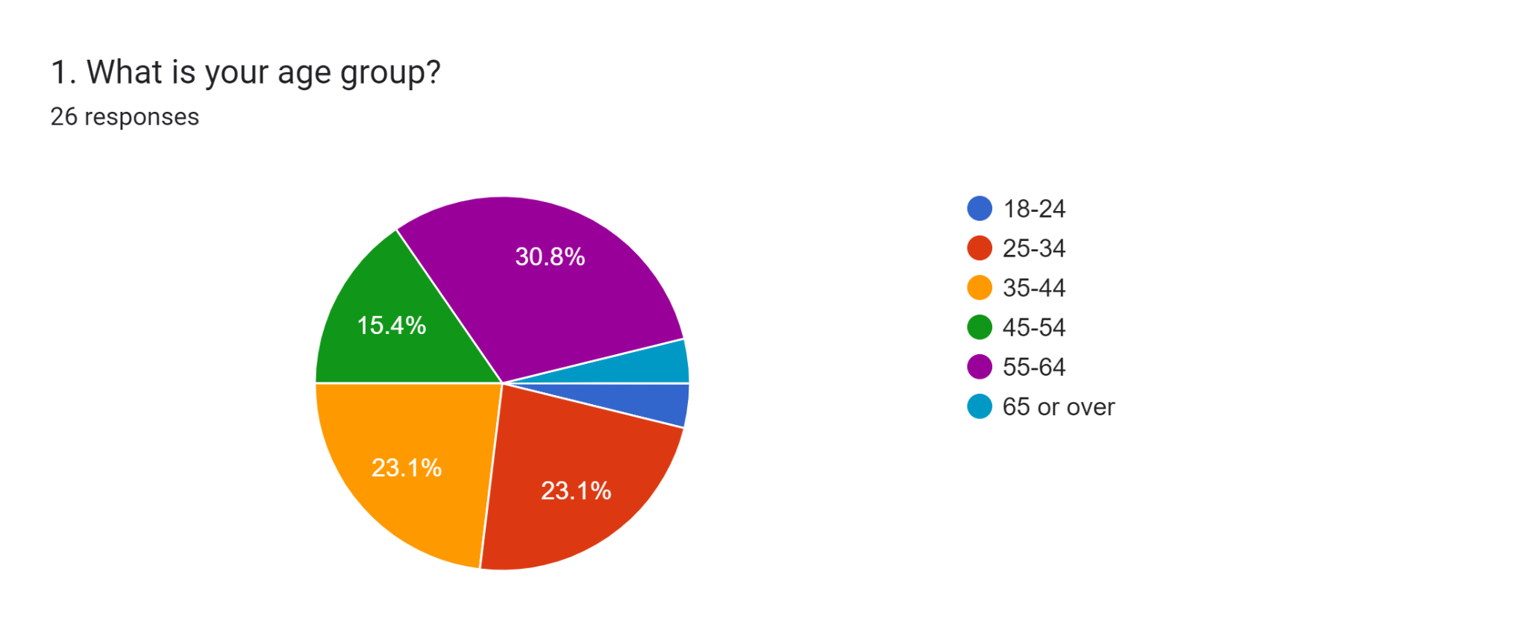

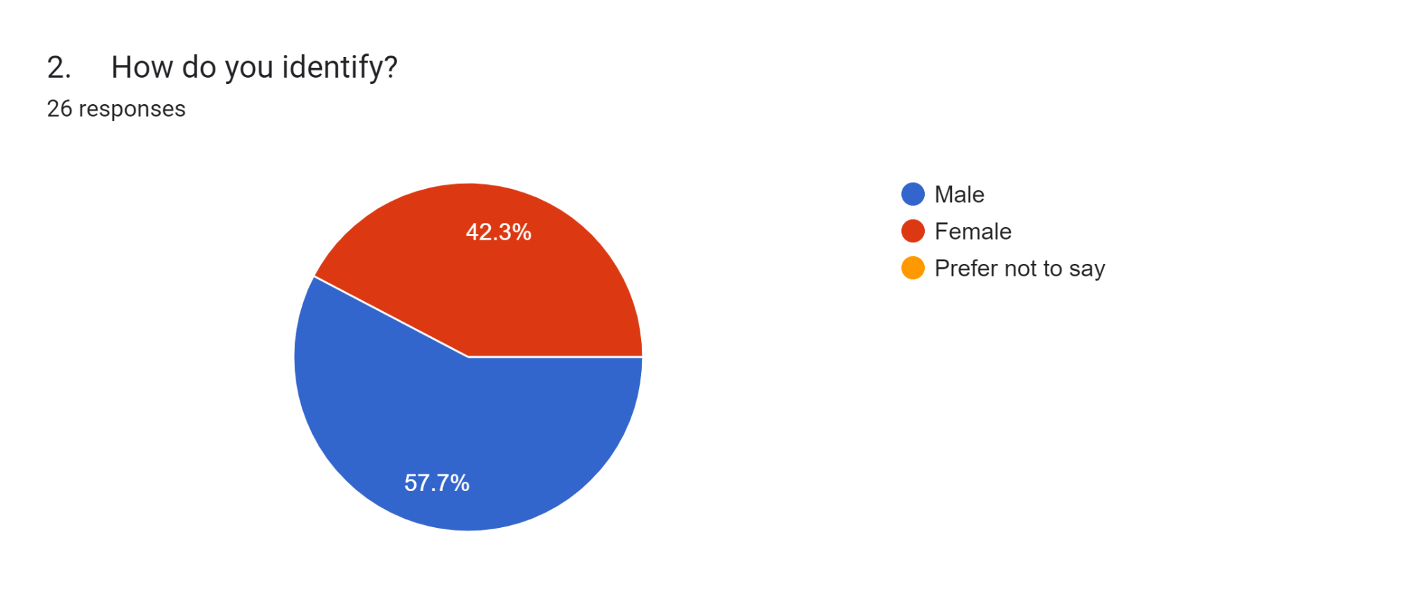

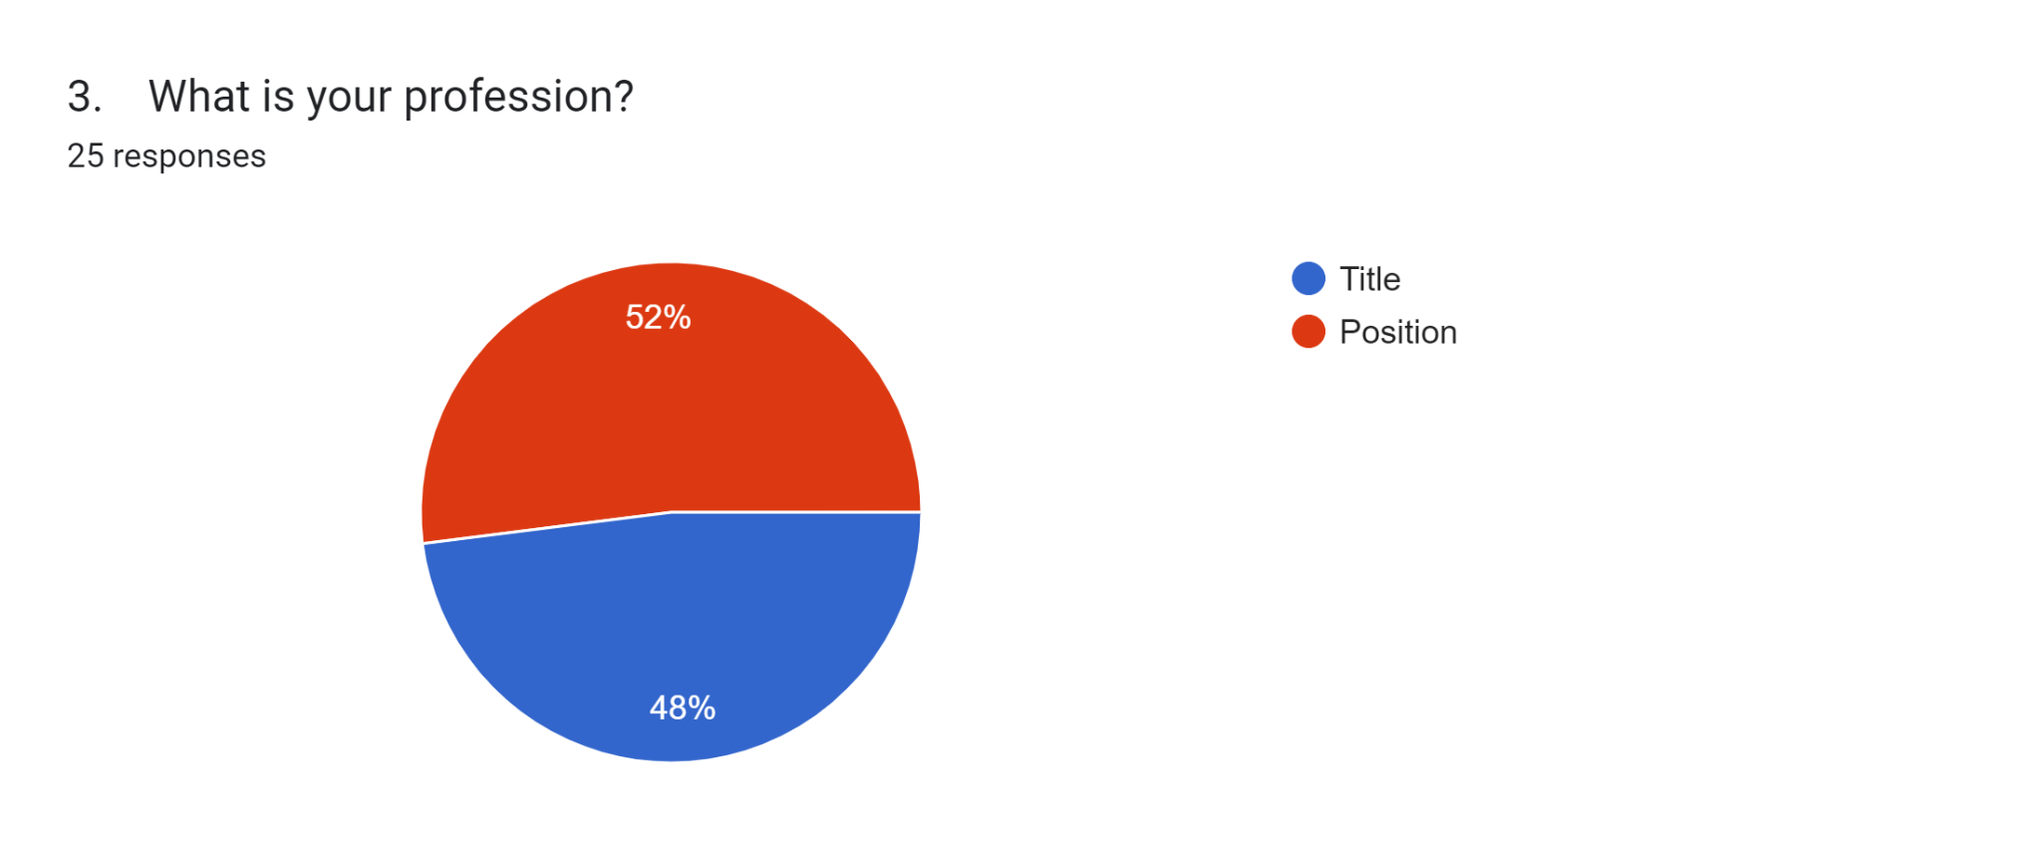

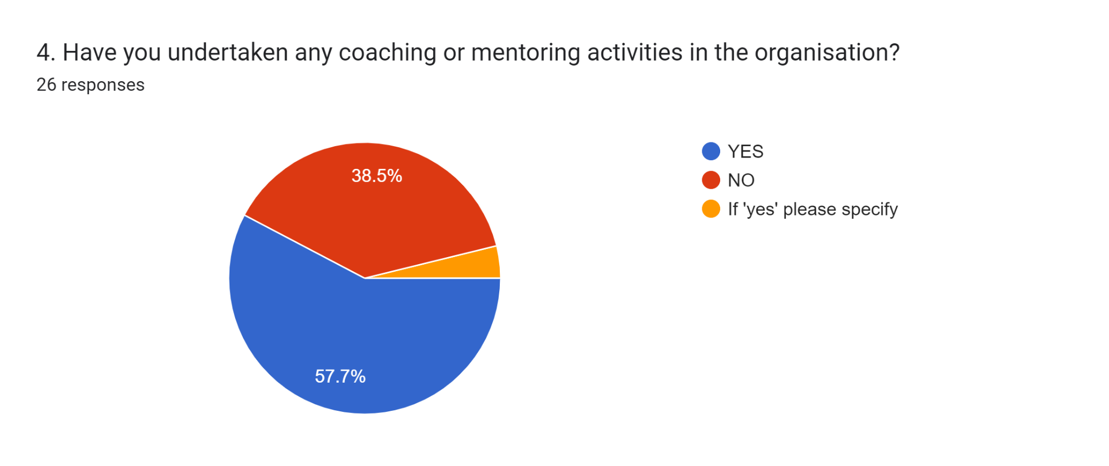

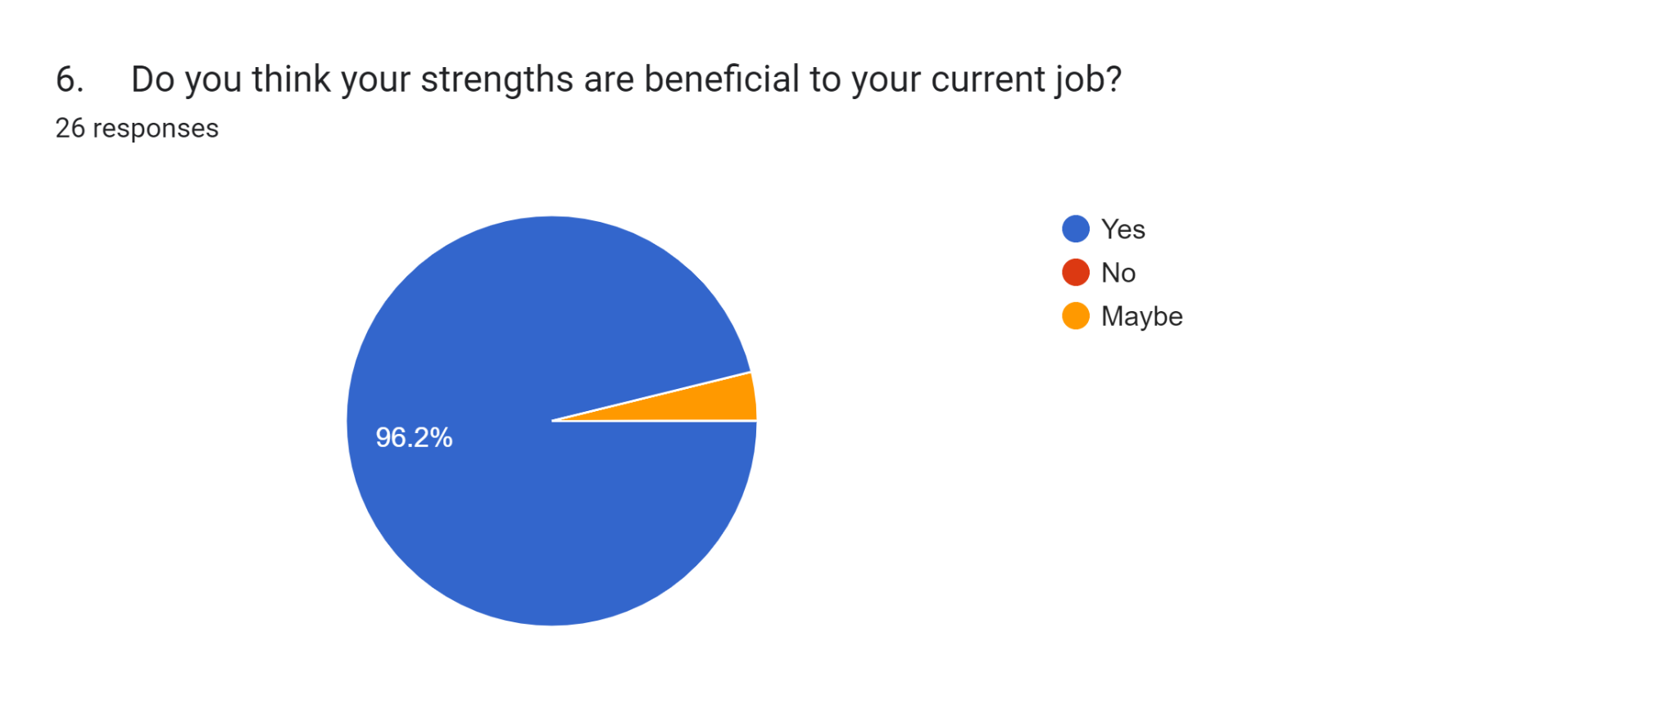

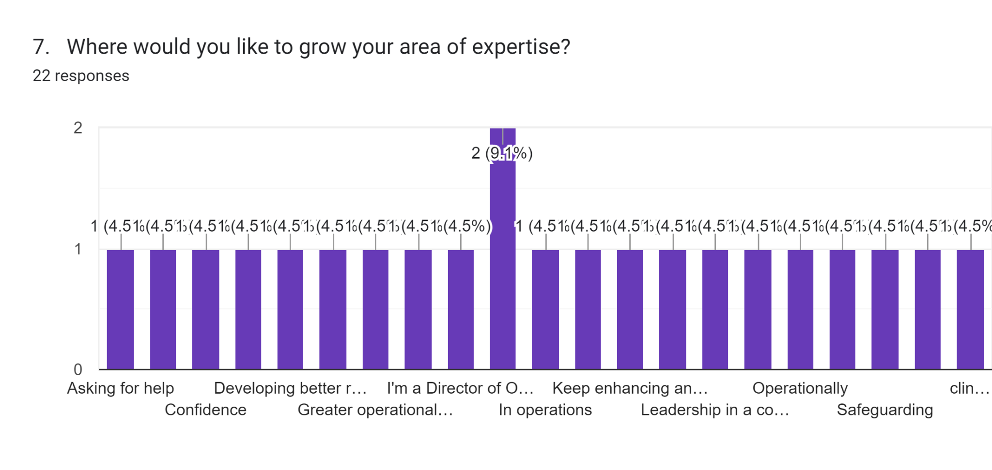

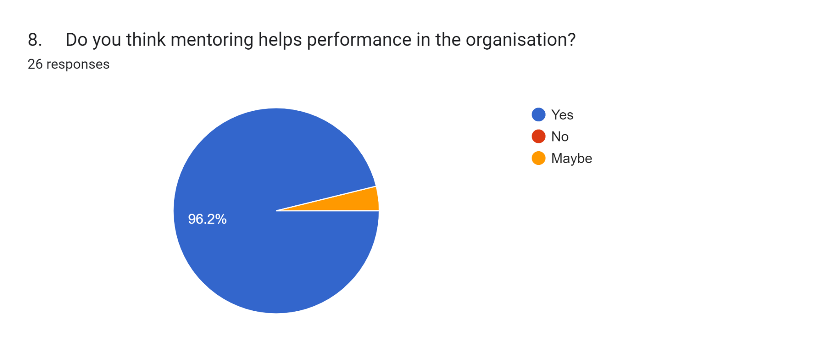

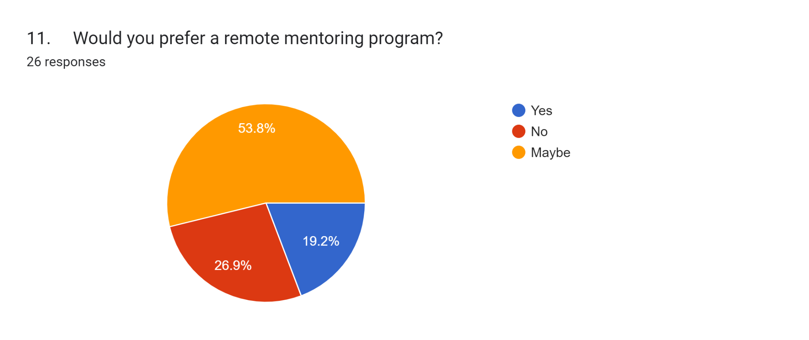

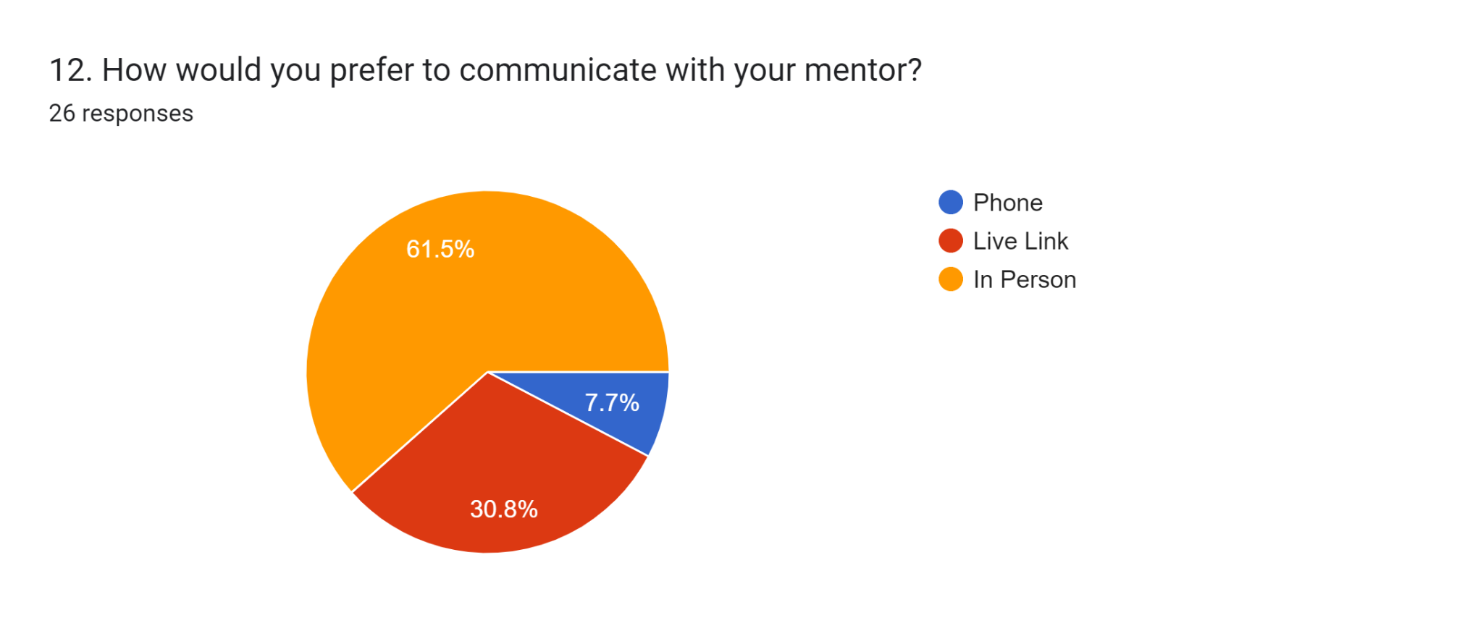

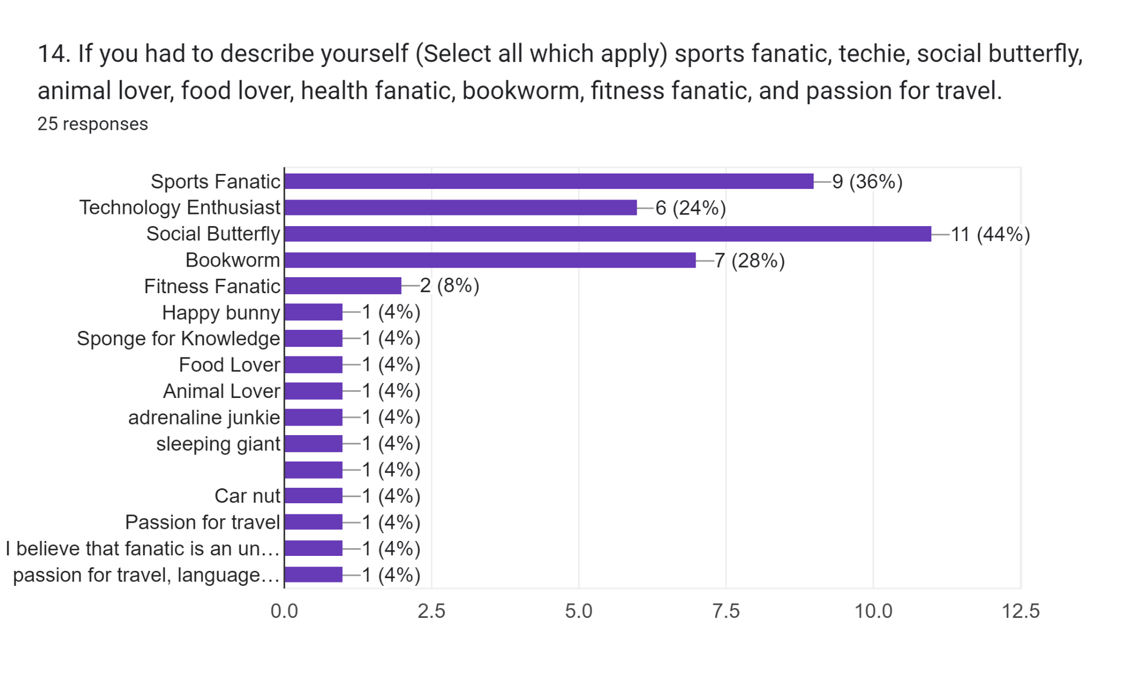

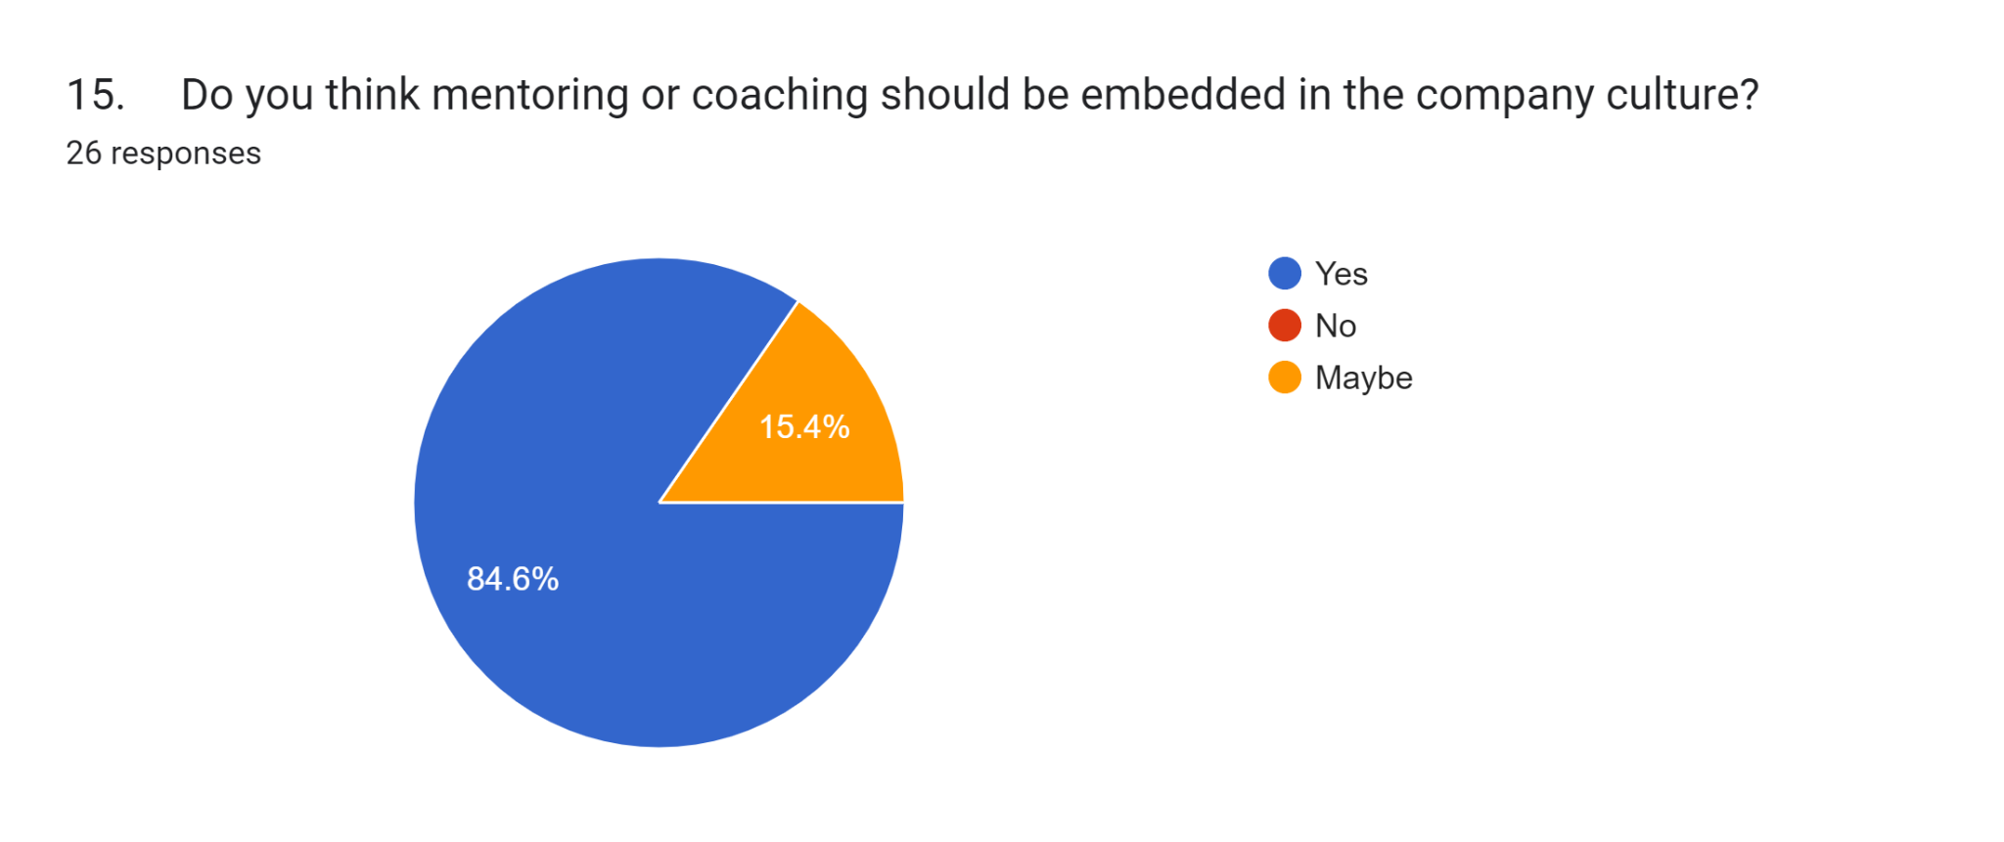

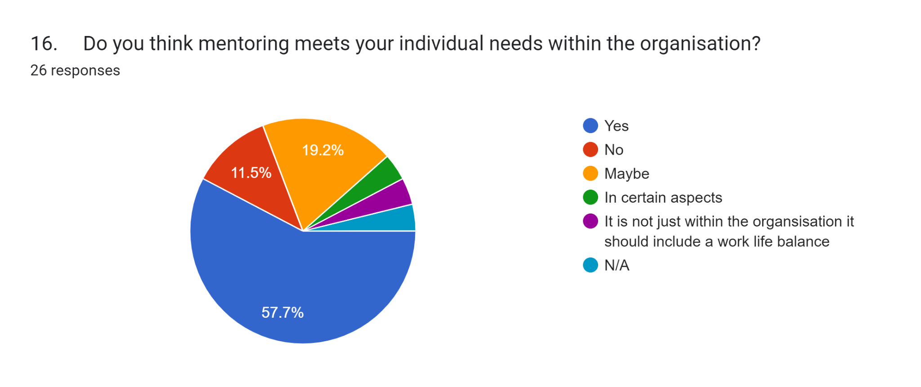

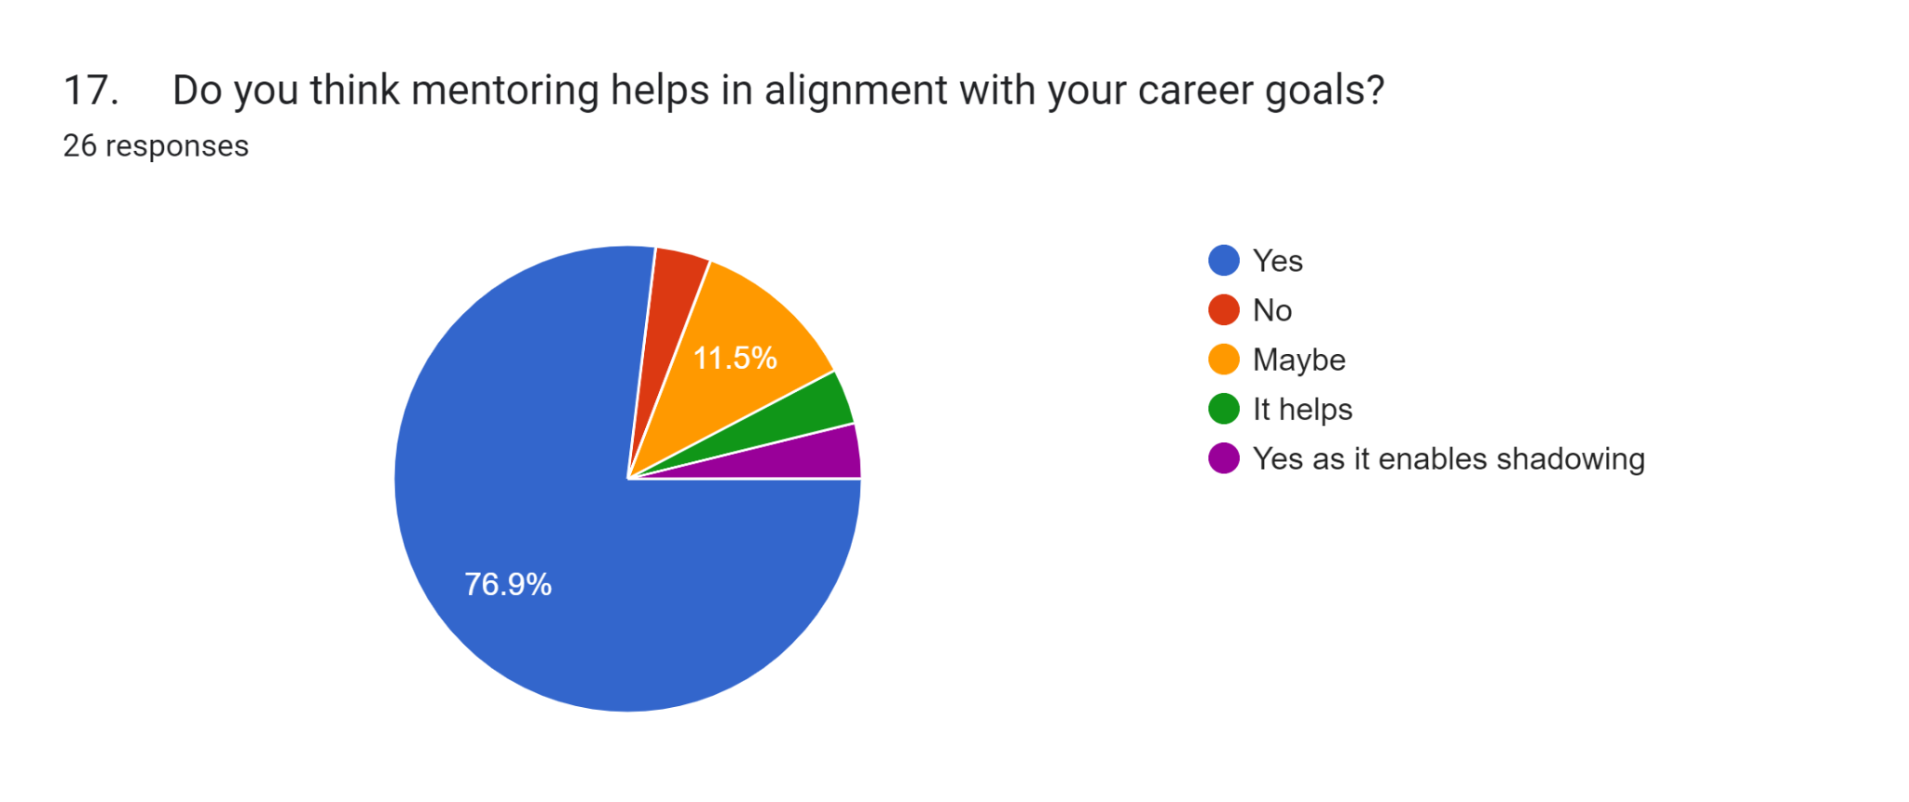

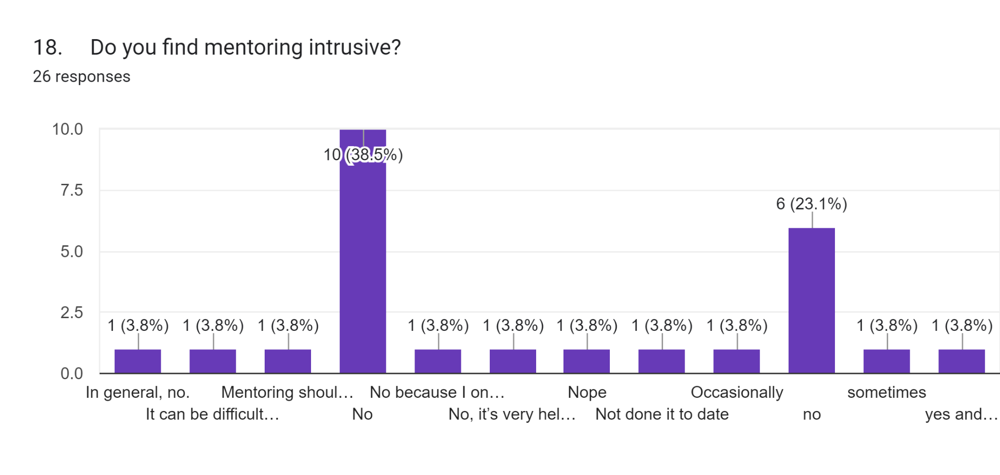

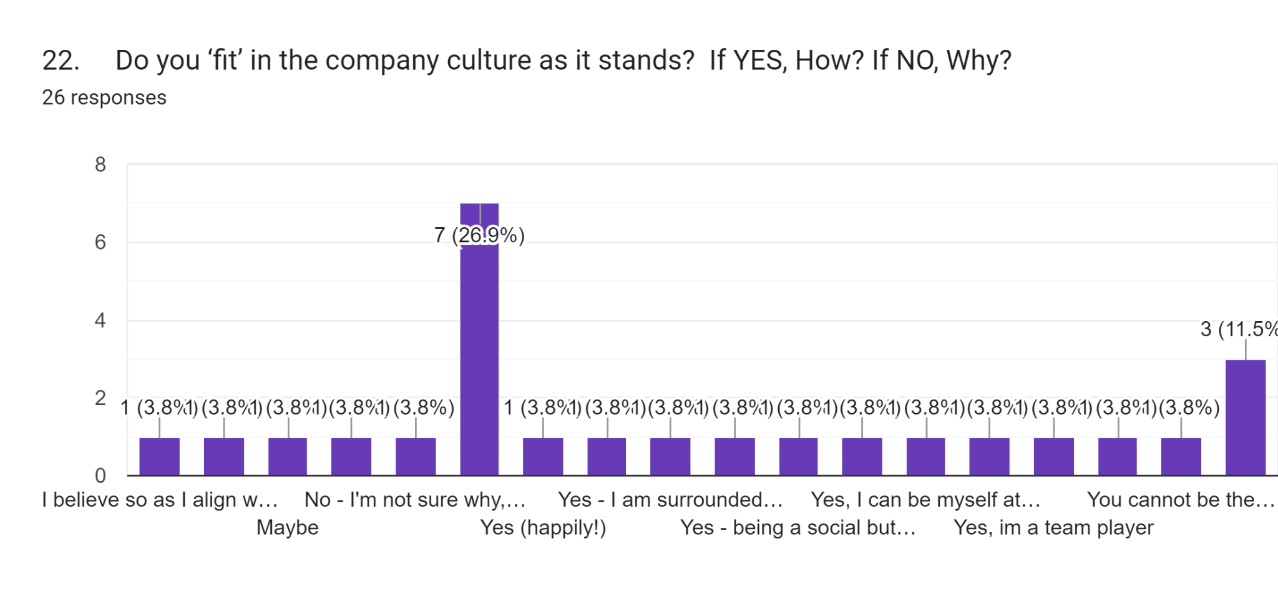

Appendix C
Written Responses to the Questionnaire
9. Have you found mentoring helpful in improving your job performance?26 responses
Yes
yes
N/A
Greatly
Yes greatly It gives you awareness
Yes as its always good to have an outside perspective
Yes I was mentored by my Peers which allowed me to progress within the Company
Yes, it’s been rally helpful in boosting my confidence
yes
Yes, especially when people from different backgrounds and roles
Any mentoring I’ve had has helped me in one way or another
absolutely
Definitely. Strong role models with excellent technical knowledge are invaluable to support your own growth
For other ... very much
Yes, where I have been in new situations
N/a
10. Have you found mentoring helpful in managing your work-life balance?
26 responses
Yes
yes
N/A
No
I think so
Yes someone to speak to helps you determine what’s best to prioritise and what can wait.
no
yes
In the past I have when managing stressful situations
maybe
N/a
To some degree although job design and workflow play also impact
11. Would you prefer a remote mentoring program?
26 responses
Yes | 5
No | 7
Maybe | 14
12. How would you prefer to communicate with your mentor?26 responses

Phone | 2
Live Link | 8
In Person | 16
13. (If applicable) What is the reason why you have not participated in the mentorship scheme?
12 responses
N/A
Workload and family schedules
n/a
I haven’t been selected as yet in my current organisation
Time constraints
Not been added on
14. If you had to describe yourself (Select all which apply) sports fanatic, techie, social butterfly, animal lover, food lover, health fanatic, bookworm, fitness fanatic, and passion for travel.
25 responses

Value | Count
Sports Fanatic | 9
Technology Enthusiast | 6
Social Butterfly | 11
Bookworm | 7
Fitness Fanatic | 2
Happy bunny | 1
Sponge for Knowledge | 1
Food Lover | 1
Animal Lover | 1
adrenaline junkie | 1
sleeping giant | 1
 | 1
Car nut | 1
Passion for travel | 1
I believe that fanatic is an unhelpful description and a closed question ion | 1
passion for travel, language and cultures | 1
15. Do you think mentoring or coaching should be embedded in the company culture?
26 responses

Yes | 22
No | 0
Maybe | 4
16. Do you think mentoring meets your individual needs within the organisation?
26 responses

Yes | 15
No | 3
Maybe | 5
In certain aspects | 1
It is not just within the organsisation it should include a work life balance | 1
N/A | 1
17. Do you think mentoring helps in alignment with your career goals?
26 responses

Yes | 20
No | 1
Maybe | 3
It helps | 1
Yes as it enables shadowing | 1
18. Do you find mentoring intrusive?
26 responses

Value | Count
In general, no. | 1
It can be difficult to juggle work and mentoring and personal life | 1
Mentoring should be aligned with your goals and aspirations | 1
No | 10
No because I only share what I chose to share | 1
No, it’s very helpful in your particular field or level | 1
Nope | 1
Not done it to date | 1
Occasionally | 1
no | 6
sometimes | 1
yes and no - depends on the Mentor | 1
19. Does mentoring add positively to your identity outside the workplace? If YES, How? If NO, Why?
25 responses
Yes
It sometimes does
It is a confidence builder
Sometimes - it can help with confidence
No, I keep my work separate from my social life
Yes, it has allowed me to have a work life balance
Yes, it build self confidence
No, I am my own Person
Yes - getting to know other cultures
Yes, if work worries are minimal, then socially is better
Yes, if it helps you and your outcomes
No, any mentoring I’ve received has only helped within work
not sure, I’ve only ever been mentored regarding work
Mentoring, if done well, should improve all aspects of your life as you grow and develop as a person. Its not just about work where you use those skills.
It allows us to understad the finite of the job and whether the job role fit my character
Confidence when dealing with individuals from all walks of life and culture
not really
Na
Yes, social interactions and dispute resolution
any function which enables you to view positively from another perspective can only contribute to your inner being and positivity
No, not done any
Yes in terms of professional shadowing
Yes, it helps you to progress further
Yes - it gives me platform to speak on situations that have arisen and listen to another persons perspective.
20. Do you believe mentoring is enough for your personal growth as an employee? If YES, How? If NO, Why?
24 responses
Yes
It helps but it is not enough
1st you need to embrace , then you need to disregard your inhibitions
No - I feel it should assist but other things can be good for personal growth
No, it needs to include training and experience
I think it is a start
No, but it plays a huge part in personal growth.
No, more is always better
No, you have to do it yourself too
Yes. It allows new visions and hopefully how to better your role
Yes, it allows me to learn about things within my field I may not have been familiar with
No - I think if we had mentoring along with training, it would help us grow
No - there are a wider range of things such as training and experiences
NO it should be a part of the structuring of your work life
No, education and training are also critical tools
not really
Yes, gives you a different ways of looking a problem and find a solution
No, nothing beats experience
No
There is no way that mentoring should be identified as sufficient it is one of the tools in assisting an ability to appraise oneself and others for inner worth and guidance
It is always useful to learn from others
No - personal goals, ambitions and endeavours shape broader personal performance
Yes - having someone that listens and gives advise from an outside perspective enables me to speak confidently and lead the team from the front.
21. Describe your ideal company culture
24 responses
Inclusive
An EOT
Inclusive and fair
To work as a Team not an individual
Inclusive and safe
Family like and friendly
inclusive to all
Like an elite sports team. Great teamwork and working together that drives improvement and standards constantly.
Family
Diverse open and transparent
Positive vibes
A supportive team with a can do attitude goes a long way in making your day-day easier..
Open door and communication is key
Open, constructive and reflective
freindly but serious
Fast paced, diverse, challenging but aligned with strong values and ethics in the workplace
Open
Lively
Professional, motivated, caring, innovative
Openness
Empowering, supportive, inclusive
Inclusive, developmental, professional
A company that focuses on their employees
22. Do you ‘fit’ in the company culture as it stands? If YES, How? If NO, Why?
26 responses

Value | Count
I believe so as I align with company values | 1
I understand the company needs and try to make sure that other staff I come across also understand it so that we are all on the same page derstand | 1
Maybe | 1
No | 1
No - I’m not sure why, some people just don’t like me no matter how hard I try or how good my work is, there is never any recognition. | 1
Yes | 7
Yes (happily!) | 1
Yes - | 1
Yes - I am surrounded by high achievers who strive for future growth | 1
Yes - I’m fair & inclusive to everyone | 1
Yes - being a social butterfly enables me to fit in with various people in different departments | 1
Yes and No, I fit in with those similar in personality or perspective as me. | 1
Yes, I can be myself at HATS | 1
Yes, everyone is allowed to be themselves | 1
Yes, im a team player | 1
Yes, with my work ethic | 1
You cannot be the one that fits all , there are many facets within the company and you can do your best with the knowledge and skills you have to be a successful cog in the wheel | 1
yes | 3
23. What significant challenges are you experiencing and trying to overcome in your current job?
23 responses
That we are all working for one company and if we supported each other the company could only get stronger. Rather than each separate units working independently.
Time management
N/A
understanding the challenges of other departments and their impact on the company as a whole
Work load management
NA
Adapting to the significant increase in size and associated workload, accepting I might not know every employee personally and maintain the same level of involvement in all areas.
Busy Schedules
Being Micromanaged
getting everybody to be productive
Workload will always be the biggest challenge
I love my job and the variety it holds
Financial acumen across the workforce
I’m doing fine so far
Work life balance
Time management
Bringing processes and procedures into every day life
Feeling stagnant in my position.
None - I communicate appropriately and ask questions and indicate where required
Creating the ideal bid library
emotional issues with patient care and logistical challenges of central london working
Juggling few things
n/a
24. Describe your ideal mentor
25 responses
I only know my mentor and I am amazed and inspired by her achievements
Someone who wants to educate me for the better
Someone who listens & offers advice catered to yourself
someone who understands the industry and has actual experience
Good listener, someone who I can look up to who I can relate to.
Some one laid back, knowledgeable
A friend
Jordan Belfort
Direct
Someone related to the role or need
Someone who knows how to communicate and allows me to thrive independently
Not sure..
Someone who can see your potential and who has the capacity and ability to help
Jordan peterson, mentoring is not jut about the job but the lifestyle required to be the best you can possibly be
Senior MD who has managed pressurised business events
a person who I could look up to and follow their lead
Someone knowledgeable and patient
N/A
Patient, wise, logical, compassionate, high EQ
Someone that can give you tools on how to navigate and grow in the workspace
Each Person has different qualities and there isn’t a one model. There are thise who posses skills that others do not have. It wouls be like a trial and error. It would depend on the training and qualifications of the
Kind, encouraging, supportive
Somebody who is mentally strong, disciplined, communicative and a positive leader
Someone who understand different cultures, open minded and have patience
Someone who listens and that give firm but fair advice.
25. What does mentorship mean to you?
24 responses
It means developing a better me, uncover my potential
Education
Someone who can help you grow
support
It means growth
Growth
hope
Taking pride in seeing junior members of staff flourish and grow.
Assistance and advice
Openness to new ideas
Taking someone under your wing
somebody who can guide me in the right direction & help me grow
Coaching, supporting, listening, developing, imparting knowledge and learning from others
creating and understanding the structure and it weaknesses as well as strengths
An opportunity to learn skills and techniques from others experiences
Support
N/A
The chance to describe successes and failures to reassure and grow the mentee through their challenges to become the better Person.
a relationship between two people where the mentor provides advice and guidance to their mentee to help them grow, learn & develop professionally.
Listening - guidance -assistance - discussion
Supporting others to develop
Guidance, leadership and an example of how to perform/conduct yourself
Someone who is there to assist you
Someone who wants to guide and see you flourish from the advice given.
27. What are your top passion/s?
23 responses
Sports
Training, reading, entertaining people
Motorsport , Education of 3rd world children , to break ‘The cycle’
Music and spending time with loved ones
Working with the community and making a change in my role
Food, personal growth, travel
Family
Sports and helping people
Family, football and pool
Helping one another
My top passion is football, I literally breathe, eat and drink football
Extreme sports, Racing & travelling the world
Family, exercise, outdoors, new experiences, challenging myself
success
Safeguarding
Achievements, providing, leading, caring, teamwork
Travelling
Myself
Architecture and design, languages, travel, yoga.
Sport, theatre and literature
Making myself proud everyday
My daughter, My dog, My job and travelling!!
26. In three years, what would you like to be doing?
24 responses
Enjoying life
Changing myself
Working and travelling
The same role I do now
Growing and managing a team
To be an industry leader
Living life to the fullest
Retired :-)
My bosses job
Still caring for people
Living my best life
Hopefully climbing up the ladder in the company!
I really don’t know, can I have mentor to help me?
the same job i am now
Senior Management Director of a high-paced business
manage my own business
Same
Retired
Still being the CEO!
Living
Same job
Finding a better work-life balance
Elevating in life and progressing on my work
Retired (if I win the lottery)
This content is neither created nor endorsed by Google. Report Abuse - Terms of Service - Privacy Policy

Statistics

Statistics

Resources | Processor Time | 00:00:03.78
Resources | Elapsed Time | 00:00:01.66

Statistics

 |  | age | 3. profession | 2. identify | 8. mentoring helps performance in the organisation | 16. mentoring meets your individual needs within the organisation | 15. mentoring or coaching should be embedded in the company culture
N | Valid | 26 | 26 | 26 | 26 | 26 | 26
N | Missing | 0 | 0 | 0 | 0 | 0 | 0

Frequency Table

age
 |  | Frequency | Percent | Valid Percent | Cumulative Percent
Valid | 18-24 | 1 | 3.8 | 3.8 | 3.8
Valid | 25-34 | 6 | 23.1 | 23.1 | 26.9
Valid | 35-44 | 6 | 23.1 | 23.1 | 50.0
Valid | 45-54 | 4 | 15.4 | 15.4 | 65.4
Valid | 55-64 | 8 | 30.8 | 30.8 | 96.2
Valid | 65 or over | 1 | 3.8 | 3.8 | 100.0
Valid | Total | 26 | 100.0 | 100.0

3. profession
 |  | Frequency | Percent | Valid Percent | Cumulative Percent
Valid |  | 1 | 3.8 | 3.8 | 3.8
Valid | Position | 13 | 50.0 | 50.0 | 53.8
Valid | Title | 12 | 46.2 | 46.2 | 100.0
Valid | Total | 26 | 100.0 | 100.0

2. identify
 |  | Frequency | Percent | Valid Percent | Cumulative Percent
Valid | Female | 11 | 42.3 | 42.3 | 42.3
Valid | Male | 15 | 57.7 | 57.7 | 100.0
Valid | Total | 26 | 100.0 | 100.0

8. mentoring helps performance in the organisation
 |  | Frequency | Percent | Valid Percent | Cumulative Percent
Valid | Maybe | 1 | 3.8 | 3.8 | 3.8
Valid | Yes | 25 | 96.2 | 96.2 | 100.0
Valid | Total | 26 | 100.0 | 100.0

16. mentoring meets your individual needs within the organisation
 |  | Frequency | Percent | Valid Percent | Cumulative Percent
Valid | In certain aspects | 1 | 3.8 | 3.8 | 3.8
Valid | It is not just within the organsisation it should include a work life balance | 1 | 3.8 | 3.8 | 7.7
Valid | Maybe | 5 | 19.2 | 19.2 | 26.9
Valid | N/A | 1 | 3.8 | 3.8 | 30.8
Valid | No | 3 | 11.5 | 11.5 | 42.3
Valid | Yes | 15 | 57.7 | 57.7 | 100.0
Valid | Total | 26 | 100.0 | 100.0

15. mentoring or coaching should be embedded in the company culture
 |  | Frequency | Percent | Valid Percent | Cumulative Percent
Valid | Maybe | 4 | 15.4 | 15.4 | 15.4
Valid | Yes | 22 | 84.6 | 84.6 | 100.0
Valid | Total | 26 | 100.0 | 100.0

Bar Chart



