

Matthew Belton

Reflection on Study Skills

UWTSD
Study Skills for Electronics

Academic Year: 2025

Supervisor: Jenni Steen
November 2025

Table of contents
Table of contents 1
Section 1 2
1.1 Presentation Skills 2
Section 2 4
2.1 Skills required for higher education 4
2.2 Generic transferable skills employers look for 4
Section 3 6
3.1 Self-evaluation and action planning 6
3.2 Goals 7
3.3 Action Plan 7
Section 4 9
4.1 Looking after your data 9
4.2 Time management 9
4.3 Self-organisation 10
Section 5 12
5.1 Conclusion 12
References 13
Section 2 13
[1] 13
[2] 13
[3] 13
[4] 13
[5] 14
[6] 14
[7] 14
Appendices 15
[A-1] 15
[A-2] 16
[A-3] 16
[A-4] 16

Section 1

1.1 Presentation Skills
My name is Matthew Belton and this a quick brief of myself. I am 24 years old, and I am from Morriston in Swansea. Currently, I am an apprentice in Caerbont Automotive Instruments as an electronic engineer. I have 3 dogs, Rosa, Kitty and Belle, who each have their own personalities that are unique. In my spare time I enjoy going out for walks, especially out in places with plenty of greenery. I also enjoy going to the gym as I find that it clears my mind and makes me feel better within myself. Watching Formula 1 is a great way for me to relax, apart from when my favourite driver crashes out of the race.
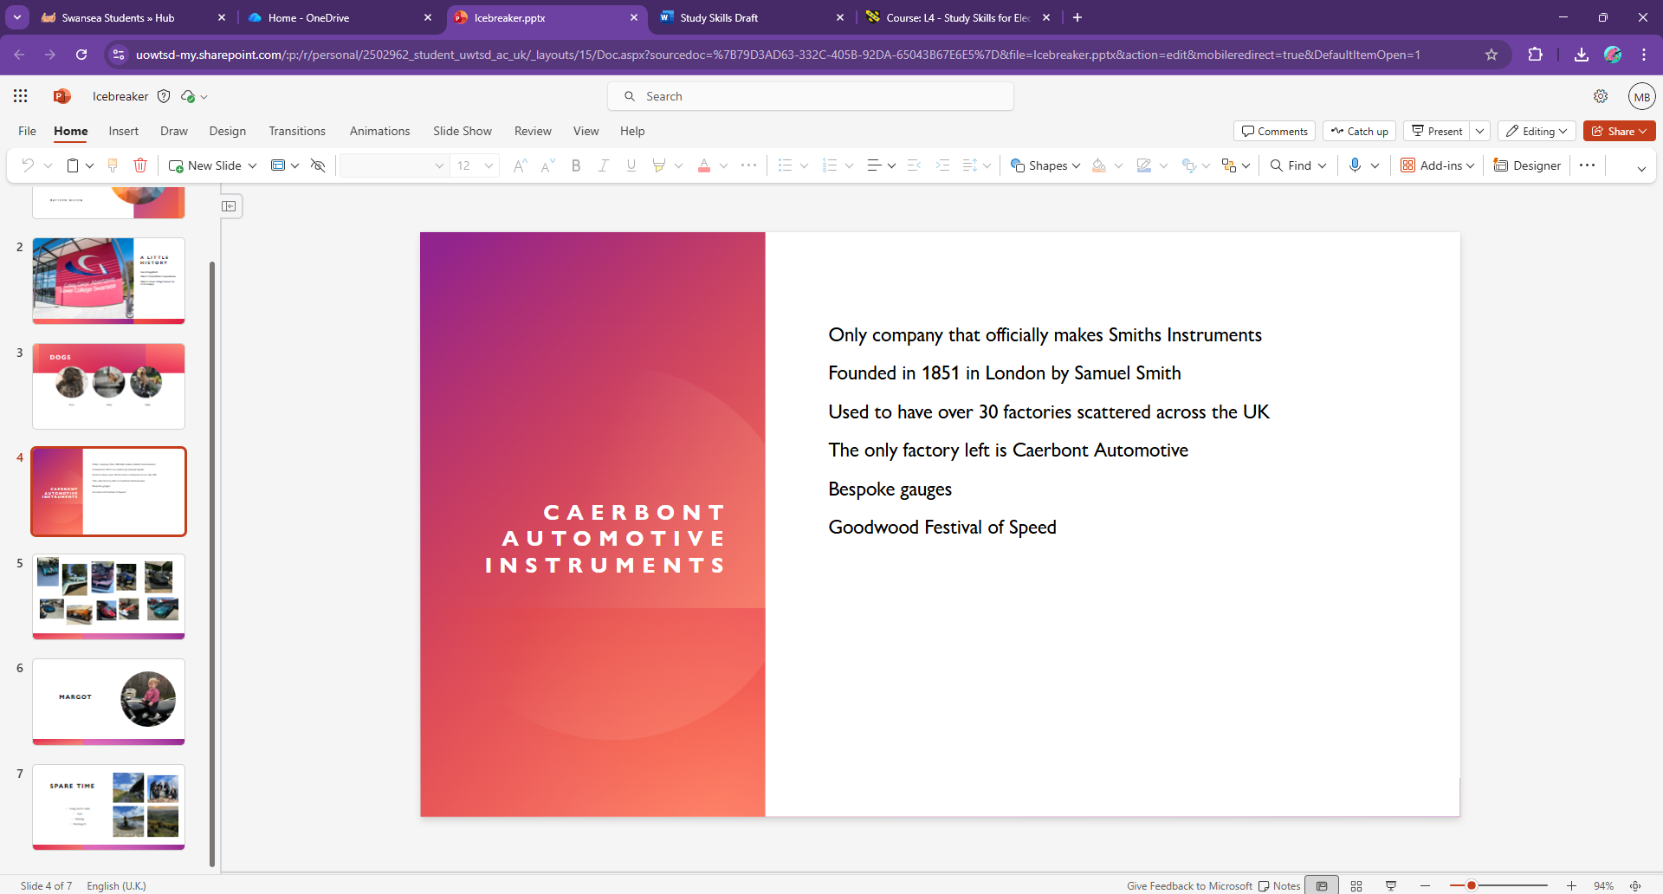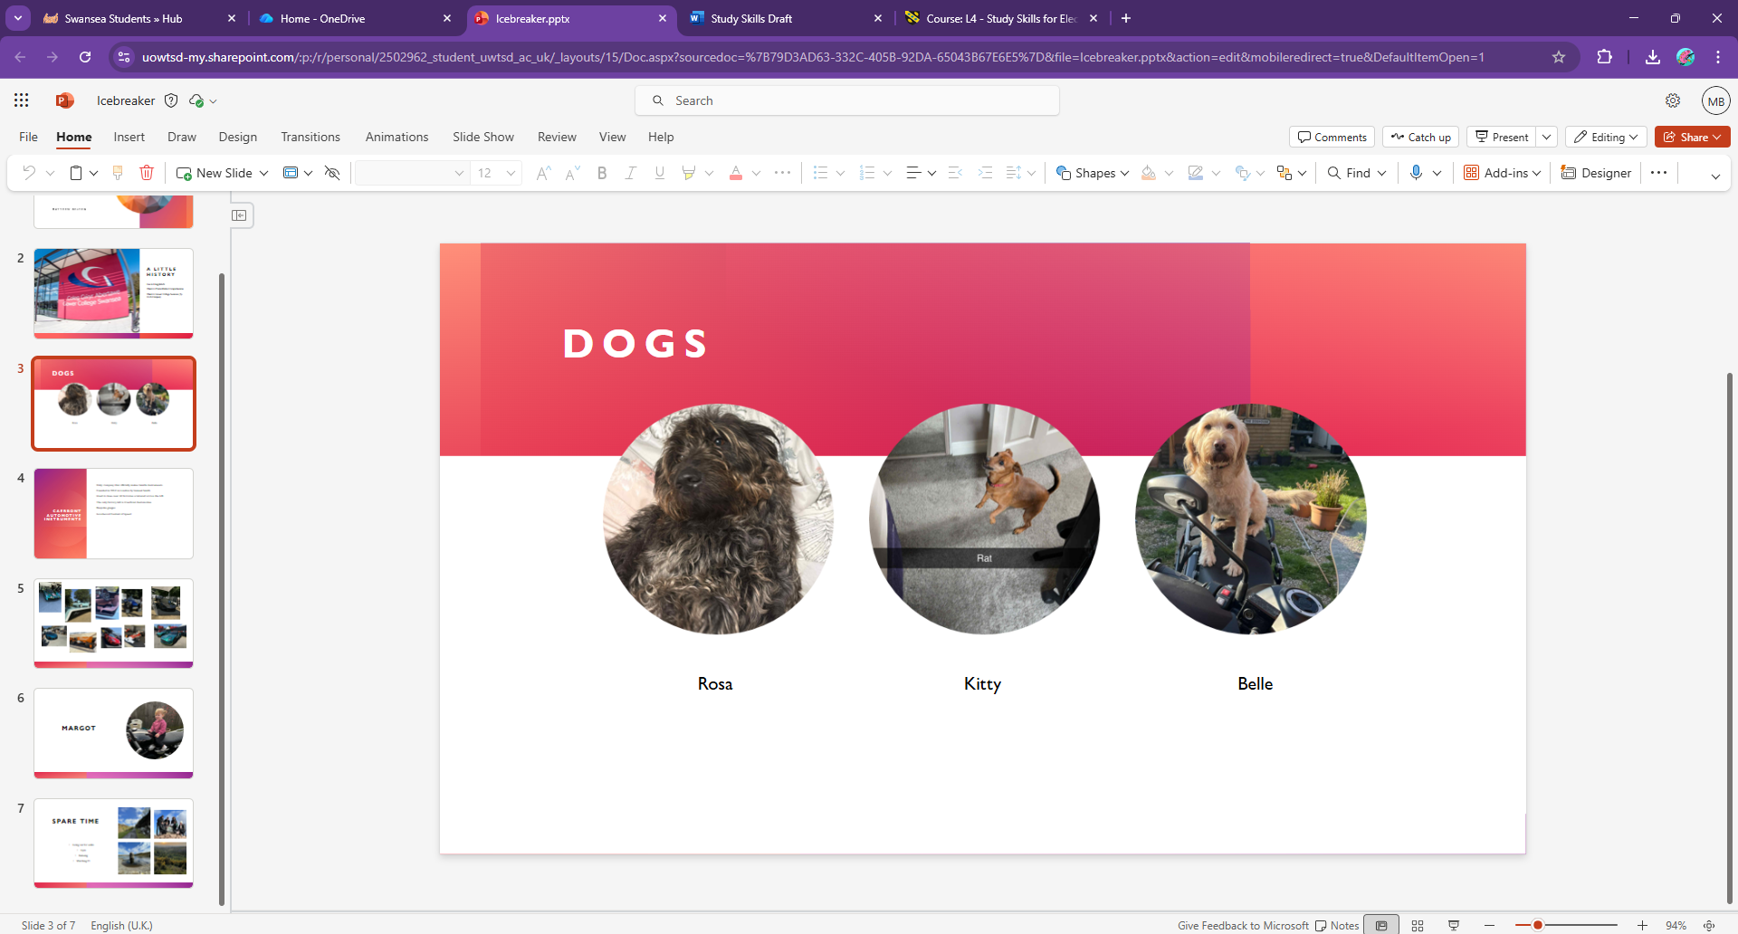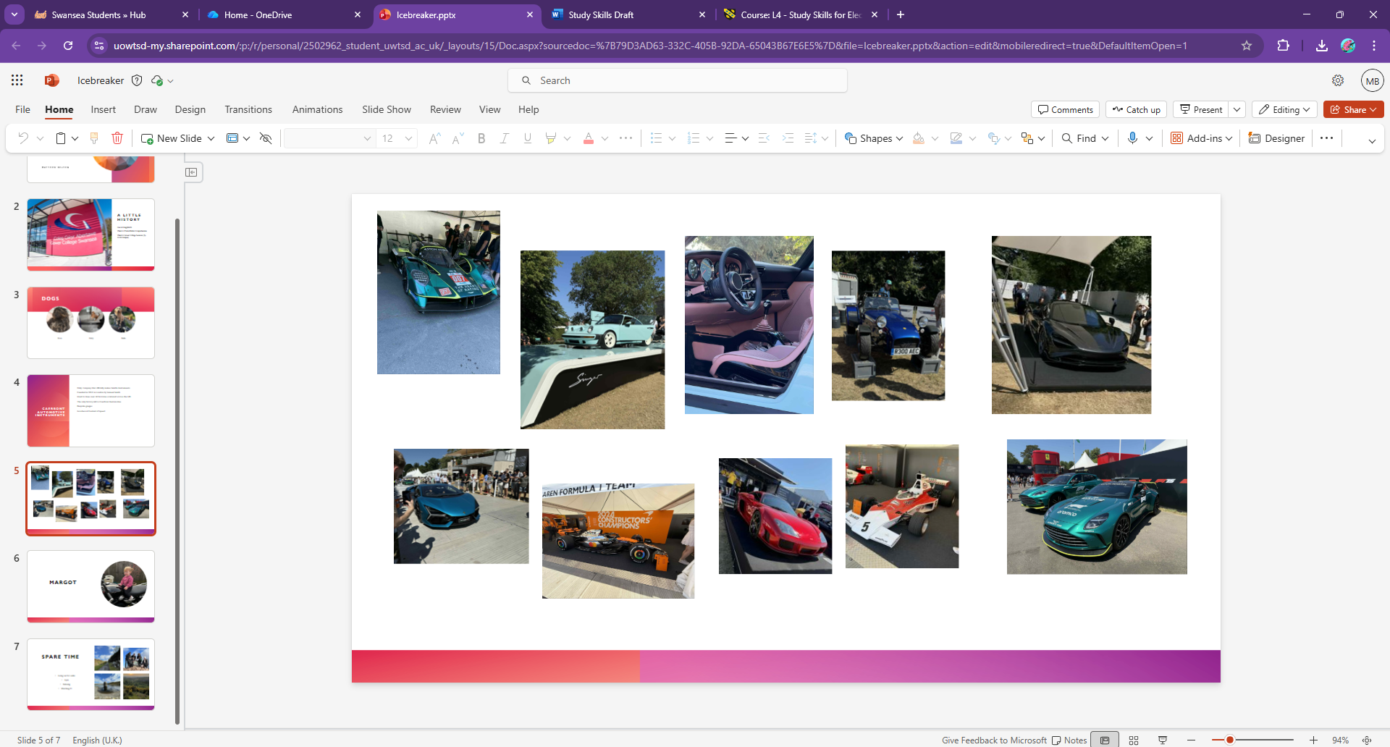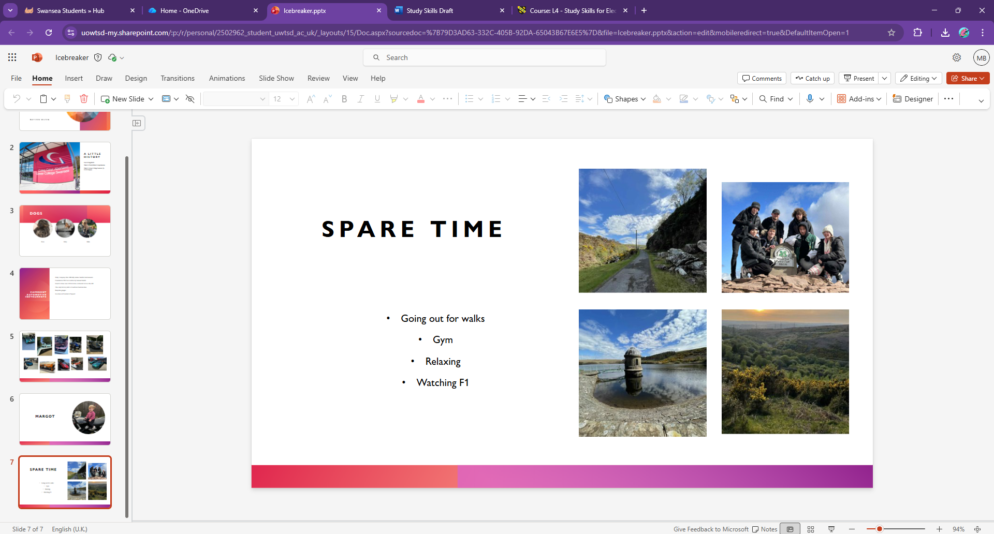
Figure A-1: Screen grabs from self-presentation
Whilst producing this presentation, the author learnt that having a bit of colour around the screen, really makes the presentation less dull. Even the smallest amount of it, not including pictures, can grasp attention from people. The author also found that, text is required for a good presentation, but not massive amounts of it as it takes away from the presenter as people will be reading instead of listening.
With delivering a presentation, a lecturer came in to explain the best way on how to deliver a good presentation. One of the key pointers was body language. If the presenter is stood there, hands in pockets, not making eye contact, stood still, they will not be giving a very enthusiastic presentation. If the presenters body language is very closed off as described, the presenter will not be able to engage people with what they are presenting, therefore, it will not be engaging audiences.

To improve on future presentations that the author compiles, the author would like to put more enthusiasm in the way that they speak. Also, to balance the amount of text and pictures on the authors slides. Some of them only have text and others only pictures, just adding that little something, the author feels, it would go a long way into developing their presentation and allow people to obtain a greater understanding of what the author is talking about without needing to be there.

Section 2

2.1 Skills required for higher education
Some of the key skills required for higher education are critical thinking, problem solving, time management, communication and team working. There are an exponential number of skills required for higher education, but these are some the, what the author considers, to be some of the key skills.
Critical thinking is a key skill as, whilst being in higher education, you need to be able to make decisions for yourself and cannot be relying on being told everything. This is essential as developing this skill will help greatly later in life.
“Critical thinking also helps you develop new ideas and innovations. This is beneficial when you're studying but is also useful during your career. Being able to think critically and suggest improvements and new ideas helps you to contribute to your job.” [1]
Having good communication skills is essential to higher education as, whilst attending higher education, you may be put into group work or have to present a presentation. Effective communication skills will greatly assist with these tasks and can develop skills ready for later in life. It can also be a great asset when it comes to asking for help or guidance in tasks.
“Good communication skills are a fundamental aspect of a student’s academic and personal growth. They not only enhance academic performance but also prepare students for future challenges in professional and social settings.” [2]
For more results collected as a class, look at [A-2]

2.2 Generic transferable skills employers look for
Employers typically look for these same skills as students who are in higher education. This is because many of these skills are transferable and can develop over time. Some of the main skills that relate to higher education and employment are communication skills. Communication skills are essential in the majority of careers and are a key aspect of everyday life.
“According to an analysis of nearly 2 million job postings, communication topped the list as the most in-demand skill across industries. Despite the AI revolution reshaping workplaces, human communication skills remain irreplaceable. Effective communication also impacts the bottom line.” [3]
Employers will also be looking for other skills such as resilience. They like having resilient employees as, if an employee gets stuck on a task, rather than giving up, they will find a new way around the issue. Or better yet, find out what is causing the issue.

“This refers to your ability to deal with setbacks, and graduate employers have increasingly started to consider it. How well do you cope with stressful situations or when something goes wrong? How do you react to unexpected changes or problems that occur during a project?
You aren't expected to be unaffected by these events, but you need to be able to show that you react to them positively and are able to develop strategies to deal with them.” [4]
For more information, look at [A-3] and [A-4] for transferable skills

Section 3

3.1 Self-evaluation and action planning
After doing a few self-evaluations, the author has found some strengths and weaknesses that they have. One of the things that the author found out is that they are an analyser. This describes them as a person who likes to analyse any information that is presented to them and get a result from there.
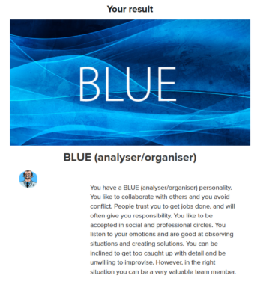
Figure 2: Results on an online personality test
As the picture above shows [Figure 2] it states that “You like to collaborate with others and avoid conflict.” The author agrees with this as they believe that things can get done better as a team and the better the team can work, and avoid conflict, the better the result.
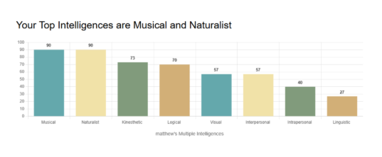
Figure 3: Results of a second personality test
As shown in the graph above [Figure 3] it shows what type of intelligences the author has. The top two results are musical and naturalist. This means that “Musical intelligence, also called musical-rhythmic intelligence, is the capacity to discern pitch, rhythm, timbre, and tone. It involves sensitivity to sounds and vibrations. People with high musical intelligence understand and express themselves through music. They can produce and appreciate music, identify distinct musical notes, and may think in rhythms or melodies.” [5]
For more results, look at [A-1]

3.2 Goals
The main short-term goal the author has is to finish the university course and get the degree as this can lead to bigger job opportunities and more responsibilities in their current job. Another short-term goal for the author is to build on their relationship with their family and partner as they strongly believe that a good connection with their family and partner will always be better for them mentally.
Long-term, the author wants, a job that pays well enough to live comfortably and to get their own house. The author knows that these goals do not seem farfetched and can be achieved within a year, but the author also wants to do other things in between such as travelling and getting a new car which will slow the process of doing some of these things but there is no harm in trying to live a little whilst reaching your end goals.

3.3 Action Plan
There are many ways on designing an action plan for life whether it is personal or professional. A simple way of designing these plans is to follow the smart guideline.
S – Specific
M – Measurable
A – Achievable
R – Relevant
T – Time-bound
By following these steps, an individual can set out a plan of what they want to achieve, and they will have a structure to help them. There are both pros and cons of the SMART goal method and they are as follows:
Pro:
“Increases productivity: SMART goals encourage individuals to use their time and resources more productively, by focusing their efforts on specific tasks that are aligned with their objectives. This can help individuals to be more efficient and effective in achieving their goals, and can lead to increased productivity overall.” [6]

Con:
“May be too rigid: The SMART framework can sometimes be too rigid, leaving little room for creativity or the ability to adapt to changing circumstances. This can be particularly challenging for longer-term goals, which may require more flexibility and a willingness to pivot or adjust course along the way.” [6]

Section 4

4.1 Looking after your data
Taking care of your data is required in all aspects of life. Whether you are working a job, in higher education or personal items such as social media, looking after your data is needed. There are many ways of doing this such as, having multiple back-ups, not sharing passwords or even having paper copies. One of the most effective ways to keep data safe is the 3-2-1 rule. This entails that there should be at least 3 copies of said data, 2 copies are stored in separate locations, and one copy should be stored off-site.
“One of the best backup strategies to have is the 3-2-1 rule. This means creating 3 different copies of your data to put on 2 different storage types and keeping 1 copy offsite. By doing so, you’ll be able to create a failsafe system that keeps your data safe. You can even maintain more than one offsite copy to be even safer.” [7]
However, the 3-2-1 method is completed, it is a safe and secure way to keep data safe. Another way of keeping data safe, although might not be as effective, is having microfiche. These are little cards that can be scanned into a device to show the information. The main issue with microfiche can be, if you have a lot of microfiche, there will need to be a location to store them all. Also, if the card gets damaged, it may become unreadable.

4.2 Time management
As the author has a fixed schedule, they are able to develop a plan for better productivity and be able to see when they have more free time for things they would like to complete in life.
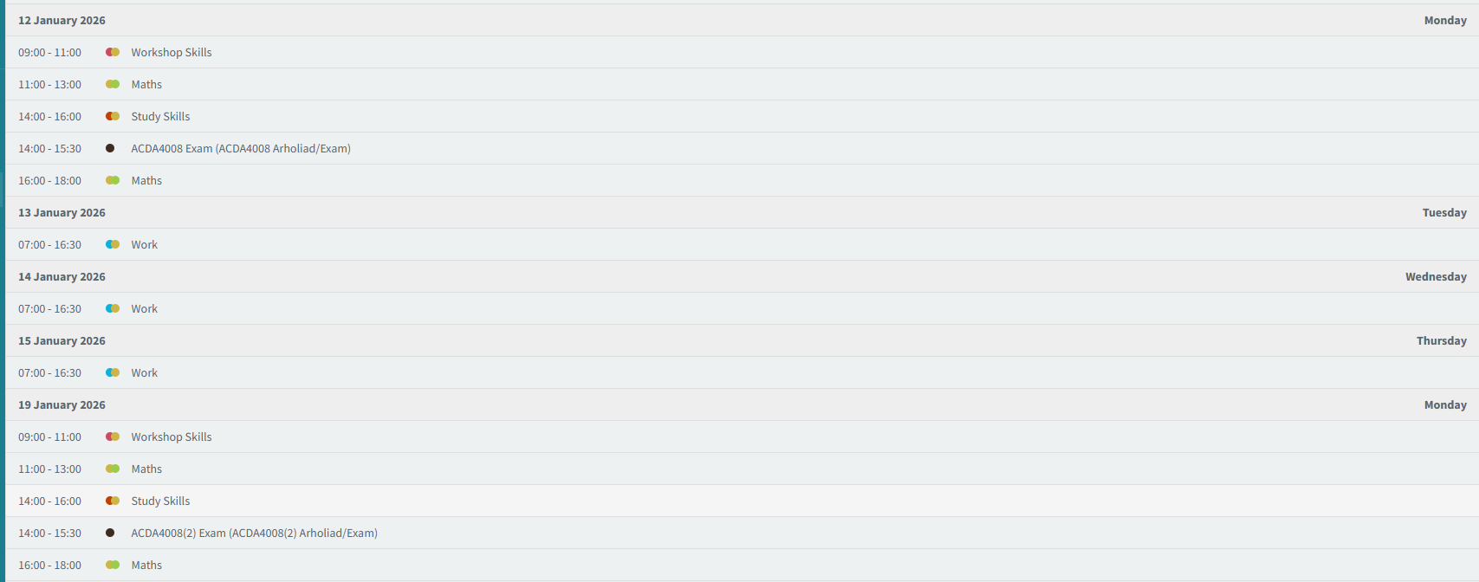Figure 4: Screen grab of the author's calendar
From the screen grab above [Figure 4] the author has a lot of free time, especially across the weekend. In figure 4, it shows us that the author has a busy start to the week and it is all colour coordinated to allow them to understand what is happening without having to read it fully. For the rest of the week, the author only has work pencilled into their calendar and does not state what they will be doing in work. This is because the work can vary and there is no way to have full certainty what they will be conducting whilst there. As the author has plenty of time on the weekend, they can plan a lot of different items for that time.

4.3 Self-organisation
An effective way of having self-organisation is to have some form of PDP. How this is set up is completely person dependent, but the author has gone for a table set up shown in figure 6.

PERSONAL DEVELOPMENT PLAN |  | NAME | MATTHEW BELTON
 |  | STUDENT ID | 2502962
 |  | TIME FRAME | 2025-2026
SKILLS TO LEARN/DEVELOP | HOW WILL THIS BE DONE | WHAT WILL BE MY SUCCESS CRITERIA | TARGET DATES
SOLDERING | PRACTICE | ENSURING ALL JOINTS/CONNECTIONS ARE SOLID WITH A SMALLER TIME SCALE | END OF 2026
TIME MANAGEMENT | KEEPING A LOG OF TASKS IN HAND | HAVING A FILLED-OUT CALANDER WITH DEADLINES | EASTER 2026
COMMUNICATION | ENGAGING MORE WITH MY PEERS | HAVING A GREATER UNDERSTANDING OF WHAT IS NEEDED TO BE COMPLETED IN WORK/UNI | SUMMER 2026
RESILIENCE | FINDING PROBLEMS TO OVERCOME THEM | SOLVING AS MANY ISSUES AS POSSIBLE I COME ACROSS IN WORK. WHETEHR THAT BE PCB OR PAPERWORK RELATED | END OF 2026
Figure 6: Personal development plan

From figure 6, it shows what goals the author would like to complete and has a time frame with it for completion. One of the key skills that the author would like to develop is their time management. As shown by the table, there is a column showing how this would be done, what the author classifies as their own success, and a target date for completion.
The author chose to do this plan in a excel spreadsheet as it is a lot easier to filter through goals and time frames. It is also a lot simpler to add more columns to be able to see if the goal has been achieved. And if not, why not.

Section 5

5.1 Conclusion
One of the key findings that the author found whilst completing this reflection on study skills, was that a lot of the skills required in higher education are also applied in the workforce. As the author has been in the workforce full-time for the past 6 years, and did not attend a university after college, they did not realise how many skills are shared amongst them both.
The author would like to dive deeper into the self-evaluation as they would like to see what other ones are out there and if they would give similar answers as before. However, the author would not do this for a few months as well as their answers might change from when they first conducted the tests.

References

Section 2

[1]
Written by Indeed Editorial Team, 25/11/25, 12 student skills that are useful for your studies, https://uk.indeed.com/career-advice/career-development/student-skills

[2]
Beta, March 21, 2025, The importance of good communication skills for students, https://mybeta.ca/importance-of-good-communication-skills-for-students/

[3]
Caroline Castrillion, May 14, 2025, Why Communication Skills Are Your Most Valuable Career Assist In 2025, Why Communication Skills Are Your Most Valuable Career Asset

[4]
Rachel Swain, June 2025, What skills do employers want? What skills do employers want? | Prospects.ac.uk

[5]
Mia Belle Frothingham, Feb 2, 2024, Musical Intelligence: Definition, Examples & Characteristics, https://www.simplypsychology.org/musical-intelligence.html

[6]
Barsham Sotoudeh, Mar 10, 2023, The Pros and Cons of Using SMART Goals to Achieve Success, https://www.linkedin.com/pulse/pros-cons-using-smart-goals-achieve-success-barsham-sotoudeh

[7]
Kyle Chin, December 1st 2025, How to back up your data: 6 effective strategies to prevent data loss, How to Back Up Your Data: 6 Effective Strategies to Prevent Data Loss | UpGuard

Appendices

[A-1]
Figure 7: John Myer-Briggs Results
Figure 8: Personality test results

[A-2]
Figure 9: A class collective of skills for higher education

[A-3]
Figure 9: A class collective of what skills are important for employment

[A-4]
Figure 10: A class collective of what skills are transferable between higher education and employment

