Apply the principles and practices of Data security, Governance and Compliance based on a given scenario
Mengying Tian
Abstract In the first part, three types of security frameworks or models were selected based on CoffeeBlue's operating status and actual needs, namely ITIL, COBIT and ISO 27000 series standards, and briefly analyzed and compared them. The second part is to formulate corresponding strategies for CoffeeBlue's demand for information system security,including the information system security policy framework.
Keywords ITIL, COBIT ,ISO 27000 series standards, information system security,policy framework
- Introduction
With the continuous development of the IT field and the increasing pressure on CoffeeBlue, the construction of information systems is crucial to the long-term development of enterprises. Based on this, this article summarizes the basic situation of the three security models and makes appropriate To compare, at the same time, a set of coping strategies was developed to meet the demand for the actual situation of CoffeeBlue.

- Introduction of the three models
  - Information Technology Infrastructure Library (ITIL)
Information Technology Infrastructure Library (ITIL) is a best practice framework for delivering IT services. ITIL is a set of practices for the management, development and operation of IT services. Its purpose is to provide a set of processes and procedures so that the organization can provide high-quality IT services. It is not specifically designed for any industrial area or specific type of company. The IT service management method of the ITIL system can help companies manage risks, strengthen customer relationships, establish cost-effective practices, and establish a stable IT environment that allows growth, scale, and change. ITIL has become a widely accepted IT service management method in the world.
The goal of ITIL is to provide a best practice framework that organizations can use as guidelines for managing IT organizations. The best practices that make up ITIL are documented in a series of books. ITIL has undergone several revisions in history, and currently consists of five books, each of which covers the various processes and stages of the IT service life cycle. The five core headings of ITIL are as follows:
Service Strategy (SS): The goal is to understand the organization's goals and business needs.
Service Design (SD): Transform service strategy into a plan to achieve company goals
Service Transition (ST): Deploy the service designed in the previous phase and process the changes during the transition.
Service Operation (SO): Operate services, handle incidents, problems, and authorize in accordance with regulations.
Continuous Service Improvement(CSI): To achieve incremental and large-scale service improvements.
ITIL describes the processes, functions, and structures that support the field of IT service management, especially from the perspective of service providers. This method describes the process of information security management.
With the positioning of information security in service management, the process of "service design" is integrated with several other processes, making it easier to simplify the ISM process in the service life cycle.
The main goal of the ISM process is to combine IT security with business security, and to ensure effective management of information security in all services and service management activities. The ITIL security management process describes the structural matching of security in the management organization. ITIL's security management is based on the ISO 27001 standard.
In ITIL 2011, the ISM process contains several sub-processes. They are the design of security control, security testing, security incident management and security review.The goal of the security control sub-process is to design appropriate technical and organizational measures to ensure the confidentiality, integrity, security and availability of the organization’s assets, information, data, and services.
However, the best part of ITIL is that it is just a framework that can adapt to any environment. For enterprises to implement ITIL, it can contribute to the final perfect service management. In ITIL's various process management, you can directly interact with various business departments to realize the redesign of business functions and processes, reduce costs, shorten turnaround times, improve quality, and improve customer satisfaction.
The implementation of ITIL enables the information system department to respond to changes in the financial, sales, marketing, manufacturing and other business processes in a timely manner. In some cases, this has led to the creation of related organizations, such as change committees, emergency change committees, and internal business managers, to improve business and IT integration.
ITIL implementation can achieve the accuracy and predictability of IT business support. The intensification of market competition requires enterprises to make quick decisions and shorten the reaction time. Traditional measures of business performance, such as revenue and market share, lag in reflecting the state of the business. Once a problem is identified, it is often too late to avoid it.
As far as the return on investment of the IT department is concerned, when considering IT investment, it is easy for IT to define the expected return and measure the return by referring to ITIL. At the same time, a multi-skilled, cross-organizational team with shared responsibilities and obligations can be clearly established.
Although ITIL contains a summary of best practices for IT management, ITIL does not, by its nature, provide a guide for how to use IT in practice.Each organization should design its own processes based on ITIL principles.
  - Control Objectives for Information and Related Technology (COBIT)
COBIT is an international standard for information system auditing. It was published in 1996 by the Information Systems Audit and Control Association (ISACA). This is an internationally recognized authoritative standard for security and information technology management and control, and has been updated to COBIT2019. It connects business risks, control requirements and technical issues to meet various management needs.
COBIT 5 provides five principles that focus on IT governance and management in organizations:
Principle 1: Meet the needs of stakeholders
Principle 2: Cover the enterprise end-to-end
Principle 3: Use a single, integrated framework
Principle 4: adopt a holistic approach
Principle 5: Separate governance and management
COBIT is an IT governance implementation guide and audit standard built by IT. Its service objects mainly include three categories: senior managers are used to design and control their activities to ensure that their governance is compatible with organizational strategies; information users are used to obtain internal or third-party service security and IT service control; auditors It is used to judge the operation status of the IT system of the audited unit and put forward suggestions for improving internal control.
COBIT helps organizations manage IT risks, align IT strategy with business goals, and ensure legal and regulatory compliance. COBIT is a set of supporting tools that allows organizations to build bridges between control requirements, technical issues, and business risks. The framework provides a set of generally accepted metrics, indicators, and processes to maximize IT value and develop appropriate IT governance capabilities.
  - ISO 27000 series standards
International safety management standards and guidelines such as ISO 27000 series standards are widely used in enterprises. It contains some informal rules that can reduce increasing threats, solve existing security problems, and improve security goals in general.
The ISO 27000 series safety standards are designed as "ISO 27000 series standards" or "ISO 27k", which are the most important international standards adopted by enterprises. It provides guidelines for information security and introduces physical and security practices and procedures. Among them are ISO 27001, ISO 27002 and ISO 27005 standards. The scope, purpose, depth, level of detail and granularity of these standards are different. In fact, ISO 27001 is the first standard related to the ISO/IEC family of standards. Provide models for the establishment, implementation, operation, monitoring, review and improvement of information security management systems. This standard divides information security requirements into 11 categories. Each category is divided into many subcategories. These subcategories and the corresponding high-level compliance requirements are the most detailed definitions provided by ISO 27001. ISO 27002 proposes a code of practice for information security management. It serves as a subject of ISO 27001 guidelines because it describes hundreds of controls that can be achieved. ISO 27005 is an ISMS standard that provides guidelines for information security risk management (ISRM) in organizations. It is based on the knowledge concepts, models, processes and terminology defined by iso27001, and adopts risk management methods to assist in implementation.
The introduction of the information security management system can coordinate all aspects of information management, thereby making management more effective. Ensuring information security is not only a firewall, but also a company that provides information security services 24 hours a day. It requires comprehensive management.
Passing ISO information security management system certification can enhance the credibility between ecommerce organizations and establish mutual trust between websites and trading partners. With the increase in electronic information communications, information security management records can be seen through information security management records. Obvious benefits, and provide basic equipment management for the majority of users and service providers. At the same time, organizations should minimize interference factors and create greater benefits.
Certification can guarantee and prove the commitment of various departments of the organization to information security, can improve the performance of all departments, eliminate distrust, and gain international recognition, can enhance the investment confidence of investors and other stakeholders, and expand business.
- Comparison of the three models
On the one hand, although these three models are all security models, their respective focuses are still different.
ITIL discusses service management, which is a road map for deciding how to organize the work practices and processes of it employees. ITIL focuses on it process management, emphasizing it support and it delivery. ITIL pays little attention to security and system development. At the same time, ITIL pays more attention to software maintenance, and software development involves very little content.
COBIT's view is top-down, separating governance from management. This is a set of practices, and senior managers should understand how they should deal with enterprise It. COBIT focuses on IT control and IT measurement, while COBIT does not involve much in IT process and security.
The ISO 27000 series of standards provide security controls and best practices to establish, implement, maintain, and continuously improve an organization’s information security management system (ISMS). The ISO 27000 series of standards emphasize the effectiveness, economy, comprehensiveness, versatility and openness of the information security management system, and provide high-quality and practical references for organizations that want to achieve a certain management effect. Its biggest feature is that it is extensive but not in-depth, and is for reference only. The ISO27000 series of standards are mainly about safety control and management. ISO27000 series standards are applicable to various organizations, but they are too general to establish minimum quality standards for organizations.
On the other hand, these three security models also have some similarities.They are all IT management methods, which provide a framework standard for the construction of security systems in enterprises and institutions. They all told you what to do, but they didn't tell you how to do it. Need to formulate specific implementation strategies according to different situations. In fact, these three security models overlap and complement each other, and there is no question of who replaces whom, just as the COBIT lineup claims that ITIL belongs to it, and ITIL regards COBIT as an aspect. They are all it management methods, but their respective focuses are different.
- An information system security policy framework that meets the requirements of CoffeeBlue
In order to meet the needs of CoffeeBlue's information system security, corresponding strategies are formulated from three levels. Strategically, it establishes the company's specific business objectives and security objectives. Considering the pivotal position of data and employees in the company, it stipulates data and employees at the strategic level. In view of CoffeeBlue's dependence on wireless networks, online and social media and the great value of intellectual property rights, the security of information technology is also very important. Therefore, the second level is from the level of technology protection. Finally, some specific requirements for customer information security and process control are put forward based on relevant international standards from the aspects of management and practical operation.
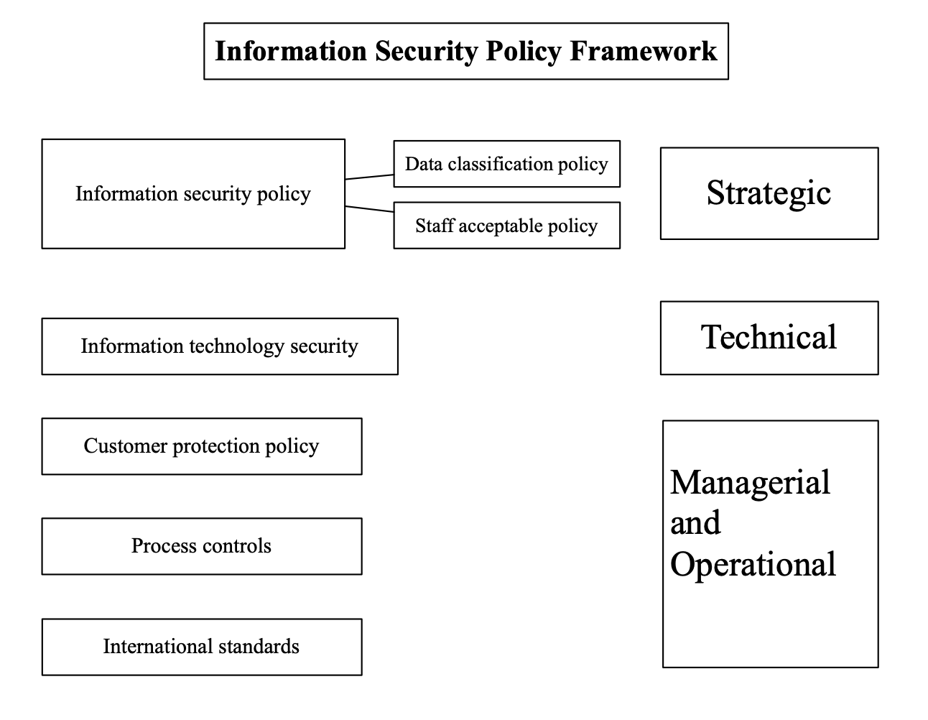
Figure 1 Information Security Policy Framework
  - Information security policy
Information security policy is the highest level. This is an advanced document. The main purpose of this document is to illustrate business goals and high-level security goals. The document also specifies the responsibilities to ensure that safety goals are achieved. The document should be owned by the CISO or CSO, but approved by the company's board of directors. The approval of the board of directors is the key, because the board approves the business strategy and goals, so it is in the interest of the board to protect the business goals.
In response to the pressure on CoffeeBlue, business objectives and high-level security objectives were identified to protect the security of employee personal data and customer data as well as its billions of dollars' worth of intellectual property.
- Data classification policy
CoffeBlue provides IT services to employees and customers. The online platform occupies a very important position, and the relevant data should also be specifically classified for better management. The high-level strategy should also provide a data classification scheme, which can then be described in detail in the data classification strategy. The type of data depends on the nature of the business, but at least it should include:
- “Public” - Data belonging to the public domain. The mistake people make here is that public data does not need any protection. For example, a company's homepage and news feeds from online platforms or media. This is typical information that the company wants to share with the world. Therefore it is classified as Public.
- “Enterprise wide” - This type of information can be shared between employees and those who have signed non-disclosure agreements. So far, this is the largest type of information in most organizations. Also known as "semi-open", the larger the organization, the more likely it is for employees or partners to leak secrets. This category is mainly aimed at employees, because in addition to technical loopholes in the company's information disclosure, to a greater extent, the company's internal personnel violated contracts and lacked professional ethics.
- “Restricted access” - Some information should be obtained on a "need to know" basis. It all depends on the nature of the business. Business plans, strategies, research data, and new product details are just examples of information that should be properly protected. In addition, due to the special nature of CoffeeBlue's business, protecting the relevant information of employees and customers is vital to the company's long-term development. At the same time, the company's long-term accumulation of intellectual property rights based on the Internet has also become the focus of the company's attention. These undoubtedly belong to the category of restricted access.
The data classification should reflect business need. The modern implementations of the data classification should include claim based rules.
- Staff acceptable policy
Due to the large number of employees, employees also occupy a very important position. This policy document should clarify the most important policies for employees. Good security and human resources experts do not expect users to remember all policy documents. The purpose of this document is to show employees what is key and where to find more information. As an employee of CoffeeBlue, based on its huge number of employees, international customer data, and the company's main business, we must first improve our business capabilities and technical level, and at the same time we must be aware of the importance of information security. Both customers and internal employees should pay enough attention. It is very necessary and necessary to protect this information.
  - Information technology security
Because CoffeeBlue relies on cloud services to provide IT services, information technology security is very important. The technical protection and operation category involves traditional information security focus. It involves the technical and physical mechanisms implemented to protect the It environment. This includes asset management, system development requirements, event management, technical operations (such as network security), and physical, environmental, and business continuity control. The technological environment must be constantly monitored and the risks of technological changes in the market must be addressed, such as the use of personal digital assistants and remote office technology.
With the continuous development of information technology today, the role of corporate CIO is becoming more and more important to the security of information technology. It has transformed into supporting the business, understanding the areas the company wants to expand, and recommending how to become more agile and effective. Information technology can be a savior or a nightmare, and the role of the CIO is crucial. The CIO-level security policy is aimed at the CIO's organization. It needs to transform business goals into security goals and controls. The safety goals and controls required by CoffeeBlue are listed below.
Security objectives are:
- Monitoring system security events
- Establish security governance
- Maintain system resistance to malware
- Provide safety training
- Manage access to information
- Monitor security compliance
- Establish a secure system/application process
- Manage security incidents
Security controls are:
- Prepare training materials; supervise the attendance rate of safety training; view the feedback of safety training
- Install anti-malware software; establish and implement security configuration for each operating system in use; update system configuration according to changes in threat conditions; patch the system within one day with vendor patches
- IT system account management—new users create accounts, modify accounts when roles change, and delete/disable accounts when they are no longer in use
Of course, firewalls, proxies, WAF, IDS/IPS are also an important part of the technology to protect IT security.
  - Customer protection policy
First of all, database backup and recovery, database backup is the storage and backup of customer information systems related to the database in different ways, for example, physical backup and storage, logical backup and storage, remote backup and storage to prevent loss and data information Omission.
Secondly, the control of database access authority. This method is mainly to set the database access authority in the customer information system. The system functions and the data browsed by employees or other functional departments in different authorization ranges are different, which effectively guarantees customers Information security of an information system is an inevitable requirement for system design and development, and it is also a basic technology for system data protection. The database of the customer information system is not open to all employees. Most of the systems are only open to managers, which can greatly reduce the improper disclosure of customer information data due to excessive open access.
Database data encryption, this method is mainly aimed at different levels of customers' systems, that is, distinguishing different levels of customer information, and identifying and classifying different customer information according to the information system database of the customer's importance. Customer information can be divided into Descriptive information, related information, and behavior analysis are three parts. Descriptive information is basic information, and customer behavior information is the behavior information recorded by employees in the daily service process. Customer-related information can help sales staff and corporate senior management provide more accurate customer data when making decisions. Encrypt these three types of information at different levels to ensure the security and reliability of the data in the customer information system
The database is regularly checked and audited, mainly for the information system and system operation to check the user's behavior, and for the unified management of whether the system operation behavior conforms to the specifications, whether there are behavior results, and consistent operation records, etc., tracking the information and information of the illegal operators Operational behavior records to help ensure the normal use and recovery of customer information systems and databases. Monitoring the behavior of information system users is conducive to fundamentally eradicating illegal behaviors by hotel employees and customers, thereby ensuring the security of customer information systems and databases.
  - Process controls
In addition to the theoretical response, some measures need to be taken in the actual process to protect the security information system. Some process control requirements are put forward below：
- Security Monitoring-Monitor events in the system, find abnormalities and security events, and report them in time.
- Security Training-Although this may be part of general IT and enterprise-wide training, it is still indispensable in process control.
- System Reinforcement-Including system configuration and patching.
- Incident Management-Manage security incidents calmly and orderly.
- Secure Development/Acquisition-Follow best practices when developing information systems, whether they are acquired internally or externally. This needs to be part of the project management process and at the same time be seen as a quality issue.
- Account and Access management-Manage the active user accounts in the system and their access to the system and data.
- Reporting-Collect all kinds of data and present it to stakeholders in the format and details they need and understand.

  - International standards for security policy and controls
Taking into account the top-down strategy framework and CoffeeBlue's focus on it services, COBIT is more suitable for the method proposed in this article, which separates governance and management, provides value to customers in the form of services, and enhances stability.First of all, according to the actual situation, from the overall point of view of the company, the effective separation of governance and management, make an overall plan in the strategy, and make specific requirements in the part related to the security of information system, create an overall framework to protect the interests of customers, employees and the company from the cloud.
References

[1]Jianwen Chen, Rhonda Childress, Iain Mcintosh, George Africa, and Arthur Sitaramayya. 2011. A service management architecture component model. In <i>Proceedings of the 7th International Conference on Network and Services Management</i> (<i>CNSM '11</i>). International Federation for Information Processing, Laxenburg, AUT, 316–319.
[2]Juan Luis Rubio and Roberto Camazón. 2018. A literature review about sequencing ITIL processes. In Proceedings of the First International Conference on Data Science, E-learning and Information Systems (DATA '18). Association for Computing Machinery, New York, NY, USA, Article 8, 1–7. DOI:https://doi.org/10.1145/3279996.3280004
[3]Georges Ataya. 2013. Information security, risk governance and management frameworks: an overview of COBIT 5. In Proceedings of the 6th International Conference on Security of Information and Networks(SIN'13). Association for Computing Machinery, New York, NY,USA,3–5. DOI:https://doi.org/10.1145/2523514.2523590
[4]Kristian Beckers, Stephan Faßbender, Maritta Heisel, Jan-Christoph Küster, and Holger Schmidt. 2012. Supporting the development and documentation of ISO 27001 information security management systems through security requirements engineering approaches. In <i>Proceedings of the 4th international conference on Engineering Secure Software and Systems</i> (<i>ESSoS'12</i>).Springer-Verlag, Berlin, Heidelberg, 14–21. DOI:https://doi.org/10.1007/978-3-642-28166-2_2
[5]A. Da Veiga PhD & J. H. P. Eloff PhD (2007) An Information Security Governance Framework, Information Systems Management, 24:4, 361-372, DOI: 10.1080/10580530701586136
[6]Avinash W. Kadam (2007) Information Security Policy Development and Implementation, Information Systems Security, 16:5, 246-256, DOI: 10.1080/10658980701744861
[7] Deborah L Anthony, “Frameworks, Methodologies and Standards:Determining the Right Mix of Each for ITSM Success”, ITSM Fusion 10, 2010.

