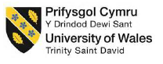

University of Wales Trinity Saint David
School of Engineering
Design of a specialist automatic control system
Faith Over
1904483
Manufacturing Systems Engineering
01/04/2022
ACMA5001 – Control and Automation

Contents Page

Contents
Contents Page ii
1. List of Figures and Tables 3
2. Introduction 4
3. Adaptive Control Systems 4
3.1 Temperature 5
3.2 Water Level 7
3.3 pH Level 9
3.4 Water Hardness 10
4.0 Using a Programmable Logic Controller to combine the systems 12
5.0 Hydraulic or Pneumatic Systems 15
4. REFERENCES 17
Works Cited 17

List of Figures and Tables

Figure 1: Model Reference Adaptive Control System Block Diagram 5
Figure 2: Block Diagram for Heater MRACS 6
Figure 3: Block Diagram for Chiller MRACS 6
Figure 4: Logic for Heater & Chiller Activation 6
Figure 5: Diagram of a pressure sensor used as a liquid level sensor 7
Figure 6: Block Diagram for Inlet Pump MRACS 7
Figure 7: Block Diagram for Outlet Pump MRACS 8
Figure 8: Logic for Water Level System 8
Figure 9: How hydrogen ion content is formed in water 9
Figure 10: Diagram of a glass PH Sensor 9
Figure 11: Block Diagram for PH Sensor MRACS 10
Figure 12: Logic for PH Level Warning Lights 10

Table 1: Components of a Model Reference Adaptive Control System 4
Table 2: Proposed Sensors and Adjustment Mechanisms 5
Table 3: Hydraulic vs Pneumatic systems 15

Introduction
This report will lay out the proposal for a self-regulating, alarmed and data gathering control system for a freshwater aquarium. This control system will automatically regulate water levels and temperature, whilst monitoring pH levels and the water hardness level of the tank, using LEDs to signal when levels are outside of the given parameters.
The species chosen is the endangered red-tailed black shark, which is currently on the IUCN Red list, due to “currently the major threat to the wild population is pollution from agricultural and domestic sources” (INJAF, 2022).
The Animal Welfare Act states that you are obliged to provide animals with a suitable home environment (Federation of Britis Aquatic Societies, 2008). This species requires the aquarium to stay within the following parameters:
- Water temperature: 72°F to 79°F
- pH levels: 6.5 to 7.5
- Water hardness: 10-15 KH
(Sheppard, 2020)
As this is a freshwater species there has been no consideration made towards corrosive resistance of the system and its components.

Adaptive Control Systems

The requirement for these parameters to be self-regulated indicates that an adaptive control system is required. An adaptive control system automatically adjusts mechanisms based on sensor feedback values to ensure the system stays within the set parameters. This type of system has two loops: a normal feedback loop with the process and the controller and a feedback/ parameter adjustment loop.
A model reference adaptive control system (MRACS) works by adjusting the controller parameters so that the output of the plant tracks that of the reference model having the same reference input. An MRACS works with three components (Jain & Nigam, 2013):
Table 1: Components of a Model Reference Adaptive Control System
Reference Model | Specifies the ideal desired response of the adaptive control system in response to the reference input
Controller | Described by a set of adjustable parameters and provides tracking.
Adjustment Mechanism | The component used (such as a valve) to alter the parameters of the controller to enable the plant to track the reference model
Plant | Has a known structure but the parameters are unknown

Figure 1: Model Reference Adaptive Control System Block Diagram
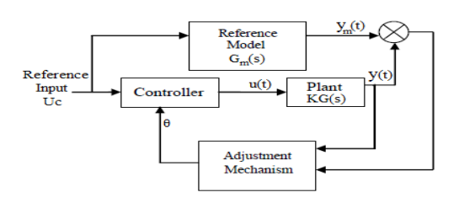
(Jain & Nigam, 2013)

A MRACS has been chosen due to the natural and consistent fluctuations all parameters will cycle through in a day, for example; temperature and light fluctuations at day vs night, water hardness and pH levels will change over time as natural waste and food particles build up.
Measurements from the reference inputs are to be taken by sensors. The below sensors and adjustments mechanisms are suggested:

Table 2: Proposed Sensors and Adjustment Mechanisms
Parameter | Sensor | Adjustment Mechanism
Temperature | Silicone Diode | Cooler and Heater
Water Level | Pressure Transducer | Butterfly Valve
pH Level | Glass pH Sensor | LED Alert Light
Water Hardness / Total Dissolvable Solids | Electronic Sensor | LED Alert Light

The MRACS for each of the above parameters will be discussed in more depth below:

Temperature
A silicone diode is proposed as the measurement sensor, these are relatively cheap and output between temperature changes and voltage is linear from -50°C to 150°C (Than, 2019).This diode will sit inside a waterproof probe which will be placed inside the tank. This will send a message to the controller which will either turn on the heater or the chiller. To avoid both the heater and chiller both consistently being on 24/7 it is recommended to send the chiller 1 degree higher than the desired temperature and the heater 1 degree lower than the desired temperature. Below are the block diagrams for how this will work:

Figure 2: Block Diagram for Heater MRACS
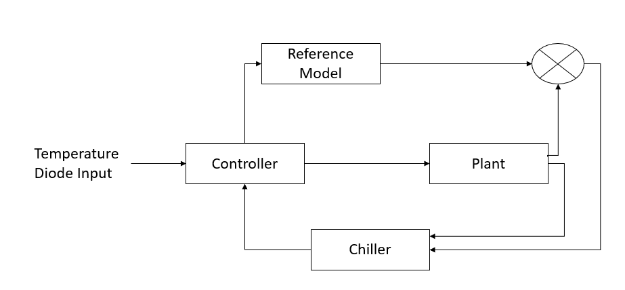
Figure 3: Block Diagram for Chiller MRACS
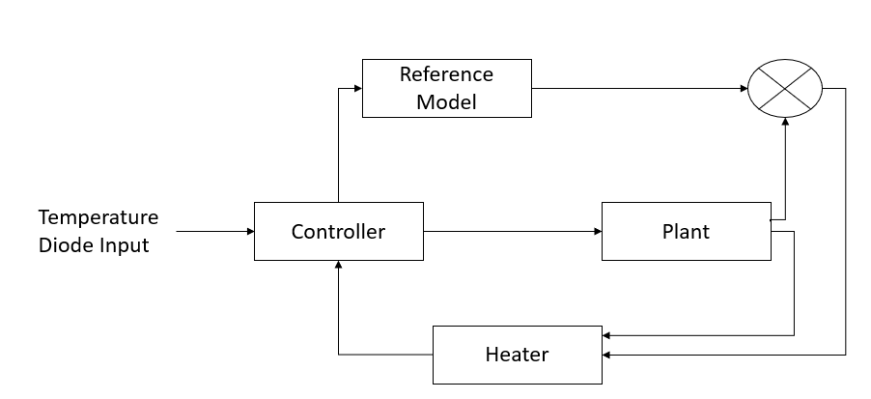
The controller will follow the below simple logic, Where; Lower Limit = LL, Upper Limit = UL, and Temperature = T
Figure 4: Logic for Heater & Chiller Activation
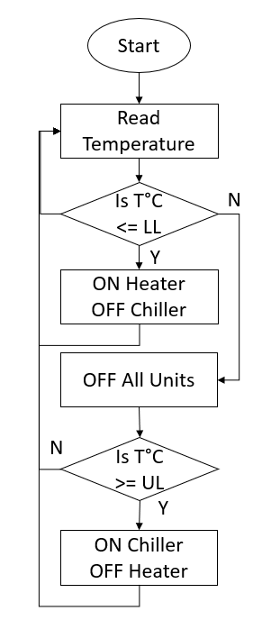

Water Level
A pressure sensor has been proposed to measure water level. The pressure sensor is placed at the top of the tank, connected to an open-ended tube which is submerged. As the water level changes, as does the pressure on the sensor via the trapped air in the tube. The senso then outputs voltage in relation to the pressure sensed, acting like a Wheatstone bridge; as changes in pressure results in changes in bridge’s resistors, R (Texas Instruments, 2011).
Figure 5: Diagram of a pressure sensor used as a liquid level sensor
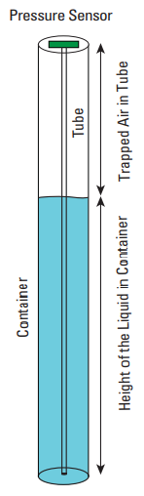

(Texas Instruments, 2011)
Below are the block diagrams for how this will work:
Figure 6: Block Diagram for Inlet Pump MRACS
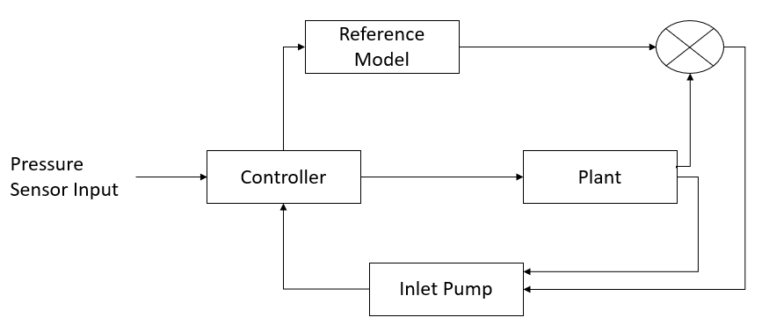

Figure 7: Block Diagram for Outlet Pump MRACS
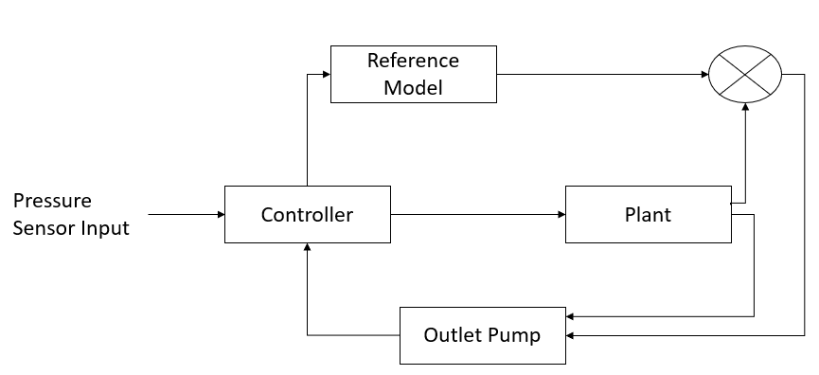
The controller will follow the below simple logic, Where Pressure = P.
Figure 8: Logic for Water Level System
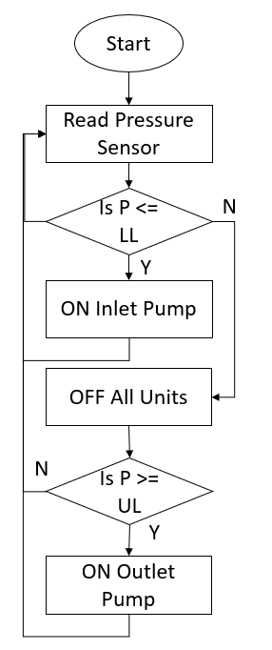
Both the inlet and outlet tanks will be connected by a butterfly valve, which will open and close with the ON/OFF commands. Butterfly valves are popular in industry as they are lightweight, fast in operation and cheap. They have a simple design with few moving parts thus fewer wear points requiring less maintenance. They can be actuated by electrical, hydraulic or pneumatic power or manually (Hawle, 2022). Nickle aluminium bronze is the chosen material for these valves due to it’s low cost and high resistance to corrosion and the build-up of bio-films (Carbin, 2022)

pH Level
A glass pH sensor is proposed to measure the PH levels of the tank. Whether a H2O solution reacts as acidic or not depends on its hydrogen ion content. Even chemically pure water will contain hydrogen ions due to the auto dissociation reaction, where H20 loses a proton resulting in the formation of a positively charged hydrogen ion:
H₂O ⇔ H⁺ + OH⁻
H₂O + H⁺ ⇔ H₃O⁺
Figure 9: How hydrogen ion content is formed in water
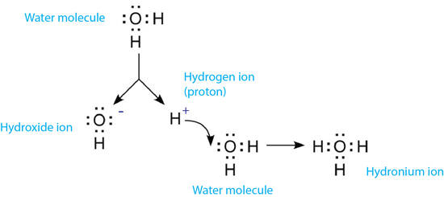
(YSI, 2022)
The glass pH sensor consists of ion selective electrodes (ISE) which reacts to a specific type of ion, as shown above in this case that is the hydrogen ion. The sensor creates a signal based on the electrochemical potential of the hydrogen ion activity of the solution. This is measured against a neutral sample and the difference between the two is converted into voltage (YSI, 2022).
Figure 10: Diagram of a glass PH Sensor
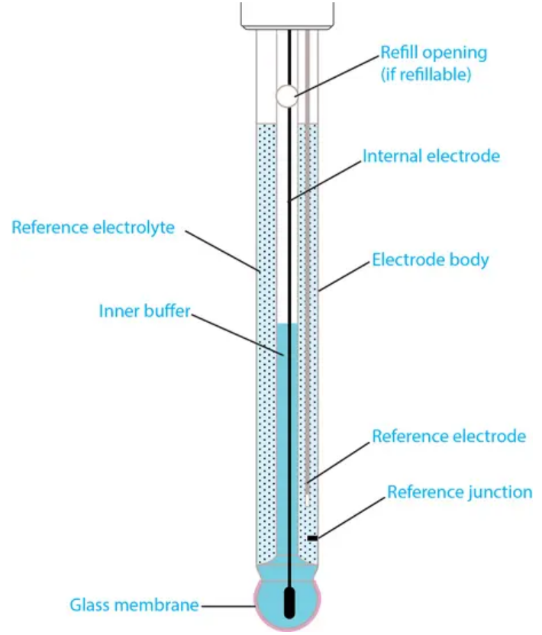

As it is very difficult to change the PH levels of the tank water with the fish still inside without causing harm to the fish, this mechanism will simply trigger a LED light system where a Red LED will indicate further action is needed
Figure 11: Block Diagram for PH Sensor MRACS
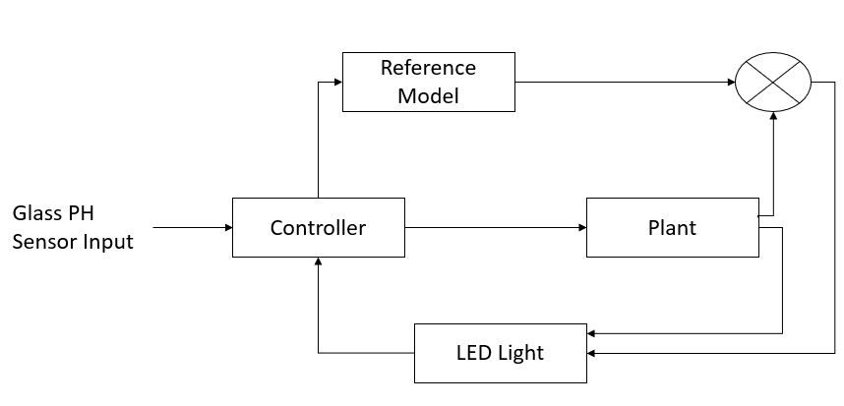

Figure 12: Logic for PH Level Warning Lights
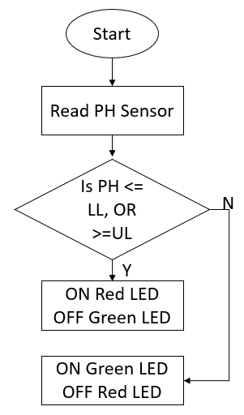

Water Hardness
A total dissolved solids (TDS) sensor is proposed to measure water hardness. TDS can be defined as anything dissolved in the water other than pure H2O, a TDS sensor works by measuring conductivity as hydrogen and oxygen conduct virtually no electricity, yet most other elements do, therefore a TDS measures the total amount of mobile charged ions found in the water (Samborn, 2008). This is only an estimation indicator of water hardness and cannot be a true indication of water hardness as it is more accurately measuring mineral content of the water (YSI, 2022). Water hardness is estimated by dividing the parts per million measurement of the TDS by 10. As with the PH sensor, it is very difficult to change the water hardness levels of the tank water with the fish still inside without causing harm to the fish, this mechanism will simply trigger a LED light system where a Red LED will indicate further action is needed.
Figure 13: Block Diagram for TDS Sensor MRACS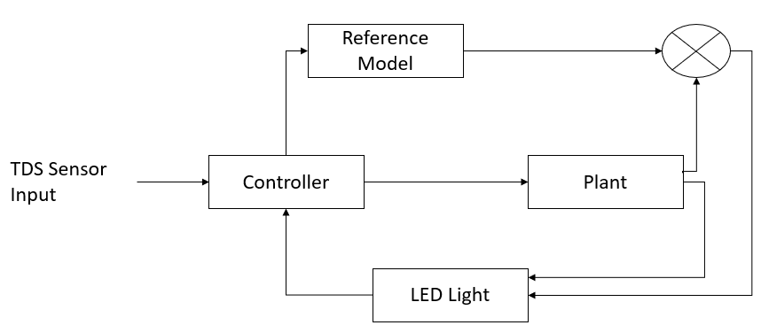

Figure 14: Logic for TDS Warning Lights
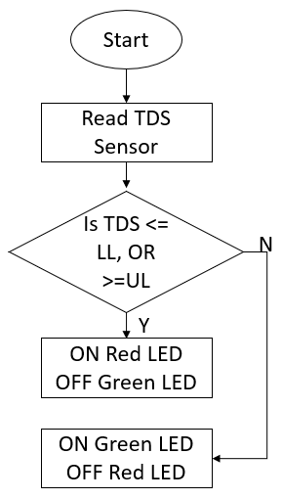

4.0 Using a Programmable Logic Controller to combine the systems
Figure 2, Figure 3, Figure 6, Figure 7, Figure 11 and Figure 13 of each MRACS block diagram can be combined and summarised in the below block diagram when a programmable logic controller (PLC) is used. Below is a block diagram of how this is proposed to work.
Figure 15: Block diagram for one integrated model reference adaptive control system for all parameters using a PLC
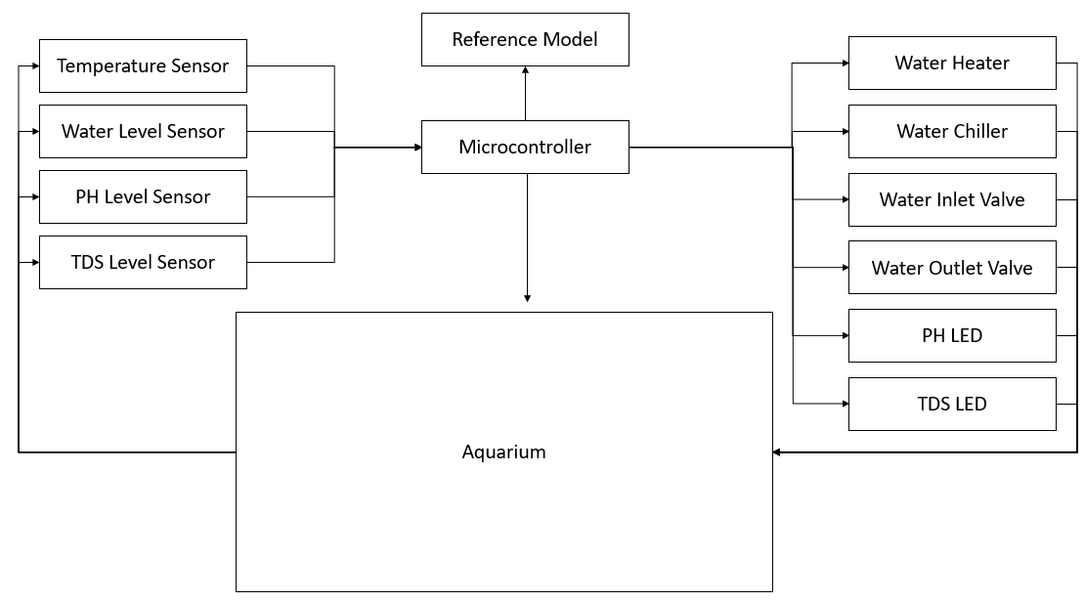
A microcontroller PLC is proposed due to its ability to receive data from multiple input/ output modules (in this case the sensors), store the information in its data memory, interpret the data against the rules provided in the reference model provided stored in its program memory and decipher and apply the incoming data to communicate and enact the appropriate action (Lutkevich, 2019).
Figure 4, Figure 8, Figure 12 and Figure 14 of the logic flow of each automated control system which is being combined by the microcontroller is summarised in the below ladder logic diagram. Water level is adjusted first as it impacts the other 3 parameters, then temperature is adjusted before the LED signals for pH and water hardness (TDS) are triggered.

Figure 16: PLC ladder logic for aquarium system
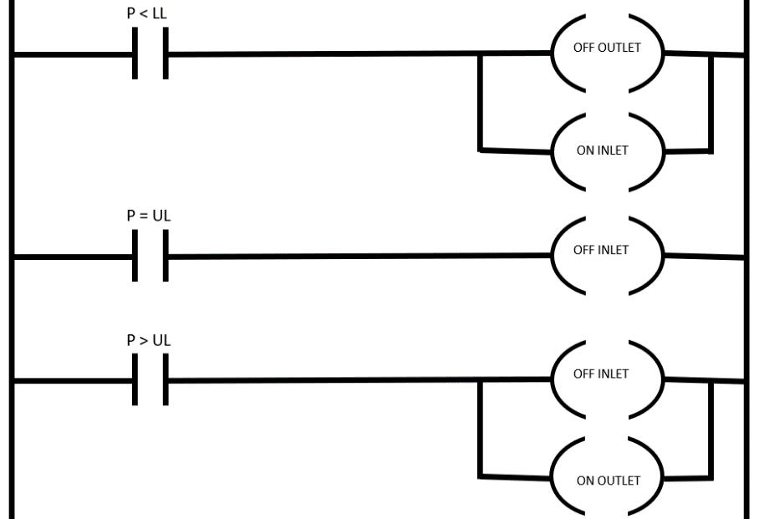
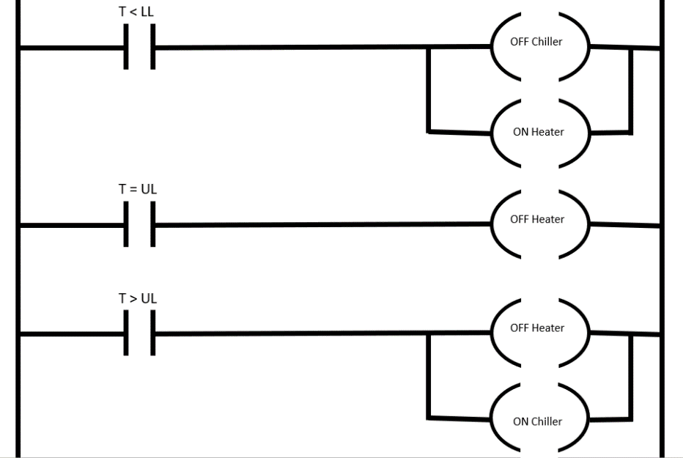

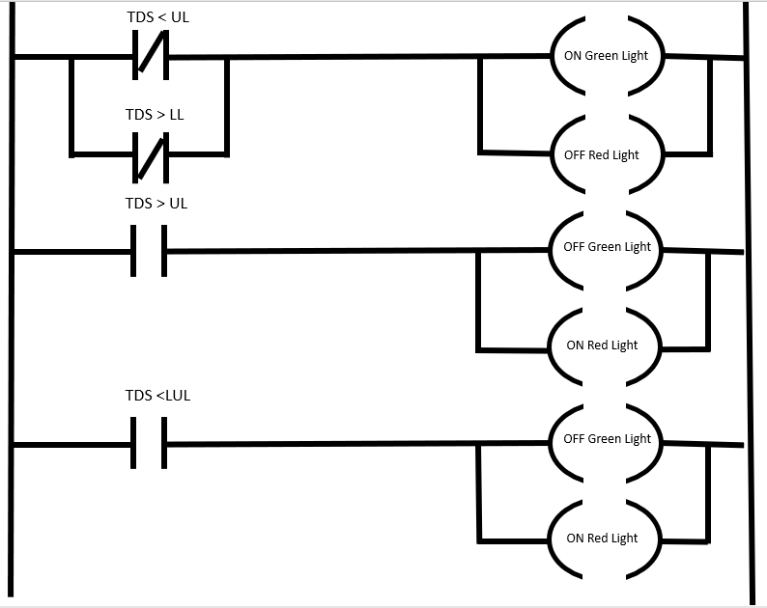
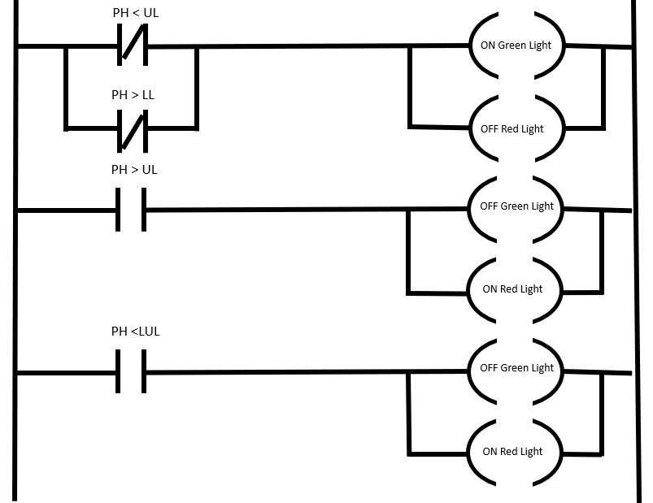

5.0 Hydraulic or Pneumatic Systems
Now that a model reference adaptive control system has been chosen, and the logic order defined, the power systems for the adjustment mechanisms need to be chosen. An analysis of fluid power options is presented in the table below to assist in deciding between hydraulic and pneumatic systems:
Table 3: Hydraulic vs Pneumatic systems
Category | Hydraulics | Pneumatics
Strength | Hydraulic systems are much stronger due to the liquid used for its operation, which has a higher mass density and is less incompressible meaning higher levels of pressure can be achieved | Pneumatic systems use low mass density fluids such as compressed gas or air therefore unable to achieve higher levels of pressure/ apply less force.
Hygiene | The fluid content (usually water or oil) in a hydraulic system has the potential to leak out via faulty seals, valves or worn hoses increasing the risk of contamination to the aquarium and corrosion of components. | The compressed air within the pneumatic system itself, will be cleaned of oil, water or metal particles, and any other contaminants, by the filtration unit. Therefore, the leakage risk is low to the aquarium as all that will leak is clean air.
Speed | Water and hydraulic oil have greater resistance than air thus hydraulic systems are slower than pneumatic systems | Due to the high flow rate of compressed air, pneumatic systems can achieve a much higher speed motion of parts
Energy | Constant electrical power to a hydraulic system is needed, as the fluid in a hydraulic system is in constant circulation to maintain system pressure. The amount of energy required | Pneumatic systems need a compressor to be continuously running to provide compressed air. These systems also loose energy through heat in the air compression process, and any air leakages will create additional waste.
Safety | Leakages from hydraulic systems can potentially be dangerous, fluids inside may be corrosive and/or poisonous and the heat of the liquid can become very high in the system. Some fluids may require special precautions with drainage and disposal | Compressed air does not pose any fire hazards, is not explosive, corrosive and does not need special measures for disposal
Complexity | Hydraulics requires a system of valves and hoses, with an externally powered pump and a storage tank for the liquid. | Pneumatic systems are often cheaper as they operate at a much lower pressure, and the fluid used is not corrosive nor combustible, cheaper components can be used, and precautions do not need to be built into the system
Maintenance | Corrosion is an issue with hydraulic systems and regular assessments of how the system of the pipes are being affected by the fluid medium is needed. | As the fluid medium is air, it is easier to maintain pneumatic systems, cleaning is not required as only filtered water is inside the system

(King, 2020).

Considering the above analysis, a pneumatic system has been chosen. This pneumatic system will operate the butterfly valves for both the inlet and outlet streams, and the compressed air generated in pneumatic systems will also be used to cool or heat the tank, as heat is created as the air is compressed, and cooled rapidly when the air expands (Air Compressor Guide, 2013).

REFERENCES

Works Cited
Air Compressor Guide, 2013. Use a compressed air heater to protect your equipment. [Online]
Available at: https://www.air-compressor-guide.com/articles/compressed-air-heater
[Accessed 1 April 2022].
Carbin, R., 2022. Common Metals & Materials Used in Butterfly Valve Manufacture. [Online]
Available at: https://www.processindustryforum.com/article/common-metals-materials-used-butterfly-valve-manufacture#:~:text=Nickel%20aluminium%20bronze%20is%20a,resistance%2C%20particularly%20in%20seawater%20environments.
[Accessed 1 April 2022].
Chiagunye, t., Ihekweaba, C. & Udean, h., 2014. The Design of an embedded Self-Diagnostic Hybrid Aquarium Control System. Proceedings of the International Conference on Embedded Systems and Applications (ESA).; Athens, 1(1), pp. 1-7.
Federation of Britis Aquatic Societies, 2008. YOUR LEGAL DUTY OF CARE FOR KEEPING FISH UNDER THE ANIMAL WELFARE ACT, London: FBAS.
Hawle, 2022. What is a Butterfly Valve?. [Online]
Available at: https://www.hawle.com/en/hawle-knowledge/basics/what-is-a-butterfly-valve/
[Accessed 1 April 2022].
INJAF, 2022. IUCN Red List and aquarium fish. [Online]
Available at: https://injaf.org/the-think-tank/iucn-red-list-and-aquarium-fish/
[Accessed 26 March 2022].
Jain, P. & Nigam, M. J., 2013. Design of a Model Reference Adaptive Controller Using Modified MIT Rule for a Second Order System. Advance in Electronic and Electric Engineering, 3(4), pp. 477-484 .
King, R., 2020. HYDRAULICS VS PNEUMATICS. [Online]
Available at: https://www.rowse.co.uk/blog/post/hydraulics-vs-pneumatics#:~:text=Pneumatics%20provides%20fluid%20power%20by,all%20factors%20to%20be%20considered.
[Accessed 1 Aprol 2022].
Lutkevich, B., 2019. microcontroller (MCU). [Online]
Available at: https://www.techtarget.com/iotagenda/definition/microcontroller
[Accessed 1 April 2022].
Samborn, R., 2008. WHAT IS TOTAL DISSOLVED SOLID (TDS) WATER TESTING?. [Online]
Available at: https://www.wqpmag.com/water-testing/what-total-dissolved-solid-tds-water-testing
[Accessed 28 March 2022].
Sheppard, M., 2020. Red Tail Shark 101: Care, Size, Tank Mates, Food, & More. [Online]
Available at: https://www.aquariumsource.com/red-tail-shark/#:~:text=Water%20parameters%20are%20an%20element,pH%20levels%3A%206.5%20to%207.5
[Accessed 26 March 2022].
Texas Instruments, 2011. Liquid-Level Monitoring Using a Pressure Senso. [Online]
Available at: https://www.ti.com/lit/an/snaa127/snaa127.pdf
[Accessed 28 March 2022].
Than, E., 2019. Diode-Based Temperature Measurement, Dallas: Texas Instruments.
YSI, 2022. Can You Determine Water Hardness From Conductivity or Total Dissolved Soilds Measurements?. [Online]
[Accessed 28 March 2022].
YSI, 2022. What is the pH of water and how is pH measured? What does pH measure?. [Online]
Available at: https://www.ysi.com/parameters/ph
[Accessed 28 March 2022].

