

Dissertation (LCMB7020_LON)

THE IMPACT OF SOCIAL MEDIA MARKETING ON CONSUMER BEHAVIOUR IN THE UK FASHION INDUSTRY

Student Name – Anna Marai Jose
Student Number – 2216778
Supervisor – Rexon Nting
Master’s Degrees by Examination and Dissertation
Declaration Form.
1. This work has not previously been accepted in substance for any degree and is not being concurrently submitted in candidature for any degree.
Signed…….…ANNA MARIA JOSE……….……………….………...
Date ……………12-02-2024…………..……………………………...

2. This dissertation is being submitted in partial fulfilment of the requirements for the degree of Master in Business Administration.
Signed………… ANNA MARIA JOSE………………………………………….
Date ………………12-02-2024………………………………………………….
3. This dissertation is the result of my own independent work/investigation, except where otherwise stated.
Other sources are acknowledged by footnotes giving explicit references.
A bibliography is appended.
Signed candidate: …… ANNA MARIA JOSE………………….……………….
Date: ………………………12-02-2024………………………………………….

4. I hereby give consent for my dissertation, if accepted, to be available for photocopying, inter- library loan, and for deposit in the University’s digital repository
Signed (candidate)……… ANNA MARIA JOSE………….………….…………...
Date…………………………12-02-2024……………………….…….……………..
Supervisor’s Declaration.
I am satisfied that this work is the result of the student’s own efforts.
Signed: ……………… Rexon Nting………….………………………………..
Date: ……………………12-02-2024……………..…………………………...

Acknowledgement
I would like to thank few people who give me opportunity to being a part of this dissertation. I would like to thank my professors for helping me throughout the entire research and help me to achieve correct results. I would also like to thank my parents, seniors and friends to give me support during the conduction of this dissertation.

Abstract
Background: Consumer behaviour can be modified through a multitude of factors. The time spent by today’s UK consumers on different social media platforms has increased as well, increasing the scope of businesses to leverage these aspects and target consumers. The present research attempts to analyse the impact of social media marketing on consumer behaviour, focusing on the UK-based fashion industry.
Methodology used: There are many rules, steps and procedures for using research methodology. Reading about interpretivism helped the researcher understand how social relations occur and how fashion organizations worked in the UK. In this study, an inductive approach was used because it is useful in understanding the situation. These designs not only depict objects, but also discuss how different aspects of the British fashion industry work. Grounded theory improves our understanding of how new ideas and perspectives are created. The secondary data analysis of this study also took a considerable amount of time. Thematic analysis has also proven useful in conducting qualitative analysis.
Result and findings: Through the help of SMM, fashion organisations in the UK such as has been able to communicate with customers regularly. SMM is that platform for the fashion industry in the UK that helps in acknowledging the purchasing intention of the customers. That is why, during the time of the COVID-19 pandemic, where physical distancing is everywhere customers have been attracted to fashion companies because of SMM as through it, companies connect with the customers easily. However, there are some challenges that have been faced by the fashion organisations such as privacy concerns of big data analytics and changes in customer behaviour. The study shows how SMM has revolutionised the UK fashion sector. SMM is essential for transparency, brand promotion, and consumer interaction. Influencers are extremely important in influencing the opinions of customers. It is accepted that there are challenges such as big data analytics and quick changes in customer behaviour. The study places a strong emphasis on the industry's adaptability, dynamic character, and tactical use of influencer marketing. This initiative can help brands overcome cultural boundaries.
Conclusion and recommendation: The study concludes the vital components of the consequences of social media advertising on consumer conduct in terms of the UK fashion industry. This relates to the principles of the use of social media structures and web sites to sell any services or products for sale. Social media marketing has been used to capture the eye of the goal customer marketplace to control their shopping for conduct in terms of meeting research objectives. However, the future scope of the study sheds light on potential implications of social media marketing approaches in future.

Table of Contents
Chapter 1: Introduction .10
1.1 Introduction 10
1.2 Background 10
1.3 Rationale 12
1.4 Aim, objectives and research questions 13
1.5 Significance of the study 14
1.6 Dissertation structure 15
1.7 Summary 15
Chapter 2: Literature Review 16
2.1 Introduction 16
2.2 Impact of social media marketing on consumer purchasing behaviour 16
2.3 Influence of Social Media Marketing upon the UK Fashion Industry 17
2.4 Process in which social media impacts purchasing behaviour 18
2.5 Factors affecting social media marketing in the UK fashion industry 20
2.6 Identification of relevant challenges regarding social media marketing in the fashion sector of the UK 21
2.7 Negative effect of social media marketing on the fashion industry and consumer behaviour 23
2.8 Current strategies for mitigating social media marketing challenges related to social media and consumer behaviour 23
2.9 Theoretical perspective 24
2.10 Conceptual framework 26
2.11 Literature gap 27
2.12 Summary 27
Chapter 3: Methodology 28
3.1 Introduction 28
3.2 Research Onion 29
3.3 Research Philosophy 29
3.4 The Approach of the Investigation 31
3.5 Design of the Study 32
3.6 Strategy Selected for the Study 33
3.7 Data collection method 35
3.8 Process of data analysis 36
3.9 Ethical consideration 37
3.10 Research timeline 38
3.11 Summary 38
Chapter 4: Results and Analysis 39
4.1 Introduction 39
4.2 Analysis of Secondary Data 39
Theme 1: “Social Media Marketing” or SMM influences the purchasing behaviour of the customers in the UK fashion industry 39
Theme 2: “Social Media Marketing” or SMM greatly influences the UK fashion industry by giving priority to consumer preferences 41
Theme 3: Factors such as data analytics, and content within social media channels affect SMM in the fashion industry of the UK 42
Theme 4: Challenges such as big data analytics negatively impact the SMM in the UK fashion industry 44
Theme 5: Rapid alteration of consumer buying behaviour negatively impacts the UK fashion industry 46
Theme 6: Influencer marketing strategy helps to overcome cultural restrictions 47

4.4 Discussion 49
4.5 Summary 51
Chapter 5: Conclusion and Recommendation 52
5.1 Conclusion 52
5.2 Linking with Objectives 52
5.3 Future scope of this study 54
5.4 Limitation 54
5.5 Recommendation 55
References 57

List of Figures
Figure 1.1: Popularism of different social media platforms by the UK fashion industry 11
Figure 1.2: Structure of the dissertation 15
Figure 2.1: Steps for social media marketing 19
Figure 2.2: Process of decision-making and influencing factors 21
Figure 2.3: Conceptual framework 27
Figure 3.1: The representation of research onion 29
Figure 3.2: The representation of different research philosophies 30
Figure 3.3: The representation of different Approaches to any Investigation 31
Figure 3.4: The representation of different Designs available in the Methodology 33
Figure 3.5: The representation of different Strategies available in the Methodology 34
Figure 3.6: The representation of different Data collection methods in the Methodology 36
Figure 3.7: The representation of different data analysis techniques 37
Figure 3.8: The representation of the research timeline 38
Figure 4.2.1: Different aspects of SMM 40
Figure 4.2.2: Use of Social Media in UK 42
Figure 4.2.3: Role of Influencer marketing through Social Media 43
Figure 4.2.4: Challenges 45
Figure 4.2.5: Use of influencer marketing in UK luxury brands 48

Chapter 1: Introduction

1.1 Introduction
Consumer behaviour can be understood as the actions and decisions undertaken by individuals when they undertake decisions for choosing what to use or buy and simultaneously dispose of a product. Understanding consumer behaviour is crucial for any business, as it is beneficial to reach the product to the targeted audience, leading to profitability. According to the views of Li et al., (2021), consumer behaviour is a complex process involving a diverse set of attitudes like thinking process, likes, dislikes, and influence. In recent times through the emergence of social media platforms, they have become instrumental in shaping the behaviour of consumers, thereby influencing their decisions towards purchase (Ruggiano and Perry, 2019). Businesses, especially the fashion industry greatly leverage the capability of these social media platforms to effectively connect with the targeted audiences, thereby building on brand loyalty, with their targeted audiences, and driving conversions in parallel. The fashion industry in the UK generates US$85 Bn and is estimated to grow at a CAGR of 3.55%. The social media platforms have been greatly leveraged, by the UK fashion industry to influence fashion trends among consumers. Social media's abilities to foster communities develop user-generated content, and the scope to interact in real-time are some of the aspects that have been exploited by the UK fashion industry to impact consumer behaviours.

1.2 Background
Social media marketing relies upon the usage of different social media platforms to build a social network, through which information can be shared, increasing website traffic and driving sales. Social media marketing has gradually emerged as a quintessential aspect of marketing activity, irrespective of the business domain. Similarly, for the UK fashion industry, which is a booming business segment, social media plays a crucial role in its success. According to the views of Djafarova and Bowes, 2021), there has been a paradigm change within the lifestyle of consumers, and social media has infiltrated leisure time. Especially within the UK, the average time spent on social media is 5 hours 47 minutes daily (Ortiz-Ospina and Roser, 2023). Social media can be considered a platform where individuals share their likes dislikes and opinions, pertaining to fashion, and their choices. These aspects lays an influence on the customer purchase journey as their decisions to make a purchase are greatly influenced by opinions shared on social media. Even more, the attractiveness of the marketing conducted by fashion businesses impacts the decisions to purchase and overall consumer behaviour. The effectiveness of social media platforms tends to vary. Within the fashion and apparel industry, majority of the fashion brands tend to highlight their products and services through Instagram and Facebook. Consumers also equally rely on the fashion-related information highlighted in these two platforms majorly, while making a decision. Additionally, platforms like YouTube, Tik tok, Snapchat, Twitter and Interest are also predominant as seen in the figure below.
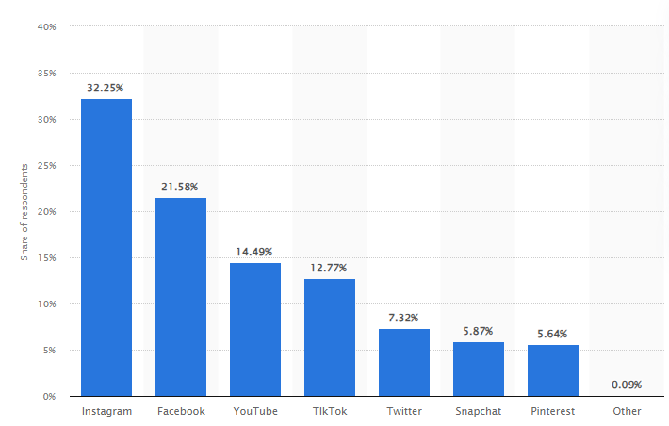

Figure 1.1: Popularise of different social media platforms by the UK fashion industry
(Source: Statista.com, 2024 )
The UK-based fashion industry is the fifth largest industry in the world, therefore contributing greatly to the GDP of the nation. Nash (2019) opines that the success behind this industry success is deeply embedded within the optimal usage of social media platforms. Fashion-related content on social media has gradually increased with the time spent by consumers on these platforms. A trend in fashion is not recognised as a trend unless it is shared and liked in the virtual space (Salem and Salem, 2021). Fashion influencers and their followers have a major role in facilitating the fashion industry and shaping trends that drive profitability. In the opinion of Noris et al., (2021) the direct communication aspect has become a cornerstone for the UK fashion industry in establishing its connection with the consumers. This also enables the brands to include personalisation, which further increases the quality of communication established by the brands with their consumers.

1.3 Rationale
The growth of e-commerce and social media sausage can be found to be on a parallel timeline, and positively contributing to one another's growth. Fashion purchases of consumers are greatly dependent on social media, as it has emerged as a platform where consumers discover new products, and brands and engage with the brands in real-time. Social media marketing also enables consumers to make a comparative analysis of similar offerings, along with reviews shared by consumers, which further shape their purchase decisions. Even though Wibowo et al., (2020) argue that the impact of social media on purchase decisions is more on younger consumers, the effect of social media on purchasing decisions remains greatly significant. Different social media platform has different capabilities to modify consumer behaviour, for example, Instagram helps fashion businesses to make fashion more accessible and have a closer look at the collections. Especially rising fashion brands and luxury fashion brands use Instagram as a platform to shape consumer behaviour by highlighting their offerings and increasing the desire for purchase. Both Facebook and Instagram are potent platforms which support fashion brands in showcasing their collections, and sales, and engaging their audience in real-time thereby shaping their behaviour.
Consumer behaviour has been relatively constant behaviour, as customers prefer to adhere to their preferences while making a purchase. This has been majorly affected following the pandemic, and the inflations, where these disruptions have changed the ways in which consumer behaviours are shaped. In the findings of Zhou et al., (2021) it can be seen that consumers have been encouraged to try new fashion brands that offer sustainable fashion, or affordable fashion following the pandemic. Customer behaviour is modified through a multitude of factors that have an impact on the mindset of the consumers. It helps in shaping the habits of consumers as well. Social media has become an inseparable part of consumer life, and the time spent on different social plats is gradually increasing. This consecutively increases the importance of social media platforms and their usage by fashion brands to modify the behaviour of consumers. The present study thereby attempts to understand the impact laid by marketing using social media to impact consumer behaviour.

1.4 Aim, objectives and research questions
Aim
This study will aim to analyse the impact of social media marketing on consumer behaviour in the UK fashion Industry.
Objective
The research has been developed in order to successfully fulfil these study objectives.
- To understand the influence of social media marketing on consumer purchasing behaviour.
- To analyse the impact of social media marketing on the consumers of UK fashion industry
- To identify the challenges related to social media marketing in the UK fashion sector and its negative impact on consumer behaviour
- To discuss the mitigation strategies for improving social media marketing to grab more attention from the customers of the UK fashion industry.
Research Questions
The following research attempts to find answers to the following research questions that ahs been farmed.
RQ 1: What is the influence of social media marketing on consumer purchasing behaviour?
RQ2: How do a social media marketing impact the consumers of the UK fashion industry?
RQ3: What is the challenge related to special media marketing and how does it negatively affect the consumer behaviour of the UK fashion industry?
RQ4: What are the effective strategies for developing a social media marketing approach to grab more attention from the consumers of the UK fashion sector?

1.5 Significance of the study
Consumer behaviours and social trends are changing constantly at an alarming pace. Social media can be found to be a leading cause behind facilitating these changes. In the fashion industry, social media is a key determinant of trends that not only encourage consumers to purchase but also encourage businesses to adhere to the trends and manufacture accordingly. On the other hand Valaskova et al., (2021) also argue that social media sets unrealistic dreams and aspirations about fashion, especially in young minds, whose impact is required to be adequately regulated. Especially after the pandemic, the spending habits of consumers have undergone a drastic change, as Akter et al., (2021) state, impulsive purchases have been reduced and planned behavioural purchases has been encouraged. The present study helps in developing a critical understanding of the diverse influencing factors that are exerted through social media platforms on consumers. The overall effectiveness of social media platforms in changing customer purchase and their purchase decisions can be understood to a great extent through the research.
This research also diverts attention towards the nature in which consumer purchase behaviour is modified by leveraging social media platforms. Evaluation and assessment of these aspects help to subsequently identify the challenges that are being encountered by the UK fashion industry while using social media to impact consumer behaviour. Through the assessment of the challenges encountered, the impact of these challenges on the consumers can be gradually understood. Through the assessment of these challenges, subsequent mitigation approaches have been formulated that help the readers gain a novel perspective in which the fashion industry businesses can elevate the challenges of using social media and consecutively grab the attention of the consumers even more effectively. The research findings become valuable for fashion businesses operating in the UK. These businesses gain an understanding of the impact social media leverages on consumer behaviour. These findings can be further utilised to design marketing activities so that consumer behaviour can be modified even further. Through understanding the ways in which social media marketing affects behaviour, targeted marketing activities can be developed, for reaching optimal marketing potential.

1.6 Dissertation structure

Figure 1.2: Structure of the dissertation
(Source: Self-created)

1.7 Summary
Social media marketing has gradually gained popularity within the business environment, as a marketing platform that holds immense potential in shaping the behaviour and purchase intention of customers. The UK fashion industry being one of the leading business niches, greatly uses this marketing approach. This chapter highlights the aim of the research which is to effectively analyse the impact of social media marketing on modifying customer behaviour in the UK fashion industry. The objectives that guide the progression of the research, along with the research questions that guide the research progressions have been stated in this chapter. The study is immensely significant in the present context, as social media has become an indistinguishable part of customer life, and significant time is spent on that platform, increasing the scope for leveraging it for marketing activities.

Chapter 2: Literature Review

2.1 Introduction
The previous published academic writings have been analysed in this section. The previous literary work relevant to this selected topic has been reviewed in this chapter and hence, the chapter has been considered the literature review section. In this aspect, a critical evaluation has been done to obtain an understanding of the existing research. This type of literary evaluation has also been executed in the form of a written report. This study has been based on analysing the impact of social media marketing (SMM) on the consumer purchasing behaviour of the British fashion sector. The previous chapter has represented the ultimate aim and objectives of this investigation. These Objectives have been considered the basis of this chapter because the previous academic writings have been searched and evaluated regarding the investigating areas identified in the research objective section. Further, a conceptual framework has been input in this chapter to promote an overview of the foundation of knowledge about the selected topic of research.

2.2 Impact of social media marketing on consumer purchasing behaviour
Social media platforms have been found as instrumental in the aspect of shaping the purchasing behaviour of the existing consumer market. However, it has not only influenced their purchasing decision but also increased consumer engagement with the brand. Shin and Lee (2021) have opined that those business organisations which have clearly understood the effectiveness of social media and developing its power have been more connected with their target audience than others. Similarly, building expected brand loyalty also drives business conversion according to the consumers’ needs. Voramontri and Klieb (2019) have stated that social media has the power to influence the decision-making approach of consumers during the projection of complex purchases. However, with the help of different social media channels, potential consumers can evaluate the brand differently, a product or service specification and rate of consumer involvement. Thus, those popular digital platforms significantly affected consumers’ marketing experiences as well as enhanced their trust towards the brand name.
With the help of social media, business organisations irrespective of any industry can advertise their product or services before the potential target market. Therefore, SMM or social media advertising has been done to show exactly what has been offered by the organisations. By supporting this information, Wibowo et al., (2020) have explained that popular social networking sites have been utilised by business enterprises to directly communicate with consumers. Thus, a trustworthy and understandable relationship has been established between the consumers and the organisation. In this aspect, consumer behaviour theory has been incorporated into the brand operation. This theoretical interpretation has supported the enterprises to relate with consumers' behaviour regarding spending money according to their taste and the shape of income. Sikrant (2020) has also supported the information and opined that SMM activities and customer experience have been considered by the business organisation to further evaluate the relationship quality with the target consumer market. The ultimate impact has been further realised through different behaviour outputs of the consumers such as intention for purchase, loyalty expression and participation.
On the other hand, Social media platforms have created forums which are effective for consumers regarding posting as well as sharing honest experiences after consuming any product or service. This has been fruitful for the companies to understand their requirement and purchasing intentions. As per Ibrahim et al., (2020), social media marketing activities have also influenced brand equity and purchase intention. By understanding these features, the companies can develop more attractive marketing content and enhance positive perceptions towards the brands.

2.3 Influence of Social Media Marketing upon the UK Fashion Industry
Usually, social media marketing has been based on integrating popular social media platforms to increase brand awareness. This approach was also found effective for business organisations in the fashion industry to drive website traffic and increase customer engagement. Thus the customer engagement rate with the brands has increased with satisfaction. Therefore, Nash (2019) has stated that fashion marketers in the UK have understood the decision-making process performed by consumers through observing their social media activities. The consumers of the fashion industry of the UK have different types of internal and external factors for motivate them and also influence them to execute a specific type of purchasing behaviour. Similarly, Lagun (2022) has suggested that the renowned fashion retailer of the UK fashion industry, ZARA has selected those social media platforms which assure more attachment with the target audience. In this aspect, ZARA has utilised Instagram to advertise stunning fashion products, behind-the-scenes views and also certain user-generated content. However, SMM activities in the fashion industry of the UK have been approached with the guidance of the Trickle-across theory. This theory has supported the sector through the movement of specific fashion trends horizontally. Therefore the followers of social media have been going after the trend presented by the SMM influencers.
Fast fashion has been considered a growing trend in the current business organisations of the UK fashion sector. 2304 fast fashion business enterprises have been found across this country during 2022. It has been found that the number has been increasing rapidly and eventually 1.3% growth obtained from 2021. Therefore the market size of revenue earned by this specific fashion segment is 21.3 billion euros in 2023. Therefore, the sustainability of this fast fashion industry has been considered a vital concern of the UK fashion sector for the future. The fast fashion retailers have also enjoyed the benefits of SMM. Sikrant (2020) has explained that social media marketing promotes a vision of the details of the existing fan base. With the help of SMM, fast fashion organisations such as ASOS, Mango, Primark, ZARA, Boohoo and others can now distinguish consumers’ gender, age as well as their preferences and fashion tastes.
Similarly, the opinion leaders who have been considered fashion influencers offer positive reviews about present and future fashion trends with the help of different social media platforms. It has been further executed in product place and endorsement of the potential consumers. However, supporting this information Zhang et al., (2021) have opined that consumers' attitudes or decision-making regarding purchasing fast fashion products has not been dependent on their age group in the UK community. Therefore, integrating SMM activities in the UK fashion industry has focused on engaging with more potential consumers to build effective brand awareness.

2.4 Process in which social media impacts purchasing behaviour
SMM is a trending way during the current situation for not only promoting or advertising the product or service but also allowing the retailers to connect with the target market with the help of more organic ways. Usually, the social media campaign is performed through 4 inter-connected processes and those are knowing the customers, setting proper targets, executing of marketing plan in the social media platform and monitoring the progress of the advertised content. As per the views of Drummond et al., (2020), knowing the customers or the target audience has been approached through knowing the customers beyond their demographic differences. In this aspect, different social media platforms have supported industries to follow the behaviour of consumers by supplying a large amount of data. In this aspect, data analytics has been considered effective for analysing consumer data and being informed about purchasing trends. The next step is to set a prominent target. Usually, the general motto of SMM for any type of business organisation is to increase the sales of new or modified products or services. In this aspect, the social media campaign has been organised with a septic plan because this advanced marketing approach simultaneously needs time and money.
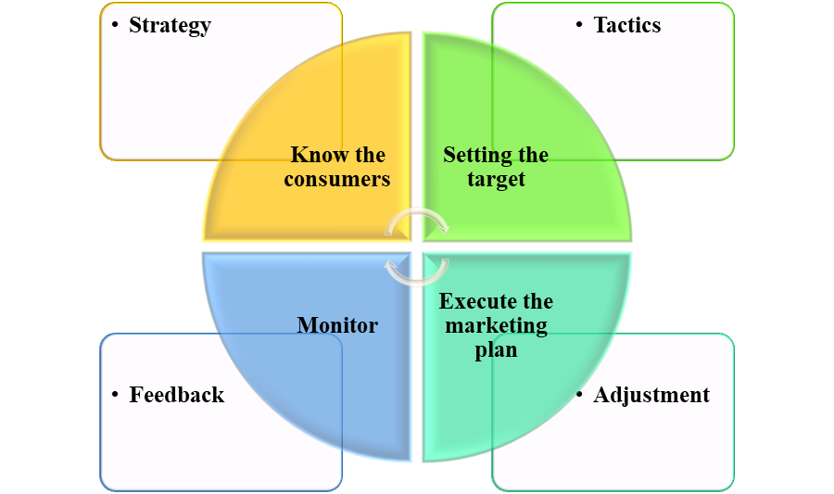

Figure 2.1: Steps for social media marketing
(Source: Self-created)
Further, the execution of the plan has been conducted by the business organisation through accumulating relevant strategies. Therefore, marketing through social media has been found effective by accompanying influencers to promote certain brands, as well as their products or services. ZARA has tied up with different fashion influencers and celebrities to increase its rhea in the target consumer market. In contrast, H&M has collaborated with lesser-known celebrities because this branding thought has been based in that the bigger has not always been found better. However, more or less, influencer marketing has been efficient for business organisations, especially for the fashion brands of the UK (Zhou et al., 2021). Therefore, plan execution in the process of SMM in the fashion sector has been based on mainly the impulsive purchase theory. With the help of social media influencers the target consumers have felt a sudden urge to purchase any fashion product within a short time.
The last stage of marketing is measuring or monitoring which has been found easier than before with the assistance of digitalisation. Castillo‐Abdul et al., (2022) have opined that throughout the social media campaign, the metrics have been monitored to understand the progress of the process. However, by analysing the feedback of the consumers, the brands can generalise their demand as well as relate what should be improved for the future.

2.5 Factors affecting social media marketing in the UK fashion industry
The adoption of the right social media platform has been considered the main effective factor for social media marketing in the UK fashion industry. As per Vinerean and Opreana (2019), Instagram has been considered the most helpful platform to promote any fashion brand in the UK. However, different social media platforms have induced different types of innovative strategies to improve the social media presence of marketers. In this aspect, Instagram has been considered the ideal marketing platform for the advertising of luxury fashion products. Therefore, ZARA, Guess, Primark, Nike, Topman, Lululemon and other brands have used Instagram. This social media platform in the UK has obtained an engagement rate of 0.779% which designated 11,211 people. This percentage has been much higher than Facebook (0.084) and Twitter (0.062). On the other hand, Diesel, ECCO, Adidas, M&S and others have utilised Facebook. Urban Outfitters and Ralph Lauren have been found which have only advertised their fashion products through Twitter.
Similarly, followers' engagement with the help of different influencers has been considered another effective factor in the discussed industrial aspect. Zhang et al., (2021) have mentioned that individual influencers, situational influencers and group influencers have incorporated social media marketing. Therefore, the existing fashion brands in the UK have been mainly performed with individual influencers to increase the followers of the brand. Simultaneously, it has lasted longer for the engagement of those followers with the brand. As per Djafarova and Bowes (2021), reaching Gen Z is the goal of fashion marketers in the UK and it has succeeded with the help of influencer marketing. However, ASOS, Boohoo, IntheStyle and others are such types of fashion brands inside this discussed industry which has used micro-influencers successfully to enhance followers' engagement.
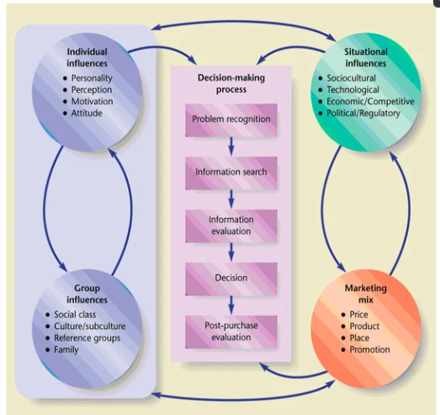

Figure 2.2: Process of decision-making and influencing factors
(Source: Zhang et al., 2021)
Right content strategy has been considered one of the most common factors that has affected social media marketing. As per Shakarbekovna (2021), the marketing strategy has been based on analysing the behaviour and perception of potential consumers with the support of the social media matrix. Therefore, integration of the theory of planned behaviour has been found relevant to understanding the psychological integration of each individual. This theoretical assistance is further accompanied by deriving attractive content with social media channels for SMM after considering the behavioural intentions of the consumers.

2.6 Identification of relevant challenges regarding social media marketing in the fashion sector of the UK
The fashion industry of the UK has been increasing rapidly with the growing demand of the target market. The introduction of fast fashion, eco-friendly fashion products, sustainable clothing and others has extended this business field throughout the world. On the other hand, clothing has been always considered a happening business ground in the UK. this industry has been expected to run a revenue of 78.80 billion euros by 2024. This has indicated to increase in the annual growth rate of the industry by 3.55% between 2024 and 2027. Therefore, a large amount of consumer data has been associated with the industry in the present state and the trend has indicated that the amount will be increased rapidly. As a consequence, working with this big data has been considered a big issue for the existing and future eras. Silva et al., (2020) have supported this information and opined that big data analysis has been found to be a relevant challenge for this industry. Similarly, Boada-Collado and Martínez-de-Albéniz (2020) have suggested that fashion retailers have to understand the needs and desires of the target market and optimise inventory levels. Therefore, effective analysis of big consumer data has been found necessary to improve customer service besides increasing sales and profit.
On the other hand, Sharma and Jhamb (2020) have considered the changeable consumer perspective and demand as the emerging challenge of this sector. The changeable demand of the existing consumers in the UK fashion industry is now approaching to know about the materialistic resources and packaging conduction of the ultimate fashion products. Similarly, the people of the target market feel interested in online purchases rather than visiting the physical outlets. Therefore, Hosain and Mamun (2023) have stated that increasing e-commerce and informing it through SMM has been considered one of the major issues in the current business environment. However, social media marketing entered the business of the British fashion industry before the global consumers and simultaneously faced problems regarding meeting all the demands of the global consumer market and balancing the contrasting consumer preferences. Similarly, promoting the product of slow fashion through the marketing of attractive fast fashion products through social media platforms has been considered another problematic concern of British fashion retailers. Brewer (2019) has emphasised that sustainable or low-fashion products are usually more expensive than similar fast-fashion products. In this aspect, the consumers show a positive interest in social media advertisements but the behaviour does not intend towards purchasing sustainable products positively.

2.7 Negative effect of social media marketing on the fashion industry and consumer behaviour
Social media marketing has facilitated fashion brands through increasing fashion reach. Along with this, Shakarbekovna (2021) has explained that SMM integrates consumer preferences and influences the consumer market to follow the fashion trend. The power of social media has been incorporated for real-time interaction between brands and their target consumers. Similarly, it has affected the community negatively. Ralph-Nearman et al., (2020) have highlighted that the fashion shows of different clothing products have been conducted with the help of underweight models. This approach has negatively affected the minds of social media users, specifically Gen Z people. The SMM has been found comparatively much more influential than the other marketing process. Therefore, similar to the positive influence regarding making decisions about purchasing the product, the users have also blindly followed the influencers for other concerns. In this aspect, promoting a product with the help of a size zero model has been found fatal for the audience of the target market.
However, in the recent era, UK fashion bosses have begun to think about engaging real-size women on the catwalk. In addition, Fixsen et al., (2023) have described that the London College of Fashion and also proposed adopting evolutionary steps to rethink the body size of the models. It has been applied not only for the models engaged with fashion events in the UK fashion industry but also for the social media advertising of trending fashion products.

2.8 Current strategies for mitigating social media marketing challenges related to social media and consumer behaviour
The SMM practice in the UK fashion industry has been functioning with challenges such as big data analysis, changeable consumer behaviour and the approach of slow fashion products in the environment of fast fashion. Therefore, in this literature review section, the mitigation strategies have been identified for mitigating such deformities as well as accomplishing more development in future. The application of data science has been considered the most effective process to manage big data and analyse those properly. Saura (2021) has presented that data science has improved decision-making and also extracted practical insight and knowledge from a big dataset. Shi and Lewis (2020) have opined that ZARA has enumerated data science analysing customer insight regarding product design. Similarly, a team of artificial intelligence (AI) improve customer experience during social media marketing campaigns. In addition, the industry has been applying Beacons technology applications (BLE) to maintain the balance between potential and existing consumers.
Hayward et al., (2022) have mentioned that BLE technology has the power to link the physical and digital worlds. With the help of this advanced technology, a communication bridge has been made between the enables of digital devices and the persons who have carried them. Thus potential clients have been transformed into loyal consumers of a specific brand. The UK fashion industry has implemented this strategy in the aspect of promoting slow fashion through social media channels. Therefore, Ted Bekar, a renowned luxury fashion brand in the UK has adopted the iBeacon application. With the help of Bluetooth beacon, the customers get detailed product descriptions with photos on their smartphones. In addition, the consumers can share this information with friends to access attractive offers. Thus social media marketing approach can be supported through free social marketing by the potential consumers inside the community.
Influencer marketing has been considered a proactive strategy for the UK fashion industry and it has been described in the previous part. However, Noris et al., (2021) have stated that the marketing projection as well as marketing context preparation, now depends on cultural and social determinants. With the help of SMM, the existing fashion brand of the discussed country has been communicating with people beyond geographic barriers (Xia and Liu, 2022). In this aspect, considering the cultural and social specialities during the creating SMM context has been found most influential for the target market. However, Primark has been significantly experiencing the importance of such strategies to extend the business in those countries which do not accept Western-designed clothes.

2.9 Theoretical perspective
Theory of planned behaviour
The theory of planned behaviour deals with the intention of consumers to buy fashion products, that are further, impacted by their preferences, attitudes, tastes, and perceived control. In this regard, social media influences these fundamental aspects through mechanisms like influencer endorsements, social sharing, and user reviews (Ajzen, 2020). However, favorable portrayals of companies on social media have the potential to beautify attitudes and generate social influence. The Theory of Planned Behaviour (TPB) posits that character behaviour is encouraged with behavioural intentions, which are fashioned via the mindset toward the behaviour, the subjective norms associated with the behaviour, and the character’s notion of the convenience of performing the behaviour.
Impulsive purchase theory
According to the impulsive purchase theory, consumers have an inherent inclination for engaging in impulsive purchases. From this perspective, social media necessitates continuous comparison of products, aesthetics, and trends (Zafar et al., 2021). The field of the fashion industry may influence impulsive purchases, that drive consumers’ buying preferences. However, engaging in the purchase, which incorporates a comparison of one’s purchase to others reflects on the consumers’ ability to make effective buying. This, however, elicits emotions of impulsion while buying preferred products. It could also play a prominent role in motivating consumers to make fashion purchases, as they tend to imitate the trends of products.
Trickle-across theory
Trickle-across theory stands with the notion of the social fashion behavioural marketing approach, established by Dwight E. Robinson. This refers to the adoption of specific fashion products, which, in turn, spread horizontally with socioeconomic classes (Mohr et al., 2022). As per this theory, fashion is found to have moved across groups at different levels. This is identified by market products as introduced by fashion enterprises. However, the trickle-across theory regulates the idea of implementing fashion styles in terms of consumers’ buying preferences.

2.10 Conceptual framework

Figure 2.3: Conceptual framework
(Source: Self-created)

2.11 Literature gap
The current study examines the overall use of social media and the way it influences fashion consumption behaviours. However, there is nonetheless a lack of facts about the precise strategies and mechanisms through which social media marketing processes impact consumer choice-making inside the UK-style enterprise. The majority of research uses a quantitative technique, which involves collecting numerical statistics on people’s social media utilization and their self-stated shopping behaviours (Creevey et al., 2022). Nevertheless, there’s a scarcity of qualitative studies that very well examine the cognitive methods, affective reactions, and societal influences that people go through after they encounter style advertising on social media. However, researchers have prioritized demonstrating correlation in place of imparting an in-depth rationalization of reason. Considering this, the present study focuses on the impacts of social media marketing on consumers’ buying behaviour by using qualitative data. This would provide scope for identifying the factual findings of the data based on the present topic.

2.12 Summary
The study summarises the fact that social media marketing often relies on integrating popular social media platforms to increase brand visibility. The method has also been found to be effective for business organizations in the fashion industry to increase website traffic and increase customer engagement. Thus, customer engagement with the brand has increased through satisfaction. This, however, entails consumers’ buying behaviour in the UK fashion industry.

Chapter 3: Methodology

3.1 Introduction
Research methodology is a particular and significant framework which provides a method and understanding of the process of conducting the study. It outlines many different aspects of research involving different techniques and tools. An appropriate solution of research methodology helps the researcher ensure the validity and reliability of the research. Researchers follow certain rules when they do their work. The methodology also discusses different details of research design and data connection processes (Newman and Gough, 2020). It handles the overall specifics of data collection and its analysis procedures. The research design and strategy for doing the entire research are also discussed here. It provides a conceptual route map for reaching research objectives. It also describes different processes of how a researcher can achieve the research goals. The credibility and accessibility of the research in this research have also been discussed.
So, the researcher can start the study and end it with useful information. The validity and trustworthiness of the study are also affected by these research methods. For some, research methodology is a collection of different parts that work together to finish the study (Zhou et al., 2022). This part also talks about how people can do research and how businesses grow after having a big sale. There were many parts to this section that talked about the methodology. It is also very important to think about the research strategy and methods in terms of the project goals.

3.2 Research Onion
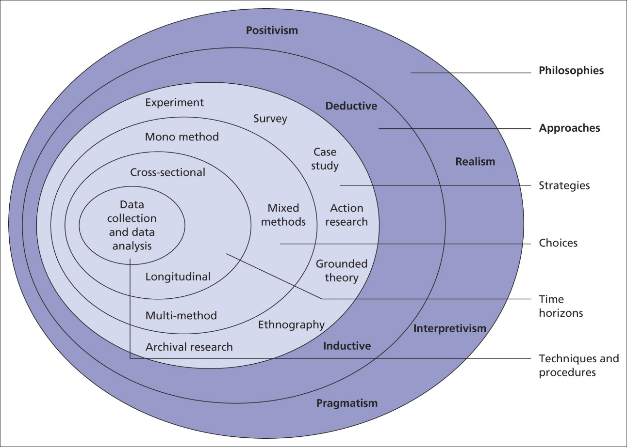

Figure 3.1: The representation of research onion
(Source: Zhou et al., 2022)

3.3 Research Philosophy
Research philosophies can be considered as a fundamental element of the methodology which tries to underline the benefits and assumptions of the researcher concerning available knowledge and reality. Research philosophy provides a methodological choice of research design and it also handles different specifications of the research. The appropriate selection of research philosophy can help the researcher to understand the validity and coherence of the study. It also helps to understand the nature of the research along with the accuracy of the findings (Alharahsheh and Pius, 2020). A well-structured philosophy can also guide the research towards appropriate data collection and analysis techniques. It can also foster a robust world and promote the consistency of the research. It also helps the researcher to identify the ontological and epistemological perspectives of the research. It helps to clarify the theory of knowledge and the true or real nature of the research topic. There are four different types of research pillars of his are available in the research topic. There are four different types of research philosophies available. These are pragmatism, realism, interpretivism and positivism.
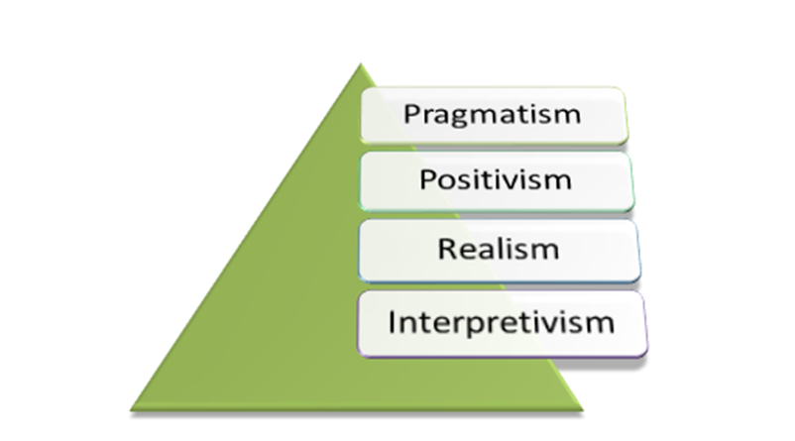

Figure 3.2: The representation of different research philosophies
(Source: Junjie and Yingxin, 2022)
Interpretivism philosophy has been selected in this research. This philosophy has helped the researcher together with a rich understanding of social media marketing in the UK and fashion industries across other countries as well. The philosophy is also very flexible as it can include interviews and observations as well as qualitative analysis. It also handles a very evolving nature of systematic understanding of the research. This philosophy also focuses on a human-centric approach which is another reason for this selection. It has enhanced the experience of empathy and has also provided a holistic understanding of the social realities of social media marketing in UK fashion organisations (Junjie and Yingxin, 2022). The complex phenomena of this philosophy have assisted the researcher in capturing the cultural aspects of the UK. Contextual validity is also another reason for this selection. The researcher has been able to provide a holistic perspective of the fashion organisations in the UK and their social media marketing strategies. It has also guided the researcher to follow the qualitative data. The ethical consideration is also very easy to maintain in this philosophy.

3.4 The Approach of the Investigation
The research approach is the strategy of contributing to the overall strategy plan of the research. It addresses the research questions and hypothesis for reaching the collaborative research design and border perspective that can influence the data collection or analysis method. Appropriate selection of research approaches can help the researcher to understand the scientific evaluations of the research and can also help the company to enhance its efficiency and effectiveness of the study (Sibeoni et al., 2020). It is a well-structured research aspect for handling proper research questions. It also contributes to the actual understanding of the relevant findings and acute information. Appropriate selection of research approaches also helps to optimise the unnecessary limitations. The appropriate selection of research approach also helps to optimise the unnecessary complexity and limitation of the research. The overall coherence of the research can also be evaluated with the increasing likelihood of objective facilitation. There are three different types of research approaches available which are deductive, inductive and abductive.
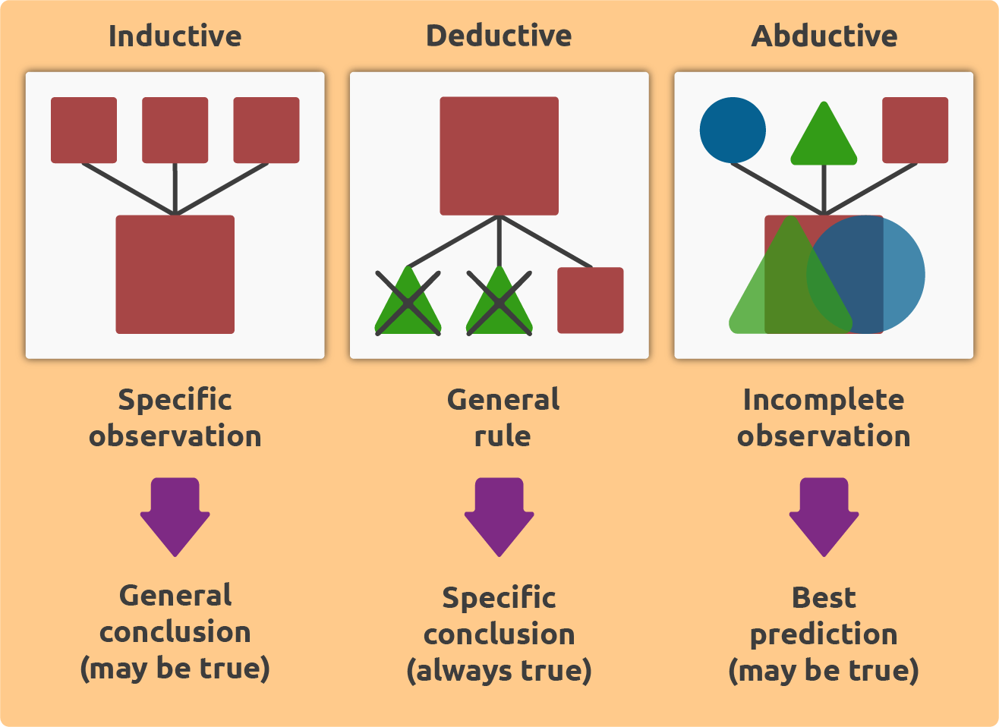

Figure 3.3: The representation of different Approaches to any Investigation
(Source: Eger and Hjerm, 2022)
An inductive research approach was selected in this study. The researcher has selected this approach based on its ability to explore and discover. The approach has assisted us to understand natural phenomena and to gain hypotheses with an open mind. This selection has provided a more flexible approach towards the research process and it has provided more accuracy and focus while selecting other research methods (Eger and Hjerm, 2022). It involves content analysis and also provides a more in-depth explanation of the social media marketing platforms in the UK fashion industry. The researcher has also selected the inductive approach due to its ability to theory generation. This has helped the researcher to explore the idea of research strategy and a proper holistic understanding of the social media marketing platforms in the retail fashion market in the UK. It has also provided a more contributively and quality richness of data. The real-world applicability of this data is also very high which another justification for this selection is.

3.5 Design of the Study
Research design contributes to the actual methodology which provides a blueprint or a systematic understanding of the process of any research. It starts with the evaluation of the research structure and the strategy of the study. The appropriate solution of the research design contributes to the actual framework development of data collection and its analysis; it also helps to interpret the data with appropriate research questions and objectives. The choice helps the researcher to influence the validity and reliability of the study (Sumartik et al., 2023). The selection of appropriate research design helps to identify the quality and validity of the research. It also promotes a more reliable field by understanding the unnecessary complexities of the research. It also handles the complexity and limitations of the research towards a coherence guide. The entire research process handles the ultimate understanding of the research outcome. It also floors the research outcomes with the robust contribution of the field to the study. There are a lot of research designs available. Experimental, descriptive, correlational, sequential, exploratory and explanatory types of research designs.
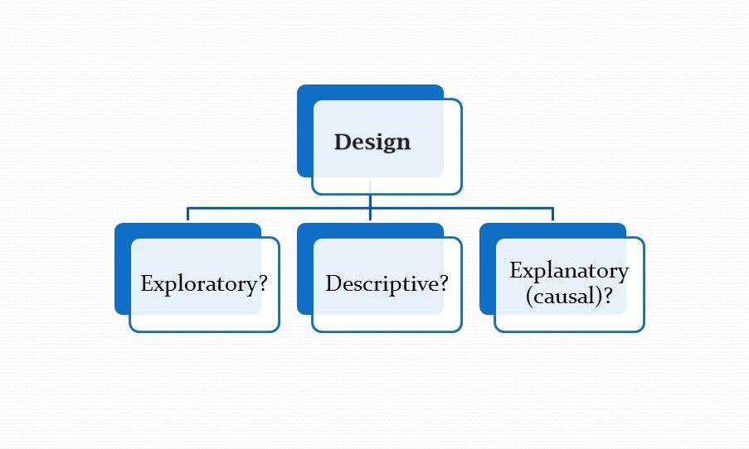

Figure 3.4: The representation of different Designs available in the Methodology
(Source: Othman et al., 2020)
An explanatory research design has been selected for this study. This research has followed this design due to its ability to explore cause-and-effect relationships between different variables. This election has helped the researcher to understand the reason for certain phenomena and also established the relationship of different variables. It has been selected due to its clarification and exploration of relationships. It has also helped the researcher in exploring different phases of the research (Othman et al., 2020). It has also provided more enhanced and predictive power by evaluating the relationship between social media marketing and consumer buying behaviour. This design has also helped the researcher to empirically test different hypotheses of the research and provide a more controlled experimental outcome. It has also helped the organisation to develop different theories. The researcher has been able to understand the strategic and generalised data through this design.

3.6 Strategy Selected for the Study
The research strategy provides a complete overview of the research based on the achieved objective. The strategies help the research to involve a lot of decision-making initiatives and understand a collective evaluation of data interpretation. It has also explored a lot of common valuation of the research based on its strategic guidance. Proper strategies help different researchers to evaluate research questions and a common understanding of research data collection initiatives. Proper selection of research strategy helps the research to align with the study topic. It also helps in evaluating the meaningful and inside full information about data collection and analysis (Charmaz and Thornberg, 2021). The validity and quality of the research can also be maintained with appropriate strategy selection. It also allows the researchers to foster the targeted intervention of the study population. The data collection also becomes enhanced with precision and coherence through appropriate strategy selection. There are a lot of strategies identified in any methodology which involves case study, experimental, ethnography, action research, service strategy or grounded theory strategy.
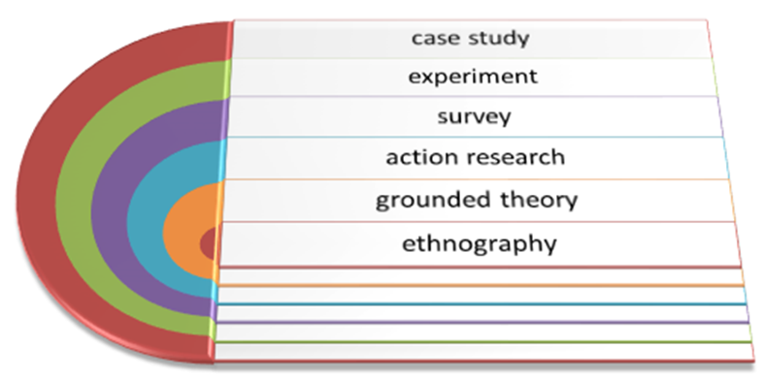

Figure 3.5: The representation of different Strategies available in the Methodology
(Source: Charmaz and Thornberg, 2021)
A grounded theory research strategy has been selected in this research. This strategy has helped the researcher to develop theory and grounded elements which are directly linked with social media marketing and consumer buying behaviour. The research has selected this strategy based on its flexibility in data collection and analysis. This has also allowed the researcher to choose interactive research processes. The contextual understanding also provides a more seeming and contextual understanding of the participants (Holt et al., 2022). It has also provided a richness of data understanding with its subject under relevant exploitation. This strategy is also participant-centric which has evaluated its holistic exploration of data and practical application of generated theories. There is such a selection of this strategy due to its iterative processes as well. This has refined the validity of information about social media marketing in the UK fashion industry.

3.7 Data collection method
Data collection is the very primary step of any research which is going to be conducted. The collection of information is a must for any research to be continued. It is a fundamental and systematic process of collecting data and information about the research. The data collection and the acquisition of raw material and information also provide meaningful insights into data through its analysis (Canteloup et al., 2020). The controlled exploration of the data is also handled with utmost care. Data collection can be performed in two different ways. The collection of data also involves a lot of instruments and techniques. Appropriate selection of data collection measures enhances the validity and the data sources verification for any research. These two different data collection methods are primary data collection and secondary data collection techniques. In primary data collection, the data is generally collected from raw sources. It includes a lot of raw and direct participation sources for collecting data. This type of data collection involves a lot of direct participants and different techniques and tools. Human involvement is a must for this type of data collection. Generally, this kind of primary data is collected from surveys, interviews and experiments. On the other hand, secondary data is collected from the available sources. This kind of information is collected from the evidence and sources which are available on the internet or any other secondary content. Journal articles, authentic websites, books, government and industry reports, and company reports are generally known as the sources of secondary data (Nabella et al., 2023). This type of data does not involve direct human participation. Generally, secondary data are collected from sources which have been published before by other researchers or publishers. However, some of the secondary sources might not be accessible due to their paid nature.
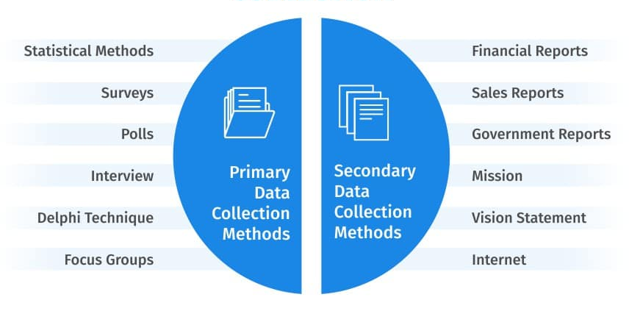

Figure 3.6: The representation of different Data collection methods in the Methodology
(Source: Ruggiano and Perry, 2019)
Secondary data collection has been followed in this research. The researcher has selected this technique for collecting authentic theoretical information about the social media marketing platforms in the UK and UK fashion industry. This method is a more time-efficient and cost-effective approach which is why there have been more social media marketing platforms in the UK and UK fashion industry. This method is a more time-efficient cost-effective approach which is why the researcher has learned more about data collection techniques. For this kind of large-scale study, secondary data collection is the most significant data collection technique. It also involves large data collection opportunities and requires expensive samples. The researcher has selected this technique with its historical analysis (Ruggiano and Perry, 2019). Most of the general articles are available in different online general databases. It also provides comparative research exploration. The access towards longitudinal studies has also in hands the quality of the research. The secondary data connection has also enhanced the opportunity to examine cross-cultural analysis. The resource accessibility has also demonstrated more insights into data collection measures. Google Scholar, ProQuest and ScienceDirect are used as online journal databases for collecting secondary information.

3.8 Process of data analysis
Data analysis is the exact immediate step after the collection of data. The objectives are generally achieved through the evaluation of data interpretation. Data can be analysed in two different methods. The qualitative analysis involves the analysis of descriptive information. Most of the descriptive theoretical and explorative discussions are generally analysed by using qualitative analysis (Campbell et al., 2021). It includes all the basic descriptions and concepts regarding social media marketing in the UK fashion industry. On the other hand, quantitative analysis involves the data analysis of numerical or statistical information.
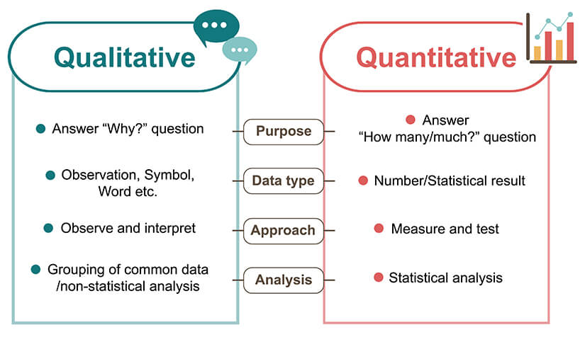

Figure 3.7: The representation of different data analysis techniques
(Source: Lester et al., 2020)
Qualitative analysis has been followed by the researcher. The researcher has selected this technique due to its ability to explore the impact of social media marketing on the fashion industry of the UK (Lester et al., 2020). All the theoretical explanations have been demonstrated through this analysis technique. Thematic interpretation technique has been used to execute the qualitative analysis.

3.9 Ethical consideration
All the ethics have been properly maintained throughout the completion of this research the secondary data has been gathered properly and also secured with proper authenticity. All the guidelines of the ethics committee have been maintained specifically for addressing the qualitative discussion. The data have only been used for academic purposes. Any secondary data has not been manipulated.

3.10 Research timeline
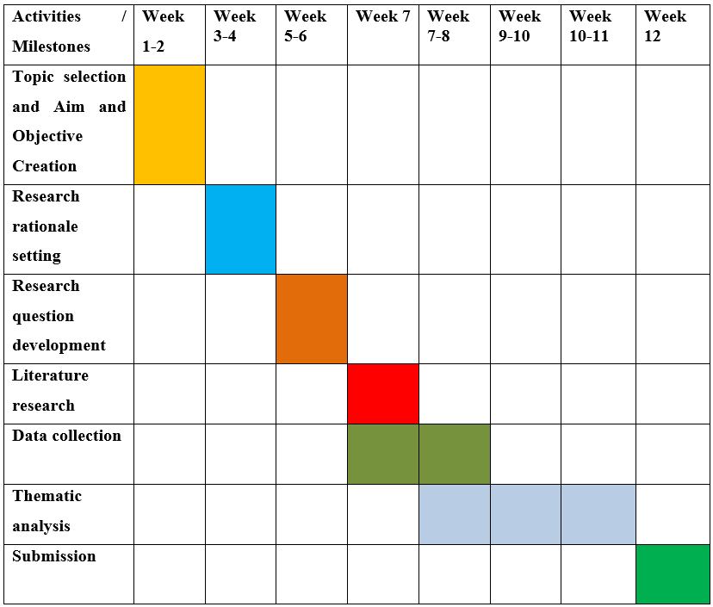

Figure 3.8: The representation of the research timeline
(Source: Created by Author)

3.11 Summary
Research methodology is all about different rules, steps, and ways of doing things. Interpretivism philosophy has provided an understanding of social phenomena and contextual insight into fashion organisations in the UK. The researcher has selected an inductive based on its affinity for contextual understanding. Different aspects of the fashion industry in the UK and its validation are also explained through the explanatory design. The grounded theory strategy has also provided more understanding of concept development and hypothesis creation. The evaluation of secondary data has also seen a lot of time for doing this research. Thematic analysis has also helped to perform the qualitative analysis.

Chapter 4: Results and Analysis

4.1 Introduction
In the present time, the competitiveness in the fashion sector of the UK is high. To stay competitive and sustain their position brands use omni-channels for marketing purposes. This part of the study discusses different themes. The developed themes are all related to consumer behaviour on social media platforms. Through the discussion, the impact of social media on consumer behaviour can be identified. The study will highlight the implications of social media platforms for luxury fashion brands. The challenges that luxury UK brands face while using these channels have been explored. Strategies that can help mitigate or deal with the identified challenges have been discussed. These strategies can assist UK luxury brands attract more customers.

4.2 Analysis of Secondary Data

Theme 1: “Social Media Marketing” or SMM influences the purchasing behaviour of the customers in the UK fashion industry
SMM has the capacity to influence the purchasing patterns of the customers in a specific industry of the UK that is, the fashion industry. Fashion organisations such as ASOS through the help of Instagram promote its fashion that is based on street style. According to the viewpoint of Voramontri and Klieb, (2019), there are some influencers within SMM, through which fashion organisations promote their goods. From this point of view, this fashion company promotes its products through Brooke Hewer who is an influence on social media. One of the advantageous parts is that SMM helps customers during the time of their complex purchases. Influencers in the channels create content on fashionable products that are trustworthy for the customers. On the other hand, it has been argued by Wibowo et al., (2020), that through the help of SMM, the fashion industry has been able to communicate with customers directly. During the time of directly communicating with the customers, it becomes possible for the organisations to know their preferences. In this respect, another fashion company which is UK-based Boohoo uses Snapchat along with Instagram for influencing the purchasing behaviour of the customers. In this respect, this organisation develops creative hashtags, and strong social content so that customers can be more attracted to the fashionable products of this business organisation.
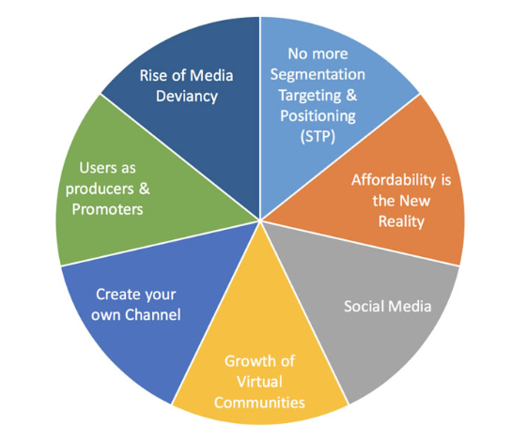

Figure 4.2.1: Different aspects of SMM
(Source: Ibrahim et al., 2020)
It has been argued by Ibrahim et al., (2020), that SMM helps to develop brand equity in fashion companies which ultimately changes the opinion of the customers regarding the brands. The time, when customers’ opinion of the fashion brand changes in a positive way, they intend to purchase more from that particular fashion organisation. In this way, the revenue of the fashion industry in the UK has been increasing day by day due to the effective utilization of SMM. SMM is that platform for the fashion industry in the UK which helps in acknowledging the purchasing intention of the customers. That is why, during the time of the COVID-19 pandemic, where physical distancing is everywhere customers have been attracted to fashion companies because of SMM as through it, companies connect with the customers easily. Another fashion company named Primark uses Facebook to mold the customers’ behaviour so that they can be attracted to fashionable products. Other than this, this organisation uses Instagram so that the customers can be well aware of how their outfit looks in the competitive market. This is the way, almost all of the fashion companies in the UK have the capacity to attract customers to their fashionable products.

Theme 2: “Social Media Marketing” or SMM greatly influences the UK fashion industry by giving priority to consumer preferences
Through the help of SMM, the fashion industry in the UK has been able to give priority to the preferences of the customers. It has been argued by Nash, (2019), that social media helps customers in their decision-making. On the other hand, customers get inspiration from this platform which is why “high-street fashion” has become more popular among the customers. The time when the fashion companies observe that the presence of customers has been increased, the authority intends to enhance website traffic. Moreover, through the help of this platform, the authority of fashion companies makes arrangements for the customers so that they can read reviews of the products on this platform. Almost all of the companies in the fashion industry of the UK such as Boohoo, Primark, and others help customers to read their reviews on the products in the platforms of social media. SMM is a kind of platform for the fashion industry where the authority wants to maintain transparency so that customers can be satisfied after reading the reviews on these platforms.
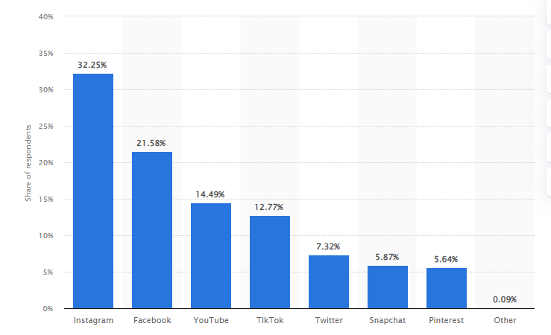

Figure 4.2.2: Use of Social Media in UK
(Source: Zhang et al., 2021)
To maintain transparency in this platform in the best possible way, the authority of the fashion industry intends to enhance product awareness through the help of this platform. If the customer faces any kind of problem regarding any fashionable product, then customers can report it through the help of Facebook or Instragram to the authority. During the time of analysis of the report of the customers, the authority of the fashionable companies can be aware of the preferences of the customers toward the fashionable items. Zhang et al., (2021), stated that in the UK customers have started to prefer sustainability for the fashion industry. That is why, companies such as Boohoo use that kind of polyester or cotton which are recycled. On the other hand, another fashion company in this country named Primary launched the “Sustainable Cotton Programme” so that sustainability can be maintained. However, customers’ preferences for fast fashion pose challenges for fashion companies in maintaining sustainability. That is why, fashion organisations try to maintain sustainability before launching their fast fashion in the competitive market. The authority of this industry has started to deeply analyse the behaviour of the customers by giving attention to their psychology, economics along with management. In this way, these companies try to maintain the preferences of the customers with the assistance of SMM.

Theme 3: Factors such as data analytics, and content within social media channels affect SMM in the fashion industry of the UK
There are different factors of SMM which have the capacity to affect the fashion industry of the UK. Among all these factors data analytics, and content within social media channels are the most important factors that have the capacity in the decision-making of the customers. It has been argued by Vinerean and Opreana, (2019), through the help of these factors, fashion organisations have the capacity to personalise communication with customers. Instagram is a kind of social media platform that promotes fashion brands which is specifically luxurious. Content within the platform has been developed in a way so that customers can be engaged with the luxurious brands for a longer period. On the other hand, the authority of the fashion company introduces influencers or celebrities on this platform so that the content of social media can be more attractive to the customers. Channels related to social media can show the journey of the customers, which helps to determine how they are purchasing a product, reviewing their products, and repurchasing the products. Fashion organisations in the UK that is why; have started to invest more in the content of social media. On the other hand, data analytics helps fashion companies to comprehend the interests of the customers, their choices for fashion products, and others. It has been argued by Salem and Salem, (2021), that data analytics help fashion organisations in increasing brand loyalty.
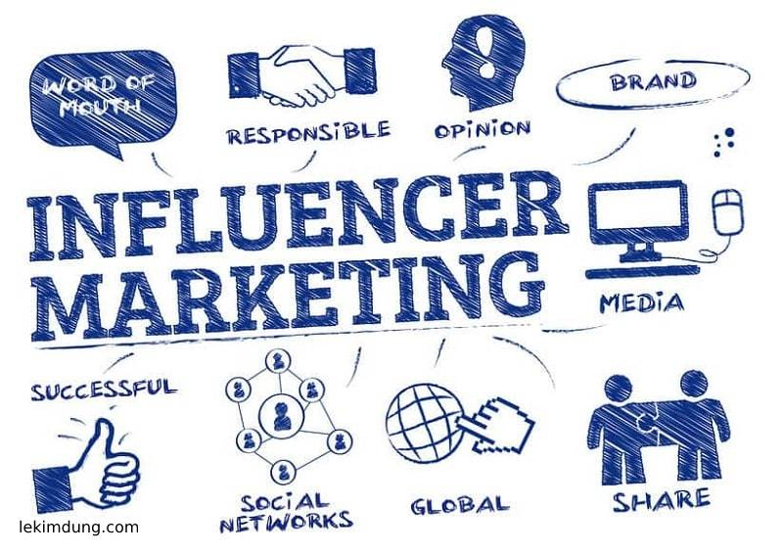

Figure 4.2.3: Role of Influencer marketing through Social Media
(Source: Djafarova and Bowes, 2021)
Through the help of data analytics, fashion companies help to create opportunities for customers that are based on real-time. Data analytics help in analysing the sales data which further helps in developing the upcoming marketing strategy. This is the way through which fashion organisations such as Boohoo and Primark have started to increase their optimal value. Using data analytics helps these companies to increase operational efficiency which ultimately helps in engaging customers for the maximum period. It has been expected that the revenue of this industry has been expected to grow by more than 3% by 2027 (Djafarova and Bowes, 2021). This has been possible because of giving importance to the content of social media and the utilisation of data analytics. On the contrary, fake information on the content of social media affects the purchasing intention of the customers. Fashion companies such as Boohoo have been reported in green washing in social media as they have started to follow unsustainable practices. This report of this company has generated a negative impact on the customers regarding their purchasing intention. Due to this report, an investigation has started to occur to identify whether the products of this business organisation are environmentally sustainable or not. To manage this situation, data analytics has been used so that the authority of this fashion company can show in the competitive market that they are not engaged in green washing instead their products are sustainable. This is a tool that helps the fashion industry visualise the upcoming marketing so that they can prepare their SMM in the best possible way.

Theme 4: Challenges such as big data analytics negatively impact the SMM in the UK fashion industry
Big data analytics introduce challenges for the SMM in the UK fashion industry. It has been argued by Silva et al., (2020), “big data analytics” introduce challenges in this respect, because of the lack of quality data. Due to the incorporation of this tool, data volume has not been maintained by the UK fashion industry which is why validation of the obtained data has not been maintained. On the other hand, due to the maintenance of accuracy within this tool, the authority of fashion companies needs to invest regularly which is somehow not possible. However, during the time of the application of “big data analytics” privacy concerns appear.
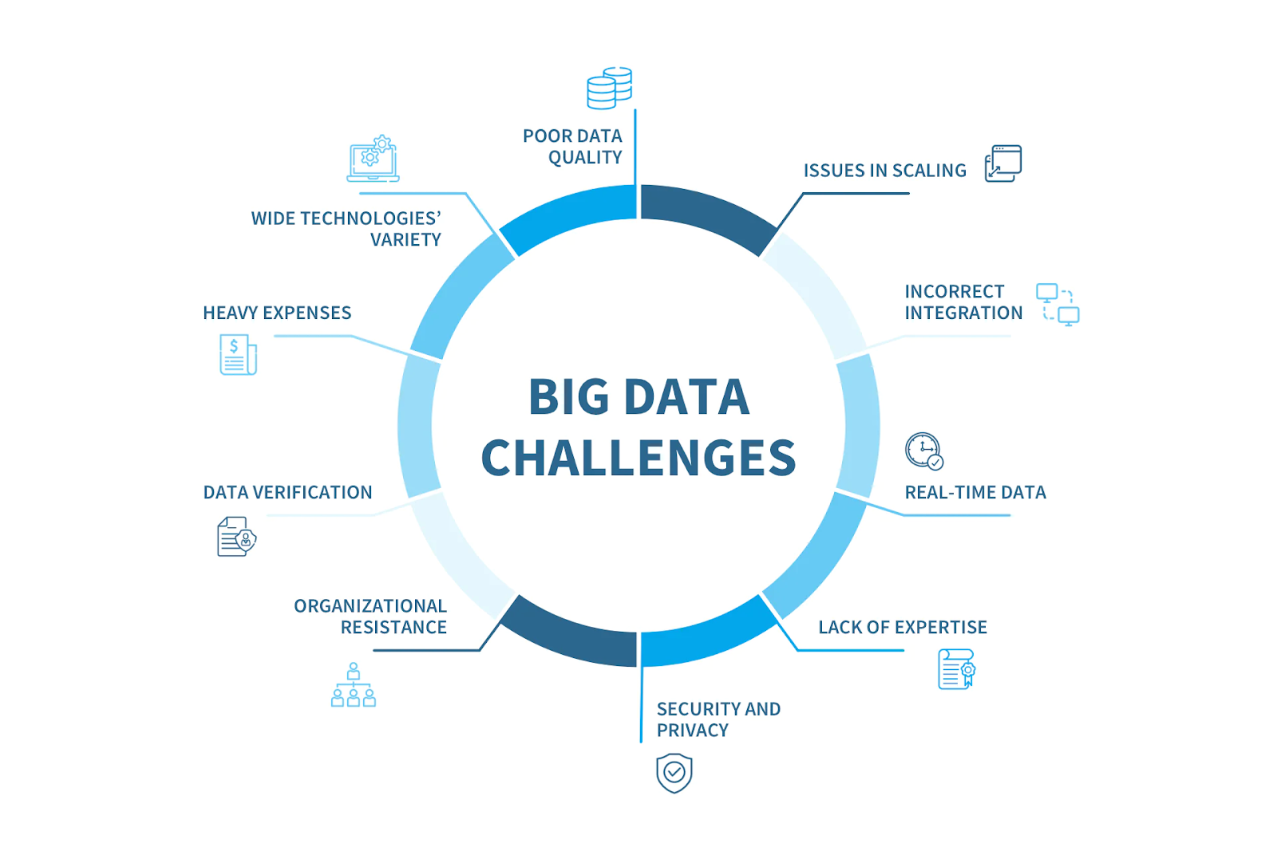

Figure 4.2.4: Challenges
(Source: Sharma and Jhamb, 2020)
That is why customer insights and preferences regarding fashionable products cannot be accessed properly. This kind of tool helps in forecasting trends in the fashion industry, however, because of privacy issues; the industry of this country has not been able to incorporate forecasting trends. That is why; the shifting patterns of the customers have not been recorded in the best possible way. Revenue of this industry has started to degrade due to inaccurate forecasting trends and not being able to identify the customers’ preferences in the changing period. It has been argued by Sharma and Jhamb, (2020), that more than 46% of users on social media believe all the content has been shared by the fashion companies in the social media accounts. This statistical data reflects the viewpoint that there is a relationship between the content of social media along with the customers’ trust. In this situation, where customers’ trust is linked to social media, the ineffective use of “big data analytics” has been initiated to break this trust. Because of the inclusion of this kind of tool, cyber-risks have emerged for which customers’ privacy has not been maintained. Cyberbullying is one of the issues that has been observed in the platforms of social media that target specific individuals by invoking harmful comments. Because of these kinds of comments, customers’ reliance on social media and their engagement with fashion companies have started to decrease. According to the opinion of Brewer, (2019), with the assistance of social media, fashion companies have been able to take virtually instantaneous activities. However, because of the challenge of this tool, the authority of fashion companies such as Primark, and Boohoo has not been able to take instantaneous activities and help the customers.

Theme 5: Rapid alteration of consumer buying behaviour negatively impacts the UK fashion industry
It has been observed that rapid alteration of consumer behaviour generates a negative impact on the UK fashion industry. Consumers now prefer to choose that kind of shopping which requires less time. That is why they now want to prefer online shopping instead of offline shopping. Using social media has become one of the ways to consumers in this country through which they can do their online shopping. Companies have been able to show their product catalogs through the help of their accounts which exist in social media. It has been argued by Saura, (2021), through the help of social networks, fashion companies are able to interact with their customers. However, due to less interaction with the customers, fashion companies are not able to comprehend the changes in the buying behaviour of the customers.
Recently, organisations such as Boohoo have not been able to give attention to customer preferences that are sustainability. However, it has been reported that the authority instead maintenance of sustainability, has started to pressurise suppliers so that they can use low-quality materials and the products can become unsustainable. According to the opinion of Salem and Salem, (2021), consumers’ reliance on online shopping has increased in the recent few years. That is why when third parties are involved in online shopping, they advertise the products through social media, and customers start to believe the comments of the third parties instead of the fashion companies. This kind of issue has been observed in Primark, where the authority claims that the customers need not buy products from third parties’ social media accounts due to higher prices. As this business organisation does not have an option for online shopping through social media, customers’ preferences for shopping through third parties have increased. Nowadays, customers have started to give priority to those fashionable products with whom they find emotional aspects. It has been argued by Vinerean and Opreana, (2019), that fashion companies have started to give more intention to increasing their competitive advantage. That is why they do not give value to the emotional responses to the customers as they are unable to respond to the changing behaviour of the customers. After the Covid-19 pandemic, customers’ preferences for online shopping have increased; however, one of the popular fashion companies in the UK named Primark does not want to go for online shopping. This business organisation has started to face huge losses after the Covid-19 pandemic; still, the authority does not want to go for online shopping or give shopping experiences to customers through social media. This is because, the authority claims that earlier the authority-initiated shopping through social media, however, higher returns were observed for which the efficiency of the organisations degraded (Djafarova and Bowes, 2021). On the other hand, customers in this country have started to give more priority to the products which are eco-friendly. However, business organisations such as Barbour are reported to produce the kind of fashion items that are responsible for climate change.
Theme 6: Influencer marketing strategy helps to overcome cultural restrictions
Businesses must navigate various cultural landscapes in today's globalised world. It is crucial to engage with their target clients effectively. Influencer marketing has emerged as a potent tactic for bridging cultural barriers and building deep customer relationships. This strategy transcends conventional marketing techniques by using influencers (Agustianet al., 2023). Influencers act as cultural ambassadors and close the gap between brands and a wide range of consumers.
Influencer marketing makes use of the reach and power of people. These people have amassed a sizable social media following. Influencers frequently possess a thorough awareness of the tastes, passions, and cultural quirks of their audience. Brands may overcome linguistic and cultural obstacles by tailoring their content to resonate with potential customer base. Influencers from different cultural backgrounds act as bridges that help brands connect with diverse customers.
It has been found that influencer marketing can provide reliability and authenticity. It is one of its main advantages in getting beyond cultural barriers (Campbel and Farrell, 2020). Influencers establish a personal connection with their audience using social media. This connection enables them to do effective market products and services effectively. When an influencer recommends a good or service, people tend to view it. The viewers view it as a sincere suggestion rather than a marketing ploy. To effectively negotiate cultural sensitivities, influencers must be honest in expressing brand messaging. The message must be conveyed in a way that is consistent with the principles and the audience’s opinions.
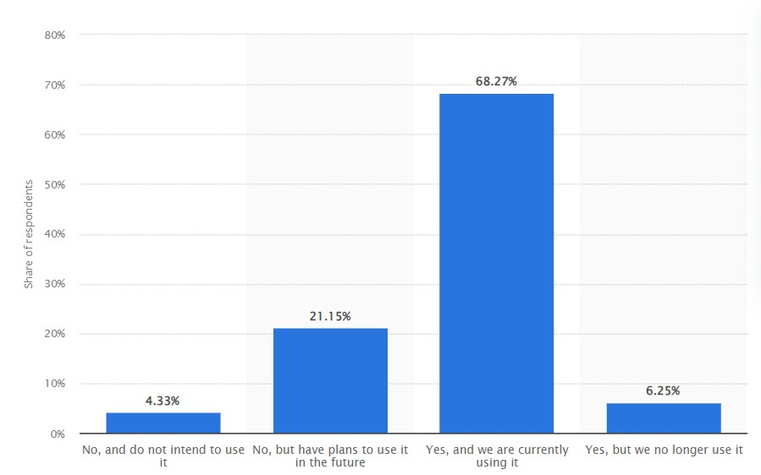

Figure 4.2.5: Use of influencer marketing in UK luxury brands
(Source: Statista.com., 2022)
According to the data, 68.27% of brands presently use influencer marketing and 21.15% intend to do so soon. On the other hand, 6.25% of firms say they no longer use influencer marketing. Only 4.33% say they do not intend to use this approach (Statista.com, 2022). Influencers also serve as cultural bridges, assisting brands in understanding the nuances of a specific audience's culture. They are aware of the taboos, societal standards, and preferences. Through this knowledge, they help brands avoid things that could affect how marketing communications are received. This information enables firms to adjust their content in a way that is sensitive to cultural differences. As a result, enables avoiding mistakes that can cause misunderstandings or alienation.
Influencer marketing offers a customised touch in diversified marketplaces. Well-known and valued influencers having an impact on viewers' lifestyles can assist brands market better. Marketing campaigns become more effective and appealing to the target audience when they are strategically aligned. In the fashion, beauty, and lifestyle industries, influencers play a particularly important role. Influencers help in breaking down barriers based on culture (Richards-Carpenter and Tafoya, 2021). These industries mainly depend on aesthetic choices and cultural quirks. Therefore, companies must appeal to a wide range of consumer preferences. Through strategic partnerships brands assimilate into these communities and promote a sense of inclusivity and acceptance.

4.4 Discussion
Fashion companies such as Boohoo have started to use influencers in social media so that customers’ reliance on this brand can be enhanced. According to the viewpoint of Wibowo et al., (2020), with the help of social media, fashion companies have been able to directly communicate with customers. In this way, these organisations become well aware of the preferences of the customers such as customers now preferring sustainability. By maintaining sustainability these organisations have become able to enhance their brand equity in the competitive market. Knowledge of the purchasing intentions of customers becomes easier to grab because of the presence of social media (Shakarbekovna, 2021). That is why, during the time of the COVID-19 pandemic, fashion organisations such as Boohoo, Primark, and others have been able to increase their revenue by knowing customers’ preferences through social media.
It is indeed true that the content within social media helps in increasing the reliance of the customers. It is possible because of the content there is transparency within the content of social media (Shin and Lee 2021). However, green washing is a major issue that has been faced by Boohoo and this news has been spread across social media which generates a negative impact on the reputation of this company (Zhang et al., 2021). The discussion sheds light on the critical aspects of thematic analysis in light of research objectives. This ensures the factors of social media marketing, which mostly focus on factors such as content, data analytics, and social media marketing strategy. This is related to theme 3 of the analysis as fashion enterprises can personalise communication with customers. According to Salem and Salem, (2021), Instagram is a type of social media platform that promotes style brands that are in particular pricey. This showcases objective 2 of the study as the impacts of social media marketing on consumer behaviour rely on the content inside the platform that has been advanced in a way so that clients may be engaged with the highly-priced brands for a longer length. On the other hand, Voramontri and Klieb (2019) argue that the authority of the fashion corporation introduces influencers or celebrities on this platform so that the content of social media can be more attractive to the customers. On the other hand, the discussion focuses on theme 4 of the analysis when it identifies crucial challenges faced by social media marketing in the UK fashion industry. This reports issues of Big data analytics while considering the need for generating revenue for the fashion industry. As reported by Silva et al., (2020), big data analytics” poses a threat in this admire, due to the dearth of quality data. Due to the incorporation of this tool, information quantity has now not been maintained via the UK fashion enterprise which is why validation of the obtained facts has no longer been maintained (Sharma and Jhamb, 2020). On the other hand, this thematic analysis entails objective 4 of the study as it identifies challenges of social media marketing in the UK fashion industry due to the maintenance of accuracy in big data analytics tools. However, UK fashion agencies wish to make investments frequently that are no longer feasible to the industry standard. Theme 5, on the other hand, focuses on the rapid alteration of consumer buying behaviour across the UK fashion industry. This, however, shows negative impacts on the industry. This relates to objective 4 of the study as it poses threats to social media marketing. Due to the rapid consumer buying approach, Sharma and Jhamb (2020) make sure that cyber-risks have emerged for which clients’ privacy has no longer been maintained. This report that cyber bullying is one of the issues that has been located in the platforms of social media that concentrates on unique individuals with the aid of invoking harmful remarks. The study emphasises how important influencer marketing is to help businesses in today's globalised market. It has been found that influencers help brands overcome cultural barriers. Influencers that have large social media followings are viewed as cultural emissaries. They assist brands connect to wide consumer demographics. Unlike traditional marketing, this strategy enables firms to overcome linguistic and cultural barriers. This approach helps by creating content that speaks to target consumers (Zhou et al., 2021). Effective marketing for goods and services is influenced by influencers' connections with their followers. These connections are based on their authenticity and dependability.
It has been found that influencer marketing is widely used by luxury brands in the UK. About 68.27% of them are now using it and 21.15% plan to use it. Influencers play more than just marketing. The influencers have an awareness of taboos, cultural quirks, and social norms which makes them valuable. This knowledge is used by brands to overcome the challenges related to cultural differences. Influencers become important agents of change in sectors like fashion, beauty, and leisure. In these sectors aesthetic decisions and cultural peculiarities are deeply felt (Agustianet al., 2023). Forming strategic alliances improves the marketing efficiency of the brands fostering acceptance and inclusity.

4.5 Summary
The study demonstrates the significant influence of SMM. It has been found that it significantly influences the UK fashion sector in several ways. Influencers are essential in promoting products and influencing consumer views. They also help brands use SMM as a dynamic tool. These tools are utilised for customer involvement, brand promotion, and transparency. The industry accepts social media as a medium for preference analysis and customer feedback. In addition, it is also used for marketing purposes. There are challenges, such as big data analytics and quick changes in consumer behaviour. It is a challenge that can have a significant impact on business operations. The study also emphasises how important influencer marketing is for breaking down barriers based on culture. It has been found that it helps brands create genuine connections, and advance diversity. The evolution of the UK fashion business may be attributed to its holistic approach. The sector is adjusting to sustainability trends and proactive responses to the ever-changing demands of consumers.

Chapter 5: Conclusion and Recommendation

5.1 Conclusion
The study concludes the critical aspects of the effects of social media marketing on consumer behaviour in terms of the UK fashion industry. This relates to the concepts of the use of social media structures and websites to promote any products or services for sale. As discussed in the study, social media marketing has been used to seize the eye of the target purchaser market to control their buying behaviour. Therefore, unique famous social media structures have been used to immediately interact with customers to build an emblem, increase income, and power internet site traffic. Social media marketing has been also taken into consideration as virtual marketing or e-advertising and marketing. However, enterprise enterprises have built effective social networks and share facts with consumers directly.
Moreover, the findings from the study reveal the projection of social media marketing to support the establishments to interact with the present customers and appeal to new consumers concurrently. However, engaging with consumers is considered a major responsibility of UK fashion enterprises to sustain their position in the market. In addition, the study has revealed that the digital approach in marketing turns out to be as effective as attracting more consumers while considering Gen Z. The UK fashion industry, being the 5th largest industry in the world, experiences a great deal of presence of Gen Z who are found to have spent time on social media.

5.2 Linking with Objectives
The first objective is associated with the influence of social media marketing on consumer behaviour. This underlies the crucial aspects of social media marketing in light of addressing consumer purchasing behaviour. It is encountered in the research earlier that social media structures have an essential position in influencing the acquisition behaviour of consumers in the present-day market. Nevertheless, via diverse social media systems, potential clients can also distinctly check the emblem, thinking about factors inclusive of service or product specifications and the extent of consumer engagement (Palalic et al., 2021). Therefore, those broadly used digital platforms have had a huge effect on customers’ advertising experiences and have also accelerated their religion inside the emblem name. Moreover, this objective of the study delves into the usage of social media, and corporate corporations from any zone that may effectively promote their services or products to their meant target market. Hence, SMM or social media advertising is used to exactly showcase the offerings of agencies.
In converse, the impacts of social media marketing on consumer purchasing behaviour have paved the way for the UK fashion industry. As reported by Nash (2019) in the research earlier, the ultimate effects of social media marketing have been identified by the distinct behaviour of consumers together with their intention for loyalty expression, participation, and purchase. This is related to objective 2 of the study which addresses the sustainability of the fast fashion industry in terms of the effects of social media marketing on customer purchase behaviour. The fast fashion shops have also enjoyed the benefits of SMM. However, Shin and Lee (2021) state that with the help of SMM, speedy fashion businesses which include ASOS, Mango, Primark, ZARA, Boohoo, and others can now distinguish purchasers’ gender, age as well as their alternatives, and fashion tastes. However, it is reported that the opinion leaders who have been considered fashion influencers offer positive opinions approximately gifts and future fashion trends with the assistance of different social media platforms.
In converse, the third objective entails challenges associated with social media marketing in the UK fashion industry while considering the negative impacts of social media marketing on consumer behaviour. As reported in the research earlier, the occurrence of fashion advertising records on social media possibly inundates customers and results in perplexity or weariness. This potentially diminishes the extent of involvement and self-assurance. However, as per the view of Goworek et al., (2020), the convenience of creating impulsive purchases through shoppable postings and the continuous merchandising of the latest products fosters excessive spending and promotes unsustainable intake behaviour. Further, the speedy dissemination of social traits engenders societal pressure to stick to positive appearances. This additionally diminishes specialty and fosters rampant intake (Silva et al., 2020). Moreover, the monitoring necessary for particular, customized marketing gives rise to apprehensions around data ethics and violations of privacy. It is also reported that consumers can also get a sense of being taken advantage of in place of being actively involved. The proliferation of content on social media necessitates fashion marketing messaging to influence attention.
The fourth objective deals with relevant mitigation strategies for improving social media marketing to attract more consumers. The adoption of the right social media platform has been considered the principal effective factor for social media advertising inside the UK-style enterprise. Instagram has been considered the maximum helpful platform to sell any fashion emblem inside the UK. However, as reported by Brewer, (2019) earlier, exceptional social media systems have brought about exclusive sorts of modern techniques to enhance the social media presence of marketers. It is also reported that the right content material method has been considered one of the maximum commonplace elements of all which has affected social media advertising. However, the advertising approach has been primarily based on analyzing the behaviour and perception of capacity clients with the assistance of the social media matrix.

5.3 Future scope of this study
The rapid evolution of social media and fashion marketing makes this study very promising for future investigation. This has the potential to perform extensive qualitative research by conducting interviews and ethnographic studies to get comprehensive insights into how consumers engage with and react to social media fashion marketing. This enables the observation of real behaviour, beyond the reliance on self-reported statistics (Dwivedi et al., 2021). However, the future scope of the study could be able to analyse the distinct purchasing features of social media platforms such as TikTok and Instagram that are influencing the buying behaviours of young customers.
With the emergence of new platforms and features, it is necessary to do updated research. On the other hand, this has the ability to analyse the variations in how different generations react to fashion marketing on social media by utilizing samples from many generations (Rienda et al., 2021). This may illustrate the need for adapting techniques to cater to distinct demographics such as Baby Boomers, Gen X, and Gen Z. However, the study can examine social media material and narratives by using language analysis and semiotics to uncover the fundamental mechanics of impact.

5.4 Limitation
The study is limited to the reliability of self-suggested records on social media utilization and style buying is compromised by factors such as selective recall, social desirability bias, and the anomaly around phrases like “influence”. This calls for additional naturalistic observations while dynamic shifts in consumer behaviours, emerging social media platforms, and growing algorithms contribute to the limited lifespan of research (Rienda et al., 2021). Continual studies are important to hold updated information. It is hard to separate the impact of social media advertising on client behaviour from different cultural and economic considerations. Moreover, the study lacks the collection of primary data as it relies on the analysis of quantitative data based on individual responses.
However, accurately and precisely measuring the publicity and impact of social media throughout many systems poses methodological demanding situations. The immoderate dependence on correlation records hinders the capability to establish causal approaches. Supplementing qualitative research may enhance the validity of causal factors. In addition, Convenience samples, such as college students do not accurately reflect larger consumer groupings as it lacks primary data. Moreover, the study has been limited to time while it faces time management issues. This, however, reports a lack of issues related to the analysis of the study.

5.5 Recommendation
It is miles necessary to use a wide variety of research methods, including diverse demographics, and utilize computational analysis to observe the impact of social media on patron behaviour inside the ever-converting style sector. An all-encompassing, rigorous, and technologically advanced method might also beautify our know-how of this commercially sizable phenomenon, each in theory and exercise.
- Adopt a mixed methods approach
The tricky interplay between social media marketing and fashion consumption necessitates the usage of many research strategies. From this perspective, surveys offer sizable quantitative statistics on traits on a huge scale. Interviews and attention agencies can also look into consumer psychology and extract narratives (Patten et al., 2020). However, the ethnographic commentary provides proper insights into real-life social media use and consumer behaviour. An amalgamation of quantitative information on patterns, coupled with qualitative insights into subjective meanings and occasions, yields a holistic point of view. It is reported that employing many techniques mitigates the constraints of a single approach.
- Conduct comparative cross-cultural studies
It is recommended to conduct comparative cross-cultural studies on social media marketing as the majority of observations are focused on adolescent and women clients. To have a comprehensive comprehension, it is important to juxtapose age cohorts together with Baby Boomers, Generation X, and Generation Z. Additionally, past-cultural research ought to take a look at the methods wherein geographical and socioeconomic variables modulate the effect (Lee and Lee, 2020). Effective style advertising in the UK would not have an identical impact while used on an international scale.
- Use technology to analyse social media content
Comprehending the underlying principles of social media algorithms is important for style entrepreneurs because these algorithms decide the visibility of their fabric. However, it is recommended to conduct audits and reverse engineering as they may additionally provide valuable insights into those algorithms (Mason et al., 2021). The software can analyse massive amounts of consumer-generated information by using photo recognition, natural language processing, and fact-mining strategies to become aware of patterns and get valuable insights.

References
Agustian, K., Hidayat, R., Zen, A., Sekarini, R.A. and Malik, A.J., (2023). The Influence of Influencer Marketing in Increasing Brand Awareness and Sales for SMEs. Technology and Society Perspectives (TACIT), 1(2), pp.68-78.
Ajzen, I., (2020). The theory of planned behaviour: Frequently asked questions. Human Behaviour and Emerging Technologies, 2(4), pp.314-324.
Akter, S., Ashrafi, T. and Waligo, V., ss(2021). Changes in consumer purchasing behaviour due to COVID-19 pandemic. Journal of Marketing and Consumer Research, 77, pp.33-46.
Alharahsheh, H.H. and Pius, A., (2020). A review of key paradigms: Positivism VS interpretivism. Global Academic Journal of Humanities and Social Sciences, 2(3), pp.39-43.
Boada-Collado, P. and Martínez-de-Albéniz, V., (2020). Estimating and optimizing the impact of inventory on consumer choices in a fashion retail setting. Manufacturing & service operations management, 22(3), pp.582-597.
Brewer, M.K., (2019). Slow fashion in a fast fashion world: Promoting sustainability and responsibility. Laws, 8(4), p.24.
Campbell, C. and Farrell, J.R., (2020). More than meets the eye: The functional components underlying influencer marketing. Business horizons, 63(4), pp.469-479.
Campbell, K.A., Orr, E., Durepos, P., Nguyen, L., Li, L., Whitmore, C., Gehrke, P., Graham, L. and Jack, S.M., (2021). Reflexive thematic analysis for applied qualitative health research. The Qualitative Report, 26(6), pp.2011-2028.
Canteloup, C., Puga‐Gonzalez, I., Sueur, C. and van de Waal, E., (2020). The effects of data collection and observation methods on uncertainty of social networks in wild primates. American journal of primatology, 82(7), p.e23137.
Castillo‐Abdul, B., Pérez‐Escoda, A. and Núñez‐Barriopedro, E., (2022). Promoting social media engagement via branded content communication: A fashion brands study on Instagram.
Charmaz, K. and Thornberg, R., (2021). The pursuit of quality in grounded theory. Qualitative research in psychology, 18(3), pp.305-327.
Creevey, D., Coughlan, J. and O'Connor, C., (2022). Social media and luxury: A systematic literature review. International Journal of Management Reviews, 24(1), pp.99-129.
Djafarova, E. and Bowes, T., (2021). ‘Instagram made Me buy it’: Generation Z impulse purchases in fashion industry. Journal of retailing and consumer services, 59, p.102345.
Drummond, C., O'Toole, T. and McGrath, H., (2020). Digital engagement strategies and tactics in social media marketing. European Journal of Marketing, 54(6), pp.1247-1280.
Dwivedi, Y.K., Ismagilova, E., Hughes, D.L., Carlson, J., Filieri, R., Jacobson, J., Jain, V., Karjaluoto, H., Kefi, H., Krishen, A.S. and Kumar, V., (2021). Setting the future of digital and social media marketing research: Perspectives and research propositions. International Journal of Information Management, 59, p.102168.
Eger, M.A. and Hjerm, M., (2022). Identifying varieties of nationalism: A critique of a purely inductive approach. Nations and Nationalism, 28(1), pp.341-352.
Fixsen, A., Kossewska, M. and Bardey, A., (2023). I’m Skinny, I’m Worth More: Fashion Models’ Experiences of Aesthetic Labor and Its Impact on Body Image and Eating Behaviors. Qualitative Health Research, 33(1-2), pp.81-91.
Goworek, H., Oxborrow, L., Claxton, S., McLaren, A., Cooper, T. and Hill, H., (2020). Managing sustainability in the fashion business: Challenges in product development for clothing longevity in the UK. Journal of Business Research, 117, pp.629-641.
Hayward, S.J., van Lopik, K., Hinde, C. and West, A.A., (2022). A survey of indoor location technologies, techniques and applications in industry. Internet of Things, p.100608.
Holt, N.L., Pankow, K., Ormond, I., Jørgensen, H., Deal, C.J. and Pynn, S.R., (2022). Grounded theory. International Review of Sport and Exercise Psychology, 15(1), pp.199-225.
Hosain, M.S. and Mamun, A.M.A., (2023). Facebook-based social media marketing and Facebook-based online purchases: evidence from the Facebook page admins of selected South Asian fashion retailers. Journal of Electronic Business & Digital Economics, 2(2), pp.191-212.
Ibrahim, B., Aljarah, A. and Ababneh, B., (2020). Do social media marketing activities enhance consumer perception of brands? A meta-analytic examination. Journal of Promotion Management, 26(4), pp.544-568.
Junjie, M. and Yingxin, M., (2022). The Discussions of Positivism and Interpretivism. Online Submission, 4(1), pp.10-14.
Lagun, C.S., (2022). Sustainable or greenwash? An analysis of how fast fashion brands use social media marketing (Doctoral dissertation).
Lee, A. and Lee, J.H., (2020). A Qualitative Study on Consumer Complaint Behaviour Based on Cross Cultural Differences-Focusing on the Formation Process of Complaint Behaviour by Korea and British Millennial Consumers. Fashion & Textile Research Journal, 22(3), pp.335-348.
Lester, J.N., Cho, Y. and Lochmiller, C.R., (2020). Learning to do qualitative data analysis: A starting point. Human resource development review, 19(1), pp.94-106.
Li, Q., Wen, Z., Wu, Z., Hu, S., Wang, N., Li, Y., Liu, X. and He, B., (2021). A survey on federated learning systems: Vision, hype and reality for data privacy and protection. IEEE Transactions on Knowledge and Data Engineering.
Mason, A.N., Narcum, J. and Mason, K., (2021). Social media marketing gains importance after Covid-19. Cogent Business & Management, 8(1), p.1870797.
Mohr, I., Fuxman, L. and Mahmoud, A.B., (2022). A triple-trickle theory for sustainable fashion adoption: the rise of a luxury trend. Journal of Fashion Marketing and Management: An International Journal, 26(4), pp.640-660.
Nabella, S.D., Rivaldo, Y., Sumardin, S., Kurniawan, R. and Sabri, S., (2023). the Effect of Financing on Islamic Banking Assets With Non-Performing Finance As a Moderating Variable in Indonesia. Jurnal Ekonomi, 12(01), pp.998-1004.
Nash, J., (2019). Exploring how social media platforms influence fashion consumer decisions in the UK retail sector. Journal of Fashion Marketing and Management: An International Journal, 23(1), pp.82-103.
Newman, M. and Gough, D., (2020). Systematic reviews in educational research: Methodology, perspectives and application. Systematic reviews in educational research: Methodology, perspectives and application, pp.3-22.
Noris, A., Nobile, T.H., Kalbaska, N. and Cantoni, L., (2021). Digital fashion: A systematic literature review. A perspective on marketing and communication. Journal of Global Fashion Marketing, 12(1), pp.32-46.
Ortiz-Ospina, E. and Roser, M., (2023). The rise of social media. Our world in data.
Othman, S., Steen, M. and Fleet, J., (2020). A sequential explanatory mixed methods study design: An example of how to integrate data in a midwifery research project. Journal of Nursing Education and Practice, 11(2), pp.75-89.
Palalic, R., Ramadani, V., Mariam Gilani, S., Gërguri-Rashiti, S. and Dana, L.P., (2021). Social media and consumer buying behaviour decision: what entrepreneurs should know?. Management Decision, 59(6), pp.1249-1270.
Patten, E., Ozuem, W., Howell, K. and Lancaster, G., (2020). Minding the competition: The drivers for multichannel service quality in fashion retailing. Journal of Retailing and Consumer Services, 53, p.101974.
Ralph-Nearman, C., Yeh, H.W., Khalsa, S.S., Feusner, J.D. and Filik, R., (2020). What is the relationship between body mass index and eating disorder symptomatology in professional female fashion models?. Psychiatry research, 293, p.113358.
Richards-Carpenter, N.N. and Tafoya, K., (2021). The unexpected players in branding and advertising: Advertising shakeout, traditional folk media, and influencer marketing. In Sustainable Branding: Ethical, Social, and Environmental Cases and Perspectives (pp. 274-290). Routledge.
Rienda, L., Ruiz-Fernandez, L. and Carey, L., (2021). Analysing trademark and social media in the fashion industry: tools that impact performance and internationalization for SMEs. Journal of Fashion Marketing and Management: An International Journal, 25(1), pp.117-132.
Ruggiano, N. and Perry, T.E., (2019). Conducting secondary analysis of qualitative data: Should we, can we, and how?. Qualitative Social Work, 18(1), pp.81-97.
Salem, S.F. and Salem, S.O., (2021). Effects of social media marketing and selected marketing constructs on stages of brand loyalty. Global Business Review, 22(3), pp.650-673.
Saura, J.R., (2021). Using data sciences in digital marketing: Framework, methods, and performance metrics. Journal of Innovation & Knowledge, 6(2), pp.92-102.
Shakarbekovna, N.S., (2021). SMM promotion as an effective tool of Internet marketing. European science, (4 (60)), pp.20-23.
Sharma, A. and Jhamb, D., (2020). Changing consumer behaviours towards online shopping-an impact of Covid 19. Academy of Marketing Studies Journal, 24(3), pp.1-10.
Shi, M. and Lewis, V.D., (2020). Using artificial intelligence to analyze fashion trends. arXiv preprint arXiv:2005.00986.
Shin, E. and Lee, J.E., (2021). What makes consumers purchase apparel products through social shopping services that social media fashion influencers have worn?. Journal of Business Research, 132, pp.416-428.
Sibeoni, J., Verneuil, L., Manolios, E. and Révah-Levy, A., (2020). A specific method for qualitative medical research: the IPSE (Inductive Process to analyze the Structure of lived Experience) approach. BMC Medical Research Methodology, 20(1), pp.1-21.
Sikrant, P., (2020, July). Impact of social media marketing on customer relationships and subsequent purchase: A case study of high fashion retail. In Proceedings of the 7th European Conference on Social Media, ECSM 2020 (pp. 271-279).
Silva, E.S., Hassani, H. and Madsen, D.Ø., (2020). Big Data in fashion: transforming the retail sector. Journal of Business Strategy, 41(4), pp.21-27.
Statista.com, (2024). Most popular social media platforms among fashion and lifestyle buyers in the United Kingdom as of spring 2022. Available at https://www.statista.com/statistics/1321178/social-media-platform-use-fashion-lifestyle-buyers-uk/. [accessed on 25-1-2024]
Statista.com., (2022). Use of influencer marketing among business-to-consumer (B2C) marketers in the United Kingdom as of spring 2022. Available at: https://www.statista.com/statistics/1319781/influencer-marketing-use-uk/ [Accessed on: 25.01.2024]
Sumartik, S., Yani, M., Hanum, G.R., Putri, D.A. and Maulidiyah, N.L., (2023). Explanatory Research Knowledge Sharing and Knowledge heterogeneity on Higher Education Business performance through Learning Value Sharing. Academia Open, 8(2), pp.10-21070.
Valaskova, K., Durana, P. and Adamko, P., (2021). Changes in consumers’ purchase patterns as a consequence of the COVID-19 pandemic. Mathematics, 9(15), p.1788.
Vinerean, S. and Opreana, A., (2019). Social media marketing efforts of luxury brands on Instagram. Expert Journal of Marketing, 7(2).
Voramontri, D. and Klieb, L., (2019). Impact of social media on consumer behaviour. International Journal of Information and Decision Sciences, 11(3), pp.209-233.
Wibowo, A., Chen, S.C., Wiangin, U., Ma, Y. and Ruangkanjanases, A., (2020). Customer behaviour as an outcome of social media marketing: The role of social media marketing activity and customer experience. Sustainability, 13(1), p.189.
Xia, S. and Liu, C., (2022). Applying Machine Learning to Study the Marketing Mix's Effectiveness in a Social Marketing Context: Fashion Brands' Twitter Activities in the Pandemic. International Journal of Business Analytics (IJBAN), 9(6), pp.1-17.
Zafar, A.U., Shen, J., Shahzad, M. and Islam, T., (2021). Relation of impulsive urges and sustainable purchase decisions in the personalized environment of social media. Sustainable Production and Consumption, 25, pp.591-603.
Zhang, B., Zhang, Y. and Zhou, P., (2021). Consumer attitude towards sustainability of fast fashion products in the UK. Sustainability, 13(4), p.1646.
Zhou, S., Blazquez, M., McCormick, H. and Barnes, L., (2021). How social media influencers’ narrative strategies benefit cultivating influencer marketing: Tackling issues of cultural barriers, commercialised content, and sponsorship disclosure. Journal of Business Research, 134, pp.122-142.
Zhou, Y., Li, H. and Sun, H., (2022). Metalloproteomics for biomedical research: methodology and applications. Annual Review of Biochemistry, 91, pp.449-473.

