

Programme Name: - Master of Business Administration
Module Name: - Human Capital Management
Module Code: - LCMB7023
Title: - Assessment Component 1: Individual Report
Assignment Title: - The Influence of National and International Labour Markets on HRM and IHRM Strategies
Lecturer’s Name: - Ejike Udeoug (Birmingham)
Student Name: - Abhi Shitalbhai Shah
Student Id: - 2511298
Submission Date: - 17th October 2025, Friday by 2pm

Table of content
Introduction 3
1. Technological Advancements and Their Implications for HRM and IHRM 4
1.1 Impact of Technological Change on Labour Markets 4
1.2 Implications for HRM and IHRM Strategies 5
1.3 Strategic and Theoretical Insights 5
1.4 Critical Evaluation and Summary 6
2. Demographic and Geopolitical Factors Influencing Employment Markets 6
2.1 Demographic Shifts and Workforce Dynamics 6
2.2 Geopolitical Forces and Labour Mobility 7
2.3 HR Challenges and IHRM Responses 7
3. Addressing Skills Gaps and Talent Shortages through Strategic HRM 9
3.1 Understanding the Skills Gap 9
3.2 Strategic HRM Tools and Solutions 9
3.3 Applying Theories and Models 9
4. Reflective Analysis on Capabilities for Global Workplaces 11
4.1 Framework and Purpose 11
4.2 Technology Competence 11
4.3 Self-Directed Learning 11
Conclusion 13
References 14

Introduction
The international labour market is experiencing deep change, being propelled by technological innovation, population changes and global instability. HRM and IHRM, in this environment, need to develop as strategic rather than administrative tasks. HRM is a term used for practices within the domestic context, and IHRM universalizes HRM concepts across borders with the inclusion of global integration and local responsiveness (Chung et al., 2024). Taylor & Francis Online
Technological disruption AI, big data analytics, cloud HR systems, and digital platforms has remapped the organisation, performance, and management of work. Scholars note that such technologies facilitate predictive workforce planning, increase talent insights, and improve HR processes (Bondarouk & Brewster, 2016). Taylor & Francis Online At the same time, the digital era requires HR functional boundaries to stretch to cover change management, data ethics, and digital upskilling (Zhang et al., 2023). PMC
At the same time, ageing populations in developed countries and youth bulges in developing countries are producing labour supply imbalances. Migration, tighter immigration policies, and geopolitical tensions complicate border mobility even further (Lina et al., 2018). Semantic Scholar+1 The "war for talent" rages on as companies worldwide compete for scarce skills, especially in the tech sectors (Stephany & Teutloff, 2022).
In light of these changing labour market forces, this report analyzes how the strategies of HRM and IHRM need to evolve across four axes: technology, demographics/geopolitics, skills shortages, and professional capability. It relies on theoretical frameworks like the Resource-Based View, Human Capital Theory, and socio-technical systems theory, alongside incorporating empirical case studies from international organisations. The objective is to emphasise how strategic HR can assist organisations in managing uncertainty, creating workforce resilience, and maintaining competitive advantage at national and global levels.

1. Technological Advancements and Their Implications for HRM and IHRM

1.1 Impact of Technological Change on Labour Markets
Technology innovation—specifically automation, AI and digital platforms—has shaken up traditional labour markets. As reported by the World Economic Forum (2023), 44 per cent of skills held by workers will be changed in the next five years. Automation displaces repetitive work but at the same time generates demand for high-order analytical and creative abilities. As an example, IBM's SkillsBuild initiative (IBM, 2024) illustrates the way in which global companies invest in digital reskilling to respond to these changes.
Online labour platforms like LinkedIn and Upwork have speeding up the gig economy, promoting labour flexibility but diminishing employment security (ILO, 2024). HRM practitioners are required to handle new types of work relationships including freelancers, contractors and hybrid workers. Further, AI-powered analytics has revolutionized workforce planning through predictive modelling for turnover, engagement and productivity (Armstrong & Taylor, 2023). Nevertheless, unequal access to technology worsens inequality between advanced and emerging economies, fuelling skill polarisation (OECD, 2024).
The UK post-pandemic labour market reflects such tensions. The automation of logistics and retail has replaced low-skilled positions while boosting the need for data analysts and digital marketers (ONS, 2023). Therefore, digital literacy, inclusivity, and responsible technology adoption need to be the top priorities for HRM.

1.2 Implications for HRM and IHRM Strategies
Technological change necessitates HRM to work as a strategic business partner. HR analytics facilitates evidence-based decision-making, enabling data-driven performance and retention insights (CIPD, 2024). For multinational corporations (MNCs), integrated Human Resource Information Systems (HRIS) like SAP SuccessFactors and Workday enable global consistency while acknowledging local legislative systems.
For instance, Unilever utilizes a single digital HR platform but tailors learning materials according to national law and cultural norms—a pragmatic example of the convergence-divergence discussion in IHRM (Brewster et al., 2022). At the same time, Deloitte (2024) points out that ethical issues—data privacy, algorithmic bias and digital monitoring—call upon HR leaders to reconcile technological effectiveness with people-centric values. Transparency and accountability are essential to sustain employee trust.

1.3 Strategic and Theoretical Insights
The Resource-Based View (RBV) contends that digital capability and technological competence are rare, valuable, and inimitable resources that lead to long-term competitive advantage (Barney, 1991). Organisations, therefore, which create digitally proficient staff enjoy strategic distinction. The Socio-Technical Systems Theory (Trist & Bamforth, 1951) also proposes that technological innovation should be counterbalanced with social considerations to ensure automation increases, rather than alienates, workers.
IBM's example illustrates this collaboration. The company incorporates AI in HR analytics to assist with personalized learning while ensuring human control to prevent bias. Likewise, PwC's Digital Fitness App involves employees in digital readiness self-assessment, which portrays the HRM role in weaving continuous learning cultures.

1.4 Critical Evaluation and Summary
Technology innovation—automatization, AI and digital platforms—has disrupted classic labour markets. According to the World Economic Forum (2023), 44 per cent of employees' skills will be modified over the next five years. Automation replaces routine work but simultaneously creates a need for high-order analytical and creative skills. For instance, IBM's SkillsBuild program (IBM, 2024) is a demonstration of how international organizations are investing in digital reskilling to counter this change. Online labour platforms such as LinkedIn and Upwork have accelerated the gig economy, facilitating labour flexibility while reducing employment protection (ILO, 2024). HRM professionals must manage new forms of work relationships such as freelancers, contractors and hybrid workers. Additionally, AI-driven analytics has transformed workforce planning through predictive modelling for productivity, engagement and turnover (Armstrong & Taylor, 2023). However, uneven access to technology deepens inequality between emerging and advanced economies, further driving skill polarisation (OECD, 2024).
The UK post-pandemic labour market is such an example of tension. Automation in logistics and retail has substituted the low-skilled jobs while increasing the demand for data analysts and digital marketers (ONS, 2023). Thus, digital literacy, inclusivity, and ethical technology adoption must be the priority areas for HRM.
Change in technology requires HRM to function as a strategic business partner. HR analytics helps in making fact-based decisions, allowing data-driven insights for performance and retention (CIPD, 2024). For MNCs, integrated Human Resource Information Systems such as SAP SuccessFactors and Workday allow the provision of global consistency while respecting the local legislative frameworks. For example, Unilever uses one digital HR platform but adjusts learning content to national legislation and cultural practices—a practical illustration of the convergence-divergence debate in IHRM (Brewster et al., 2022). Meanwhile, Deloitte (2024) suggests ethical challenges—data privacy, algorithmic bias and digital surveillance—challenge HR leaders to balance technology efficiency with human values. Transparency and accountability are critical to maintain employees' trust.
The Resource-Based View (RBV) argument is that technological competence and digital capability are scarce, valuable, and inimitable assets that bring long-term competitive advantage (Barney, 1991). Organisations thus that produce digitally able personnel have strategic uniqueness. The Socio-Technical Systems Theory (Trist & Bamforth, 1951) also suggests technological innovation to be balanced with social issues so as to ensure automation raises, not alienates, workers. The example of IBM indicates such cooperation.
While technology encourages agility, over-reliance on automation can de-humanise organisational culture. Brynjolfsson and McAfee (2022) caution that algorithm-driven decision-making reduces managerial accountability and employee autonomy. Therefore, HRM and IHRM strategies should include empathy, transparency and inclusion. The task of strategy is not to embrace technology in general but to responsibly utilise it to leverage human potential.

2. Demographic and Geopolitical Factors Influencing Employment Markets

2.1 Demographic Shifts and Workforce Dynamics
Demographic change is reshaping labour supply everywhere. European and Japanese ageing populations have resulted in declining workforces and high dependency ratios (OECD, 2024). By contrast, Sub-Saharan Africa and South Asia are youth-abundant and face attendant unemployment challenges. HRM needs to respond to the needs of different generations and craft inclusive employment policies that will support older workers and digitally born youth (Shore et al., 2018).
Population change is reshaping labour supply around the world. Aged populations in Europe and Japan have resulted in declining workforces and rising dependency ratios (OECD, 2024). Sub-Saharan Africa and South Asia, by contrast, have youth-saturated demographics, creating opportunity and unemployment challenges. HRM needs to engage with generational diversity and craft adaptable employment policies that involve older workers and digitally born youth (Shore et al., 2018).

2.2 Geopolitical Forces and Labour Mobility
Geopolitical transformation greatly impacts international labour mobility. The UK's Brexit has cut back on EU migration, leading to chronic shortages in health, agriculture and hospitality (BBC, 2023). HRM mitigation involves spending on training at home and visa sponsorship policy reform. Similarly, the Ukraine war led to millions displaced, impacting European labour supply and wage competition (ILO, 2024).
Multinational companies working in volatile regions must apply flexible IHRM frameworks to manage international assignments. Siemens, for instance, has started elastic international deployment strategies to counterbalance geopolitical risk (Brewster et al., 2022). The changing world also introduces sustainability issues such as the shift to green employment, which demands varied skillsets in alternative sources of energy, so HR practitioners are compelled to integrate sustainability in planning human resources.

2.3 HR Challenges and IHRM Responses
The interaction of demographic and geopolitical drivers creates HR issues such as cross-cultural management, conformity with convergent labour legislations, and talent management during uncertainty. IHRM reactions encompass strategic workforce planning, global mobility programmes and inclusive leadership development. Unilever's Future of Work strategy, for instance, supports reskilling programs in consonance with sustainable business objectives, exemplifying social responsibility-human capital strategy integration (Unilever, 2024). HRM therefore acts as a stabiliser connecting workforce resilience to organisational resilience.
Figure 1: Demographic and labour indicators impacting HR/IHRM:
- Old-age dependency (2023) – 31%
- Projected dependency (2060) – 52%
- Employment rate 60-64 (2024) – 55.9%
- Mobility shareholder workers – 37%
- Mobility impact on productivity – 0.9%

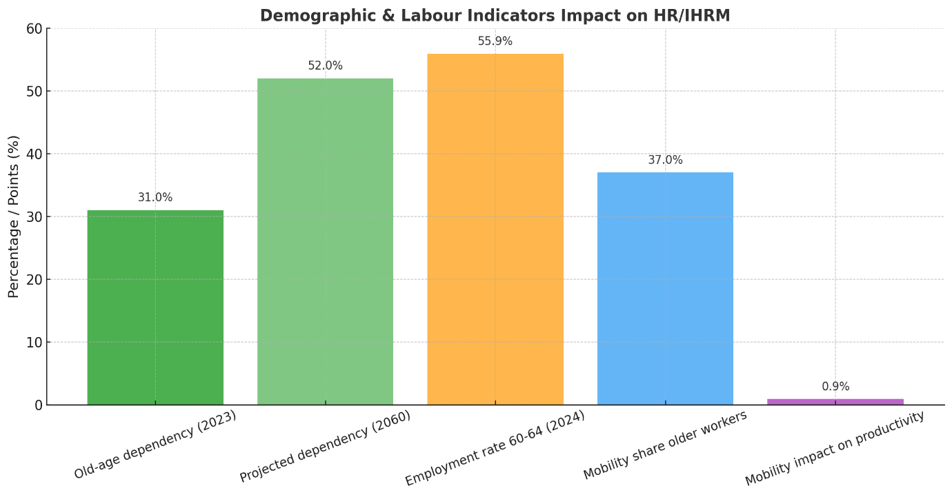

3. Addressing Skills Gaps and Talent Shortages through Strategic HRM

3.1 Understanding the Skills Gap
Global shortages of skilled talent persist in technology, healthcare, and manufacturing. By an estimate of the World Economic Forum (2023), a half of all workers will need to be reskilled by 2027. In the UK, the NHS has chronic shortages of nurses and allied health professionals, and the digital economy has difficulties in filling positions in cybersecurity and data analysis (OECD, 2024). Such shortages limit productivity and innovation, requiring long-term strategic HR responses.

3.2 Strategic HRM Tools and Solutions
To overcome talent deficits, organisations utilize comprehensive SHRM strategies that integrate workforce analytics, ongoing learning, and employer reputation. Upskilling and reskilling are exemplified by Amazon's Career Choice programme, which covers tuition costs for staff earning technology and logistics certifications, illustrating investment in internal mobility (HBR, 2023). Talent pipelines are strengthened through initiatives such as the NHS partnering with overseas universities to hire and develop healthcare professionals, exemplifying cross-border HRM coordination (ILO, 2024). Flexible work practices, including remote and hybrid work, expand labour engagement, particularly for women and individuals with disabilities, increasing inclusivity (CIPD, 2024). Employer branding is also emphasised, with companies like PwC encouraging learning-friendly cultures in order to recruit digitally skilled graduates.

3.3 Applying Theories and Models
Human Capital Theory (Becker, 1993) assumes that training and education are investments that bring productivity gains. Organisation with learning culture has greater rates of innovation. In figure 2 it has shown basic premise of human capital theory as defined by Becker (2008). In Ulrich's (2012) HR Model supports that strategic HR should match operational efficiency with long-term talent building.
Case studies demonstrate this strategy: -
PwC's 2020 Global Upskilling Initiative promises US$3 billion towards training employees in digital and leadership skills, in line with corporate transformation objectives (PwC, 2024).
The NHS Long-Term Workforce Plan (2023) incorporates predictive analytics to predict future labour shortages and bring national HR policy in line with population trends.

Summary
Addressing the skills gap requires systemic, data-driven HRM strategies that link talent development with organisational objectives. Companies that proactively invest in employee learning and global talent mobility maintain competitiveness while fostering social equity. The alignment of SHRM with national education and migration policies is central to sustainable labour market development.
Figure 2: - Human Capital Theory by Becker
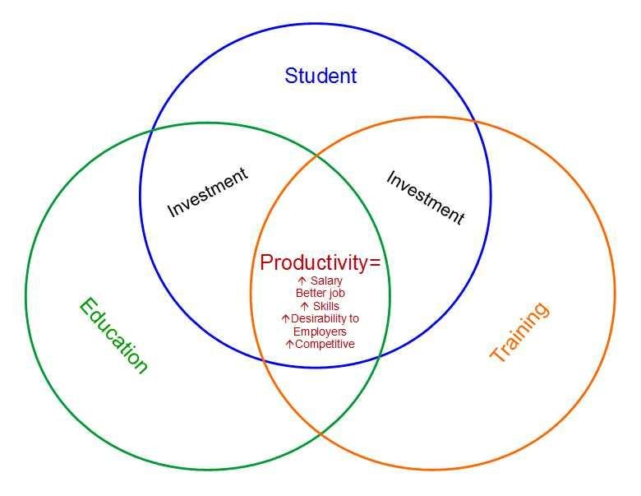

4. Reflective Analysis on Capabilities for Global Workplaces

4.1 Framework and Purpose
Successful engagement in global labour markets requires flexibility, digital literacy and intercultural skill. Adopting the Gibbs Reflective Cycle (1988) as a framework for analysis, this section assesses skills in technology, communication, collaboration, management, and autonomous learning—principal competencies set out by the Chartered Institute of Personnel and Development (CIPD, 2024).

4.2 Technology Competence
Digital collaboration tool proficiency, HR analytics, and data-driven decision-making are the building blocks for next-generation HR professionals. A Deloitte (2024) study reveals that digital literacy has become the benchmark of employability in industries. Building analytical skills in tools like Power BI or SPSS increases evidence-based management, with the increasing focus on HR analytics in international organisations.5.3 Communication, Teamwork and Leadership
Global workplaces necessitate cross-cultural communication and inclusive leadership. Research identifies that transformational leadership approaches nurture creativity and motivation in diverse teams (Northouse, 2023). Successful teamwork entails resolving conflicts, cultural sensitivity, and shared accountability. Initiatives like IBM's Leadership Academy exhibit how multinationals develop global leadership pipelines through experiential learning.

4.3 Self-Directed Learning
Continuous learning is an essential employability skill. Kolb's (1984) model of experiential learning highlights the value of reflection in personal development. Figure 3 as shown the learning cycle of Kolb’s. Research by PwC (2024) indicates that staff receiving self-initiated digital training perform better than colleagues in terms of adaptability. Creating formal professional development plans with the use of the SMART framework guarantees long-term improvement in competence and confidence.
Summary
Technological competence, communication competence, leadership competence and self-directed learning competence increase employability and international performance. Organisations look for professionals that can combine digital competence with emotional intelligence and ethical consciousness—competences necessary to operate in global and multicultural environments.

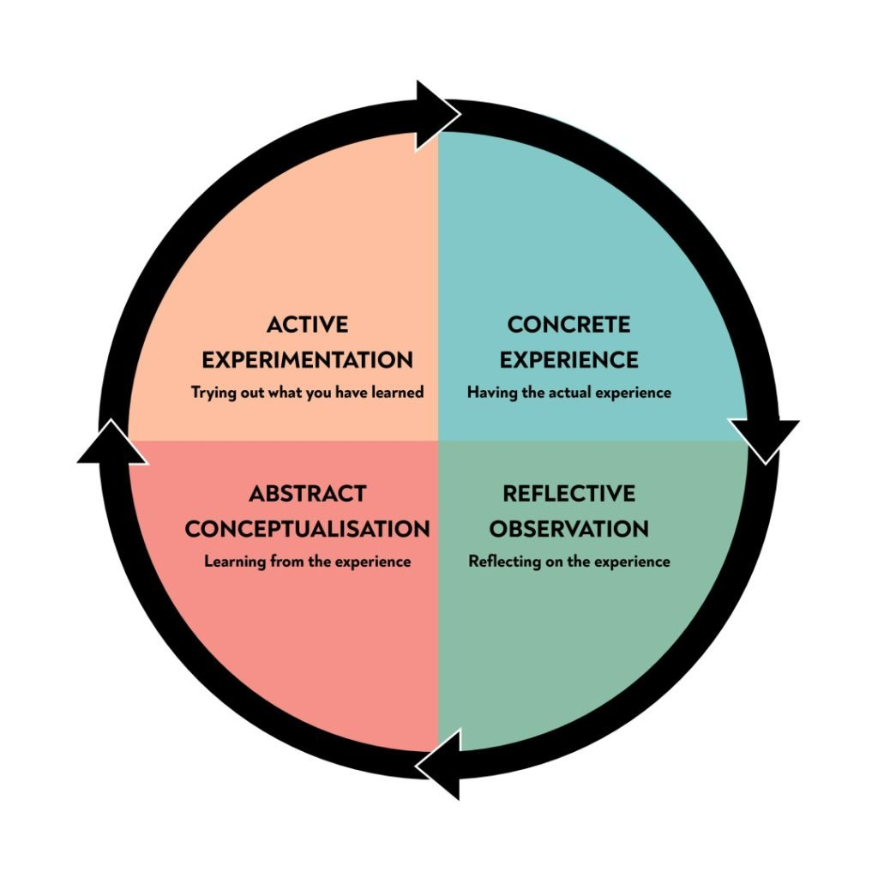
Figure 3: - Kolb’s Learning Cycle

Conclusion
In conclusion, the dynamic interplay of national and international labour market forces requires HRM and IHRM to transform from operational support functions to strategic facilitators of organisational achievement. Technological advancements—AI, analytics, digital platforms—promise enormous opportunities for efficiency, in-depth understanding and quick responsiveness. However, their deployment has to be guided by human-centric design, ethical protection, and inclusion to avoid dehumanisation (Tursunbayeva et al., 2019). PMC
Demographic changes and geopolitical uncertainty complicate matters: ageing populations, migration controls, and changing global power relationships limit talent mobility and labour supply (Ključnikov et al., 2023). ScienceDirect Strategic HRM needs to embrace flexibility, diversity, and localisation in order to continue to be globally responsive.
Closing skills gaps demands more than training schemes; it is about developing a culture of permanent learning, creating responsive talent pipelines, and integrating HR strategy with macroeconomic and education policy. The complementarity of skills—particularly in AI and digital fields—encourages thinking in terms of capability bundles rather than discrete competencies (Stephany & Teutloff, 2022).
Lastly, HR professionals in the future of work to emerge need to be highly digitally fluent, interculturally competent, and agile in team management. Globalized workplaces will increasingly need professionals who can navigate complexity, harness analytics, build inclusive cultures, and constantly upskill.
In turbulent and integrated labour markets, success will accrue to organisations whose HRM and IHRM approaches are anticipatory, integrative and morally based. Building synergy between technology, talent development, and human values will be the key to whether HR propels transformation or simply responds to disruption.

References
Armstrong, M. & Taylor, S. (2023) Armstrong’s handbook of human resource management practice. 17th edn. London: Kogan Page.
https://scholar.google.co.in/scholar?q=Armstrong,+M.+%26+Taylor,+S.+(2023)+Armstrong%E2%80%99s+handbook+of+human+resource+management+practice.+17th+edn.+London:+Kogan+Page.&hl=en&as_sdt=0&as_vis=1&oi=scholart
Aydin, O., Karaarslan, E. & Narin, N. G. (2024) Artificial Intelligence, VR, AR and Metaverse Technologies for Human Resources Management.
https://arxiv.org/abs/2406.15383
Barney, J. (1991) ‘Firm resources and sustained competitive advantage’, Journal of Management, 17(1), pp. 99–120.
https://scholar.google.co.in/scholar?q=Barney,+J.+(1991)+%E2%80%98Firm+resources+and+sustained+competitive+advantage%E2%80%99,+Journal+of+Management,+17(1),+pp.+99%E2%80%93120.&hl=en&as_sdt=0&as_vis=1&oi=scholart
BBC (2023) Brexit: labour shortages continue to impact UK sectors. Available at: https://www.bbc.co.uk/news/business (Accessed: 7 October 2025).
Becker, G. (1993) Human capital: a theoretical and empirical analysis with special reference to education. 3rd edn. Chicago: University of Chicago Press. https://scholar.google.co.in/scholar?hl=en&as_sdt=0%2C5&as_vis=1&q=Becker%2C+G.+%281993%29+Human+capital%3A+a+theoretical+and+empirical+analysis+with+special+reference+to+education.+3rd+edn.+Chicago%3A+University+of+Chicago+Press.&btnG=
BM Corporation (2024) SkillsBuild impact report 2024. Armonk, NY: IBM Corporation.
https://scholar.google.co.in/scholar?hl=en&as_sdt=0%2C5&as_vis=1&q=BM+Corporation+%282024%29+SkillsBuild+impact+report+2024.+Armonk%2C+NY%3A+IBM+Corporation.&btnG=
Bondarouk, T. and Brewster, C. (2016) ‘Conceptualising the future of HRM and technology research’, The International Journal of Human Resource Management, 27(21), pp. 2652–2671. https://scholar.google.co.in/scholar?hl=en&as_sdt=0%2C5&as_vis=1&q=Bondarouk%2C+T.+and+Brewster%2C+C.+%282016%29+%E2%80%98Conceptualising+the+future+of+HRM+and+technology+research%E2%80%99%2C+The+International+Journal+of+Human+Resource+Management%2C+27%2821%29%2C+pp.+2652%E2%80%932671.+%28Accessed%3A+7+October+2025%29.&btnG= (Accessed: 7 October 2025).
Brewster, C., Chung, C. & Sparrow, P. (2022) Globalizing human resource management. 3rd edn. London: Routledge. https://scholar.google.co.in/scholar?hl=en&as_sdt=0%2C5&as_vis=1&q=Brewster%2C+C.%2C+Chung%2C+C.+%26+Sparrow%2C+P.+%282022%29+Globalizing+human+resource+management.+3rd+edn.+London%3A+Routledge.&btnG=
Brynjolfsson, E. & McAfee, A. (2022) The second machine age: work, progress and prosperity in a time of brilliant technologies. New York: W. W. Norton. https://wwnorton.com/books/the-second-machine-age
Chartered Institute of Personnel and Development (CIPD) (2024) Workforce planning and diversity report 2024. London: CIPD.
https://www.cipd.org/globalassets/media/knowledge/knowledge-hub/reports/2024-pdfs/8662-resource-and-talent-planning-2024-report-web.pdf
Chung, C., Sparrow, P. and Brewster, C. (2024) ‘Integrating international HRM and national context research: Directions for the future’, The International Journal of Human Resource Management. https://www.researchgate.net/publication/317772293_Globalizing_human_resource_management_Second_edition (Accessed: 7 October 2025).
Deloitte (2024) Global human capital trends 2024: navigating the digital workplace. London: Deloitte Insights.
https://www.deloitte.com/us/en/insights/topics/talent/human-capital-trends/2024.html
Eprianto, I., Djunaedi, et al. (2025) “Digital Transformation in Human Resource Management: Challenges and Opportunities for Modern Organizations.”
https://www.researchgate.net
Gibbs, G. (1988) Learning by doing: a guide to teaching and learning methods. Oxford: Oxford Polytechnic. https://scholar.google.co.in/scholar?q=Gibbs,+G.+(1988)+Learning+by+doing:+a+guide+to+teaching+and+learning+methods.+Oxford:+Oxford+Polytechnic.&hl=en&as_sdt=0&as_vis=1&oi=scholart
Harvard Business Review (2023) ‘The business case for diversity and inclusion’, HBR Online. Available at: https://hbr.org (Accessed: 7 October 2025). https://www.researchgate.net/figure/llustration-of-the-basic-premise-of-human-capital-theory-as-defined-by-Becker-2008_fig1_342106096
International Labour Organization (ILO) (2024) World employment and social outlook 2024. Geneva: ILO. https://scholar.google.co.in/scholar?hl=en&as_sdt=0%2C5&as_vis=1&q=International+Labour+Organization+%28ILO%29+%282024%29+World+employment+and+social+outlook+2024.+Geneva%3A+ILO.&btnG=
Indra Bratamanggala, R. I. (2025) “Digital Transformation in Human Resource Management: A Systematic Literature Review.”
https://review.e-siber.org/
Ključnikov, A., Civelek, M. and Suler, P. (2023) ‘Global labour market transformations and workforce resilience in post-pandemic economies’, Journal of Business Research, 166, pp. 113–127.
https://en.wikipedia.org/wiki/Journal_of_Business_Research#:~:text=The%20Journal%20of%20Business%20Research,Kleijnen%20(Vrije%20Universiteit%20Amsterdam). (Accessed: 7 October 2025).
Kolb, D. A. (1984) Experiential learning: experience as the source of learning and development. Englewood Cliffs, NJ: Prentice Hall.
https://www.simplypsychology.org/learning-kolb.html
Lina, M., Cassiman, B. and Valentini, G. (2018) ‘Managing cross-border human capital flows: Migration, globalisation, and innovation’, Strategic Management Journal, 39(12), pp. 3083–3110. (Accessed: 7 October 2025).
https://en.wikipedia.org/wiki/Lina,_M.,_Cassiman,_B._and_Valentini,_G._(2018)_%E2%80%98Managing_cross-border_human_capital_flows:_Migration,_globalisation,_and_innovation%E2%80%99,_Strategic_Management_Journal,_39(12),_pp._3083%E2%80%933110._(Accessed:_7_October_2025).
Northouse, P. G. (2023) Leadership: theory and practice. 9th edn. London: Sage
.https://scholar.google.co.in/scholar?hl=en&as_sdt=0,5&as_vis=1&q=Northouse,+P.+G.+(2023)+Leadership:+theory+and+practice.+9th+ed.+London:+Sage.
Organisation for Economic Co-operation and Development (OECD) (2024) Skills outlook 2024: strengthening workforce resilience. Paris: OECD Publishing. https://www.oecd.org/en/publications/serials/oecd-skills-outlook_d4187381.html
OECD (2025) Employment Outlook 2025: Navigating the golden years. Paris: OECD Publishing.
https://www.oecd.org/en/publications/serials/oecd-skills-outlook_d4187381.html
OECD (2025) Job markets remain resilient but https://www.oecd.org/en/publications/serials/oecd-skills-outlook_d4187381.html population ageing will cause significant labour shortages. Paris: OECD Publishing.
Parry, E. & Tyson, S. (2018) “An analysis of the use and success of online recruitment methods in the UK,” Human Resource Management Journal.
https://onlinelibrary.wiley.com/
PwC (2024) Global upskilling initiative report. London: PwC Insights. https://www.simplypsychology.org/learning-kolb.html
Scuotto, V. et al. (2023) “The digital humanism era triggered strategy and policies: reshaping HR space.”
https://dinastipub.org/DIJELMSS,
Shore, L. M. et al. (2011) ‘Inclusion and Diversity in Work Groups: A Review and Model for Future Research’, Journal of Management, 37(4).
https://scholar.google.co.in/scholar?hl=en&as_sdt=0%2C5&as_vis=1&q=Shore%2C+L.+M.+et+al.+%282011%29+%E2%80%98Inclusion+and+Diversity+in+Work+Groups%3A+A+Review+and+Model+for+Future+Research%E2%80%99%2C+Journal+of+Management%2C+37%284%29.&btnG=
Shore, L. M. et al. (2018) ‘Inclusive workplaces: a review and model’, Human Resource Management Review, 28(2), pp. 176–189.
https://www.sciencedirect.com/science/article/abs/pii/S1053482217300529
Stephany, F. and Teutloff, O. (2022) ‘The global geography of AI talent: Labour market dynamics and implications for policy’, arXiv preprint. https://www.researchgate.net/publication/347345625_Does_It_Pay_Off_to_Learn_a_New_Skill_Revealing_the_Economic_Benefits_of_Cross-Skilling (Accessed: 7 October 2025).
Trist, E. L. & Bamforth, K. W. (1951) ‘Some social and psychological consequences of the longwall method’, Human Relations, 4(1), pp. 3–38.
https://scholar.google.com/scholar?hl=en&as_sdt=0%2C5&q=Trist%2C+E.+L.+%26+Bamforth%2C+K.+W.+%281951%29+%E2%80%98Some+social+and+psychological+consequences+of+the+longwall+method%E2%80%99%2C+Human+Relations%2C+4%281%29%2C+pp.+3%E2%80%9338.&btnG=
Tursunbayeva, A., Di Lauro, S. and Pagliari, C. (2019) ‘People analytics: A systematic literature review and future directions’, Journal of Organizational Effectiveness: People and Performance, 6(3), pp. 197–222. (Accessed: 7 October 2025).
https://www.researchgate.net/publication/328743407_People_analytics-A_scoping_review_of_conceptual_boundaries_and_value_propositions
Unilever (2024) Future of work and sustainability report 2024. London: Unilever PLC.
https://www.unilever.com/sustainability/
World Economic Forum (2023) The future of jobs report 2023. https://www.weforum.org/publications/the-future-of-jobs-report-2023/ Geneva: World Economic Forum.
Zhang, X., Liu, W. and Huang, H. (2023) ‘Digital transformation and HRM innovation: Evidence from multinational enterprises’, Frontiers in Psychology, 14, 1092187. https://www.scirp.org/reference/referencespapers?referenceid=3980195 (Accessed: 7 October 2025).

