Single page Poster

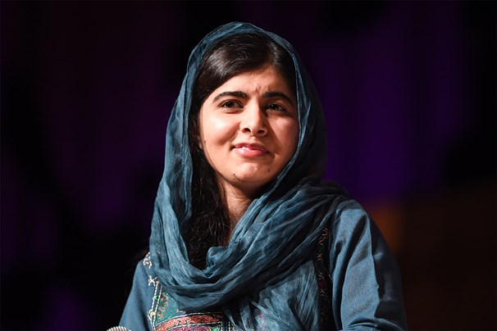
Malala Yousafzai
Nobel Peace Prize laureate
D.O.B 12 July 1997

Malala Yousafzai is one of the most successful women of our time.
At the age of 15 she advocated for girls right to attend school when the Taliban tried to band girls going to school.
It resulted in her getting shot, but she survived.
Now she has the world stage to advocate women’s right to education.
She continuously using her presence to empower girls/women

