

The Role of a Care Assistant in Providing Person-Centred Care in Residential Care Homes

Programme: Certificate of Higher Education Skills for Workplace (Health and Social Care)
Module: Academic and Employability Skills
Module code: LCHS4001
Lecturer: Brian Mashumba
Student Name: Hamna Nasir
Student Id Number: 2523960
Word Count: 1200 (Excluding Table of Contents, In-text Citations and References)

Submitted on 23/April/2026

Table of Contents
1. Introduction 3
2. Role of a Care Assistant in Residential Care Homes 3
3. Essential Skills Required for Care Assistants 4
3.1 Communication Skills 4
3.2 Empathy and Compassion 4
3.3 Observation and Attention to Detail 5
4. Strategies to Improve Essential Skills 5
5. Conclusion 6
References 7

1. Introduction
Health and social care services are significant in helping vulnerable communities especially the old people who need help in their daily living activities. Residential care homes offer professional guidance to all persons that cannot live a life of their own because of age, disability or health conditions. Care assistants are vital component of the workforce within these settings, as they play a role in ensuring that residents get safe, respectful and person-centred care. Person-centred care is concerned with the dignity and respect of individuals as well as taking into consideration their personal preferences, values as well as needs. The strategy would ensure the residents actively participate in matters concerning their care and everyday activities. Care assistants hence have crucial responsibility towards preserving the lives of residents in terms of quality, independence and wellbeing. This report outlines the job of a care assistant in residential care homes, the kind of duties and responsibilities that the job entails. It then outlines three critical skills one needs to be successful in the profession, which are communication, empathy, and observation, and talks about the strategies that can be used to enhance the three skills in professional practise (Parkinson and Thompson, 2022).

2. Role of a Care Assistant in Residential Care Homes
A care assistant will have a responsibility to offer both practical and emotional assistance to people who are staying at residential care homes. The main purpose of this role is to help the residents to do their daily tasks and achieve dignity, independence and wellbeing. Care assistants most of the time collaborate closely with the nurses, other healthcare professionals as well as the family members in order to ensure that residents are well taken care of. Providing personal care to the residents through bathing, dressing, grooming, and toileting is one of the most important roles of a care assistant. These activities should be performed in a respectful and thoughtful manner to ensure the comfort and dignity of the resident (Hedman, Sandman and Edvardsson, 2022).
The other significant responsibility is to help residents with their mobility and body functions. There are several residents who might have reduced mobility because of age or health and condition and in this case, the care assistants can make sure these people have moved safely around the care home, reduce falls, and promote physical activity where feasible. Another important task is emotional support. A large number of residents would experience loneliness or isolation once they are admitted in a care home. Therefore, care assistants are significant in establishing a trusting relationship with residents, communicating with them, and promoting social interaction (Silies et al., 2023).
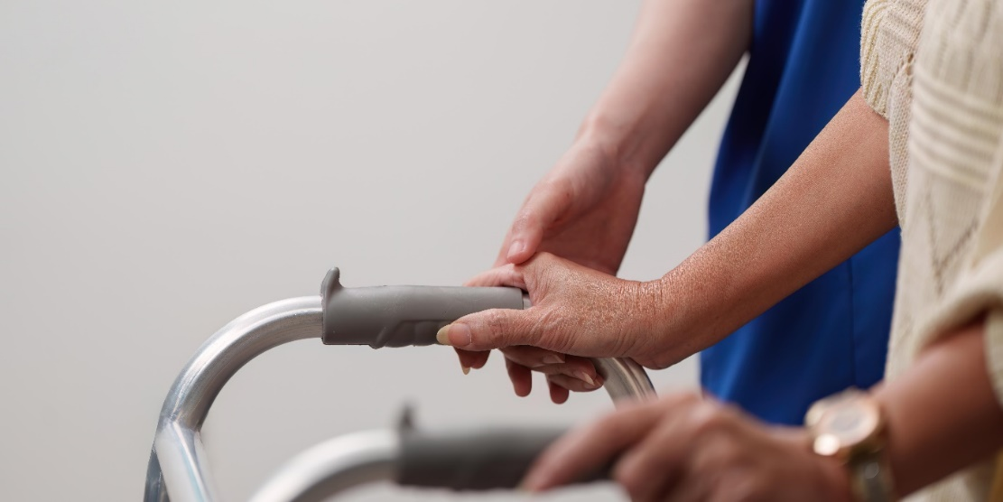
Figure 1 Daily responsibilities of care assistants (Silies et al., 2023)

3. Essential Skills Required for Care Assistants

3.1 Communication Skills
One of the most critical skills that are needed by care assistants is communication. Efficient communication enables the care assistants to know the needs of residents, communicate effectively and maintain constructive relations with residents and other workers. Communication in residential care environment takes various shapes such as verbal communications, non-verbal communications and active listening. Care assistants need to speak directly and courteously to residents and mainly those who have hearing problems, dementia and/or cognitive weaknesses. As an example, a care assistant might be expected to demonstrate medication procedures or daily routine in a gentle and encouraging way. They should also pay attention to issues or preferences of residents in order to have their needs comprehended. Effective communication can also assist staff in working with other professionals in the healthcare sector to deliver integrated care (Backman et al., 2025).

3.2 Empathy and Compassion
Emotions Empathy and compassion are core values of the person who works in the health and social care. Sympathy and compassion can be considered opposites of each other in that one can be involved in another person rather than act on their behalf to ease or prevent suffering. In the residential homes, mental health problems might be experienced by them that may include loneliness, anxiety, or frustration. Care assistants should then be in a position to identify such feelings and react appropriately with compassion and empathy. An illustrative case includes a dementia resident, who gets disoriented or frustrated with the world around. The kind home helper is able to support the resident, speak soothingly, and make them feel safe and comprehensive (Forsgren and Saldert, 2022).

3.3 Observation and Attention to Detail
Care assistants also need to have observation skills as they are usually the first to notice a change in the physical or emotional state of the residents. Care assistants spend a lot of time with the residents and as such they are in a good position to screen the slightest sign of health defects. As an illustration, a care assistant can note the change in appetite, mobility, mood, or sleeping habits (Hoglander et al., 2023). Such observations can be the signs of possible health problems (infection, dehydration or emotional distress). Correct observation enables care assistants to communicate safety issues early to nurses or other medical practitioners.
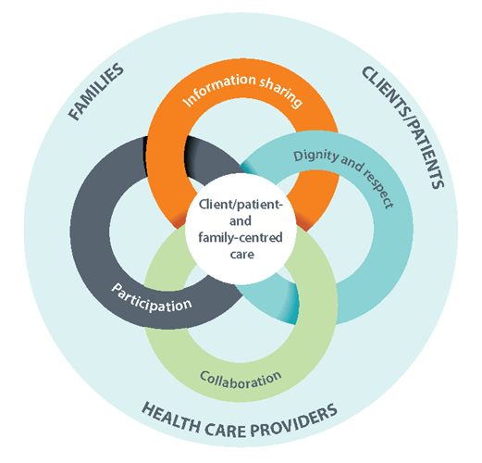
Figure 2 Understanding Person-Centred Care (Hoglander et al., 2023)

4. Strategies to Improve Essential Skills
The professional skills are essential in improving quality care. Care assistants can improve communication, empathy, and observations with the help of several strategies. Professional training and workshops may be seen as one of the effective strategies. The level of interaction with the residents and the possibility of adequately responding to various circumstances can be improved considerably thanks to training sessions in the communication techniques, care of dementia, and safety (Poelen, Kuppenveld and Persoon, 2023). To illustrate, it might be applied through the communication training to ensure that care assistants learn how to listen in an active manner and how to effectively communicate with residents with cognitive impairments. The other approach is reflective practise. Reflective practise is about looking into the past and realising on what one did well and the improvements.
The third strategy is observation and mentoring learning strategies. The care assistants who are new may acquire good skills by following the example set by the experienced staffs and supervisors. Mentorship enables junior employees to acquire empirical skills on how to relate with the residents, identify health issues, and provide effective care that is person-centred. Furthermore, reading and professional development can also be carried out continuously and assist in the growth of skills. Assessment of professional guidelines, research articles, and best practise standards can enable care assistants remain updated with current care practise. These measures help in individual growth as well as the enhancement of care quality in the residential care facilities.

5. Conclusion
Care assistants are very special as they assist when any individual is in the residential care homes. They are charged with the role of supporting the daily living activities of the residents, emotional support, monitoring their wellbeing, and conducting person-centred care plans. Care assistants will need a number of key skills, such as communication, empathy, and observation in order to effectively undertake this role. Such skills will also help care assistants to know the needs of the residents, establish trusting relationships with them, and recognise possible health concerns. The professional development is also important in improving these skills. Solutions like professional training, reflective practise, and mentoring might be applied to make care assistants improve their skills and deliver better quality care. A care assistant plays a crucial role in enhancing dignity, autonomy and welfare of residents residing in residential facilities by ensuring that residents get personalised and highly responsible care in residential facilities.

References
- Backman, H. et al. (2025) ‘Health and Quality of Life in Nursing Homes: A Repeated Cross‐Sectional Study on the Impact of Leadership and Person‐Centred Care’, Nursing Open, 12(7), p. e70283. Available at: https://doi.org/10.1002/nop2.70283.
- Forsgren, E. and Saldert, C. (2022) ‘Implementation of communication routines facilitating person‐centred care in long‐term residential care: A pilot study’, Health Expectations, 25(6), pp. 2982–2991. Available at: https://doi.org/10.1111/hex.13606.
- Hedman, R., Sandman, P. and Edvardsson, D. (2022) ‘Enacting person‐centred care in home care services for people with dementia’, Journal of Clinical Nursing, 31(11–12), pp. 1519–1530. Available at: https://doi.org/10.1111/jocn.16004.
- Hoglander, J. et al. (2023) ‘Implementing A person-centred CommunicaTION (ACTION) educational intervention for in-home nursing assistants – a study protocol’, BMC Geriatrics, 23(1), p. 112. Available at: https://doi.org/10.1186/s12877-023-03831-3.
- Parkinson, M. and Thompson, J. (2022) ‘An exploration of the challenges of providing person‐centred care for older care home residents with obesity’, Health & Social Care in the Community, 30(4). Available at: https://doi.org/10.1111/hsc.13519.
- Poelen, A., Kuppenveld, M.V. and Persoon, A. (2023) ‘Nurses’ perspectives on shift‐to‐shift handovers in relation to person‐centred nursing home care’, Nursing Open, 10(8), pp. 5035–5043. Available at: https://doi.org/10.1002/nop2.1740.
- Silies, K.T. et al. (2023) ‘Expanded nursing competencies to improve person-centred care for nursing home residents with complex health needs (Expand-Care): study protocol for an exploratory cluster-randomised trial’, BMJ open, 13(7), p. e072955.

