Student Name: | Kaysar Ahmed
Student Number: | 2211257
Module | Valentine’s Food Menu

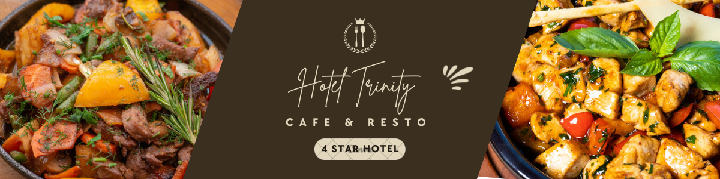

Valentine's Dinner Special Menu
FEBRUARY 14, 2023, | TUESDAY, 7:00 P.M. - 11:00 P.M.
Trinity Hotel offers a special three-course Valentine's Day lunch menu. Stunning environment, excellent food, and a complimentary Valentine’s special live music are all part of your romantic evening.
For Reservation: 0213456789
Three Course Dinner with Live Music Show
Per Couple £43 with Complementary Beverage

Soup & Salad Selection
(CHOICE OF ONE)
RED ENDIVE AND SEVEN-LEAF SALAD TOASTED IN WALNUT VINAIGRETTE (For Allergens)
Or,
LOBSTER CHOWDER WITH CREAMY MAINE SHRIMP
Entrée Selection
(CHOICE OF ONE)
COLORADO RIB EYE STEAK AND GARLIC HERB SHRIMP ON A BED OF RED SLATE KITCHEN STOVE TOPPED POTATOES
Or,
LUMP CRAB MEAT ON TOP OF RED SNAPPER & SAUTÉED JULIENNE VEGETABLES
Couples Dessert of the Night
MOSSE CAKE WITH MANGOES
FLAVORED WITH PASSION FRUIT, THIS MOIST VANILLA SPONKY CAKE HAS AN EXOTIC TASTE FROM THE TROPICAL MANGO MOUSSE WITH A TOUCH OF COCONUT. PAIRED WITH FRESH BERRIES AND CHEF BAILEY'S WHIPPED CREAM And,
TUXEDO MOUSSE CAKE WITH TRUFFLES
DARK CHOCOLATE MOUSSE AND WHITE CHOCOLATE MOUSSE, TOPPED WITH OMBRE DARK AND WHITE CHOCOLATE CUPCAKE.
YOU ARE MOST WELCOME WITH YOUR BELOVED ONE
References
A taste of Italian, 2015. The History of Lasagna. [online] A Taste of Italian. Available at: <https://mybravoblog.wordpress.com/2015/07/22/the-history-of-lasagna/>
Canva, 2023. Banner Template Canva https://www.canva.com/design/DAFakCfg044/hl4tkBKxK3bqk56CHlEx-Q/edit
Cookies, 2023. Background Picture https://thebakerupstairs.com/2018/02/valentines-day-cookie-party.html
Donnelly, K., 2014. How to Pair Wine with Mushroom Risotto. [online] Food & Wine. Available at: <http://www.foodandwine.com/blogs/how-pair-wine-mushroom-risotto>
FlorenceItaly, 2014. Italian recipes: Carpaccio di manzo. [online] Florenceitaly.org. Available at: <http://www.florenceitaly.org/italian-recipes-carpaccio-di-manzo/>
Gazzoli, G., Hancer, M. and Park, Y., 2019. The Role and Effect of Job Satisfaction and Empowerment on Customers’ Perception of Service Quality: A Study in the Restaurant Industry. Journal of Hospitality & Tourism Research, 34(1), pp.56-77.
Miller, J. and Pavesic, D., 2016. Menu pricing & strategy. New York: John Wiley & Sons.
Pinterest, 2023. Menu Inspired from https://www.pinterest.com/pin/301811612537360755/.

