HISTORY AND THEORY 2
Module code: M5X01981
Mohammad Shirazi

What do you think the inclusion of ornament actually signifies, in architectural terms?

Introduction:
Undoubtedly, the architecture is the combine of the understanding of art, science, technology, humanity and other engineering sciences to build residential, urban, industrial spaces, etc.
Architecture is one of the most important achievements of mankind that has helped him to express many things. From the Pyramids to the valuable monument of ancient Greek civilization, all of which are one of the main ways of expressing thoughts and culture and showing it by the most palpable forms possible.
Architectural works can represent the culture of a nation and can count as a category of artwork. In most cases, Historical civilisation is known by architectural works which remain from years before.
From the very beginning of the creation, the desire to show the beauty and glory in human has caused to try to beautify every single thing which made by himself.
Ornament and decoration are elements which added to an architectural work to enhance aesthetic features and its depth. In other words, decoration in architecture is an integral part of this profession, which expresses more details of thoughts, cultures and religions.
To find out the answer of this question, firstly, we Should accurately examine the role and function of decorations in each period of architecture. By analysing different architectural styles, the importance and position of decorating in different periods, we can realize whether decorations can be the true meaning of architecture.
In the meantime, there are other questions to consider, including what factors affect the emergence of the architectural styles and decorations, or in other words, either of architecture or decoration is the main element and which one is the Dependent element And to what extent has one been inspired by another.

Main body / Development:
Herein, various definitions of the ornament will be reviewed. Several scientists and researchers agree that the traditional definition of the term ‘ornament’ refers to the decoration utilised to embellish objects of the buildings as the contemporary ornament has no particular definition yet, due to its multifaceted nature.
In architecture, decorating, ornament and many other elements have effects on the construction of each building that they each have their own definitions and characteristics. In the meantime, architectural ornament and decoration include a group of elements which can beautify the interior, exterior and flooring surface of any architectural monument.
Ornamentation is a source of aesthetic pleasures rooted in our small and big world. It is observed in the quilt surrounding our bodies and the carpet under our feet. It imparts joy to life and adds charm and fun to the buildings. As mentioned before, ornamentation is the process of adding items to a work of art in order to enhance the aesthetic characteristics and the depth and the clarity of its symbolic implications, it is used by every culture as an integral part of the artworks. However, it should be considered that the public artwork inherently is not just concerned with aesthetic values, it extends to involve social, cultural, religious and political aspects.
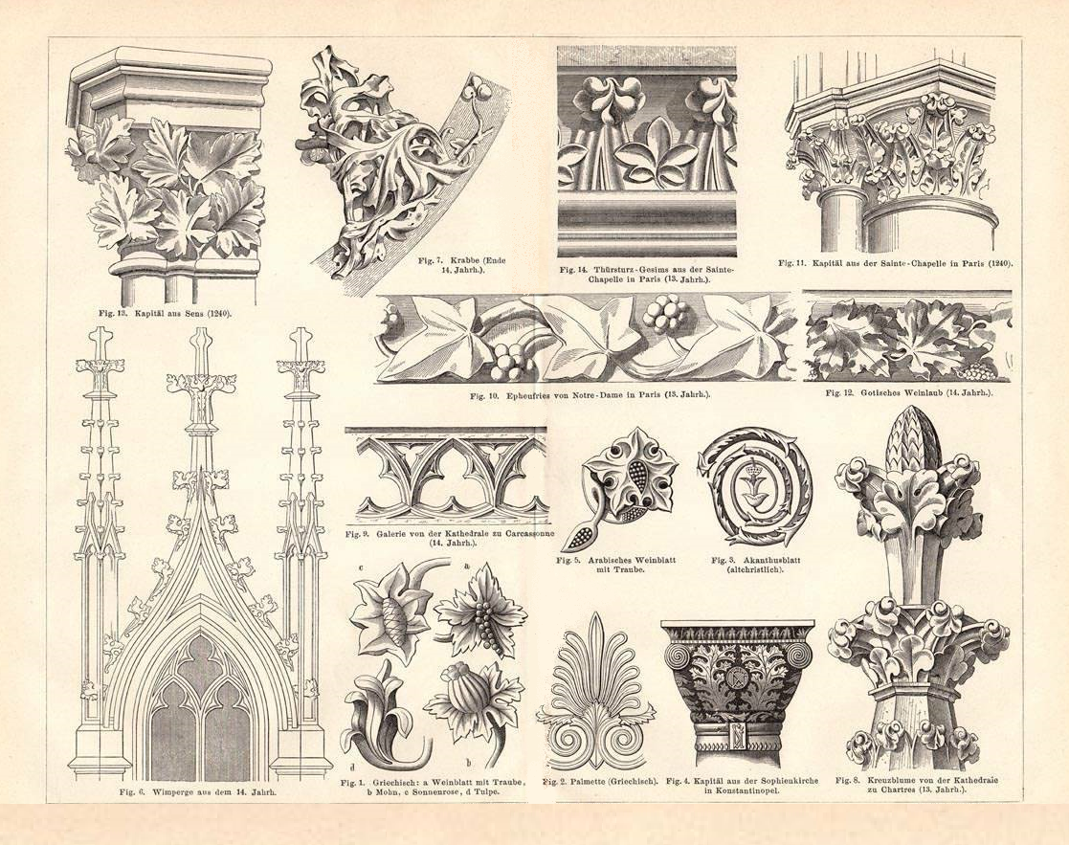
Figure 0 https://www.iberlibro.com/servlet/BookDetailsPL?bi=21836629362&cm_sp=collections-_-2haU4Sm3N0DdSSs2b0FTR3_item_1_8-_-bdp
Decorations and ornament depend on two main factors which are the function of the building and the available materials to the professors and skilled technicians of each period, which are generally determinants of the style of each historical period.
Almost in all of the architectural styles, decorations have become the main character or the principles of the architectural style. For example, in the classical style of architecture, the pillars and decorations on the columns and capitals are one of the remarkable features of this architectural style. The type of ornament on columns and capitals expresses its style, branch and period.
In figure 1 you can see the five differents capital of classic architecture which have different ornaetation.
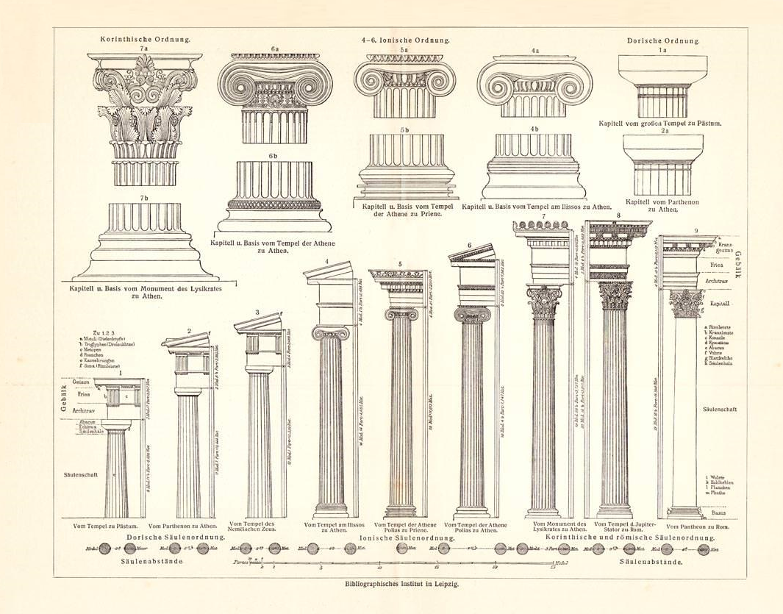
Figure 1 source:https://www.iberlibro.com/servlet/BookDetailsPL?bi=21836629362&cm_sp=collections-_-2haU4Sm3N0DdSSs2b0FTR3_item_1_8-_-bdp

In the following (figure 2), different architectural styles from the ancient Egyptian period to contemporary, and the type and characteristics of the ornamentations and decorations and their period will be mentioned. Examples for each one has been considered.
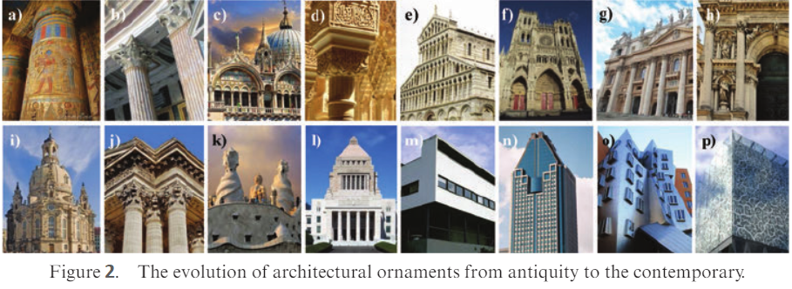
Resource: http://www.chadwicks.ie/blog/10-key-architecture-styles-and-their-defining-characteristics/

Types of ornamentation:
Ornaments in architecture are divided into integral and applied ornaments. The integral ornament is an integral part of the framework of the building, whether it is façades, ceilings, roofs, or the entire building. According to Riisberg and Munch, the most appropriate ornament is that stemming from the building’s structure and materials, and which is not masking the real building. The contemporary ornaments disclose the architecture of the building with various materials, innovative technologies, and structure. If a contemporary building lacks unifying space and surface, the ornaments become like wallpaper, and structural ornaments free ornaments from being an applied decoration. The applied ornament is an architectural detail, on a small scale compared to the scale of the building to which they are attached; they often include carvings, sculptures, paintings, mosaics and inlay.
As it has been said, in different periods and different styles of architecture, decoration and ornament were very important, but they have had many differences in terms of performance and function. In some architectural monuments, decorations have been used to add magnificence and glory to the palaces and mansions while in some other buildings ornament has been used to give importance to buildings such as castles or to show the power of kings and rulers.
And in religious buildings, decorations were tools of showing the importance of churches and inspiring in communicating with God and the clergy, especially in the Gothic style of the 12th-16th centuries which was the peak of the religious era, and in other words the era of faith and the period which building religious buildings (at the head of them, churches) have been of special and widespread importance.
Massive churches were built in European cities such as Paris and Milan which paved the way for a new image of decorative and architectural compositions, and made churches a decorated jewel of cities.
The main decorations in the churches are painted glasses, figurines, sculptures, and murals, which most of them reflect the life of Jesus Christ and his mother Mary and the story of his crucifixion.
Though years have passed since the construction of these buildings, audiences and even those who do not know much about Jesus Christ and his story, after seeing and visually interact with such decorations, are impressed and receive the ornaments'(painting, decoration, sculpture, etc.) feelings.
By passing past architectural styles that contained the ornaments, and by approaching to the contemporary architecture and the style of modernism and the activities of architects such as Le Corbusier, Mies Van Der Rohe and Bauhaus from 1920 to 1930, the decline and disappearance of decorative details became a feature of modern architecture. And Modern architecture became the equivalent of moral virtues, simplicity, honesty and purity. What began as a taste became the concept of beauty and aesthetics after passing years.

In contemporary architecture, and in recent years, we still see the use of decorations in buildings, but not in former shape and form, which the ornaments and decoration were Depend on a particular architectural style.
But in recent years (contemporary architecture), decorations are much less than before but are interspersed with the style of modern architecture and serve it, in a way that the decorations in a different way from the past become a tool for the transfer of concepts by the designers and architects to the needs of mankind.
With the advancement of science, decorative tools have dramatically expanded so that architects and designers can express concepts and issues through the inclusion of decorations and details in their designs and buildings.
For example, in some commercial buildings or restaurants or places requiring more visitors, the entrance of the buildings will be designed wider and decorate with inviting elements such as curved handrails that Induce the movement and encourage people specifically to visit the building.
In contemporary architecture the use of ornaments sometimes can be a specific design(specific staircase, door, window or floor designing), use of details, or it can also be the use of a particular type of floor covering, or the lighting and painting of spaces, which themselves pursues certain concepts and goals which we can see this kind of special attention to the details in Carlo Scarp's Works.
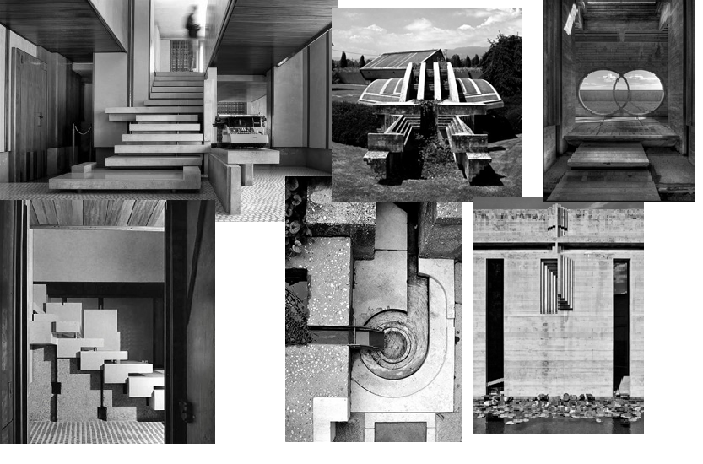
Resource : https://www.formidablemag.com/carlo-scarpa/
sometimes, the placement of two different materials alongside each other brings about a great meaning from it, which can be a significant part of the reason for using decorations in contemporary architecture and its function in urban buildings and spaces.
Also, the type of design or decorating can clarify the kind of use, whether private or public, the importance of buildings, including government buildings such as an embassy, parliaments, etc., or type of function, including educational, residential, commercial, sports, public, etc. In the past, the installation of signs for the guidance and introduction of space and parts of buildings was common, but in the contemporary architecture special attention has been paid to this issue, with decorations, details and specific design, spaces can be identified without the installation of signs and boards.
Urban elements such as squares, unique buildings are part of this series of designs. Some are showing independence and separatism, some signs of solidarity and sympathy, some signifying equality and equality among ethnic groups, some signs of protest, some signs of the history of a land, Some signify the importance and glory of a nation and humanity.

In the following, I will describe and analyse two different modern buildings (in terms of decoration and design)which are the Scottish parliament building as a modern decorated building which expresses independence and Swansea guild hall which signifies power.

Scottish Parliament Building:
The Scottish Parliament Building located in Edinburgh’s central which designed by Enric Miralles, the Catalan architect who died before its completion.
He was influenced by thoughts of Catalan nationalism and the supporters of the independence of Catalonia or the so-called Catalan lands of Spain and France. Catalan independence is based on the idea that Catalonia is a nation based on its history, language and culture and should be separated from Spain.
So he who had ideas close to the Scottish people (in terms of separation from the dominant government) designed the parliament building in a way that reflects glory, greatness, importance, separation and independence.

The construction of the building lasted for five years from 2004 to 2009 and from the begining, the building and its construction process have been polemical.
Despite the criticisms and the people's reaction, the building was welcomed by critics and architectural academics. The building aimed to achieve a poetic union between people, its culture, the Scottish landscape, and the city of Edinburgh. The Parliament Building won many awards including Stirling Prize in 2005 and Charles Jencks landscape architect described the building as a " tour de force of arts and crafts and quality, without parallel in the British architecture's last 100years."

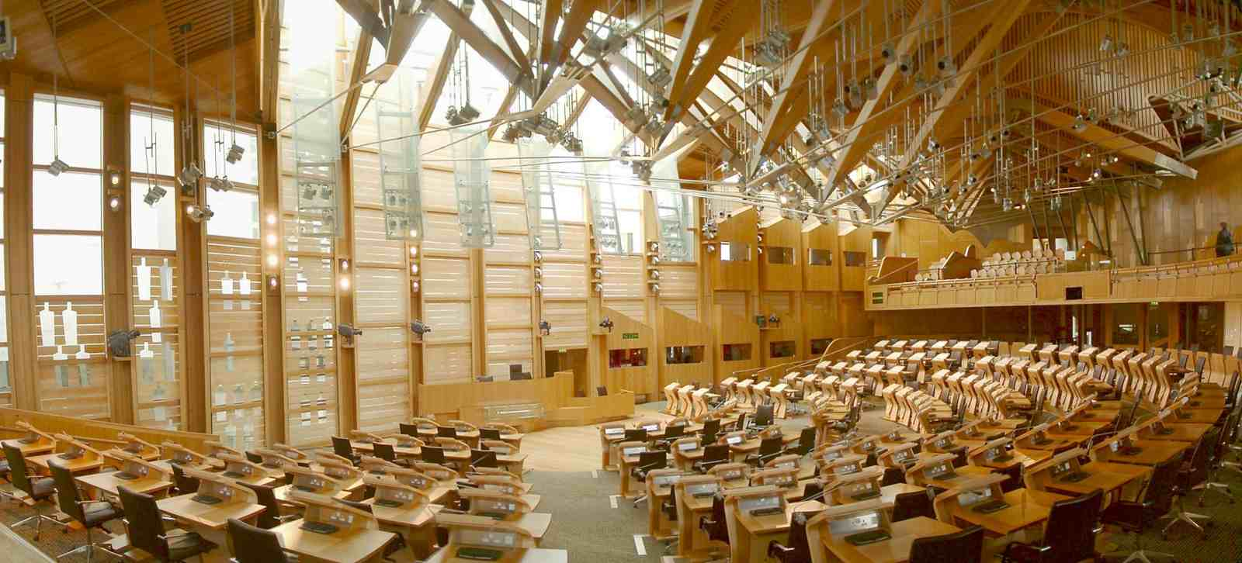
Resource: https://www.archdaily.com/111869/ad-classics-the-scottish-parliament-enric-miralles
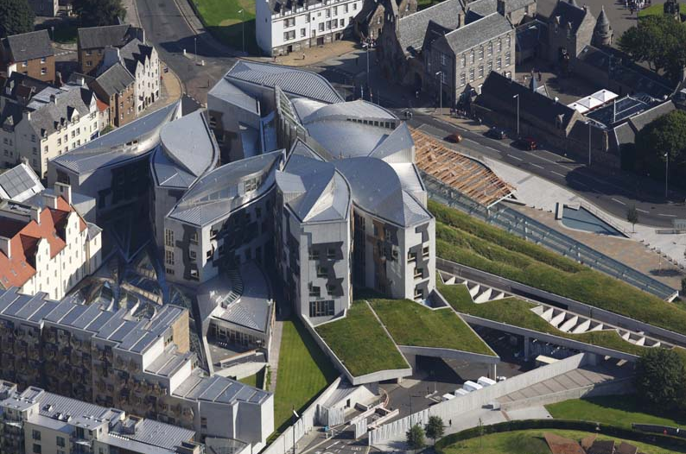
Resource: https://www.archdaily.com/111869/ad-classics-the-scottish-parliament-enric-miralles

Swansea Bryngwyn Hall:
Swansea Bryngwyn Hall which designed by percy Thomas (who became Sir Percy Thomas in 1946) and opened in 1934. Actually the construction process began in 1930 and completed in 1934. The building was formally opened on 23 October of that year.
At the opening time, it was a somewhat controversial building. It was described as having a 'stripped classical' style and represented the modern movement in architecture. The building Facade made of white Portland stone and includes a tall art deco clock-tower which make it a landmark.
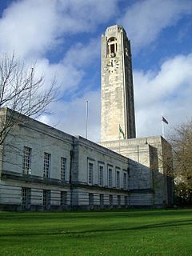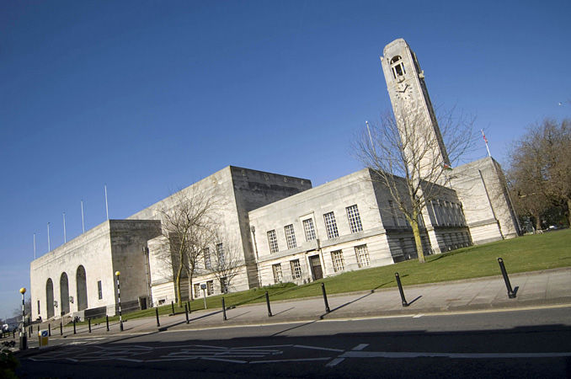
Figure 1 & 2 resource: https://artuk.org/visit/venues/brangwyn-hall-7566
The building has a very small amount of classical decorations which if we take out the decoration from the building it became a modern functionalism box and in that condition we can’t say that the building signifies nothing. It’s steel has its power and function and in terms of visual communication the building can still impress its audiences.

Conclusion:
As we started by discussing the question which is 'What do you think the inclusion of ornament actually signifies, in architectural terms?' we explain that the transition from different architectural periods and the emergence of different types and shapes decorations, ornament and decoration became the elements which added to an architectural work to enhance aesthetic features and its depth. And also we explained that the decoration in architecture is an integral part of this profession, which expresses more details of thoughts, cultures and religions.
Decoration and decorating is the language through which the architecture communicates with the general public, and each of these removes a degree of division between the profession and the public.
The decorations are an anthropological constant that is practically used in all cultures as an intrinsic part of the artwork. Research and debate over the nature, use and definition of social and cultural decorations are still posed. Despite the many writers' opinions, they seem to agree on a subject: "Decoration is indispensable."
As noted, decorations in modern architecture have not been accepted. However, one can not ignore the importance of decorations in architecture. Decorations are seen as more significant elements in classical architecture, Gothic architecture, and some other architectural styles, in which adornment is of particular importance. In this essay, I have been attempted to investigate the relationship between modern architecture and decorative arts and the viewpoints of the decorations and the composition and balance between art and architecture. I hope that the above articles will cover the answer to the question.

References:

Anon., 2014. 2 Building Materials, Construction and Interior Decoration. Art and Architecture of Ireland Volume IV: Architecture 1600-2000 Art and Architecture of Ireland.
Anon., 2014. 2 Building Materials, Construction and Interior Decoration. Art and Architecture of Ireland Volume IV: Architecture 1600-2000 Art and Architecture of Ireland.
Allen, B., Einberg, E., Postle, M., and Shanes, E., 2012. Windows on that world: essays on British art presented to Brian Allen. London: The Paul Mellon Centre for Studies in British Art.
Audsley, W., 2019. Victorian Sourcebook of Medieval Decoration: With 166 Full-Color Designs [online]. The B&N Sci-Fi and Fantasy Blog. Available from: https://www.barnesandnoble.com/w/victorian-sourcebook-of-medieval-decoration-w-audsley/1111653218?type=eBook [Accessed 10 Mar 2019].
Baltzer, 2013. 9 Ways to Bring Home a Little British Colonial Style [online]. Houzz. Available from: https://www.houzz.com/magazine/9-ways-to-bring-home-a-little-british-colonial-style-stsetivw-vs~14228300 [Accessed 10 Mar 2019].
Britannica, T. E. of E., 2016. International Style [online]. Encyclopædia Britannica. Available from: https://www.britannica.com/art/International-Style-architecture [Accessed 10 Mar 2019].
Anon., 1925. Catalogue of the third exhibition of the Architecture Club: British architecture and decoration. London: Architecture Club.
1970. Modern British domestic architecture and decoration (1901 edition) [online]. Open Library. Available from: https://openlibrary.org/books/OL6914579M/Modern_British_domestic_architecture_and_decoration [Accessed 10 Mar 2019].
Anon., 2019. London Architecture - Buildings [online]. e-architect. Available from: https://www.e-architect.co.uk/london-architecture [Accessed 10 Mar 2019].
Michell, G. and Zebrowski, M., n.d. Architectural decoration. Architecture and Art of the Deccan Sultanates, 115–144.
Anon., 2012. Modern British Domestic Architecture and Decoration [online]. Amazon. Available from: https://www.amazon.com/Modern-British-Domestic-Architecture-Decoration/dp/1290293872 [Accessed 10 Mar 2019].
Anon., 2018. Modern British domestic architecture and decoration [online]. Find in a library with WorldCat. Available from: https://www.worldcat.org/title/modern-british-domestic-architecture-and-decoration/oclc/1087519 [Accessed 10 Mar 2019].
Museum, A. and Digital Media, 2013. Victoria and Albert Museum [online]. Introduction to 20th-Century Fashion. Available from: http://www.vam.ac.uk/content/articles/s/style-guide-rococo/ [Accessed 10 Mar 2019].
Museum, A. and Digital Media, 2013. Victoria and Albert Museum [online]. Introduction to 20th-Century Fashion. Available from: http://www.vam.ac.uk/content/articles/r/robert-adam-neo-classical-architect/ [Accessed 10 Mar 2019].
Papadakis, A. C., 1982. British architecture: (Architectural Design project awards 1982). London: Academy Ed.
Roeten, L., n.d. I Architecture, Decoration and Interpretation. The Decoration on the Cult Chapel Walls of the Old Kingdom Tombs at Giza, 1–31.
Anon., 2013. The English Country House [online]. Quintessence. Available from: https://quintessenceblog.com/english-country-house/ [Accessed 10 Mar 2019].
Anon., 208AD. The history of British architecture timeline. [online]. Timetoast. Available from: https://www.timetoast.com/timelines/the-history-of-british-architecture [Accessed 10 Mar 2019].
Tinniswood, A., 2011. History - A History of British Architecture [online]. BBC. Available from: http://www.bbc.co.uk/history/british/architecture_01.shtml [Accessed 10 Mar 2019].
WendyBee, Flory, J., Tucker-Wolek, J., Criste, V., and My Crafty Home Life, 2018. Day 8 British Colonial Style [online]. Decor to Adore. Available from: https://www.decortoadore.net/2012/10/day-8-british-colonial-style.html [Accessed 10 Mar 2019].

