Llwybr Datblygu’r Gymraeg
DARLITH 7 – Trawsieithu a Chyfoethogi Iaith
- Padlet – Trawsieithu (Casglu Syniadau)
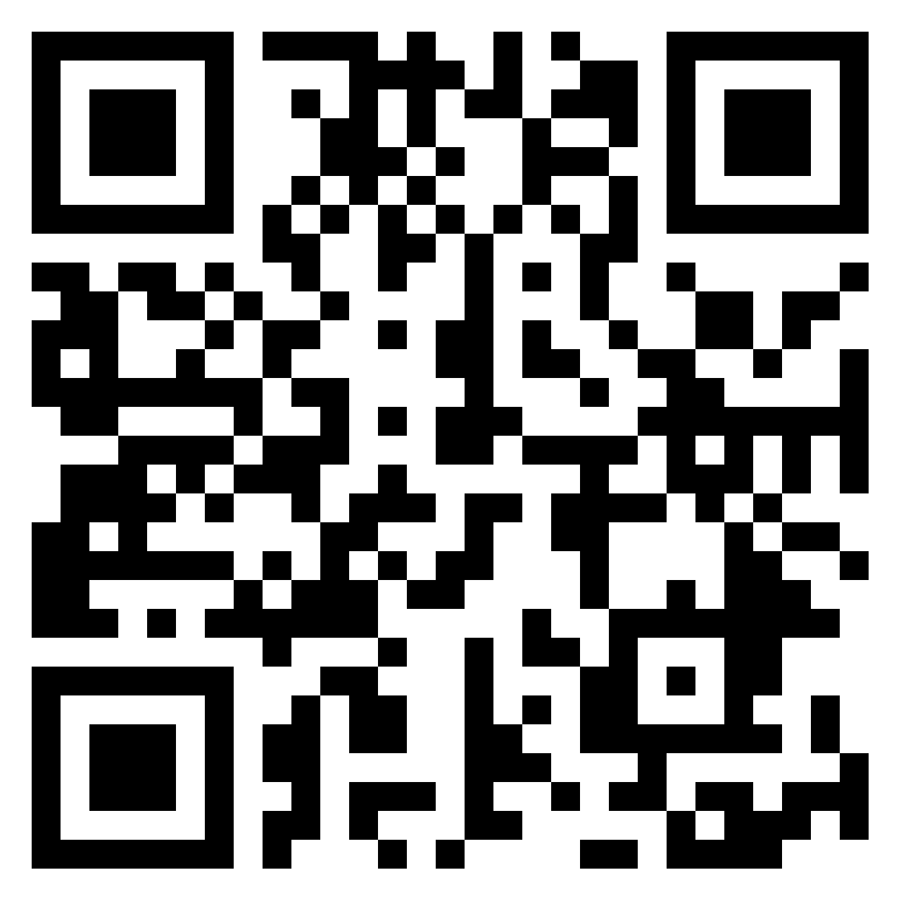
https://padlet.com/bethangriffiths/oykfyuvs10c1ob4y

- Tasg Ymarfer Trawsieithu - Erthygl BBC
https://www.bbc.co.uk/news/uk-wales-59408148

Ymarferion Wordwall
https://wordwall.net/resource/3199612
https://wordwall.net/resource/7569547

- Y Dystysgrif Sgiliau Iaith
Papurau Enghreifftiol
http://www.colegcymraeg.ac.uk/cy/astudio/sgiliauiaith/adnoddau/papurauenghreifftioltsi/
Anoddau o Wefan y Coleg Cymraeg Cenedlaethol
https://www.porth.ac.uk/cy/collection/tystysgrif-sgiliau-iaith-adnoddau-cefnogol
- Gwefan Cwricwlwm i Gymru
https://hwb.gov.wales/api/storage/b0e91f7c-0050-47b6-9b23-0273d39df9f3/canllawiau-cwricwlwm-i-gymru-070220.pdf

- Erthyglau diddorol
https://www.bell-foundation.org.uk/eal-programme/guidance/effective-teaching-of-eal-learners/great-ideas/translanguaging/#

https://multilingualparenting.com/translanguaging-as-a-way-of-enhancing-learning/

https://ealjournal.org/2016/07/26/what-is-translanguaging/

https://www.digitalpolyglot.com/idioms-important-achieve-fluency/

