TERM 1 GROUP 3
PROGRAM NAME: BA BUISNESS MODULE
STUDENT NAME:PAVEL BODUSHKI
STUDENT NUMBER: 2023711
MODULE NAME: MARKETING FUNDAMENTALS ASSESSMENT 1
MODULE CODE: LCBB4004
NAME OF LECTURE: HOSSEIN SHOKRI
NAME OF UNIVERSITY: UNIVERSITY OF WALES TRINITY SAINT DAVID
WORD COUNT:2833
SUBMISSION DATE:25.04.2021

Table of Contents
Introduction 3
Definition of Marketing 3
Importance of Marketing 3
The Marketing Processes and Its Main Stages 3
Segmentation, targeting positioning 8
The 4P’s Marketing Mix 9
Conclusion 10
References 11

Introduction
At present, the role of marketing is essential for growing the business and get opportunity inj developing future sustainability. The concerned study has included different marketing stages with importance if it in developing the business process for achieving competitive advantages. On the other hand, marketing strategies have been demonstrated with marketing mix tool for improving the product value and identifying customer needs.

Definition of Marketing
Marketing is one of the most essential components within a business or organisation. The sole purpose of marketing is to attract different customers and audiences to the products and services of the organisation. With the help of marketing and various processes linked with it, the objective of marketing is to deliver value to the prospect clients and consumers through various platforms such as content, brand loyalty, increase in the process of sales volume and through a demonstration of product value (Bocigas Solar et al., 2020).

Importance of Marketing
The main purpose of marketing is to analyse and evaluate the different wants of the consumers in the market so that the organisation is capable of catering to the several needs and demands of the market. The marketing activities includes the process of researching the market, analysing the various factors that influences and impacts the activities of the business and having a proper insight of the interests of the customers. It also focuses on many other aspects such as the development of the products, methods of distribution, sales and advertising the products to improve the functional aspects of the company along with improving its productivity and profitability.

The Marketing Processes and Its Main Stages
The various processes of marketing involves the analysis of the opportunities of the market, selection of the target audiences and markets, the process of developing the marketing mix and managing the efforts of the marketing (Baines et al., 2017). There are four steps of the marketing process. These are:
Analysing the opportunities of the market: Analysing the opportunities within the market is one of the most essential factors of marketing and is the very initial stages of marketing. Market opportunity analysis helps the marketers to understand the demands of the consumers and to address them in order to get a competitive advantage in the marketplace (Bergkvist and Eisend, 2020). It further helps them to improve the performances of their business unit and enhance their functional aspects.
Selection of the target markets: In order to compete in the market today, it is very important that the organisations are customer centred. The organisations need to provide products and services to the customers that are of great value so that they could divert the consumers from the competitors and attract them towards their products and services (Zozul'ov and Tsarova, 2020).
There are five stages of a marketing process. These are:
Awareness: Awareness is the very first stage of acquiring a customer. This is the point where the customer gains knowledge of the products and services that are being offered to them by the company (Bocigas Solar et al., 2020).
Education: Education is the process where the customer learns more about the features of the products and the services so that they can decide on opting for the products based on their suitability and requirements (Seturi and Urotadze, 2017).
Sample: This is the stage where the company creates a way for prospects in order to provide the products and services of the business as samples.
Purchase: This is the stage where the customer decides on making a purchase and depending on their experiences becomes a loyal customer of the company or never makes another purchase from the company (Riedel et al., 2021).
Refer: The whole marketing process is about referrals which generate happy customers and they bring in more customers by spreading their word of mouth.
SWOT analysis of Amazon
The SWOT analysis has been identified as one of the most effective situational analysis model and as far as Amazon’s current status in the marketplace is concerned; the SWOT analysis of the company is reflected as follows;
Strengths | Weaknesses
- Strong brand name  - High brand valuation; ranked #2 after Apple; brand value $200bn  - Customer-oriented  - Differentiation and innovation  - Cost leadership; numerous strategic alliances with multiple companies like Thalmic Labs, The Orange Chef etc  - Strong value chain system that helps maintaining low-cost structure  - Largest merchandise selection  - Large no. of 3rd party sellers  - Go Global and Act Local strategy  - Involved with 3 key businesses- Amazon Marketplace, Amazon Web Services (AWS) and Amazon Prime  - Superior logistics and distribution systems  - Minimum pay raise to $15 per hour as compared to Costco ($14/hr), Walmart ($11/hr) and Target ($12/hr)(Bocigas Solar et al., 2020) | - Easily imitable business model  - Loss of profit margins in few areas like India  - Flop of products and failures  - Controversy related to tax avoidance  - Restricted brick-and-mortar presence  - Declination of consumer safety  - Unfair means of using 3rd party data; faced anti-trust charges in the EU with a probable fine of $28bn(Riedel et al., 2021)  - Overdependence on distributors  - Employees strike due to unsafe working conditions
Opportunities | Threats
- Can penetrate/extenuate operations in developing countries  - May expand physical stores to improve competitiveness against big box retailers  - May improve technological measures and organisational policies to reduce counterfeit sales  - May improvise backward integration  - Self-driving technology  - Launch of electric rickshaws in India | - Threat due to stringent government regulations  - Links to exploitative labour  - Increasing cybercrime  - Aggressive competition from Walmart and eBay  - Severe competition in video streaming services (Netflix, AppleTV+ and Disney+); logistics (FexEx); and self-driving technology (Tesla, Ford, Uber)(Baines et al., 2017)  - Economic recession  - Fake reviews

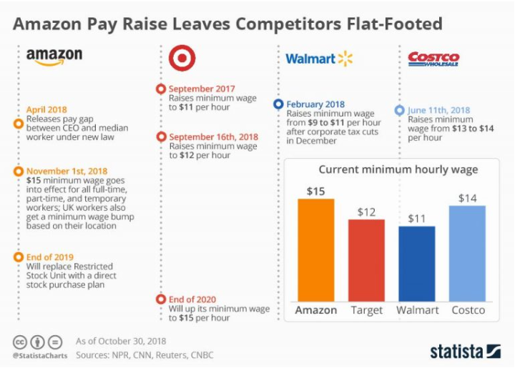
Figure 1: Amazon Pay rises with competitors
(Source: Feldman, 2018)
PESTEL analysis of Amazon
The PESTEL analysis is the tool that enables Amazon to identify and evaluate the external business environment that significantly affects the performance and growth of the country. The PESTEL analysis tool involves external factors that need to be identified to understand their respective impacts. The Political factors that impact the functions and operations of the company are political instability due to Brexit implications that created an uncertain environment for the organization. Amazon being a online retailer operates in several countries across the globe. Thus these political aspects impacting the countries interfere with its supply chain and thereby impact the business. The Economic factors also impact the business operations as the positive economic growth helps the organizations to flourish whereas the negative economic effect acts as a barrier to the business operations. COVID 19 has potentially affected the economic stability of the business across the world but the positive economic investment of the company over groceries and safety equipments significantly helped it to grow. Other economic factors that impact the organization are the competitors in the market but the company has potentially gained this advantage during the pandemic by its optimum customer service. Social factors also impact the business as the enhancing imbalance of the wealth act as a threat to the business (David, 2020). Enhancement of the needs of the consumers over online products and dependency on online buying habits for variety if things such as groceries, luxury items, health equipments and so on act as a opportunity to the organization.
The technological factors also drove the growth of the organization it enables the organization to be one of the largest online platform and powerhouse of the cloud computing. Technological advancements and efficiencies thus act positively over the organizational growth but it can affect the organization too as it enhances the competitiveness in the market. The environmental factors also influence the online company. Increase in the environmental consciousness as well as focus on the sustainability of the business act positively over the company. Enhancement of the prevalence in low carbon lifestyles also act as a opportunity for the business. The organization focuses on corporate social responsibility and this increases their competence in the market. The legal factors such as increase in regulation of goods and products as well as increase in regulations to protect the environment positively affect the company (David, 2020). The change in the legislations related to import and export owing to Brexit can affect the organizational operations.
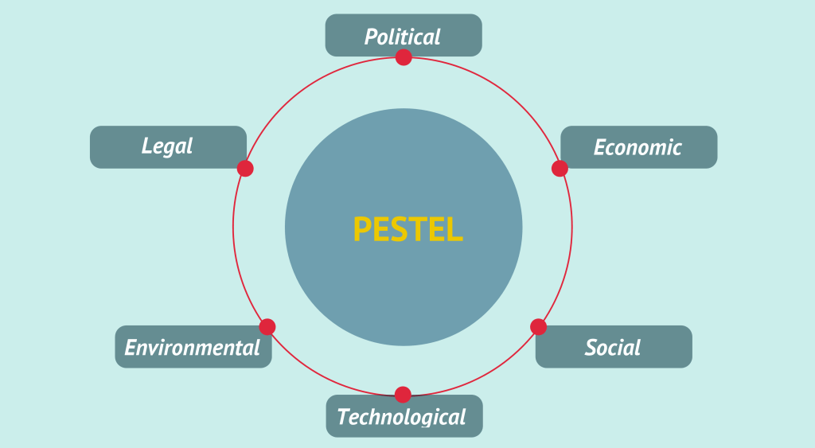
Figure 2- PESTEL factors impacting Amazon

Recommendations:
It can be recommended that consolidating the market dominance can be helpful for Amazon in growing their business. Moreover, dealing with global controversies by resolving tax issues and managing app’s features can also develop the strategic outcome. On the other hand, opening of more number of physical stores can be identified as a useful solution for growing business. Enlarging the gap between Amazon and its competitors can be possible with decision making process and effective solutions. Enhancing network security systems for protecting consumer rights can emerge an important productivity and distribution strategy. Moreover, addressing the issues of counterfeit sales and cybercrimes by upgrading technology measures can help Amazon for growing their business opportunities.
Porter’s 5 Forces of Amazon
Competitive rivalry (High): Retail firm with high brick-and-mortar presence such as Walmart is a strong competitor. Low switching cost also imposes strong force(Seturi and Urotadze, 2017).
Bargaining power of customers (High): High quality of information (string force); low switching cost (strong force); and high availability of substitutes (strong force)
Bargaining power of suppliers (Moderate): Small population of suppliers (strong force); medium forward integration (moderate force); and moderate size of suppliers (moderate force)(Bocigas Solar et al., 2020).
Threat of substitutes (High): Rivals like Walmart provides affordable products with high level of substitution which induces customers to change brand as per their need
Threat of new entrants (Low): The high brand value and image of Amazon automatically weakens the impact of new entrants on Amazon’s performance. The company also gets benefitted from high economies of scale making its e-commerce business way too strong.

Segmentation, targeting positioning
The STP strategy of Amazon is to ensure that the market is evenly distributed based on their needs and requirements. The company targets a huge population and is not limited to any group of individual or selective geographical regions. It caters to every place where the individuals can have an access to (KAWSWAT, 2017). Amazon is one of the largest retailers that caters to the various needs of the customers through an online platform and has gained the sole importance due to customer satisfaction.
After successfully implementing all the above factors, the companies are required to manage their efforts of marketing in order to achieve the various goals and objectives in the markets that they have targeted (Seturi and Urotadze, 2017). This is the stage where four management functions are being performed which includes the processes of analysis, planning, implementation and control.

The 4P’s Marketing Mix
Marketing mix is a bunch of controllable variables of marketing that helps the firms blend in to produce and satisfy the demands of the market that has been targeted. A marketing mix is being designed by the organisations in order to attain their objectives and goals with the help of delivering products of value and generating customer satisfaction (Riedel et al., 2021).
Product-Customer Solution
Price - Customer Cost
Place -Convenience
Promotion-Communication
Product: Amazon is an ecommerce platform that serves its customers with a huge range of products and services starting from kindle, jewellery, books, clothes, and so on. Amazon caters to a huge range of population globally and helps in generating customer satisfaction. It has a huge loyal customer base that prefers to shop online and get it delivered to their doorsteps (Jindal et al., 2021).With the help of continued expansion and diversification, the products of Amazon currently comprise not just online retail but also variety of other products addressing market needs such as retail goods and services, Amazon Prime, consumer electronics, Amazon Video, digital content distribution service, Amazon Web Services, Amazon Publishing, AmazonFresh, Amazon Dash, Amazon Prime Pantry, and Video Direct (Farahand Ramadan, 2017).
Place: With a huge employee base of skilled and talented individuals the company has been catering to the needs of various customers all across the world. They have a very strong online presence where the employees are friendly and serve the very needs and enquiries of the customers (Stadler, 2017).Amazon uses the following places/platforms to reach out to its potential e-commerce customers; Amazon Books, official e-commerce websites such as Amazon.com, Audible.com (a subsidiary), and a number of other sites possessing specific target markets. The annual AWS Summit held in various places allows Amazon in reaching out to potential customers and persuade them to pay for its e-commerce services (Lorenzo, 2017).
Promotion: Amazon chooses to promote its products through online digital platforms as well as traditional medium in order to reach out to its customers. It has also optimised its site so that the website has a high ranking in the search results and customers prefer to opt for the company’s website. The promotions of the products and services of the company are also being done through the word of mouth by the individuals who have made a purchase from the company’s official site (Jarek and Mazurek, 2019).Some of the promotional tactics and strategies implemented by Amazon are advertising, sales promotions, direct marketing and public relations. Amazon Smile is the company’s strongest public relations profile that donates a percentage of sales to charitable organisations. Amazon also utilised discounted sales to attract more no. of customers.
Price: Amazon is very competitive when it comes to its prices and manages to offer a better value for its products and services to gain customers who are loyal to the company. Having an effective competitive price for the products it offers to its customers, it has gained popularity within every part of the globe, further enhancing the competitiveness and generating customer satisfaction (Khorsheedet al., 2020).Some of the pricing strategies utilised by Amazon are market-oriented pricing strategy, price discrimination strategy and value-based pricing strategy.

Conclusion
With the above essay, it can be stated that the main purpose of marketing is to analyse and evaluate the different wants of the consumers in the market so that the organisation is capable of catering to the several needs and demands of the market. The marketing activities includes the process of researching the market, analysing the various factors that influences and impacts the activities of the business and having a proper insight of the interests of the customers. It has also further established that the fundamentals of marketing focus on many other aspects such as the development of the products, methods of distribution, sales and advertising the products to improve the functional aspects of the company along with improving its productivity and profitability. With the implementation of the different factors of the marketing environment and the usage of the technological aspects to foster growth and innovation increases the opportunity of the organisation to capture the market and increase its sales volume.

References
Baines, P., Fill, C., Rosengren, S. and Antonetti, P., (2017). Fundamentals of marketing.Oxford University Press.
Bergkvist, L. and Eisend, M., (2020). The dynamic nature of marketing constructs. Journal of the Academy of Marketing Science, pp.1-21.
Bocigas Solar, M.O., FernándezdelHoyo, A.P. and Martín García, D.F., (2020). Fundamentos de Marketing/Fundamentals of Marketing.
David, J., (2020). PESTEL analysis of Amazon. [online] Howandwhat.net. Available at: <https://howandwhat.net/pestel-analysis-amazon/> [Accessed 25 April 2021].
Farah, M.F. and Ramadan, Z.B., (2017). Disruptions versus more disruptions: How the Amazon dash button is altering consumer buying patterns. Journal of Retailing and Consumer Services, 39, pp.54-61.
Feldman.S (2018), Amazon Pay Raises Leave Competitors Flat-Footed . Available at: https://www.statista.com/chart/15949/amazon-hourly-wage/ (Accessed: 25 April 2021).
Jarek, K. and Mazurek, G., (2019). MARKETING AND ARTIFICIAL INTELLIGENCE.Central European Business Review, 8(2).
Jindal, R.P., Gauri, D.K., Li, W. and Ma, Y., (2021).Omnichannel battle between Amazon and Walmart: Is the focus on delivery the best strategy?.Journal of business research, 122, pp.270-280.
KAWSWAT, P., (2017). Exploring the marketing mix and service factors that influence Thai consumers' purchasing at cafe amazon in Thailand.
Khorsheed, R.K., Abdulla, D.F., Othman, B.A., Mohammed, H.O. and Sadq, Z.M., (2020). The Role of Services Marketing Mix 7P's on Achieving Competitive Advantages (The Case of Paitaxt Technical Institute in Kurdistan Region of Iraq). TEST Engineering and Management, 83, pp.15947-15971.
Lorenzo, L., (2017). Targeting International Customers in Japanese E-commerce: A Web Content Analysis of the Marketing Mix in Rakuten and Amazon.co. jp.
Riedel, A.S., Lawley, M. and Birch, D., (2021). Communication channel efficiency across the early lifecycle stages of a brand. Journal of Strategic Marketing, pp.1-13.
Seturi, M. and Urotadze, E., (2017).About Marketing Process Model and Relationship Marketing.In Proceedings of International Workshop „Model-Based Governance for Smart Organizational Future (pp. 169-171).
Stadler, D., (2017), December.AMAZON CASE STUDY DRIVING CUSTOMER EQUITY.In NierNATſon Al conference (p. 276).
Zozul'ov, O. and Tsarova, T., (2020).The marketing epochs by key elements of enterprisecompetitiveness.Economic bulletin of National technical university of Ukraine «Kyiv polytechnic institute», 1(17).

