Personal Digital Identity Management

Introduction
This essay will explore the differences in the Personal Digital Identity Management of one of the most powerful leaders in the world to a normal social media user across digital platforms. This essay will also provide analysis on how each of them build on their personal brand in order to reach future goals, what they do well and where improvement is needed. Donald Trump is someone who has built a strong personal brand on social media which has provided many opportunities for him to capitalise on, one of which was becoming the 45th President of the United States of America. Kelly Lewis Bennett is a student studying Rural enterprise at Carmarthen business school, she is also a director of a sporting organisation (BTAC. 2020).

Digital Identity
A Digital identity is made up of an individual’s characteristics or data attributes such as a Username and password, Date of birth, Social security number, Medical history, Online search activities, interests, purchasing history or behaviour. Digital identity can be defined as all the online information and data specifically about an individual. A digital identity is made up of four categories of information.
*Data authentication elements - email address, username, password, last name, first name, IP address,
*Personal data - administrative, occupation, banking details, social data.
*Identifiers -photograph, logo, image, avatar.
*Digital traces - contributions to online platforms, content on social media, YouTube, Wikipedia, search engines, locations you’ve visited (Yees. 2015).
In the digital world, governments, banks, healthcare organizations, and commercial entities, from phone companies to Internet giants such as Google, Facebook, Twitter collect, use, and share parts of our identity for our benefit and their own. As a result, in some ways, you are not in control your digital identity. This lack of control or ownership is a major contributor to the digital identity crisis, because it creates an environment of uncertainty, mistrust, and fear (moodle book).
Digital footprint
Every time you do something involving the internet you leave a trace of your activity, this is known as your digital footprint. Your digital footprint grows with time as all of your ongoing internet activity accumulates. “It's the data you leave behind when you go online. It's what you've said, what others have said about you, where you've been, images you're tagged in, personal information, social media profiles, and much more.” (Institute for Academic Development. 2017).
Social media Advertising
Social media advertising will build your brand awareness significantly, it makes people aware of what you have to offer and provides a wide target audience. It is thought that the more familiar people are with your brand the more likely they will be to purchase your product or service. It is also the most cost-effective form of advertising and creates an opportunity to reach a wider target audience through evangelism (lyfe marketing. 2019).
Personal Brand
It is thought that, an individual’s personal brand is a promise of value and performance, it is necessary to meet the expectations of your audience. Effective brand management is a key component to maintaining a positive brand reputation (Philbrick. L. J. 2015).
Donald Trump represents wealth and success, a businessman, property developer, reality T.v star as well as 45th President of The United States of America. His experience as a high -profile businessman allowed him to use marketing skills that helped him win an election and gain a following of people that serve as his political supporters. With each new venture he takes on it allows his personal brand to grow. His willingness to speak his mind on controversial topics often generates attention from the public whether positive or negative and encourages people to become emotionally invested. Some believe he provides a voice to the feelings of millions of people in America….(ref). However, not everyone agrees with his views and at times some find his behaviour questionable.
Kelly is a director of a sporting organisation, her role and expertise are fundraising and co-ordinating new business (BTAC. 2020). However, there is little information of these skills on her personal social media, this prevents her from building on her personal Brand and could result in her missing out on future employment opportunities and achieving future goals.
Social Media Platforms
Social media platforms are changing the way we do business and how we are perceived as individuals. According to a Harvard business school review, today's leaders must embrace social media for three reasons, First, they provide a low-cost highly accessible platform on which to build a personal brand, communicating who you are both within and outside your company. Secondly, they allow you to engage rapidly and simultaneously with peers, employees, customers in order to develop relationships, it also demonstrates the individual’s commitment as well as providing opportunities for reflection. Third, they provide an opportunity to access and learn from instant information (Dutta. S. 2010)
Donald Trump Joined Twitter in 2009 he’s used the social media platform to build his brand and uses it to communicate with his four million…..followers. It is thought that he calls it his own personal newspaper. (Barbaro. M…….).
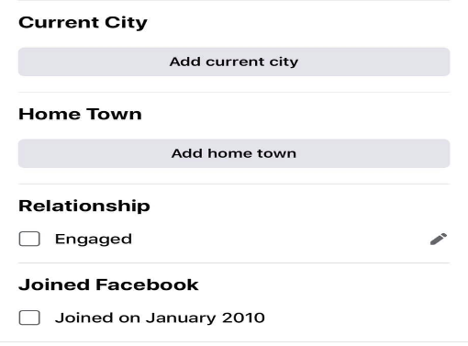
As visible in the image Kelly joined Facebook in 2010. She created the platform to communicate socially with family and friends and understandably hadn’t considered using the platform to build her personal brand in the same way as Donald Trump did.
When forming a personal digital brand across social media platforms it is important to consider which online platforms are best to promote yourself on such as, Facebook, Twitter or Linked in. To build a professional personal brand it is essential to consider the following steps.
*Determine your personal brands identity – Promoting an individual’s strengths, values and commitments builds on their personal brand, promoting the individuals story attracts emotional interest form others who share the similar values. Donald Trump’s expertise are in real estate, sport and politics which he promotes across his social media.
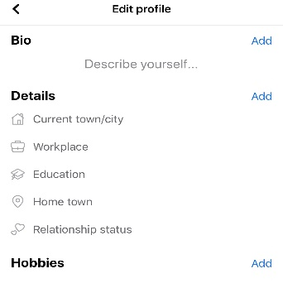
Kelly, however, doesn’t use social media to promote her personal strengths and values, this can cause a false perception of who she really is. Kelly could build on her personal brand by updating and promoting her skills in the “About” section of her profile.

*Determine which platform is best to use – While Donald Trump uses a number of different platforms to promote himself and his goals on such as, Twitter, Facebook and linked in, while Kelly only uses Facebook. Taking advantage of a number of platforms allows Donald Trump to generate a wider target audience. Kelly however limits herself to one platform, Facebook.
*Image – It is essential to use a professional profile picture. It is important to consider every aspect including the background colour which enable the image to stand out.
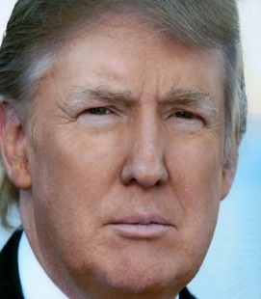
Donald Trump uses the same Image across each of his social media plat forms. A professional photo with a blue background enabling his image to stand out.

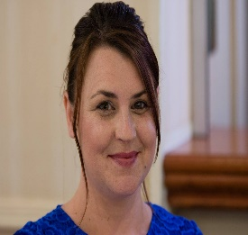
Kelly’s profile image on Facebook is less professional, although she does appear presentable.

* Promote Goals and Objectives - Stating your personal and professional goals and objectives publicly will provide justification as to the importance of your values, service or message.
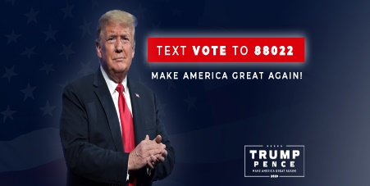
Donald trump promotes and markets his goals throughout his social media platforms, one example is his desire and promise to “Make America great again” in his position as the President of the united states of America. This enables him to generate a wider target audience.
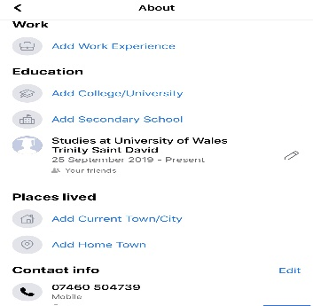
Kelly hasn’t included any previous or current employment details or personal goals or interests in her “About” section therefore it is difficult to gain an understanding of who she is or what her values and expertees are. The only information provided is the university she currently studies at.

*Engagement and consistency – It is thought that, “Active participation in social media can be a powerful tool, it can be the difference between leading effectively and ineffectively, and between advancing and faltering in the pursuit of your goals” (Dutta. S. 2010). Donald Trump is currently campaigning to become re-elected in the 2020 election. He is currently engaging with his followers by tweeting and updating his goal and objectives across social media platforms, he is also reminding his followers of the achievements he’s gained while in power as president such as, “ As the 1st President to formally recognize the issue of Missing & Murdered Native Americans, today, I was proud to sign Savanna’s Act & the Not Invisible Act. We have also provided $295 Million to support public safety & crime victims. Forgotten NO MORE!” (Trump. 2020).
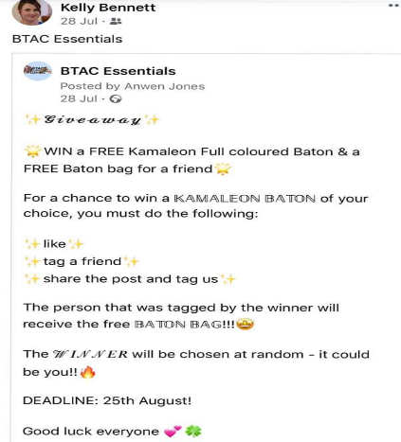
Kelly only uses social media to engage with her family, friends and colleauges socially any status updates are with regards to her personal life. Although, she also updates and shares opportunities and achievements connected the organisation she works with.
*Reputation - Your behaviour both online and off is extremely important to how you want to be publicly perceived, which can sometimes have devastating impacts on the reputation off the business and goals your trying to achieve. Content you put out and how you interact online such as commenting on controversial topics could create a false perception of the goals your aiming to achieve. Therefore, it is important to think before sharing any content you update and to always conduct yourself in a professional manner. A good reputation is essential in achieving success in business and in reaching your future goals. Donald Trump utilises his social media platforms to actively share his views, however controversial. This allows him to engage with an audience. Donald Trump is authentic, and that’s the most important aspect of personal branding. Confidence, arrogance and thinking big have always been a part of who Donald Trump is. These are not new traits that are being introduced just for the sake of the Presidential race, Donald Trump is true to who he is. (Aruuda. W. 2015). It would be unacceptable for Kelly to behave in this way publicly or on her personal social media account as she is governed by the rules of the constitution of the organisation she works for. Kelly also has different values compared with Donald Trump.

Conclusion
It is clear to see that Donald Trump currently uses social media platforms for political gain, especially Twitter as it is one of his primary means to communicate with voters. It is thought that an American presidential candidate had never attempted personal use of social media platforms of this magnitude ever before, though past presidents had adopted other technologies to win tough presidential races (Johnson. J. S. 2018). By utilising his knowledge of marketing skills across his social media platforms, he was able to win an election and build his personal brand as one of the most powerful leaders in the world. It is suggested that a large factor in Trump’s rise in politics is the leader follower dynamics of his target audience which enabled him to win an uncritical and devoted following. In Kelly’s case it is obvious that she has not considered using social media to build her personal brand or promoter her personal skills, or even to generate a target audience. This could potentially prevent her from achieving future goals and objectives such as employment opportunities. They both have different reasons for using social media platforms, Trump uses it to build his brand while Kelly uses it to communicate socially with family and friends. The amount of data collected on Donald Trump’s Digital Identity or digital footprint due to developing a strong personal brand through the use of his use on digital platforms would be considerably greater than the data collected on Kelly.

References
Aruuda. W. (2015). 6 Personal branding lessons we can learn from Donald Trump https://www.forbes.com/sites/williamarruda/2015/12/20/six-personal-branding-lessons-we-can-learn-from-donald-trump/#2eaf97d0be82
Barbaro. M. (2015). The New York Times. How Donald Trump Uses Twitter (Hint: Impulsively) https://www.nytimes.com/2015/10/06/us/politics/how-donald-trump-uses-twitter.html
BTAC. (2020). BTAC. Meet The Team https://www.nbtacymru.co.uk/?lightbox=dataItem-jnzr70ve
Digital footprint. (2017). https://www.ed.ac.uk/arts-humanities-soc-sci/about-us/academic-digital-footprint
Yees. (2015). Guides for teachers and trainers. Personal Digital Identity. https://yees.pixel-online.org/documents/guides-for-teachers-and-trainers/Persona%20Digital%20Identity_ENG.pdf
Moodle book
Dutta S. (2010). Harvard Business Review. What's your personal social media strategy? https://europepmc.org/article/med/21049685
Goethals. R. G. (2017). Leadership. Almost “Nothing New Under the Sun”: American politics and the election of Donald Trump. https://journals.sagepub.com/doi/abs/10.1177/1742715017724533
Johnson. J. S. (2018). Donald Trump, Disruptive Technologies, and Twitter's Role in the 2016 American Presidential Election. https://heinonline.org/HOL/LandingPage?handle=hein.journals/wjpl27&div=7&id=&page=
Smith. M. (2020). The Mirror. Facebook and Twitter crack down as Donald Trump claims Covid-19 less deadly than flu https://www.mirror.co.uk/news/politics/facebook-twitter-crack-down-donald-22804167
Image https://twitter.com/realDonaldTrump/photo
Philbrick. L. J. (2015). Personal Branding: Building Your Pathway to Professional Successhttps://www.tandfonline.com/doi/citedby/10.1080/02763869.2015.1019324?scroll=top&needAccess=true
Lyfe Marketing. (2019). Blog. Facebook advertising benefits

Image Donald trump https://www.facebook.com/DonaldTrump/photos/a.10151443611915725/10165461741635725/?type=1&theater
Screenshot 1 Work (2020). Facebook. About. https://www.facebook.com/photo?fbid=3736865369679768&set=pcb.3736865979679707
current city screenshot https://www.facebook.com/photo?fbid=3736865286346443&set=pcb.3736865979679707
https://www.facebook.com/DonaldTrump - Donald trump fb

