

Wireless Networks and Simulation (Carlene) (ACCB5004)
Design and Evaluation of Wireless Sensor Networks
Shaun Holborow (1704229)
Course: Computer Networks and Cyber Security
Faculty name: SOAC
Date of Submission: 17th August 2020

Contents
2 Abstract 3
3 Introduction 3
4 Related Work 3

4.1 Functions of Modulation: 3

4.2 Fundamentals of chosen Modulation Technique 4
5 Problem Formulation 4
6 Implementation 4
7 Results/Findings and discussions 4
8 Conclusion 4

8.1 5
9 References: 5

Figure 1 - Analog Signal[2] 4
Figure 2 - Digital Signal[2] 4

Abstract

This report has looked into the various modulation schemes of choice for the task at hand mainly BPSK, QPSK and QAM with a review and justification for said chosen modulation technique as it related to the simulation method of the design.
The conclusion was that

Introduction

When it comes to wireless networks, various technologies are required in order to design and implement said networks. This requires sound understanding of the role, concepts and principles surrounding computer network simulation before simulation models can be created, configured by protocol, tested and finally analysed critically to ensure that said networks meet the real world requirements of simulation tools.
For this to be achieved, research and evaluation of available modulation schemes is required before the design and implementation of a Wireless Sensor Network (WSN) can be done to understand the differences of each scheme in terms of performance.

Related Work

Functions of Modulation:

Part of communication systems is modulation which is the process of changing the properties of a periodic waveform known as "carrier signal" with a modulating signal that usually contains information to be transmitted, radio stations for example use FM (Frequency Modulation) or AM (Amplitude Modulation) to broadcast these radio waves.[1]
Modulation comes in two types, analogue and digital. Analog signal is a continuous time varying signal whereas a Digital signal is a discrete/non-continuous.[2]
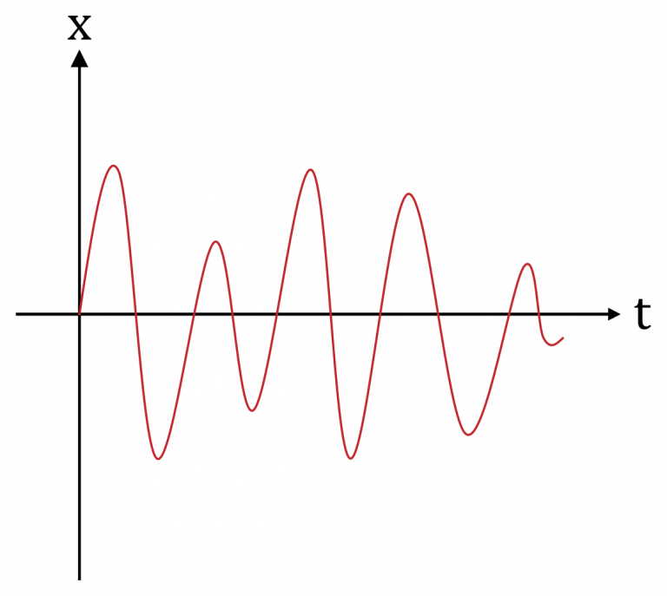
Figure 1 - Analog Signal[2]
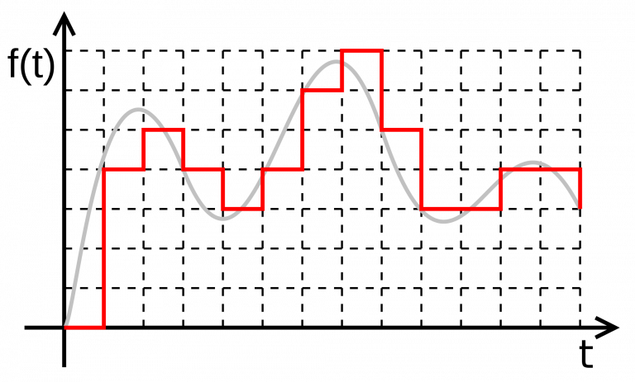
Figure 2 - Digital Signal[2]

Fundamentals of chosen Modulation Technique

For the author to proceed with the experiment, a modulation technique had to be chosen from a list of 3, the choices were BPSK(Binary Phase Shift Keying), QPSK(Quadrature Phase Shift Keying) or QAM(Quadrature Amplitude Modulation).

The author decided to go with the modulation technique QAM with the main reasoning being the prior experience from using it as well as its pros like lower SNR, better spectral efficiency etc.

Implementation

In order to provide a suitable implementation/design for said modulation scheme, appropriate simulation software was required thus Photoshop was deemed appropriate for this task and was used to create said implementation.

Results/Findings and discussions

Conclusion

In conclusion

References:

[1]"Types of Modulation : Analog And Digital Modulation", WatElectronics.com, 2020. [Online]. Available: https://www.watelectronics.com/types-of-modulation-techniques-with-applications/. [Accessed: 05- May- 2020].
[2]"What are Analog and Digital Signals, and Their Differences", ElProCus - Electronic Projects for Engineering Students, 2020. [Online]. Available: https://www.elprocus.com/differences-between-analog-signal-and-digital-signal/. [Accessed: 05- May- 2020].

http://castalia.npc.nicta.com.au/.Google Scholar
Mistlab website. http://mistlab.csail.mit.edu/.Google Scholar
I. Akyildiz, W. Su, Y. Sankarasubramaniam, and E. Cayirc. A survey on sensor networks. Communications Magazine, IEEE, 40(8):102--114, 2002. Google ScholarDigital Library
D. Cavin, Y. Sasson, and A. Schiper. On the accuracy of manet simulators. In POMC '02: Proceedings of the second ACM international workshop on Principles of mobile computing, pages 38--43, New York, NY, USA, 2002. ACM Press. Google ScholarDigital Library
D. Curren. A survey of simulation in sensor networks. http://www.cs.binghamton.edu/ kang/teaching/cs580s/david.pdf.Google Scholar
E. Ertin, A. Arora, R. Ramnath, V. Naik, S. Bapat, V. Kulathumani, M. Sridharan, H. Zhang, H. Cao, and M. Nesterenko. Kansei: a testbed for sensing at scale. In IPSN '06: Proceedings of the fifth international conference on Information processing in sensor networks, pages 399--406, New York, NY, USA, 2006. ACM Press. Google ScholarDigital Library
C. P. from Texas Instrument. CC2420 datasheet. 2003.Google Scholar
G. P. Halkes, T. van Dam, and K. G. Langendoen. Comparing energy-saving mac protocols for wireless sensor networks. Mob. Netw. Appl., 10(5):783--791, 2005. Google ScholarDigital Library
D. I., E. C., and F. Alagoz. Mac protocols for wireless sensor networks: a survey. Communications Magazine, IEEE, 44:115--121, 2006. Google ScholarDigital Library
S. Ivanov, A. Herms, and G. Lukas. Experimental validation of the ns-2 wireless model using simulation, emulation, and real network. In 4th Workshop on Mobile Ad-Hoc Networks (WMAN'07), 2007.Google Scholar
D. Kotz, C. Newport, R. S. Gray, J. Liu, Y. Yuan, and C. Elliott. Experimental evaluation of wireless simulation assumptions. In MSWiM '04: Proceedings of the 7th ACM international symposium on Modeling, analysis and simulation of wireless and mobile systems, pages 78--82, New York, NY, USA, 2004. ACM Press. Google ScholarDigital Library
K. Langendoen and N. Reijers. Distributed localization in wireless sensor networks: a quantitative comparison. Comput. Networks, 43(4):499--518, 2003. Google ScholarDigital Library
C. Mallanda, A. Suri, V. Kunchakarra, S. S. Iyengar, R. Kannan, A. Durresi, and S. Sastry. Simulating wireless sensor networks with omnet++.Google Scholar
P. Naik and K. M. Sivalingam. A survey of mac protocols for sensor networks. pages 93--107, 2004. Google ScholarDigital Library
J. Polastre, J. Hill, and D. Culler. Versatile low power media access for wireless sensor networks. In SenSys '04: Proceedings of the 2nd international conference on Embedded networked sensor systems, pages 95--107, New York, NY, USA, 2004. ACM Press. Google ScholarDigital Library
J. Polastre, J. Hui, P. Levis, J. Zhao, D. Culler, S. Shenker, and I. Stoica. A unifying link abstraction for wireless sensor networks. In SenSys '05: Proceedings of the 3rd international conference on Embedded networked sensor systems, pages 76--89, New York, NY, USA, 2005. ACM Press. Google ScholarDigital Library
N. Ramanathan, E. Kohler, and D. Estrin. Towards a debugging system for sensor networks. Int. J. Netw. Manag., 15(4):223--234, 2005. Google ScholarDigital Library
A. Varga. The omnet++ discrete event simulation system. In European Simulation Multiconference (ESM'2001), 2001.Google Scholar
A. Varga. OMNET++ Discrete Event Simulation System User Manual. 2006.Google Scholar
S. Wang, K. Liu, and F. Hu. Simulation of wireless sensor networks localization with omnet. In Mobile Technology, Applications and Systems, 2005 2nd International Conference on Mobile Technoloy, Applications and Systems, 2005.Google Scholar
G. Werner-Allen, P. Swieskowski, and M. Welsh. Motelab: a wireless sensor network testbed. In IPSN '05: Proceedings of the 4th international symposium on Information processing in sensor networks, page 68, Piscataway, NJ, USA, 2005. IEEE Press. Google ScholarDigital Library

