BMSW4011
Managing Enterprise
Task 1: Part 1 & 2

Student ID: 2421416
Student name: Silviu Ciobotaru

Table of Contents
Part 1: Business Plan 4
Introduction 4
Main Analysis 5
Description of the product/ service proposition 5
Explanation on “The Story” of your idea 5
Types of business ownership 6
Mission statement, aim and 4 SMART objectives (USP) 6
Physical 9
Human resources 9
Marketing activities 10
Market research 12
Primary research 12
Secondary market research 14
Financial resources 15
Conduct a competitor analysis 17
Illustration of business idea using SWOT model 17
Conclusion 18
Part 2: Individual reflection 19
Introduction 19
Main analysis 20
Gibbs reflection cycle 20
Conclusion 22
Reference List 23
Appendices 25
Appendix 1: 7Ps of marketing 25

Part 1: Business Plan

Introduction
A business plan is developed to highlight the proposed solutions to the targeted services holders or customers. According to Barringer (2008), a business plan is a documentation to highlight the core objectives and operations strategies to fulfil the demand of the target market. The purpose of this assignment is to highlight the operational considerations, demand of the services and competitor analysis of Ecoharmony homecare.

Figure 1: Company logo

Main Analysis

Description of the product/ service proposition
The business idea will be providing homecare services to the patients of Scotland. The homecare services will be provided to the patients to cure their physical, mental health issues. As stated by Sun and Li (2023), dementia, Alzheimer's, obesity and other chronic diseases are considered common physical and mental health issues suffered by the people. The patient care services will be provided at the doorstep of the people of Scotland. The sustainability initiatives for the environment will be the uniqueness of this business in which Ecoharmony uses biodegradable medical equipment and eco-friendly vehicles for transportation to the place of patients.

Explanation on “The Story” of your idea
The healthcare services at home are important to foster the independence of patients and boost the speed of recovery through delivering patient centric care. Commented by Sánchez-Torrijos et al. (2022), the hospitalisation invites the risk of the infections and side effects among the patient. The homecare patient service influences in maintaining proper nursing care with maintaining proper cleanliness, which promotes the fast recovery of the patient.
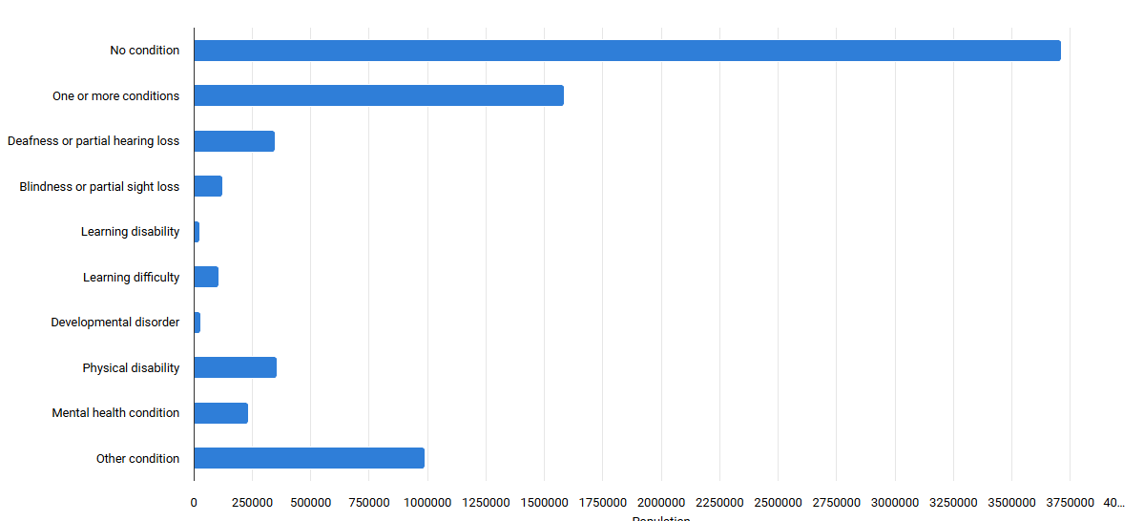
Figure 3: Long-term health conditions in Scotland
(Source: Scotlandscensus, 2025)

The Scottish people are highly suffering with the physical and mental issues which are depicted in the figure 3 (Scotlandscensus, 2025). Personal care at home is important for healthcare professionals to analyse the health issues and needs of patient centric care (Kröger, 2022). Therefore, this social issue related to physical and mental health issues of the patient from old and young age is identified as a “The Story” behind the establishment of the business. I am passionate about resolving social care related issues such as mental and physical illness.

Types of business ownership
Sole trader will be the selected type of business ownership for Ecoharmony Homecare, which facilitates in providing homecare services to the patient. Business ownership is categorised in different types such as sole trader, partnership, limited liability partnership, limited companies, franchise and social enterprise that fosters in establishing a business (Sorvisto et al., 2022). In this context, solar trader is a person who set-up a business based on the analysis of the community problems (MAKUDZA et al., 2022). This ownership type will be suitable in terms of initiating the business and providing homecare services to the patients suffering from mental and physical health issues.

Mission statement, aim and 4 SMART objectives (USP)
Mission statement: The mission of Ecoharmony Homecare will be to provide healthcare services at the doorstep of patients based on the online and offline bookings.
Aim: The aim of this business is to offer best homecare services in Scotland, which fosters the fast recovery of the patients.

Objectives:
SMART Objective includes specific, measureable, achievable, and relevant and time bound factors to achieve the goals (Swaidi and Jumaan, 2023).
Objective 1 | To increase the sales by 4% in each month of first year
Specific | It will be important provide patient centric care to increase sales
Measurable | It will increase the retention of patients by 3% in the first year
Achievable | This objective will be achieved by delivering services through online and offline medium
Relevant | This objective is relevant to capture 4% of sales increment within 1 year
Time bound | 12 months

Objective 2 | To hire medical professionals to provide healthcare services to the patient
Specific | The international and domestic consultancy will be acquired to hire medical professionals
Measurable | The increment of positive feedback will identified by 6%
Achievable | This objective will be achieved through increasing retention rate of 90% of medical professionals
Relevant | This objective will be relevant to hire experienced medical professionals
Time bound | 12 months

Objective 3 | To develop a regular client base of minimum 30 old and young age people
Specific | The patient centric care will be provided at the home of patients to improve retention
Measurable | This objective will be measured by increasing retention rate of patient by 30%
Achievable | This objective is achievable by maintaining cleanliness and involvement of experienced medical professionals
Relevant | This objective will be relevant to increase 20% of client based in first month
Time bound | 12 months

Objective 4 | To expand the business in 20 locations of Scotland for next 5 years
Specific | The expansion of the business will be achieved in 20 locations of Scotland through opening new branches
Measurable | This objective measured through identifying the acceptance of homecare services to the patients of Scotland
Achievable | This objective will be achieved through measuring the 15% increment in market share in Scotland
Relevant | This objective will be relevant to expand its business in next 12 months
Time bound | 12 months

USP: “Commitment to health and environment is our priority”

Physical
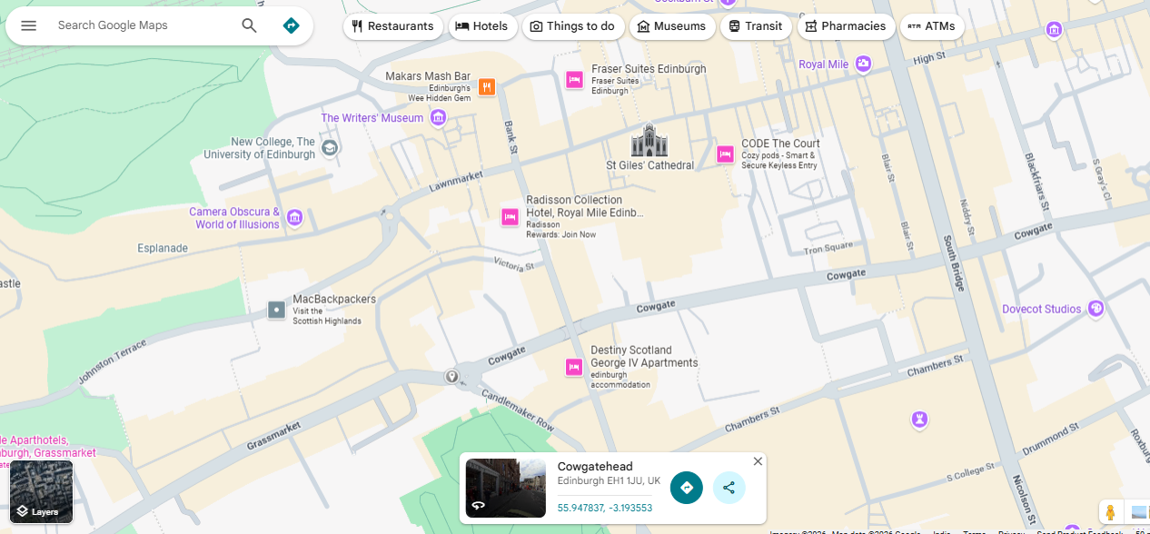
Figure 4: Location of Cowgate, Edinburgh, Scotland
(Source: Google Maps, 2021)
The location of this business will be Cowgate, Edinburgh, Scotland that is the busiest location in Scotland. This location will be suitable as it will be beneficial to promote and highlight the services of Ecoharmony Homecare to the patients through establishing a physical healthcare centre.

Human resources
The 30 people including nurses, clinical and doctors will be employed with the business of Ecoharmony Homecare to provide quality healthcare services at doorstep. According to Boselie and van der Heijden (2024), human resources are identified as key stakeholders to manage the operations of the firm. The acquisition of consultancy and recruitment organisations will be beneficial to acquire experienced healthcare professionals. The role of consultancy will be to analyse the experience of the medical professionals such as doctors and nurses to appoint with the business of Ecoharmony Homecare. The organisation chart is depicted below,
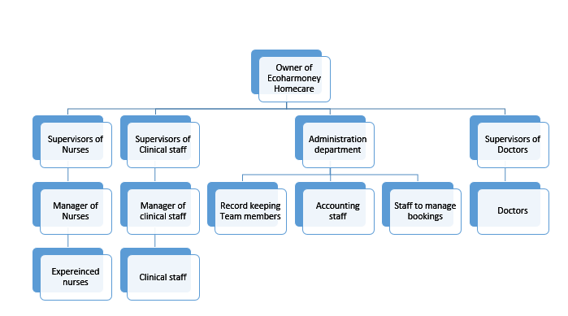
Figure 5: Organisational chart

Marketing activities
The social media marketing will be used in terms of promoting the homecare services to the targeted audiences to increase their sales [Refer to Appendix 1]. As stated by Kotler (2012), marketing is a practice in terms of promoting the products and services to the targeted audiences. The Ecoharmony Homecare will design flyers and Facebook launch posts in terms of delivering the homecare services to the patient.

Flyers

Figure 6: Flyers for Ecoharmony Homecare
Facebook launch post
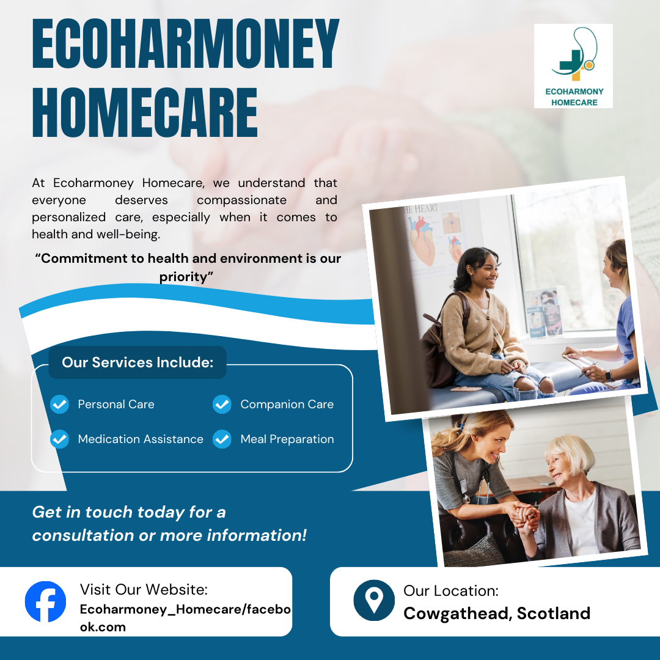
Figure 7: Facebook launch Post

Market research

Primary research
Primary research is a process to collect original information to generate authentic findings for the study (DePoy, 2024). The findings of primary research is presented below,
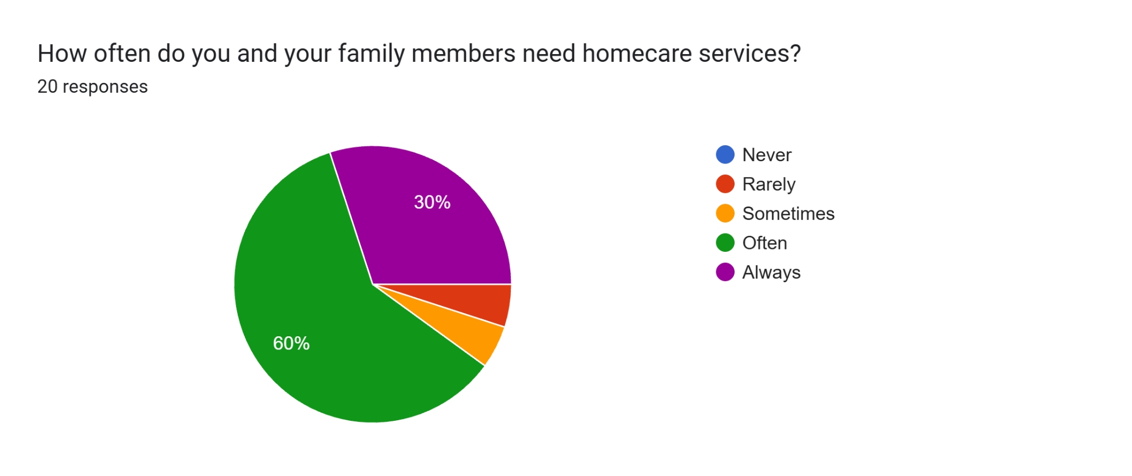
Graph 1: Question 1
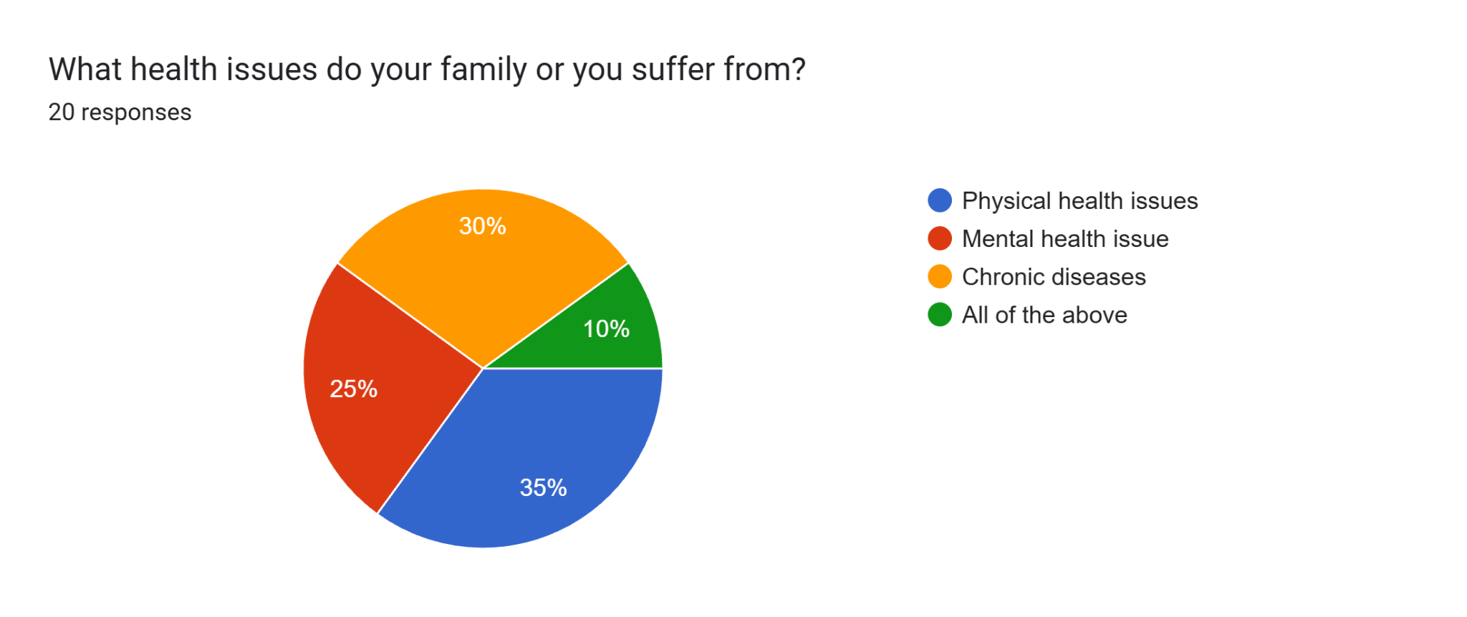
Graph 2: Question 2
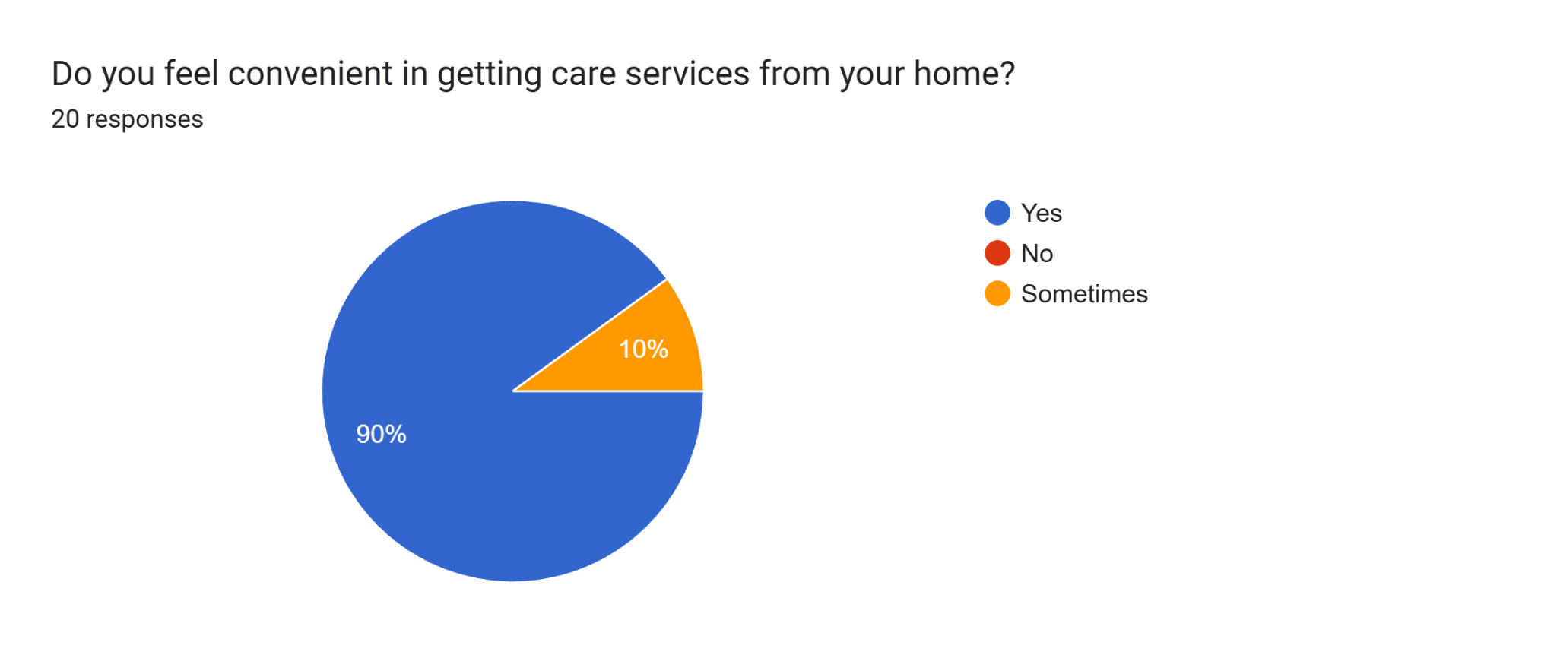
Graph 3: Question 3
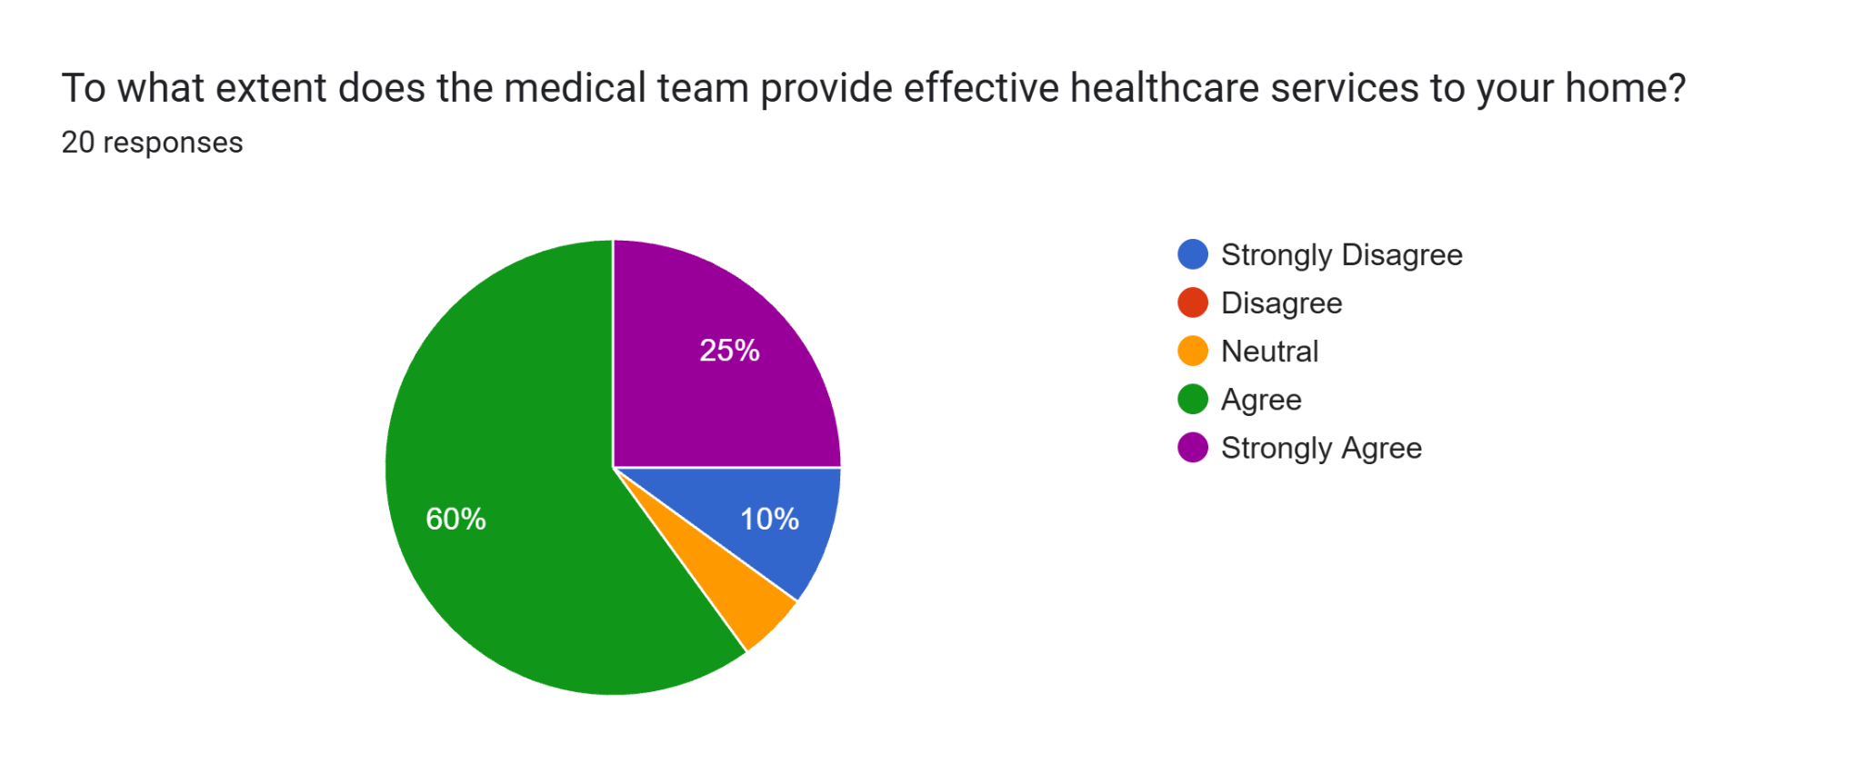
Graph 4: Question 4
The primary research has been conducted with 20 family members of patients of Scotland. As per the primary research findings, Ecoharmony Homecare will deliver significant value as the presence of high demand of homecare in Scotland.

Secondary market research
Secondary market research is performed by accessing statistical information from the existing journals and authentic websites relevant to the mental and physical health issues of Scottish people.
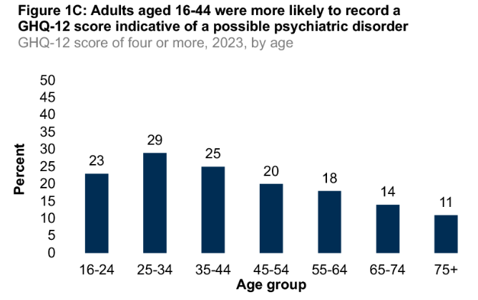
Figure 8: Percentage of psychiatric disorders in the Scotland
(Source: Scottish Government, 2024)
As per the above figure, 25-34 and above 65 age groups of people are suffering with physical and mental health issues in Scotland (Scottish Government, 2024). This insight will increase the demand of homecare among the people of Scotland for fast health recovery.
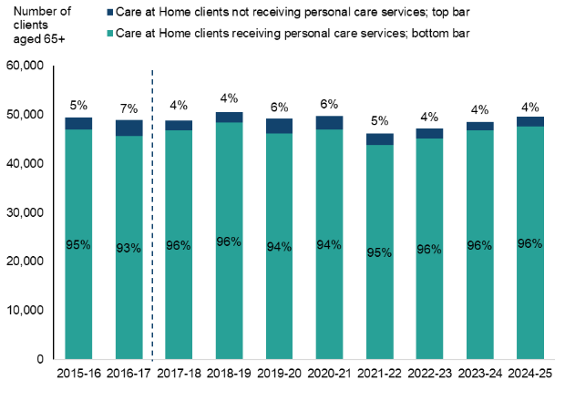
Figure 9: Requirement of care at home
(Source: Scottish Government, 2025)
As per the above figure, the demand and preferences of Scottish people for home care services is increased (Scottish Government, 2025). This insight influenced Ecoharmony Homecare to introduce this homecare service.

Financial resources
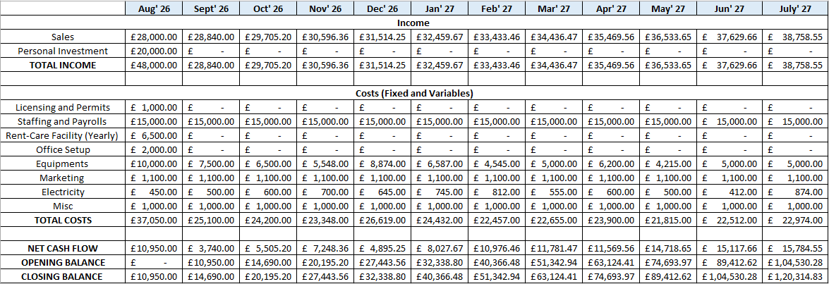
Figure 9: Financial projection
As per the above financial projection, the own investment of £20,000 will be initiated for the business of Ecoharmony Homecare. The own investment will be the initial source of finance as this business follows the sole trade ownership style.
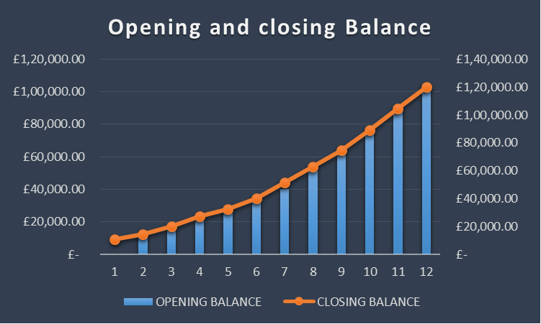
Figure 10: Opening and closing balance

Figure 11: Net cash flow
The incremental nature of cash flow will be identified for Ecoharmony Homecare, which is realistic and feasible as the growing demand of homecare services in Scotland.

Conduct a competitor analysis
Competitors | Business model | Pricing | Learnings
Home Instead | Online and offline | Competitive pricing | Consideration of the strategies of competitors
Bright Care | Online and offline | Value based pricing | Include innovation and uniqueness in business

Illustration of business idea using SWOT model
Strengths | Weaknesses
Presence of expert human resources  Commitment in patient centred care  Sustainability framework | Poor financial stability
Opportunities | Threats
Opportunity to utilise sustainability framework to attract clients  Expansion of business in multiple branches in Scotland | High competition in Scotland

As per the findings of SWOT model, this business will be viable due to the presence of high demand of homecare services and strength of experts and sustainability framework of Ecoharmony homecare.

Conclusion
It can be concluded that the business idea is to provide homecare services to the patients of Scotland who suffered with the physical and mental health issues. This business will be established with the help of sole trader ownership to establish homecare business in Scotland.

Part 2: Individual reflection

Introduction
The purpose of this reflection is to identify the new and existing entrepreneurial skills that developed through the lecture series. This reflection follows the stages of Gibbs reflective model to illustrate the learnings from the module.

Main analysis

Gibbs reflection cycle
Description
I participated in the module of managing enterprise in which I got an opportunity to analyse the different types of business ownerships and processes to generate creative business ideas. I developed my knowledge related to the financial cash flow, which helps me in identifying the required funds for establishing a business.
Feelings
Identification of new and existing entrepreneurial skills
I accessed multiple lecture materials during the module session in which I gained an idea about the process to become self-employed. I realised that critical thinking, entrepreneurship, and problem-solving abilities are my existing skills that fosters in improvement of entrepreneurial skills. I developed knowledge about marketing plans, which facilitates in identifying the promotional strategies and identification of the target audiences for the newly established business. I developed an idea about the process of cash flow chart development. The development of cash flow including fixed and variable costs enabled me to prepare the financial projections for the new start-up business.
Evaluation
I gained a good experience in terms of participation in this module, which helped me to develop my financial analysis and marketing skills. I participated in an assessment session in which I was appointed to develop a creative business idea and develop a business plan to attract investors. However, I faced difficulties in terms of performing effective communication with the team members, which created conflict in the workplace. This experience was bad for me in terms of participating in the assessment session.

Analysis
Skills and knowledge have the biggest impact on me and why?
Participating in the module session, I gained knowledge about the financial projections and marketing strategies. The improvement of knowledge about financial projection and marketing strategies will positively affect the improvement of my entrepreneur skills. It will be helpful for me to establish my business in the future by brainstorming creative ideas and solutions on social issues.
Conclusion
It is concluded that I developed my creative thinking, problem-solving abilities that foster my entrepreneurship skills. However, I need to improve my conflict resolution and communication skills along with the knowledge of financial projections and marketing strategies.
Action Plan
Skill to be developed | Strategies | Timeframe (Days)
Communication | It will be important to participate in the group discussion session to increase my fluency in communication. | 20
Conflict resolution | The participation in the interaction session with the team members will foster in resolving conflict between the team. | 15
Knowledge about financial calculations | It will be important to access YouTube Videos and books on financial calculations topics such as cash flow, projections, start-up and variable costs to improve my knowledge of financial calculations. | 30

Conclusion
It is concluded that my current skills are critical thinking and problem solving, which helps me to generate creative business ideas to resolve social problems. The improvement of knowledge related to financial calculation, skills related to conflict resolution and communication will be important to improve my entrepreneurship skills.

Reference List
- Barringer, B.R. (2008). The truth about starting a business. FT Press.
- Boselie, P. and van der Heijden, B. (2024). Strategic human resource management: A balanced approach. McGraw Hill.
- DePoy, E. (2024). Introduction to research-e-book: Understanding and applying multiple strategies. Elsevier Health Sciences.
- Google Maps (2021). Google Maps. [online] Google Maps. Available at: https://www.google.com/maps/@55.9486596 [Accessed 13 Feb. 2026].
- Kotler, P. (2012). Kotler on marketing. Simon and Schuster.
- Kröger, T. (2022). Care poverty: When older people’s needs remain unmet (p. 250). Springer Nature.
- MAKUDZA, F., MANDONGWE, L. and MURIDZI, G. (2022). Towards sustainability of single-owner entities: An examination of financial factors that influence growth of sole proprietorship. The Journal of Industrial Distribution & Business, 13(5), pp.15-26. https://koreascience.kr/article/JAKO202214034579119.pdf
- McLeod, S. (2025). Gibbs Reflective Cycle. [online] Simply Psychology. Available at: https://www.simplypsychology.org/gibbs-reflective-cycle.html [Accessed 13 Feb. 2026].
- Scotlandscensus (2025). Scotland’s Census at a glance: Health. [online] Scotland’s Census. Available at: https://www.scotlandscensus.gov.uk/census-results/at-a-glance/health/ [Accessed 13 Feb. 2026].
- Scottish Government (2024). The Scottish Health Survey 2023 - volume 1: main report. [online] Gov.scot. Available at: https://www.gov.scot/publications/scottish-health-survey-2023-volume-1-main-report/pages/7/ [Accessed 13 Feb. 2026].
- Scottish Government (2025). Free Personal and Nursing Care, Scotland, 2024-25. [online] Gov.scot. Available at: https://www.gov.scot/publications/free-personal-and-nursing-care-scotland-2024-25/pages/section-3---care-at-home-clients-receiving-personal-care-services-at-home/ [Accessed 13 Feb. 2026].
- Sorvisto, J., Rautiainen, M., Pihkala, T. and Parada, M.J. (2022). Ownership Strategies in Family Businesses: A Conceptual Framework. In The Palgrave Handbook of Managing Family Business Groups (pp. 223-240). Cham: Springer International Publishing.
- Sun, X. and Li, X. (2023). Aging and chronic disease: public health challenge and education reform. Frontiers in public health, 11, p.1-3. https://doi.org/10.3389/fpubh.2023.1175898
- Swaidi, A. and Jumaan, S. (2023). An Approach to Assess the Effectiveness of Smart Goals in Achieving Sustainable Business Development. NILES journal for Geriatric and Gerontology, 6(1), pp.344-352. https://journals.ekb.eg/article_265468_9ef5e20642071c4fce06a71a2c50693c.pdf
- Tranah, T.H., Ballester, M.P., Carbonell-Asins, J.A., Ampuero, J., Alexandrino, G., Caracostea, A., Sánchez-Torrijos, Y., Thomsen, K.L., Kerbert, A.J., Capilla-Lozano, M. and Romero-Gómez, M. (2022). Plasma ammonia levels predict hospitalisation with liver-related complications and mortality in clinically stable outpatients with cirrhosis. Journal of hepatology, 77(6), pp.1554-1563. https://doi.org/10.1016/j.jhep.2022.07.014
Bibliography
- Burns, P. (2022). Entrepreneurship and small business. Bloomsbury Publishing.

Appendices

Appendix 1: 7Ps of marketing
Marketing mix factors | Strategies
Product | Homecare services
Price | Value-based pricing
Place | Scotland
Promotion | Social media marketing
People | Clinical staff, nursing and doctors
Process | Online and offline
Physical evidence | Patent, logo and office premises

GAI Declaration
I declare that this academic work is entirely my own, and I have ensured that all ideas, arguments, and conclusions presented reflect my independent research and analysis. Generative AI, such as ChatGPT, was not used to assist in improving sentence structure, grammar, and overall clarity without contributing substantive content or arguments. I take full responsibility for the originality, accuracy, and integrity of this work.

